
PDP – PLP

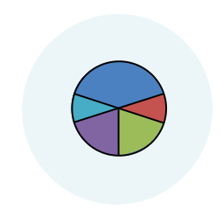
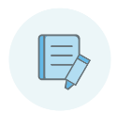

ENGHREIFFTIAU – EXAMPLES

03/2020

Cyflwyniad – Introduction

Pwrpas y llyfryn hwn yw i rannu rhai enghreifftiau o sut mae darpar-athrawon rhaglenni eleni wedi mynd ati i gysylltu tystiolaeth gyda’r Safonau Proffesiynol (SAC) yn y PDP  Er mwyn gwneud y gorau o’r enghreifftiau hyn, rhaid cofio’r canlynol:  - Mae’r PDP yn unigryw i chi – mae’n dystiolaeth o’ch datblygiad chi ar hyd y rhaglen.  - Nod y PDP yw i chi dynnu ynghyd tystiolaeth o sut yr ydych wedi cwrdd gyda safonau SAC unigol, ac egluro’r effaith mae hyn wedi cael ar eich dysgu ac addysgu chi a’r dysgwyr.  - Does dim ‘ffordd gywir’ o gwblhau’r PDP, ond mae angen cwrdd gyda’r gofynion o ran nifer y darnau tystiolaeth a’r datganiad effaith.  - Mae hefyd angen ysytried i ba raddau mae’r dystiolaeth rydych yn ei chynnwys yn cefnogi bod safon wedi’i chwrdd, e.e. ydy’r un darn o dystiolaeth yn mynd i fodloni mwy na 5 safon?  - Bydd y PDP yn ffocws i drafodaeth byddwch chi’n ei chael gyda staff allweddol ar ddiwedd y rhaglen, ac yn cyfrannu at ddyfarniad SAC.  Diolch yn fawr i’r darpar-athrawon rhoddodd ganiatad i gael cynnwys eu gwaith yn y llyfryn hwn. | The purpose of this booklet is to share some examples of how this year's student-teachers have worked on linking evidence to the Professional Standards (QTS) in the PLP  To make the most of these examples, you must remember:  - The PLP is unique to you - it is evidence of your development throughout the programme.  - The aim of the PLP is for you to draw together evidence of how you have met individual QTS standards, and to explain the impact this has had on your teaching and learning, and your pupils’ learning.  - There is no 'right way' to complete the PLP, but the requirements regarding the number of pieces of evidence and the impact statement need to be met.  - There is also a need to consider the extent to which the evidence you provide supports that a standard has been met, e.g. to what extent will the same piece of evidence satisfy more than 5 standards?  - The PLP will be the focus of a discussion you have with key staff at the end of the programme, and will contribute to the award of QTS.  Many thanks to the student-teachers who gave permission for their work to be used in this booklet.

Enghraifft 1 – Example 1
Yn yr enghraifft hon, mae’r darpar-athro wedi ffocysu ar y defnydd o themau traws-gwricwlaidd mewn gwersi.

In this example, the student-teacher has focused on the use of cross-curricular themes in lessons.
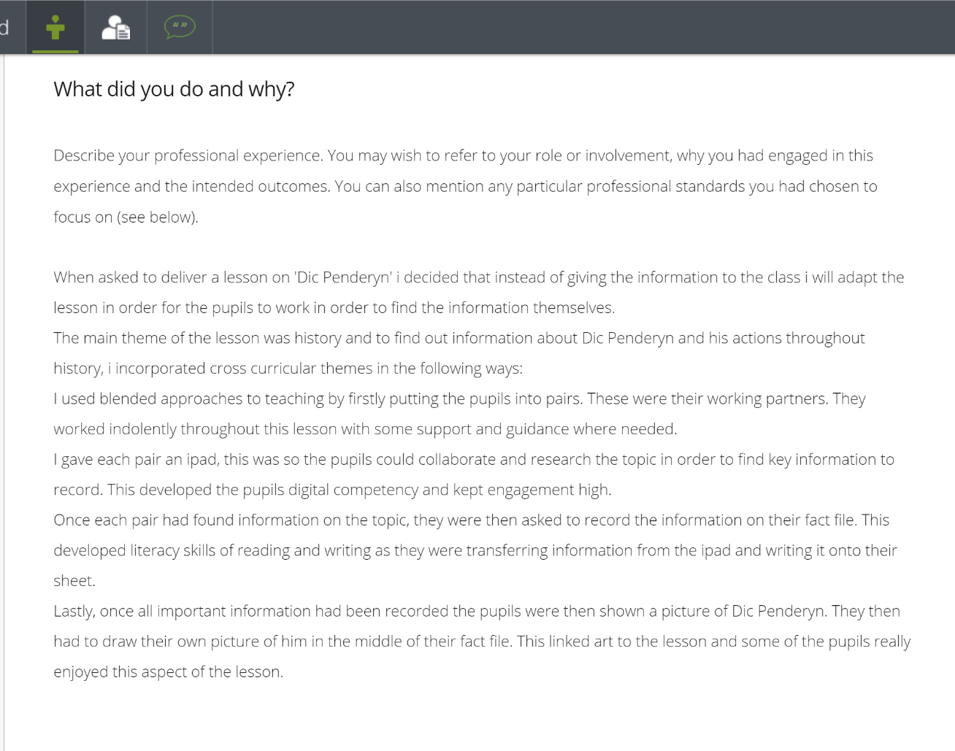
Esboniad a chyfiawnhad clir o benderfyniadau.
Clear explanation and justification of decisions.

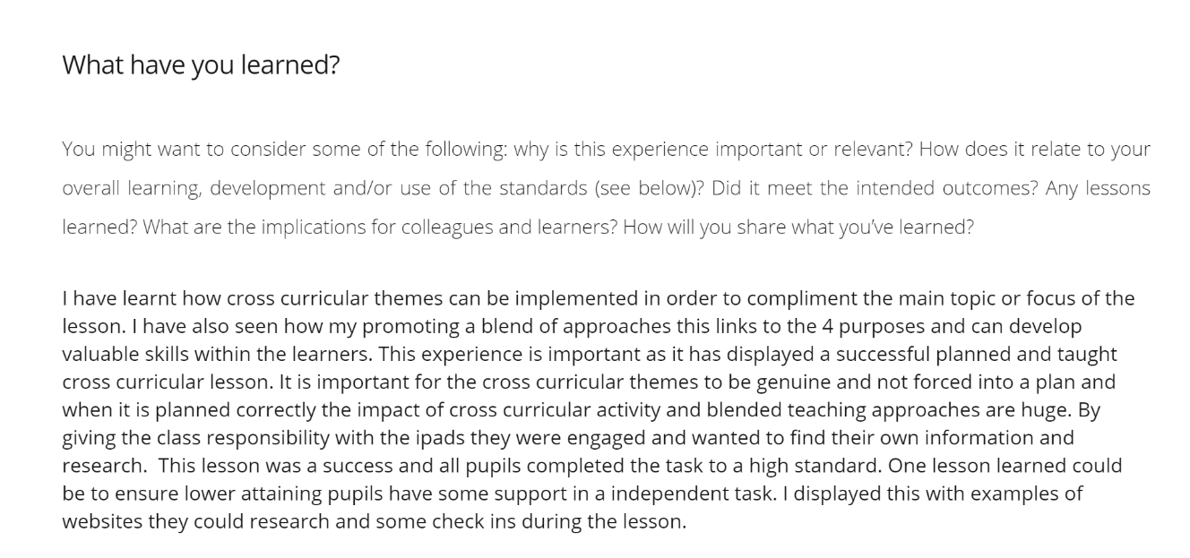
Cyswllt at bedair safon.
Link to four standards.
Adfyfyrio ar yr effaith ar ddysgu ac addysgu, a sut i wella ymhellach.
Reflecting on the impact on teaching and learning, and how to improve further.

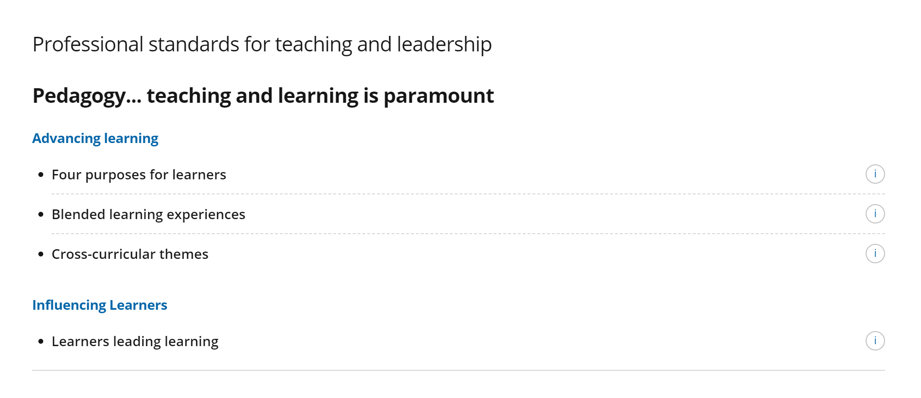

Mathau o dystiolaeth a ddefnyddiwyd:
1. Rhan o gynllun gwers
2. Llun o waith dysgwr A
3. Llun o waith dysgwr B.
Types of evidence used:
1. Part of a lesson plan
2. Picture of pupil A’s work
3. Picture of pupil B’s work

Enghraifft 2 – Example 2
Yn yr enghraifft hon, mae’r darpar-athro wedi ffocysu ar safon gyfan, sef Addysgeg – Mireinio. Mae wedi cyfeirio ar bob is-safon fel rhan o’r un templed.
In this example, the student-teacher has focused on a complete standard, which is Pedagogy – Refining. All of the sub-standards have been included as part of the one template.
Mae un templed wedi’i ddefnyddio i gyfeirio at bob un o’r is-safonau sy’n rhan o Addysgeg – Mireinio.
One template has been used to address all the sub-standards that are part of Pedagogy – Refining.

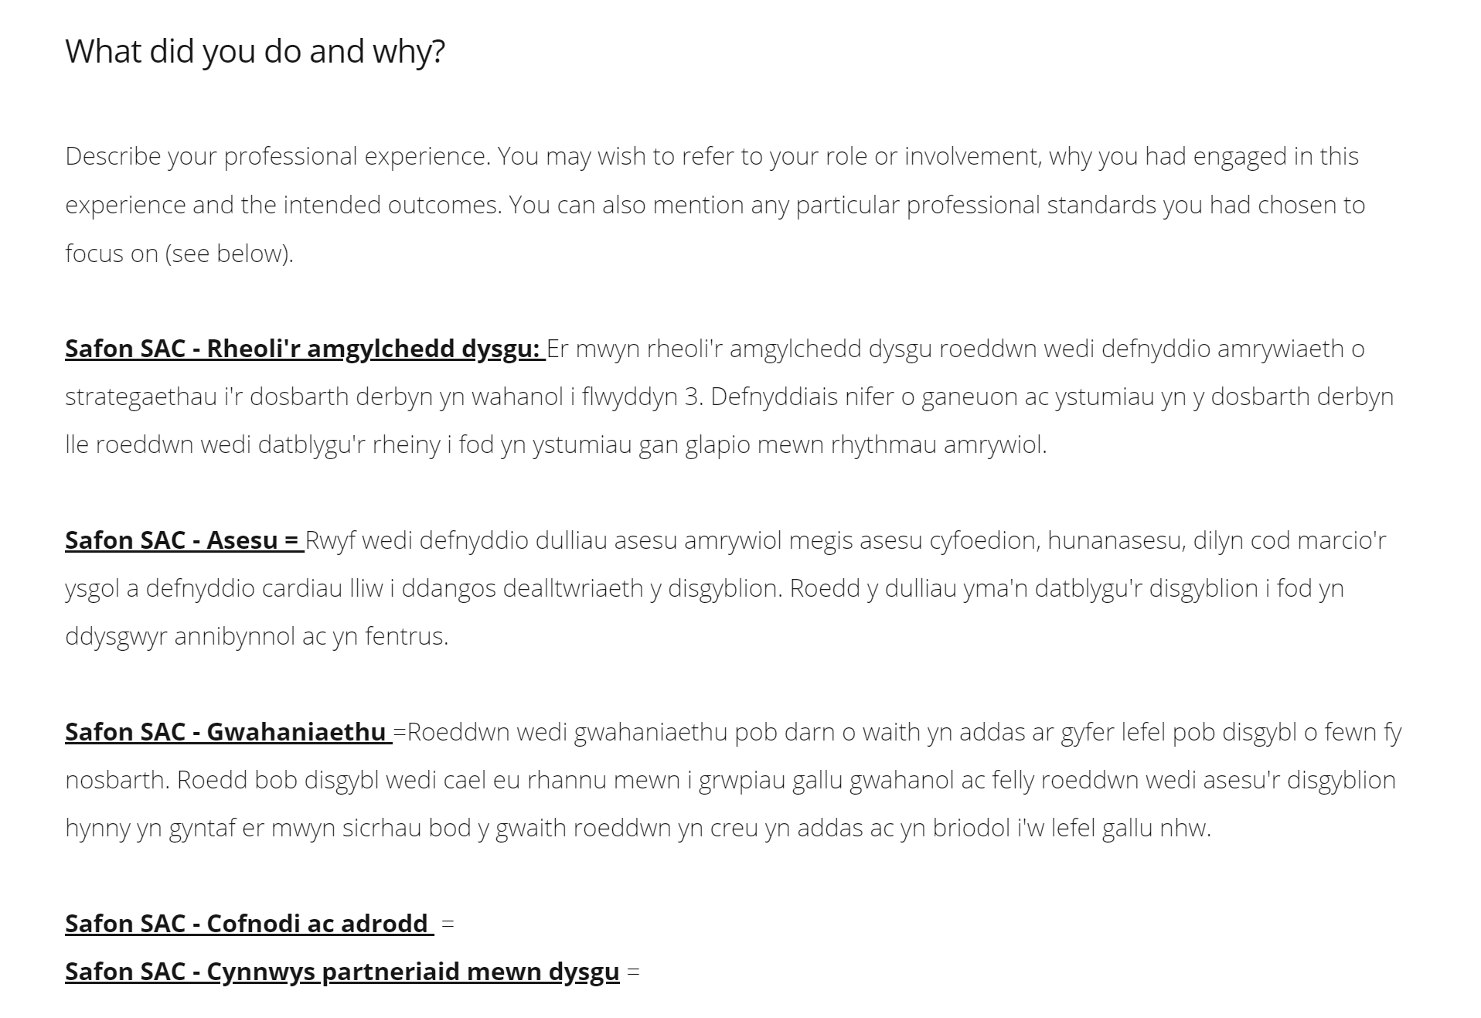

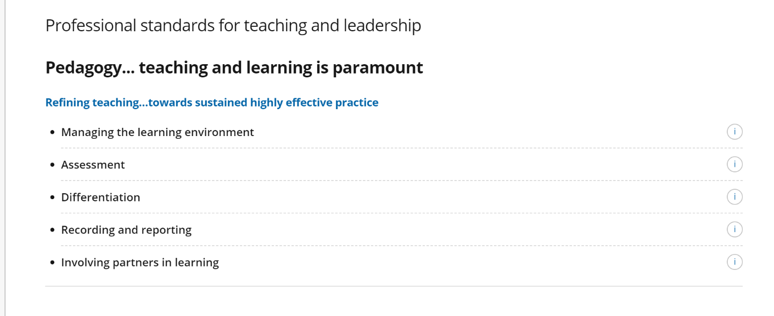
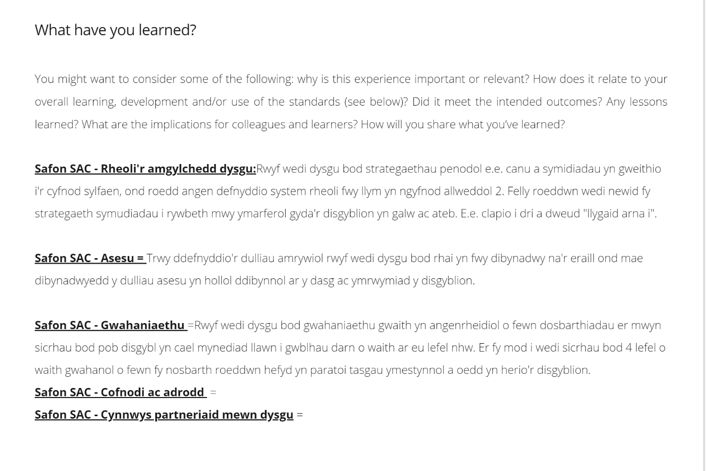
Mae cyswllt at bob un o’r is-safonau sy’n rhan o Addysgeg – Mireinio.
A link has been made to all the sub-standards that are part of Pedagogy – Refining.
Mae datganiad effaith wedi’i chynnwys ar gyfer pob un o’r is-safonau sy’n rhan o Addysgeg – Mireinio.
An impact statement has been included for all the sub-standards that are part of Pedagogy – Refining.

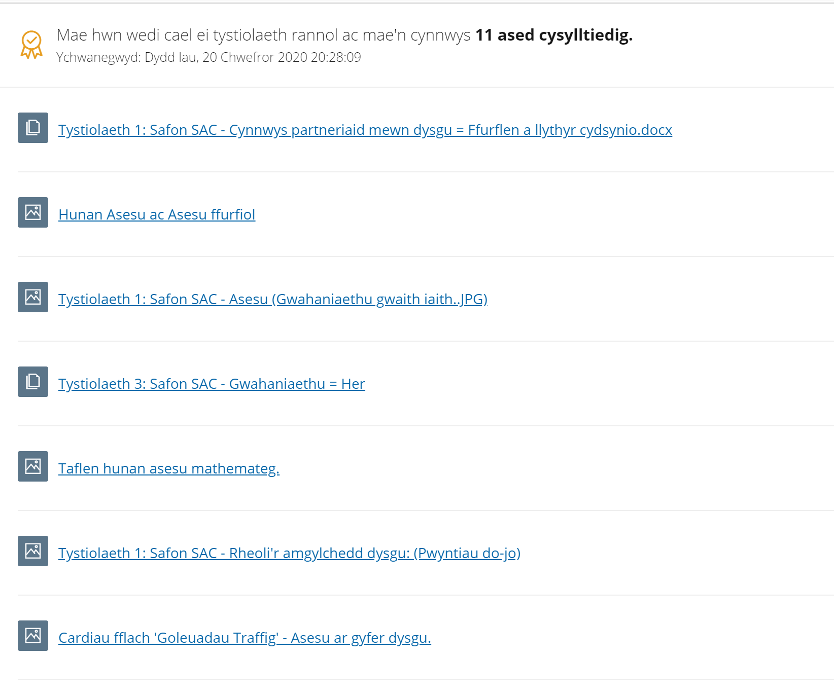
Mae’r dystiolaeth wedi’i labelu’n glir i ddangos i ba is-safon mae’n perthyn.
The evidence has been clearly labelled to show which sub-standard it belongs to.

Mathau o dystiolaeth a ddefnyddiwyd:
1. Ffurflen cydsynio (Modiwl ECAD7004)
2. Taflen hunan-asesu dysgwr C
3. Llun o ‘bwyntiau do-jo’ ar waith yn yr ystafell ddosbarth.
Types of evidence used:
1. Consent form (Module ECAD7004)
2. Pupil C’s self-assessment sheet
3. Picture of ‘class do-jo’ points being used in the classroom.

Enghraifft 3 – Example 3
Yn yr enghraifft hon, mae’r darpar-athro wedi ffocysu ar gofnodi ac adrodd.
In this example, the student-teacher has focused on recording and reporting.
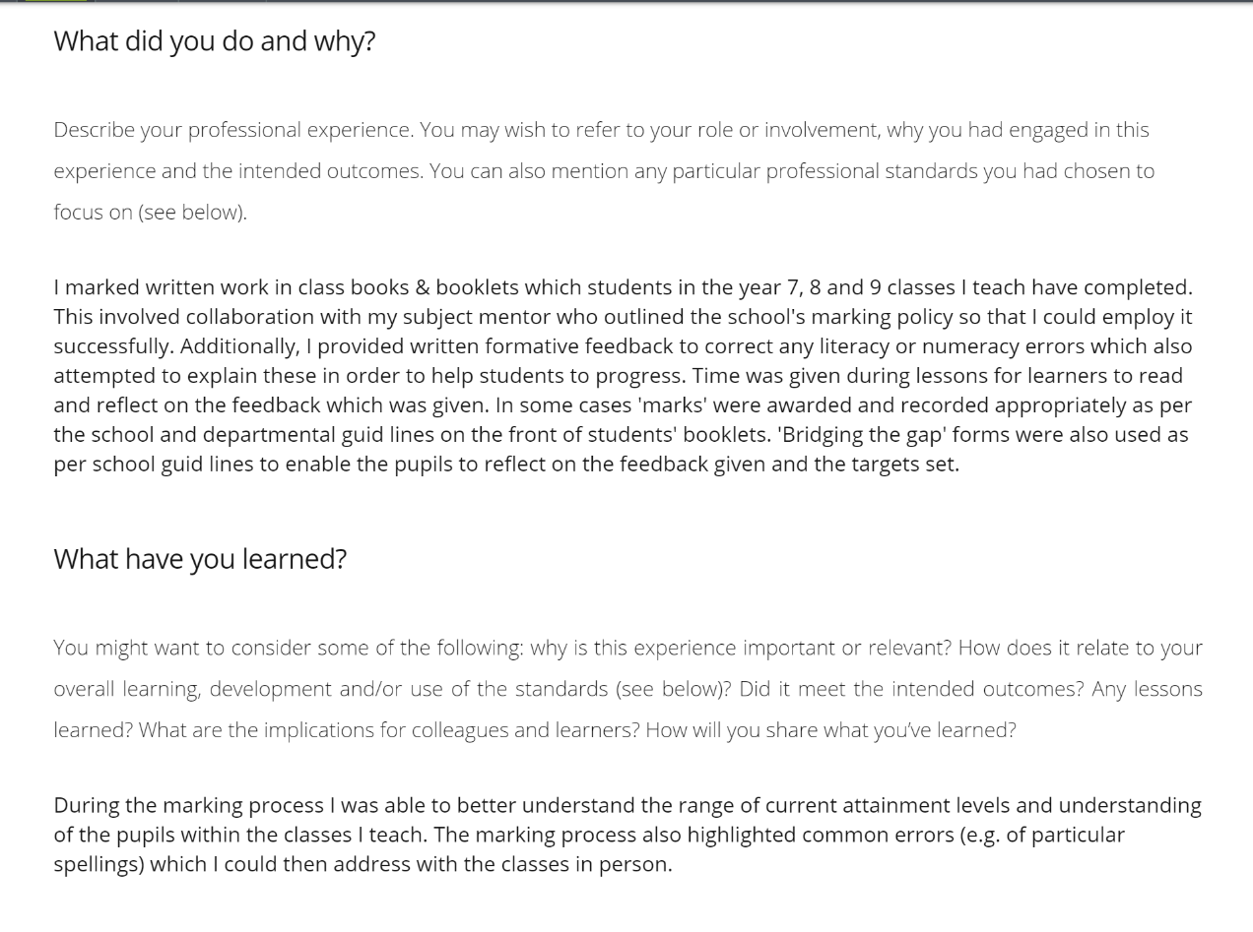
Esboniad a chyfiawnhad clir a chryno o benderfyniadau.
Clear and concise explanation and justification of decisions.
Adfyfyrio cryno ar yr effaith ar ddysgu ac addysgu.
Concise reflection on the impact on teaching and learning.


Cyswllt at dair safon.
Link to three standards.

Mathau o dystiolaeth a ddefnyddiwyd:
1. Llun o adborth yn y Dyddlyfr Dysgu
2. Llun o’r Adolygiad Canol Lleoliad
Types of evidence used:
1. Picture of feedback from the Learning Journal
2. Screenshot of the Mid-Placement Review

