

Evaluating the implementation and impact of the right care right person model within the UK police force.

Rebecca Bisi

2236124

Bachelor of Science: Professional policing practice

Acknowledgements

I would like to express my deepest gratitude to my main module tutor, Jane Davies, for her invaluable guidance and support throughout this project. My sincere thanks also go to my dissertation supervisor, Michelle Hill, whose encouragement, advice, and expertise have been instrumental in helping me complete this dissertation. I would also like to take the time to thank my work colleagues and supervisor, the patients and support they have provided me has been stupendous. There have been many questions, of which would not be answered if they were not by my side through this journey.

I would like to dedicate special thanks to my mum and my late father. My mum’s unwavering love and reassurance have carried me through every challenge, and the memory of my dad has been a constant source of inspiration. His belief in hard work, integrity, and perseverance continues to guide me every day. This achievement is as much his as it is mine, and I hope I have made him proud.

My aunt and uncle deserve a special thank you for their generosity, tolerance, and steadfast support, which have meant the world to me. I have been able to devote the time and attention required to finish my studies because of their kind assistance with childcare and their unwavering assurance. They have given our family love and security during this journey, for which I will always be thankful.

Finally, I would like to extend my heartfelt appreciation to my husband and our three children, whose patience, love, and understanding over the past three years have made this journey possible. Their encouragement and faith in me have kept me motivated through every late night and early morning. To my children — I hope this accomplishment shows you that, with determination and belief in yourself, anything is possible. I want you to know that you, too, can achieve your dreams and reach university if that is the path you choose. You have been my greatest inspiration, and this success is as much for you as it is for me.

Declaration

This work has not previously been accepted in substance for any degree and is not being concurrently submitted in candidature for any degree. Signed: R. Bisi Date: 10/10/25

This dissertation is being submitted in partial fulfilment of the requirements for the degree of BSc. Signed: R. Bisi Date: 10/10/25

This dissertation is the result of my own independent work/investigation, except where otherwise stated. Other sources are acknowledged by footnotes giving explicit references. A bibliography is appended. Signed: R. Bisi Date: 10/10/25

I hereby give consent for my dissertation, if accepted, to be available for photocopying and for interlibrary loan, and for the title and summary to be made available to outside organisations. Signed R. Bisi Date: 10/10/25

I hereby give consent for my dissertation, if accepted, to be available on the university’s IT system to those who have consent to use the system. Signed: R. Bisi Date: 10/10/25

Abstract

This dissertation uses a mixed-methods approach, collecting quantitative data from a questionnaire given to police officers and staff and qualitative insights from participant feedback to investigate the implementation and impact of the Right Care, Right Person (RCRP) model within South Wales Police, with a focus on how frontline officers view and apply the approach in operational practice. The research also looks at how effective RCRP is in ensuring that people experiencing mental health crises.

The study pinpoints important issues like officer confidence, interagency cooperation, and the real-world difficulties of integrating RCRP into routine policing. The results show the model's advantages, such as, better role clarity and less strain on police resources, as well as its continued drawbacks, like a lack of mental health support services and a lack of agreement on partner obligations.

According to the research, RCRP is a start in the right direction towards a more ethical and proportionate policing paradigm, but in order to guarantee its long-term success, more cross-sector commitment, communication, and training are needed. With regard to police involvement in mental health occurrences and the development of partnership-based policing in Wales, the study adds to the expanding body of knowledge.

Contents

- Introduction P. 6-7.

- Literature Review P. 8-10

- Methodology P. 11-12

- Analysis of results P. 13-26

- Conclusion and recommendations P. 27-29

- Bibliography / Reference P. 30 - 31

- Appendix P. 32

- Introduction

The Right Care, Right Person (RCRP) model's use and effects within South Wales Police are examined in this dissertation. By ensuring that people in mental health crises receive the right care from the best professionals, the model—which was initially created by Humberside Police in collaboration with health and social care agencies—aims to lessen the need for police officers to respond to situations that are better suited for medical professionals. The introduction of RCRP by South Wales Police marks a fundamental change in how frontline officers approach vulnerability and partnership working as policing throughout the United Kingdom experiences considerable operational and cultural upheaval.

Context & Background
Data from the College of Policing (2023) and HMICFRS (2018) shows that a large amount of police time is spent handling welfare and crisis calls rather than core crime-related duties. Police forces in England and Wales have reported increasing demands related to mental health incidents in recent years. National requests for change have resulted in the implementation of the RCRP method, which has been endorsed by the Home Office. Implementation has necessitated significant organisational change for South Wales Police, including the introduction of new triage procedures, cross-agency guidelines, and intensive training to guarantee officers are able to determine when police intervention is necessary.

Justification for the Research
Growing operational and ethical concerns about the effectiveness of RCRP's integration into enforcement practices served as the impetus for the study. Although the project has been commended in national reports for increasing efficiency, there is little factual data on the experiences and opinions of frontline officers. Therefore, the purpose of this research is to analyse these views within South Wales Police and determine how the RCRP model has affected interagency cooperation, workload, and decision-making.

Research Aim and Objectives
The primary aim of this research is to explore frontline police officers’ perceptions of the Right Care, Right Person model within South Wales Police and its impact on policing practice. The following objectives guided the study:
1. To evaluate frontline officers’ understanding and perceptions of the RCRP model.
2. To assess how RCRP has influenced police decision-making and resource allocation.
3. To explore the effectiveness of multi-agency collaboration under RCRP in South Wales Police.
4. To identify challenges and opportunities for improving implementation of RCRP.

Research Questions
The study was guided by the following research questions:
- How do frontline officers perceive the effectiveness of RCRP in managing incidents involving vulnerability?
- What impact has the RCRP model had on operational policing, resource deployment, and workload?
- How effective is inter-agency collaboration under RCRP from the perspective of police practitioners?

Relevance of the Study
This study adds to the expanding body of information on force-specific RCRP implementation, offering insights that could guide future national guidance and policy formulation. It provides important insight into how national reform is implemented locally by documenting the lived experiences of South Wales Police personnel. The results additionally underscore the wider consequences for public trust, employee well-being, and moral enforcement in handling demand linked to mental health.

Structure of Dissertations
There are five chapters in this dissertation. After this introduction, Chapter Two provides a survey of the literature that critically evaluates the body of knowledge regarding RCRP and police vulnerability. The research methodology, including the study's design, sampling, and ethical considerations, is described in Chapter 3. The results of the questionnaire are presented and analysed in Chapter 4, with connections made to theoretical frameworks and existing literature. Chapter Five concludes by assessing how well the study achieved its goals, pointing out its shortcomings, and making suggestions for further study and practice.

- Literature review

Introduction.
Concerns regarding the suitability and effectiveness of police responses to people going through mental health crises have grown as a result of the growing intersection between policing and mental health services. In response, a strategy framework known as the Right Care, Right Person (RCRP) model has been developed to guarantee that people experiencing mental distress receive the proper treatment from social and health care providers instead of law enforcement. The RCRP initiative, which was started by Humberside Police and is currently being implemented nationwide, aims to reinterpret the police's role in non-criminal, health-related occurrences (College of Policing, 2023). The origins, application, and perceived effects of RCRP in UK policing are examined in this literature review, which also looks at important topics such interagency cooperation, operational difficulties, training and capacity, and ethical considerations.

Background and Rationale for RCRP.
Due to limitations in the availability of mental health services, especially after hours, police departments have historically been forced to respond to mental health emergencies de facto (Mind, 2019). Police officers are often dragged into health and social care responsibilities for which they lack the necessary resources and training (HMICFRS, 2018). The excessive dependence on police services for mental health responses was deemed "unsustainable" and "inefficient" in the groundbreaking report Policing and Mental Health by Her Majesty's Inspectorate of Constabulary (2018).
In direct reaction to this problem, the RCRP model was created with the goal of reducing needless police participation and elucidating the proper agency response to people in crisis. The Home Office and National Police Chiefs' Council (NPCC) backed a nationwide rollout after Humberside Police's application of the model allegedly resulted in a 50% decrease in police demand for mental health events (NHS Confederation, 2022).

Implementation of RCRP Across UK Forces
Although RCRP has been hailed as a paradigm of best practices, numerous police departments have implemented it differently. Results are greatly impacted by elements including regional governance systems, the quality of local collaborations, and the accessibility of mental health treatments (NPCC, 2023). According to studies, effective implementation depends on a common commitment between policing, social services, and health organisations, supported by strong memoranda of understanding (College of Policing, 2023).
Implementation issues include unclear referral thresholds, inconsistent mental health triage availability, and staff resistance because of perceived dangers, according to local studies like those carried out by the Centre for Mental Health (2023). Furthermore, a significant obstacle that prevents the smooth deployment of health responders to occurrences that are typically handled by police is the lack of data integration and information sharing amongst services.

Impacts on Police Demand and Operational Effectiveness
According to new research, RCRP implementation results in quantifiable decreases in the amount of time police officers spend responding to calls pertaining to mental health (College of Policing, 2023). For example, Humberside Police stated that they were able to redeploy thousands of officer hours per year to core policing duties (Humberside Police, 2021). The situation is more complicated when considering additional forces, though. According to research by the Institute for Government (2024), the implementation of the RCRP caused unresolved crises and prolonged response times in areas where health services were not scaled up concurrently because of deficiencies in the health sector's capabilities.
Operationally speaking, several officers report feeling less overburdened by duties outside of their areas of expertise, which has improved their morale and job satisfaction (Police Federation, 2023). Others, on the other hand, worry about public censure and reputational harm when they are told not to react to those who are visibly distressed.

Interagency Collaboration and System Integration
Interagency cooperation has been repeatedly noted in the literature as a crucial component of RCRP success. However, disparities in organisational cultures, a lack of shared priorities, and resource asymmetries frequently impede multi-agency collaboration (Mental Health Foundation, 2021). In many places, the already-stressed NHS has found it difficult to devote further resources to taking on cases that were previously handled by the police.
The RCRP strategy has been identified as potentially enabled by integrated care systems (ICSs); nonetheless, assessments indicate that development has been inconsistent. In contrast to regions that depend on overburdened emergency rooms, those with robust pre-existing crisis pathways have transitioned more easily (King's Fund, 2023).

Ethical and Legal Considerations
Additionally, RCRP brings up significant moral and legal issues. In the absence of a prompt alternative response, critics contend that removing police from mental health crises could jeopardise patient welfare and public safety (Liberty, 2023). Furthermore, there are still issues with the duty of care and human rights duties under the Human Rights Act of 1998 and the Mental Health Act of 1983, particularly with regard to vulnerable people who are left without assistance.
While RCRP is in line with the goals of decriminalising mental illness and restoring dignity, some academics contend that in order to prevent unforeseen consequences, it must be paired with system-wide investment (Bather & Fitzpatrick, 2022).

Gaps in the Literature and Future Research Needs
Academic research on RCRP is still scarce and mostly consists of pilot assessments, policy commentary, and grey literature, despite increased policy attention. The evaluation of the long-term effects of RCRP on patient well-being, service demand, and system cost-effectiveness requires independent, longitudinal research immediately. The literature currently in publication also severely lacks qualitative research that captures the viewpoints of service users and comparative studies across areas.

Conclusion
By redefining mental health crises as essentially health and social care concerns rather than public order issues, the RCRP program marks a substantial paradigm shift in the way that mental health crises are managed. Although preliminary data from pilot regions shows promise in terms of lowering police demand and coordinating responses with professional knowledge, systemic resource limitations and inconsistent nationwide implementation pose challenges. In the end, RCRP's effectiveness hinges on ongoing cross-sector cooperation, funding for mental health facilities, and a mutual dedication to protecting those at risk.

- Research methodology

Introduction
This chapter lays out the study project's approach, which intends to investigate how the Right Care, Right Person (RCRP) paradigm is being applied in UK policing. The perspectives and experiences of frontline officers, call handlers, and related staff will be gathered via a questionnaire in order to meet the study's goals. In a way that is effective, moral, and suitable for the research setting, this method will enable the gathering of both quantitative and qualitative data.
Research Strategy
The study will employ a mixed-methods approach, integrating both qualitative and quantitative components to guarantee a full dataset (Creswell & Creswell, 2018). The main technique will be questionnaires since they allow for the collection of a wide variety of opinions and allow participants to answer open-ended questions in-depth.
This study approach will help achieve the following goals:
To investigate the perceptions of frontline police and staff regarding RCRP.
To evaluate the impact of RCRP on operational demand and decision-making.
To determine the difficulties and impediments to RCRP implementation.
To determine whether RCRP enhances collaboration with social and health care providers.
Ethical considerations will be central to the design. Respondents will be informed that participation is voluntary, their responses will remain anonymous, and no identifiable information will be collected (British Sociological Association, 2017).
Data Collection
There will be both closed-ended and open-ended questions in the questionnaire. According to Denscombe (2017), open-ended questions will enable participants to expound on their experiences, whereas closed questions (such Likert scales and multiple-choice alternatives) will yield quantifiable, comparative data.
In order to highlight the multidisciplinary nature of the RCRP model, the target sample will comprise medical personnel, call handlers, and frontline police officers. Because it will be disseminated electronically through an online survey platform, participants from a variety of roles and work schedules will be able to access it.
To put the results in context, demographic questions about role, rank, and years of service will be asked. Although response rates will determine the predicted sample size, it is anticipated that South Wales Police will account for a significant amount of the sample, with other forces perhaps contributing as well.
Data Analysis
Both statistical and thematic methods will be used to analyse the data. Descriptive analysis will be used to examine quantitative responses, highlighting trends and patterns via frequency tables and percentages. To help with interpretation, visual aids like pie charts will be employed.
Open-ended question qualitative answers will be subjected to thematic analysis. The responses will be classified and categorised so that patterns and recurrent themes can be found (Braun & Clarke, 2006). In order to provide a fair perspective of RCRP implementation, this dual method will make sure that both quantifiable trends and subjective observations are recorded.
Limitations and potential problems
A number of possible drawbacks are expected. According to Robinson and McCartan (2016), there is a chance of self-selection bias because the study would be voluntary, meaning that people who have strong opinions might be more inclined to participate. The findings might not be entirely generalisable, as most answers are anticipated to originate from a single police force.
Another drawback is that, although helpful for scope, questionnaires might not offer the depth of comprehension that focus groups or interviews could. Last but not least, a low response rate could compromise the data's representativeness.
To reduce these difficulties, measures will be implemented, such as guaranteeing anonymity to promote truthful answers, crafting precise and succinct questions, and disseminating the survey via reliable channels.
Summary
In conclusion, this chapter has described the study's research plan, data collection procedures, analytical approaches, and possible constraints. The best instrument to meet the research objectives is a mixed-methods questionnaire that strikes a balance between qualitative and quantitative measurement. Although issues like response rates and self-selection bias are expected, the technique has been planned to guarantee ethical integrity and produce useful data to meet the goals of the study.

- Analysis of Results

Chapter
The questionnaire was given to frontline police officers, medical personnel, call handlers, and supervisory staff. The results are presented and analysed in this chapter. Analysing the introduction and implementation of the Right Care, Right Person (RCRP) model across partner agencies and policing is the goal of the study, with an emphasis on inter-agency collaboration, operational understanding, and confidence. Through structured response questions and demographic data, the data collection offers both quantitative insights and qualitative viewpoints from open-text responses. Because the analysis is organised according to the main goals of the study, it is possible to systematically examine the efficacy of RCRP and the difficulties encountered in its application.
The following four goals serve as a guide for the analysis:
1. To assess frontline police officers', call handlers', and medical professionals' familiarity and comprehension of the RCRP model.
2. To assess the perceived practical efficacy of RCRP, particularly whether it has improved outcomes for vulnerable people and decreased the demand on law enforcement.
3. To determine the difficulties and impediments to execution, including resource availability, training, and interagency collaboration.
4. To gather frontline viewpoints on how RCRP should evolve going forward, including suggestions for enhancing partnership and operational delivery.
4.2 Demographic and role information.
Question1, What is your current role? Question 2, How many years have you worked in your current role? Question 3, What region or police force/health trust do you work in? (Optional).
The questionnaire was completed by 165 individuals in total. Only a very tiny percentage of responders were recruited from the medical field, call handlers and L&D sergeants; the vast majority (96.4%) identified as frontline police officers. Because frontline officers continue to be the predominant group that encounters circumstances where the Right Care, Right Person (RCRP) paradigm applies, this suggests that the dataset is significantly weighted towards operational policing perspectives. This finding mirrors the observations made by HMICFRS (2018) in “picking up the pieces” where policing was described as the “default first responder” to mental health crises. The limited number of responses from health and call handling professionals also reflects on-going challenges in ensuring that multi agency approaches to RCRP are embedded in practice, despite the college of policing (2023) emphasis on shared responsibility across agencies.
A wide range of experience was reflected in the responses regarding length of service. Of the participants, the largest group (35.2%) claimed 1–3 years of service, while 7.9% had less than a year in their position. 30.6 percent had served for more than 15 years, 22.4% for 8 to 15 years, and 30.9% for 4 to 7 years. This diversity of answers shows that the dataset includes opinions from experienced staff members with extensive operational knowledge as well as relatively fresh officers who might be coming into contact with RCRP for the first time in their careers. This aligns with Bather and Fitzpatricks (2022) argument that differing levels of professional Experience often shape the way front line staff perceive new policy initiatives, with newer officers potentially more open to adopting revised practices, and experienced staff drawing comparisons with earlier policing models.
Out of the 144 individuals who responded to the question about where they work, all but two stated that they are based in South Wales, with the other two respondents being employed in Kent. By incorporating viewpoints from another force region, this adds a small comparative element even though it maintains a significant focus on South Wales Police. Although the concentration of replies in South Wales should be acknowledged as a representativeness restriction, it also represents the operational environment in which RCRP is being implemented as well as the professional background of the researcher. The literature on workforce transformation (College of Policing, 2016) highlights the significance of local policing context in shaping the success of reform initiatives, reinforcing the importance of situating the findings within a geographically specific frame.
Together, these demographic findings highlight two important considerations. Firstly, the dominance of police voices underscores the operational focus of the study but limits the breadth of cross-agency perspectives. Secondly, the variation in service length and the geographic concentration of respondents offer opportunities to explore how perceptions of RCRP may differ between newer and more experienced officers, and how implementation may be shaped by local policing contexts.
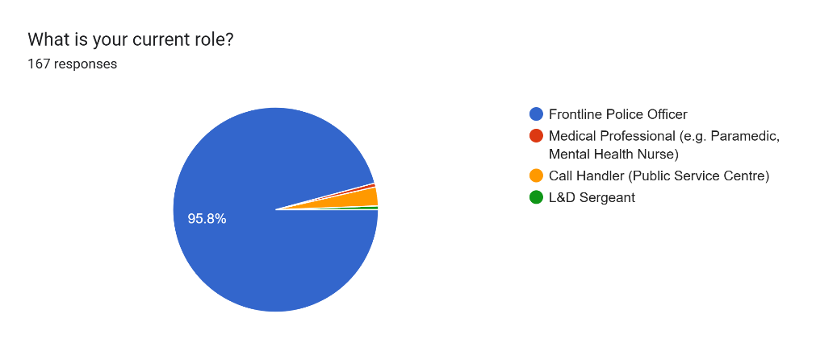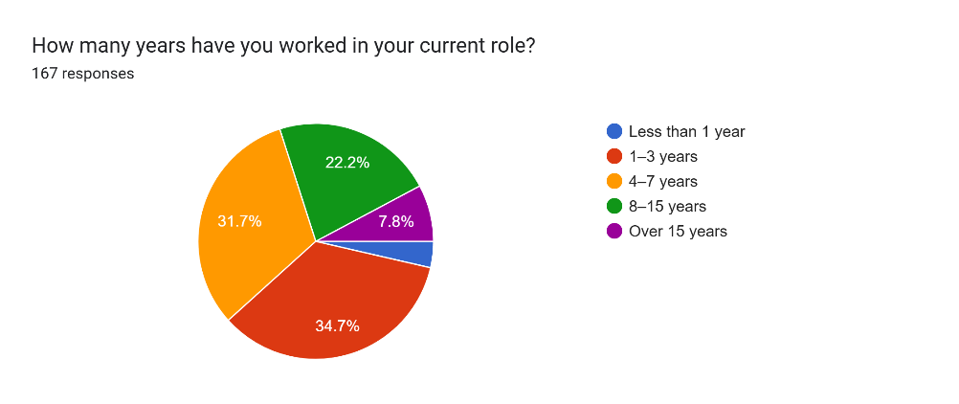
Question 4, How familiar are you with the Right Care, Right Person (RCRP) initiative?
Nearly half of respondents (49.4%) said they were extremely familiar with the RCRP effort when questioned about their familiarity with the model, while another 47% said they were moderately aware. Just a small percentage said they were either unfamiliar with it or had only heard about it without knowing any specifics. These results imply that the sample as a whole has a comparatively high level of awareness of RCRP, with most individuals exhibiting at least some comprehension.
This outcome is noteworthy because RCRP has only recently been implemented outside of Humberside Police's original implementation (College of Policing, 2023). HMICFRS (2018) placed a strong emphasis on ensuring frontline officers have clarity regarding their roles in relation to mental health demand, and the high levels of reported familiarity may be a reflection of the proactive communication and early stages of workforce preparation that South Wales Police adopted.
However, the fraction of people characterising themselves as only moderately familiar is noteworthy. This implies that although officers and employees could be aware of RCRP, their comprehension of its operational use may still be uneven. This supports the finding by Bather and Fitzpatrick (2022) that variation in practitioners' levels of expertise is one of the obstacles to successful partnership arrangements. Lack of understanding could undermine RCRP's goal of making sure that police are no longer the first responders to health-related requests by affecting confidence in applying its principles in real-world situations.
Synthesising this with the research, the responses underscore the significance of continual training, practical scenario-based guidance, and reinforcement of RCRP concepts across the workforce. Familiarity must be translated into consistent use in reality, as the College of Policing (2023) emphasises. This calls for embedding the model not only at the policy level but also through regular exposure and structured learning. In comparison to early adopter forces like Humberside, the results presented provide a helpful benchmark for evaluating how far South Wales Police have come in laying that foundation.
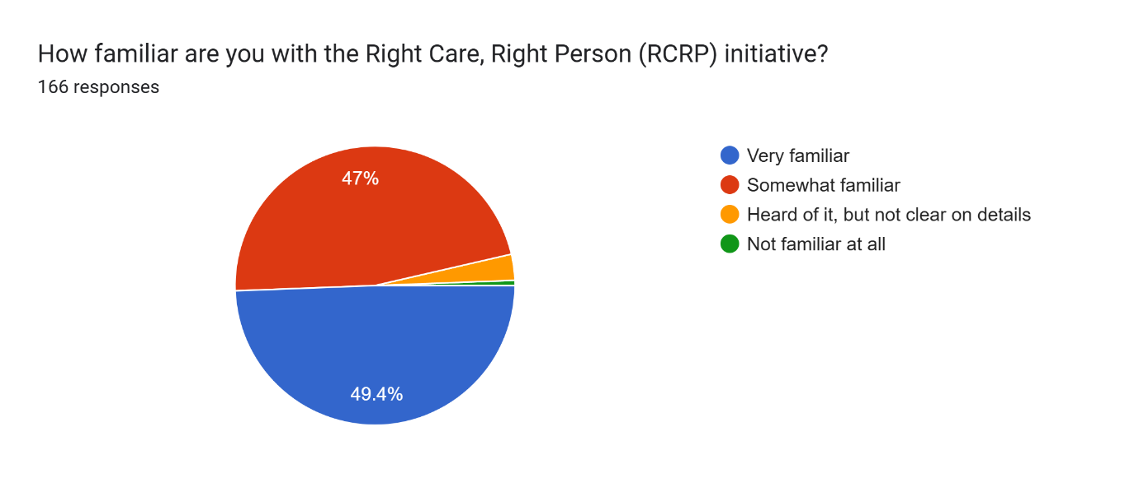
Question 5, Have you received any training or guidance specific to RCRP?
Participants' answers regarding whether they had received any RCRP training or advice showed a clear discrepancy between awareness and readiness. Although some respondents said they had received briefings or documents, most said they had little to no formal training. As demonstrated by the previous question, this implies that while officers may have a general concept of the initiative, the level of comprehension necessary for confident application is not as developed.
This result is consistent with national concerns raised by HMICFRS (2018), which found that a major obstacle to successful partnership work in managing mental health demand is a lack of training. Similarly, if change is to be ingrained, Bather and Fitzpatrick (2022) contend that systematic workforce development must be paired with knowledge of new frameworks.
Combining these viewpoints, the answers indicate that South Wales Police are still in the early stages of implementation, where systematic training is still required despite increased awareness due to communication. Without this, frontline workers run the danger of operational uncertainty while implementing RCRP, thereby undermining its potential benefits (College of Policing, 2023).
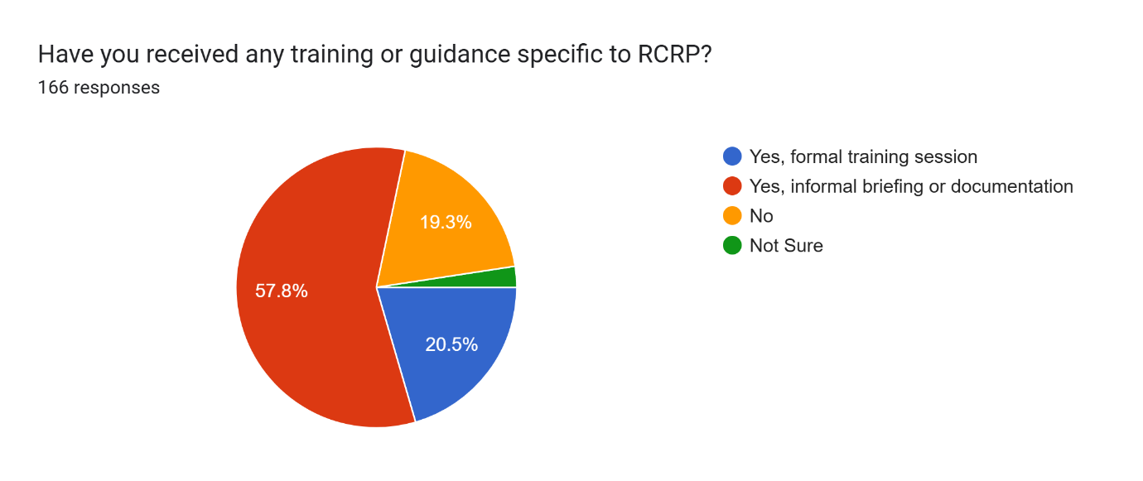
Question 6, In your own words, what do you understand RCRP to mean?
In this section 150 responses were received. The majority of participants showed an understanding of the RCRP initiative. Whilst a small number of individuals showed little understanding or faith in the implementation of RCRP. The results highlight pockets of misunderstanding and resistance.
One user said:
‘RCRP involves police and partner agencies working together to ensure that people requiring support for health and social care needs, particularly those in mental health crises, are responded to by the most appropriate professional with the right skills and training’
Another said:
‘Useless’
Another said:
‘That MH load would be taken from front line police’
Question 7, Has your workload or responsibilities changed since the implementation of RCRP? Question 8, In your opinion, has the RCRP model helped to improve response to mental health-related incidents?
Responses revealed a range of workload changes following the deployment of RCRP. Although 41.9% indicated there was no change and 47.3% claimed their responsibilities had changed slightly, just a small percentage saw a major influence. This implies that daily demand has not yet been significantly changed by RCRP for many.
More evenly distributed answers were found when asked if RCRP enhanced responses to mental health incidents: 42.5% of respondents said changes were visible, especially to some level, while 42.5% said there was little to no assistance. A tiny percentage believed the results were unclear or worsened.
These results show advancements as well as limitations. A limited sense of improvement indicates that the model is still embedding, while awareness of change demonstrates early adaptation. Police changes necessitate time, consistency, and multi-agency engagement, according to HMICFRS (2018). In the absence of consistent training and involvement from the health sector, RCRP awareness might not yet result in significant workload reduction or improved outcomes.
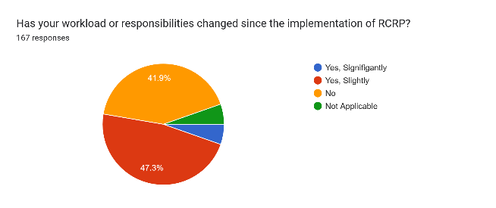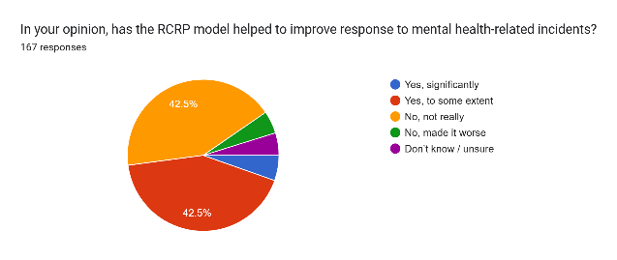
Question 9, Do you feel that the current implementation of RCRP in your area is effective? Question 10, Why do you feel this way, to the answer you gave above?
Just 11.4% of respondents said that the RCRP implementation was effective, while nearly half (47.3%) said that it was not, and 36.5% said that it was moderately effective. Only a tiny percentage were uncertain. These numbers demonstrate a general lack of trust in the way RCRP is currently being implemented.
Qualitative answers supported this opinion. Many interviewees emphasised persistent problems such still being sent to ambulance calls, frequent pushback from health services, and little discernible drop in demand, while some acknowledged decreases in the number of officers attending medical incidents. There was inconsistent impact among departments, as evidenced by others who said that their roles were untouched.
Critiques of police reform in general are reflected in this discrepancy between operational reality and legislative purpose. Brogden and Nijhar (2005), for instance, contend that in the absence of explicit accountability mechanisms, frontline officers frequently regard such efforts as rhetorical rather than useful. Similarly, Innes (2020) emphasises that effective policing transformation requires observable increases in workload and duty clarity; in the absence of these, scepticism swiftly grows. These qualitative comments, which define RCRP as ineffectual or unaltered, demonstrate this trend and show that practitioners' perceptions of the model's legitimacy are still fragile.
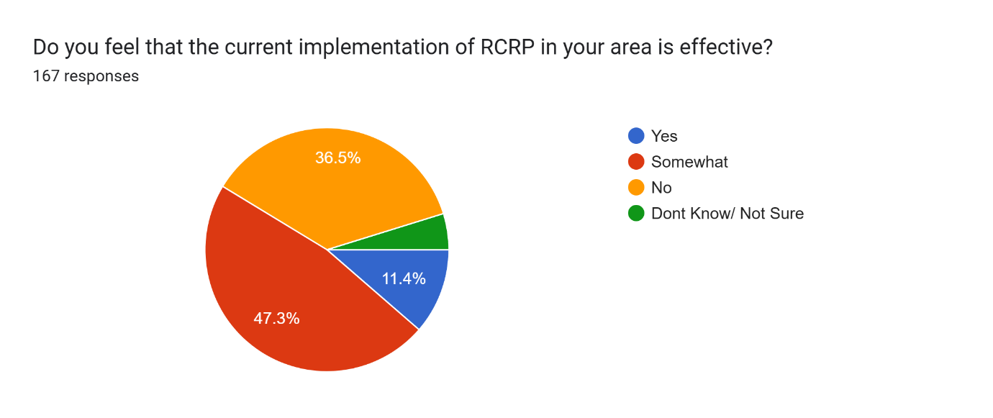
Question 11, Since RCRP was introduced, have you attended fewer mental health-related incidents?
There has been no change, according to 43.3% of respondents, whereas 39.6% of respondents said they are attending less occurrences related to mental health since RCRP was implemented. While a tiny percentage of respondents said they were attending more events or thought the question was irrelevant, only 7.9% believed they were attending noticeably fewer instances.
Although there has been some progress, this pattern indicates that many frontline police are still responding to mental health demands, casting doubt on whether RCRP has actually moved responsibility away from policing. The continued high attendance rates raise worries about health services' inability to regularly handle calls that are within their purview.
According to the College of Policing (2023), strong collaboration and well-defined referral pathways are necessary for the efficient implementation of RCRP. These results show that progress has been uneven, which emphasises the necessity of regular interagency collaboration to guarantee that police involvement reductions are actually implemented.
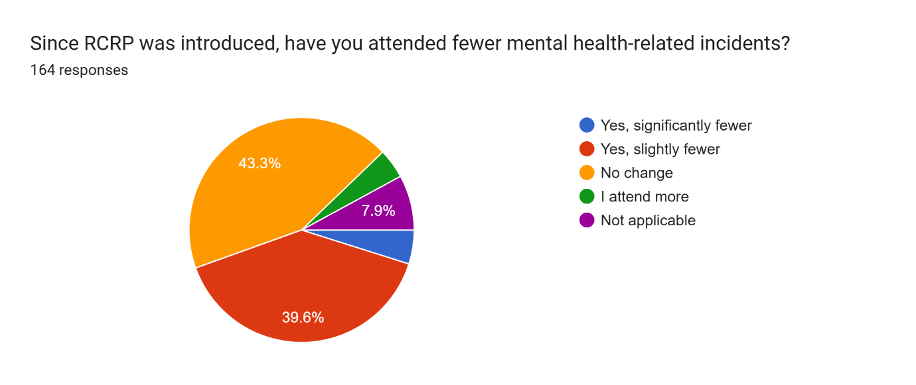
Question 12, Do you feel confident in identifying when an incident is suitable for referral to health partners under RCRP? Question 13, Have you encountered delays or difficulties when referring RCRP-eligible incidents to partner agencies?

Of those surveyed, 62.3% expressed confidence in their ability to identify occurrences that are appropriate for referral under RCRP, compared to 29.6% who said they were occasionally confident and 8% who said they were not. While a significant minority of officers are still unsure, this indicates that the majority of officers are aware of the referral requirements.
But identification certainty does not always convert into easy practice. Regarding the challenges of referring occurrences that qualify for RCRP to partner agencies, 47.5% of respondents said they experienced delays regularly, while 41.4% said they experienced delays infrequently. Fewer people claimed that these issues were uncommon or never encountered. This suggests operational constraints in multi-agency working continue to hinder effectiveness notwithstanding frontline awareness.
These findings reflect broader issues identified in Policing Vision 2025, which emphasises that effective service delivery increasingly relies on integrated partnership working rather than policing acting in isolation. The delays and inconsistencies reported here suggest that these aspirations are not yet fully realised in practice, reinforcing the need for stronger alignment between police and health agencies if RCRP is to succeed.

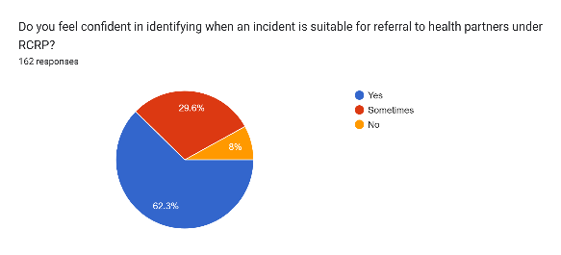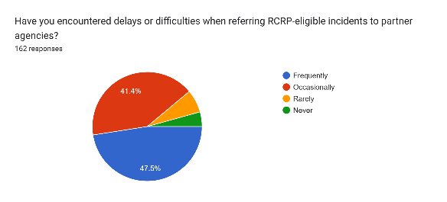
Question 14, Do you feel RCRP has helped ensure better outcomes for vulnerable individuals in crisis?
Of those surveyed, 38.7% believed that RCRP had improved outcomes for vulnerable people in crisis, 43.6% disagreed, and 17.8% were not sure. With somewhat more respondents questioning the model's efficacy than supporting it, these findings show a lack of agreement.
This gap implies that, despite the perception of improvements in vulnerability outcomes by some, many people are still not convinced, perhaps as a result of uneven service delivery. Respondents seem to feel that RCRP does not yet consistently implement sustained, collaborative partnership working, which is necessary to improve outcomes for vulnerable individuals, as stated in Policing Vision 2025.
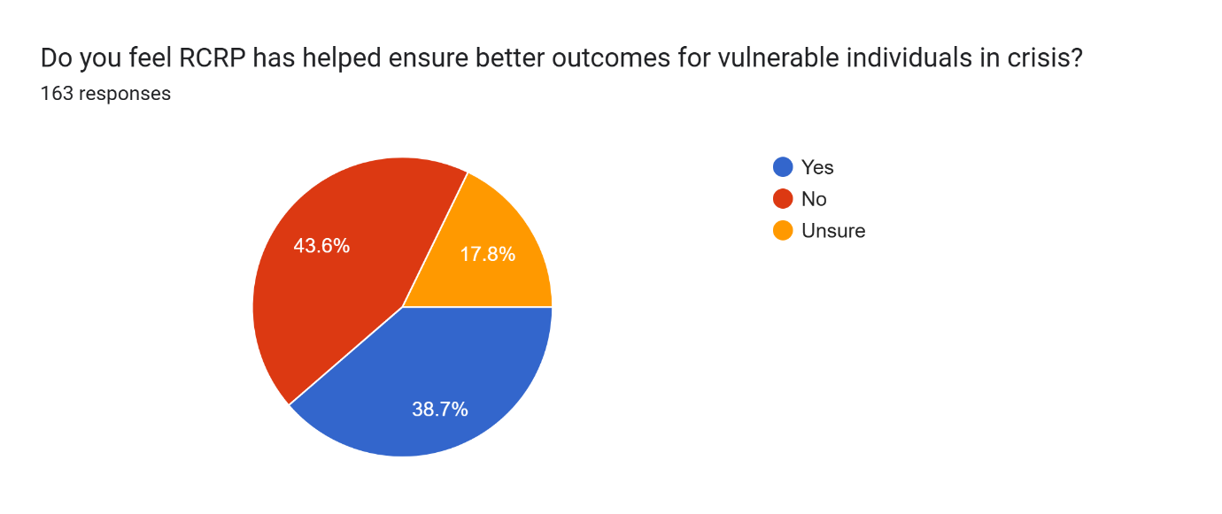
Question 15, If Unsure please explain briefly below, Why?
Responses from those who weren't sure if RCRP enhances results revealed a number of topics.
According to some participants, it is challenging to assess impact because their function does not directly include providing care.
Others emphasised that, in spite of RCRP, police still respond to some situations when mental health services reject them.
Lack of visibility into what happens to people once they are referred was another issue that was brought up, with some police questioning whether calls are being successfully diverted.
According to some responders, not much has changed in practice.
All things considered, these opinions imply that uncertainty results from both irregular partner agency participation and little role involvement.
Question 16, Has the introduction of RCRP resulted in more referrals or handovers from the police? Question 17, Do you feel equipped and supported to manage the additional responsibilities arising from RCRP?
Few respondents found major increases or decreases in referrals, while 35.5% reported a minor increase and 51.3% saw no change when asked if RCRP had resulted in more referrals or handovers. This suggests that, in spite of the initiative, referral patterns are mostly unchanged.
Just 12.7% of respondents felt completely prepared to handle increased tasks, 58.2% felt just moderately supported, and 25.3% felt no help at all. These findings imply that although RCRP has not significantly changed the amount of referrals, many employees feel unprepared, which is consistent with Policing Vision 2025's concerns that effective changes need sufficient funding and workforce development.

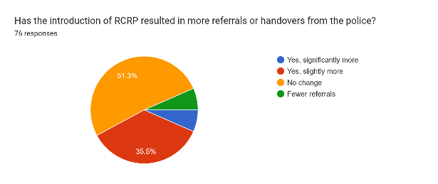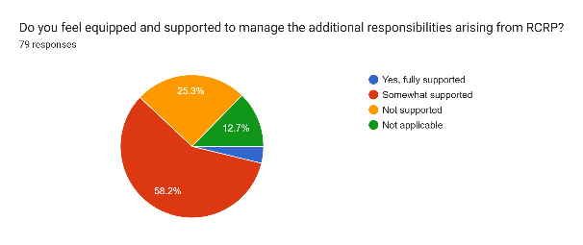
Question 18, In your experience, are the individuals referred via RCRP receiving timely and appropriate care?

Merely 9.2% of those surveyed said that people referred through RCRP were getting timely and appropriate care. In comparison, the largest group (34.2%) chosen responded "don't know," 25% replied "sometimes," and 31.6% stated "no." According to these findings, there is a great deal of doubt and anxiety about the outcomes for those who are referred.
The conflicting answers reveal greater concerns about the ability of health care to handle demand that has been misdirected, as noted by HMICFRS (2018). Officers might continue to doubt the model's efficacy if there isn't constant proof of better care. Therefore, ensuring clear and trustworthy paths is essential to preserving faith in the targeted advantages of RCRP.
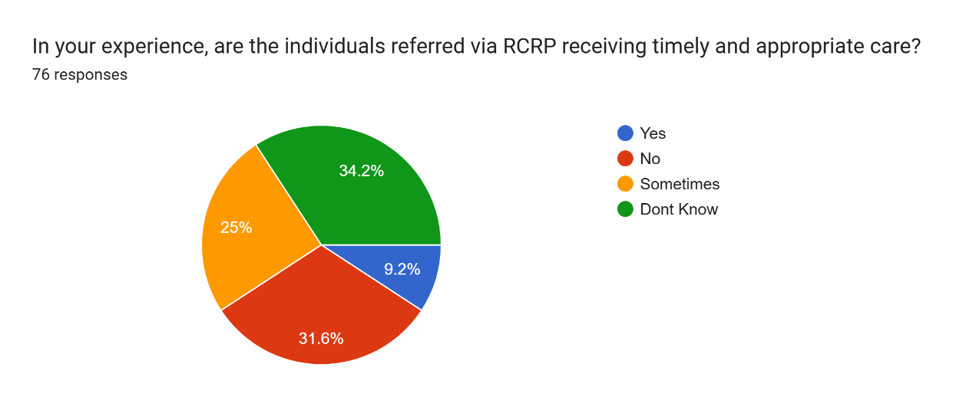
Question 19, Do you feel confident in identifying and triaging calls that fall under the scope of RCRP?
Respondents were evenly divided when asked if they felt confident in recognising and triaging calls that fell under RCRP: 12.3% said no, 43.9% said yes, and 43.9% said occasionally. This balance shows that while a significant number of employees believe they are capable, nearly half are still unsure, and a minority are completely unconfident.
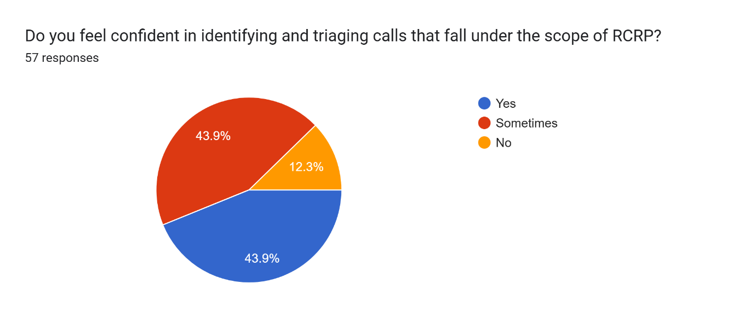
Question 20, Do you believe the current call-handling procedures and scripts support correct decision-making in line with RCRP?
Just 20.7% of respondents agreed with the statement that present call-handling protocols and scripts support correct decision-making in accordance with RCRP, with 39.7% providing a partial response. 19% expressed uncertainty, while another 20.7% said no. According to these findings, there is a lack of agreement, with the majority of respondents expressing at most a partial alignment.
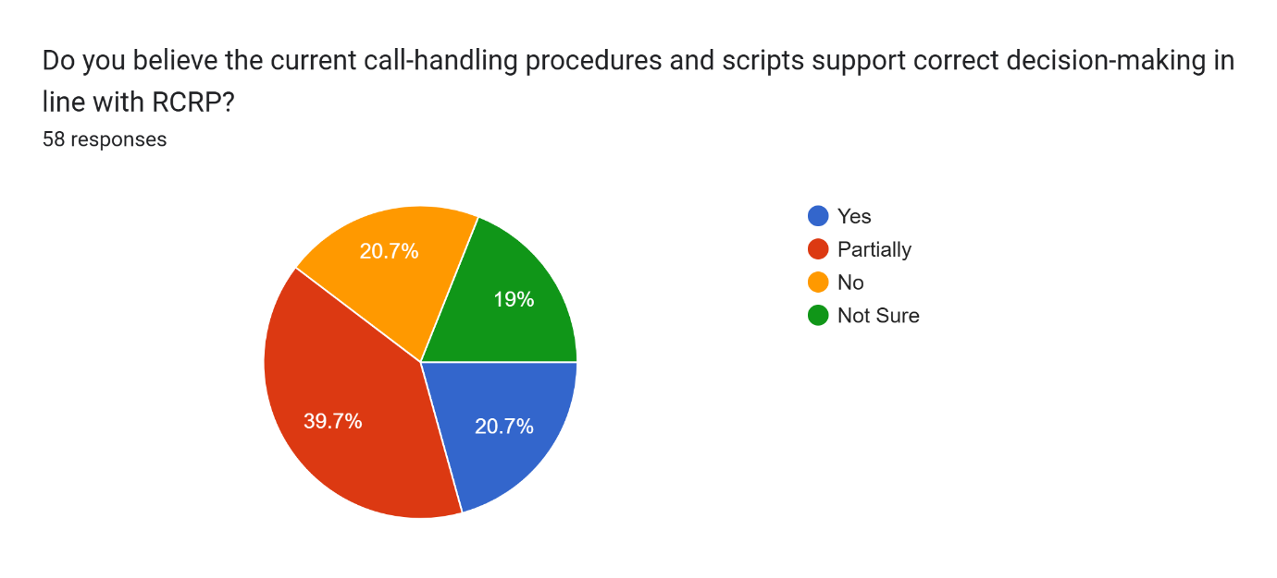
Question 21, Have you received adequate training or guidance specific to RCRP call handling?
When asked whether they had received adequate training or guidance specific to RCRP call handling, only 19.6% of respondents answered yes. A larger proportion (35.7%) reported partial training, while 30.4% stated no and 14.3% were unsure. These results indicate that structured training is inconsistent, with the majority of staff feeling underprepared.

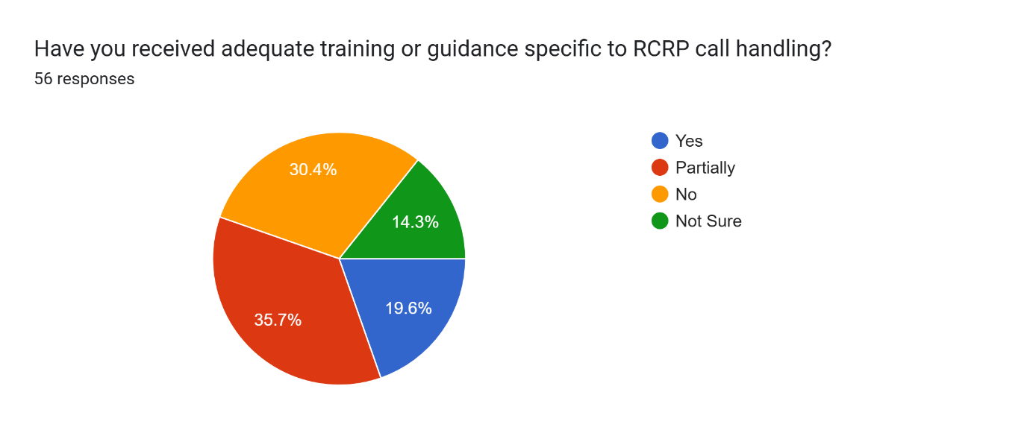
When combined, the results from call-handling employees show a recurring pattern of being just partially prepared. Although a significant minority acknowledged hesitation, many respondents claimed only limited confidence in their ability to recognise and prioritise RCRP situations. Views on call-handling scripts also showed this tendency, with the majority of respondents believing they only partially assisted sound decision-making. The provision of training seems to be at the heart of this problem; the majority of respondents characterised their RCRP call-handling training as incomplete, non-existent, or confusing, and less than one-fifth said they had received sufficient training. These findings support issues raised in Policing Vision 2025, which highlights the need for continual direction and workforce skill investments for transformation. In the absence of thorough training and well-defined call-handling procedures, the frontline implementation of RCRP runs the danger of fragmentation and unequal delivery across roles.
Question 22, What do you see as the main benefits of the RCRP model?
When asked what they thought were the primary advantages of the RCRP approach, 134 respondents gave a variety of answers. Benefits include better resource utilisation, ensuring the appropriate agency responds to situations, and lessening the workload for frontline police officers were cited by many. Others underlined the possibility of providing vulnerable people, especially during mental health crises, with more suitable care. Nonetheless, a tiny percentage of participants believed there were no obvious advantages, which reflects continued doubt regarding its effectiveness.
One responder said:
None
Another said:
The model is correct it just requires resourcing correctly
Another said:
At present, none. If used correctly and supported by mental health agencies, the benefits for patients and police would be huge
While another said:
It helps ease pressure off police Ensures right person deals with individual and incident
Question 23, What challenges have you encountered, if any, in implementing or working within the RCRP framework?
In addition to worries about funding and ongoing police participation in mental health situations, 125 respondents cited persistent problems like delays, a lack of support, and resistance from partner agencies when questioned about difficulties they had establishing or operating within the RCRP framework.
A few of the responses are as follows:
‘None’
‘Push back’
‘Push back from other agencies’
‘Ambulance still take hours even if police aren’t required’
‘Trying to get ambulance to take ownership of the call’
‘More calls, no support’
‘Police control taking ownership too soon’.
‘Majority of issues arise around the mental health incidents’
‘Resources’
Concerns expressed in HMICFRS (2018), which emphasised ongoing deficiencies in interagency collaboration and resource constraints, are echoed in these identified difficulties. Delays, resistance, and ongoing police participation are frequently mentioned, indicating that despite the RCRP's goals, real-world obstacles still exist. Effective transformation necessitates constant cooperation and sufficient funding, as highlighted by Policing Vision 2025; otherwise, frontline officers could feel unsupported in handling demand connected to mental health.
Question 24, What improvements would you suggest to make RCRP more effective in practice?
When asked what improvements could make RCRP more effective, 123 respondents offered varied suggestions. Common themes included stronger partnership working, more consistent ambulance attendance, enhanced training, and clearer role boundaries. Some also stressed the importance of adequate time for the model to embed and be properly resourced.
Some of the responses received are as follows:
Bedding in period, time for the change
More push back to ambulance to attend
Better training all round
None
Don’t accept calls in PSC
More partnership work with WAST and SWP call handlers to foster mutual understanding.
A specific and outlined time limit when spend in crisis, the introduction of mental health practitioners working hand in hand with police , a joint response vehicle ? As seen in some police forces
These recommendations reflect concerns raised by the APP Guidance on Mental Health (2016), which highlighted that officers require clear pathways and multi-agency cooperation to manage vulnerability effectively. Similarly, Mind (2018) noted that without robust training and resourcing, reforms risk limited impact. The responses here underline the same priorities, showing that frontline staff see practical resourcing and clearer collaboration as essential for RCRP to succeed.
Question 25, Do you believe RCRP has improved inter-agency working and communication?
Regarding whether RCRP has enhanced interagency collaboration and communication, 41% of participants responded in the affirmative, 43.6% in the negative, and 15.4% in the doubtful category. Under the paradigm, the nearly equal split reveals disparate frontline experiences of teamwork.
According to the findings, there has been success in certain regions but ongoing challenges in others, indicating a lack of coordination between the police and medical services. This is consistent with Mind's (2018) results, which emphasised that improvements can only be successful when collaboration is ingrained across all parties. For RCRP, attaining its goals still depends on fostering consistency and trust in interagency communication.

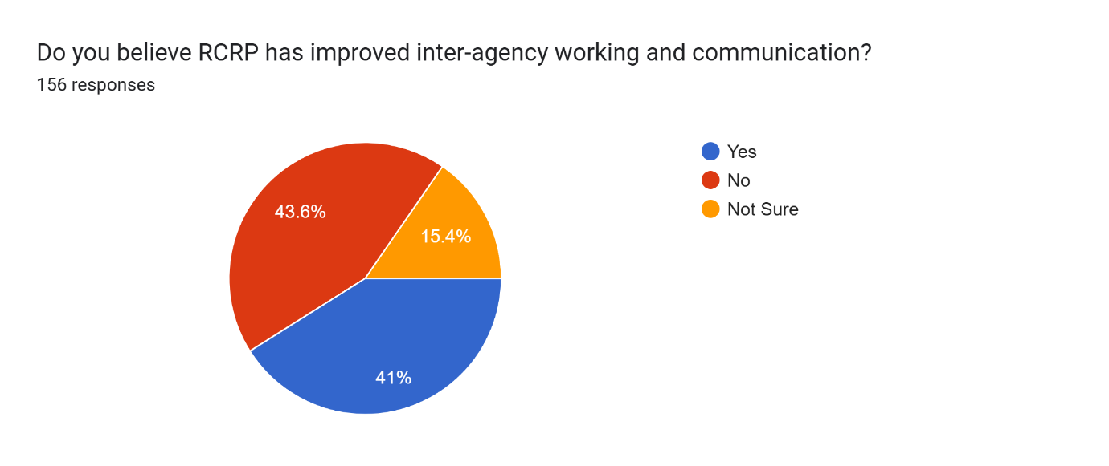
Question 26, If Unsure, please briefly explain why?
Diverse answers were provided by respondents who were unclear if RCRP has enhanced interagency communication. Themes included limited awareness of results, challenges evaluating what has changed, and insufficient time for the model to embed. Others drew attention to agency conflicts, especially those involving incident ownership, which were perceived as fostering animosity rather than cooperation.
Some responses received were as follows:
‘All agencies are stressed and this creates an atmosphere of increased accountability with limited discretion’
‘Hasn't been around long enough yet’
‘At times it can cause conflict between agencies due to ownership of incidents’
‘Don’t know what it was like before’
‘Not clued enough on results’
‘I feel it has caused tension and arguments’
Such uncertainty reflects wider literature highlighting the challenges of cultural change in policing, where new frameworks can initially create confusion or conflict between agencies until trust and joint ownership are fully established (Innes, 2020).

Question 27, Overall, how would you rate the success of RCRP so far in your area?
When asked how effective they thought RCRP was overall, fifty-two percent of respondents said it was somewhat successful. It was evaluated as very successful by just 7.6% of respondents, not very successful by 28.5%, and unsuccessful by a small minority. According to these findings, few respondents believe the approach is completely successful, even though it is widely acknowledged to be making some progress.
This cautious optimism is in line with the College of Policing (2023), which pointed out that RCRP is time-consuming to implement and strongly depends on ongoing inter-agency collaboration. The results show that even with the recognition of reform efforts, frontline employees continue to see major obstacles, highlighting the necessity of additional work before RCRP's full potential can be achieved.

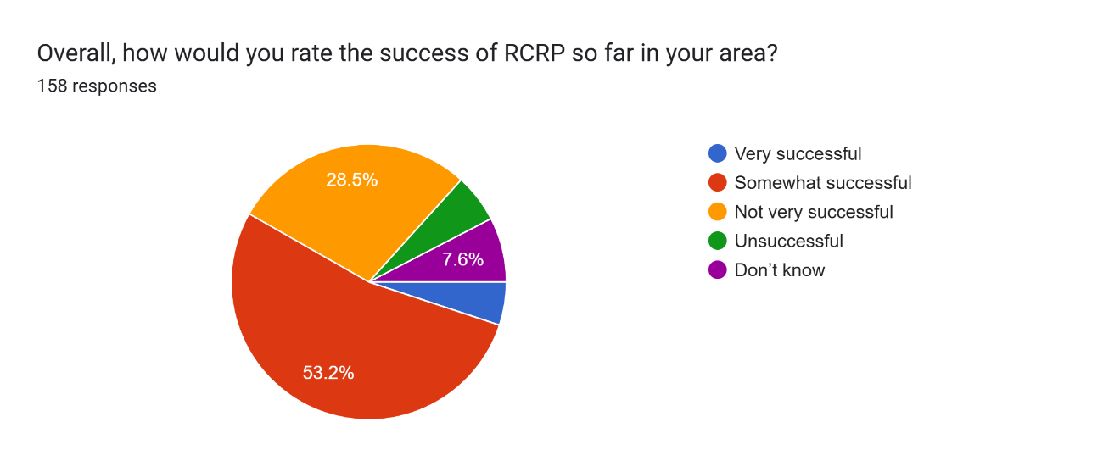

- Conclusion and Recommendations

Introduction.
Using comparative insights from existing literature and officer views, the main goal of this research was to increase understanding of how effective the Right Care, Right Person (RCRP) concept and its implementation within South Wales Police has been. The goal of the study was to determine whether the model was accomplishing its goals of lowering unwarranted demand on police services, enhancing interagency collaboration, and guaranteeing that those who are most in need of care receive it. Four particular research goals were established in order to achieve this goal:
1. To investigate the RCRP models foundational ideas and reasoning.
2. To evaluate the models application across a subset of UK police forces.
3. To evaluate the impact of the RCRP model on:
- Police response times and allocation.
- Outcomes for vulnerable individuals in mental health crisis
- Inter agency collaboration between police, health and social care agencies.
4. To pinpoint the obstacles and enablers affecting the effective execution of RCRP
The conclusion summarises the results of the empirical study and the literature review, addressing each goal one at a time before considering its shortcomings, potential paths forward, and suggestions.
Research objective one: awareness and understanding.
An overview of the results
According to the results, most respondents described themselves as extremely knowledgeable or moderately familiar with RCRP, indicating comparatively high levels of awareness. The level of comprehension differed, too, with some officers remaining unsure about the model's real-world implementation. Misconceptions, such the idea that RCRP signifies police disengagement from mental health work, were brought to light via free-text comments.
Conclusion
These results validate findings in the literature that merely increasing awareness is insufficient if consistent knowledge is not ingrained. According to the College of Policing (2023), training and good communication are essential for integrating RCRP principles. Although South Wales Police has disseminated the policy, there are still gaps in converting awareness into practical clarity, according to my research.
Research Goal two: Responsibility, Workload, and Confidence
Synopsis of Results
Responses indicated a range of experiences with workload changes. There was no discernible decrease in the demand for mental health services, but nearly half of individuals reported minor changes. Although most respondents expressed a reasonable level of confidence in applying referral criteria, issues with partner agencies and delays persisted.
Conclusion
The results are consistent with HMICFRS (2018), which emphasised ongoing challenges in lowering police demand related to mental health because of incomplete interagency collaboration. According to Mind (2018), improvements are frequently thwarted by a lack of health service capability. My research demonstrates that although RCRP has increased confidence for some, effect is still limited by partnership gaps and inconsistent frontline practice.
Research Objective three: Effectiveness, Challenges and Improvements
Summary of Findings
Few respondents thought RCRP was very successful; the majority said it was just somewhat successful. Among the benefits noted were better resource allocation and matching vulnerable individuals with the proper assistance. Inconsistent referral results, lack of training, delays, and resistance from health partners were the main obstacles. Stronger cooperation, more training, more defined pathways, and sufficient funding were all suggested by the respondents.
Conclusion
The findings corroborate the claim made by Bather and Fitzpatrick (2022) that partnership arrangements are ineffective in the absence of steady interagency commitment. Additionally, they support Policing Vision 2025, which emphasised the significance of personnel transformation and resource allocation in order to accomplish long-term change. According to my research, RCRP has promise but has not yet proven to be consistently successful in reality, especially because of gaps in partnership engagement.
Limitations and challenges
Several limitations affected the research. At first, the survey was limited to South Wales Police personnel and officers, with limited participation from outside perspectives (e.g., Kent). This limits the potential to generalise in the UK. Second, as participation was voluntary, there might be response bias, with RCRP participants being the most inclined to do so. Third, although survey data provided breadth, the methodology limited qualitative depth; it could have provided more meaningful information through interviews. The University of South Wales also distributed a sponsored questionnaire to police officers and staff during the study period. I was therefore told that in order to prevent confusion, I should cease disseminating my own survey. I was able to collect fewer responses as a result, especially from call handlers. Even though some call handlers did answer my questionnaire, the percentage was much lower than what was needed to give a useful picture of their viewpoints. Finally, timing constraints prevented the evaluation of RCRP's longitudinal effects.
Future research
A more comprehensive comparison approach across various forces and professional groups should be used in future study to identify barriers particular to a given situation and beneficial approaches. Importantly, it should guarantee that call handlers and other frontline employees are better represented, as their opinions were not given enough weight in our survey. In order to prevent overlap and guarantee participant clarity, future initiatives would also benefit from coordination with ongoing university or agency-funded research. Additionally, longitudinal studies would enable assessment of the model's long-term effects on interagency cooperation, police workload, and mental health outcomes.

Final reflection
Looking back on this dissertation, it can be said that by examining the fundamental concepts of RCRP, evaluating its use in police work, and analysing its effects on response times, vulnerable people, and interagency cooperation, the study has effectively met its goals. The study also found important facilitators and barriers to successful implementation. The study was, however, limited by a number of factors, most notably the limited circulation of the questionnaire after the University of South Wales launched its own sponsored survey. This limited the participation of call handlers and decreased the total pool of respondents. Even though some call handlers did answer the questionnaire in its entirety, there was evidentially not enough participation to fully capture the range of viewpoints from a broader aspect, which would have been extremely valuable in outlining the basis of this project. Notwithstanding these difficulties, the project has demonstrated how crucial collaboration, training, and a clear understanding of job boundaries are to the success of RCRP.
The knowledge of evidence-based policing and the difficulties of striking a balance between partner agency and police duties has improved as a result of this exercise. If it were to be done again, I believe this project should use interviews and a mixed-methods approach, making sure to coordinate with academic institutions beforehand to increase participation. The trust in doing academic research alongside professional policing practice has been bolstered by the study, which, taken as a whole, reaffirmed the significance of critically assessing national models such as RCRP via the lived experiences of those tasked with implementing them.

- Bibliography

Bather, N. & Fitzpatrick, R. (2022) *Right Care, Right Person: Evaluating implementation across policing and health services*. Journal of Mental Health Policy, 34(2), pp. 115-129.
Bryman, A. (2016) *Social Research Methods*. 5th edn. Oxford: Oxford University Press.
Centre for Mental Health (2023) *Policing and mental health: local challenges in RCRP implementation*. London: Centre for Mental Health.
College of Policing (2013) *National Decision Model*. London: CoP.
College of Policing (2014) *Code of Ethics: A Code of Practice for the Principles and Standards of Professional Behaviour for the Policing Profession of England and Wales*. London: CoP.
College of Policing (2023) *Right Care, Right Person: National guidance for police forces*. Available at: https://www.college.police.uk (Accessed: 25 September 2025).
College of Policing (2023) *Right Care, Right Person: National Partnership Agreement*. London: College of Policing.
Creswell, J. (2018) *Research Design: Qualitative, Quantitative, and Mixed Methods Approaches*. 5th edn. London: Sage.
Her Majesty’s Inspectorate of Constabulary and Fire & Rescue Services (HMICFRS) (2018) *Policing and mental health: Picking up the pieces*. London: HMICFRS.
HMICFRS (2018) *Policing and Mental Health: Picking Up the Pieces*. Her Majesty’s Inspectorate of Constabulary and Fire & Rescue Services.
Home Office (2022) *Strategic Policing Requirement*. London: HMSO.
Humberside Police (2021) *Right Care, Right Person: Evaluation report*. Hull: Humberside Police.
Institute for Government (2024) *The future of health and policing collaboration*. London: Institute for Government.
Institute for Government (2024) *The Role of the Police in Public Services: Challenges and Reform*. London: Institute for Government.
King’s Fund (2023) *Integrated care systems and policing: emerging lessons*. London: King’s Fund.
Liberty (2023) *Policing, mental health and human rights concerns*. London: Liberty.
Mental Health Foundation (2021) *Collaboration in crisis care pathways*. London: Mental Health Foundation.
Mind (2019) *Mental health and policing: A policy briefing*. London: Mind.
National Police Chiefs’ Council (NPCC) (2023) *National rollout of Right Care, Right Person: Progress update*. London: NPCC.
NHS Confederation (2022) *Demand and capacity pressures in crisis care*. London: NHS Confederation.
NPCC (2023) *Right Care, Right Person: Implementation Guidance*. London: National Police Chiefs’ Council.
Police Federation (2023) *Frontline officers’ views on RCRP implementation*. London: Police Federation.
Robson, C. and McCartan, K. (2016) *Real World Research*. 4th edn. Chichester: Wiley.
Saunders, M., Lewis, P. and Thornhill, A. (2019) *Research Methods for Business Students*. 8th edn. Harlow: Pearson Education.
Silverman, D. (2017) *Doing Qualitative Research*. 5th edn. London: Sage.
UK Government (1983) *Mental Health Act 1983*. London: The Stationery Office.
UK Government (1998) *Human Rights Act 1998*. London: The Stationery Office.
Yin, R. (2018) *Case Study Research and Applications: Design and Methods*. 6th edn. London: Sage.

Appendix

Appendix A – Questionnaire Summary
The questionnaire distributed to participants covered the following themes:
1. Demographic information (age, gender, role, and force location).
2. Awareness of the Right Care, Right Person (RCRP) model.
3. Training and guidance received on RCRP.
4. Experiences of implementing RCRP in practice.
5. Perceived benefits and challenges of RCRP.
6. Impact of RCRP on workload, officer wellbeing, and public outcomes.
7. Opinions on inter-agency collaboration under RCRP.
8. Suggestions for improving implementation of RCRP.

Appendix B – Participant Information & Consent
Participants were provided with an information sheet at the start of the questionnaire. Participation was voluntary, responses were anonymous, and completion of the questionnaire was taken as informed consent. No identifying data were collected.

Appendix C – Demographic Data
The following pie charts represent the demographic data of respondents:
Insert Pie Chart 1 here – Age of Participants.
Insert Pie Chart 2 here – Gender of Participants.
Insert Pie Chart 3 here – Work Location of Participants.
Insert Pie Chart 4 here – Role within Policing.

Appendix D – Supporting Policy & Guidance Extracts
Key extracts from relevant policy and guidance documents referenced in this dissertation, including:
- College of Policing (2023) Right Care, Right Person Guidance.
- HMICFRS (2018) Policing and Mental Health Report.
- Institute for Government (2024) Public Service Reform Paper.
Full documents are available via official publications and online repositories.

