

Matt Claridge

Systems Thinking Design Report

UWTSD
Ordnance, Munitions & Explosives

BEng Degree Apprenticeship
Academic Year: 2025 - 2026

Lecturer: Dave Holley
July 2026
Table of Contents
List of Figures 3
1 Introduction 4
2 Identification of Key Customer Requirements 6
3 Critical System Functionality 9
4 Concept Derivation and Design Choices 12
5 Potential Failure Modes 15
6 Manufacturing Processes 17
7 Critical Process Steps 19
8 Process Control Measures 21
9 Waste and Disposal 23
10 Conclusion 24

List of Figures
Figure 2-1 Level 1 & 2 Requirements 6
Figure 2-2 Pairwise Comparison 7
Figure 2-3 Pairwise Graph 7
Figure 3-1 Functions 9
Figure 3-2 QFD 1 10
Figure 3-3 Function Importance 10
Figure 3-4 Function Means Analysis 11
Figure 4-1 System Pugh 12
Figure 4-2 QFD 2 13
Figure 4-3 Design Feature Importance 13
Figure 5-1 P Diagram 15
Figure 5-2 What - Why Diagram 15
Figure 6-1 Manufacturing Requirements 17
Figure 6-2 Process Map Drone 18
Figure 7-1 Manufacturing QFD 1 19
Figure 7-2 Process Importances Chart 20
Figure 8-1 Manufacturing QFD 2 21
Figure 8-2 Means Importance 21
Figure 9-1 Waste Stream Management Plan 23

Introduction
Systems engineering is a structured, lifecycle approach which begins at the earliest design phase and extends to all aspects of a products lifecycle, through manufacture, operation and disposal. It emphasises the importance of relationships between subsystems, stakeholders, processes and constraints, ensuring that every design decision is traceable back to an explicit requirement. By using formal analytical tools, systems engineering enables designers to understand interactions, optimise performance, manage risk and ensure that the final solution remains safe and fit for purpose. [1] Systems have behaviours that no subsets of their elements have. These behaviours are products of the interactions between the elements. They may be anticipated and designed in, or they may be unanticipated, in which case they are called emergent. This approach is particularly critical within the defence and ordnance industry, where reliability, safety, legislative and environmental compliance are essential to design criteria.
The brief for this report required a system capable of detecting, communicating and neutralising OZM-72 anti-personnel mines and M15 anti-tank mines to allow medical supplies to pass through a steep walled desert pass. Use of helicopters is unviable due to threat of MANPADS. The solution needs to be portable by Land Rover or Hi-Lux. Python is not an authorised solution due to vulnerability to bullet/ fragment attack. This brief was resolved using a toolset from a systems engineering approach including analysis of requirements, functional decomposition, QFD, concept evaluation, failure mode analysis, process mapping and through life planning. This ensured customer needs were capture, prioritised and transferred into measurable functions.
To address the brief, the design team applied a structured systems engineering toolset. Requirements analysis captured and prioritised the stakeholders needs, functional analysis translated these into measurable system behaviours, QFD established functional importance, concept generation and evaluation compared the performance of proposed solutions, failure mode analysis identified risks, and process mapping ensured the solution could be manufactured, operated and disposed correctly and safely. Together the tools provided a disciplined framework which guided the team from an initial problem to a justified system concept.

Identification of Key Customer Requirements
Systems engineering begins with the identification of stakeholder needs. [2] Completeness is a crucial attribute for high-quality requirements and specifications. Missing and incomplete requirements can be mitigated by addressing functions, components, and iterations within an optimized approach to the requirements specification. Level 1 and Level 2 requirements across the stakeholders, including users, customer, logistics, manufacturers, safety and legislation representatives, were captured using the requirements table below.
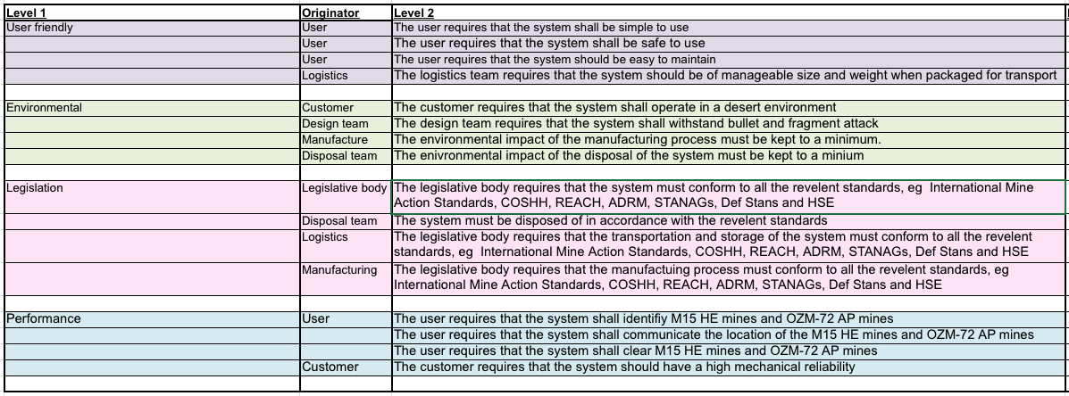
Figure 2-1 Level 1 & 2 Requirements
This table provided traceability, ensuring that each design decision could be linked backed to the original requirement. A pairwise comparison was then conducted which allows the importance of each requirement to be assessed by comparing one requirement against another. The results of the pairwise comparison are in Figure 2-2 and Figure 2-3.
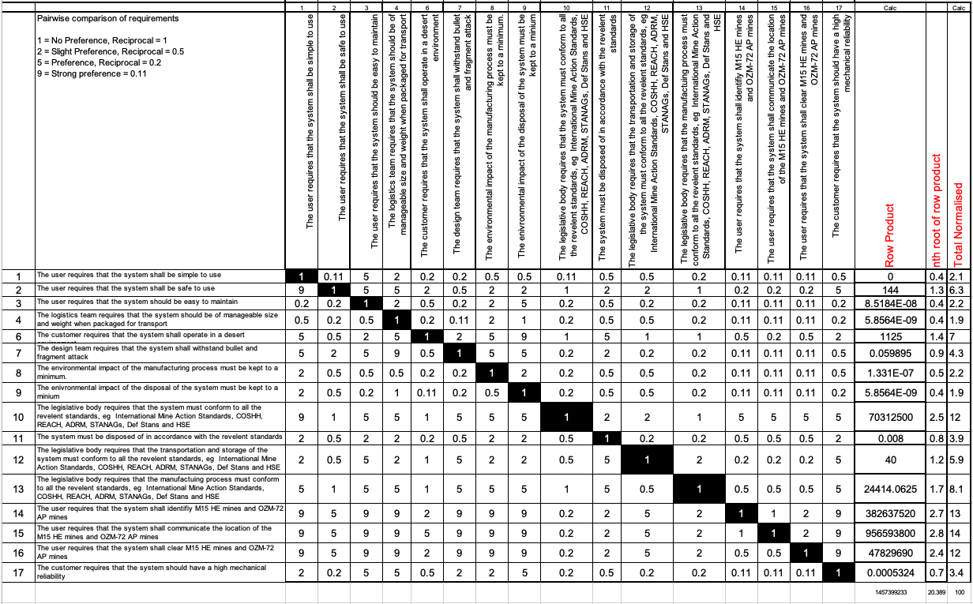
Figure 2-2 Pairwise Comparison
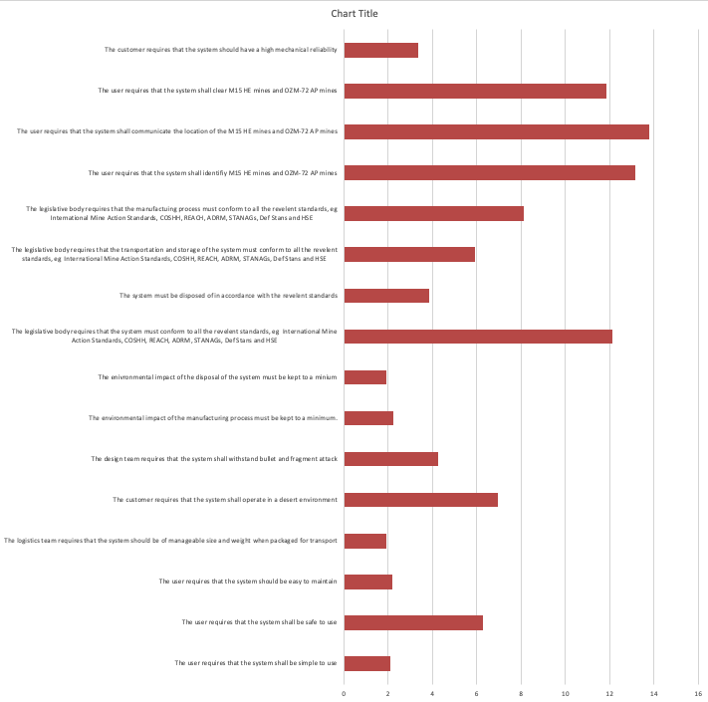
Figure 2-3 Pairwise Graph
The pairwise comparison results were calculated to establish the relative importance of each customer requirement before applying the QFD tool. Each Level 2 requirement was compared against each other requirement. The design team judged the requirements importance to system success. The first requirement scored 1, 2, 5 or 9, with the reciprocal requirement receiving a score of 1, 0.5, 0.2 or 0.11 dependent on weight of importance. The spreadsheet normalised the importance of each requirement. This process allows subjective assessments to be converted into distinguishable values.
The results show that detection, communication and neutralisation requirements were perceived as the most important requirements, reflecting the priority of clearing a safe path for medical convoys. Environmental, legislative and disposal requirements also scored highly, demonstrating the need for a compliant sustainable solution.

Critical System Functionality
Functionality is fundamental to systems engineering because it defines what the system must do, before consideration of how it will be achieved. Identifying the functions early ensures that every subsystem, process and design feature directly contributes to meeting a stakeholder requirement. [3] Functional modelling provides a structured means of defining what a system must do, independent of how it will be implemented. The functions in Figure 3-1 were derived from the Level 1 and Level 2 requirements in Figure 2-1.
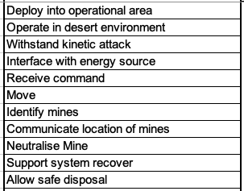
Figure 3-1 Functions
To systematically determine which system functions are most critical to mission success, the functional requirements were rated against weighted customer needs using QFD, Figure 3-2. Focus, money and time can then be directed towards the functions of highest importance reducing the risk of system failure and saving cost. The result of the function importance is shown in Figure 3-3.
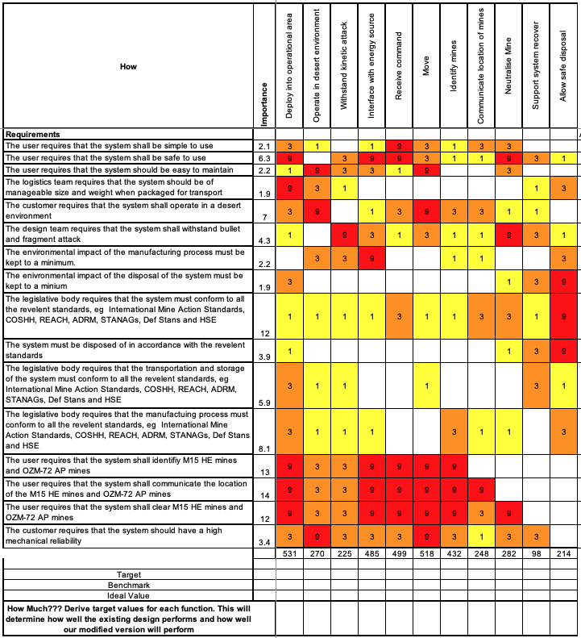
Figure 3-2 QFD 1
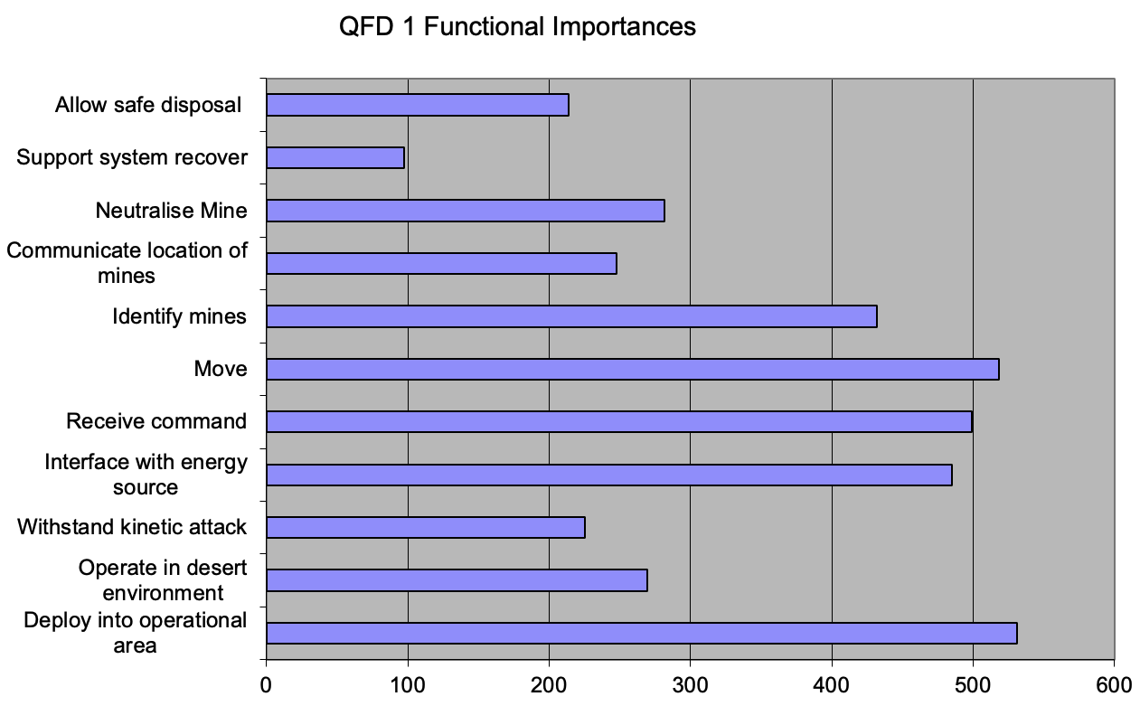
Figure 3-3 Function Importance
The results give a clear hierarchy of functions with an ability to deploy into the operational area the highest scoring function followed by an ability to move and receive commands.
Following the prioritisation of the system behaviours, a Function Means Analysis (FMA) was performed, Figure 3-4, to evaluate how each function could be implemented. [4] FMA typically represents functions through structured descriptions (e.g., verb-object formulations) and diagrammatic models, supporting the exploration of alternative working principles, the allocation of roles to subsystems, and the early identification of missing or conflicting elements. First as many different solutions to each function were listed, before the list was reviewed highlighting the preferred options. This allowed all the options to be fairly reviewed and different FMA’s were competed for different outcomes such as reliability, cost efficiency and all round.
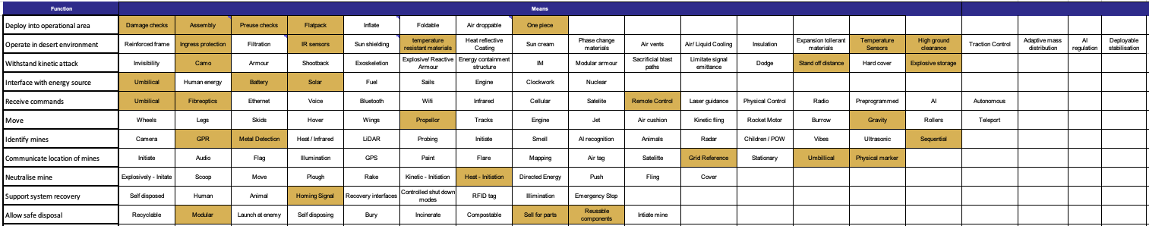
Figure 3-4 Function Means Analysis

Concept Derivation and Design Choices
FMA resulted in preferred options a Drone clearance system and as well as high tech unmanned ground vehicles. These concepts were put into a Pugh matrix and measured against the normalised stakeholder requirements, including their weighted importance, and along with baseline existing solutions which were a soldier with a handheld metal detector and a simpler UGV.
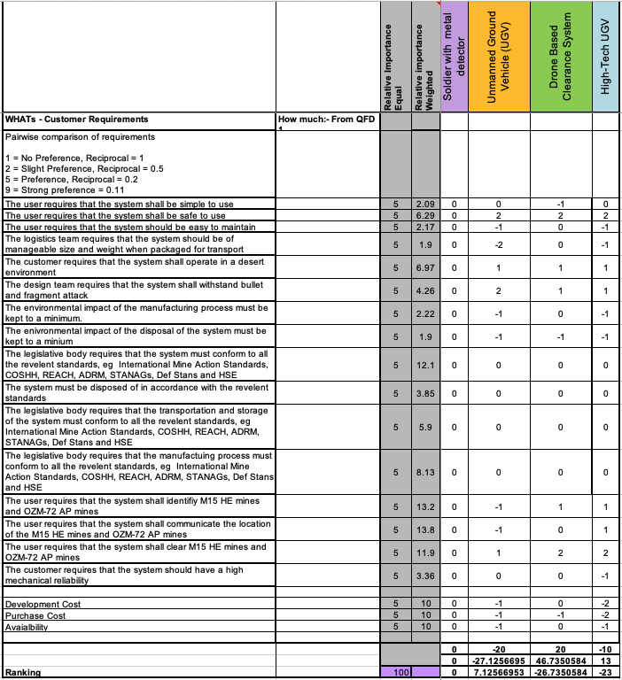
Figure 4-1 System Pugh
The results show in Figure 4-1 show that the Drone based clearance system was the preferred solution with a normalised score of 46.74. The Drone scored highly on safety and clearance effectiveness. Its airborne capability aligned with the workbook’s emphasis on minimising ground signature and avoiding terrain-based failures.
The UGV solutions were marked down due to size and weight causing transportability concerns. The high tech UGV was additionally criticised for high development and purchase costs.
The drone system was chosen as the concept and its design features identified in FMA were then scored against the functional requirements in QFD 2, Figure 4-2. This scored the features which most impact performance.
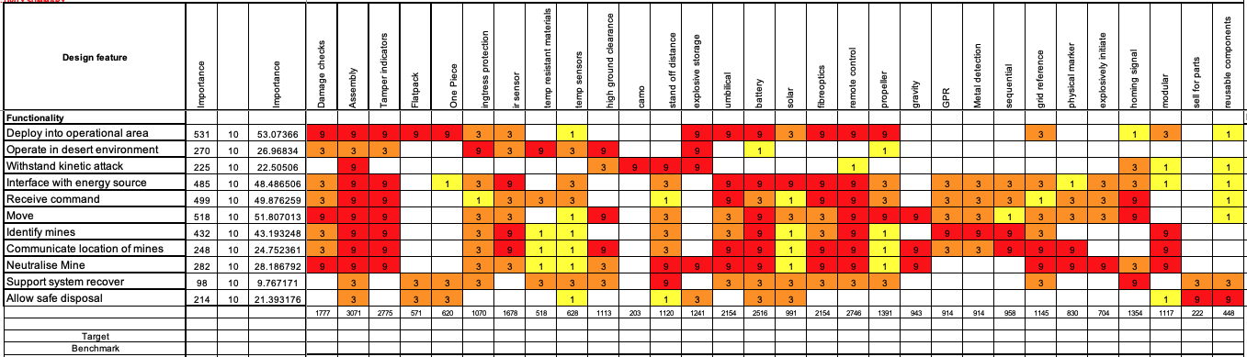
Figure 4-2 QFD 2
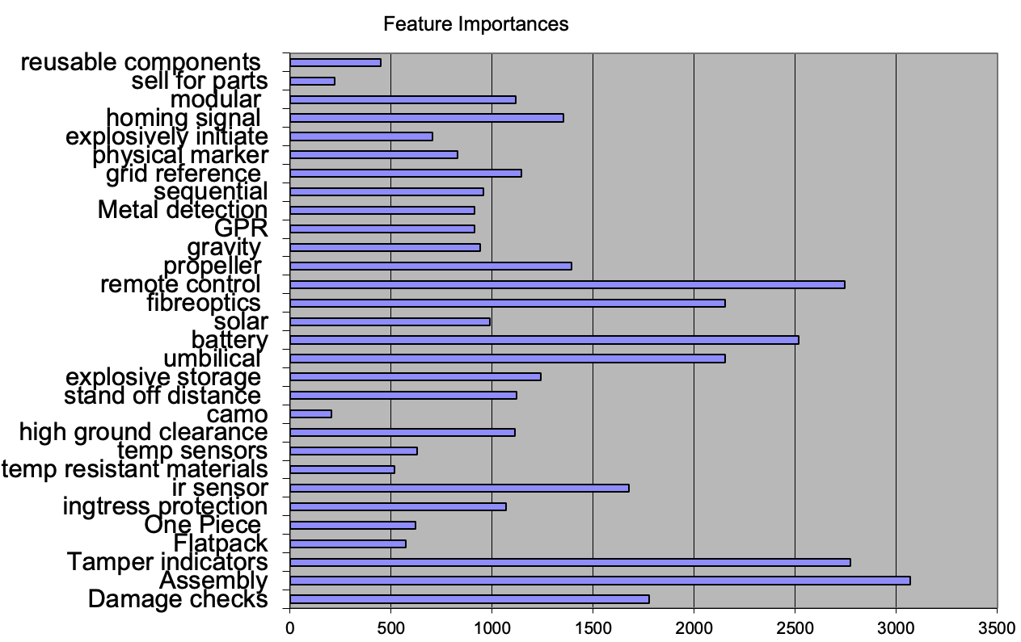
Figure 4-3 Design Feature Importance
Assembly, remote control and tamper indicators scored highly meaning they impact multiple functionalities and are potential volatile areas of the design. Knowing these figures allows the design team to make data driven decisions on where to direct design focus for risk mitigation.

Potential Failure Modes
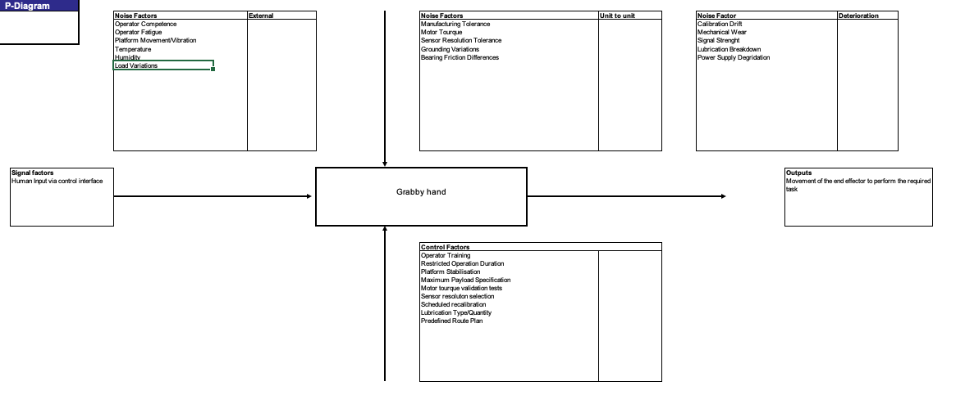
Figure 5-1 P Diagram
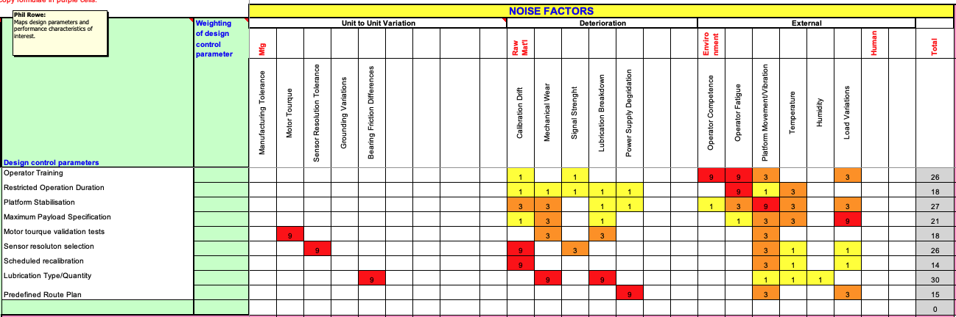
Figure 5-2 What - Why Diagram
A P diagram Figure 5-1 was created to identify the relationship between a systems input, its intended outputs and variables which might affect its performance. This can help identify failures before time and money is spent creating prototypes.
The P diagram identifies control factors and noise factors which are then put into a What Why diagram, Figure 5-2. The rows of the What Why diagram are filled with control factors and the columns have noise factors or variables which could affect the controls. Each cell is then scored based of the strength of relationship between the two. For the ‘Grabby hand’ lubrication type/quality scored highest with a score of 30. This quantifies the risk of different controls and identifies the lubrication as being the highest risk. The design team could then decide to focus more resources on this area to improve system reliability.
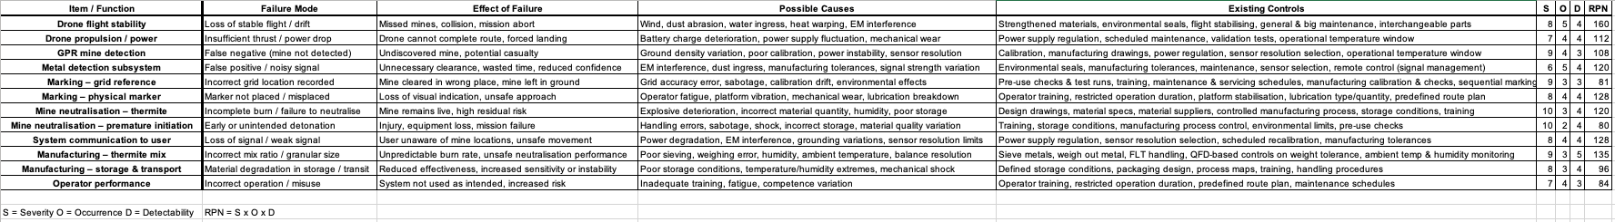
Failure Mode and Effect Analyses (FMEA) was also conducted to identify how the system might fail and the consequences of doing so. FMEA breaks the system into functions, listing the failure mode, it’s effect and cause. The function is then scored by scoring the severity, occurrence and detectability of the failure. These scores are multiplied resulting in a Risk priority number (RPN). High risk priority numbers identify areas of design most susceptible to impact from failure. In this design Drone flight stability (160) and Manufacturing thermite (135) came with the highest risk.
[5] This structured approach aligns with Boulanger’s observation that “certifiable systems must demonstrate control over hazards, failures and configuration throughout the lifecycle”. Embedding this principle into the failure-mode analysis ensured that risks were not only identified but also systematically mitigated, supporting the development of a safe, dependable and certifiable system.

Manufacturing Processes
The manufacturing requirements Figure 6-1 were derived from the MoD as the customer purchasing the product and BAE as the manufacturers of Thermite. The requirements fall into six subcategories, manufacturing costs, surge capability, reliability, maintenance, quality and safety. The requirements tree establishes safety boundaries which govern manufacturing of explosive materials.
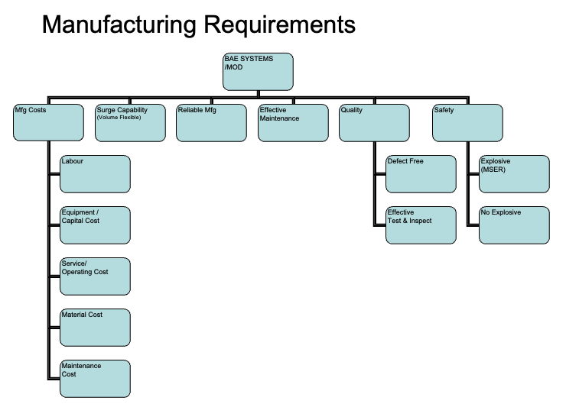
Figure 6-1 Manufacturing Requirements
Process maps like the one in Figure 6-2 were created for each subsystem which can track how the components move through the production life cycle. Mapping out the production pathway can be used to identify production bottlenecks or safety concerns might arise.
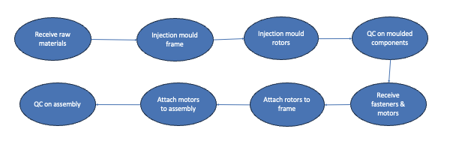
Figure 6-2 Process Map Drone

Critical Process Steps
A QFD 1, Figure 7-1, was completed in the way as the design QFD 1, but this time scoring the manufacturing requirements against functions. The standardised weighting allows the correlation between requirement and function to be fairly and accurately quantified to identify an importance score for each stage of production. Weighing out the metal (363) scored highest for the manufacturing of thermite QFD.
Final assembly (281) scored highly which relates back to the original requirement of having high mechanical reliability.
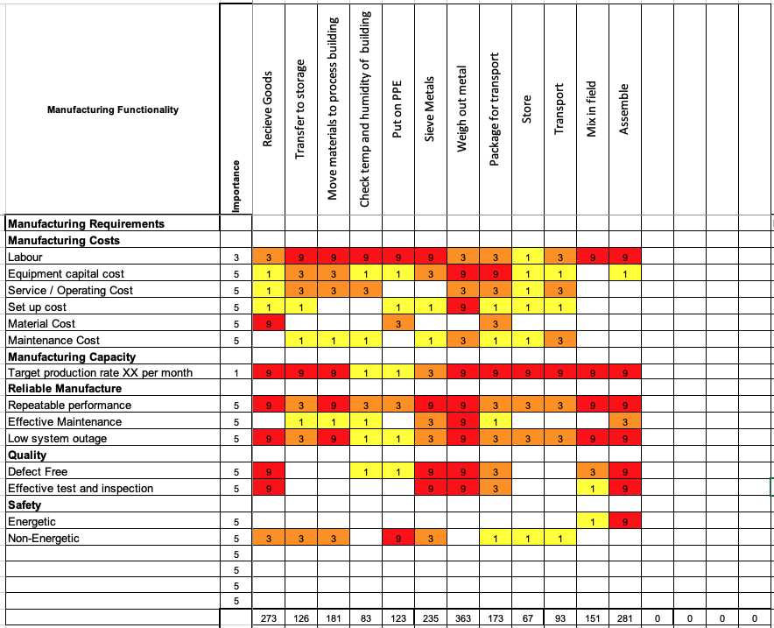
Figure 7-1 Manufacturing QFD 1
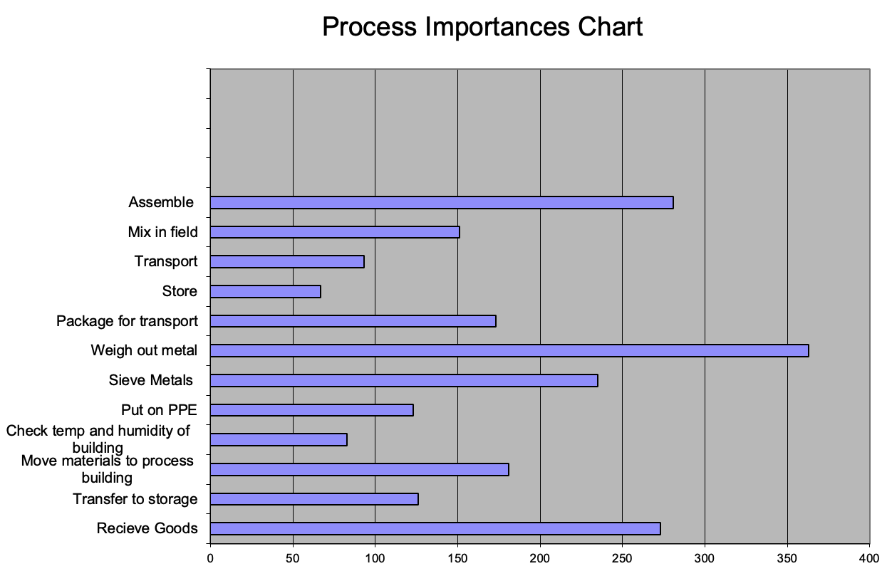
Figure 7-2 Process Importances Chart

Process Control Measures
To prevent manufacturing variances which could result in unreliable performance the manufacturing control measures were evaluated through QFD 2. The manufacturing QFD 2, Figure 8-1, rated the functions against how they could be achieved. The scores were then multiplied by the importance from QFD 1. The results at the bottom identified the critical manufacturing process steps.
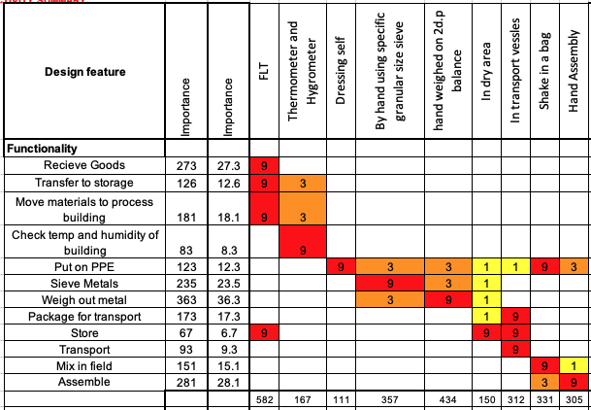
Figure 8-1 Manufacturing QFD 2
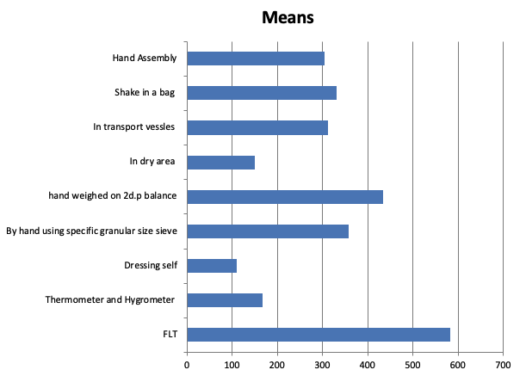
Figure 8-2 Means Importance
The results show that the use of forklift trucks (FLT) scored highly (582) as they reduced risk at several manufacturing stages. The use of FLTs establishes standardised mechanical lifting which prevents harm to employees by eliminating physical handling and aligns with the requirement for safety.
Hand weighing to 2 decimal places (434) and granular sized sieves (357) also scored highly as they offer manufacturing precision ensuring the performance requirement of repeated, predictable performance.

Waste and Disposal
[6] Appropriate management of municipal solid waste is essential for accomplishing many Sustainable Development Goals, and requires the integration of systems engineering models to ensure safe disposal and reduced environmental impact. Waste and disposal were considered throughout the design process and integrated into every stage of the design process. This directly reflects the requirement that the system must minimise environmental impact and be capable of being disposed of in accordance with relevant standards. [7] In line with Section 3 of the Health and Safety at Work Act, organisations must conduct their activities in a manner that avoids, as far as reasonably practicable, exposing any person to risks arising from their work. This legislative duty reinforced the need for a disposal approach that was safe, controlled and compliant.
The disposal plan fed directly into the design and was a key contributing factor as to why the design was a thermite payload, rather than an explosive, as thermite has less environmental footprint and an easier disposal route.
Disposal was rated as a high importance key requirement and then was transferred into a function at QFD 1, Figure 3-2.
A waste stream management plan, Figure 9-1, was created which enable waste from each of the products life cycle stages to be identified. The type of waste, hazard the waste presents and level of risk were recorded and the safest disposal route was chosen.
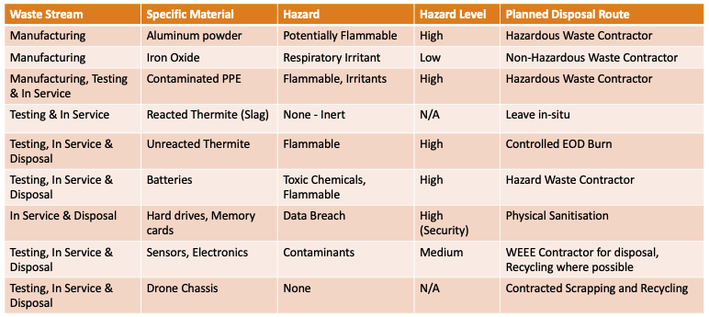
Figure 9-1 Waste Stream Management Plan
The waste st was keeping with key regulations and standards

Conclusion
The systems engineering methodology applied throughout this project provided a disciplined, traceable and evidence-based pathway from an initial mission need to a justified system concept. By structuring the work around formal analytical tools, each stage of the design process remained relevant to explicit stakeholder requirements, ensuring that no decision was made in isolation and that every subsystem, function and process contributed directly to mission success.
Requirements analysis established a clear and prioritised understanding of stakeholder needs, converting subjective judgements into weighted, comparable values through pairwise comparison and QFD. This ensured that critical operational behaviours, particularly detection, communication and neutralisation were consistently emphasised in later design stages. Functional modelling then translated these needs into measurable system behaviours, enabling the design team to evaluate alternative means of achieving each function and to identify the most robust and reliable implementation pathways.
Concept generation and evaluation demonstrated the value of structured comparison. The Pugh matrix showed that the drone-based clearance system offered superior performance, safety and transportability when assessed against normalised stakeholder requirements. Subsequent QFD analysis of design features highlighted assembly, remote control and tamper indicators as areas requiring focused engineering attention due to their strong influence on multiple system behaviours.
Risk identification was embedded through P-diagram analysis, What-Why evaluation and FMEA. These tools quantified the relationships between inputs, controls and noise factors, enabling early identification of high-risk areas such as lubrication quality and drone flight stability. The calculated RPN values gave a clear, evidence-based justification for where mitigation effort should be focused.

Manufacturing analysis ensured that the chosen concept could be produced safely, consistently and in compliance with legislative constraints. QFD scoring identified weighing of thermite constituents and final assembly as critical manufacturing steps, while process control measures such as forklift-assisted lifting and precision weighing were shown to significantly reduce variability and risk. Waste and disposal planning was integrated from the outset, reinforcing environmental and legislative requirements and directly influencing the selection of a thermite payload due to its lower environmental footprint and simpler disposal route.
Overall, the systems engineering framework ensured that stakeholder needs were captured, prioritised, transformed into functional behaviours, evaluated against feasible concepts, and carried through into manufacturing and disposal planning. The resulting design is justified, traceable and aligned with operational, safety and environmental requirements, demonstrating the effectiveness of a structured systems approach in developing a reliable mine-clearance capability.

11 Works Cited
[1] | E. Crawley, O. de Weck, S. Eppinger , S. Magee, J. Moses, W. Seering, J. Schindall, D. Wallace and D. Whitney, “THE INFLUENCE OF ARCHITECTURE IN ENGINEERING,” MIT esd, p. 26, 2004.
[2] | J. Santos, L. Martins and J. Molléri, “Requirements extraction from model-based systems engineering: A systematic literature review,” Journal of Systems and Software, vol. 226, 2026.
[3] | J. Holt and S. Perry, SysML for Systems Engineering: A Model-Based Approach, London: The Institution of Engineering and Technology, 2018.
[4] | G. de Lima, R. Rizziole, D. Berzieri and C. Favi, “Using functional analysis for product decomposition in engineering,” Research in Engineering Design , vol. 37, no. 26, p. 1, 2026.
[5] | J. Boulanger, Certifiable Software Applications 1: Main Processes, London: ISTE Press, 2016.
[6] | A. Singh, “Sustainable waste management through systems engineering models and remote sensing approaches,” Circular Economy and Sustainability, vol. 2, pp. 1-20, 2022.
[7] | H. a. S. Executive, ““Enforcement: Health and Safety at Work etc Act 1974,” 1974. [Online]. Available: https://www.hse.gov.uk/enforce/hswact/. [Accessed July 2026].

