ASSESSMENT COMPONENT: FINANCIAL PERFORMANCE AND MANAGEMENT
TESLA (2021-2025)
Name : chaklashiya dhruviben mukeshbhai
Student ID :2431413
Subject: financial management

Table of Contents
1. Introduction 4
2. Financial Health Check 4
2.1 Financial Statement Overview 4
2.2 Ratio Analysis 4
2.3 Trend Analysis 5
2.4 Key Findings 6
3. Working Capital Management 7
3.1 Cash Operating Cycle Analysis 7
3.2 Evaluation of Working Capital Efficiency 8
3.3 Strategies to Improve Liquidity 8
3.4 Comparison of short-term vs long-term financing options 9
4. Strategic Financial Restructuring 10
4.1 Need for Restructuring 10
4.2 Proposed Strategies 12
4.3 Impact Analysis 13
4.4 International & Ethical Considerations 14
5. Investment Appraisal & Capital Budgeting 15
5.1 Project Evaluation Methods 15
5.2 Analysis of Projects (A, B, C) 15
5.3 Comparison & evaluation of techniques 16
5.4 Capital Rationing Decision and justification 17
5.5 Recommendation with Business Justification 18
6. Conclusion 19
6.1 Summary of key findings 19
6.2 Final recommendations 19
References 21
Appendices 24
Appendix 1: Profitability Ratio 24
Appendix 2: Liquidity Ratio 25
Appendix 3: Efficiency Ratio 26
Appendix 4: Gearing Ratio 27
Appendix 5: Investment Ratio 28
Appendix 6: Cash Flow 29
Appendix 7: Cash Operating Cycle 30
Appendix 8: Project A Appraisal 31
Appendix 9: Project B Appraisal 32

1. Introduction
This report interprets the financial status and strategic implementation of Tesla Inc. during the tenure of 2021-25 based on the fast global growth and current changes in the market of electric cars (EV). Tesla, as the market leader in the perspective of sustainable mobility, is critically evaluated on the basis of ratio analysis, working capital efficiency, and the trends in cash flows. The report also suggests some fundamental financial issues, and it provides a strategic process of restructuring in relation to the maximum profit of shareholders. Investment appraisal methods are used for understanding capital budgeting decision and helps in taking better financial decisions and recommendations

2. Financial Health Check

2.1 Financial Statement Overview
The Tesla, Inc. financial forecast of its financial performance between 2021 and 2025 indicates that the company experienced a high growth in its revenue between 53,823 and 94,827 with an increase in total assets and equity. The profitability decreased rapidly since 2022 with net profit decreasing to 3,794 in 2025. The operating cash flow has been improved (Annualreports.com, 2024). This is likely that the costs and margins are under pressure as the financial performance and effectiveness are duly affected.

2.2 Ratio Analysis
Profitability ratios
Profitability declined rapidly that is in relation with operating margin decreasing from 16.98 %( 2022) to 5.11 %( 2025) and ROE from 28.15% to 4.62%. The gross margin that increases stability at 18% and the column chart shows the declining profitability that is related to pressure of cost. The inefficiency that is based on revenue performance that is remaining constant during the provided time period (Appendix 1)

Liquidity ratios
The Liquidity ration that is improving with the current ratio rising from 1.38 (2021) to 2.16 (2025) and quick ratio to 1.77. There is a decrease of cash ratio to 0.52 as the column chart indicates a high short-term solvency and low cash availability in the short run which means that it depends on receivables to provide it with cash, as opposed to cash reserves (Appendix 2).
Efficiency ratios
There is a decline in the efficiency as since inventory days is decreased from 57.31 as compared to 21.22 and asses turnover is decreased from 0.69 (2025) as in comparison to 0.99(2022). There is an increase in the number of days as the horizontal bar chart indicates the lower rate of inventory move and underutilization of asses that low operational efficiency (Appendix 3).
Gearing ratios
The gearing ratio is interpreted as based on low 0.019 that is 2025 is related to debt-to equity as the debt ratio is low that is 0.11. The interest coverage that is declined from 72.142 of 2022 and that is from 14.35 that is 2025. 2). the result illustrates that the leverage is low, and the power to pay interest is declining implying lower profitability and not too much debt (Appendix 4).
Investment ratios
EPS declining from a 4.70(2023) to 1.02(2025) as while P/E that increases sharply to 414.41 as indicating overvaluation. The yield of dividend is zero as the column chart indicates shareholders returns and large investor anticipation indicating that the company is being overvalued and not performing well financially (Appendix 5).
Cash flow
There is also an increase in cash flow and operation of cash flow that is increasing to an 0.055 as compared to 0.031 and margin to 0.018. Cash return on assets did not increase or decrease that is 0.01 as indicated by line chart that is the subtle improvement has taken place. This results in enhancing case generation but there are certain reductions in profits (Appendix 6).

2.3 Trend Analysis
The Tesla, Inc. financial performance in the 2021-2025 reflects certain trends that there is tremendous growth in revenue which grew 53,823 to 94,827 just understanding good growth in the market. Liquidity is also getting better as with the current ratio increasing to 2.16 as compared to 1.38; showing improved short term solvency. This is from 2022 and afterwards there is a downward trend of profitability with net profit decreasing between 14,999 in 2023 and 3,794 in 2025 and a decline in ROA and ROE. There was also reduced efficiency with higher inventory days and reduced asset turnover, indicating more dedicated operation. The Tesla, Inc. trend analysis shows that the company has a high degree of fluctuation in the major financial variables between 2021 and 2025. The profitability is very much downward trending with significant decreases in terms of margins and returns expressed in figures like -35.63, -45.18 and - 52.86. This implies mounting cost pressures and stagnant profit generation growth in spite of growing revenue. There has been gradual increase in short-term financial stability with a value of 6.89 and 10.31 respectively (Annualreports.com, 2020). This indicates better ratio current and quick which translates to a higher capacity to fulfill short term obligations. The efficiency indicators are quite random as there are both positive movements (6.58) and negative ones (-14.01), and these metrics give the priorities to the variation of asset utilization and management of the working capital (Annualreports.com, 2023,). The trend of investments is also volatile with a very sharp rise of 413.40 which reflects the changes in the market valuation and expectations of investors. In the meantime, the cash flow trends are upbeat with the figures of 23.84 and 6.48 indicating enhanced production of cash.

2.4 Key Findings
Key Strengths
There are several key strengths of the financial performance of Tesla, Inc. over 2021 2025. Strong revenue growth can be mentioned as one of the largest strengths since the revenue grew during the period, 53,823 in 2021 to 94,827 in 2025. This is indicative of a robust market position since Tesla is an ever-growing company operating worldwide and needs a significant number of electric cars. The company has recorded a steady growth in liquidity as the current ratio has increased relative to the initial of 1.38 to 2.16 and the quick ratio has also been on the upward trend. This indicates that Tesla has increased its resource to cover the short term financial demands which has improved its financial security.
The low gearing levels of the company is another advantage. The debt-to-equity ratio is low, which means that the company has not been depending on external debt financing and that the financial risks are low. This gives Tesla flexibility to increase its debt in future as necessary. Operating cash flow has been on a consistent rise over the years, which shows an enhancement in cash generated by core operations. This boosts the capability of the company in financing growth and controlling operational costs in a way.
Key weakness
This has a number of major financial concerns as the most alarming is the sharp decrease in profitability following 2022. The net profit has been significantly lower than in 2023 (14,999) as 3,794 in 2025, with a drop in profitability ratios, including the return on assets (ROA) and the return on equity (ROE).
The another area of concern is efficiency as the level of inventory days have increased seriously whereas the level of total asset turnover has reduced and it shows that the inventory flows more sluggishly and the utilization of assets has dropped. This interprets poor operations and management working capital that can translate to increase holding costs and lowered productivity (Klinge et al., 2025). There are more receiver days which indicate slow payments by the customers to the company which further affects the efficiency of the cash. The indicators on investment are as well weak as the trend in earnings per share (EPS) has decreased throughout the period and price-earnings ratio is too volatile, thus reflecting the uncertainty in market valuation and possibility of overvaluation.

3. Working Capital Management

3.1 Cash Operating Cycle Analysis
The cash operating cycle of Tesla, Inc. is evaluated that is with the help of inventory days, receivable days, and payable days in the years that is from 2021-2025. This is based on the understanding of the level of inventory days that is instead of around 21 days it was well above 57 days, which described the slow movement of inventory and there could be overstocking at hand. The receivable (days) that is also increased rather averagely between approximately 12.88 days and 15.78 days indicating a small decrease in the collection efficiency. This is on the contrary as the payable days is related down to some 60.68 days as compared to 72.95 days that implies that Tesla is paying its suppliers faster (Appendix 7).
This is based on the formula cash operating cycle based on inventory days +receivable days-payable days as the cycle in general has grown over the years. This indicates extended period in outflows and inflows of cash which brings to focus the inefficiencies in working capital management (Wang, 2025). The principal causes of this trend are the increasing inventory days and decreasing payable days.
The cash operating cycle of Tesla has decreased in efficiency as with cash being held up in operations longer than before. This implies that there is a requirement for the betterment of the process of managing the inventory and for better optimization of the supplier payment terms to get a better liquidity.

3.2 Evaluation of Working Capital Efficiency
Tesla, Inc. consisting of mixed performance of the working capital efficiency between the years 2021 and 2025. There is a definite improvement in liquidity ratios where the current ratio has improved to 2.16, as compared to 1.38 and the ratio of quick has also improved steadily. This shows that Tesla has increased its capacity to fulfill short term liabilities and financial stability.
There are weak points in efficiency ratios as this is based on the decreasing of inventory turnover with an increase in the inventory days implying slow stock turnover and ineffective inventory management. The total asset turnover is reduced to 0.69 per 1, which also shows that the efficiency of using assets to generate revenue was lower. Receivable days were also slightly up, indicating slow collection by customers.
Tesla consists of a high liquidity but has deteriorated operational efficiency. This company has increased inventory and is not using assets efficiently and drastically impacts working capital performance (Cao, 2025). This imbalance underscores the necessity for making operational changes that can ensure supported liquidity gains with the help of efficient resource mobilization.

3.3 Strategies to Improve Liquidity
There are different strategies for enhancing liquidity, Tesla, Inc. must consider specific working capital reforms of the management of inventory, receivables, and payables.
This is necessary for improving the management of inventory as Tesla needs to maintain shorter inventory holding times as it should practice just-in-time (JIT) holding and enhance demand forecasting. This reduces unnecessary inventory and holding cost especially in in highly capital intensive EV production process (Feng et al., 2025). The policy of receivables management have to be improved by strict credit control measures and quicker payment mechanisms. This is by achieving a faster receivables turnover and quicker cash flows can be achieved by introduction of payment incentive on early payments and better assessment of credit to customers.
Tesla needs to makes the process smooth of the payables by striking deals with the suppliers to have longer payables. This is by having a good market presence as the company able to make use of its supplier relationships to make delayed payments without ruining partnerships, thus enhancing its cash flow (Chen et al., 2025). These strategies reduces the duration of the cash operating cycle, enhance liquidity and make the working capital resources to be utilized more efficiently. The different strategies show that Tesla is well-positioned to grow, enhance its liquidity situation, and have a financial foundation for continuing its growth and gain the competitive edge in the global electric vehicle market

3.4 Comparison of short-term vs long-term financing options
Aspect | Short-term Financing | Long-term Financing
Examples | Bank overdraft, trade credit, WC loans | Long-term debt, equity
Cost | Generally higher | Lower (debt), high (equity dilution)
Flexibility | High | Low
Risk | High (repayment pressure) | Lower (spread over time)
Purpose | Day-to-day operations | Expansion & stability
Table 1: Comparison Table
(Source: Self-created Table)

Short-term and long-term financing is an important factor that Tesla, Inc. must consider as when it comes to the management of working capital. Short term sources like bank overdraft and trade credit as these allow flexibility and availability of money within a short period, and these are appropriate in dealing with daily operational requirements. The sources may interpret the process of increasing expenses and repayment rates that risk more finances.
This is on the other perspective as long-term financing such as long-term debt and equity are more stable financially as repayments are paid over a longer time. Finance Debt financing is described cost effective with tax breaks and equity does not instills repayment but may dilute ownership.
This is with Tesla experiencing better liquidity performance and yet reducing profitability as it is advisable for having a balanced strategy. The company must use short-term financing for introducing flexibility in the operation but gradually use long-term debt to help stabilize and minimize the risk of a company. This is related to the understanding of the importance of short term and long-term financing in relation to the perspective of the Tesla organization.

4. Strategic Financial Restructuring

4.1 Need for Restructuring
Financial restructuring by Tesla, Inc is based on the strategy that of changing its long-term debt financing policy towards moderate debt financing, backed by selective vertical acquisitions, and without divestiture. This is a solution for this inefficiencies in the existing Tesla financing structure which offers a solid, real world solution that makes sense in its growth model.

Strategic Choice
- Primary Strategy: Grow Long-Term Debt Financing.
- Tesla needs to propose semi-large amounts of long-term debt to finance growth such as. Gigafactories) as this reduces the use of equity and avoids shareholder dilution.
- Strategy Support: Selective Vertical Acquisitions.
- Battery and semiconductor supply chain as purchasing companies for enhancing cost management and minimize supplier power.
- Recommendation that is there is no divesting
- The idea of divestiture is not an appropriate option as because the system of Tesla (EVs, energy, software) lies in the core of its competitive edge.
The main policy entails augmenting long-term debt funding. Historically, Tesla has been making heavy use of the equity to finance its growth, thus posing the risk of shareholder watering down and insufficient use of its financing ability. Moderate amounts of debt allow Tesla to fund capital-intensive initiatives like Gigafactories more cheaply and take advantage of tax breaks (Naveed and Vazir, 2026). This enhances capital structure without majorly heightening financial risk provided that leverage is contained. The support strategy entails the choice of vertical acquisitions, especially in battery technology and semiconductor supply chains (Xiao, 2025). These acquisitions will lead to increased cost management, less reliance on outside suppliers and streamlining of processes. These acquisitions are not standalone but they enhance the efficacy of the debt-led strategy as internal strengths are enhanced.
The strategy not to divest because it is evident that the competitive advantage of Tesla lies in its ecosystem of electric vehicles, energy solutions and software. Selling business elements would undermine this integration and decrease long-term strategic worth (Chari and Ferreira, 2025). Tesla must use a debt-based reorganization plan with targeted acquisition and no divestiture that help it to achieve better capital efficiency, less reliance on equity and long-term growth.

4.2 Proposed Strategies
The results of the debt led restructuring strategies that is done by the vertical acquisitions and zero diversification having a strong effect on the financial and business performance of Tesla Inc. This part is directly interpreting the impacts of strategy that is based on the shareholder values and capital structure and based on the flexibility of operations. This is as a shareholder as the equity for debt financing enhance the value and long-term returns (Sec.gov, 2021). Tesla can reduce its dependence on the issue of equity, thus preventing the issue of shareholders becoming diluted due to the reduction in equity issuance, which is a primary issue with high-growth companies. The acquiring firms improves the efficiency and it solidifies the profitability and increases the valuation of firms. Debt introductions lead to augmented financial responsibilities that presents risk amid economic deceleration or dispatch able fluctuations.
The most significant effects on the shareholder value are:
- A decrease in equity issuance is associated with a decreased shareholder dilution.
- Better operational efficiency Causes long-term profitability to increase.
- More debt that is equal to financial risk unless this is well managed.
The strategy that is in terms of capital structure presents a more balanced method, adding moderate long-term debt. This enhances efficiency in finances and decreases the cost of capital in general as it has tax benefits in regard to payments of interest (Sec.gov, 2025). This is important for understanding a dedicated amount of debt as high leverage would put the company in a more financially vulnerable position.
Important effects on capital structure are that
- More balanced that is debt-equity ratio.
- Lower cost of capital due to the fact that there are benefits to interest taxes.
- Risk of excessive leverage in case the debt levels are not regulated.
The supporting approach of selective vertical acquisitions improves the control of the supply chain and production stability of Tesla. The company has a better chance of controlling the costs and increasing the level of production as the dependence on external suppliers is reduced (Annualreports.com, 2022). This enhances flexibility in its operations and enhances the competitiveness of Tesla in the international EV market.

4.3 Impact Analysis
The impact analysis of Financial and operational performance of Tesla, Inc. is dependent on the effect of financial restructuring strategy that is based on a higher extent of long-term debt financing. This helps in understanding the impacts of the implemented strategy on shareholder value, capital structure, and operational flexibility.
This is in terms of shareholder as debt financing eliminates or reducing the use of new issues for raising equity thus retaining the value of ownership and avoiding dilution. This is especially crucial to Tesla as the frequent issuing of equity can undermine the trust of investors. Debt enables the company to keep expanding without decreasing the shareholder control. The interpreting of long-term debt financial results as causing risk in economic uncertainties
Important effects on the shareholder value:
- Less dependence on equity power - ownership is not diluted.
- Further growth as there may be an increase in returns in the long term.
- More debt means financial risk is more in a recession.
Capital structure wise as the moderate debt that is introduced over a long period gives a more balanced debt equity structure. That enhances financial efficiency and the overall cost of capital is lower because of the tax benefits on interest payments. This is also imperative for having an optimal level of debt since an over extreme debt may result in financial imbalance.
The major effects on capital structure include that is based on improved debt-equity balance and Tax benefits on cost of capital as debt is uncontrolled as a risk of over-leverage based on operations. Debt financing helps Tesla finance expansion initiatives like Gigafactories and technological investments without using the equity markets. This enhances the capacity for expanding operations and addressing increased demand by the company. The facilitating of quicker growth and capital base. The decreasing reliance on stock markets as Uncertainties in situations might not allow flexibility in cases of fixed repayments.

4.4 International & Ethical Considerations
This is based on financial restructuring model as based on the use of long-term debt financing is related to the process of understanding international and ethical factors in order to make the Tesla, Inc. practices fully sustainable across the globe. Tesla is subject to diverse external threats which have direct impacts on the success of this strategy. This is based on the global standpoint as debt financing is more exposed to financial risk like currency loss and variations in interest rates. Tesla has different locations; revenues and costs can be severely affected by the fluctuations in exchange rates.
Key international considerations
- Currency Risk as these fluctuations in the exchange rates may impact international revenues and expenses; hedging measures are needed.
- Taxation as Debt financing allows you to enjoy the tax benefits in terms of interest deductions, but international tax law should be observed (Olugbenga, 2025).
- Inflation refers to the process of increase in the prices of raw materials and labor could bring margins; long-term contracts can be used to regulate the volatility of costs.
Tesla needs to confirm that its financial choices do not go against its brand aimed at sustainability. This is based on Environmental or social responsibilities should not be compromised by use of debt to finance expansion. This is important for understanding ethical standards to be trusted by stakeholders in the long run.
Key ethical considerations
- Corporate Social Responsibility (CSR) provides attention to green energy and green manufacturing.
- Ethical Supply Chain as environmentally friendly sourcing of lithium and cobalt (McHugh and Ma, 2023).
- Stakeholder Impact as providing the balance between profitability, employee welfare, and social responsibility.
These aspects should not be misunderstood because they might harm the financial performance and reputation of Tesla on the global level. This is by incorporating an international and ethical approach as the debt-financing approach not only helps in profitability but long-term sustainability.

5. Investment Appraisal & Capital Budgeting

5.1 Project Evaluation Methods
Investment Appraisal refers to a financial assessment procedure for determining the feasibility of a respective investment project concerning its profitability prior to the allocation of capital (Dai et al. 2022). It allows organizations to make evidence-based decisions grounded on expected returns vs cost and risk and make sure that the limited financial resources are invested in the most value-generating opportunities. This section is the assessment of three potential investments projects, namely Project A, Project B and Project C, which all have an initial outlay of 50 million in five years. The analysis is done with a discount rate of 10% and these existing techniques of appraisal are: Payback Period (PBP), Accounting Rate of Return (ARR), Net Present Value (NPV), Profitability Index, and Internal Rate of Return (IRR). Both approaches provide a unique understanding of financial performance and risk. This analysis is to determine which project is the most economically viable and to make the best investment decision based on the company strategy and financial interest.

5.2 Analysis of Projects (A, B, C)
Payback Period (PBP): Project C is the quickest to pay off the initial investment of 50 million pounds as it breaks even after 3.60 years. The slowest Project A is 4.50 years, and Project B is the fastest at 4.55 years (Appendix 8, 9, 10). Liquidity and risk wise, it is evident that Project C would be much better in this case, as the exposure to uncertainty is minimized by prior recoveries.
Accounting Rate of Return (ARR): Project C once again has the highest ARR of 6% and this is the one that brings the highest average annual profit as compared to the cost of investment. Project B comes next with 2%, and Project A is the least profitable with 1.6% for accounting (Appendix 8, 9, 10).
Net Present Value (NPV): Each three projects give a negative NPV at the 10% rate of discount; Project A: (8.68m), Project B: (8.30m) and Project C: (-1.98m). Despite the fact that all NPVs are negative, Project C has the lowest negative NPV, hence it has been the relatively best performer. This means that none of the projects break even in present value terms even at a discount rate of 10%, but Project C is closest to breaking even (Appendix 8, 9, 10).
Profitability Index (PI): Project C offers the best PI with the closest PI measure 0.960, which is nearest to 1.0, or, put differently, it provides the best present value per pound invested. Project B comes next at 0.834 and Project A is least powerful at 0.826 (Appendix 8, 9, 10).
Internal Rate of Return (IRR): Project C shows the IRR, which is the nearest to the 10% hurdle rate at around 7.38. Project B is (1.40) and Project A is (5.29) which is quite a long way out of the needed return (Appendix 8, 9, 10).
Key Observations:
- Fastest Payback: Project C
- Highest NPV: Project C
- Best IRR: Project C
Hence, it shows project C is the only project which is consistent in all five years.

5.3 Comparison & evaluation of techniques
Payback Period (PBP): Payback Period is one of the easiest and most popular appraisal tools. Its main strength is that it is liquidity-based - it determines the speed at which an investment can cover the initial outlay, which can be highly helpful when a firm is sensitive to cash flow management. In the case of Tesla, where its liquidity ratios have been improving (Current Ratio increased to 2.16 in 2025, up against 1.38 in 2021), it will be strategically important to sustain the speed of cash recovery. Project C has the highest payback of 3.6 years, and it is the best in this case. The major drawback with PBP, however, is that the method disregards all cash flows beyond the payback point, and cash flows that take place over the long term due to the time value of money may not be looked at accurately to determine long-term profitability.
Accounting Rate of Return (ARR): ARR calculates the average annual profit percentage of the investment, which makes it simple to compare it with the intended yield. The advantage of it is that it involves familiar accounting profit figures. The ARR of Project C of 6% is the highest. Nonetheless, ARR does not consider the timing of the cash flows and fails to consider the time value of money and hence it is inaccurate as a single metric used to undertake capital budgets.
Net Present Value (NPV): The NPV is generally considered as the most theoretically sound method of investments appraisal as it clearly accounts for the time value of money that discounts all future cash flows at the necessary rate of monetary reward. Although the three projects have negative NPV at the 10% discount rate, the NPV project C which is (1.98) million is the; least negative, which implies that it destroys the least shareholder value. The fact that Tesla is becoming increasingly less profitable, with the net profit margin decreasing to only 4.00% in 2025, supports the need to choose the investments that would have minimal erosion values. One of the drawbacks of NPV is that it is sensitive to the discount rate used; a marginally low discount rate might cause changes to the results of the computation.
Profitability Index (PI): PI is especially useful in the conditions of capital rationing, when the projects are ranked by the value created per pound invested in it. The PI of Project C being 0.960 is nearest to 1.0, thus proves to be the most efficient use of capital. This is particularly so, considering the tight capital budget of Tesla (100 million pounds).
Internal Rate of Return (IRR): IRR represents project returns in percentages which is intuitive and can be easily communicated with the stakeholders. Project C is nearest to the 10% rate of hurdle at 8.57%.
Recommendations: The reason that makes Project C recommends is that it has been shown to be better in all five methods. Based on the financial standards of Tesla that fact that company is better off with its liquidity situations however reducing in profitability and tighten margins in the process Project C with its quicker payback at the least destructions of value fits the current financial constraints of the company (Olanrewaju et al. 2024). Non-financially Tesla has good customer loyalty and recognition worldwide, which minimize the risk of entry into the market related to new investments, which can be taken as additional evidence in favor of Project C as the most rational and financially reasonable decisions.

5.4 Capital Rationing Decision and justification
The three projects as that is based on initial investment of £50 million. The has to be made on the basis of the selection of the combination that maximizes the total Net Present Value (NPV) that is the most important measure of value creation.
The NPVs of projects are:
Project A: –£8.68m
Project B: –£8.30m
Project C: –£1.98m
Considering the combinations which are possible:
A + B = –£16.98m
A + C = –£10.66m
B + C = –£10.28m
The NPVs for the projects are Project A (–£8.68m), Project B (–£8.30m), and Project C (–£1.98m). This is based on the process of evaluating the possible combinations, shows that A + B results in –£16.98m, A + C in –£10.66m, and B + C in –£10.28m.
Justification
This is out of these as the B + C lead to maximized (least negative) NPV and is the most financially interpretable provided capital limitations. The NPVs are negative at the 10 percent discount rate. Project C is better because it has more cash inflows towards the later years whereas Project B yields stable and predictable returns.
Project B + Project C provides a stability/growth potential balance as Project B guarantees steady cash flows based on the process of supports liquidity. This is whereas Project C has greater opportunity to return but with certain volatility. The mix minimizes total risk as opposed to using one high-risk project.
This is based on the capital rationing as Tesla ought to choose Project B and Project C as this is the choice that would eliminate the maximum value without endangering the financial sustainability and further growth strategies. The B + C makes the biggest (least negative NPV and thus is the most viable investment choice under the financial constraint of investment.

5.5 Recommendation with Business Justification
Project C offers the best overall financial performance that is with a high Accounting Rate of return (6%) and the shortest payback period (3.6 years) and the least negative NPV (- £1.98m) of the three possible projects as the Tesla, Inc. should invest in. These results indicates that Project C has a higher potential of profitability and speed of recovering initial investment as which is important in an industry that is capital intensive and competitive.

Justification on the Performance on Finances
The financial analysis of Tesla reveals that profitability started declining in 2022 and the net profit, ROA, and ROE decreased. This implies that there is a necessity of undertaking projects that can earn more returns. Project C is in keeping with this need because it has a better ARR and better cash inflows in the subsequent years. This is also despite the improvements in the liquidity position of Tesla, cash efficiency is still crucial. The higher payback period of the project C assist in enhancing liquidity through payback of the investment in a shorter time, lowering the financial burden.
Project A and Project B on the other hand have lower returns and slower payback and are not as effective in alleviating the Tesla current financial challenges. Project C is more effective in promoting profitability growth and efficient use of capital. Targeted influences on returns is based on factors like the political risk, supply chain interruptions, and regulatory changes in the world markets and it is interpreted through project C for understanding.

6. Conclusion

6.1 Summary of key findings
The key analysis interprets that the company has good revenues and there is increased l improved liquidity that implies good market position and short-term stable financial base. Profitability has become negative post 2022 in respect to margins, ROA and ROE going down. The efficiency has also been on the decline that is manifested in the growth in days of inventory and decreased in the utilization of assets. The cash operating cycle is increased that indicates working capital inefficiencies. Results of investment appraisals reveals that Project C is better in financial terms and capital rationing supports the choice of the project B and C.

6.2 Final recommendations
Tesla, Inc. Is based on the process of the increasing in profitability and operational efficiency by means of controlling costs and improving inventory management. The debt-based financial restructuring approach is an ideal approach that the company must implement in order for rationalizing its capital structure and minimizing dependence on equity. Project C is preferable in terms of investment as it has better returns and pay back based on under capital rationing, the better projects should be chosen between Project B and C. Tesla needs for enhancing management of working capital by decreasing the level of inventory, increasing receivables collection, and using supplier payment optimization for achieving greater liquidity and long-term sustainability.

References
Annualreports.com, 2020, For the fiscal year ended December 31, 2020, Available at: https://www.annualreports.com/HostedData/AnnualReportArchive/t/NASDAQ_TSLA_2020.pdf [Accessed on: 7th April 2026]
Annualreports.com, 2022, For the fiscal year ended December 31, 2022, Available at: https://www.annualreports.com/HostedData/AnnualReportArchive/t/NASDAQ_TSLA_2022.pdf [Accessed on: 7th April 2026]
Annualreports.com, 2023, For the fiscal year ended December 31, 2023, Available at: https://www.annualreports.com/HostedData/AnnualReportArchive/t/NASDAQ_TSLA_2023.pdf [Accessed on: 7th April 2026]
Annualreports.com, 2024, For the fiscal year ended December 31, 2024, Available at: https://www.annualreports.com/HostedData/AnnualReports/PDF/NASDAQ_TSLA_2024.pdf [Accessed on: 7th April 2026]
Cao, X., 2025, August. A Comparative Analysis of Financial Performance of Tesla and BYD Based on Financial Statements Ratios. In 2025 5th International Conference on Enterprise Management and Economic Development (ICEMED 2025) (pp. 544-559). Atlantis Press. https://doi.org/10.2991/978-94-6463-811-0_57
Chari, M. and Ferreira, V.F.M., (2025). Strategy as What a Business Should Do Over Time to Succeed: A Case Study of Tesla, Inc. American Business Review, 28(1), p.15. https://doi.org/10.37625/abr.28.1.319-343
Chen, J., Haw, I.M., Swink, M., Wang, W. and Zhang, W., 2025. Supply‐Chain Analysts and Supplier Relationship‐Specific Innovation. Journal of Supply Chain Management. https://doi.org/10.1111/jscm.70014
Dai, H., Li, N., Wang, Y. and Zhao, X., (2022), March. The analysis of three main investment criteria: NPV IRR and payback period. In 2022 7th International Conference on Financial Innovation and Economic Development (ICFIED 2022) (pp. 185-189). Atlantis Press. https://www.atlantis-press.com/article/125971510.pdf
Feng, M., Xie, W. and Wang, X., 2025. Inventory Strategies for Warranty Replacements of Electric Vehicle Batteries Considering Symmetric Demand Statistics. Symmetry, 17(6), p.928. https://doi.org/10.3390/sym17060928
Klinge, T., Ouma, S. and Hendrikse, R., 2025. Capitalising on conjunctures: Tesla’s ups and downs in financialised capitalism. Finance and Society, 11(1), pp.36-55. https://doi.org/10.1017/fas.2024.23
McHugh, P. and Ma, M., (2023). Rare but problematic: Tesla’s rare metals supply chain headache. Teaching Notes, 19(6), pp.857-877. https://doi.org/10.1108/TCJ-09-2021-0174
Naveed, A. and Vazir, C., (2026). Capability and Risk: A New Framework for Downstream Diversification in Mineral-Rich Developing Countries. In Downstream Diversification of Mineral-Rich Countries: Challenges and Opportunities to Add Value in Energy Transition Supply Chains (pp. 49-73). Cham: Springer Nature Switzerland. https://doi.org/10.1007/978-3-032-06139-3_4
Olanrewaju, O.I.K., Daramola, G.O. and Ekechukwu, D.E., (2024). Strategic financial decision-making in sustainable energy investments: Leveraging big data for maximum impact. World Journal of Advanced Research and Reviews, 22(3), pp.564-573. https://www.researchgate.net/profile/Darlington-Ekechukwu/publication/381317626_Corresponding_author_Omowonuola_Ireoluwapo_Kehinde_Olanrewaju_Strategic_financial_decision-making_in_sustainable_energy_investments_Leveraging_big_data_for_maximum_impact/links/6668e8dfde777205a32596b1/Corresponding-author-Omowonuola-Ireoluwapo-Kehinde-Olanrewaju-Strategic-financial-decision-making-in-sustainable-energy-investments-Leveraging-big-data-for-maximum-impact.pdf
Olugbenga, A.F., (2025). Corporate Financing of Mega Projects: Analyzing the Impact of Capital Structure Choices on Project Viability and Profitability (2018–2025). Journal of Banking and Financial Dynamics, 9(12), pp.30-41. DOI: 10.55220/2576-6821.v9.811
Sec.gov, 2021, For the fiscal year ended December 31, 2021, Available at: https://www.sec.gov/Archives/edgar/data/1318605/000095017022000796/tsla-20211231.htm [Accessed on: 7th April 2026]
Sec.gov, 2025, For the fiscal year ended December 31, 2025, Available at: https://www.sec.gov/Archives/edgar/data/1318605/000162828026003952/tsla-20251231.htm [Accessed on: 7th April 2026]
Wang, Y., 2025. Liquidity Management and Financial Stability in High-Growth Tech Companies. Advances in Economics, Management and Political Sciences, 146, pp.37-43. https://doi.org/10.54254/2754-1169/2024.LD19054
Xiao, Y., (2025). A Case-study on Tesla Inc. Based on the Value Chain Theory. Academic Journal of Business & Management, 7(10), pp.35-40.https://francis-press.com/uploads/papers/jGqe9rYXp8PFC9zZlXBttXIYFZ69IyQ6eZ2tgps2.pdf

Appendices

Appendix 1: Profitability Ratio
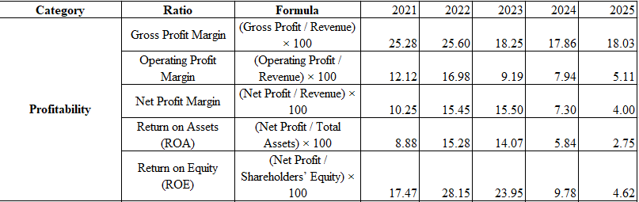
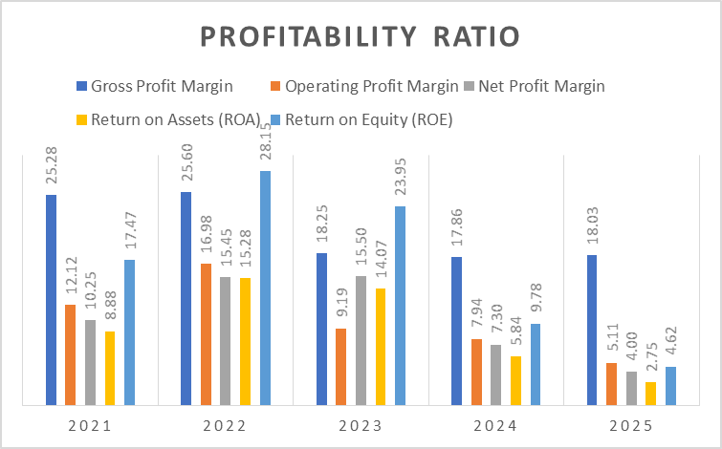
(Source: Own-Representation Derived from Excel)

Appendix 2: Liquidity Ratio
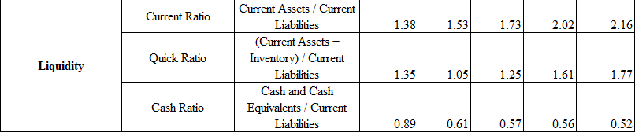
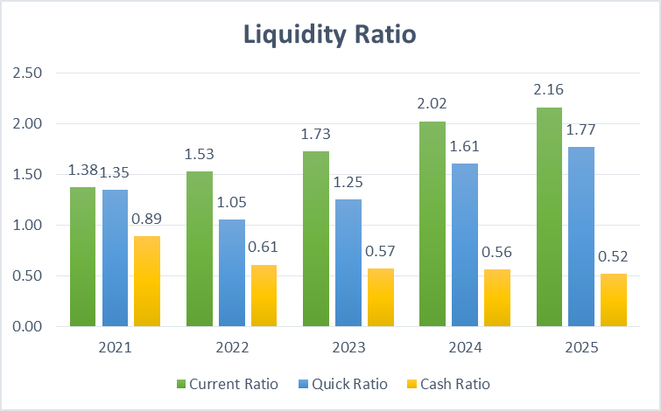
(Source: Own-Representation Derived from Excel)

Appendix 3: Efficiency Ratio
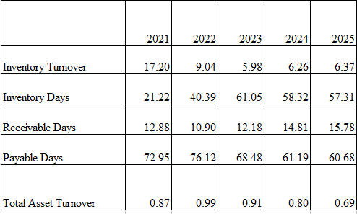
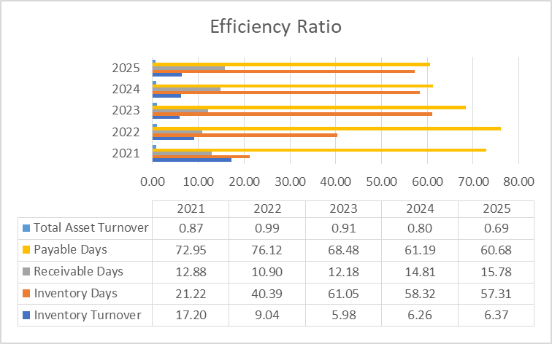
(Source: Own-Representation Derived from Excel)

Appendix 4: Gearing Ratio
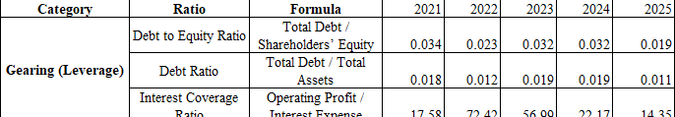(Source: Own-Representation Derived from Excel)

Appendix 5: Investment Ratio
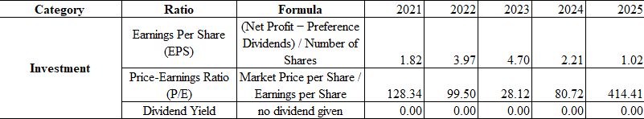
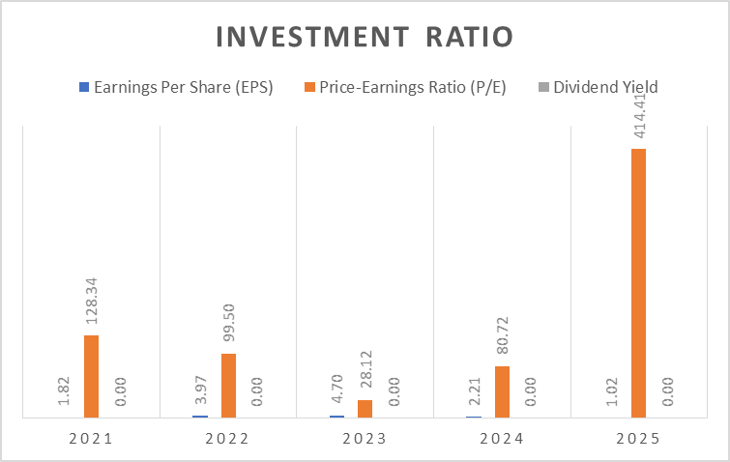
(Source: Own-Representation Derived from Excel)

Appendix 6: Cash Flow
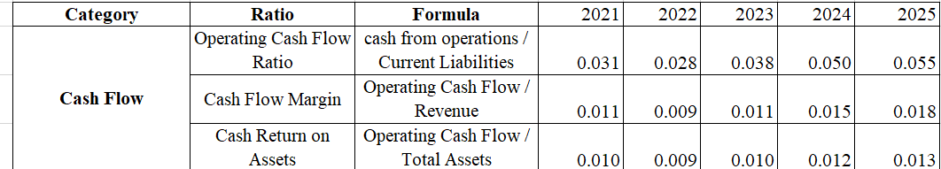
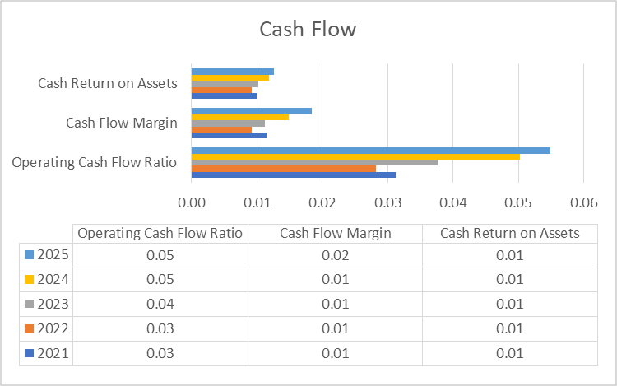
(Source: Own-Representation Derived from Excel)

Appendix 7: Cash Operating Cycle
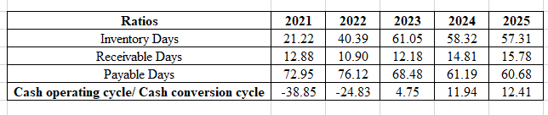(Source: Own-Representation Derived from Excel)

Appendix 8: Project A Appraisal
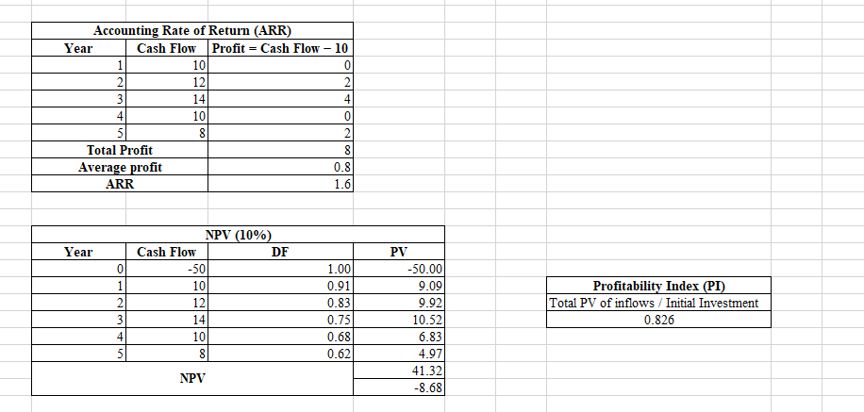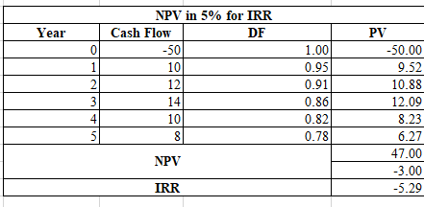
(Source: Own-Representation Derived from Excel)

Appendix 9: Project B Appraisal
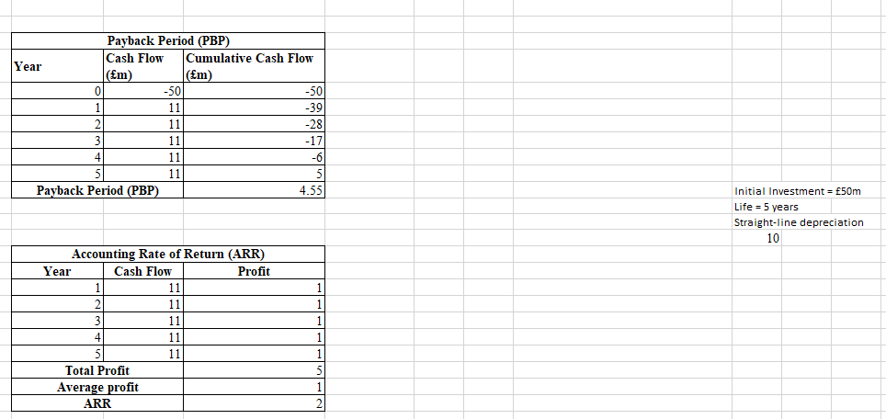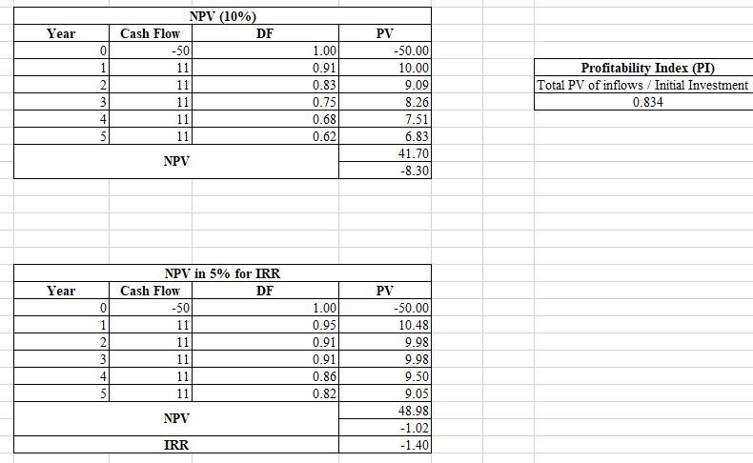(Source: Own-Representation Derived from Excel)

Appendix 10: Project C Appraisal

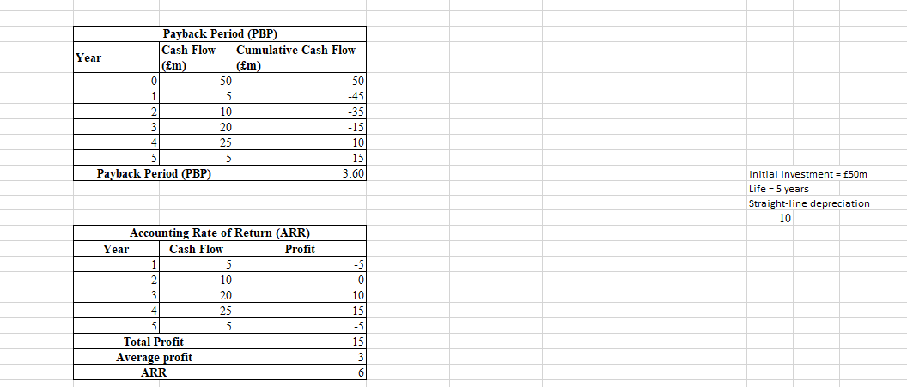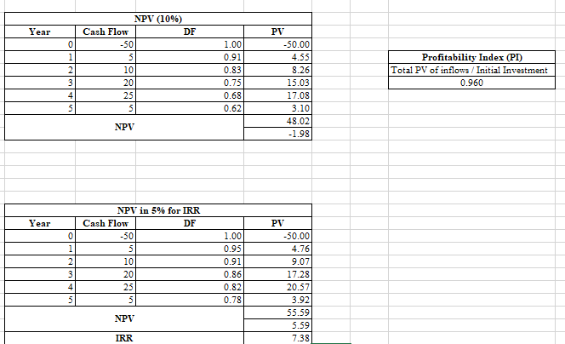
(Source: Own-Representation Derived from Excel)

