
An investigation into the rise of primark
Problem solving and decision making BMSK4004

June 12, 2019
Corey jones
University of wales trinity St David

Contents
1.0 Terms of Reference 2
2.0 Procedure 3
The information conducted by the researcher and was gathered using information acquired from a case study and websites relevant to the report. 3
3.0 Findings 4
4.0 Conclusion 10
5.0 Appendices 11
7.0 references 14
References 14

Terms of Reference

This report was requested on the 12th July 2019 by c.o. Primark compiled by consultant Corey Jones, the purpose of the report is to examine the rise of Primark and outline problems.

Procedure

The information conducted by the researcher and was gathered using information acquired from a case study and websites relevant to the report.

3.0 Findings

Primark is an international retailer that offers the latest fashion, homeware, cosmetics at a very reasonable affordable prices, Primark is a very popular store on the high street.
Primark originated from Ireland in 1969, Primark started trading as a store called Pennys.
In 1971 Penny’s opened a large store in Belfast City, In 1973 opened a store in Derby, because the company (Penny’s) was already registered name, the name Primark was born. The name Primark was invented to be able trade in Europe (com, nd)
Owning over 350 stores, the largest being the store in Birmingham which opened in April 2019 store containing a café, beauty treatments, Disney store etc.
Expanding rapidly in the UK in 2000-2005
In may 2006 Primark opened a store in Madrid, Spain after 10 years of development of 40 stores in Spain, Primark opened a bigger one again in oct 2015
Primark opened a store in Netherlands in 2009, followed by Portugal and Germany, Belgium, now operating 44 in the counties.
In November 2011 Primark worked with Selfridges Birmingham and Manchester UK
it expanded to France in 2013 in Marseille, then the first Italian store opened in 2014.
In 2015, Primark opened its first united states store in Boston, later in New York city, Philadelphia and Danbury, operating 8 stores in America, with plans of new jersey by the end of 2019 Primark is also hoping to expand and open a store outside of the north eastern corridor, Miami 2020
On June 13th, 2019 Primark expanded to its 12th country with a store being located in Ljubljana, Slovenia, Also signing a lease for a store in Poland, followed by a new store in Prague.

Primark offers a diverse range of products including baby and children’s clothing, Homeware, menswear and women’s ware accessories, footwear, range of beauty Products and Confectionary.
Primark sells clothes at the low- cost end of the market below average prices, Primark contributes to the latest fast fashion trends, for many shoppers Primark has a unavoidable offers, Amazing trendy clothes at amazing low prices, Selling women’s range of party wear, formal dress, work wear, holiday shop, lingerie, accessories and footwear, Men’s wear everyday essentials and footwear.
Jewellery for adults and children at affordable prices, Primark also sells home ware such as bedding, towels, curtains and home accessories. (Racked, n.d.)
One of the biggest stores is in Birmingham, the store itself will be so big it will have almost 1,000 employees. Customers will be able to do everything from eat there to getting their brows and nails done there will be Primark’s largest ever beauty studio far nails, make -up, hair, eyebrows and lashes - and there will be an in-house barber too. Also, Birmingham’s Primark will offer three unique and amazing dining experiences.

Whilst researching the company Primark the reporter discovered a news article online, by south wales evening post posted June 26th 2014 headlining “Concerned shoppers speak out as Primark investigates ‘sweatshop’ labels.
Primark is investigating claims of how two shoppers claim to have found labels sewn into their £10 summer dresses saying “Sweat shop conditions” and “Exhausting hours”
Rebecca Gallagher, 25 Spotted the Label reading “Forced to work exhausting hours” next to the washing instructions of her garment, and then a second shopper Rebecca jones, 21, also revealed her discovery in a label reading” Degrading sweat shop conditions “.
The two women claiming to not know each other purchased the same item from the same whitewalls, Swansea Primark store, also another person came forward from northern Ireland claiming to have found a ‘cry for help note’ written in Chinese.
After ringing Primark to explain the findings, with thoughts of could be a call for help or child labour the call was put on hold for 15 minutes to be then cut off.
A Primark spokesman described the findings on the labels as “strange” and has asked for the items to be sent for investigation.

Back in 2011, Primark ethnics came under fire after the collapse of a garment factory in Bangladesh killing 1,000 workers 580 of whom were employed by a Primark supplier.
The company announced it will pay out compensation to workers and families of workers who had died or been injured in the collapse.

The high street chain Primark assured that it has “ a code of conduct in place , to ensure products are made in good working conditions and all employees are treated fairly”

SWOT ANALYSIS ON PRIMARK
Strengths
- 207 stores around Europe
- 145 stores in UK
- Offers a range of job opportunities
- Employs more than 30,000
- Produces high street quality for affordable prices
- Primark is part of the ETI
- Provides clothing ranges for all ages
- Provides clothing ranges for men women, children
- Sells homeware
- Sells cosmetics
- Affordable, competitive prices
- Stores are in high street locations
- Providing quality services with a good organised business structure
- Primark has a 28 days refund policy
Weaknesses
- faced publicity for child labour in India and Bangladesh for producing products
- After negative reports they faced Primark stopped working with three big organisations
- Primark was found to have poor working conditions, and not giving full rights
- With lack of advertisement, gives competitors more of an advantage
- Employees stressed with workloads

Opportunities
- Primark expanding their businesses opening new stores in the UK and in Europe,
- Primark now has good quality clothes to fashion conscious people in UK and Europe
- Primark’s energy consumption in Great Britain is sourced against the green power generated and sold into the grid by sister company BritishSugar
Threats
- Primark shares many of its suppliers with its competitors on the high street
- the competition with other companies such as Zara, and H&M which is their biggest threat.
- As Primark do not advertise for their products while their competitors do, this can be a threat to Primark for not advertising giving competitors adavantage
- Financial crisis – Credit crunch
- Some Cheap quality products
- Increasing competitive pressures from Matalan, Peacocks, H&M

PESTLE ANALYSIS ON PRIMARK

POLITICAL FACTOR
- Primark’s energy utilization in UK is sourced against the green
power generated and sold into the grid by British Sugar.
- promoting an ethical approach to people worldwide in factories and farms to improve living conditions in countries with vulnerable situations such an India and Bangladesh Primark is a British clothing retail.
- to help young people in developing countries. “Primark Better Lives Foundation” provide financial

- Primark’s following government policies and regulations providing proper working environment for their workers.

- To deal with workers and to improve their working conditions Primark is part of the ETI (ethnical trading initiative)

ECONOMICAL FACTOR
- focusing on young Customer’s especially the under 35 of age.
- expanding their business by opening new stores in the UK Every year and progressed moving its businesses around Europe.
Primark offers to customers quality of clothing at affordable prices.
- Primark has a high rate of loyal customers.
- The retail contributes to the economy in developing countries, therefore this provides opportunities of employment.

SOCIAL FACTOR

- Working with the community, Primark has recruitment programmes to reach a wider range of people such as Job Centres, Universities, local communities,
- providing flexible hours brings an effective and friendly workplace.
- received numerous awards for being value retailer of the UK.
- Primark works with government and abides by regulations

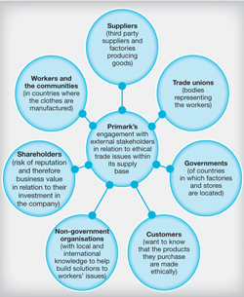
Every stakeholder has their own rights in the organisation. In the reporter’s point of view, the main three would include, The customer The Supplier and the Employee.
In order to build a relationship and the company to succeed each individual needs and expectations would have to be met for business to work.
For the customer the main objective would be to satisfy the customer with good value and offering good service by providing good services it is promoting the company and would have a regular customer base.
Primark knows that every customer want value for money which they are going to spend the on the product and service., also a good experience without a customer a business wouldn’t exist
The key factors of the business are Safety and environmental which have major impact on the research and development process making sure products are
Suppliers are an important role as they supply the goods, Primark has got a reputation to keep up with selling the latest brands at affordable prices making sure supplies are retraceable after previous allegations Primark use child labour factory work in un fair conditions.
Employees of Primark need to be influenced and have an affect on their employers as well as customers making sure they are proviing a good service in order for loyalty of return creating business. Primark employees need commitment to ensure it is good standard of work, .
Primark’s main priority is to respect the customer. With the positive influence on employees it keeps them safe and motivated. (Primark.com, n.d.)
As a Primark is very popular organisation and it is very famous for selling fashionable items at a far affordable price tag. Primark deals with their suppliers very closely and also works very closely with their all factories staff that produce its goods.

Conclusion
After researching Primark and performing a SWOT analysis, the researcher discovered a lot of information on the investigations they had faced regarding their factories, working conditions but unfortunately it took a broken reputation and a loss in sales in order to wake up and follow regulations keeping up with changes. Primark joined and became a member of the independent Ethical Trading Initiative (ETI) since 2006 and have held the top level of leadership since 2011.From Primark joining ETI zero tolerance approach for issues like child labour, Primark aim to respect workers’ right to form a trade union, and to ensure workers do not work excessive hours burning employees out from work overload. factories should be maintaining appropriate environmental working practices. Primark aim to take care of its employees by maintaining ethical relationships and respecting human rights. By engaging with its many suppliers, including factory owners and workers in countries that specialise in the production of the fashionable items, it ensuring that everybody gains from the business process and everyone is treated fairly following the right regulations, making the right choices, doing the right thing building and progressing the business.
After a lot of bad publicity the researcher also found good news that the company is now thriving and continuing to with new developments planned for 2020 and recently opening a mega store in Birmingham containing a Disney store, beauty and hair, nail salon coffee shop, design your own clothes it just proves Primark have managed to get over their bad patch and put things right Proving to its consumers they are following regulations and perhaps now people don’t feel guilty splashing out on Primark’s products not feeling guilty of where it came from who made it? Primark’s website can show you all the questions and answers you would like to know and all about Primark’s ethnics

After researching there has been support from Primark since the Rana Plaza building collapse in Bangladesh , Paul Lister, responsible for Primark’s Ethical Trade and Environmental Sustainability Team, said: “Five years on from the Rana Plaza building collapse in Bangladesh, Primark continues to support those who were affected and over the period has contributed a total of over $14 million in aid and compensation.
In June 2017 Primark signed the 2018 Transition Accord, reaffirming Primark’s commitment to collaborate with other brands, factory owners, NGOs, trade unions and the Government of Bangladesh to bring about sustainable positive change in the Bangladeshi garment industry.” (Primark.com, n.d.)

Appendices

Primark operates stores in the following countries:^{[2]}
Country | Number of stores | First store opened
United Kingdom | 192 | 1973
Spain | 47 | 2006
Ireland | 37 | 1969
Germany | 29 | 2009
Netherlands | 20 | 2008
France | 15 | 2013
Portugal | 10 | 2009
United States | 9 | 2015
Belgium | 7 | 2009
Austria | 5 | 2012
Italy | 4 | 2014
Slovenia | 1 | 2019
Poland | 0 | Opening 2020
Czech Republic | 0 | Opening 2020
Total | 376

(Bing.com, n.d.)

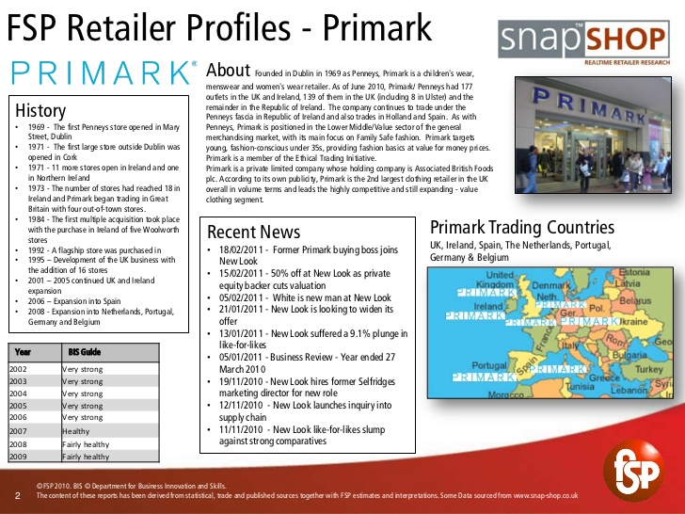

(Bing.com, n.d.)

7.0 references

References
Bing.com. (n.d.). primark timeline - Bing. [online] Available at: https://www.bing.com/images/search?view=detailV2&id=F5CE54719F742902BBA94F98A8767B7E7E4C3EE4&thid=OIP.U1k6WqN8BEA-7A6W23PNTgHaFj&mediaurl=https%3A%2F%2Fimage.slidesharecdn.com%2Fcompanyprofile-primark-110316102953-phpapp01%2F95%2Fcompany-profile-primark-2-728.jpg%3Fcb%3D1300271539&exph=546&expw=728&q=primark+timeline+&selectedindex=5&ajaxhist=0&vt=0&eim=1,6 [Accessed 7 Jul. 2019].
Bing.com. (n.d.). primark timeline - Bing. [online] Available at: https://www.bing.com/images/search?view=detailV2&id=88E628A1AFA4951EC7744F98A8767B7E7E4C3EE4&thid=OIP.U1k6WqN8BEA-7A6W23PNTgHaFj&mediaurl=https%3A%2F%2Fimage.slidesharecdn.com%2Fcompanyprofile-primark-110316102953-phpapp01%2F95%2Fcompany-profile-primark-2-728.jpg%3Fcb%3D1300271539&exph=546&expw=728&q=primark+timeline&selectedindex=4&ajaxhist=0&vt=0&eim=1,6 [Accessed 7 Jul. 2019].
Mail Online. (n.d.). Bangladesh factory death toll could reach 1,400: Primark says it will compensate families of killed and injured. [online] Available at: https://www.dailymail.co.uk/news/article-2317012/Primark-factory-collapse-Death-toll-Bangladesh-set-jump-1-400.html [Accessed 7 Jul. 2019].
MANAGEMENT VIEWS. (n.d.). Primark Stakeholders. [online] Available at: http://managementviews.weebly.com/primark-stakeholders.html [Accessed 7 Jul. 2019].
Primark.com. (n.d.). Our Ethics | Primark UK. [online] Available at: https://www.primark.com/en/our-ethics [Accessed 7 Jul. 2019].
Racked. (n.d.). Everything to Know About Primark, the European Fast Fashion Brand About to Crush Its US Competition. [online] Available at: https://www.racked.com/2015/4/1/8321127/primark-us-openings [Accessed 7 Jul. 2019].
South Wales Evening Post. (2014). Concerned shoppers speak out as Primark investigates 'sweatshop' labels. [online] Available at: https://web.archive.org/web/20150921101557/http://www.southwales-eveningpost.co.uk/Primark-investigating-shoppers-express-concerns/story-21288579-detail/story.html [Accessed 7 Jul. 2019].
Young, G. (2019). Primark reveals opening date and secrets of giant new store in Birmingham. [online] birminghammail. Available at: https://www.birminghammail.co.uk/whats-on/shopping/worlds-biggest-primark-birmingham-reveals-15895931 [Accessed 7 Jul. 2019].

