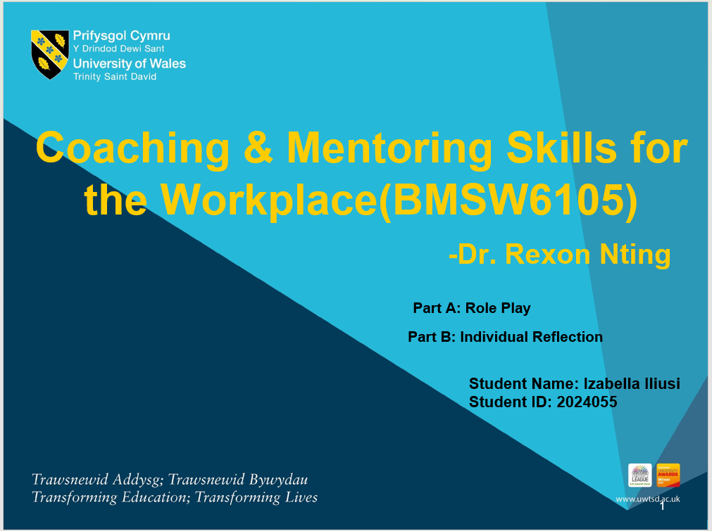
Table of Contents
Part A: Role Play 3
Part B: Individual Reflection 5
Gibb’s Reflective Cycle 5
Evaluation of the role of coaching or mentoring in improved performance and morale 7
Analysis of the skills, behaviours, attitudes, values, and beliefs of an effective coach 10
References 13

Part A: Role Play
Role-play between the senior microbiologist John Griffiths of Healthcare International and the manager Phillippa Graham.
Phillippa: Hello John, are you facing any issues in your current work?
John: Hello Mam, I have been at Healthcare International for 8 years as a senior microbiologist and was promoted during the reorganization, after my promotion my workload increased and in my free time I used to work in a voluntary youth club so, I am facing difficulties in managing the workload.
Phillippa: I have recently introduced automation for flexible working within the organization and that will help in reducing the workload. Also, you can manage the workload by dividing the time between your job in Healthcare International and the youth club then start prioritizing your tasks, and make strategies to complete the task effectively on or before the deadline. If these practices will not work for you, we can provide you with a coaching session on workload management that will help you in developing your workload and time management skills systematically within the given period. So, are you comfortable taking the coaching session to resolve your problem and improve your performance?
John: Yes, although I thought to demand a less demanding role similar to my existing role but if the coaching session can help me then I will change my mind.
Phillippa: The coaching session of skills development will help you to develop workload and time management skills and a GROW model is there that will help in structuring your coaching session as it stands for Goal, Current Reality, Options, and Will. It starts with establishing the goal and your goal is to learn and perform better in your new role and that is a SMART goal, then comes examining the current reality so, as you already told me about facing issues in workload management and this skill will be developed by the coaching session of 2 months, the third step is exploring the possible options so, have you searched for options to reach you objective?
John: I am facing issues in managing the responsibilities of the new job. Also, to respond to corporate pressure you have decided to increase our functions by introducing new equipment, I am facing more load of my work as my role does not need much equipment, it requires mental energy.
Phillippa: So, as you are facing problems in managing the responsibilities of your new role, what are your plans to solve the issue?
John: I have gained good knowledge in my existing role as a senior microbiologist and I am not feeling confident and motivated while working in my new role as having a fear of spending too much time learning the new responsibilities. Focusing on workload management and learning about my new role in less time will help me without converting to a lower role.
Phillippa: Ok so according to the last stage Willingness of the GROW model, your will is to either have a less demanding role similar to your existing position or get a way to learn the new role. To help you, I will be providing you with a coaching session on workload management skills, and a training session that will help you in learning about the roles and responsibilities of your new role in a limited time as changing the promotion to a lower position is not the solution as it will affect your growth so, an effective coaching and training will help you. The coaching session will be of 1 month that includes the development of various skills required in managing the workload and the training will be of 2 months in which every detailed information about your role will be explained to you so, will it be better for you and are you satisfied with the solution?
John: Yes, I can easily give my 3 months to developing new skills and roles and the session will also help me in future so, I am satisfied and ready for the coaching and training session.
.

Part B: Individual Reflection

Gibb’s Reflective Cycle
In 1988, Graham Gibbs developed this cycle to help individuals to reflect on their learning from the situation along with analyzing the good and bad experiences and the areas of improvement (Markkanen et al., 2020). The role-play of planning a coaching session will be reflected by coachee John Griffiths through this reflection model.
Description: I have been working with Healthcare International as in charge of Quality Assurance for four years and now has positioned as a manager of the microbiology department I have noticed that the microbiologist's team is facing several issues individually regarding their working and job role so, I through a meeting with the team members I have tried to solve their problems by finding the best possible way. I have introduced a system of team briefings that deliver briefs by Microsoft Teams technology to explain the policies and implications to every team member of the department but during the meeting, every individual was discussing the issues they were facing so, I have planned to overcome the issues regarding skills, organizational performance, future goals, managing change, or personal needs through coaching or mentoring session that will help them to work on their problems along with satisfying and motivated in the workplace with growth and development (Samardzic, Doekhic and Wijngaarden, 2020).
Feelings: During my meeting with John Griffiths, a senior microbiologist who has been with the company for eight years and got promoted during the reorganization because of his steady performance and seniority I was nervous as I am the manager and I cannot show nervousness and negativity as it will directly demotivate the employee. I asked him several questions regarding the issues he was facing and I came to know that he was unhappy and dissatisfied with his new role as it was not similar to his existing role also he was facing problems with workload management as he used to spend his spare time in a voluntary youth club as a counsellor and supporter. I felt disappointed that time because when I was working in charge, the satisfaction and expectations of employees were being prioritized but I have not shown any negativity during the meeting and just prioritized his choice and preference and planned everything according to him (Sugiarti, Finatariani and Rahman, 2021).
Evaluation: During the meeting, I encouraged John and prioritized his choices as employee motivation and satisfaction play an important role in a successful organization (Ali and Anwar, 2021). I was not happy with his concern as he was having lack of the most important skills. Although, I have decided to increase the functions of the remaining team members to fill the gaps of staff cutting but also introduced new equipment to make their work easier and faster. John was prepared to ask for a less demanding role as he was stressed at that time but I have motivated him to not waste his hard work by losing a senior position, he was happy with the company but just facing problems with workload and his new role but after discussing with him about providing him with the coaching and training sessions, he agreed to work on his skills and to stay in the company as a new position (Hilali et al., 2020).
Conclusion: John faced issues of workload management, and high responsibilities in a new role but his fear of underestimating his capabilities and experience has made him incapable of choosing the best option and taking the right decision. A coach or mentor has the responsibility to provide guidance, skills, and knowledge to help an individual to grow and develop (Muller and Kotte, 2020). As a manager, I have decided to prepare and deliver an introductory coaching session to the team members having lack skills, performance, etc. as I am having a good experience as an in charge there are several skills that I need to develop in myself as a manager that could help me to handle the situation better. I have to work on my problem-handling skills because as a manager I have the responsibility to listen to every problem and to suggest them the best possible solution but I usually got panicked in difficult situations.
Action: After a 20-minute meeting, we have decided to develop a coaching session for John to help him develop his workload and time management skills, and a training session to make him gain knowledge about his working in a new role. The session will be for 3 months in which John will work on his skills development for 1 month and on learning about his new role for 2 months, and he has agreed to manage his work for 3 months. The coaching provided to John will be focused and I will focus on the other skills also as a coach like planning, time management, decision-making, problem-solving, and prioritizing tasks.

Evaluation of the role of coaching or mentoring in improved performance and morale
Coaching involves a coach who has the responsibility to provide guidance and support to the client for the achievement of their objectives and to help them grow (Ibarra and Scoular, 2019). On the other hand, mentoring involves a mentor who shares their skills, experience, and knowledge with the other to help them grow and develop. Several types of coaching and mentoring could be provided to the staff members like change management, succession planning, performance enhancement, skills development, etc. the aim behind this coaching session in the department is to improve performance and morale. After knowing the lack of skill among various staff members, the need and importance of coaching have been identified (Digirolamo and Tkach, 2019). The role of coaching in improving performance and morale are as follows:
Skills development- The most important aspect of the coaching session is the development of skills like workload management, time management, problem-solving skills, decision-making skills, etc. development of skills will help the members to work efficiently will increase their productivity and improve their performance (Niati, Siregar and Prayoga, 2021).
Increased confidence- Developing a skill build self-confidence to complete the given responsibility without any difficulty and this confidence helps in the decision-making process.
Increased self-awareness and motivation- Self-awareness is connected with performance and development and providing feedback to the team members on their practices, behaviours, and performance will help them analyse their progress, insights, opportunities, and challenges (Farooq et al., 2023).
Being self-confident and self-aware will make the members feel motivated in the workplace as the role in the microbiologist's department. The coaching session will help them in challenging themselves to take themselves out of their comfort zone, and in becoming better contributors by awarding them with their strengths and weaknesses.
Change management- Every organization needs to change to changing environment, changing behaviours, and changing demands but the adaption of changes can create stress among the employees and this coaching session will help them to increase resilience by developing or improving adaptability, innovation to make the members think creatively and find new ways, and building effective strategy for current performance and future (Drosos et al., 2021).
Problem handling- The coaching session will develop the skill of handling and solving problems among the team members to complete their tasks effectively. Problem-handling is more important than problem-solving because solving will come after facing the problems especially unexpected issues in the workplace, which can make the members get panicked and take the wrong decision. However, having control of emotions in the workplace will help the employees to handle unexpected problems, to think positively, and to find the best possible solution to overcome the issue (Park, 2019).
Applying the best coaching technique- The best approach by a coach is to give suggestions and corrections politely without hurting someone because this will make the members motivated and empowered without creating conflicts. The techniques involved in the coaching session include making the members realise their need in the organization and the need for change in the coaching session so, that they understand the impact of their actions in the workplace. The second technique is to avoid blaming as I will avoid directly blaming the member instead will explain the perception by suggesting better ways to improve the performance.
Selecting the best coaching style- A coaching style is important to execute the session and choosing the style depends on the issue and the capabilities of the team member. The most common and effective types of coaching styles include holistic coaching which aims to improve a member's health, outlook, and multiple areas of the member's life, mindful coaching focuses on removing anxiety and depression, etc.
In the case of a coaching session for John, the best style would be an integrated coaching style that aims on providing real-time coaching with feedback. It connects me as a coach and a team member by entrance and exit of the inputs and guidance from the coach to the members. It is usually used for addressing a specific behaviour, skill, or area of development and in the case of John, adopting this style will help Phillippa to focus on its workload management skills.
Gathering feedback- For the identification of the coaching behaviours and business outcomes, gathering feedback from the team members after the successful completion of the session is the responsibility of a good coach because the members will feel important and realise the impact of their opinion on the working within the department. This can be done by conducting feedback programs where the employees can freely express their opinions either positive or negative.
Use of KPIs- Key Performance Indicators is the best tool to measure the progress of the coaching session. The most effective KPIs are a rating of coachee satisfaction, reduced turnover, innovation, improvement in management, and promotion.
The members of the microbiological department needed only coaching and adopting an effective technique, style, and strategy will help Phillippa as a coach to successfully work on the issues faced by the coachee.

Analysis of the skills, behaviours, attitudes, values, and beliefs of an effective coach
Skills of an effective coach
A coach has the responsibility to guide and to help an individual or a team to achieve their goal and being an effective coach needs some effective skills to help the client in building self-awareness, self-confidence, and also the business to reach its goals. Some of the important coaching skills of an effective coach are as follows:
Comprehensive leadership- An effective leader does not focus only on providing a sense of belonging in the workplace but also helps the employees to analyse their strengths and weaknesses, making them more innovative, productive, and engaged (Yalcinyigit and Aktas, 2023).
Effective communication- Along with having great communication skills, an effective coach builds rapport with the coaches as a coaching technique. Effective communication skills result in flexible transmission of opinions and ideas, less or zero conflicts, strong relationships between the coach and the coachee, etc.
Active listening skills- An effective coach always believes in listening before communication as understanding and evaluating a situation or a problem starts from listening to it and it helps the coach to build strong relations with the coaches. According to the GROW model, there are four levels of active listening that include attentive, accurate, emphatic, and generative listening.
Innovative skills- An effective coach always has new ideas to explain things to the coaches and an innovative coach always encourages and motivates the coachees for being creative and bring new ideas.
Building Rapport- A rapport shows a relationship of trust between the coach and the coachees that are to be maintained throughout the relationship by allowing the coachees to be free and frank with their coach to share every difficulty with the coach.
Problem handling and solving- Problem solving starts from problem handling and a good coach always keeps patience and tolerance to handle the problems of the coachee.
Feedback- A good coach can receive and give feedback which is not an easy task as it includes giving feedback without hurting the coachee also that coach believes in feedback-receiving practices to work on the areas of improvement.
Empathy- An effective leader always has the skill of empathy that shows the behaviour of understanding the feelings of the coachees as they also are human beings and has their personal lives too.
A growth mindset- Having a growth mindset provides several opportunities to the coach and the coachee as it includes positive and innovative approaches and strategies that focus on the personal and professional growth of the coach and the employees.
Behaviours of an effective coach
The behaviour of the coach can also impact the development, motivation, and morale of the coaches there are two types of specific coaching behaviours that a good coach has and those are as follows:
Encourage-to-explore- This behaviour includes coaches who provide minimal guidance and encourage the coachees to explore and learn by using inspirational motivation, interesting approaches and intellectual stimulation, especially in transformational leadership (Corrie, Lawson and Rowland, 2020). The coaches having this kind of behaviour generally focus on enhancing employee’s learning orientation by encouraging them to independently find new ways of professional improvement that will increase their tendency to explore and develop competencies resulting in an effective learning orientation (Lai and Palmer, 2019).
Guide-to-learn- Coaches having this behaviour focuses on providing complete guidance, the right direction, and providing feedback and learning techniques to coachees by engaging them in pre-planned activities. According to the Pygmalion model, coaching relates to the learning and self-efficacy of employees which affects their relationships moderately (Veestreten et al., 2021). The feedback provided can also hurt the employees by reducing their intrinsic motivation. Providing complete guidance helps the employees to increase their confidence, and competence along with building intrinsic motivation to learn (Harbi, Alarifi and Mosbah, 2019).
According to the achievement motivation theory, goal orientation plays an important role in motivational orientation influencing an individual’s behaviour and it believes in providing learning and performance goal orientation (Zhou, 2021).

Values and Beliefs of an effective coach
Values have a crucial role in every individual’s life as it binds them with some rules of life that reflect the right direction and helps in achieving goals. The values of an effective coach include teamwork, being honest with others, positive attitude, being encouraging, and being goal-oriented.
Successful coaching depends on building trust, integrity, empathy, and a positive environment that comes from beliefs like breaking trust will break relations in the workplace, a negative environment results in negative thoughts and decisions, etc. Values and beliefs are not similar as beliefs include our assumptions from our personal experiences, learnings, and culture. Our beliefs influence our values that include principles or standards to live our life. Our beliefs majorly impact our behaviour, some can results in success and some can hold us back, this behaviour of beliefs is known as limiting beliefs that can also make people confused.

References
Al Harbi, J.A., Alarifi, S. and Mosbah, A. (2019) Transformation leadership and creativity: Effects of employees psychological empowerment and intrinsic motivation. Personnel Review, 48(5), pp.1082-1099.
Al Hilali, K.S., Al Mughairi, B.M., Kian, M.W. and Karim, A.M. (2020) Coaching and mentoring. Concepts and practices in the development of competencies: A theoretical perspective. International Journal of Academic Research in Accounting, Finance and Management Sciences, 10(1), pp.41-54.
Ali, B.J. and Anwar, G. (2021) An empirical study of employees' motivation and its influence on job satisfaction. Ali, BJ, & Anwar, G.(2021) An Empirical Study of Employees' Motivation and its Influence on Job Satisfaction. International Journal of Engineering, Business and Management, 5(2), pp.21-30.
Corrie, I., Lawson, R. and Rowland, T. (2020) Transformative action coaching in healthcare leadership. Journal of Transformative Learning, 6(2), pp.39-51.
Digirolamo, J.A. and Tkach, J.T. (2019) An exploration of managers and leaders using coaching skills. Consulting Psychology Journal: Practice and Research, 71(3), p.195.
Drosos, D., Kyriakopoulos, G.L., Gkika, E.C., Komisopoulos, F., Skordoulis, M. and Ntanos, S. (2021) Managing Change and Managerial Innovation towards Employees Satisfaction at Workplace. TEM Journal, 10(2).
Farooq, K., Yusliza, M.Y., Muhammad, Z., Omar, M.K. and Nik Mat, N.H. (2023) Employee ecological behaviour among academicians at the workplace. Social Responsibility Journal, 19(4), pp.713-740.
Ibarra, H. and Scoular, A. (2019) The leader as coach. Harvard Business Review, 97(6), pp.110-119.
Lai, Y.L. and Palmer, S. (2019) Psychology in executive coaching: an integrated literature review. Journal of Work-Applied Management, 11(2), pp.143-164.
Markkanen, P., Välimäki, M., Anttila, M. and Kuuskorpi, M.,(2020) A reflective cycle: Understanding challenging situations in a school setting. Educational Research, 62(1), pp.46-62.
Müller, A.A. and Kotte, S. (2020) Of SMART, GROW and goals gone wild: A systematic literature review on the relevance of goal activities in workplace coaching. International Coaching Psychology Review, 15(2), pp.69-97.
Niati, D.R., Siregar, Z.M.E. and Prayoga, Y. (2021) The effect of training on work performance and career development: the role of motivation as intervening variable. Budapest International Research and Critics Institute (BIRCI-Journal): Humanities and Social Sciences, 4(2), pp.2385-2393.
Park, S. and Park, S. (2019) Employee adaptive performance and its antecedents: Review and synthesis. Human Resource Development Review, 18(3), pp.294-324.
Sugiarti, E., Finatariani, E. and Rahman, Y.T. (2021) Earning Cultural Values as A Strategic Step to Improve Employee Performance. Scientific Journal of Reflection: Economic, Accounting, Management and Business, 4(1), pp.221-230.
Veestraeten, M., Johnson, S.K., Leroy, H., Sy, T. and Sels, L. (2021) Exploring the bounds of Pygmalion effects: Congruence of implicit followership theories drives and binds leader performance expectations and follower work engagement. Journal of Leadership & Organizational Studies, 28(2), pp.137-153.
Werdhiastutie, A., Suhariadi, F. and Partiwi, S.G. (2020) Achievement motivation as antecedents of quality improvement of organizational human resources. Budapest International Research and Critics Institute-Journal (BIRCI-Journal) Volume, 3, pp.747-752.
YALÇINYİĞİT, S. and Aktaş, H. (2023) A Research on the Relationship of Social Intelligence and Cultural Intelligence with Leadership Styles. Istanbul Business Research, 52(1).
Zhou, K. (2021) The influence of creative personality and goal orientation on innovation performance. Frontiers in Psychology, 12, p.634951.

