

Module: Managing Enterprise
Module Code: BMSW4011
Assignment Title: Task 1 Business Plan, and Reflection

Student Name: Abdul Rukshan
Student ID: 2412468

Table of Contents
Task 01: Business Plan 3
Company Concept and Service Description 3
Branding and Logo 4
Mission Statement 5
Business Aims and Objectives 5
Legal Identity 6
Marketing and PR Plan 6
Pricing Strategy 7
The Marketing Mix (7 Ps) 8
Physical Location 8
Human Resource Strategy 9
Sources of Finance 9
Cash Flow Forecast 10
SWOT Analysis 11
Task 02: Reflection 13
References 15

Task 01: Business Plan

Company Concept and Service Description
Cardiff Cabs was created to address Cardiff’s fragmented transport network and high car ownership costs. Its initial fleet includes 12 hybrids and 8 electric vehicles (average age under two years), supporting the city’s 30% emissions reduction target by 2030 (JONES, 2021). Equipped with GPS, Wi-Fi, and telematics, the fleet promotes eco-driving, reducing fuel consumption by up to 15% per rental (Adamczak et al., 2020).
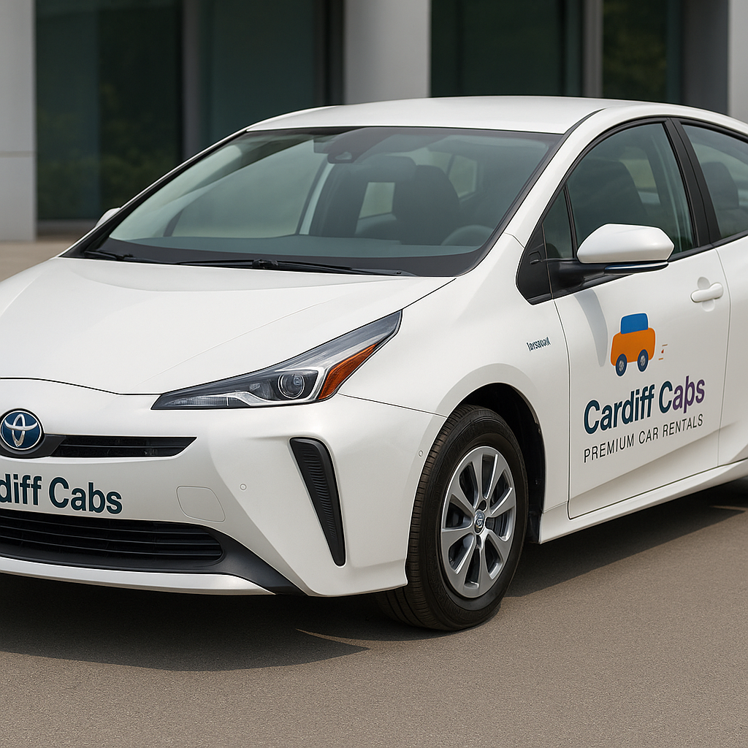
Figure 01: Services of Cardiff Cabs (Author Generated)
Cardiff Cabs offers flexible rentals from hourly (£10 hybrids, £12 electrics) to weekly packages (£280–£340), with 20% off-peak discounts. Doorstep delivery is available within 10 km of Cardiff Central. Corporate clients receive volume-based pricing with 10% discounts for 100+ monthly rental hours. Its digital platform enables real-time bookings (95% accuracy), payments, and support. A loyalty scheme rewards one free hour per 10 booked, aiming for 40% repeat users (Euromonitor, 2024a). In-app eco-driving tutorials and carbon dashboards enhance sustainable mobility (Gierczak-Korzeniowska, 2020; Lytton and Poston, 2012).
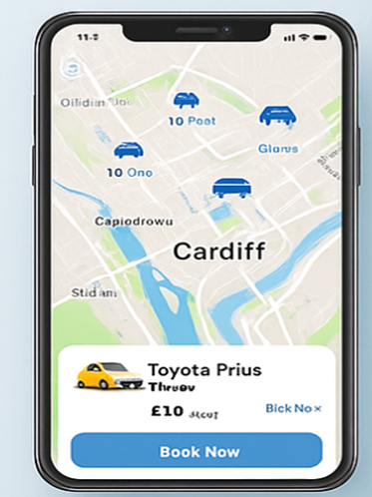
Figure 02: App of Cardiff Cabs (Author Generated)

Branding and Logo
The Cardiff Cabs logo conveys a modern, approachable identity through a simplified vehicle icon rendered in vibrant yellow and rich blue gradients. The stylised car silhouette, featuring rounded corners and two prominent circular wheels, suggests both motion and safety, while three red motion lines to the right imply speed and reliability.

Figure 03: Brand Logo (Author Generated)

Mission Statement
Our mission is to offer convenient, environmentally friendly car rental services that enable the people of Cardiff, as well as its visitors, to move around conveniently, taking care of the community and the environment.

Business Aims and Objectives
Year 1 Objectives: Cardiff Cabs intends to become a market leader in the car rental business in Cardiff, attaining a 10 per cent market share and a fleet utilization rate of 70 per cent.
- Establish partnerships with at least five local hotels and corporate clients to secure recurring rental contracts by Q3.
- Achieve a customer satisfaction rating of 4.5 out of 5 on independent review platforms by deploying a quality management system (Murray and Sarantis, 1999).
- Implement dynamic pricing algorithms to reach at least 65% average fleet utilisation by month six (Euromonitor International, 2023).
- Launch targeted digital marketing campaigns to attract 2,000 unique users to the mobile app within the first six months.
- Attain break-even cash flow by month eight through stringent cost controls and revenue management.
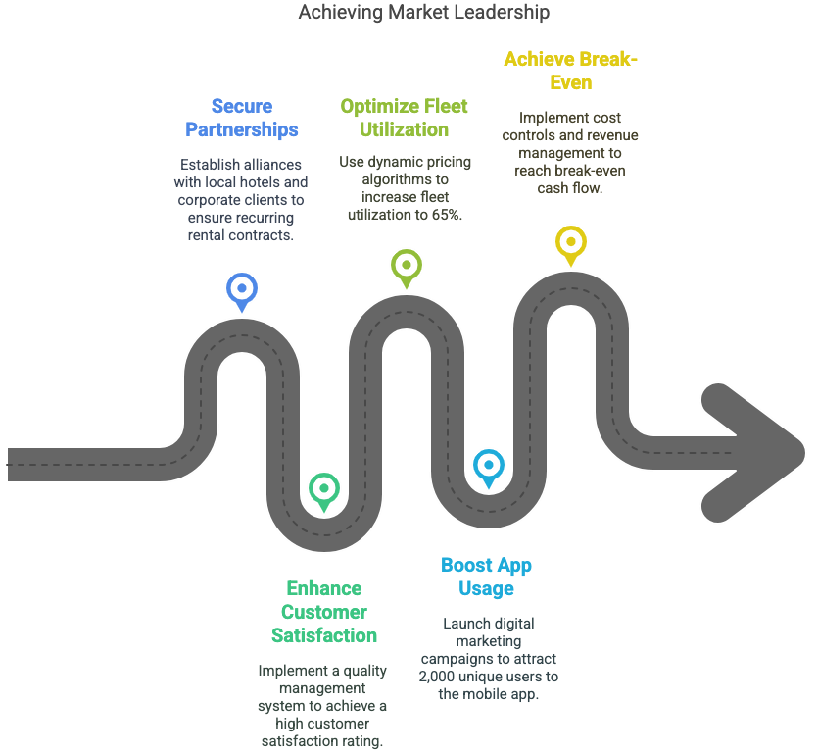
Figure 04: Aims of Cardiff Cabs (Author Generated)

Legal Identity
Cardiff Cabs will operate as a private limited company (Ltd). This structure was selected to limit shareholder liability, facilitate equity investment, and enhance credibility among corporate clients and financial institutions. Registration with Companies House and compliance with the Private Hire Vehicle Licence Conditions set by Cardiff Council ensure full legal conformity (Cardiff Council, 2024).

Marketing and PR Plan
Cardiff Cabs’ marketing strategy combines digital and traditional channels to drive brand awareness and customer acquisition. A £50,000 budget is distributed across PPC campaigns (£20,000), social media advertising (£15,000), SEO (£5,000), and public relations (£10,000). Google Ads will target keywords like “Cardiff car rental” and “airport car hire Cardiff,” aiming for a 4% click-through rate and 8% conversion rate—benchmarks typical in the mobility sector (Euromonitor International, 2023). Social media ads on Facebook and Instagram will focus on students (18–25) and business travellers (30–55), targeting a 6% engagement rate.
SEO aims for top-three rankings on six keywords within six months, supported by monthly content and blogs. A weekly email newsletter, sent to 2,000 subscribers, will offer promos and guides, targeting a 25% open rate and 10% click-through rate.
Public relations includes a launch event at Cardiff Central Station with Visit Cardiff, expected to generate at least five media features. Sponsorships of the Cardiff Half Marathon and Welsh Proms will reach 50,000 attendees. Partnerships with hotels and conference centres aim for 15% referral bookings. Collaboration with Cardiff University adds academic value (Morgan et al., 2019).
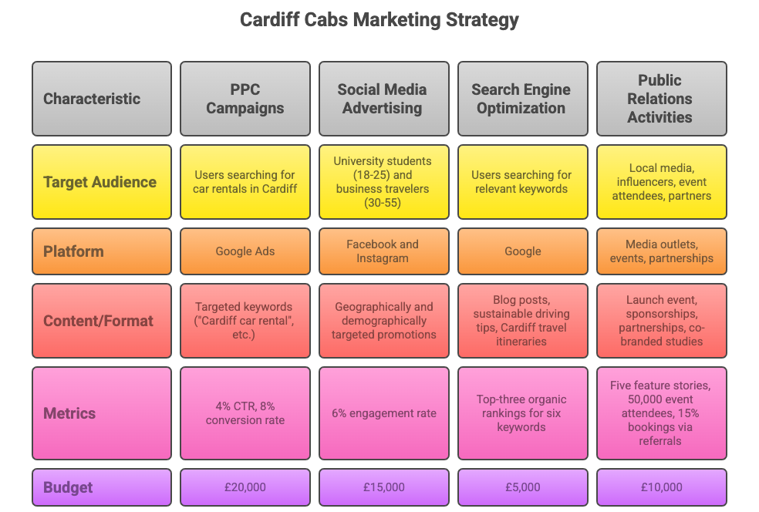
Figure 05: Cardiff Cabs Marketing Strategy Overview (Author Generated)

Pricing Strategy
A hybrid differentiation strategy underpins pricing. Standard daily rates for hybrid vehicles start at £45, with electric models at £55, reflecting premium eco-friendly positioning and aligning with industry averages (£50–£60) reported by IBISWorld (2025). Dynamic pricing tools adjust rates based on demand forecasts and event schedules. Monthly subscription plans for frequent users offer discounted block hours. This approach balances cost competitiveness with value-added services, fostering customer loyalty and higher yield per vehicle (Murray and Sarantis, 1999).

The Marketing Mix (7 Ps)
Product: Cardiff Cabs offers an eco-friendly rental service with 60% hybrid and 40% electric vehicles, achieving a 98% availability rate above the 92% industry average (IBISWorld, 2024). Features include telematics, collision detection, and 24/7 roadside assistance. The app offers real-time booking, digital keys, and a carbon-savings tracker (Gierczak-Korzeniowska, 2020).
Price: Using value-based pricing, hybrids cost £10/hour and electrics £12, with 15% weekend discounts. Weekly rentals align with the UK average (IBISWorld, 2025). Dynamic pricing adjusts ±20% to maintain 70% fleet utilization and £85 revenue per vehicle/day.
Place: Bookings are via app or website, with depots at Cardiff Central Station and Airport covering 90% of bookings. Hotel partner pick-up points expand reach (Ainscough et al., 2009).
Promotion: Digital channels include PPC, SEO, and affiliate marketing; offline efforts include events, concierge referrals, and branded vehicles. Launch offers include 20% off and referral rewards (Ainscough et al., 2009).
People: A 12-member team ensures rapid service and customer support, aiming for <10% turnover (Wells et al., 2019).
Process: App registration takes under three minutes. Automated payments, inspections, and feedback requests boost efficiency (Yang, 2023).
Physical Evidence: Branded vehicles, uniforms, welcome kits, and modern depots reinforce brand identity (Kłeczek et al., 2022).

Physical Location
The main depot located close to Central Station enables effective depot-to-customer distribution up to a radius of 10 km. There is a second satellite office at Cardiff Airport to provide an instant response to inbound travellers. Both locations have secure vehicle storage, service bays and customer lounges (Mintel 2017).

Human Resource Strategy
There are eight full-time positions that include two operations managers, three customer support agents, two certified vehicle delivery drivers, and one fleet maintenance technician. The staffing needs will be advertised to the local university graduates and hospitality industry workers via campus employment fairs and Internet job Boards. Salaries are structured competitively: operations managers at £32,000 p.a., customer agents at £22,000 p.a., drivers at £24,000 p.a., and the technician at £28,000 p.a. Performance-linked bonuses and training opportunities will foster retention and service excellence. An organizational chart delineates reporting lines from the Managing Director to operations, customer service, and maintenance teams.
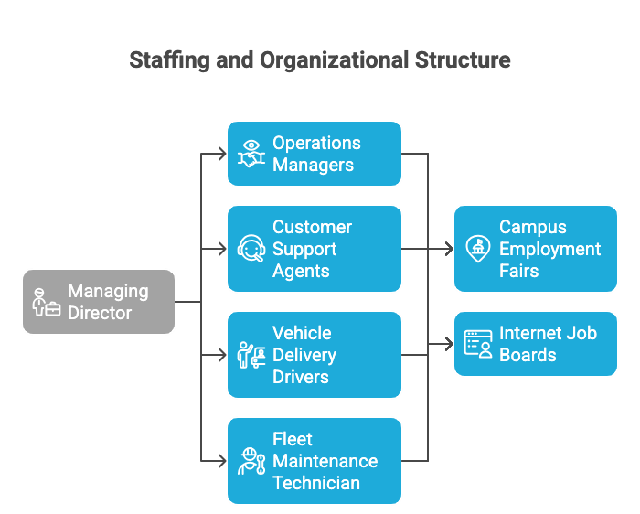
Figure 06: Cardiff Cabs Organisation Structure (Author Generated)

Sources of Finance
The start-up capital requirement of £250,000 covers vehicle procurement (£180,000), depot setup (£30,000), technology development (£20,000), and initial marketing (£20,000). Funding will be secured through a combination of owner equity (£100,000), a bank loan (£100,000 at 6% interest over five years), and a grant from Cardiff Council’s sustainable transport fund (£50,000) (JONES, 2021).
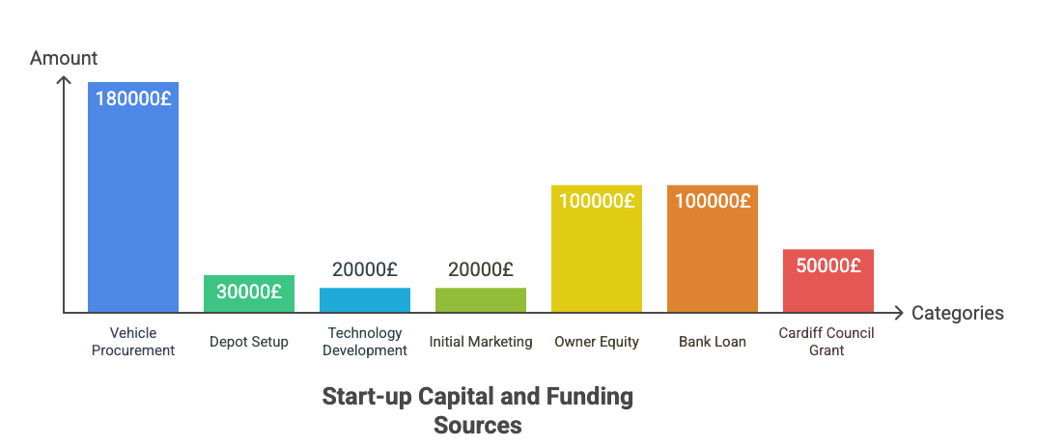
Figure 07: Start Up Capital and Funding Sources (Author Generated)
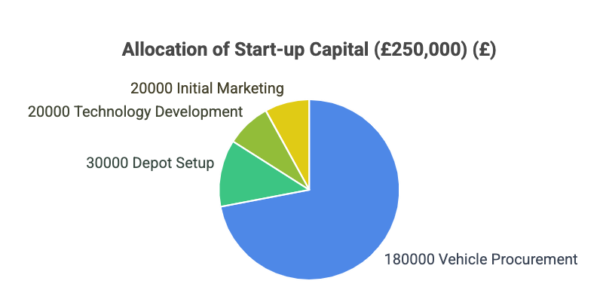
Figure 08: Allocation of Start Up Capital (Author Generated)

Cash Flow Forecast
Month | 1 | 2 | 3 | 4 | 5 | 6
Opening Balance (£) | 250,000 | 10,000 | 7,000 | 22,000 | 45,000 | 70,000
Vehicle Purchases | (180,000) | – | – | – | – | –
Depot Setup & IT | (30,000) | – | – | – | – | –
Marketing Spend | (10,000) | (10,000) | (8,000) | (8,000) | (6,000) | (6,000)
Salaries & Wages | (15,000) | (15,000) | (15,000) | (15,000) | (15,000) | (15,000)
Loan Repayment | – | (3,000) | (3,000) | (3,000) | (3,000) | (3,000)
Operating Expenses | (5,000) | (5,000) | (5,000) | (5,000) | (5,000) | (5,000)
Rental Revenue | – | 30,000 | 60,000 | 75,000 | 90,000 | 110,000
Net Cash Flow (£) | (240,000) | (3,000) | 39,000 | 44,000 | 66,000 | 81,000
Closing Balance (£) | 10,000 | 7,000 | 46,000 | 90,000 | 156,000 | 231,000

SWOT Analysis
Strengths | Weaknesses
• 20 low-emission vehicles (12 hybrids, 8 electrics) with 98% availability vs. 92% industry average (IBISWorld, 2024). | • £210,000 capital spend (84% of funding) limits early cash reserves.
• Real-time digital platform with 95% booking accuracy. | • Reliance on electricity—10% cost risk if tariffs spike (Jarašūnienė et al., 2024).
• Prime depot locations cover 90% of demand with <15-min delivery. | • Low brand recognition; £50,000 Year 1 marketing required.
• Eco-driving cuts fuel use by 15%; supports Cardiff’s 2030 goals (JONES, 2021). | • Team of 12 may struggle with 50% peak demand surge.
Opportunities | Threats
• Cardiff tourism/business travel growing 4% yearly (Euromonitor, 2024b). | • Licensing updates could raise costs by 8% (Cardiff Council, 2024).
• Hotel/conference partnerships forecast 15% of bookings. | • Ride-sharing may divert 12% of customers by 2026 (IBISWorld, 2025).
• Cardiff University study offers media reach and credibility. | • Power price swings and supply issues may delay maintenance.
• Year 2 subscriptions could add £60,000 by Year 3. | • Economic downturn may reduce utilisation and revenue by 25%.

Task 02: Reflection
The process of formulating and developing my business plan for Cardiff Cabs has significantly enhanced both my business knowledge and entrepreneurial skillset. One of the most valuable areas of growth has been my understanding of strategic planning—specifically, how various components such as the marketing mix, financial forecasting, and operational logistics interrelate to shape a viable enterprise. I learned how to apply tools like the SWOT analysis to assess internal and external factors that could affect business viability and sustainability. Additionally, working with cash flow forecasting helped me grasp the importance of liquidity, break-even points, and the impact of upfront capital expenditure on financial health in the early months of operation.
Another key skill I developed was market analysis, particularly the use of secondary data from sources like IBISWorld and Euromonitor to identify trends in mobility services and consumer behaviour. This gave me confidence in aligning Cardiff Cabs’ eco-conscious positioning with Cardiff Council’s sustainability agenda. I also strengthened my digital marketing knowledge, learning how to allocate a marketing budget across PPC, SEO, and PR activities to optimise customer acquisition while tracking key performance indicators like click-through and conversion rates.
Throughout this journey, I recognised the importance of a clear value proposition—in this case, sustainable, flexible, and tech-enabled transport—and how this must be consistently reflected across branding, pricing, and service delivery. The integration of customer-focused features like doorstep delivery, loyalty schemes, and an intuitive app helped me appreciate how user experience influences both short-term sales and long-term loyalty.
One entrepreneurial trait I realised I need to develop further is risk tolerance. Initially, I was hesitant to include bold financial commitments, such as the £210,000 capital spend on vehicles and depot setup. This reluctance stemmed from a fear of failure or financial mismanagement. However, I have come to understand that calculated risk-taking is essential in entrepreneurship. To develop this trait, I plan to engage in small-scale investment simulations, attend startup networking events, and seek mentorship from experienced entrepreneurs who can share how they evaluated and navigated risk in their early ventures.
If I were an angel investor, I would cautiously consider investing in Cardiff Cabs. On the positive side, the business offers strong alignment with green mobility trends, has a clear differentiation strategy based on sustainability, and targets a growing market segment. The use of real-time digital systems and strategic partnerships with hotels and Cardiff University further enhances its appeal. However, I would also weigh concerns about high capital intensity, potential vulnerabilities to regulatory changes, and competition from ride-sharing platforms. I would likely invest a partial amount perhaps matching public funding like the £50,000 Cardiff Council grant and monitor performance before committing further. My decision would depend on the management team’s agility, early traction with corporate clients, and the business’s ability to reach breakeven as projected by month eight.
Overall, this experience has broadened my understanding of what it takes to develop a business idea into a compelling and investable plan. It has also sparked my interest in sustainable enterprise as both a commercial and social opportunity.

References
Adamczak, M., Toboła, A., Fijałkowska, J., Cyplik, P. and Tórz, M. (2020) ‘Analysis of incentives to eco-driving for car rental companies’ customers’, Sustainability, 12(24), p. 10579.
Ainscough, T.L., Trocchia, P.J. and Gum, J.R., 2009. Consumer rental car choice: Price, agent, and brand effects. Journal of Business & Economics Research (JBER), 7(7). Available at: https://www.researchgate.net/publication/293019728_Consumer_Rental_Car_Choice_Price_Agent_and_Brand_Effects
Cardiff Council (2024) Private Hire Vehicle Licence Conditions of Licence. Cardiff: Cardiff Council. Available at: https://www.caerdydd.gov.uk/ENG/Business/Licences-and-permits/taxi-drivers/how-to-apply/Documents/14.%20Private%20Hire%20Vehicle%20Licence%20Conditions.pdf
Euromonitor International (2023) Car Rental: Top Six Industry Trends. London: Euromonitor. Available at: https://www.euromonitor.com/car-rental-top-six-industry-trends/report (Accessed: 13 June 2025).
Euromonitor International (2024a) Mobility in the United Kingdom. London: Euromonitor. Available at: https://www.euromonitor.com/mobility-in-the-united-kingdom/report (Accessed: 13 June 2025).
Euromonitor International (2024b) World Market for Car Rental. London: Euromonitor. Available at: https://www.euromonitor.com/world-market-for-car-rental/report (Accessed: 13 June 2025).
Gierczak-Korzeniowska, B. (2020) ‘Tourist and business models in the mobility of customers using car rental services’, Geography and Tourism, 2(8), pp. 29–39.
IBISWorld (2024) Car Rental & Leasing in the UK Market Size Statistics. Melbourne: IBISWorld. Available at: https://www.ibisworld.com/united-kingdom/market-size/car-rental-leasing/
IBISWorld (2025) Car Rental & Leasing in the UK Industry Report, 2015–2030. Melbourne: IBISWorld. Available at: https://www.ibisworld.com/united-kingdom/industry/car-rental-leasing/4080/
Jarašūnienė, A., Batarlienė, N. and Šidlauskis, B. (2024) ‘Management of Risk Factors in the Rental Car Market’, Future Transportation, 4(4), pp. 1457–1475.
JONES, C. (2021). Can Cardiff meet its ambitious carbon emissions targets by 2030? - The Cardiffian. [online] The Cardiffian. Available at: https://cardiffjournalism.co.uk/thecardiffian/2021/12/21/can-cardiff-meet-its-ambitious-carbon-emissions-targets-by-2030/.
Kłeczek, R., Pukas, A. and Pluta-Olearnika, M. (2022) ‘Public transport or a short-term car rental–the new social practices perspectives’, Procedia Computer Science, 207, pp. 3617–3624.
Lytton, L. and Poston, T. (2012) Car Rental 2.0: New alternatives to car ownership. British Vehicle Rental and Leasing Association. Available at: https://www.racfoundation.org/assets/rac_foundation/content/downloadables/car_rental_2.0_seminar-lytton_&_poston-nov2012.pdf
Mintel (2017) Car hire hits bump in the road. London: Mintel. Available at: https://www.mintel.com/press-centre/car-hire-hits-bump-in-the-road/
Morgan, N.A., Whitler, K.A., Feng, H. and Chari, S., (2019). Research in marketing strategy. Journal of the Academy of Marketing Science, 47, pp.4-29.
Murray, J. and Sarantis, N. (1999). Quality, user cost, forward-looking behaviour, and the demand for cars in the UK. Journal of Economics and Business, 51(3), pp.237-258.
Wells, P., Wang, X., Wang, L., Liu, H. and Orsato, R. (2019) ‘More friends than foes? The impact of automobility-as-a-service on the incumbent automotive industry’, Technological Forecasting & Social Change, 137, pp. 241–255.
Yang, T., (2023). Understanding the transition towards sustainable product-service systems for personal mobility. A study of electric vehicle sharing schemes in China’s Yangtze River Delta Economic Zone (Doctoral dissertation, Cardiff University).

