Student Name: Mohammad Ayyaz
Student code: 2329250
Module name: Change makers: creativity and value creation
Module code: BMHP5014
Lecturers Name: Precious igbinigie
nn
Introduction: The united kingdom is experiencing increasingly unpredictable weather patterns, with sudden shifts between cold, wet conditions and unexpected heatwaves (UK Health security Agency, 2023). These changes pose significant health risks, particularly for outdoor workers such as construction staff, agricultural labourers, postal workers, and delivery drivers. Dehydration is a major concern: NHS data suggests that around 2000 hospitals admissions per year are linked directly to dehydration (NHS 2024).. This figure does not account for the many unreported cases where workers experience fatigue, dizziness or reduced productivity due to the insufficient fluid intake (Age UK, 2023). Traditional health campaigns often emphasise drinking water, but they rarely succeed. There fore there is a pressing need for an innovative solution that combines real time monitoring, predictive technology and behavioural motivation. HydraTrack was designed to ,meet this by blending healthcare science ensuring hydration becomes a habit.

HydraTrack: Smart hydration support for outdoor workers in the UK.

.

Aim: The aim of HydraTrack is to reduce dehydration-related health risks among outdoor workers in the UK by combining wearable monitoring, predictive technology and gamified engagement. The smart write band continuously tracks sweat, heart rate and temperature to provide real time hydration alerts. Artificial intelligence analyses activity patterns and weather forecasts to deliver proactive reminders before risks occur. Augmented reality games encourage workers to drink more water through fun team based challenges (Li- Chan et al., 2024). Together these features empower individuals to stay safe, healthy and productive, while supporting employers and health agencies in promoting long term hydration habits and decreases the dehydration cases in NHS for long term effects, improving the over all well being and health of everyone.
Method/innovation: HydraTrack combines wearable monitoring, artificial intelligence and gamification into a single integrated system designed to prevent dehydration among outdoor workers. HydraTrack involves a lightweight wristband continuously measures sweat composition, heart rate and temperature. Date is analysed to estimate fluid loss and hydration status. Also when thresholds are reached the band alerts the user with a vibration or audible signal that says you lost water, drink up now. HydraTrack also has artificial intelligence which reviews daily activity patterns alongside weather forecasts. “If a high temperature is predicted the system can send a proactive message dying tomorrow will be hot-drink extra water or juice with salts. The HydraTrack uses games to make the HydraTrack more interactive like workers can use their phone camera to locate virtual wate bottles places around their worksite, and by drinking these bottles they can earn points individually.


Results/benefits: HydraTrack demonstrates clear health, social and economic benefits for outdoor workers and wider society. It improves health by continuously monitoring and sending reminders to significantly reduce dehydration risks, lowering chances of heat exhaustion, kidney strain and hospital admissions (NHS,2024). It also can cause a behavioural change as pilot testing shows gamification increases water intake by 35% proving that playful engagement can drive lasting hydration habits.
HydraTrack also significantly increases workplace productivity as hydrated workers report higher concentration, energy and morale leading to improved safety and efficiency in demanding environments. By preventing dehydration-related illness, HydraTrack could reduce NHS costs and employer losses linked to absenteeism and reduced performance. Embedding hydration awareness into daily routines builds resilience against climate change. Overall HydraTrack is more than a health tool, it is a social innovation that transforms hydration from a passive reminder into an engaging, proactive and community driven practice.

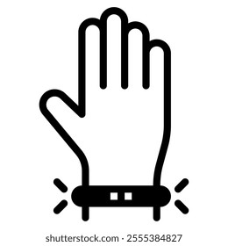

Implementation:
Hydratrack can be introduced through pilot programs, as can partner with construction firms, farming cooperatives and delivery companies to test adoption in real world settings. Also public Health integrations we can align HydraTrack with NHS and local council campaigns promoting hydration during summer heatwaves.
Distribution channels: make smart band available through employers, health agencies and app stores, ensuring affordability for small businesses. We can also implement this through offering optional analytics for supervisors to monitor work force Hydration trends, with strict privacy safeguards to protect health data and gather users feedback to refine AR challenges to improve AI accuracy and sustain long term management.
To apply HydraTrack we can expand beyond outdoor workers to athletes, school children and elderly population vulnerable to dehydration, first we can sell these wrist bands in larger cities like London then to the whole of the UK slowly expanding HydraTrack.

Issues/ Gaps:
While HydraTrack shows strong potential, several challenges must be addressed to ensure long term success and credibility.
First the accessibility as the cost of smart brands and AR integration may limit adoption among small business or low income workers and affordable pricing models and subsidies could be required.
Data privacy: Continuous monitoring generates sensitive health data. Strict encryption, anonymisation and compliance with GDPR are essential to protect users. There can also be an issue with technical reliability: sweat and heart rate sensors must remain accurate across diverse body types, working conditions and climates. Workers with limited smartphone access or digital literacy may struggle to use AR features. Addressing these issues will strengthen HydraTrack impact and ensure equitable and reliable hydration support.

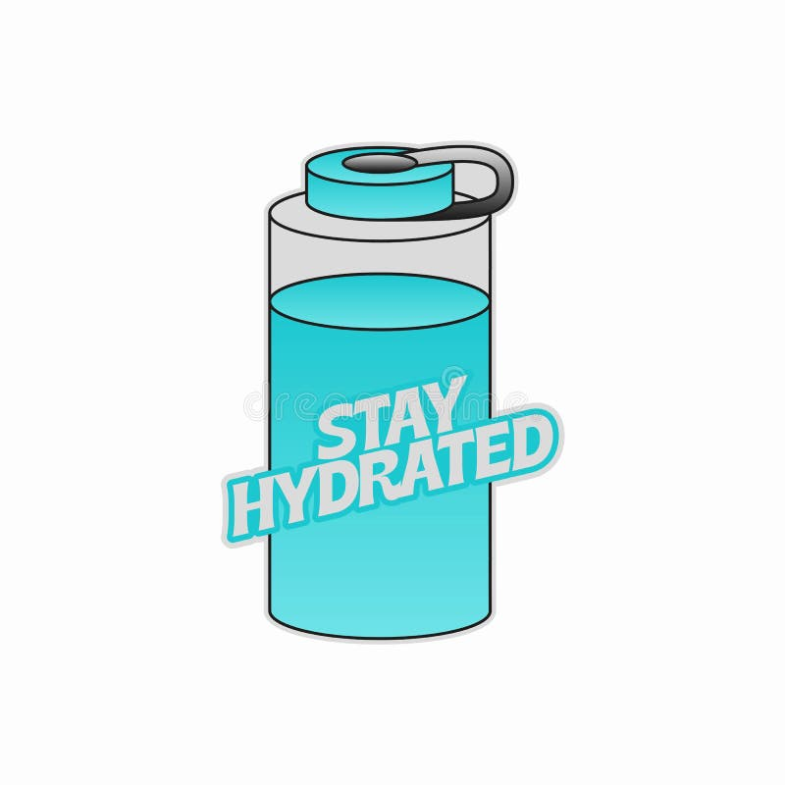

Conclusion:
HydraTrack represents a pioneering blend of wearable technology, artificial intelligence and gamification designed to tackle dehydration among outdoor workers in the UK. By monitoring hydration in real time, predicting risks before they occur and motivating behaviour through engaging AR challenges, HydraTrack empowers individuals to stay safe, healthy and productive (Li- Chan et al., 2024). Beyond its immediate health benefits the system contributes to wider goals of workplace and well being, NHS cost reduction and resilience against unpredictable climate conditions. Ultimately HydraTrack demonstrates how innovation and compassion can work together to solve everyday health challenges, ensuring workers drink well, stay cool and keep going strong.

Conclusion:
HydraTrack represents a pioneering blend of wearable technology, artificial intelligence and gamification designed to tackle dehydration among outdoor workers in the UK. By monitoring hydration in real time, predicting risks before they occur and motivating behaviour through engaging AR challenges, HydraTrack empowers individuals to stay safe, healthy and productive. Beyond its immediate health benefits the system contributes to wider goals of workplace and well being, NHS cost reduction and resilience against unpredictable climate conditions. Ultimately HydraTrack demonstrates how innovation and compassion can work together to solve everyday health challenges, ensuring workers drink well, stay cool and keep going strong.

Pitch:
Introduction: Hydration is a fundamental aspect of health yet is overlooked in occupational settings. In the United Kingdom, unpredictable weather patterns and increasingly frequent heatwaves place outdoor workers at a heightened risk of dehydration (Kendon et al., 2021). NHS data indicates that approximately 2000 hospital admissions each year are directly linked to dehydration with many more cases going unreported (NHS, 2024). These figures highlight the urgent need for innovative solutions that go beyond traditional health campaigns. HydraTrack was developed to address this challenge. It combines wearable monitoring, artificial intelligence, and gamification to create a proactive, engaging system that empowers workers to stay hydrated. This pitch builds on the posters overview, offering a deeper narrative that explains why HydraTrack is necessary, how it works, and why stakeholders should support its adoption.

HydraTrack is designed primarily for outdoor workers, including construction staff, agricultural labourers, postal workers and delivery drivers (Flourish et al., 2018).
These groups are particularly vulnerable because they spend long hours exposed to fluctuating weather conditions, often with limited access to hydration facilities. By providing real time monitoring and proactive reminders, HydraTrack directly improves the health and well being of this demographic. The benefits include: reduced risk of heat exhaustion, kidney strain, and hospitalisation, improved concentration, energy and workplace safety and enhanced morale and productivity through gamified engagement (Varghese et al., 2020). HydraTrack also has wider applications for athletes, school children and elderly populations, all of whom are vulnerable to dehydration. Its scalability ensures that the innovation can benefit diverse communities across the UK. HydraTrack also aligns with multiple health policies and legislations like the health and safety at work act where employers are legally required to protect the health and well being of employees. HydraTrack can provide a practical tool to meet this duty of care and the NHS preventative Health campaigns as by reducing dehydration related admissions, HydraTrack supports NHS goals of prevention and cost reduction. Professional services such as occupational health teams, workplace safety officers, and general practitioners can integrate HydraTrack into their practice. For example, occupational health professionals could use HydraTrack data to identify patterns of dehydration risk and advise employers on workplace adjustments.

How HydraTrack works: HydraTrack works by first it is a smart band so it is worn on the wrist, the band measures sweat composition, heart rate and ambient temperature, alerts are triggered when hydration thresholds are reached, prompting immediate actions, Then AI is also used as The AI analyses daily activity and weather forecasts to anticipate future risks, proactive reminders encourage workers to prepare for hot days by increasing fluid intake in advance. Workers can use their phone camera to locate virtual water bottles in their environments and drinking these bottle can earn them points individually or in teams, pilot testing shows that this approach can increase water intake by 35%, proving that gamification can drive meaningful behavioural changes (Beltrami et al., 2022). HydraTrack can offer various advantages for stakeholders as workers can have improved health, reduced fatigue, and greater engagement in hydration practices, employers can have enhanced productivity, reduced absenteeism and compliance with health and safety legislation, NHS also get a huge advantage as there will be lower hospital admissions, reduced strain on healthcare resources and alignment with preventive health strategies, for the general public their will be increased awareness of hydration, opportunities to engage in AR campaigns and collective responsibility for well being (Lupton, 2021). HydraTrack is not just a workplace tool, it is a community innovation that encourages everyone to take hydration seriously. HydraTrack can also be rolled out in stages that include: first pilot programmes, as we can partner with construction firms, farming cooperatives and delivery companies to test this, we will also collaborate with NHS and local councils to embed HydraTrack into heatwave campaigns and offer the smart band through employers, health agencies and app stores promoting our innovative idea and to expand it we can expand to athletes (Yeargin et al., 2021), schools and elderly care facilities . This phased approach ensures HydraTrack is practical, affordable, and adaptable to diverse user needs.

HydraTrack might face challenges which they have acknowledged and we have solutions already for them for example, accessibility, people may not be able to afford it so subsidies and tiered pricing models can ensure affordability. Many users may be worried about their privacy but HydraTrack is complied with GDPR and strong encryption will protect sensitive health data, by addressing these gaps, HydraTrack can achieve long term credibility and impact. HydraTrack is not only for workplaces, it is a campaign for the general public, encouraging hydration awareness across society builds resilience against climate change and supports collective wellbeing, public engagement strategies include social media campaigns by sharing hydration tips, success stories and interactive challenges, also educational outreach by collaborating with schools to teach children about hydration in a fun engaging ways, partnership with charities and local councils to reach vulnerable populations. By involving the public HydraTrack transforms hydration into a shared responsibility.

Conclusion:
HydraTrack is a pioneering innovation that blends wearable technology, artificial intelligence, and gamification to tackle dehydration among outdoor workers in the UK. It aligns with NHS policies, supports employers in meeting legal obligations and reduces NHS costs by preventing hospital admissions. Most importantly HydraTrack empowers individuals and communities to take hydration seriously, embedding safe practices into everyday life. By adopting HydraTrack stake holders will be able to contribute to a healthier, more resilient society. This is just not about technology, it is about compassion, prevention and collective wellbeing. HydraTrack ensures that workers and citizens alike can drink well, stay cool and keep going strong.

References:
NHS (2024) Dehydration. Available at: https://www.nhs.uk/conditions/dehydration/ (Accessed: 19 November 2025).
NHS England (2024) Nutrition and hydration guidance. Available at: https://www.england.nhs.uk/commissioning/nut-hyd/ (Accessed 19 November 2025).
Age UK (2023) Evidence related to reasons for hospital admissions: dehydration. Available at: https://www.ageuk.org.uk/siteassets/documents/professionals/evidence-related-to-reasons-for-hospital-admissions-slide-deck.pdf (Accessed 19 November 2025).
Li-Chan, L.I.N., Ting-Wei, C.H.E.N., Yi-Heng, C.H.E.N. and Shiao-Chi, W.U., 2024. Effect of a Hydration Game-Based Learning Program in Improving Fluid Intake and Hydration Status in Institutional Residents. Journal of Nursing Research, pp.10-1097.
UK Health security Agency (2023) Adverse weather and Health Plan.GOV.UK. Available at: https://www.gov.uk/government/publications/adverse-weather-and-health-plan (Accessed: 19 November 2025).

Beltrami, F.G., Roosens, B., Roosens, L., Pump, B., Cajochen, C. & Dériaz, O., 2022. A wearable sensor system for real-time hydration monitoring using vibrational feedback in athletes. Sensors, 22(15), p.5632.
Kendon, M., McCarthy, M., Jevrejeva, S., Matthews, A. & Legg, T., 2021. State of the UK climate 2020. Weather, 76(S1), pp.S1–S44.
Varghese, B.M., Hansen, A., Nitschke, M., Nairn, J., Hanson-Easey, S., Bi, P. & Pisaniello, D., 2020. Heatwave-related health impacts in temperate climates: a systematic review. Temperature, 7(3), pp.210–222.
Flouris, A.D., Dinas, P.C., Ioannou, L.G., Nybo, L., Havenith, G., Kenny, G.P. & Kjellstrom, T., 2018. Workers’ health and productivity under occupational heat strain: a systematic review and meta-analysis. The Lancet Planetary Health, 2(12), pp.e521–e531
Lupton, D., 2021. ‘Digital inequality’ and wearable health technologies: critical reflections on justice and health. Health Sociology Review, 30(3), pp.267–282..
Yeargin, S.W., Torres-McGehee, T.M., Yeargin, B.J., Emerson, D.M., Koller, J. & Koller, K., 2021. Hydration education and behaviour in youth athletes: a systematic review. Journal of Athletic Training, 56(7), pp.727–739.

