ACDB 4011: DETERMINATION OF THE FORMULA OF MAGNESIUM OXIDE

REPORT IS DUE July 24, 2024 @3.00 pm
submitted via MOODLE as ONE .doc file

The maximum mark available is 100 points and it is based on the accuracy of your measurements and calculations but also the depth of the analysis you provide.
You gain marks for correct observations, calculations and determination of formula of magnesium oxide.
Remember to use the appropriate units and provide a list of supporting literature properly referenced in IEEE format.

READ THIS HANDOUT CAREFULLY AND ADDRESS ALL QUESTIONS !!!

ATTACH THE ORIGINAL DATA SHEET !!!
Guidance for lab report:
- Title page, TOC, etc
- Introduction (100-150 words)
  - State the purpose/aim and objectives of the experiment.
  - Write the hypotheses that are going to be tested. what do you guess from the prior experience the formula of magnesium oxide would be? Do you expect the mass of the product to increase or decrease? Why?
  - Define the dependent, independent and control variables and/or terms and show the equations that will be used in the report.
- Theory (Background information) supported by literature, including
  - Basic concepts, principles and laws, definitions (e.g. law of conservation of mass, law of definite proportions, stoichiometry, empirical formula)
  - Chemical equation and formulas for calculations (what else besides oxygen can react with magnesium in this experiment?, write chemical equations; equation to calculate mass/moles/molar mass, % by mass, mole ratio etc)
- Results (150-250 words)
  - Present observations/data (as of the Data Sheet provided below) in a clear and organised manner.
  - Use tables, graphs or figures to illustrate the results effectively (if relevant).
  - Briefly describe the key findings and patterns observed in the data.
  - Calculations
- Discussion (200-350 words)
  - Interpret the experimental results and explain their significance in terms of general chemistry concepts.
  - How does the experimental formula compare to the theoretical formula — do they match? What are primary sources of experimental errors? Compare the mass of the Mg chips with the mass of the magnesium oxide and explain the difference. Are the law of conservation of mass and law of definite proportions obeyed?, etc.)
  - Describe the relevance of the experiment to OME and relate the findings to the existing scientific knowledge and literature (OME specifically).
  - Address any limitations or potential sources of error in the experiment.
- Conclusions (50-100 words)
  - Summarise the main findings and evaluate whether they support the hypothesis or not.
  - Suggest potential directions for future research based on the findings.
- References (IEEE)
- Appendix: Materials and method
  - List all materials and equipment.
  - Describe the experimental procedure in a detailed and stepwise manner. (You can use bullet points).
  - Explain, the steps you undertake.

POTENTIAL HAZARD
Chemical | Hazards
Magnesium | 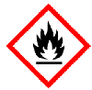  Flammable solid,  Flammable gases generated when in contact with water

PROCEDURE
Put on the lab coat, safety goggles, and gloves. Make sure that long hair is tied.
In this experiment, you will determine the formula of magnesium oxide by analysing the mass/mole ratio of magnesium and oxygen in the product of combustion of magnesium in air.
IMPORTANT: Record all your observations, calculations, and conclusions in the data sheets at the end of this script.
Lab tools and supplies:
- Crucible and cover
- Ring stand, Bunsen burner, clay triangle , Crucible tongs (WE USE FURNACE INSTEAD!)
- Analytical balance
- Magnesium chips, 1-2 g

Apparatus:

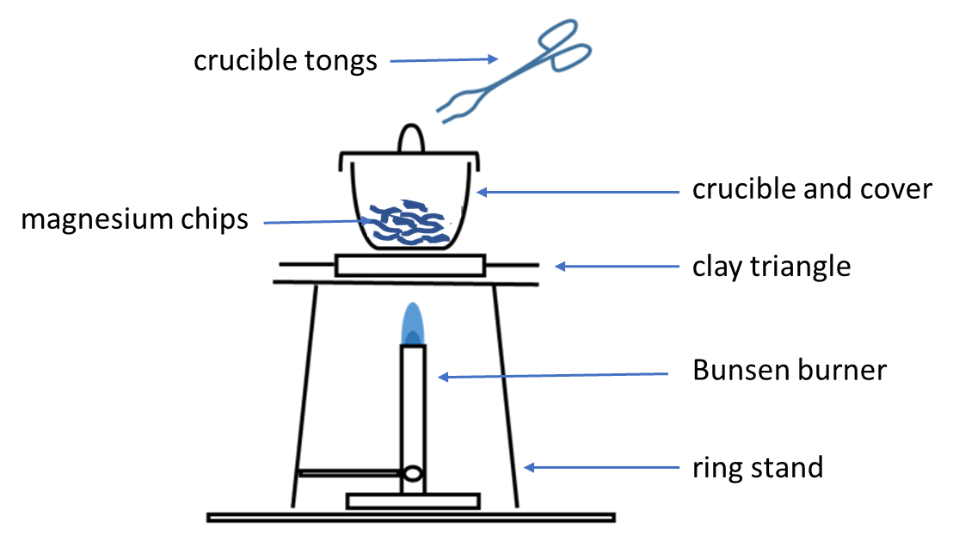
Procedure:
- Set up the ring stand and Bunsen burner on the surface of the heat-resistant mat. Place the clay triangle on top of the ring.
- Light the Bunsen burner and open the air vent to obtain a non-luminous flame with two blue cones. Ensure that the safety yellow flame is on when the Bunsen burner is not in use.
- Make sure that the crucible and lid are clean and dry, then weigh them on analytical balance and record the value in your data table.
- Add approximately 1 – 2 g of magnesium chips to the crucible, weigh it and record the combined mass of crucible, lid and magnesium.
- Place the crucible on the clay triangle. Set the lid slightly off-centre on the crucible to allow air to enter but to prevent the magnesium oxide from escaping.
- Start gently heating the crucible, cover and magnesium by brushing the bottom of the crucible with the flame for about 1 minute; then, place the burner under the crucible and heat strongly.
- Heat until all the magnesium turns into gray-white powder (probably around 10 minutes).
- Allow the crucible to cool and then record the mass of the crucible, cover and product of the reaction.

REPEAT THE PROCEDURE !
DATA SHEET to RECORD OBSERVATIONS, CALCULATIONS and RESULTS
date___________
STUDENT’S NAME: ____________________________________________________
PARTNER’S NAME: ____________________________________________________

 | TRIAL 1 | TRIAL 2
Mass of crucible and cover
Mass of crucible, cover and magnesium
Mass of magnesium before heating
Mass of crucible, cover and product after heating
Mass of product after heating
Mass of oxygen which reacted with magnesium
Moles of oxygen
Moles of magnesium
Mole ratio of Mg to O
Determined formula of the oxide
Percent by mass of Mg in the oxide
Percent by mass of O in the oxide
Balanced chemical equation

To calculate moles of magnesium and oxygen, use the correct molar masses as a conversion factor . Refer to lecture notes for the details

SHOW ALL YOUR CALCULATIONS and REMEMBER THE UNITS !!!

Recommended sources:
Empirical Formula of Magnesium Oxide by Experiment Chemistry Tutorial
Empirical Formula of Magnesium Oxide and videos within.

