Project Management Assignment

Managing a Hardware/Software Project for Disaster Recovery

Christine Woods 1704446

Sue Maw

School of Applied Computing

University of Wales Trinity Saint David

Submission Date – 25.01.19

Declaration by Christine Woods

The work of this report completed under the supervision of Susan Maw. I declare that this report is the product of my own work and is not being submitted for any other degree etc.



Acknowledgments
- Sue Maw – Lecturer University of Wales Trinity St David
- Silvia Settle – Student
- Matthew Stokes – Student
- Lwys Davies – Student

Introduction

Initiation of the C.A.L.M.E.R project took place using various management tools. Planning involved analysis of the role that quality has when a project is developed.

A Project initiation document highlighted the main roles and responsibilities reviewing time lines and processes.

This project report discusses involvement of risk management, codes of practice and assurance issues whilst providing analysis, evaluation and providing solutions to problems.

Contents
Centralised Alignment of Local Medication and Emergency Resources (C.A.L.M.E.R) Project Report 6
1. Risk Management 6
1.1 Risk Evaluation Matrix 7
2. Code of Practice (Sustainability Issues) 8
3. Code of Practice (Legal and Ethical) 10
4. GDPR 12
5. Brexit 12
6. Quality Assurance Issues 13
7. References 16
8. Appendix 17
9. Screenshots of Tableau database 19

Centralised Alignment of Local Medication and Emergency Resources (C.A.L.M.E.R) Project Report.

Risk Management
Identification of any risks that may require a strategy to ensure that processes are in place should such an occurrence happen:
 | Risk | Risk Reduction Strategy
A | Personnel Shortfalls | - Ensure staff fully trained and aware of expectations.  - Ensure team are constantly updated for requirements.  - Team building.  - Regular performance reviews.
B | Unrealistic time management | - Regular meetings ensuring tasks are met and adjustments made as necessary.
C | User interface unusable/system failure | - Regular testing and training.  - Fit for purpose.
D | Resources unavailable | - Requirements implemented and agreed at the start of the project with signed agreements.
E | Changes to requirement | - To be reviewed and assessed ensuring that project will not be under pressures or under delivering on agreements already made.
F | Performance issues (Real time), Technology changes, Robustness, Understanding. | - Constant testing ensuring the system is up to date and fit for purpose with version updates as needed.
G | Transport Issues | - Ensure agreement is in place with local transport companies and the armed forces should this be required.  - Look at using drones to deliver medications.
H | Staffing issues/illness | - Constant contact with project managers with up to date staffing register.  - Ensure backup measurements are in place.
I | Power outage | - Keep up to date HALO specification requirements
J | Forces not able to assist | - Ensure that arrangements are up to date and enforceable.
K | Public Awareness | - Campaign set up to make the public aware of the project.  - User involvement.
Impact | High |  | C D | F | I J
Impact | Significant |  | B | G H
Impact | Moderate | K | A | E
Impact | Low
 |  | Low | Moderate | Significant | High
 |  | Probability

1.1 Risk Evaluation Matrix

The Risk Evaluation Matrix has highlighted that there would be devastating issues should the following occur
- Performance issues (Real time), Technology changes, Robustness, Understanding. (F)
- Power Outage (I)
- Forces Unable to assist (J)
(F). Performance issues (Real time), Technology changes, Robustness, Understanding – Constant testing is required to ensure there are no problems with the software. Please see Appendix 1 (Screen print showing the map of the routes for the transport). If this had not had testing the routes were incorrect due to a glitch in the data set. Appendix 2 shows the updated transport map with correct coordinates. Continual testing will pick up any anomalies that need repairing.
As shown in Appendix 3 there may be an issue with different cultures understanding the data i.e. illiteracy. The use of informative picture icons can show users which service is available in which location. The database will use different languages for different parts of the world should the database be used worldwide.
(I). Power Outage - Reduce the risk of these issues by engaging H.A.L.O in a strategic plan in the event power is not available. Generators will be provided along with H.A.L.O communications to ensure that users can still access the system.
(J). Forces not able to assist - A plan will be put into place with the forces before any disaster occurs with clear implementation specifications.

2. Code of Practice (Sustainability Issues)

Data centres use over 2% of all U.K. power [1] being impacted by the growth of industry, especially with the expanded use of servers in comparison to previous years. Historically price and performance have been the major factors when looking at sustainability issues, energy efficiency and environmental impact is now a major contributary factor.
It will be a requirement that the C.A.L.M.E.R project ensures regular reviews of sustainability issues and updates accordingly.
Software Quality Framework implementation will be a requirement for analysis of the sustainability of all software with a focus on Social, Environmental, Technical and Economic Sustainability [2]

First Order (Directly affected by the project)
Server usage – the project will implement a larger growth in server usage (depending on the growth of the database).
E-Waste – Hardware will become obsolete or fail to function correctly creating disposal problems.
Energy (Greenhouse gas emissions).
Plastic Waste, Food Waste – provision of water bottles and food.
Transport.
Open source software and cloud computing.

Second Order (Indirectly affected by the project)
Renewable energy sourced to generate electricity such as solar, wind, thermal, hydro & geothermal.
Environmental sustainability - Arrange meetings through Skype saving on fuel, lighting, heating. Attended meetings will provide hot desks only which can be pre-booked to ensure there is a provided area.
Social sustainability - Arrangements for staff to work from home at least 75% allowing for less fuel emissions, lighting, heating etc. “Team Member Location -the location of people involved in the project influences the travels, the working times, and the communication infrastructures of the project. Consequently the location of team members may have a significant impact on the carbon footprint of the whole project” [3]
Dematerialisation - Save paper by implementing a no paper policy.
Economic sustainability - All servers will have the power saving mode activated.
Server storage will be in cool areas/countries saving on cooling costs.
Cloud computing – allowing for more efficient use of servers and less waste.

Third Order (Systemically affected by the project)
Less vehicles on the road during the rush hour, (this would be during system implementation rather than in the event of a disaster).
Less impact to the greenhouse gas emissions (working from home).
Improvement of human welfare.
Overall impact of care (NHS). Patients not overcrowding emergency areas saving valuable time and money.
Environmental sustainability.
Less traffic in the emergency service locations due to transport being in place.

3. Code of Practice (Legal and Ethical)
It is a recommendation that this project becomes a member of “BCS The Chartered Institute for IT and IEEE” [4] [5]
The BCS Code of Conduct covers five principles – Integrity, Objectivity, Professional Competence and Due Care, Confidentiality and Professional Behaviour. It promises to
“Sets out the professional standards required by BCS as a condition of membership;
applies to all members, irrespective of their membership grade, the role they fulfil, or the jurisdiction where they are employed or discharge their contractual obligations.
Governs the conduct of the individual, not the nature of the business or ethics of any Relevant Authority “ [4]
The IEEE Code of Conduct is approved by the IEEE Board of Directors.(June 2014).
We, the members and employees of IEEE, recognize the importance of our technologies in affecting the quality of life throughout the world and we accept a personal obligation to our professions, the members of IEEE, and other individuals involved in IEEE activities in our fields of interest. By this obligation, we commit ourselves to the highest standards of integrity, responsible behaviour, and ethical and professional conduct [5].
1.There may be a risk of vulnerability with certain patients that have mental health issues or other types of issues. The Code of Conduct will ensure there is no discrimination for the patients that require medical attention or ongoing treatments:
BCS Section 1“conduct your professional activities without discrimination on the grounds of sex, sexual orientation, marital status, nationality, colour, race, ethnic origin, religion, age or disability, or of any other condition or requirement” [4]
IEEE Section2 “We will not discriminate against any person because of characteristics protected by law (e.g., age, ancestry, colour, disability or handicap, national origin, race, religion, gender, sexual or affectional orientation, gender identity, gender expression, appearance, matriculation, political affiliation, marital status, veteran status).” [5]
2.The project organisers will not allow users to gain access to transport or medical supplies/treatments by the offering of financial gains ensuring that all users gain fair access to the services provided:
BCS Section 2G“reject and will not make any offer of bribery or unethical inducement.” [4]
IEEE 5A” We will comply with all applicable laws, rules and regulations governing IEEE’s business conduct worldwide and all relevant procedures established by IEEE whenever and wherever we are acting on behalf of IEEE, or participating in IEEE activities, including but not limited to the following: a) Rejecting bribery in all forms. [5]
3.Due to the nature of some of the ongoing medical conditions, users may not wish to share information regarding treatments or disclose medical conditions. Section 3D states that the project shall:
BCS Section 3D “NOT disclose or authorise to be disclosed, or use for personal gain or to benefit a third party, confidential information except with the permission of your Relevant Authority, or as required by Legislation” [4]
IEEE Section 1” We will be respectful of the privacy of others and the protection of their personal information and data. [5]
4.Provides assurances that the project remains reputable giving the assurance that it will run correctly:
BCS Section 4C“uphold the reputation and good standing of BCS, the Chartered Institute for IT.” [4]
IEEE Section 5” Comply with applicable laws in all countries where IEEE does business and with the IEEE policies and procedures” [5]
The BCS Codes protect both the user and the project, giving clear outlines, rules and expectations of behaviour. The BCS ensures accountability in the event these are not upheld.
For the purposes of C.A.L.M.E.R, there will be no personal data stored in order to gain access to the system. Areas that provide treatments/medicines will have registration requirements in order to record and update medical records that will be managed by the NHS staff.
In the event that the C.A.L.M.E.R database becomes a global tool, it will need to ensure that each country abides by the rules either by adhering to BCS code of conduct or IEEE Code of Conduct [5]
Both BCS and IEEE recognise the importance of assurance that companies etc. will be bound by similar rule enforcement.
BCS | IEEE
Integrity | Be respectful to others
Objectivity | Treat people fairly
Professional competence and due care | Avoid injuring others, their property, reputation or employment
Confidentiality | Refrain from retaliation
Professional Behaviour | Comply with applicable laws in all countries where IEEE does business and with the IEEE policies and procedures

4. GDPR
The new law for the General Data Protection Regulation came into effect on May 25th 2018. This law is recognised across the EU.
There are three reasons that companies should hold personal information [6]
- To service the contract you have with customers – C.A.L.M.E.R will not need a contract with the user as the database will be for information only
- To invite them to buy more from your company- C.A.L.M.E.R will not advertise or request that users buy products from them
- To make better decisions about where to take the business –C.A.L.M.E.R will need to give access to their users to report problems and complete surveys regarding service improvement. No user details will be required and therefore, G.D.P.R rules will be upheld.
In the event that data should be requested later, the rules must be made clear. Once the data is used it should be kept for the initial reason, once it is no longer required for legitimate reasons it should be destroyed.

5. Brexit
Although the UK may leave the European Union the C.A.L.M.E.R database may be used globally where the rules for GDPR will still apply. In order to work amicably with other counties whilst providing the users with peace of mind, it is a recommendation that the G.D.P.R rules are complied with.
The BCS Digital Brexit Report [7] highlights choices that should be made to ensure that the U.K is a leader in data protection. It also calls for three additional areas
- Digital Capture
- Digital Security
- Digital Connectivity
The C.A.L.M.E.R project will ensure that it abides by the implemented rules enforcing an infrastructure that provides digital integrity. This will be included in all local and wider policies without exception avoiding any financial/legal issues that may arise following Brexit.

6. Quality Assurance Issues

A range of quality standards will be implemented ensuring requirements are assessed and met at intervals throughout the implementation and deployment of the database.
The database must have the following ISO 25010 software quality standards [8](Appendix 4):
Reliability
The database will be available in a pre-loaded packaged workbook which will allow time for updates and maintenance.
Any maintenance/downtime will take no longer than 1 hour per week at appropriate times.
Crash rates and error reports will be measured - acceptable rates will be no more than 5 crashes of software per month.
Usability
The database will be suitable for everyone to use. Testing will be implemented throughout to ensure the following measurements are reached:
Age | All ages (As long as the user can access the system) | Icons have been included so that users can click on the picture in case they do not understand the wording
Nationality | Multi Language Optional | All Nationalities – the database will have the option to change the text language depending on its location.
Education | Database will use information icons should the user be illiterate or have learning difficulties (see Appendix 3) | All levels of competence will be able to manage the system

During implementation a user questionnaire will be used to assess whether all requirements are met:
Do you have any other requirements which need to be added to the database?
Do you find the database easy to use?
Can you find what you want easily?
Are the travel routes accessible to you?
Do you have any further suggestions to make the database easier to use?

Efficiency
Response time will be used to measure efficiency
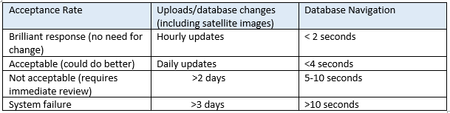
The software will be available for all types of hardware. Tableau software gives options for tablets, mobile telephones and laptops. It will be an application that can be downloaded an any SMART device. It will take a small amount of memory (less than 10GB disk space, 30MB memory).

Functionality
The database will provide accurate information giving the user direction to required resources. To ensure accuracy the database will work in real time with satellite updates at regular intervals. If a connection is not available, the software will provide the latest release in the form of a packaged workbook until such time that the system can be updated.
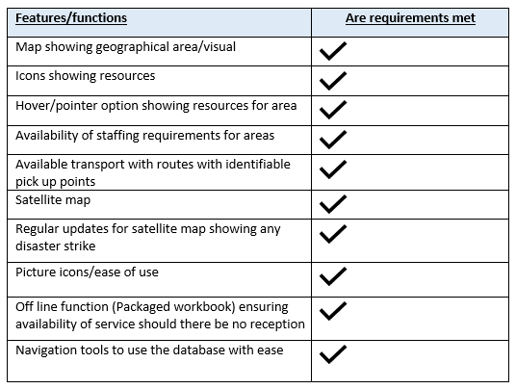

User satisfaction will be assessed through a series of simulation exercises with target users.
Portability
This database will be fully portable as it can be used on all types of hardware. This will be assessed during the simulation exercise with a wide variety of devices being implemented.
Upgrades will take place on a regular basis with satellite images and database changes as set out in the efficiency standards.
Maintainability
To ensure maintainability the database will have daily updates during the testing period.
1 failed update per day Acceptable Re-testing
More than 1 failed update per day Not acceptable System failure
Once implemented it will provide a packaged workbook (this is where the system will not receive updates and cannot be changed) whist the updates take place so that at no time will the system be unavailable even if off line.

7. References

[1] | S. Maw, Sustainability IT Project Managment Presentation, Swansea: Sue Maw, 2018.
[2] | S. A. K. I. C. a. B. P. Patricia Lago, “Framing Sustainability as a Property of Software Quality,” Cpommunications of the ACM, vol. 58, no. 10, pp. 70-78, 2015.
[3] | ICSSP, “A methodology to Derive Sustainability Inducators for Software Development Projects,” ACM, San francisco, CA, USA, 18-19.
[4] | B. T. C. I. f. IT, “BSC Code of Conduct,” [Online]. Available: https://www.bcs.org/category/6030. [Accessed 27 November 2018].
[5] | IEEE, “IEEE Code of Conduct,” June 2014. [Online]. Available: https://www.ieee.org/content/dam/ieee-org/ieee/web/org/about/ieee_code_of_conduct.pdf. [Accessed 28 November 2018].
[6] | B. T. c. i. f. IT, “Navigating Brexit and GDPR,” BCS, 6th October 2016. [Online]. Available: https://www.bcs.org/content/conBlogPost/2612?utm_source=British%20Computer%20Society&utm_medium=email&utm_campaign=7611269_Brexit%20Bulletin. [Accessed 28 November 2018].
[7] | B. D. B. Report, “BCS Policy Hub,” 21 February 2017. [Online]. Available: https://policy.bcs.org/position_statements/bcs-digital-brexit-report. [Accessed 30 November 2018].
[8] | I. 25000, “Software Product Quality,” ISO, 2018. [Online]. Available: https://iso25000.com/index.php/en/iso-25000-standards/iso-25010. [Accessed 11 December 2018].

8. Appendix
Appendix 1.
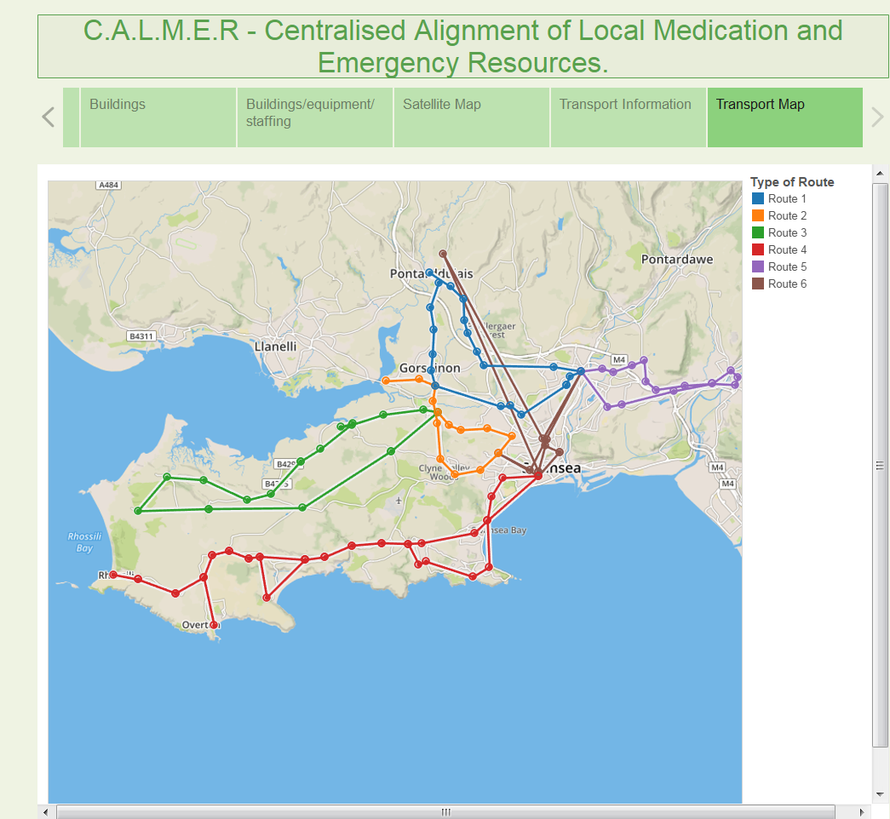

Incorrect coordinates entered into the database – showing an incorrect data point.

Appendix 2.

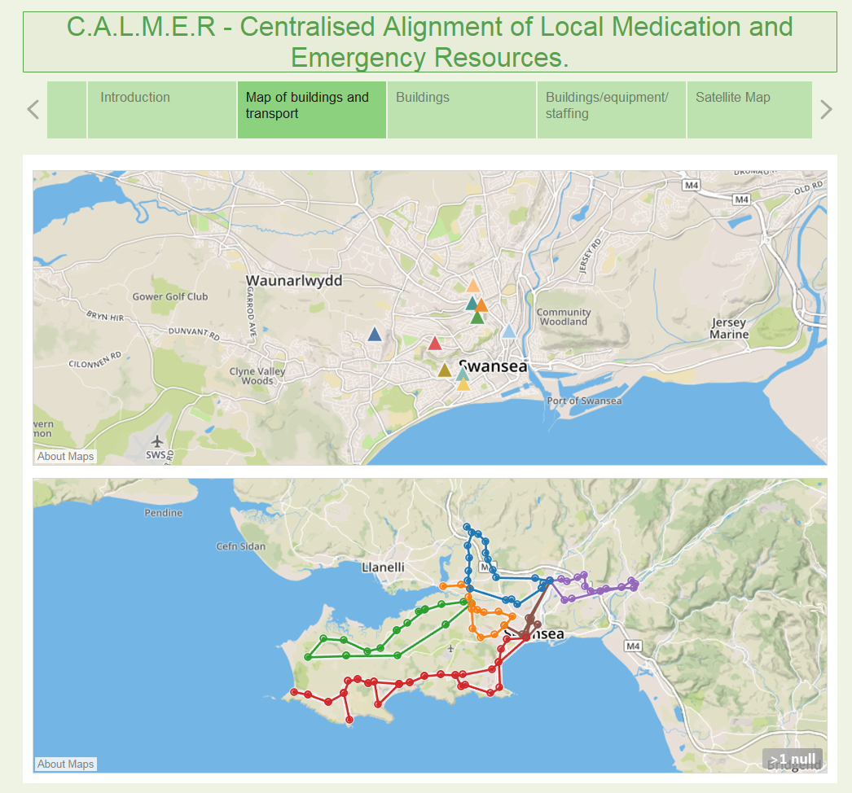

Incorrect coordinates updated – data point no longer showing in the incorrect position.
Appendix 3.

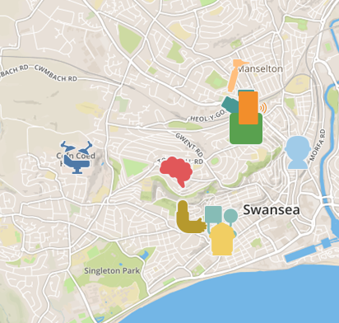
Understanding the database – if users are illiterate the use of picture

Appendix 4
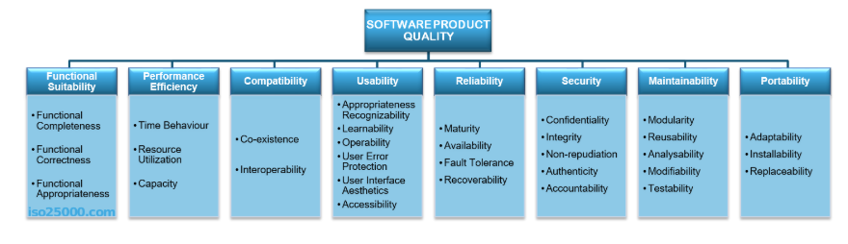
ISO 25010

9. Screenshots of Tableau database

Screen prints of Tableau database
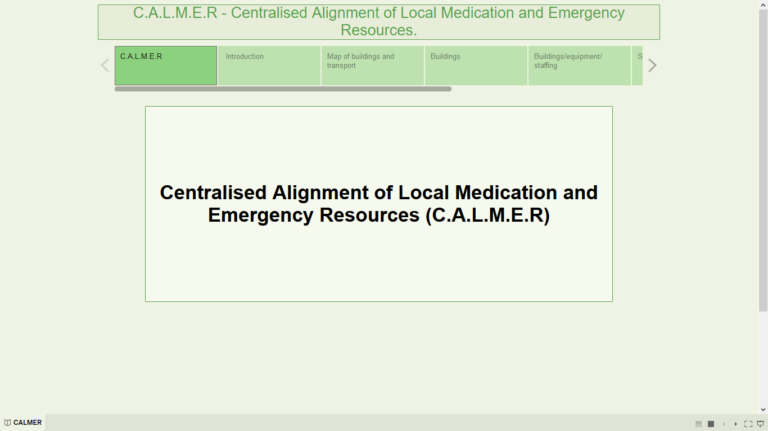
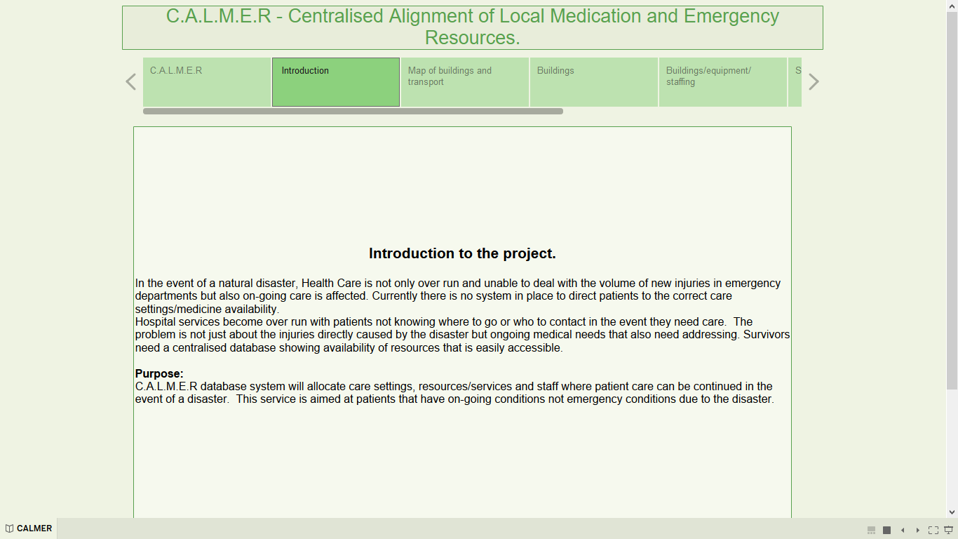
The above screen print is only for use in the demonstration.


