Task 1

Student name: Haleema Sadia Qureshi Student ID: 2112158
Module Code: BMSW 4001
Assignment Title: Task 2 – Reflective report on Employability skills in the learning module
Lecturer name: Abdi Rahman

Table of content
Introduction: 3
Description: 3
Presentation skills: 4
Description: 4
Teamwork skills: 5
Description: 5
Meaning: 6
Finding information and research: 6
Description: 6
Primary source: 6
Secondary source: 6
Craap Test: 7
Conclusion: 8
Recommendations: 8
Reference list 9
Appendices: 10

Introduction:

Description:
This reflective report portrays the skills I applied during the start of my module (Academic and Employability skills) and how I improved my learning in an adroit manner. To elaborate, I will confer about how I used the CRAAP test to expand my learning and what steps I took to develop my chosen skill(s).
“A skill is a type of work or activity which requires special training and knowledge”.
“Most of us will know someone who is always learning new skills or studying new fields”.
(Collins English Dictionary, 2021)
Having people skills is a great ability to have, since it can help you understand others better on an emotional and social level. Majority of people should have the ‘soft skills’ also known as interpersonal skills, that help us identify one’s strengths and weaknesses. The following are some personal skills which I think are relevant to have such as: curiosity, determination, perseverance, drive, leadership. The list could go on, but these are some of many of the qualities one should acquire.
“Research conducted by Harvard University, the Carnegie Foundation and Stanford Research Centre has all concluded that 85% of job success comes from having well‐developed soft and people skills, and only 15% of job success comes from technical skills and knowledge (hard skills). These statistics were extrapolated from A Study of Engineering Education, authored by Charles Riborg Mann, and published in 1918 by the Carnegie Foundation.” (Association, 2021)
Developing many types of skills is great because it helps us consolidate us understand how to do different things. It can also increase employment opportunities, improve verbal language, and increase personal growth because, modern day solutions are often resolved by using skill and technique. Skills can be discovered through a favourite hobby, because it is the ability to do well in a particular field of interest. I believe practice makes perfect!


Presentation skills:

Description:
Presentation skills are vital when delivering a message or informative data in order to engage with an audience. For instance, the ability to deliver presentation skills, require confidence, vocality, and decent body language. In class we watched a TED talk video on ‘How to avoid Death by PowerPoint.’ The clip discussed the poor use of PowerPoint, and how to prevent inadequate deliverance due to poor use of presentation software. I learnt many techniques such as: using visual aids (pictures, graphs), how to devise interesting slides and how to keep the audience connected instead of them zoning out.
I comprehended that too much information/text per slide can be distracting for the reader, therefore, you should stick to one message per slide. This way you can involve your audience more in answering and asking questions, to avoid it becoming monotonous and overwhelming.
“In a recent survey conducted by Dave Paradi, a well-known PowerPoint designer, it was found that one of the top five PowerPoint annoyances was “Slides are hard to see because of colour choice.” Here’s an example of a slide that could be illegible under certain lighting
conditions or on some monitors. There is very little contrast between the black text and the grey background, which makes the slide hard to read.” (Bajaj, 2011)
In brief, selecting the appropriate colour scheme and text size is important for the audience. These things can contribute to the fact that, psychologically the choice of colour and appropriate level of contrast is vital for content visibility. Therefore, I avoided any colours that clashed together (both background and text) to support those with visual problems and make it easier for everyone to recognize.
According to this source, “When used correctly, colour can help audience members sort out the various elements of a slide. But its power goes beyond mere clarification. To some extent the colours you choose for your visuals guide the emotional response of your audience.” (Lerner, 2013)
Considering that it was my first time presenting with people I had just met, my experience was rather pleasant, as I like meeting new people and taking part in new experiences. Towards the end of our presentation, we received constructive criticism from other peers, on our groups ‘highlights and lowlights.’ I took note of the areas I could improve on like: being more assertive (eye contact) when speaking and including hand movements to connect and engage with my audience.

Teamwork skills:

Description:
Me and my team were assigned a task to complete; it was to produce a slideshow to highlight the key factors that make good presentations. Additionally, we had to speak individually on our interpersonal skills, and I felt like It was difficult for me to speak as I was quite nervous.
I overcame this feeling by taking deep breaths before talking to stop myself from mumbling on. I had written all my words on a piece of paper to memorise, so I was prepared to speak promptly.
During the time I was presenting, I felt tense, and my anxiety fluctuated, but my group encouraged one another whenever we felt anxious during the whole process
Also, if one of us got stuck on our words we would gesture on what to say next to prevent any awkward silence ; therefore, I felt reassured.
Collectively, there was a variety of decision making involved during the whole process; due to the last-minute absence of one the members in my group. One of my strong abilities is that I am very decisive and can adapt to new situations quite well. For every problem there should be a solution, is the mindset that keeps me going throughout my life. Prior to this, a similar incident to this occurred when one of my peers had a family grievance and was in no state of presenting in front of others – as an empathising team member I provided support in talking on his behalf and to guide him throughout the whole process. By clarifying the new main goals and responsibilities, I demonstrated great leadership skills by being action-oriented, and displaying effective time management skills, critical thinking, and collaboration.
“However, when asked which achievement has made her the happiest, Vidailhet's immediate answer is about building her team and fostering collaboration while also enabling individuals to achieve personal goals. She understands and emphasises the importance of teamwork, taking care of the members and ensuring that all of them can work together, but she thinks it is equally important that they can stand by themselves and function independently.” (Vidailhet 2021, quoted in Venkatesan 2021 pp. 889–889.)

At first, I struggled to maintain eye contact with my target audience, but minutes into it I was fine with the help my supportive group. Each one of us explained everything thoroughly, beforehand and constructed a plan just in case things didn’t go as expected. One of the main things I recollected was to go with the flow and to act naturally because all for one and one for all-

Meaning:
“A phrase that emphasizes solidarity and support within a group; the group will support its members and its members will support the group” (All for one, and one for all, 2015)

Finding information and research:

Description:
Research is a: “Systematic investigation to establish facts or principles or to collect information on a subject” (Collins English Dictionary, 2021)

We research to find information, collect data and to check the reliability of a source. It also helps us find answers to our questions as we can improve and dive into specifics. Research can be carried by using primary and secondary resources, internet, visual media, books/journals, and articles from libraries. With extensive research, data can also be collected from interviews, questionnaires, and observations. This can then later be put into graphs, and be turned into datasets in spreadsheet formats like Excel

Primary source:

Primary sources come from those who created it originally or had a correlation with the source. These can be diaries, speeches, letters, and historic things.

Secondary source:
Secondary sources come from the work of people who have not experienced their finding first-hand and have updated a primary source. They collect their data either by writing about in journals or online blogs.

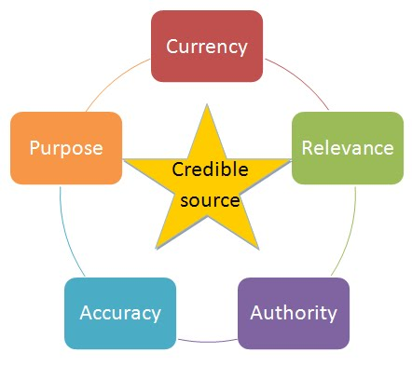
Source:(LibGuides: HIST 284: History of Hawaii (Ickes): Home, 2021)

Craap Test:
When finding information, it is crucial to find the authenticity of it. This is where the CRAAP test comes in handy, CRAAP is the acronym for the five criteria used to evaluate the credibility of sources. (LibGuides: HIST 284: History of Hawaii (Ickes): Home, 2021)
To check the validity with any type of source its important to evaluate the origin, who wrote it and many other aspects.
Currency: Currency just means how current was the information sourced and found, like the date it was published and how recently it was last reviewed and updated.
Relevance: Relevance is how much it matters to what you are trying to find, and whether it relates to your findings.
Authority: Authority is the source of the information, and who the author is.
Accuracy: Is just how accurate your source is, and if there is evidence to back verify any type of research.
Purpose: And purpose is just the reason it exists. What is the purpose of this information?
By using the CRAAP test I was successfully able to support my findings with thorough checks of authenticity for my previous assignment.
When completing my assignments, the UWTSD library was a very useful place to start as it had legit sources to access and use in my work. We were taught how to “Harvard reference” our work and how to give credit to the authors; along with using text in-citation. I found quite daunting at first but ‘practice makes perfect’ is my motto. We were advised not to use unreliable sources such as Wikipedia, or blogs without a secure website, due to the fact Wikipedia being a user-generated source, which meant that it could be edited by anybody at any proposed time.

Conclusion:
To conclude, the following skills I have discussed are essential in the learning and working environment. Presentation skills are great for introducing new topics and building confidence because with overtime practice, your English can improve and, your communication skills will gradually become more refine. Besides, teamwork skills are critical in modern day society because “When teamwork is effective, communication, collaboration and combined efforts makes for a better outcome. Everyone brings their skills, talents, and experiences together for a common goal. The different styles of each person make for more creativity and innovation. (Barrett, 2017)

Recommendations:
Overall, I found the first module was a good experience to polish up my teamwork skills because I usually enjoy working independently, and it brought me out of my comfort zone. Personally, I believe “comfort is a cage” because you never really know what something is like until you try, instead of resorting to the same old cycle, which is ‘being too comfortable doing the usual stuff!’ The opportunities I discovered were endless and limitless as I had a turn to demonstrate my leadership skills and how to exercise good judgment regarding any dilemmas I may ever come across. It also taught me to pre-plan and try to stay organised with any upcoming deadlines or presenting. Due to this, I have kept a diary/personal planner to plan things accordingly and just in case I forget, and to avoid poor punctuality.
Nevertheless, skills are vital to learn as they help us develop maturely. With the brain being so powerful, the list of skills to learn is endless. This can vary from thinking skills, problem solving skills, a favourite hobby, or a routine which was mastered over time. This specific module also taught me determination, hope, accountability, co-operation and most importantly creativity, because I describe myself quite in tune with my artistic side and use a creative approach to problem solve. I have also discovered how to check the validity of a source, by being more aware, checking for established institutions, reading the URL link and how long ago it was uploaded. This type of skill leads back to ‘Research skill’ which involved the CRAAP test.

Reference list
Association, N., 2021. The Soft Skills Disconnect - National Soft Skills Association. [online] National Soft Skills Association. Available at: < https://www.nationalsoftskills.org/the-soft-skills-disconnect/ > [Accessed 2 December 2021].
Bajaj, G., 2011. How to Avoid the Four Biggest PowerPoint Color Mistakes. [online] PowerPoint and Presenting Stuff. Available at: < https://blog.indezine.com/ 2011/10/how-to-avoid-four-biggest-powerpoint.html[Accessed 11 December 2021].
Barrett, D., 2017. Teamwork is a valuable work and life skill. [online] MSU Extension. Available at: < https://www.canr.msu.edu/news/teamwork_is_a_valuable_work_and_life_skill > [Accessed 13 December 2021]
Bedford, & Wilson, E. (2013). Study skills for foundation degrees (Second edition.). Routledge. https://doi.org/10.4324/9780203119686
Collinsdictionary.com. 2021. Research definition and meaning | Collins English Dictionary. [online] Available at: < https://www.collinsdictionary.com/dictionary/english/research > [Accessed 12 December 2021].
Collinsdictionary.com. 2021. Skill definition and meaning | Collins English Dictionary. [online] Available at: < https://www.collinsdictionary.com/dictionary/english/skill > [Accessed 2 December 2021].
https://doi.org/10.1016/S1474-4422(21)00209-X.

Lerner, K., 2013. The Psychology of Color in PowerPoint Presentations. [online] The Presentation Team. Available at: < https://presentationteam.com/psychology-of-color-in-powerpoint-presentations/ > [Accessed 11 December 2021].
TheFreeDictionary.com. 2015. all for one, and one for all. [online] Available at: < https://idioms.thefreedictionary.com/ all+for+one%2c+and+o ne+for+all > [Accessed 12 December 2021].
Venkatesan, P. (2021) ‘Marie Vidailhet: recognising the importance of teamwork’, Lancet neurology, 20(11), pp. 889–889. (https://www.sciencedirect.com/science/article/pii/S147444222100209X)

Appendices:
Appendix 1

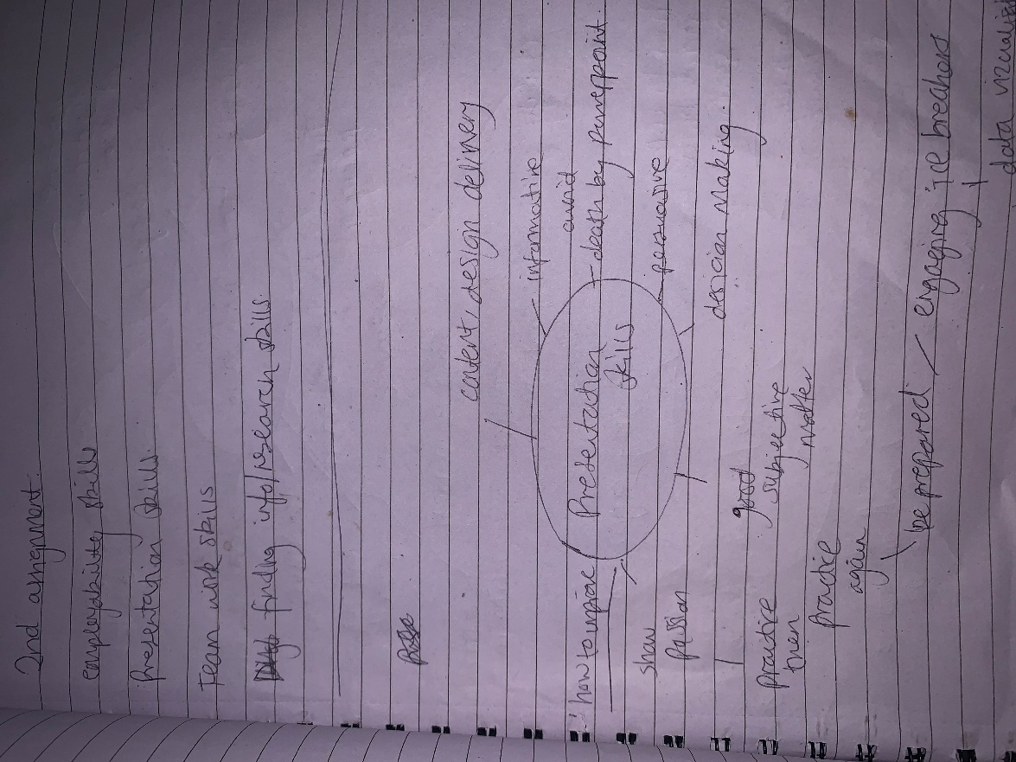
- Images showing my planning for my reflective report

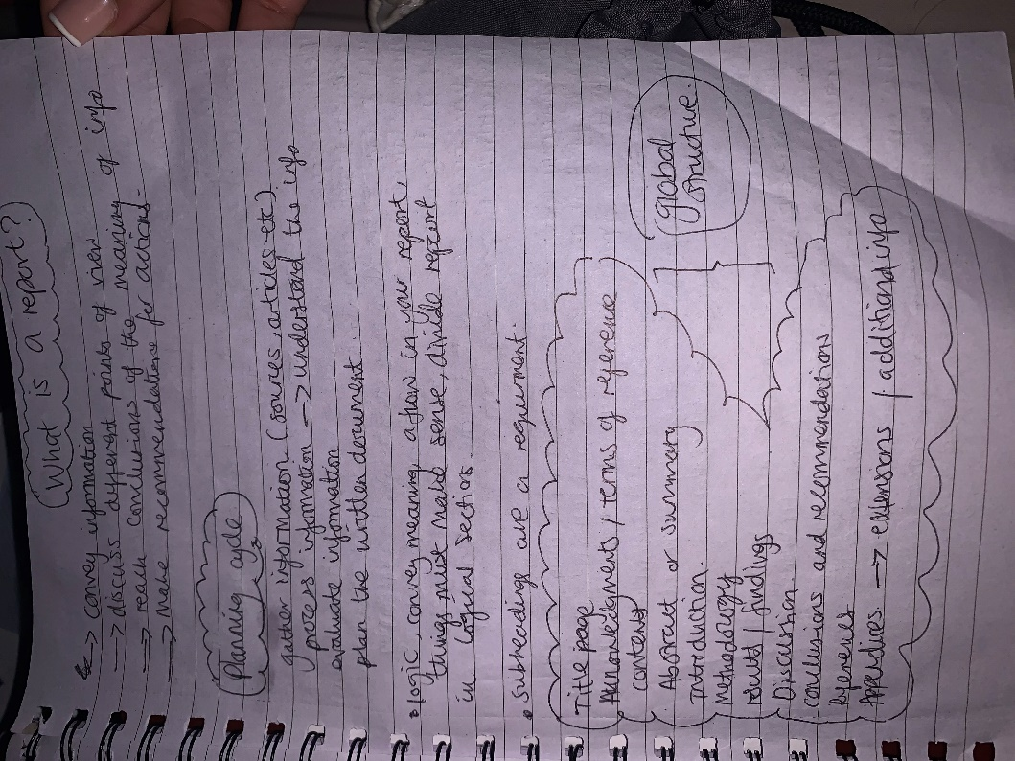
Appendix 2
- Planning cycle regarding the layout and structure of report, in chronological order
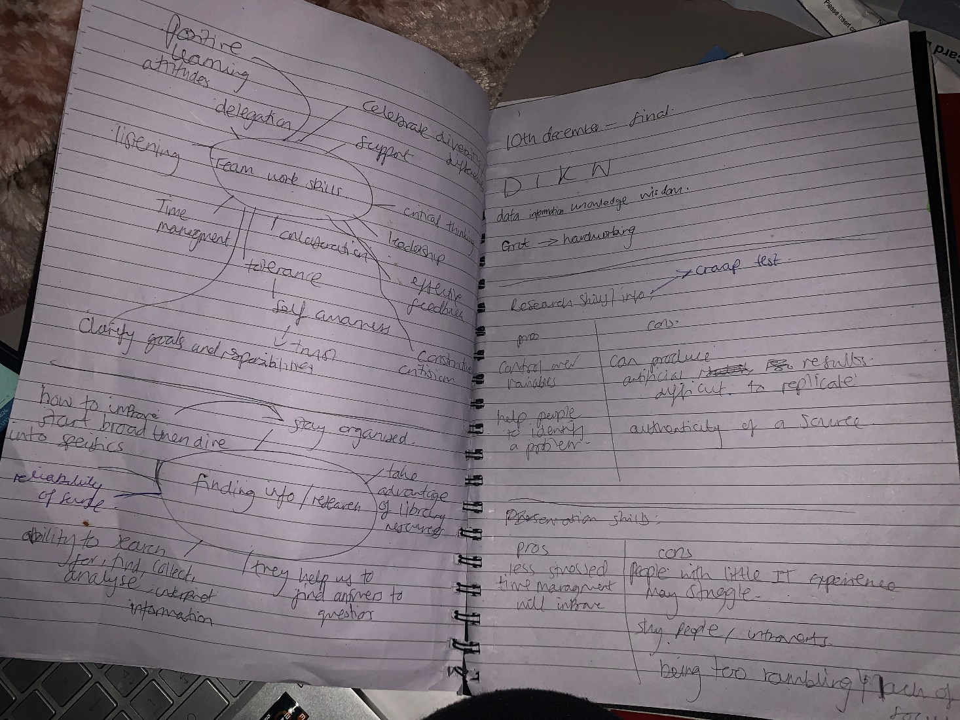
Appendix 3
Additional bubble diagrams for my pla

