
Applied Leadership and Management in the Workplace
Module Assignment Submission
Student Name: | Maxine Guymer
Student Number: | 2241348
Module No: | BMSK4013
Module Title: | Management Communication

Statement of Confirmation of Authenticity
By the act of making this submission, the student declares that this is the work of the student named above. The work has not, in whole or in part, been knowingly presented elsewhere for assessment, or where assessment has been built on a previous assessment, this has been identified. Where materials have been used from other sources it has been properly acknowledged. If this statement is untrue, the student acknowledges that an assessment offence has been committed.
Attention is drawn to the plagiarism and unfair practice policies of both the University and of ILM.

Table of Contents
Contents
Section 1: Communication 3
1.1 Explain the relevance of the communication cycle for effective communication in management 3
1.2 Explain, with examples, the importance of selecting an appropriate tone, language, and level of formality in management communications 4
1.3 Assess the effectiveness of a range of verbal and written communication methods within your area of the organisation 4
Section 2: Motivation 5
2.1 Evaluate theories of motivation relevant to your workplace 6
2.2 Evaluate the principal factors that may affect performance and motivation in the workplace 6
2.3 Select a theory of motivation - apply it to your workplace – evaluate the impact 6
Pick one theory of motivation and apply it to the workplace making sure you evaluate the impact 7
2.4 Develop appropriate criteria to evaluate own ability to communicate effectively 7
Prepare development plans for yourself and another person 7
2.5 Collect and analyse feedback on own verbal and written communication skills 7
2.6 Evaluate own communication skills as a manager, identifying strengths and areas for improvement……then Produce a PDP to address these 7
SWOT analysis based on your own questionnaire and the results of your feedback from others – 7
References 8
1. Communication

Definition of communication
Communication is the intricate process of exchanging information, ideas, emotions, and intentions among individuals or groups through various channels. It involves verbal, non-verbal, and written forms of expression, including speech, gestures, facial expressions, body language, and text. Effective communication relies on clarity, comprehension, and mutual understanding, nurturing meaningful connections and enabling collaboration. It underpins human interaction, facilitating knowledge exchange, relationship building, and conflict resolution. In essence, communication connects diverse perspectives, cultures, and experiences, shaping our collective worldview and propelling societal advancement through shared dialogue and cooperation.

1.1 What is the purpose of communication.
Communication is how we exchange information from person to person by writing, speaking, sign language, body language and facial expressions.
Some purposes of communication include:
- Sharing Information: Communication facilitates the transmission of knowledge, facts, and data, allowing individuals to stay informed and make informed decisions.
- Building Relationships: Effective communication fosters connections, trust, and understanding between people, nurturing personal and professional relationships.
- Expressing Emotions: Communication enables individuals to express their feelings, emotions, and experiences, promoting empathy, support, and social bonding.
- Achieving Goals: Communication plays a vital role in coordinating actions, setting objectives, and achieving desired outcomes within teams, organizations, and societies.
- Resolving Conflicts: By promoting dialogue, negotiation, and compromise, communication helps address misunderstandings, disagreements, and conflicts, fostering resolution and reconciliation.
- Exchanging Ideas: Communication encourages the exchange of thoughts, perspectives, and creativity, stimulating innovation, problem-solving, and intellectual growth.

1.2
Definition of language and formalities
Formal language this is used in a official professional situation followed by good grammar and polite expression, this can be used in business letters, academic papers or speeches.
Informal languages are used mostly to communicate between family, friends or peers, for examples includes text massages casual conversations, and personal emails.

Definition on tone
Tone of voice is the way a person speaks to a person, it refers to the choice of words, volume, pitch, and speed of the message, this can affect how the listener perceives and responds. This means actively adjusting your tone to match the situation, sad angry happy etc and body and face expressions will be the same.
Definition of body language?
Body language is a used as a nonverbal signal to indicate your feelings and intentions by using your posture facial expressions and hand gestures, by looking at other people’s body language this will help you understand how the other person may be feeling.
I am briefly going to describe a few of the progress of communication used in my workplace.
Meeting: meeting is a gathering of two or more people, conversations between employees, managers, and healthcare practitioners, this a good opportunity to share information, solve problems and keep the team working together, notes will be recorded by a notetaker.
Appraisal: this is a more formal process with your manager usually annually or every 60 months, a manager will ask re-evaluation of set objectives, ask about their job description, recognising their strengths and weaknesses, and identifying areas to improve.

Interview: This is a formal conversation between two or more people, the interviewer is asking questions to obtain information, qualifications, skills and asses if the right candidate is suitable for the job.

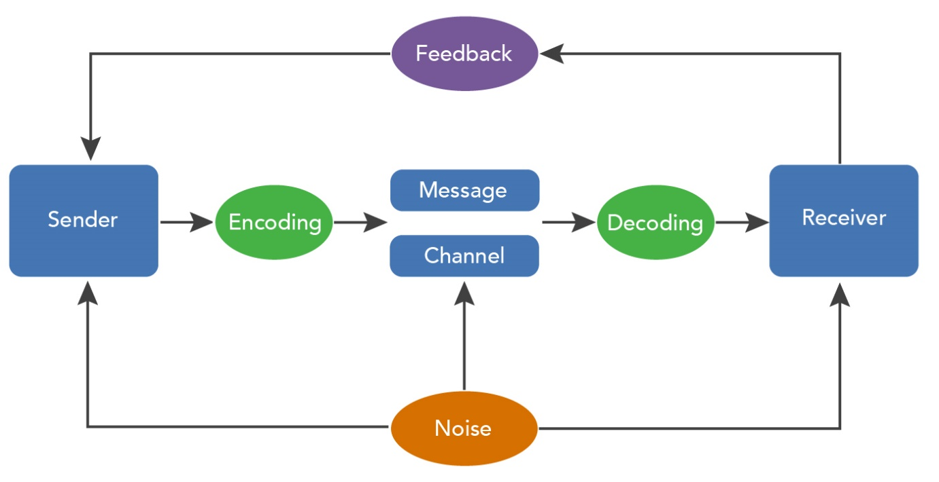

Communication is the sending and receiving of information and involves a sender who initiates communication and encodes, meaning transfers thoughts, into a message that sent to the receiver, or the person who is meant to receive the communication, who must then decode, meaning interpret, the message.


This model explains how information is transmitted by using noise, channel, message , receiver, channel, information destination, encode and decode.
Sender: the originator of the message or the information source selects desire massage.
Encoder: the transmitter which converts the messages into signals
Decoder: the reception place of the signal which converts signals into messages.
Receiver: the destination of the message from sender.
1.3
The barriers of communication at my workplace are that the people we support are all nonverbal so we must understand the change in behaviour of the person, that could be a good indicator if they are happy or sad.
Manages use email to contact all employees, not all employees look at email on a day-to-day basis, so they have set up a WhatsApp Messager for all employees to inform everyone what is going on.
The tone of a person voice refers to how the person is trying to communicate from person to person it’s how someone may sound when words are said out loud, it refers to the choice of words, volume, pitch, and speed of message.
Language is the way humans communicate with each other, this consists of a set of sounds, speech, writing symbols, signs language, gestures this is flowed by body language.
WRITTEN COMMUNICATION
Email: is used to communicate by message from a electronic devices to send a message across other devices networks, these devices receive and send messages.
Writing an email is the most used method of communication in today’s workplace. To send an email, all you need is a valid email address, a computer or mobile device, an active internet connection, and the destination email address.

Letters: is used as a message, often formal or informal in nature, expressing thoughts, feelings, information, or instructions. Letters can serve various purposes, including conveying personal correspondence, business communication, official notices, or requests. They often adhere to specific formats and conventions depending on the context and intended recipient.

Policies: all workplaces have policies and procedures that must be followed, allows employees to understand the rules at the workplace, if there was no communication policy at work, and employees don’t follow this policy, the company could miss out on opportunities because of breakdowns in communications.
Verbal communication use is the process of sharing information though spoken words it includes sending and receiving the messages, making it an interactive exchange between individual or groups.
Word or language: the word and grammar used to create meaningful sentences.
Tone and Pitch: variation in voice that can change the meaning or emotion in the words used.
Listening skills: the ability to effectively hear and interpret the message.
Feedback: feedback from the listener and have clarification that the message was understood.

Team meeting: Team meeting is where a group of employees get together and a meeting is scheduled, a group discussion takes place, a list is done of all topics that will be discussed in the meeting. A leader will take the meeting, it is a good opportunity for people to communicate openly, get their point across, share ideas and using this as a team bonding activity.
Job interview: This known as a formal meeting, this is done between a job applicant and employer, several verbal communication questions will be asked to indicate if the person is suitable candidate for the position.
Meetings: A meeting is a gathering of two or more people; this can be in a formal or informal setting to discuss and address a specific topic or issue, purpose meetings are for sharing information, making decisions solving problems brainstorming ideas, participants meetings involve a group of people who are more involved in the topic being discussed, this can be team members, managers or clients, when a meeting is being held this will always include a organizer who plans and leads

Example of verbal communication at my workplace.
Team meeting: This is a team meeting with a large group of employees and manager present, one person taking minutes, we all have a open discussion on each service user that is at the project, in this discussion we will all have our own say, so we could get our point and share ideas or raise any concerns.
Job interview: at my interview, I had a formal interview with two people asking me five questions each, with documenting whet I had said, then it goes by how many points you have achieved by your answers.
Meetings: I have had a formal meeting with myself and my manger this was for a one to one, she would ask me a number of questions like my future goals, feedback from work, any problems with service users or other employees, my wellbeing.

2: Motivation
Motivation is the drive, desire, or willingness that propels individuals towards achieving their goals within the workplace, motivation holds significant importance in terms of performance and this can be affected due to several factors:
a. Enhanced productivity: motivated employees tend to be more productive, when people are motivated, more effort and energy is put into their work. Leading to higher results.
b. Elevated job satisfaction: motivation workers often experience greater satisfaction with their roles and a deeper connection, so this reduces employment turnover.
c. Increased engagement: employment engagement is a sense of belong and commitment to an organisation, when employees are more engaged in the work, they demonstrate dedication and enthusiasm to the organisation.
d. Goal achievement: employees have the desire to develop future goals which provides long-term direction and short-term motivation.
e. Innovation and creativity: motivated employees are more likely to become more creative and create new ideas and not afraid to take risks.
f. Positive work environment: in a workplace environment there needs to be trust, cooperation, safety, risk-taking support, accountability, and equity. A great work environment it is important to keep communication open and honest, manages need take the time and ask for feedback off employees.
g. recognising and rewarding
This is a good way to motivate employee’s confidence skills and positivity in the workplace, companies can praise their employees, when goals are met by rewarding and providing positive feedback for the work and behaviour this may lead in a repeat, in good work motivation.
Companies reward employees and show recognition by rewarding with work bonus, a day off with full wages, gift voucher buffet coupons etc.
2.1 Opportunities and growth
This gives people the accountability to learn new skills, good opportunities for growth and professional development within the organization, employees perform best when their environment is conductive to growth, this will boost work morale. Provide opportunities for learning and development, new skills and knowledge this can include training programs, workshops, or career opportunities this will keep employees engaged and motivated.
2.2 financial benefits
Financial benefit can be a strong motivator for many people. The idea of earning money or receiving financial rewards can provide individuals with the incentive to work hard achieve their goals and improve their financial situation. It is important to consider how financial benefits can impart motivation and drive individuals to succeed in various aspects of their lives.

2.3: Work life balance
A work life balance between work and personal life is essential for employees being motivate, organizations that support flexible working hours and benefits like parental leave this contributes to a positive in awork environment.
2.4: Work environment
When employee has poor environment, this can seriously affect how employee would be motivated at work such as poor lighting, temperature, noise, layout, design, view, and privacy this could have a great impact on how the employees would not feel motivated enough and restore their motivation.
2.5: Relationship with colleagues
Encouraging teamwork and collaboration among employees, when they feel connected to their peers this makes them work together towards common goals and boosts morale and motivation. if good and honest effective is used to communicate to employees and you create a sense of trust and belonging, and they feel heard and informed, they are more likely to be motivated and contribute to the organization. If there is a communication breakdown then this can lead to conflict and this has to be dealt with otherwise performance will be affected. Conflict can be managed by:
- Taking action immediately. It’s important to resolve a disagreement as soon as possible before it causes severe tension or spreads to other employees. Simple discussions can help with miscommunications.
- Remain positive. You can call the conflict resolution meeting a “brainstorming” or “chat session” to make employees approach it positively.
- Avoid focusing on the individual. This involves encouraging employees to concentrate on problem-solving, rather than making personal accusations. (Indeed.com, 2024)
2.7: Leadership
Leadership leads to inspires great motivation within teams, this encourages employees to work towards company goals, and targets met, this makes the employee perform further and develop their skills.

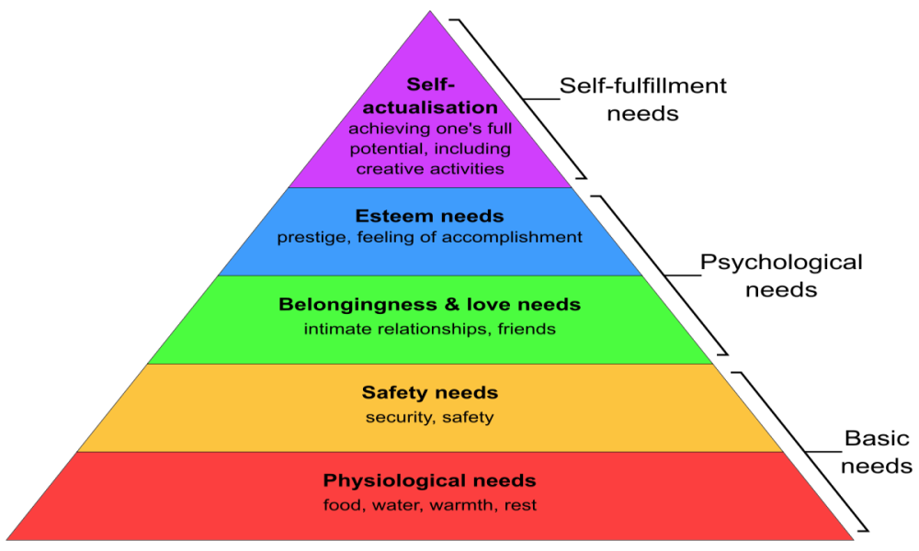

Maslow motivation theory is a way to describe the various levels of human needs to progress and develop, starting with basic needs that a person needs to survive then working their way through the diagram.
The second step is security and safety needs people need financial security, health and wellness safety against accident and injury.
The third step is love and belonging where we need friendship, romantic attraction, family relationships, social groups, and community groups.
The fourth step this level it is important to gain respect and appreciation from others, this will grow a person’s self-esteem.
Herzberg has two factor theory this states the factors that affect an individual’s satisfaction and motivation at the work place this is influenced by two sets of factors and motivators, hygiene factors, working conditions and salary, by addressing this it will increase your team satisfaction, engagement and loyalty.
McCelland
David McClelland was best known for his work in the motivation theory, he was best known for developing the achievement and the three needs theory they are.
Need of achievement.
Individuals with a high need of achievement set challenges and goals, they are driven by desire to accomplish something and very focused and determined to succeed, individuals like tasks that are neither too easy or to difficult and this requires good effort and motivation. Based on their efforts people like to receive feedback on their work.
Need of Power.
People who have a need for power prefer to work in a place where they influence the behaviour and decisions of others these people like a position where they can take control and be a good motivator for other people.
These individuals give it their all to achieve and motivated by power and they have a reputation for working their way up the organization as soon as a better position presents itself this is done with great achievement and effort.
Need for Affiliation
People with the need for affiliation are motivated by their connections with others. Affiliation motivates interpersonal relationships and emotional connections. Often people with the need for affiliation prefer working in groups rather than working independently in order to build those relationships. (Indeed.com, 2024)

McClelland's research showed that 86% of the population are dominant in one, two, or all three of these three types of motivation. His subsequent research, published in the 1977 Harvard Business Review article "Power is the Great Motivator", found that those in top management positions had a high need for power and a low need for affiliation. His research also found that people with a high need for achievement will do best when given projects where they can succeed through their own efforts. Although individuals with a strong need for achievement can be successful lower-level managers, they are usually weeded out before reaching top management positions. He also found that people with a high need for affiliation may not be good top managers but are generally happier, and can be highly successful in non-leadership roles such as the foreign service

Whilst all three models can be applied to my workplace the model, I will concentrate on is Herzberg. In the care industry I believe that attempts are made to satisfy employees through the hygiene factors which are necessary for an individual to feel comfortable and content in the workplace. These factors include company policies, and job security. When these hygiene factors are lacking or unsatisfactory, they can lead to job dissatisfaction and the poor salary, and lack of interpersonal relations are some reasons why the turnover in the care industry is so high. However, an increase in salary may not do much to retain staff because working conditions can be challenging.
When motivators are present, they have the power to increase job satisfaction and overall motivation levels however carers often experience little praise, reward, or recognition for the role that they do. Motivation factors allow employees to be content in their jobs and promote growth, but carers do not often get offers of promotion or development opportunities that would make them more engaged with their work/workplace and possibly lead to more loyalty and commitment.
If the care sector adopted some of the theory of motivation, then they would at least concentrate on addressing the satisfiers and ensuring that carers are paid a decent wage and working unsociable hours get the same wage grade as working days, if the working conditions are improved so that staff are not working long hours and over worked.

2.6 PDP For myself
What do I want to learn? | What do I have to do? | What support and resources will I need? | How do I measure success? | Target date for review?
More knowledge on how to use Microsoft word | Gather for research.  Make posted notes.  Give myself more study time. | Updated laptop | Feedback from mentors | 3 months
Be more confident in myself | Believe in myself  Make myself more motivated to achieve my future goals | from other students, family and friends, touter, work colleges and mangers | Feedback is important, ask how you think you are doing? | 1 year
I do have poor listening and spelling skills | Give myself more time to complete work | Ask for support | Work hard on my weaknesses | 4 months

PDP for someone training to be a nurse.
What do I want to learn? | What do I have to do? | What support and resources will I need? | How to I measure success? | Target date review?
Becoming a registered nurse in the acute team. | Be a good communicator.  Be flexible. | Obtain certifications to expand my knowledge. | Go and do a master’s degree. | Two years
Decide what nursing skills I need to look at to further my career. | Organized with my time.  Passionate about my work. | Apply for nursing programs. | More ambitious | Two years

Personal objectives

Short Term Goals {next 12 months}
Finish my level 4 in business management and get my qualification and look forward in doing level 5
Medium Team Goals {2-3 years}
Open my own business and be coming my own boss
Long Term Goals
Expand my business in different county’s around the UK.

2.5 This is data collected and feedback given about my communication skills.
 | criteria | average | evidence
1 | Empathy approachable | 4 | very good at recognising feelings of the people around her and acting accordingly | Has a friendly disposition makes her very approachable.
2 | listening | 4 | Listens well to instructions and pay attention when important discussions are made.
3 | Tone of voice | 4 | Very good at expressing herself clearly verbally.
4 | Honesty | 5 | Is a very trustworthy person and will be honest about a situation even if it’s a difficult topic.

SWOT ANALYSIS
Strengths  Being flexible.  Determined.  Creative.  What do people like about you and your business. | Weaknesses  What does my business lack?  Look at other computation?  Improve my skills in marketing my business.  Ask for more feedback.
Opportunities  Becoming a better service for your customers.  Have a look in what advertisement is best for me.  Opportunity to expand the business. | Threats  Other businesses offering lower rates.  Recruitment.  Businesses success over other businesses.

I was asked 25 questions that I had to answer to examine the best that I communicate and how good my communication skills are of the best of my own knowledge , in the pie chat I have recorded my results.

A = Always and almost always F= Frequently or often
B= Sometimes or reasonably R= Rarely or never

References
https://www.communicationtheory.org/shannon-and-weaver-model-of-communication/https://
www.indeed.com/career-advice/career-development/how-to-write-a-letter
https://www.zoho.com/mail/glossary/what-is-email.html
recognizeapp.com/cms//articles/factors-affect-employee-motivation
https://simple.wikipedia.org/wiki/Maslow%27s_hierarchy_of_needs
https://www.verywellmind.com/what-is-maslows-hierarchy-of-needs-4136760
https://en.wikipedia.org/wiki/Need_theory
https://educationlibaray.org
McClelland, D. and Burnham, D., Power is the Great Motivator, Harvard Business Review, 1977, 2001.Definition of communication

McClelland, D. Human Motivation, 1988. Cambridge University Press
Indeed.com, 2024, Conflict Management: Examples for the Workplace, https://uk.indeed.com/hire/c/info/conflict-management-examples?gad_source=1&gclid=Cj0KCQjwpNuyBhCuARIsANJqL9NXfIVQafG53hXq8jY4mDhwWdx39s1iBCwzmZfbBHBt-o3EmnNQm_saAhCzEALw_wcB&aceid=&gclsrc=aw.ds, accessed 29/5/2024

Indeed.com, 2024, How to Use McClelland’s Theory of Needs to Motivate Employees, https://www.indeed.com/hire/c/info/mcclelland-theory-of-needs#:~:text=McClelland's%20theory%20says%20that%20everyone,assignment%20and%20do%20it%20well., accessed 29/5/24

