

‘Training and Development
needs for an HR officer’
Assessment 1 (JUNE 2022)

INDIVIDUAL PRESENTATION

Table of Contents
Slide 1: Cover page 3
Slide 2: Introduction 3
Slide 3: Knowledge, skills, and behaviour (KSB) required by HR Professionals 3
Slide 4: KSB required by HR professionals 4
Slide 5: KSB required by HR professionals 4
Slide 6: KSB required by HR professionals 5
Slide 7: Constructive SWOT Analysis and training needs identified 6
Slide 8: Skills Audit and training needs identified 7
Slide 9: Benefits of training and development as an HR officer and in Tesco 8
Slide 10: Benefits of training and development as an HR officer and in Tesco 9
Slide 11: Conclusion 9
Slide 12: List of References 10

Slide 1: Cover page
Title: Training and Development needs for an HR officer
Student Name: MARIANA GOLEMANOVA
Student Number: 2030688
Lecturer Name: EJIRO ESOHWODE
Module Name: DEVELOPING RELATIONSHIPS AND WORKPLACE ACHIEVEMENTS
Programme: BA (HONS) LEADERSHIP AND MANAGEMENT SKILLS FOR THE WORKPLACE

Slide 2: Introduction
- Human Resources officer (HR officer) plays a crucial role in protecting the workplace, recruiting the right employee and retaining skills (Nyberg et al. 2021)
- Tesco is chosen organisation where I am working as an HR officer (Tesco-careers, 2022a)
- The HR department of Tesco is named "People Team”
- HR inform the employees about organisational goals and instruct them (Tesco-careers, 2022b)
Aim of the presentation:
- Knowledge, Skills, and Behaviour (KSB) identification of an HR officer
- SWOT and Skills Audit analysis
- Identifying the benefits of Training and development

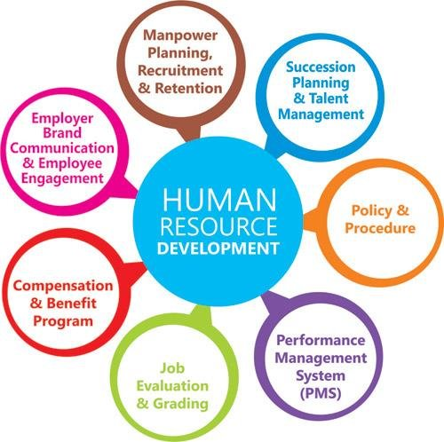

SN: Human Resources are one of the important people in an organisation who retain the foundation of employees. Employees are the pillars of an organisation and the HR plays a crucial role in maintaining the pillars. I have selected Tesco PLC for this presentation to construct roleplay information as an HR officer. Tesco has named its HR department as a people team and the organisation believes the employees are the heart of them. Concerning this, the presentation will describe the KSB required by an HR officer and constructive SWOT and Skills Audit analysis to identify my training needs. Apart from this, the slide will demonstrate the benefits of training and development when I am working as the HR officer in my chosen organisation.

Slide 3: Knowledge, skills, and behaviour (KSB) required by HR Professionals
- Human Resources and Personnel: Implement policies, and determine the effective use of people within the organisation (Ugryumova et al. 2020)
- Introducing cultural diversity: Tesco is a Multinational corporation (MNC)
- Recruiting and retaining staff
- Negotiation capability: with trade union officials, staff and representatives
- Employee record maintenance and payroll administration (Graczyk-Kucharska, 2021)
SN: Knowledge, Skills and behaviour are three key terms used for a person while working in an organisation. This slide defines the overview of the skills, behaviour and knowledge needed by an HR officer. For instance, understanding cultural diversity is vital for Tesco since it is an MNC. The other represented terms are defined on a general basis that is required by almost every organisation. As an HR officer of Tesco, I need to have significant HR skills to negotiate with staff and Trade union officials regarding problems, strategy and opportunities. Other roles of HR where KSB applies are Taking employee records and administration of payroll, recruiting and retaining staff and determining the effective use of people.
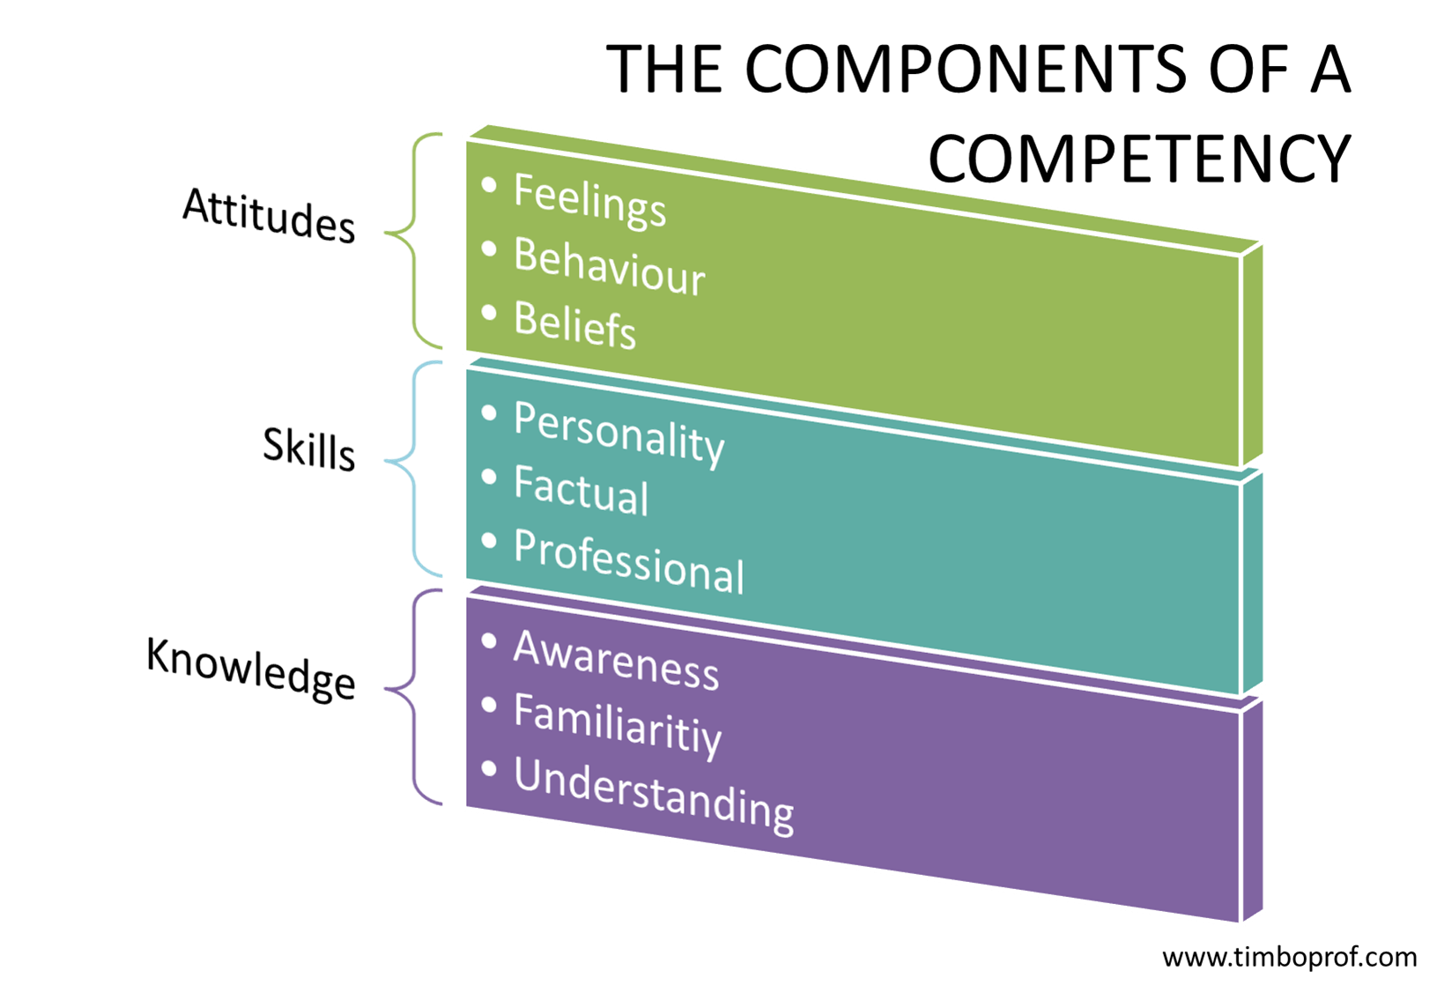

Slide 4: KSB required by HR professionals
Knowledge of HR professionals
- Knowledge of HR theories: Strategic contingency theory, Transaction cost theory (Safari and Saleh, 2020)
- Psychology: Human behaviour, Learning and motivation, Interest
- Communications and media: Dissemination techniques, Media Production
- Clerical: Designing forms, Transcription, terminology
- Anthropology and sociology: Group dynamics and behaviour (Hitka et al. 2019)
- Mathematics: Statistics
SN: The slide mainly represents the Knowledge needed to be an HR officer. Since Tesco is a large MNC, statistical knowledge is highly essential. The HR officer has to deal with evidence-based information to sustain the employee foundation of Tesco. As an Hr officer, I need to identify their annual reports and have to present the challenges in employee management with proper statistics. HR theories are essential to employ all the essential skills in Tesco at the right time. Apart from this, the other knowledge required by HR professionals is mentioned in this slide. I can add here also the most needed skills for any HR position as literacy skills, good time management, and problem-solving skills as well as the ability to work with specialized software.

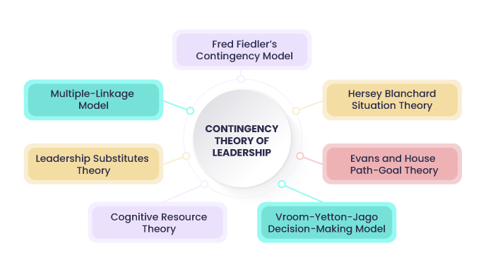

Slide 5: KSB required by HR professionals
Skills of HR professionals in Tesco
- Advertising skills to inform about a Job vacancy
- Interview skills: Telephonic interview and store interview
- Active listening and speaking skills: Training and development
- Negotiation skills (Edeh et al. 2022)
- Presentation skills
SN: The slide shows the skills required by HR professionals while working at Tesco PLC. It has been found that Tesco focuses on an advertisement, telephonic interviews and Store interviews mostly. Hence, active listening, speaking and negotiating skills are the most important skills HR professionals need. Other than this, presentation skills are required in Tesco to present the entire company with the weekly and monthly statistics of employees. Concerning this, Judgement, decision-making and writing skills are necessary. I can add here also that it is very essential to know very well the law and policy as well as health and safety requirements. The HR Manager is needed to have the ability to use the related software during the daily based job.

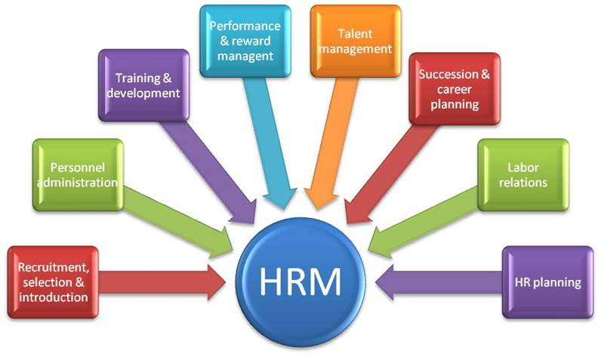

Slide 6: KSB required by HR professionals
The behaviour of HR professionals at Tesco
- Personal and customer service: Ethical behaviour, emotional intelligence
- Leadership behaviour is needed to guide the team
- Maintaining clear construction of sentences during writing and speaking (Anwar et al. 2020)
- Instructing team in simple words
SN: These are the behaviours of an HR professional needed for an organisation including Tesco. As an HR officer, I also need to understand these behaviours and implement them in the organisation. Emotional intelligence is crucial to determine the belief, interests, strengths and weaknesses of an individual. Ethical behaviour is important to ensure everyone is respected equally. Other than this, the use of proper language in English is essential to highlight the good behaviour of an HR. The use of the right English phrase during training and guiding is important.
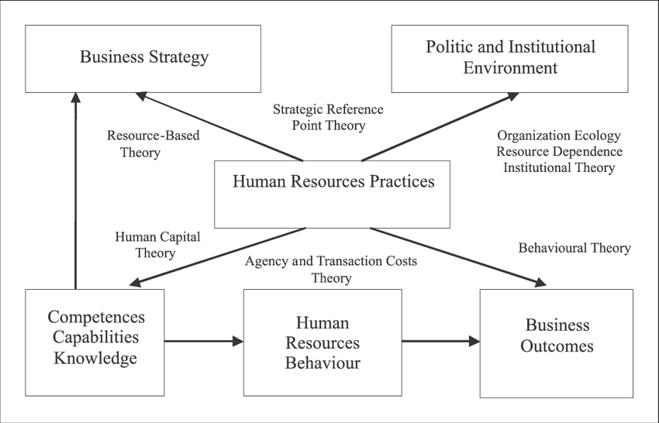

Slide 7: Constructive SWOT Analysis and training needs identified
Strengths  “What do you do well?”  “What unique resources can you draw on?”  “What do others see as your strengths?” | Weaknesses  “What could you improve?  “Where do you have fewer resources than others?”  “What are others likely to see as weaknesses?”
- I am a capable communicator (Score: 50) (Mindtools, 2022)  - Negotiating and presentation skills  - Team Leading and conflict management skills  - I prefer using the Eisenhower technique to improve organisational skills ( Eisenhower matrix used to prioritise tasks) | - Statistical, database and anthropological knowledge  - Less access to HR courses on software  - Language barrier  - Public speaking
Opportunities  “What opportunities are open to you?”  “What trends could you take advantage of?”  “How can you turn your strengths into opportunities?” | Threats  “What threats could harm you?”  “What is your competition doing?”  “What threats do your weaknesses expose to you?”
- Using my communication skills, I can further improve my leadership abilities.  - Widening HR skills through CIPD courses to improve my knowledge  - I can get a consultation with other HR professionals | - Competition in the market  - A competitor can have higher skills as HR officers  - Inflation may affect my employment because higher inflation will increase wages and that may allow companies to fire some employees  - Similarly, political instability also increases financial uncertainty which ultimately questions the permanent employment opportunity.

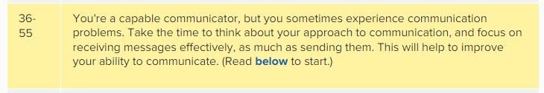

Training Needs: Understanding theoretical knowledge of anthropology and knowing advanced skills needed as an HR officer
SN: The slide shows my personal constructive SWOT analysis along with my training needs. The training needs are related to knowing advanced HR skills that will provide me with a competitive advantage at Tesco.

Slide 8: Skills Audit and training needs identified

Personal Skills Audit
Name MARIANA GOLEMANOVA
Job role: Human Resource Officer

 | Very good | Good | Adequate | Little or no experience
Information Technology
Use Microsoft Office  Word | ✓
Use Excel spreadsheet |  | ✓
Use a Database |  |  | ✓
Use specialist  HR software |  |  | ✓
Use the internet | ✓
Use e-mail | ✓
Use PowerPoint | ✓
Please tick as appropriate to indicate how you would rate your skills in relation to the following work /

Communication Skills
Drafting contracts of  employment |  |  | ✓
Taking notes of  disciplinary hearings | ✓
Write reports | ✓
Produce material to  support presentations |  | ✓
Delivering a training  session |  | ✓
Resolving  disputes/complaints |  | ✓
Interviewing |  | ✓
Advising on HR issues |  | ✓

 | Very good | Good | Adequate | Little or no experience
Problem-solving skills
Make good use of verbal reasoning skills, able to handle complex data and make selective use of  information |  | ✓
Explore more than  one solution in order to solve a problem |  | ✓

Consider the ideas of others to help  solve problems |  | ✓

Supervisory Management
How much experience have you had in your role? |  |  | < 1 month | 1-3 months ✓ | > 3 months
How many people have you managed at any one time? | None |  |  | 1-5 | Above 5 ✓

I declare that the information given in this form is true
Signed  Date | MARIANAGOLEMANOVA  17.11.2022

SN: The slide shows my skills audit test of mine while working as an HR officer. The slide suggests that I have adequate skills in HR software and accessing the database. Otherwise, I have good knowledge and experience in resolving complaints, delivering training and interviewing. I believe I have good/ satisfactory problem-solving skills which I need to improve in training sessions. Therefore, my training needs are developing knowledge of databases, HR software, problem-solving, delivering training and interviewing.

Slide 9: Benefits of training and development as an HR officer and in Tesco
Continuous professional development (CPD)
Continuous professional development (CPD)
● A holistic approach toward the maintenance of professionalism in the workplace (personal achievements)
● Improvement of knowledge regarding HR (Aga, 2019)
(Compliance and customer satisfaction)
● Digital learning in Tesco (career progression)
● Use of online learning platform to gain skills to work in Tesco (Tescoplc, 2022) (ensuring high performance)
● Self-led training and salary expectations(satisfaction)
SN: The slide shows how the CPT helps in the professional development of HR officers. Parts of training and development in Tesco are presented in this slide. It can be observed that, via the training and development programme of Tesco, the HR officer will gain digital skills and knowledge on the stakeholders and the operation of Tesco. Self-led training is encouraged within the organisation. Ultimately this helps in balancing every operation in the company.

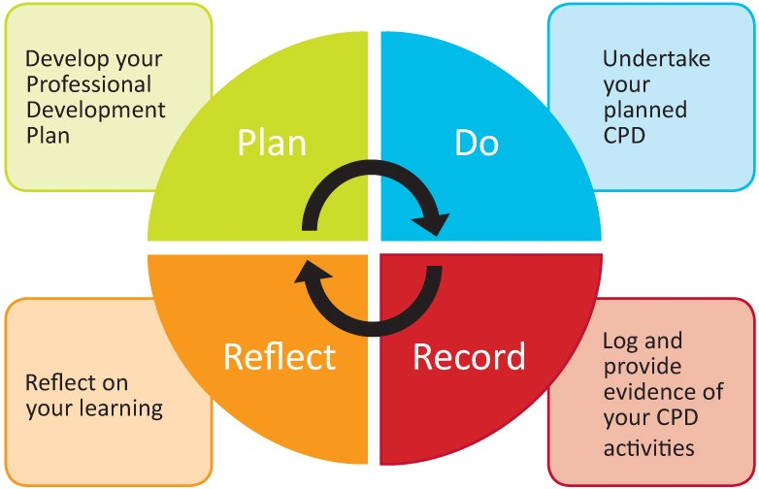

Slide 10: Benefits of training and development as an HR officer and in Tesco
● Maintenance of registration and qualification of HR officer(legislation)
● Maintaining a professional inclusive culture (ensuring high performance)
● Improves colleague awareness (Grabiec, 2021)(help of profit or not lost)
● Helps in decision-making (compliance and customer satisfaction)

SN: There are other benefits of participating in training and development. It shows that the programme will help the HR officer to know about colleague awareness. The HR officer will be aware of the colleague's interests, strengths and weaknesses. Moreover, the inclusive culture of the organisation is well-maintained when training and development programmes are launched.
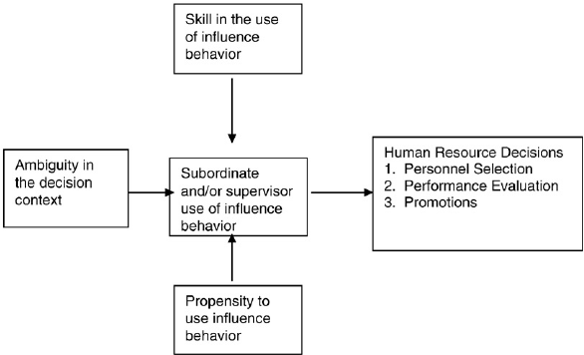

Slide 11: Conclusion
- The slide described important information on HR officers and professionals
- Personal SWOT and skills Audit results are shown
- As an HR officer of Tesco, the training programme will help me to understand inclusivity, professionalism, and qualification
SN: Overall, the presentation has represented information on Human Resources. My role was as an HR officer at Tesco. Using secondary research, I found that I will know about inclusive culture during the training and development programme of Tesco. Other essential knowledge areas are described on the slide.
I can add that in my opinion, this analysing presentation defines for myself that my experience of over 20 years in HR operations is a factor, but not enough for a successful HRM. It is very essential to continue studying and developing in the specialised areas of Human resources to improve my professionalism!

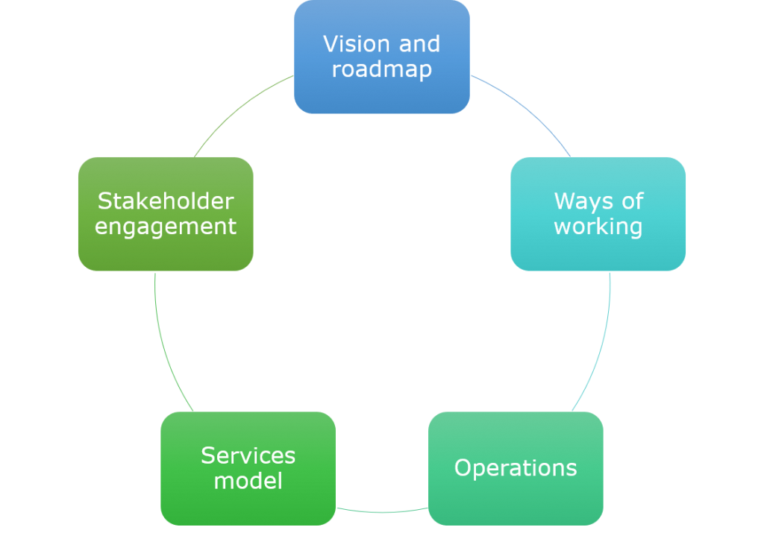

Slide 12: List of References
Aga, B.M., 2019. The Practices And Challenges Of Continuous Professional Development Program On Teachers'pedagogical Skills Improvement: The Case Of Primary Schools In Dandi Woreda.
Ahaduzzaman, M. (2020) Selection process in human resource management (HRM), BBA Lectures. Available at: https://www.bbalectures.com/selection-process-human-resource-management/ (Accessed: November 18, 2022).
Anwar, N., Mahmood, N.H.N., Yusliza, M.Y., Ramayah, T., Faezah, J.N. and Khalid, W., 2020. Green Human Resource Management for organisational citizenship behaviour towards the environment and environmental performance on a university campus. Journal of Cleaner Production, 256, p.120401.
BUCĂȚA, G. and RIZESCU, A., 2020. HUMAN RESOURCES MONITORING AND DEVELOPMENT. Annals of'Constantin Brancusi'University of Targu-Jiu. Economy Series, (6).
Drory, A. and Vigoda-Gadot, E., 2010. Organizational politics and human resource management: A typology and the Israeli experience. Human Resource Management Review, 20(3), pp.194-202.
Edeh, F.O., Ugboego, A.C. and Adama, L., 2022. Human Resource Skills Adjustment and Organisational Resilience in Times of Global Crisis. Kelaniya Journal of Human Resource Management, 17(1).
Grabiec, O., 2021. Training Needs and the Benefits of Training for Employees of Polish Enterprises. European Research Studies, 24(3B), pp.350-360.
Graczyk-Kucharska, M., 2021. Human Resources Responsibilities in Logistic System of Waste Management for Sustainable Growth and Circular Economy. European Research Studies, 24, pp.221-233.
Hitka, M., Kucharčíková, A., Štarchoň, P., Balážová, Ž., Lukáč, M. and Stacho, Z., 2019. Knowledge and human capital as sustainable competitive advantage in human resource management. Sustainability, 11(18), p.4985.
iEduNote (2022) Contingency theory of leadership by Fiedler, iEduNote. Available at: https://www.iedunote.com/contingency-theory (Accessed: November 15, 2022).
Lingayasvidyapeeth (2022) Top Private University in Faridabad: Best University in Delhi NCR, Lingaya's Vidyapeeth. Available at: https://www.lingayasvidyapeeth.edu.in/ (Accessed: November 16, 2022).
MindTools (2022) How good are your communication skills?: – speaking, listening, writing, and reading effectively, from MindTools.com. Available at: https://www.mindtools.com/pages/article/newCS_99.htm (Accessed: November 11, 2022).
Nyberg, A.J., Cragun, O.R. and Schepker, D.J., 2021. Chief executive officer succession and board decision making: review and suggestions for advancing industrial and organizational psychology, human resources management, and organizational behavior research. Annual Review of Organizational Psychology and Organizational Behavior, 8, pp.173-198.
Olmos, N. (2019) 7 tips to master your continuous professional development plan, Medium. Medium. Available at: https://medium.com/@nuriaolmosruano/7-tips-to-master-your-continuous-professional-development-plan-2c84f9596852 (Accessed: November 17, 2022).
Peña Garcia Pardo, I. and Fernández Moreno, M., 2009. Looking into the black-box: analysis of the effectiveness of human resources strategy. Zbornik radova Ekonomskog fakulteta u Rijeci: časopis za ekonomsku teoriju i praksu, 27(1), pp.31-56.
Pešaković, D., Flogie, A. and Aberšek, B., 2014. Development and evaluation of a competence-based teaching process for science and technology education. Journal of Baltic Science Education, 13(5), p.740.
Safari, A. and Saleh, A.S., 2020. Key determinants of SMEs’ export performance: a resource-based view and contingency theory approach using potential mediators. Journal of Business & Industrial Marketing.
Tesco-careers (2022a) Corporate functions | tesco careers. Available at: https://www.tesco-careers.com/office/corporate-functions/ (Accessed: November 8, 2022).
Tesco-careers (2022b) People, Tesco IE. Available at: https://roi.tesco-careers.com/office/people/ (Accessed: November 9, 2022).
Tescoplc (2022) Jobs and skills, Tesco PLC. Available at: https://www.tescoplc.com/sustainability/colleagues/jobs-skills/ (Accessed: November 10, 2022).
Ugryumova, A.A., Zamakhovsky, M.P., Pautova, L.E. and Olgarenko, D.G., 2020. Formation of human resources policy and labor potential of the meliorative industry of the agricultural industry of the Russian Federation. In GEOLINKS Conference (pp. 253-262).

THANK YOU!

