Valentina Ionela Cergan
1816239

Task 1 : Organizations beliefs, values and attitudes towards sustainability
It is important to understand the significance of sustainability in business to make sure that businesses and organizations have minimal impact on the environment, community and society. However, sustainability is known to be the practice that protects the natural environmental and resources such as water, air soil, forests and wetlands. It is mandatory for companies to adopt positive attitude towards sustainability to mitigate with harmful impacts on the environment, society and community. Business sustainability can be defined as pro-active strategy of a company to enhance their integrity and values by increasing the positive impacts on environment and minimize the negative influences on the overall environment. However, there are several factors that can have a huge influence on the sustainability of the company such as product quality, profitability, social responsibility, ethical values and many more. However, the attitudes, value and beliefs of companies regarding environmental sustainability have a significant impact on their business policies concerning sustainability. However, companies and organizations have a responsibility to protect the environment by reducing the harmful impacts on the environment through reducing air pollution, water pollution, deforestation, and promoting environmental friendly and sustainable packaging. It is important for every business to understand their responsibility towards environment and society and fulfil their social responsibility. Organizations demonstrate their values, beliefs, and attitudes towards sustainability through various effective ways such as developing and implementing social and ethical policies, supporting causes to protect environment from threats and hazards, incorporating their strategies through introducing environmental friendly products and packaging.
There are several ways organizations can become socially responsible by implementing policies and practices that maximize the environmental protection and minimize the negative influences. However, there are several types of organizations such as manufacturing companies that can pose a serious threat to the environment sustainability through harmful emissions of gasses during the production, air pollution, waste resources, use of plastic or other material in packaging that are harmful for the environment etc. However, it is essential for organizations to function according to the requirements of social responsibilities and ethical considerations to analyze activities that can create maximize the threats to environment and community.
Moreover, businesses should develop effective strategies to act in a manner that benefit the society. However, due to the rapid evolution and development of technology in business environmental concerns have become of the most important aspect for all corporates. There are several industries, businesses and companies that are responsible for creating environmental problems. It is important to assess the attitudes, beliefs and values of businesses towards environmental sustainability to be able to understand their efforts and part in minimizing the environmental problems. There are several companies that do not follow ethical and social responsibility towards environment and society. However, environmental and social conditions have been compromised due to the negligence of the companies and industries that fail to adopt social and ethical values into their businesses. However, one of the most significant challenges that are being faced in the world of business is to advocate sustainable practices of business. It is mandatory to encourage and promote all businesses to fulfil their social responsibilities consciously to make sure that they are not posing threat to the environment.
The side effects of unethical practices of organization on environment sustainability cause several threats such as natural disasters, floods, extreme weather conditions, global warming and climatic change etc. Moreover, environmental crises such as natural disasters, extreme weather conditions, climatic change and global warming etc can also have a huge impact on activities carried by many businesses. Therefore it is mandatory to for organizations to demonstrate positive attitude towards environment sustainability and safety and protection of the society from various health hazards.
Organizations demonstrate their values, beliefs and attitude through corporate environmental policies to show their concern and support towards sustainable environment. However, it also helps business and organizations to gain more customers if they promote green initiative and implement environment friendly policies such as introducing environment friendly packaging for their products, setting their industries far from residential areas to ensure that no harmful emission of gasses or particle effect the quality of life. Moreover, it is important to safe wildlife and sea life through implementation of suitable policies that will reduce the deforestation and dumping of waste products into water. However, the main objectives of organizations should be to minimize the negative impacts of the business activities. If their products, packaging or waste materials are posing threat to the sustainability of the environment. It is important for them to reevaluate their policies and make appropriate changes to make sure that the negative effects are minimized.
It is concluded that the attitudes, values and beliefs of organization regarding environment sustainability have a huge impact on how they implement social and ethical policies to fulfil their social responsibilities. There are various ways how organization demonstrate their values, attitude and beliefs in their business activities that depict their overall position in the market. Moreover, organizations that aim to demonstrate their values and beliefs regarding environmental in an effective manner tend to attract more customers and develop a competitive edge against their competitors. Their positive attitudes and beliefs towards environment can help them become more successful and sustain a significant position in the market.

References

Amoah, P. "Impact mitigation or ecological restoration? Examining the environmental sustainability practices of multinational mining companies." Business Strategy and the Environment, 2021: 551-565.

Nold, H., (2017). “Using Critical Thinking Teaching Methods to Increase Student Success: An Action Research Project”. International Journal of teaching and learning in Higher Education, 29(1), pp.17-32.

Porter, T. "Sustainability and business in a complex world." Business and Society Review, 2012: 33-53.
Sartori, R., Costantini, A., Ceschi, A. and Tommasi, F., (2018). “How do you manage change in organizations? Training, development, innovation, and their relationships”. Frontiers in psychology, 9, p.313.
Sorko, S.R. and Brandstätter, C., (2020). “Motivating Employees in Times of Industry 4.0: The Suitability of Classical Motivation Theories Within the Framework of Industry 4.0”. In Eurasian Business Perspectives (pp. 15-27).

Task 2: Developing workplace critical thinking report

Table of Contents
Introduction 3
Critical analysis of classical management theories relevant to the organisational example 3
Critically assess the impact of these theories on the implementation of the beliefs, and values of the organisation 6
Critically evaluate the impact on its employees as well as on the wider society in terms of future sustainability and impact on the environment 9
Align personal values, attitudes and Beliefs with the organisational example used in report 10
Conclusion 12
Reference list 13

Introduction
According to the functional aspects associated with the organization in the market application of classical management is the belief related to the working culture of the employees associated with their economic and classic needs (Cletus et al., 2018). On the other, when bringing in comparison with other management theories classical management theories does not give major focus on the factor of job satisfaction and social needs. Besides this, the respective theoretical aspect accurately advocates a core specialization based on profit maximization, centralized leadership, decision making and labour. Classical management theory came into existence during the 19th century along with gaining higher prominence by the 20th century. Moreover, it includes certain competitive principles that play an important part in the organization gaining sustainability from the current and future perspectives.

Critical analysis of classical management theories relevant to the organisational example
For the business, the application of effective classical management theory accurately outlines a systematic and ideal workplace (Boa et al., 2018). Moreover, the respective theoretical aspects move through three major stages within the internal environment of the organization. It includes interviews, a hierarchal structure and specialization.
Hierarchical Structure
In the respective model, workplace management is divided and distributed into three major distinct layers. As per Hester (2021), the operational activities happen among the executives, director board and owners. Moreover, their major activity is associated with the system of developing and designing long term objectives and goals for the organization. On the other hand, the middle-level management of the company takes the core responsibility in overseeing the function of the supervisors during the time of gaol setting under department level. Tesco middle level management is responsible for managing and controlling the organizational resources along with identifying the budget requirement of the company. Zhurenkov and Trushkova, (2019) has stated that in the lowest organizational level, it includes the supervisors for the daily activities of the organization. They also take feedback from the organizational employees and offers adequate training and development programs when required. For example, Tesco in the market follows a hierarchical model reflecting upon the larger size of the company. On the other hand, under the store level, there are several organizations following four managerial layers for performing effectively.
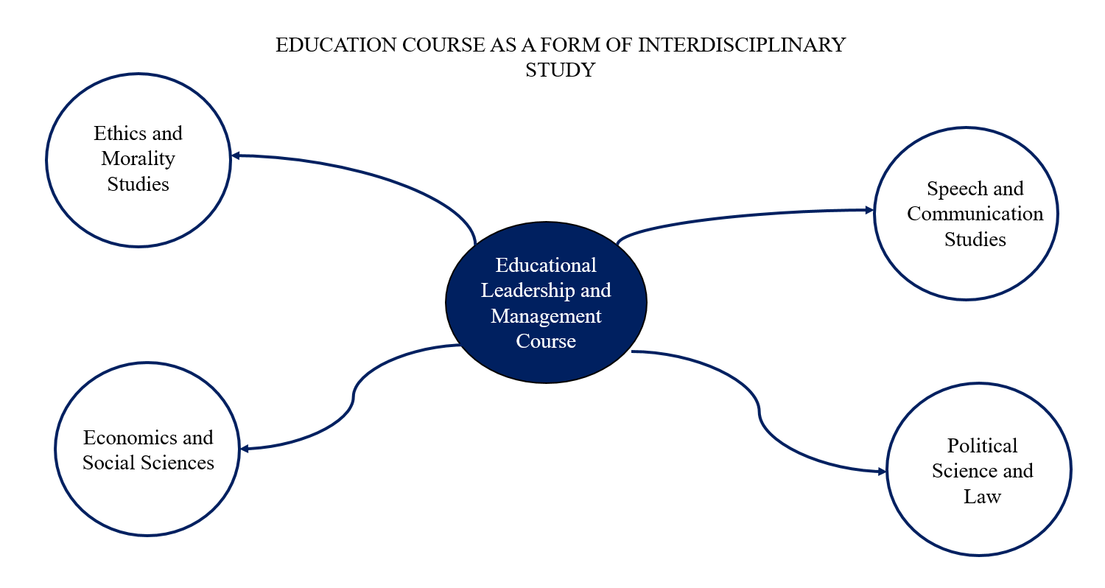
Figure 1: University Example of Classical Management Theory
(Source: Sartori et al., 2018)
Specialization
According to the classical management theory in the organization, it includes a mode of assembly line workplace view under which the larger task associated with the organization is broken into smaller segments. Based on the operational aspects of the business the company believes this to be the most beneficial and easy technique to accomplish their internal function within the desired schedule and timeframe. Field, (2020) has stated that the classical management theory enable the workers in the organization in evaluating and understand their assigned roles along with specialize in the core work area based on their expertise. Moreover, it will be a supportive part for the organization in increasing their efficiency and productivity in the current and future perspectives. However, it is also an encouraging segment for the employees which will keep them eliminated from performing multiple and complex tasks.

Incentives
According to Nold, (2017), the classical management theory it is estimated that employees’ satisfaction in the organization happens through offering financial rewards. Moreover, based on the derived results the employee in the organization become dedicated and productive during the point of time they are offered additional benefits based on their performed work. On the contrary, the employers in the organization having the capability in motivating their organizational employees with incentives tend to achieve an increased level of profitability, productivity and efficiency. For example, According to the 2021 data it is estimated that the organization Tesco has increased their employee pay to the level of 2.7% (Ritter et al., 2018). In this, the structure of the payments of the employees is expected to increase from the level of £9.30-£9.55. In the form of additional benefits, the employees in the organization are offered 15% off from their colleague club card for the 4 days in which the rest of the 10% is offered by the end of the month on made purchases.
It includes the implementation of an accurate management structure for the business along with controlling the overall operations and functions of the company. On the other hand, under the respective theoretical aspects, the labour division system will enable the organization in making their activities easier along with the efficient accomplishment of the same. Khorasani and Almasifard, (2017) has stated that apart from the above-mentioned information application classical management theory includes certain competitive beneficial aspects for the organization to remain competitive and sustainable in the market. On the contrary, the respective approach will directly reflect on the factor of increasing the profitability value of the business in the future. For example, the company Tesco in the market bring the better application of classical management approach for the part of benchmarking their standard, quality, communication and production between the employees of the company. Sužiedelytė-Visockienė and Tumelienė, (2019) has added that classical management approach in the market has helped the company in achieving its goals through collective efforts that have influenced the company in goals attainment. It also plays a vital part for the company in understanding the expectation and needs of the employees along with rendering them required training and development programs.

Critically assess the impact of these theories on the implementation of the beliefs, and values of the organisation
Under the current market competition, the operational and functional aspect associated with the organization is practical. According to Nicotera, (2019), the management of the company operated through a simplified micro approach in which the value a+b=c model. The main objective and reason behind the development of the respective theoretical aspect are to understand the importance of theory within the internal environment of the organization. Some of the theoretical aspects under the Classical Management Theory considering the values and beliefs of the organization are demonstrated below:
Bureaucratic Theory
Under this, during the point of time the organization is formed in the market, it brings the better application of certain policies and rules that are required to be adopted by the company for the successful operation in the market. Bello (2018) has added that the operational aspects associated with the mechanistic and formal organization is considered to be effective under the bureaucratic theory. It is the most vital segment of the classical management theory under which the management task is delegated among the individuals and the departments. In this, they also function in the area of central administration. On the other hand, the respective theory is considered to be more popular and effective and is used by certain public and private institutions in the market. For example, the educational institutions along with certain universities and schools strictly rely on bureaucratic theory for the part of bringing a better system of compatibility with their overall function through the mode of task delegation.
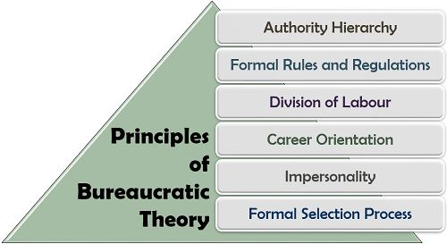
Figure 2: Bureaucratic Theory
(Source: Bello, 2018)
On the other hand, the made compatibility process during the time of decision-making is effectively discussed among the subordinates for the part of carrying out the activities based on the planned initiatives. In Tesco, the organization follows the respective organizational model in some segments (Geschwil and Nieswandt, 2020). The company follows a hierarchical structure due to the presence of increased departments within the internal environment of the organization. On the contrary, the bureaucratic model also offers a strong system of the outline of labour division for the successful undertaking of the activities. Moreover, the process associated with labour division is the highlighting factor associated with the respective Bureaucratic model.
Scientific Management Theory
Under the classical management theory application of scientific management theoretical aspect is used for the part of evaluating and measuring the internal perspectives of the business. It gives importance to emphasise the area of increasing the organization's productivity and profitability value in the initial stage. McNamara and Trimmer, (2019) has mentioned that the activities are performed by bringing an accurate evaluation of the competitor performance through enhancing differentiated and unique approaches in the market. For example, the universities and the colleges use better application of statistics for the part of measuring the graduation rates, research tracking and acceptance rates for keeping and changing their current methods. Under this, the application of the respective statistics provides a stronger platform for generating comparisons with other institutions. On the contrary, when bringing in comparison with the behavioural aspects of the organization the respective classical management theory focuses on developing values and beliefs within the organization.
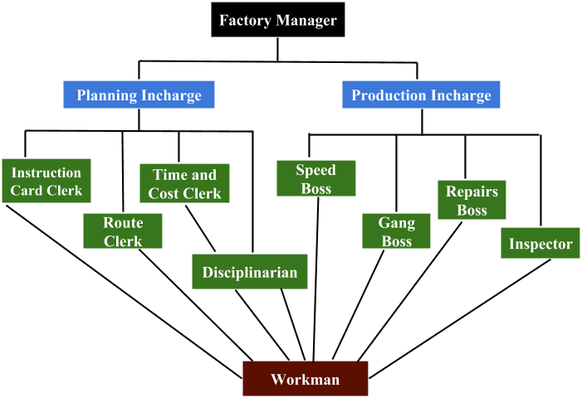
Figure 3: Scientific Management Theory
(Source: McNamara and Trimmer, 2019)

For example, the company CAPCO brings the better application of scientific management concept for increasing the company customer base and sales value in the market. Sužiedelytė-Visockienė and Tumelienė, (2019) has stated that the application of the respective approach it has enabled CAPCO in offering adequate training and development programs for their employees whenever required. With the scientific management approach, the organization CAPCO schedules their task through increased professionalism by considering the capabilities and skills of the individuals. It has become a supportive part for the organization increasing the organizational behaviour, beliefs, culture and values for smooth functioning of the business in the current and future perspectives.

Critically evaluate the impact on its employees as well as on the wider society in terms of future sustainability and impact on the environment
According to the functional aspects associated with the organization in the market classical management theory offers a better opportunity to the employees in the organization in addressing the issues. Moreover, for the business making necessary approaches and initiatives through meeting the needs and expectations of the employees will enable the organization in enhancing sustainability both under the domestic and international competition. Smirnov, (2017) has mentioned that some of the core aspects associated with the classical management theory are based on the factor of increasing efficiency, specialization, quality, employee relationship and cost reduction. However, under the current market competition application of classical management theory is used by the organization to remain competitive in the market for the current and future perspectives. As per Sorko and Brandstätter, (2020) the employees in the organization, the highlighting factor is associated with defined labour division. Under this, the activities undertaken within the projects are broken into smaller segments are distributed among the employees for the part of making their performed task easier. It will enable the employees in the organization for meeting their targets within the planned schedule and timeframe. Through the process, the expectations and responsibilities of the employees remain defined along with allowing them to narrow their expertise field through specializing in a single area. For example, within the segment of classical management theory, the company CAPCO has made better application of transactional leadership style for the part of systematically controlling and managing their internal functioning in the market.
The respective approach has offered a supportive part for the company CAPCO in bringing a strong system of communication with their employees along with changing their work process and complexities based on their working requirements. However, the respective theoretical aspects have critically highlighted that it will be a vital initiative adopted by the organization for motivating their employees through monetary rewards. It will enable the employees in the organization to operate with an increased level of efficiency that will reflect on the value of organizational profitability and productivity factor. According to Yuan et al., (2021), it will also benefit the organization in the market by keeping a strong system of control over their employees. On the contrary, through the respective process employees in the company will feel more appreciated during the point of time they are rewarded for their hard work and dedication.Under this, it will be beneficial for the owners of small businesses for motivating their employees for achieving the production goals. Under the classical management theory, autocratic leadership is the central part. Benjaafar and Hu, (2020) has added that classical management includes a single leadership concept for making decisions. It is the advanced and competitive approach for directing and organizing the employees. The highlighting part is that under this decision by the management is made at the top level and is communicated to the lower level. For example, the organization CAPCO has both informal and formal groups for fulfilling its goals and objectives. It will be a supportive part for the organization in the area of preventing and controlling the complexities along with enhancing sustainable performance in the market.

Align personal values, attitudes and Beliefs with the organisational example used in the report
As mentioned above, within the internal environment of the organization CAPCO numerous factors promote attitudes, beliefs and values within the organization for rendering effective teamwork and successful operation. However, with the better application of the same the organization CAPCO has succeeded in performing their organizational task efficiently and effectively. As per Zhurenkov and Trushkova, (2019) the application of classical management theory the process of teamwork plays a vital part for the business as it produces high-quality outcomes, builds strong trust, teaching the skills associated with conflict resolution. It helps the organization in achieving the desired goals along with guiding the higher authorities to achieve the goals of the organization and leading them towards profitability. Based on the organization behavioural structure developed by the organization CAPCO it is the core initiative of the business to develop a strong system of coordination and communication. However, the respective approach in the current operation plays a success factor for the company in terms of their developed culture, values and attitudes.
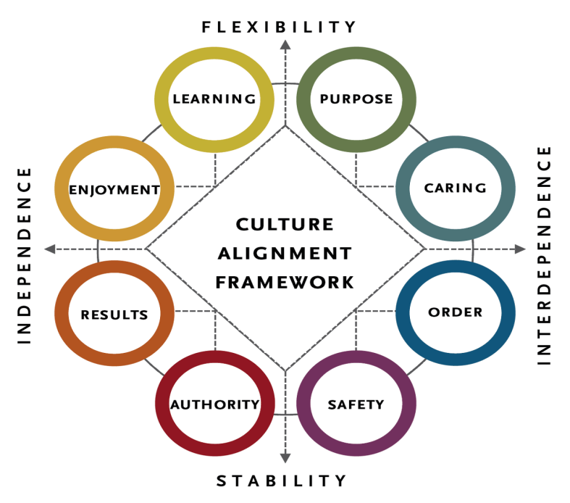
Figure 4: Culture, beliefs and Values in Organization
(Source:Zhurenkov and Trushkova, 2019)
According to the organization CAPCO, the company has both informal and formal groups for the part of fulfilling their desired objectives and goals. Lim and Kim, (2021) mentioned that the formal group of the organization CAPCO include a strong system of managerial operation in the form of their organizational structure. Based on the classical management theory the respective groups in the organization CAPCO is equipped with both physical and financial resources having appropriate authority for the part of carrying out their roles and responsibilities. Resmini, (2021) has argued that the formal group of the company acquires a strong system of communication and organization structure. Under this, the functional aspects associated with informal and formal group has difference with one another during the time of undertaking wider activities. CAPCO depending upon their culture and beliefs have the capability the area of completing the task both informally and formally. For the company, to complete the task within the desired schedule and timeframe the organization employees need to operate through developing mutual understanding to operate with a better system of consistency and competitiveness in the future.

Conclusion
It can be concluded that based on the derived results the employee in the organization become dedicated and productive during the point of time they are offered additional benefits based on their performed work. Moreover, it will enable the employees in the organization to operate with an increased level of efficiency that will reflect on the value of organizational profitability and productivity factor. Under this, some of the core aspects associated with the classical management theory are based on the factor of increasing efficiency, specialization, quality, employee relationship and cost reduction. Besides this, it will also benefit the organization in the market by keeping a strong system of control over their employees. On the other hand, it will also benefit the organization in the market by keeping a strong system of control over their employees.

Reference list
Bello, B.A., (2018). “Myths, Stereotypes and Realities of Classical Management Theories: The Quest for Equilibrium for School Management Effectiveness”. ATBU Journal of Science, Technology and Education, 6(1), pp.125-136.
Benjaafar, S. and Hu, M., (2020). “Operations management in the age of the sharing economy: what is old and what is new?”. Manufacturing & Service Operations Management, 22(1), pp.93-101.
Boa, E.A., Wattanatorn, A. and Tagong, K., (2018). “The development and validation of the Blended Socratic Method of Teaching (BSMT): An instructional model to enhance critical thinking skills of undergraduate business students”. Kasetsart Journal of Social Sciences, 39(1), pp.81-89.
Cletus, H.E., Mahmood, N.A., Umar, A. and Ibrahim, A.D., (2018). “Prospects and challenges of workplace diversity in modern day organizations: A critical review”. HOLISTICA–Journal of Business and Public Administration, 9(2), pp.35-52.
Field, L., (2020). “Organisational learning: basic concepts”. In Understanding adult education and training (pp. 159-173).
Geschwill, R. and Nieswandt, M., (2020). “Cracks in the World View of Classical Management”. In Lateral Management (pp. 39-61).
Hester, J.P., (2021). “Building Relationships and Resolving Conflicts: Infusing Critical Thinking into Workplace Practices”. The Journal of Values-Based Leadership, 14(1), p.7.
Khorasani, S.T. and Almasifard, M., (2017). “Evolution of management theory within 20 century: A systemic overview of paradigm shifts in management”. International Review of Management and Marketing, 7(3).
Lim, S.H. and Kim, D.J., (2021). “The effect of unmindfulness on impulse purchasing behaviours in the context of online shopping from a classical attitude theory perspective”. Behaviour & Information Technology, pp.1-18.
McNamara, J.M. and Trimmer, P.C., (2019). “Sequential choices using signal detection theory can reverse classical predictions”. Behavioral Ecology, 30(1), pp.16-19.
Nicotera, A.M., (2019). “Classical Management Theory”. In Origins and Traditions of Organizational Communication (pp. 89-105).
Nold, H., (2017). “Using Critical Thinking Teaching Methods to Increase Student Success: An Action Research Project”. International Journal of teaching and learning in Higher Education, 29(1), pp.17-32.
Resmini, A., (2021). “Classical to Contemporary: An M3-Based Model for Framing Change in Information Architecture”. In Advances in Information Architecture (pp. 9-17).
Ritter, B.A., Small, E.E., Mortimer, J.W. and Doll, J.L., (2018). “Designing management curriculum for workplace readiness: Developing students’ soft skills”. Journal of Management Education, 42(1), pp.80-103.
Sartori, R., Costantini, A., Ceschi, A. and Tommasi, F., (2018). “How do you manage change in organizations? Training, development, innovation, and their relationships”. Frontiers in psychology, 9, p.313.
Smirnov, V., (2017). “The genesis of the entrepreneurship theory at the classical and non-classical stages of science development”. , 164(3-4), pp.14-19.
Sorko, S.R. and Brandstätter, C., (2020). “Motivating Employees in Times of Industry 4.0: The Suitability of Classical Motivation Theories Within the Framework of Industry 4.0”. In Eurasian Business Perspectives (pp. 15-27).
Sužiedelytė-Visockienė, J. and Tumelienė, E., (2019). “Abandoned land classification using classical theory method”. Baltic surveying: international scientific journal/Latvia University of Life Sciences and Technologies, Vytautas Magnus University, University of Warmia and Mazury in Olsztyn., 2019, vol. 10 (1).
Yuan, T., Honglei, Z., Xiao, X., Ge, W. and Xianting, C., (2021). “Measuring perceived risk in sharing economy: A classical test theory and item response theory approach”. International Journal of Hospitality Management, 96, p.102980.
Zhurenkov, D.A. and Trushkova, Y.A., (2019). “Post-non-classical discourse of civilizations as a self-developing poly-subject environment for improving the mechanisms of international stability”. IFAC-PapersOnLine, 52(25), pp.349-354.

