Level 5 Associate Diploma
in People Management

5CO02

Evidence-Based Practice

(BMPD5017)

Resubmission word count 4251

AC1:1: Evidence Based Practice

According to the CIPD, Evidence-Based Practice is a process of making decisions by systematically searching for and integrating the best available evidence from multiple disciplines. (CIPD, 2024). The idea behind this approach ensures a favourable outcome by identifying decisions being made by practitioners and minimising reliance on people's opinions, (conscious or unconscious biases) for dealing with certain cases.

Evidence-based management has been implemented throughout multiple professions, with a strong emphasis on using data and statistics, originated by David Sackett and was used initially int the world of medicine.

CIPD has identified and recommends using the following six steps listed below, along with some of the four possible sources that were identified by Barends, Rousseau and Briner (2014), to increase the likelihood of a favourable outcome, (CIPD, 2024)


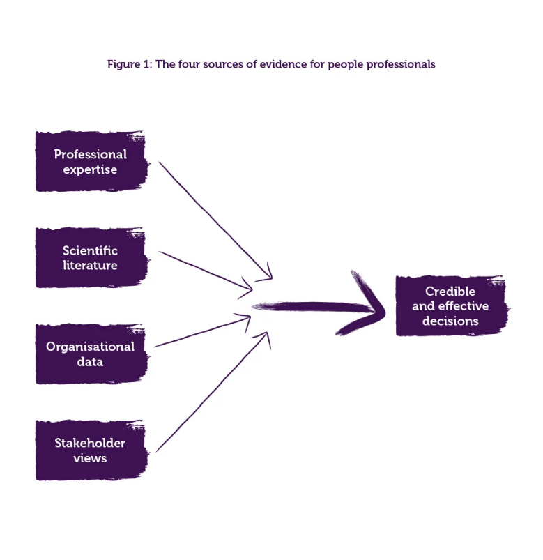

Those working in HR work with a range of people and various issues, by using evidence-based practice to make decisions, organisations can ensure ‘bad’ decisions are not made, and in turn being costly to the organisation.

To ensure strong principles-led, evidence based, and outcome driven requires organisations to be asking critical questions that allows the most favourable outcome to be had. (CIPD, 2024) Not only it allows factual decisions to be made, it can also allow organisations to support a recognition of issues using data.

By using the recommended process, allows professionals to make an informed decision, i.e. using evidence to help avoid assumptions, ensuring consistency in reliable decision making and ensuring decision makers are accountable for their choices, backed by the evidence. Ensuing that there is adequate quality of evidence the following questions are likely to be used.

- Where and how is evidence gathered?
- Is it the best evidence available?
- Is it sufficient to reach a conclusion?
- Might it be biased in a particular direction? If so, why? (CIPD,2024)

Within a local authority setting, one of the many ways evidence-based practice is used, could be the recruitment process where managers match evidence-based practices to a role. It all starts with the same template application for every candidate, so that there is an equal playing field to begin evaluating whether someone is fit for the organisation. Applications are assessed against a person's specifications before getting two references, followed by an interview. Every paper trail with everyone is documented, and each candidate gets scored with a matrix at both the paper and interview stages. Enabling the hiring manager and the interview panel to better assess if a candidate is fit for a role in the organisation.

However, challenges with Evidence Based Practice could be with the reliability and validity of the data. Depending where and how the evidence has been gathered could affect the reliability and its accuracy, or if there has not been sufficient evidence to reach a conclusion or is not the best available evidence, could affect the validity.

AC1:2: Analysis tools and Method

Within people practices, analytical tools such as PESTLE, SWOT can be used to support any Evidence Based Practice, these allow us to identify and manage any challenges organisations may face in the future and can be extremely useful for effective decision-making.

CIPD factsheet provides a good step by step on how to carry out a PESTLE analysis, and recommends carrying a regular PESTLE analysis, in order to help informed decisions (CIPD, Battista 2024)

The PESTLE Analysis is particularly useful for a Local Authority school setting as it offers an organised way to comprehend the external environment, and can provide a valuable insight into the Business Strategic Planning and assists in identifying gaps in the workforce (CIPD, 2024). Considering external factors in six main key areas: Political, Economic, Social, Technological, Legal and Environmental. (CIPD, Battista 2024) Analysing these helps settings identify existing trends and trends which may alter the strategic direction of their organisation. For example, changes in government policies or leadership could shift to either spending more on education or scaling it back drastically affecting the schools, for instance. Budgetary issues that affect staffing and programming may be caused by local or national economic conditions. Demographic and community changes—the social factors that impact school structure—can assist schools with adjusting their services and programs to meet the needs of students and families.

However, along with all its benefits the using PESTLE is not without some limitations. It is a lengthy process and does not address all the internal aspects that can influence the organisation. In addition, if the PESTLE analysis is not frequently updated, it will become obsolete as the external environment can evolve quickly.

Within a local authority setting, benchmarking is a particularly useful method to then ask the ‘why’ question. Benchmarking allows comparability and benchmarking against either similar organisation, however data needs to timely and be used and should be measured at set milestones, for eg. at the end of each quarter. So, for example, when comparing sickness data allows organisations, to benchmark where they compared to the same industry or sector to then try and understand if there are any underlying reasons, for example if there is a spike in absences relating to stress, could it be to do with changes within the organisation?

Along with PESTLE, Managers within a local authority setting are guided by the knowledge they gain from this collection of various complementary methods used in their decision-making process.

Such methods can be via interviews with staff around the practices both formal and informal that are in place; Return to Work meetings (which will help integrate staff back into the workplace); well-being questionnaires (to measure morale and job satisfaction among their teams); observations within classrooms (to identify effective teaching practice) as well as work sampling, where managers assess their direct reports' workflow and performance.

Using these different types of methods enables the Managers to create a well-rounded picture of how the whole organisation is doing and where there are opportunities to improve.

In conclusion a PESTLE analysis is an important tool for organisation to see all the things that surround them affecting their day-to-day and future plans. Combined with SWOT analysis — that considers internal strengths and weaknesses and external opportunities and threats — these analytical tools give a fuller view of planning for strategy and decisions. Local authorities will compare quarter to quarter and year to year to allow practitioners to understand organisations (or individuals) within its own context, or even within certain teams. Benchmarking allows us to identify characteristics that may need to be focused on to then make informed decisions.

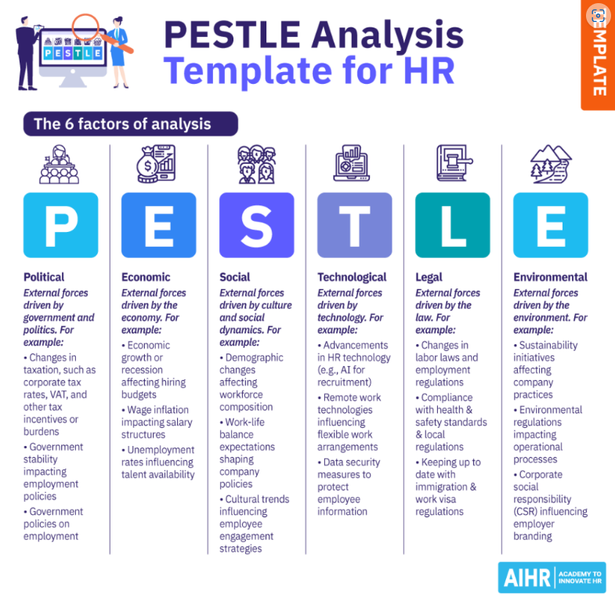
AC1.3: Critical Thinking

According to Howlett (Howlett, W, 2024) critical thinking is a key skill for HR professionals, that allows reflection on ideas, opinions and arguments and the three key factors are being able to provide a critique on other people's ideas, and opinions, second is how arguments and opinions are communicated and finally, identifying when others use methods to form an argument.

Critical thinking is a skill that allows professionals and leaders to effectively assess, analyse and support Evidence-Based Practice in order to make an informed decision and involves questioning any assumptions to promote objectivity in decision making.

Coburn (Podcast, 2024) says critical thinking is a human habit of thought that engages various considerations/pushes people to reach conclusions that enjoy consensus along with others.

Critical thinking in problem-solving and evidence-based practice is integral to supporting decisions to ensure that are well-rounded. This means working with, assessing evidence, taking up perspectives and applying relevant analytic techniques to provide objective arguments supported by solid reasoning.

According to Mindtools, there are some skills individuals can focus on to develop their critical thinking skills, these include Curiosity, Logical thinking, and Self-awareness.

For example, within the workplace, and dealing with people as part of the absence management policy, consideration is given to why people may be off work, the ‘triggers’ that they may meet that requires ‘intervention’ or support to try and improve attendance. If stress is factor of why someone is off work or had frequent periods of absence, then managers would look at the data, the pattern, identify if it is incidental stress, such as a bereavement, breakdown in relationship, or if there is an underlying medical condition that becomes a medical diagnosis that then could be a protected characteristic. When looking at all these factors would determine the support that is required, the personal situation, if there are any performance concerns, and if temporary support and reasonable adjustments would allow the employee to have better attendance in the workplace. Critical thinking inevitably involves conscious and subconscious biases. And it also means challenging the source of that information and whether they can be trusted or not if their answer was correct.
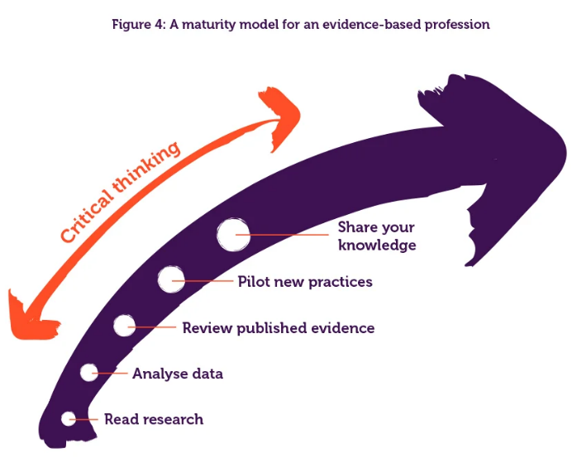
Within a workplace, an auditor very often come in to decide and a judgment of the work place practices by gathering a range of data and evidence. They consider if the information source is trustworthy, do they have up to date information? What is the potential risk? What evidence supports the decisions made, (for example, as part of a safer recruitment process, does the application form, interview notes, references support the decision of employing the correct candidate?

Finally, the evaluation step includes critical thinking that leads to critical listening. This, in turn, helps professionals to create informed evidence-based approaches that will benefit their respective fields

AC1:4: Decision Making

At this stage of decision-making, managers must identify the important considerations for effective outcomes.

Employing the various decision-making tools available to organisations — like De Bono's Six Thinking Hats. This technique looks at a problem from 6 different perspectives:

White Hat- Focuses on the data available, looks at the information you have and see what you can learn from it. Looks for gaps in the knowledge and either try to fill them or take account of them
The Red Hat- Looks at the decision using intuition, gut reaction, and emotion. Also try to think how other people will react emotionally and try to understand the intuitive responses of people who do not fully know your reasoning.
The Black Hat- Think of things pessimistically, cautiously, and defensively. Try to see why approaches might not work. This is useful as it highlights weaker areas and allows you to eliminate them. Makes plans more robust and resilient
The Yellow hat helps you to think positively. It is the optimistic viewpoint that helps you to see all the benefits of the decision and value in it, you should also be able to spot the opportunities, the yellow hat keeps you going when things are gloomy and difficult.
The Green Hat stands for creativity, creative solutions to a problem. It is a freewheeling way of thinking, in which there is little criticism of ideas
The blue hat is for process control. This is the hat worn by people chairing meetings. When running into difficulties because ideas are running dry, they may direct activity into green hat thinking.

The approach can provide an approach to be used within a group discussion or can help individuals take on a ‘metaphorical hat’ that each represents different perspectives. That can then provide clear insight into a decision to make an informed decision by considering a problem and the next steps.

This process can help to reduce bias, enhance creativity, balance emotion and logic, and identify risks and benefits. Six Thinking Hats® - Looking at a Decision in Different Ways (Mind Tools Content Team By the Mind Tools Content Team et al.)

While it is often used within a group setting, it can be used by an individual, as it allows them to make a conscious switch to see different perspectives. According to Mindtools, the benefits of this method allow us to be confident in considering a variety of angles, strengthen critical thinking, provide the opportunity to deepen our listening skills, and also question others.

Each Hat represents a different metaphorical perspective.
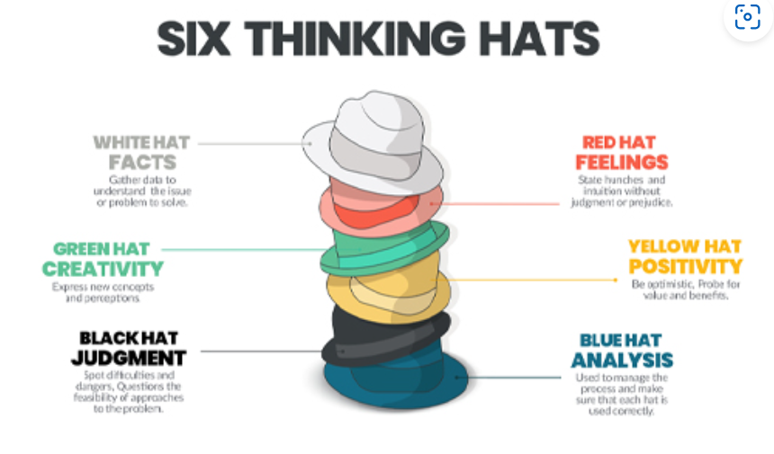Source: Open university

Force Field Analysis, developed by Kurt Lewin (Bell & MacLeod, Understanding the Three Stages of Change) in the 1940s, is another helpful tool for decision-making. It is a simple analysis that assists businesses in deciding if an action should be taken (a go/no-go or for/against analysis). Though it is a visual instrument outlining the major hurdles to leap over for change, it can be biased and based on personal perceptions. (Hancock, Analysing the Pressures For and Against Change)

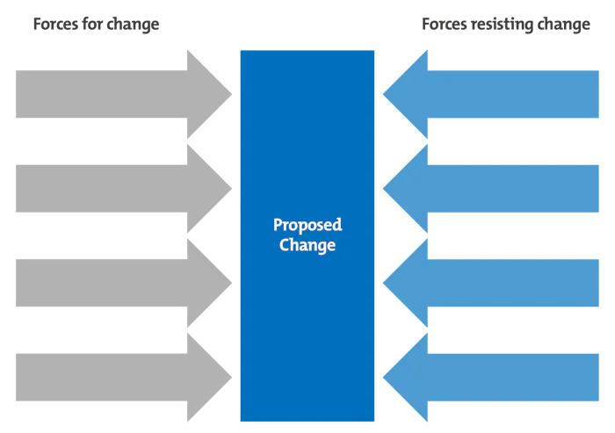

Source:

To use Force Field Analysis, take the following steps:
- Define the goal.
- Identify the driving forces for change, considering both internal and external factors.
- Identify the opposing forces against the change or problem, again analysing internal and external influences.
- Assign scores to each force based on its influence.
- Analyse the decision to determine whether to proceed with the change or explore ways to strengthen the decision and reduce resistance.
In an HR setting, both tools can assist in decision-making. For instance, the chair of a meeting might start by wearing the Blue Hat but may need to switch to a different hat to maintain focus. Force Field Analysis could be applied when HR professionals contemplate a policy change or decide whether to update HR systems.

AC1:5: Ethical Practice

Ethical practice is about applying ethical values into the organisation, and is integral to the organisation. (CIPD, Young, 2024). Within people practice, ethical perspectives play a key role when making decisions, it is also an important part of an organisations to establish and demonstrate the organisations values and a framework for the company's culture.

For example, utilitarianism focuses on the results of decisions, and deontological (duty based) focuses on what people do, rather than the consequences or results.

Both perspectives are important when making decisions. It allows managers to understand the relations between employees and the organisation.

Duty Based ethics follow principles that adhere to moral or duties, where sticking to his or her moral principles is more important than the consequences. This frame is all about the notion that right or wrong actions exist in advance of and outside man-made laws, morals, and traditions

For example, those employed by public authorities such as local authorities and schools expected to follow The Seven Principles of Public Life (also known as the Nolan Principles) (Committee on Standards in Public Life, 1995). This means, as individuals, they follow ethical principles when making decisions while making decisions in the workplace, these are Selflessness, Integrity, Objectivity, Accountability. Openness, Honesty, and Leadership. (Gov.UK). This can create support and loyalty for employees because leaders are aligning their decisions with these ethics/principles.
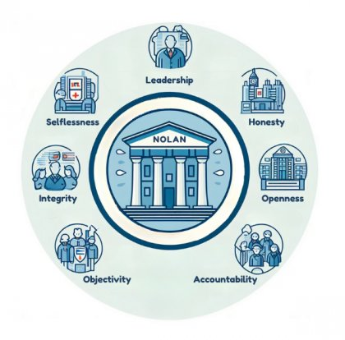

Civil Service College, 14 Jan 2025

When leaders make decisions aligned with these principles or explain their alternative choices in their context, they provide a standard for their teams and contribute to an environment that encourages ethical practice.

On the other hand, utilitarianism was used in a recent pandemic. Decision-makers faced a range of actions that would limit how fast the virus spreads, and then they had to balance keeping some aspects of public health intact. Here, the officials had to weigh risks against decisions such as imposing lockdowns, requiring people to wear masks, and providing vaccines—selecting those with a sufficiently high reward-to-risk ratio for the population. That is the sort of decision that makes use of utilitarianism in practice, where decisions are made based on a balance of net benefits against net harms.

Similarly, to the Nolan Principles, CIPD, uses the Profession Map, which reflects the principles for the People Practice profession. (CIPD, Young, 2024).

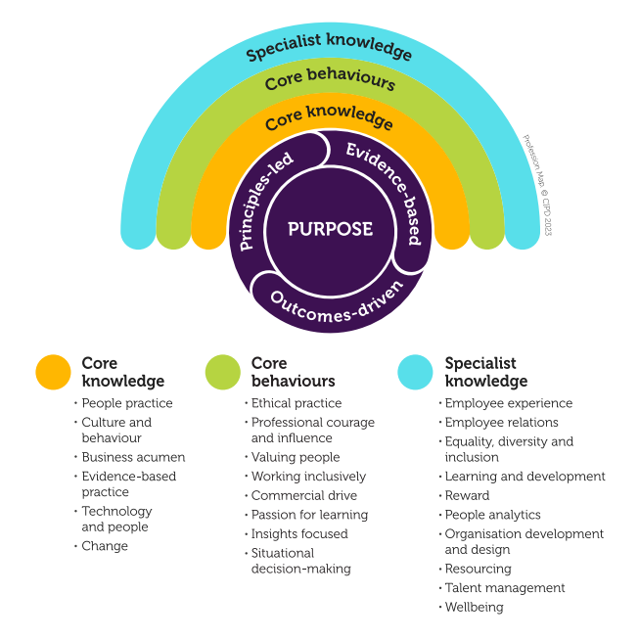
Tina Russell, CIPD Professional Conduct Manager is quoted below on how and why ethics is important within the people practice, however, this should relate to anyone in a managerial position to ensure decisions are made with integrity.
‘Internally, establishing a culture of ethical practice improves morale and reduces risks that arise from unethical practice. On a macro level, reputable ethical practice not only contributes towards good relations with customers, but has proven to impact financial performance’ (Russell, CIPD, 2024)
Consequently, they form a part of the decision-making framework in their respective workplaces for utilitarianism and duty-based ethics. Embedding a culture that uses these ethical mechanisms can not only reinforce the management function of the organisation but also instil ethical undertones in each employee while taking responsibility. In turn, this translates to a unified workplace that is founded on principle and guided at all levels by principle-driven decision-making.

AC3:1: Financial and non-financial performance

It is crucial to acknowledge that the success of an organisation depends as much on what work they do but also how they perform their tasks. To assess their own success and guide strategic decision-making, organisations use a variety of financial and non-financial performance measures. Performance measures or KPI’s help improve the quality of decision-making processes and can be important in achieving organisational goals, but also a new way for managers to think about their KPI’s.
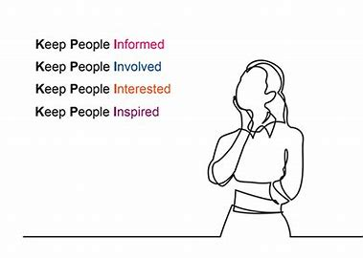

Within the public or a local authority setting, setting some of these performance measures gives structure to focus on risks, challenges, benefits, and overall organisational financial health. It includes aspects through quantitative data states that might incorporate numerical statistics, performance markers and financial records as well as qualitative data which in turn contains feedback, surveys, and observational insights.

One such non-financial performance measure that organisations use, and which is quite relevant, is the employee appraisal system. Such an approach allows us to set specific objectives, targets, and outcomes that staff and management agree on and provides an objective evaluation method. When leaders align individual performance with the delivery plan of the organisation, they can measure progress over time. This enables a more granular view of how successful the employees were in terms of their goals. It also highlights those areas that may require training and development, making certain that all employees have the skills and support to improve their productivity

One such non-financial performance measure that organisations use could be a staff survey, this can show an organisation commitment to creating a positive working environment. It can provide staff the opportunity to share their experiences and is a platform for suggestions on how to improve the workplace. According to HBR, the difference between a good and bad workplace survey is quite simply, is careful and informed design (Harvard Business Review, Morrel-Samuels 2002). When reviewing a staff survey to measure organisation performance. It is important to look at the numbers of people who complete the survey, share the results and from the results, pull ideas together to create a post survey action plan that demonstrates listening to employees.

The survey should be about the employees however, should like most data, should not be treated in isolation. If conducting a wellbeing survey, does it correlate with sickness absence rates? For example, is stress at work a theme in absence results and the wellbeing/workplace survey.

Financial performance measures are crucial on the other hand as they are intended to manage the resources of the organisation efficiently. This encompasses things like keeping budgets allocated properly and monitoring that spending does not exceed previously defined thresholds.

The success of a school is assessed based on student results, but other important non-financial measures should be considered. These include the Pupil-Teacher Ratio, Literacy, Numeracy, and Science Point scores. All of these non-financial performance measures are recorded and are easily accessible on the government website (my local school, gov, UK). This platform provides benchmarking data that allows schools and parents or carers to compare performance, that focuses on schools with similar eligibility levels of free school meals. This information provides stakeholders with an understanding how their child(ren) might perform. However, it is important to note that this data should not be used in isolation, as a school's budget position can also influence its performance. Local authorities and schools are responsible for providing financial statements to the public. This data can also be found on the government website and the annual Governors report to parents. The statements provide a horizontal analysis of the costs involved in running a school. The financial performance data enables schools and local authorities to compare spending with that of other similar settings while also linking this to the non-financial data mentioned earlier. As HR professionals, we can support a school leadership team by supporting processes to meet the established benchmark that suggests an ideal staffing cost ratio of 80% to the overall budget.

Through careful monitoring of financial metrics, companies can assess their fiscal well-being and that they are functioning optimally. Such checks not only help ensure the sustainability of the organisation itself but also provide insights on how one should plan and deploy resources. Therefore, both financial and non-financial measures are vital for creating a more dynamic view of organisational performance to initiate improvements.

AC3.2 Adding Value

People are a fundamental component of any organisation, playing a key role in influencing its overall success. The relationship that organisations have with their employees is linked with their core values and how they treat their workforce. When organisations prioritise a supportive and respectful environment, employees are more likely to respond favourably to these values, which fosters a sense of commitment and engagement.



Effective people practice within organisations is crucial for supporting managers in their efforts to create and maintain a positive work atmosphere. These practices encompass adherence to established policies that protect both the employer and the employees, ensuring a safe and fair workplace.

Human Resources (HR) departments have evolved significantly over the years. Initially focused on handling administrative tasks such as providing contracts and managing payroll, whereas they now play a vital role in organisational development. (Lattimer, 2024)

This shift now highlights the importance of employee welfare, talent management, and strategic planning in driving organisational success. The CIPD Profession Map has been designed to guide professionals within the people sector, offering a comprehensive framework for best practices.

CIPD advocates for a structured approach to people analytics, recommending a nine-step process that guides organisations from initial planning through to evaluation/appraising people practices. This structured methodology allows organisations to address their people management strategies and assess their effectiveness.

People's practices help in times of conflict with support of policies and procedures and providing guidance to managers on effective team leadership. By adopting these strategies, organisations can enhance employee loyalty, increase engagement levels, and build trust, all of which contribute to improved performance and productivity on both sides of the employment relationship.

To effectively measure the impact of people's practices, organisations can utilise several analytical methods. One common approach is cost-benefit analysis, which involves reviewing the costs associated with training, recruitment, and other human resource activities, and comparing them to the tangible and intangible benefits these initiatives yield (Bailey et al., 2018).
Another important method is the return on investment (ROI) framework, which provides outcomes generated from specific people practice activities compared to the invested resources. This analysis can consider all associated costs and gives them the anticipated results or advantages gained (Bailey et al., 2018).

Such evaluations are crucial for HR departments, as they assist in justifying their investments and strategies, in turn demonstrating the overall value of their contributions to the organisation.

In conclusion, organisations committing to the continuous improvement of their human resources can position themselves advantageously for long-term success and sustainability. This also emphasises a culture of development and support not only benefits employees but also aligns with organisational goals, enhancing the workplace environment.

Part 2: Performance Data
Regular performance reviews provide feedback on how individuals are contributing to an organisation's objective, where the strengths are and where there is room for improvement.

Assumptions
The following information is based on the assumption that those absent did not meet the requirements for meeting the KPI, for example, Sally Starling was absent in Quarter 1 and no longer in employment in Quarter 2 and that all employees who received a bonus worked full time, as while part time employees should not be treated any differently to full time colleagues, they would receive a pro-rata of a bonus, unless there was a justification for why they should. (ACAS, 2024)

Findings
The survey results provide a good insight for the company’s contribution to employee growth, and also allows the company to make an informed decision about potential bonus payments. There is no legal requirement for an employer to provide a bonus, however it can help keep employees engaged and motivated, recognise and reward an employee’s performance and also retain staff.

 | Number of employees in each dept
Admin | 11
Logistics | 20
Research | 10
Sales | 13

An evaluation of the company’s Q1 and Q2 performance has been published and indicated that across all four departments.
- Based on 54 members of staff (breakdown of number of employees in each department can be found above)
- It assumed, 53, were eligible for a bonus payment in Quarter 1 (one person was absent) and 50 in Quarter 2, (three members of staff absent and one assumed to have left)
- 9 have achieved an ‘Outstanding’ judgement in Quarter 1 and 11 in Quarter 2, and similar pattern for those who met their individual KPI’s (26 in Quarter 1 and 29 in Quarter 2).
- The Sales team were the only team that had no change to their performance (in both Quarters, all of the sales team met their individual KPIs. But did not qualify for a bonus.
- Out of the total amount of bonuses awarded, 47.2% of the bonus was awarded to the Research and Development department, followed by the 37.5% in the logistics department.
- 6 members of staff had a bonus awarded to them for Quarter 1 and Q2, 9 in total in Quarter 1 and 11 in Quarter 2.
- The table below indicates the breakdown by each team performance 30% of the Research team having equal split of outstanding, meeting individual KPI’s and 30% also underperforming in Quarter 1, but in Quarter 2 shows an improvement where 50% had outstanding followed by 30% meeting individual KPIs and only 10% ‘not quiet there’. However, due to the different sizes of the teams, this would not be a good way to measure performance,

 | % of Team Q1 Outstanding | % of Team Q1 -Meet set Ind. KPI | % of Team Q1 -Not quite there | % of Team Q1 -Under-performing | % of Team Q1 - Absent
Admin | 18% | 18% | 27% | 27% | 9%
Logistics | 20% | 40% | 30% | 10% | 0%
Research | 30% | 30% | 10% | 30% | 0%
Sales | 0% | 100% | 0% | 0% | 0%

 | % of Team Q2 Outstanding | % of Team Q2 -Meet set Ind. KPI | % of Team Q2 -Not quite there | % of Team Q2 -Under-performing | % of Team Q2 - Absent
Admin | 10% | 40% | 40% | 10% | 0%
Logistics | 25% | 45% | 20% | 0% | 10%
Research | 50% | 30% | 10% | 0% | 10%
Sales | 0% | 100% | 0% | 0% | 0%

 | Quarter 1 |  |  |  |  | Quarter 2
 | Q1 Outstanding | Q1 -Meet set Ind. KPI | Q1 -Not quite there | Q1 -Under-performing | Q1 - Absent | Q2 -Outstanding | Q2 -Meet set Ind. KPI | Q2 -Not quite there | Q2 - Under-performing | Q2 –  Absent
Administration | 2 | 2 | 3 | 3 | 1 | 1 | 4 | 4 | 1 | 0
Logistics | 4 | 8 | 6 | 2 | 0 | 5 | 9 | 4 | 0 | 2
Research | 3 | 3 | 1 | 3 | 0 | 5 | 3 | 1 | 0 | 1
Sales | 0 | 13 | 0 | 0 | 0 | 0 | 13 | 0 | 0 | 0
TOTALS | 9 | 26 | 10 | 8 | 1 | 11 | 29 | 9 | 1 | 3

- The total bonus amounts are as follows:

Dpt. | Salary | Q1  4% Award | Q2  4% Award | Total  Qs 1&2 | Total per Dpt.
Administration | £31,500.00 | £1,260.00 | £0.00 | £1,260.00 | £3,180.00
Administration | £24,000.00 | £960.00 | £960.00 | £1,920.00 | £3,180.00
Logistics | £23,750.00 | £0.00 | £950.00 | £950.00 | £7,790.00
Logistics | £23,750.00 | £0.00 | £950.00 | £950.00 | £7,790.00
Logistics | £23,750.00 | £950.00 | £0.00 | £950.00 | £7,790.00
Logistics | £26,000.00 | £0.00 | £1,040.00 | £1,040.00 | £7,790.00
Logistics | £19,500.00 | £780.00 | £780.00 | £1,560.00 | £7,790.00
Logistics | £19,500.00 | £780.00 | £0.00 | £780.00 | £7,790.00
Logistics | £19,500.00 | £780.00 | £780.00 | £1,560.00 | £7,790.00
Research | £32,500.00 | £1,300.00 | £1,300.00 | £2,600.00 | £9,800.00
Research | £32,500.00 | £0.00 | £1,300.00 | £1,300.00 | £9,800.00
Research | £29,500.00 | £0.00 | £1,180.00 | £1,180.00 | £9,800.00
Research | £29,500.00 | £1,180.00 | £1,180.00 | £2,360.00 | £9,800.00
Research | £29,500.00 | £1,180.00 | £1,180.00 | £2,360.00 | £9,800.00
 |  | £9,170.00 | £11,600.00 | £20,770.00

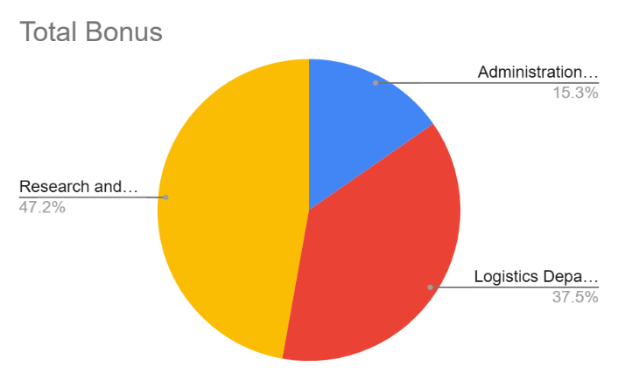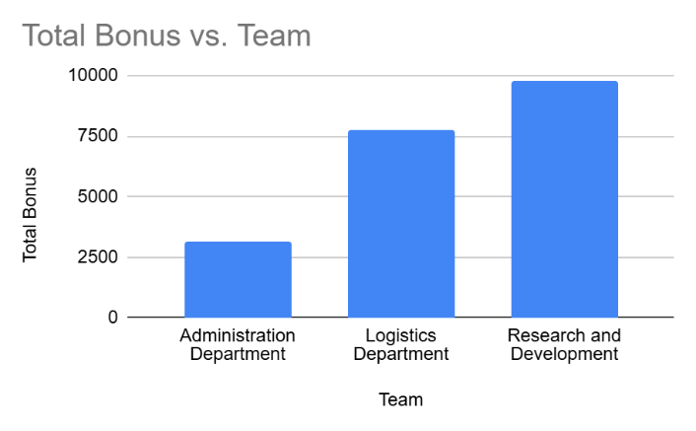

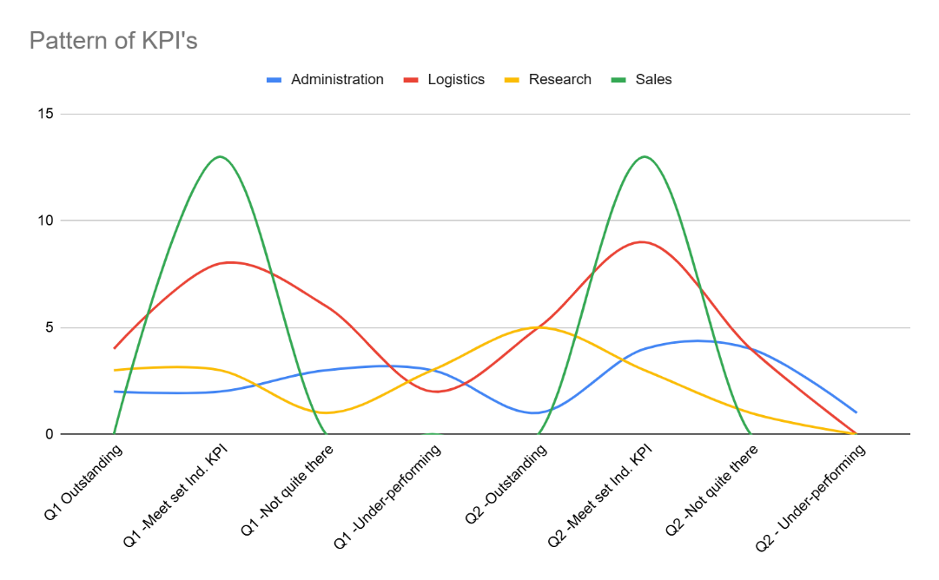

Part 2: Staff Survey

A recent staff survey closed where 235 employees and 50 managers provided feedback on their views of the organisation’s approach to monitoring performance from both the manager and employees perspective, this allows the organisation to identify potential training and constructive feedback for managers and for both managers and employees to have a say on their experience and expectations.

The overall headline results are in the table(s) below:

Table 1 - (Employees)

 | Strongly agree | Agree | Disagree | Strongly disagree
During my reviews my line manager listens to the ideas I put forward | 2.13% | 5.01% | 26.26% | 2.58%
My line manager has time to listen to me | 35.74% | 10.15% | 2.11% | 36.77%
My line manager possesses good people management skills | 6.38% | 12.72% | 12.50% | 20.65%
My line manager provides a balanced response when conducting my reviews | 0.00% | 18.38% | 12.92% | 0.00%
My line manager provides clear and direct guidance | 0.85% | 14.27% | 16.99% | 0.65%
My line manager provides me with constructive feedback | 29.36% | 8.35% | 7.87% | 29.03%
My line manager provides me with learning and development opportunities so I can do my job better | 22.98% | 12.98% | 9.83% | 6.45%
My line manager provides positive feedback | 2.55% | 18.12% | 11.52% | 3.87%

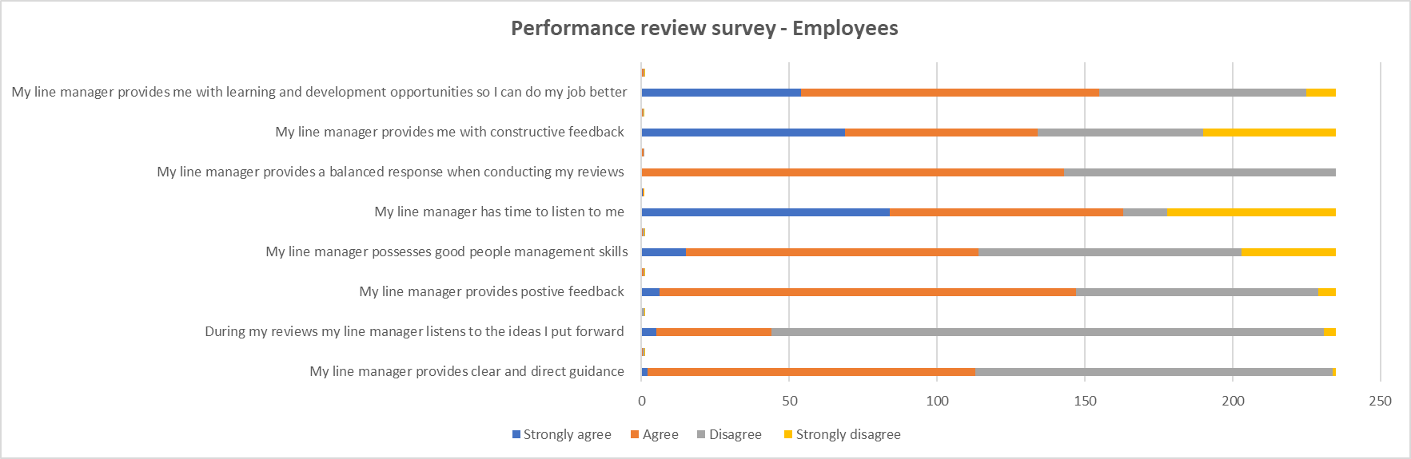

Table 2 (Managers)

Column 1 | Strongly agree | Agree | Disagree | Strongly disagree
I feel confident in carrying out a performance appraisal | 13.79% | 17.74% | 15.33% | 2.13%
I have had training to enable me to undertake appraisals | 0.00% | 0.00% | 29.33% | 12.77%
I have no concerns when applying ratings when conducting appraisals | 24.14% | 27.42% | 6.00% | 0.00%
I have no issue in challenging underperforming employees | 0.00% | 7.26% | 24.67% | 8.51%
I'm confident that I'm able to assess employee’s performance fairly | 10.34% | 20.97% | 7.33% | 21.28%
I'm given time to prepare to for employee appraisals | 10.34% | 23.39% | 7.33% | 14.89%
I'm good at providing feedback and agree set performance targets | 41.38% | 3.23% | 10.00% | 40.43%

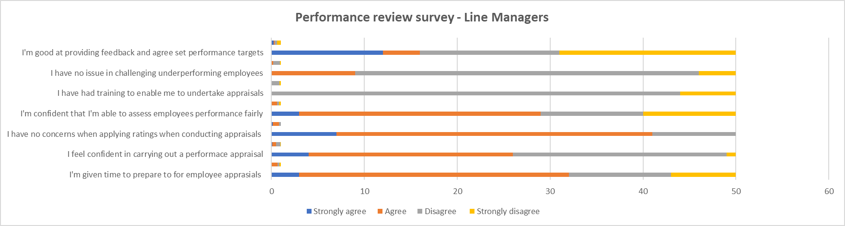

Findings:
The majority of employees do not feel that their line managers listens to their ideas which could be supported by managers saying they have not had training to enable them to undertake appraisals however, managers then say they do not have any concerns when conducting appraisals.

Employees feel that their line manager provides constructive feedback and offers learning and development opportunities, however managers do not feel they are good at provisioning feedback to set performance targets and also not confident in challenging underperforming.

Recommendations:
The recommendations could be to provide additional training for line managers to ensure managers know their duties and key responsibilities for line managing staff, as there are discrepancies between what the managers think and how the employees feel. For example, the majority of employees feel that line managers do not listen or possess good management skills, or that they give clear guidance. This can be supported by line managers saying they have not had training, and they are not confident in challenging underperformance or giving feedback and performance targets.

By having a whole organisation approach to managing performance, allows the company to manage risks such as poor culture, supports both employees and line managers in their roles and allows both to focus on planning activities monitoring progress while working towards the same objectives.

Bibliography
Academy to innovate HR. Available at: Free PESTLE Analysis Templates and Actionable Guide - AIHR (Accessed 24 January 2025)
Bell, M. (no date) Understanding the Three Stages of Change, MindTools. Edited by C. MacLeod.
Barends, E., Rousseau, DM. and Briner RB. (2014). Evidence-Based Management: The Basic Principles. Centre for Evidence-Based Management. Available at:
https://cebma.org/assets/Uploads/Evidence-Based-Practice-The-Basic-Principles.pdf (Accessed: 15 November 2024)

Committee on Standards in Public Life (1995) The Seven principles of public life, GOV.UK. Available at: https://www.gov.uk/government/publications/the-7-principles-of-public-life (Accessed: 22 November 2024)
CIPD (2015) Ethical decision-making: Eight perspectives on workplace dilemmas, CIPD: London
Available at: https://www.cipd.org/globalassets/media/knowledge/knowledge-hub/reports/ethical-decision-making-2015-eight-perspectives-on-workplace-dilemmas_tcm18-9564.pdf (Accessed: 15 November 2024)

CIPD (2024 a) Evidence-based practice for effective decision-making, CIPD: London
Available at: https://www.cipd.org/uk/knowledge/factsheets/evidence-based-practice-factsheet/
(Accessed: 10 November 2024)

CIPD (2024b) PESTLE analysis, CIPD: London Available at: https://www.cipd.org/uk/knowledge/factsheets/pestle-analysis-factsheet/ (Accessed: 13 November 2024)

CIPD (2024d) Ethical practice and the role of people professionals, CIPD: London Available at: https://www.cipd.org/uk/knowledge/factsheets/ethics-role-hr-factsheet/ (Accessed: 18 November 2024)

CIPD Podcast 154: Critical thinking October 2019 Available at: https://soundcloud.com/cipd/podcast-154-critical-thinking (Accessed: 18 November 2024)

Critical Thinking | HRM Handbook https://hrmhandbook.com/core/critical-thinking/ 2021
Accessed: 18 November 2024

Harvard Business Review: Kaplan, R., S. and Norton, D.,P. (1992) Available at: https://hbr.org/1992/01/the-balanced-scorecard-measures-that-drive-performance-2
Accessed: 18 November 2024

Harvard business school. Available at: https://online.hbs.edu/blog/post/financial-statement-analysis (Accessed: 15 November 2024)

Lattimer, C. (2024) How to make sure Hr adds value to the business, People Development

MindTools, Available at: https://www.mindtools.com/ajm9l1e/lewins-change-management-model?from=shared-link (Accessed: 19 November 2024).

MindTools. Available at: https://www.mindtools.com/a23ewmr/force-field-analysis (Accessed: 19 November 2024)

Mangers.org. Available at: https://www.managers.org.uk/knowledge-and-insights/advice/top-models-for-effective-decisions/ (Accessed: 18 November 2024)

Mindtools. Available at: https://www.mindtools.com/aiplsat/how-to-make-decisions (Accessed: 15 November 2024)

My Local School. Available at: https://mylocalschool.gov.wales/ (Accessed: 21 January 2025)

Open University. Available at: Why riot? Community, choices, aspirations: Session 3: 2.1 | OpenLearn - Open University (Accessed 25 January 2025)
People Development,2019 at: https://peopledevelopmentmagazine.com/2019/05/01/hr-adds-value/ (Accessed: 18 November 2024).
Taylor, S. (2018) Resourcing and Talent Management CIPD: Kogan Page

Taylor, S. and Woodhams, C. (Eds) (2022) Studying Human Resource Management, A Guide to the Study, Context and Practice of HR, 3rd Ed, CIPD: Kogan Page

Taylor, S. and Woodhams, C. (Eds) (2022) Human Resource Management, People and Organisations, 3rd Ed, CIPD: Kogan Page

Waite, K., Beevers, K., Small, N., Tomlinson, K. and Hussain, S. (2021) People Practice A Complete Guide. CIPD: Kogan Page

