Hand rendered draft - 5 x spot brick repeat tile. This is a useful way to layout/compose a tile (technically repeating as a block, but could be worked as a drop, brick or other repeat system). This example has been worked as a brick repeat, repeating out in a brick bond pattern.
Draft: the first version of a design (not finished, but has the bones to become a finished outcome)

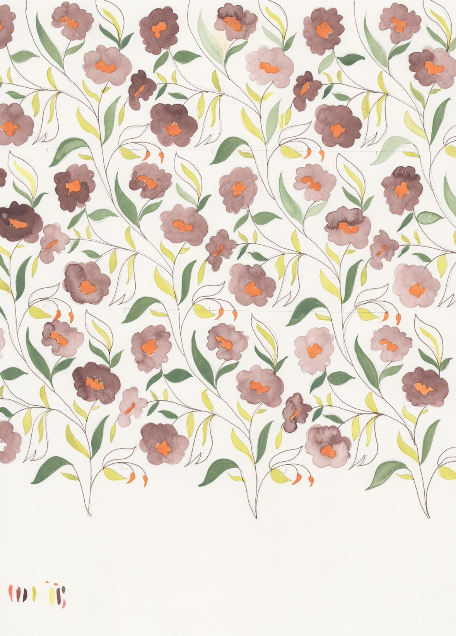
Original artwork ink

These pattern types can work well in a spot repeat layout, but are not limited to this method of repeat. Abstract, Fauna, Floral, Foliage, Geometric, Paisley, Scattered, Spot, Stripe, Toile de Jouy.

You can draft out a 5 spot repeat within the framework of a square or rectangle, something like this…

5 x spot tile layout (arrows indicate direction/ rotation of motif but can be used without)

5 x spot tile layout repeated out

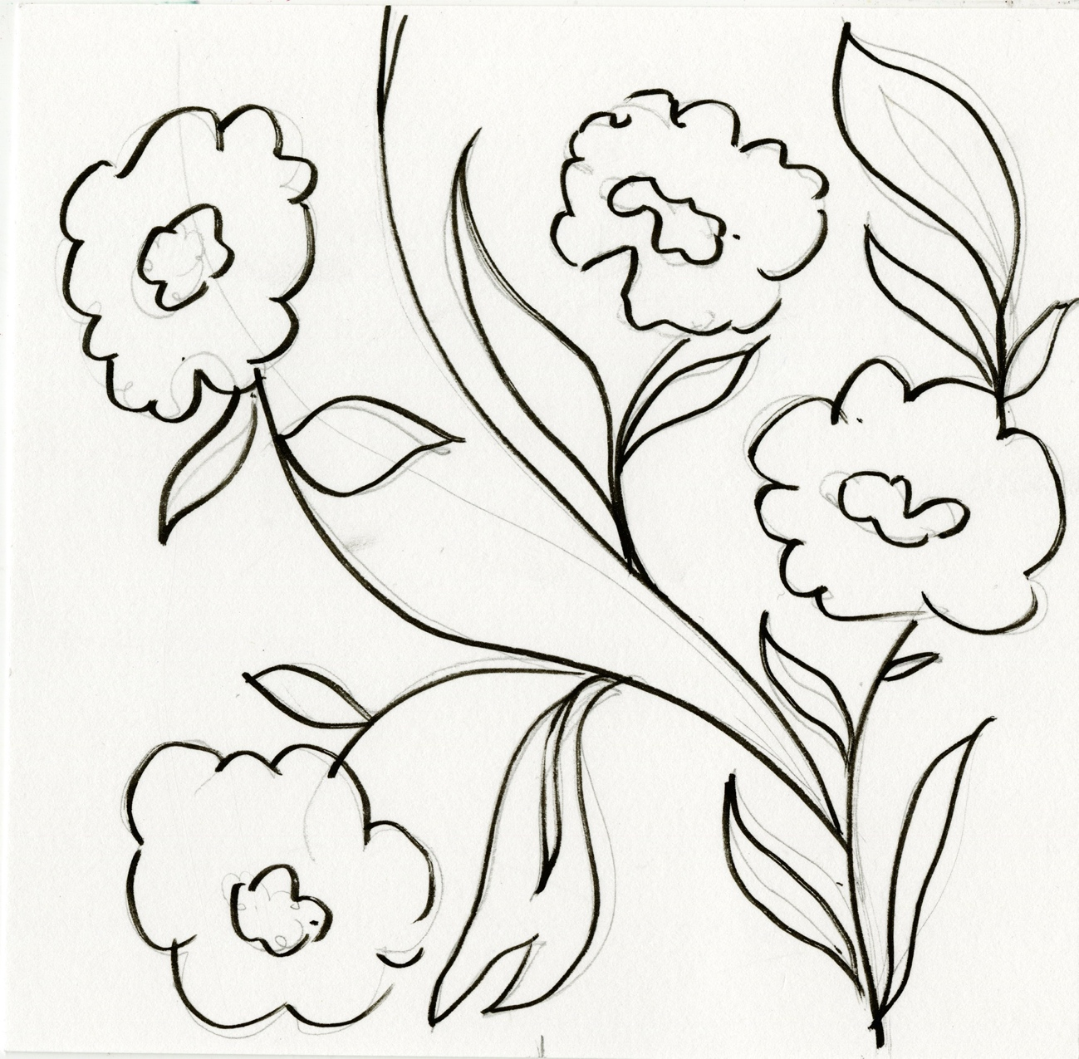
Hand rendered 5 x spot tile (draft) (notice only 4 spots used, the 5th appears in the final draft to fill in a bridge the gap, eliminating a blocky looking repeat).

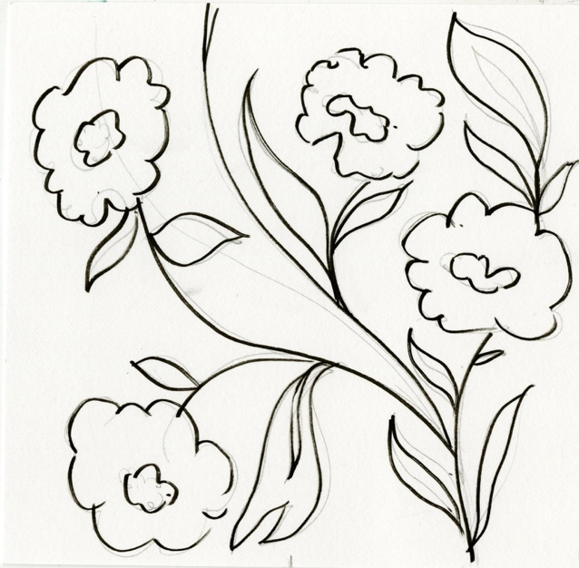
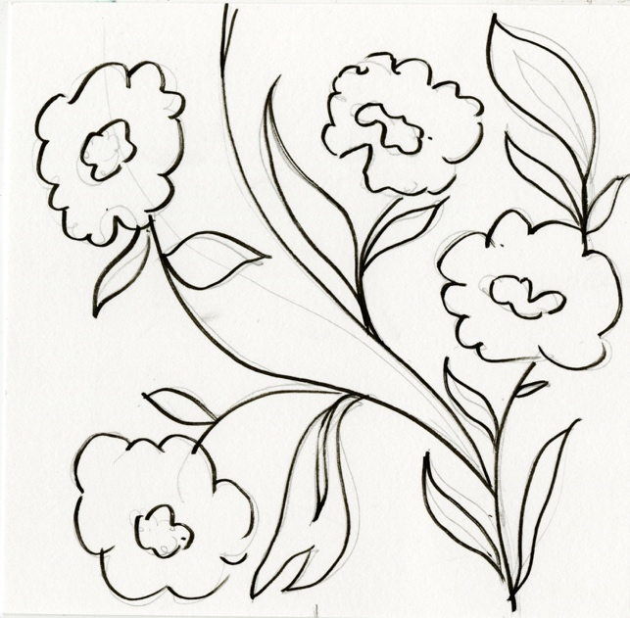

The draft pattern has also been worked so that it repeats out as a brick repeat network

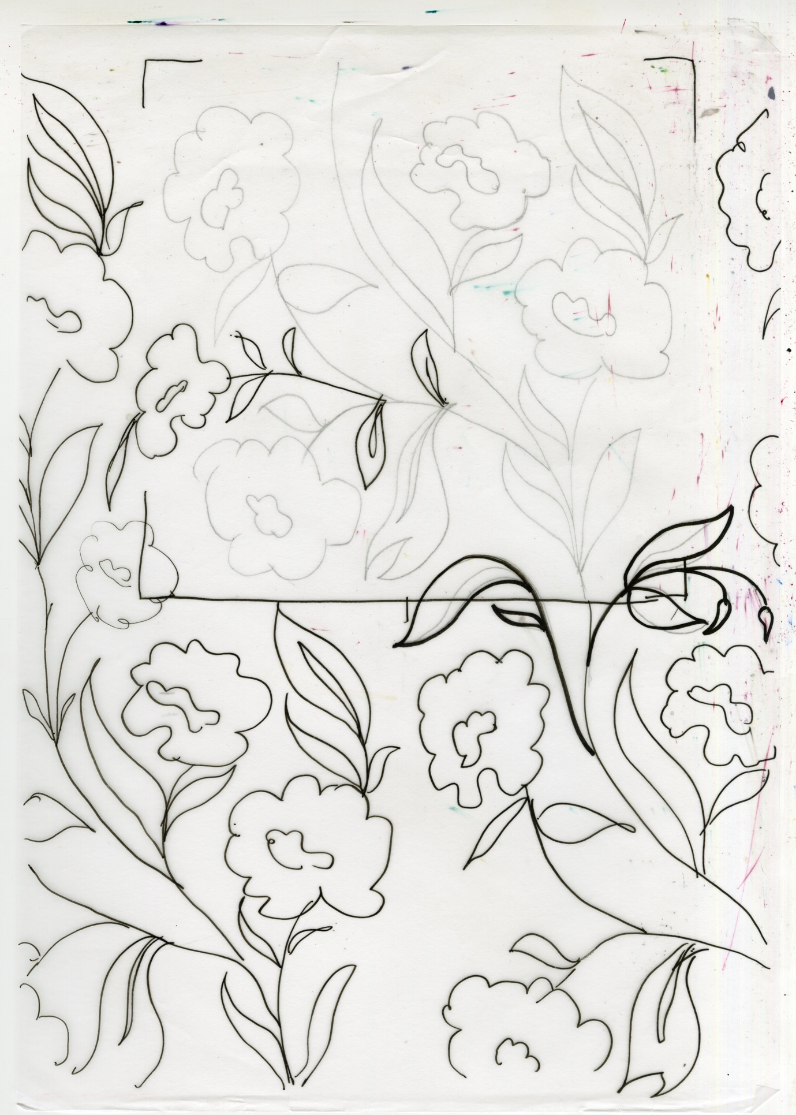

5th Spot has been drawn in, it falls over the edge of the original tile into the gap, creating a repeat that has a pleasing rhythm and flow
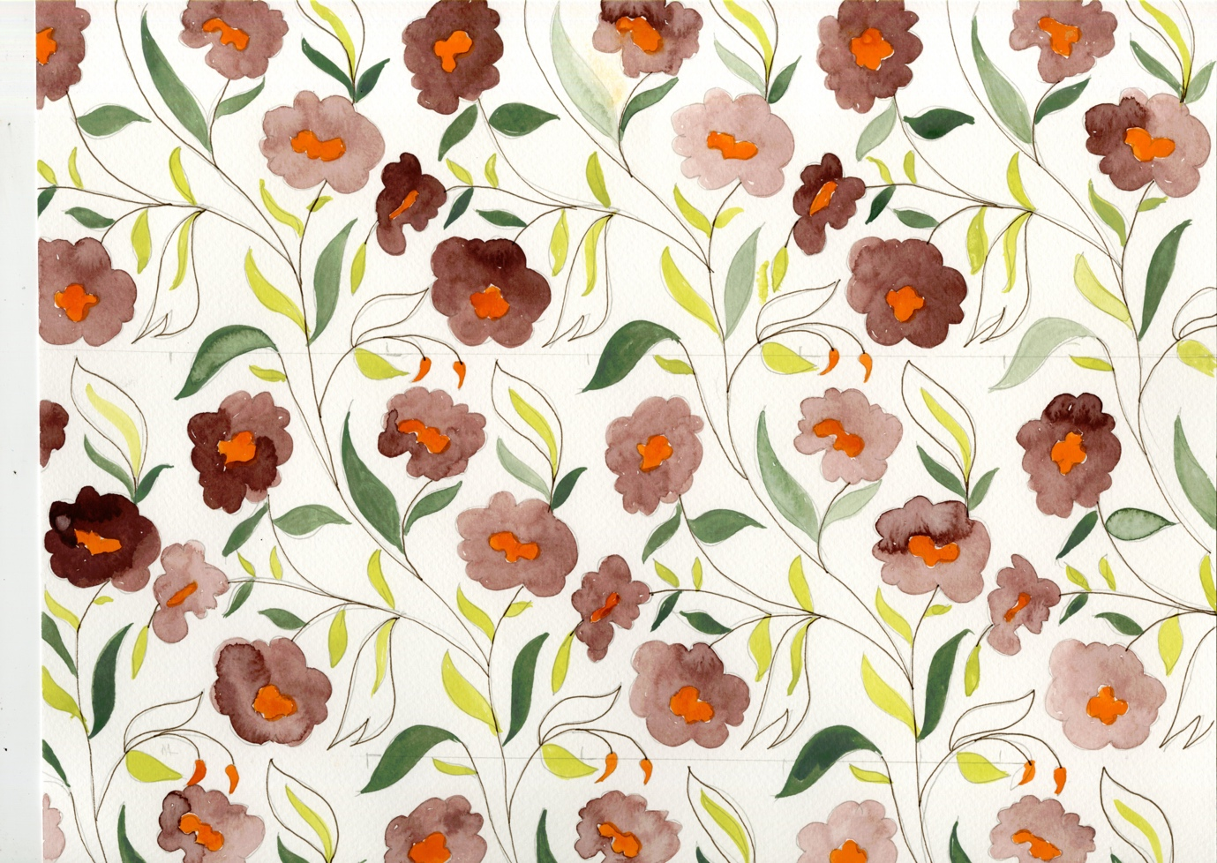
Hand rendered 5 x spot… drawn out and coloured with ink

