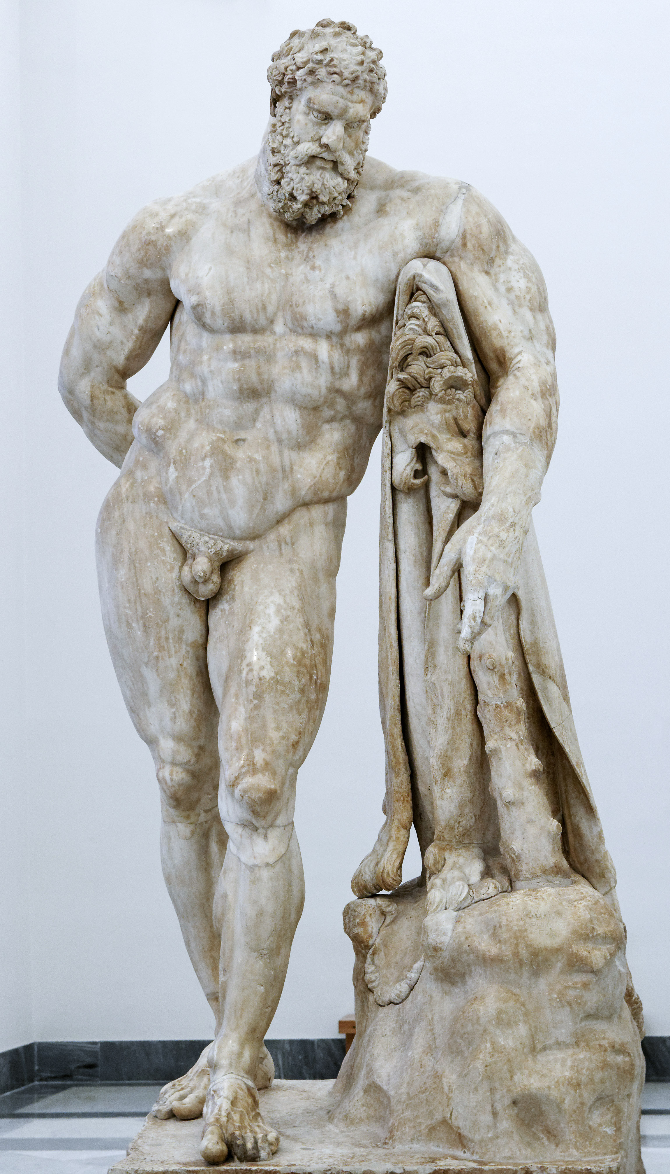
The Farnese of Hercules
Figure 1: A marble copy of Lysippos ‘Farnese of Hercules’, sourced from: https://commons.wikimedia.org/wiki/File:Herakles_Farnese_MAN_Napoli_Inv6001_n01.jpg
This statue was crafted by Lysippos, who is considered to be one of the greatest sculptors of the Late Classical period (Boardman, 1995), sometime between 350-300 BC. The original would have been cast in bronze using the lost-wax method (Hyde, 1907, p396), but it has since been lost to time and only Roman marble copies survive. The statue conveys Hercules in the late prime of his life after doing his 12 labours (Vermeule, 1975).
This statue was crafted by Lysippus, who is considered to be one of the last greatest sculptors of the Late Classical period (Boardman, 1995, p57), Sometime between 350-300 BC. The original would have been casted in bronze using the lost-wax method (Hyde, 1907, p396), but it has since been lost to time and only Roman marble copies survive (Boardman, 1995). This portrayal of Hercules is considered by scholars such as Boardman to be the most common way that Hercules is presented in ‘Greece’ during the 5th and 4th Century BC (Boardman, 1995), in the late prime of his life after the 12 labours (Vermeule, 1975).

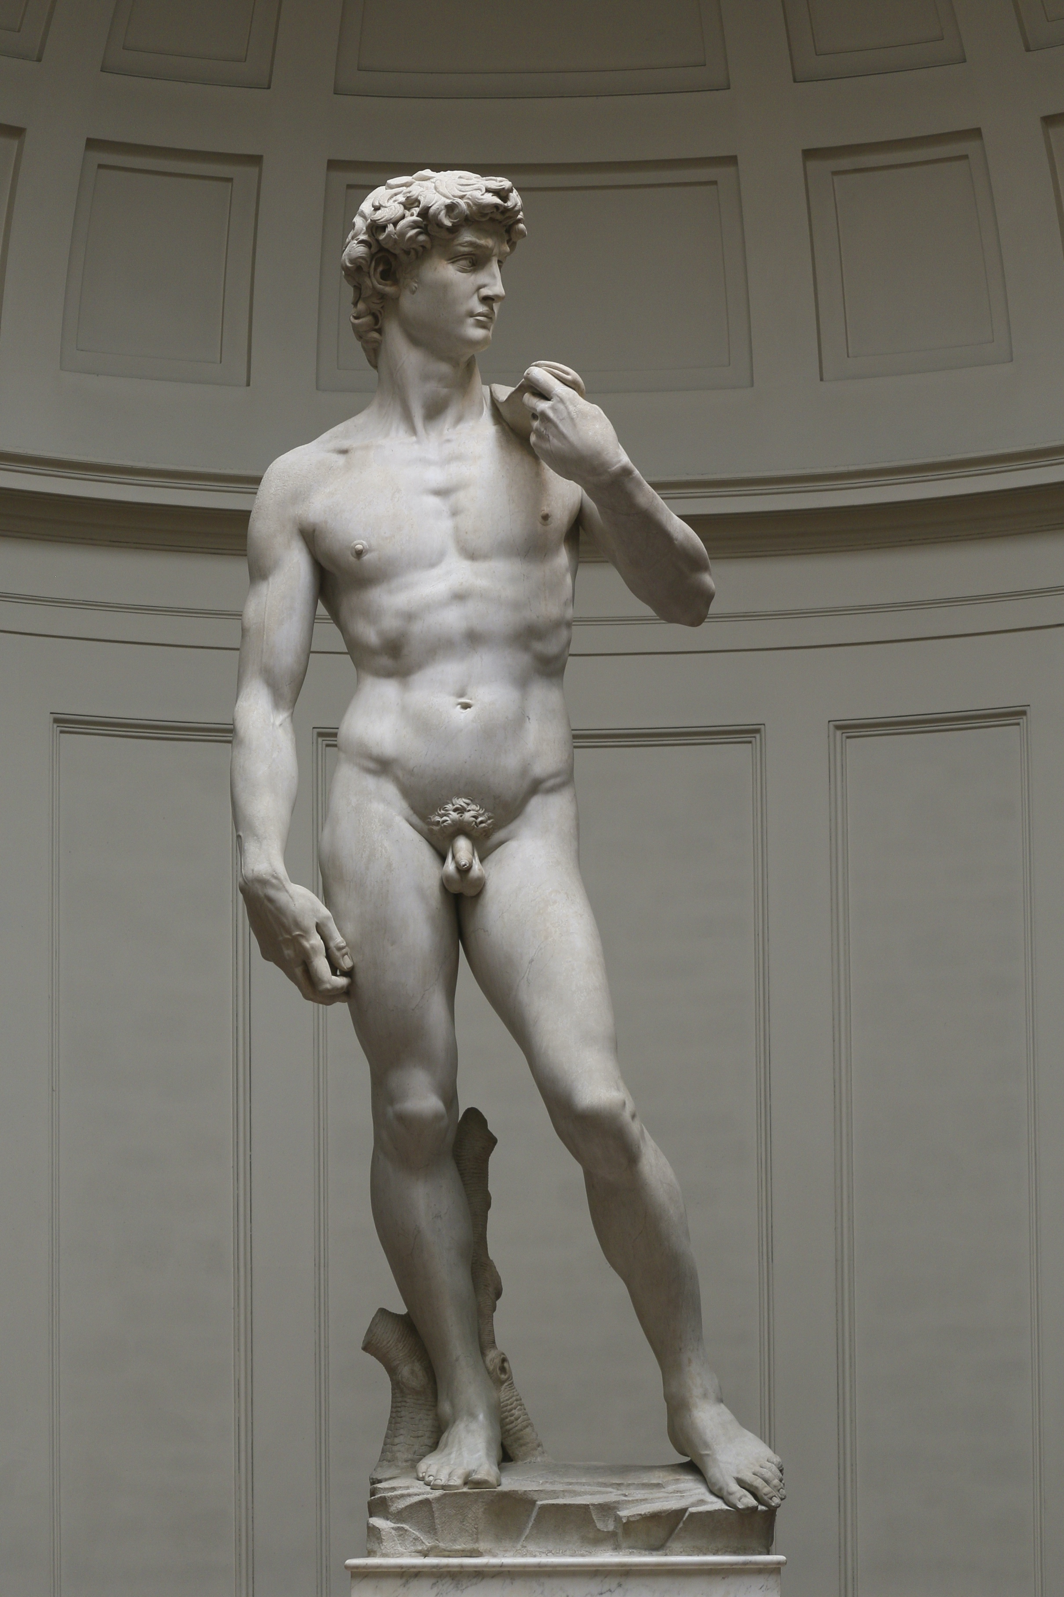
The statue is covered in symbolism, from ideal image to Hercules’ labours. Items relating to the labours can be seen around the statue: the Nemean Lion and the Golden Apples of the Hesperides (Vermeule, 1975). Also, the ideal male for the ‘Greeks’ (mainly Sparta) in the late classical period, are portrayed in this statue (Papadopoulou, 2004). Hercules’ masculinity is all for show in this statue and no area is left untouched from his chest to his genitals, which can be compared to the Homeric heroes such as Achilles and to Hercules own descriptions in the Classical Period (Papadopoulou, 2004). However, his appearance would also appeal to the Romans as well, as in late republic and Imperial era, this statue would have been placed in public baths and in areas where men would conduct sports and socialise (Papadopoulou, 2004). By now Hercules was still seen as a masculine figure but his image became more widespread and the statue helped change Roman sculpture as they moved away from Realism to Hellenistic (Boardman, 1995). Realism aimed to capture natural beauty of the human figure showing cuts, wrinkles, scars and imperfections (Boardman, 1995). But Hellenism was completely different and aimed to show youthfulness and no imperfections to humanity. Despite Hercules being old in this statue, seeing that it’s after the 12 labours, He still looks partially youthful with very little wrinkles and very masculine body (Boardman, 1995).

Compelling new evidence from examining at other bronze statues from the classical period, suggest that the original would have possibly been in colour (Boardman, 1995, pp11, 14). This changes our perception of Greek art as its been largely influenced by the Renascence (Boardman, 1995) which portrayed the statues without colour due to nearly over 1000 years of erosion and the paint falling off, so the statues they were studying were just bland with the original marble left (Boardman, 1995). However, this in turn sparked a huge revival in Hellenistic sculpture, which lead to sculptures such Michelangelo to craft his masterpiece, the statue of ‘David’ (Boardman, 1995). Nowadays, we are coming to terms that most marbled buildings and statues would have been a wash of colour and that the Ancient world was one of colour and not marble (Boardman, 1995).
Figure 2: Michelangelo’s ‘David’ in marble, created from 1501-1504 in Florence, Italy, sourced from: https://commons.wikimedia.org/wiki/File:%27David%27_by_Michelangelo_Fir_JBU002.jpg

Reference List:
Boardman J. (1995), ‘Greek Sculpture: The Late Classical Period’, London, Thames and Hudson Ltd

Hyde W.W. (1907) ‘Lysippus as a Worker in Marble: American Journal of Archaeology, Vol. 11, No. 4, pp. 396-416’, USA, Archaeological Institute of America, https://www.jstor.org/stable/496921, First Accessed: 31-01-2020 20:24 UTC

Papadopoulou T. (2004), ‘Herakles and Hercules: The Hero's Ambivalence in Euripides and Seneca’, Mnemosyne, Fourth Series, Vol. 57, Fasc. 3, pp. 257-283, Brill, https://www.jstor.org/stable/4433556, Accessed: 07-02-2020 11:10 UTC

Vermeule C. (1975), ‘The Weary Herakles of Lysippos: Source: American Journal of Archaeology, Vol. 79, No. 4, pp. 323-332’, USA, Archaeological Institute of America, https://www.jstor.org/stable/503065, Accessed: 31-01-2020 20:35 UTC

