



ACFA7004 Research Methods and Professional Development
2231139 - Jenishkumar Paghadar UNIVERSITY OF WALES TRINITY SAINT DAVID - Wales Institute of Science and Arts - School of Applied Computing
CYBERSECURITY RISKS In Artificial Intelligence

Contents

Contents 1
Tables And Figures 2
Abstract 3
1. Introduction 4
2. Background 6
2.1 Malicious AI: 6
3. Problem Area 8
3.1 Research Questions: 8
4. Literature Review 9
3.1.1 most significant cybersecurity risks associated with AI? 12
3.1.2 How do these risks differ across different AI applications and industries? 14
3.1.3 What are the current mitigation strategies for addressing these risks? 18
3.1.4 How effective are these mitigation strategies in practice? 18
5. Methodology 21
6. Time Horizons (Gannt chart) 22
7. Results 23
8. Evolution 24
9. Conclusion 25
Bibliography 26

Tables And Figures
Fig. 1.0. Evolution of computer crime towards the use of ICT and AI technologies. 6
Fig. 2.0. The Concept of Artificial Intelligence 9
Fig. 3.0. Attack percentages from the total number of records 11
Fig. 4.0.Traditional Targeted Cyberattack Decision Logic. 13
Fig. 5.0. DNN Cyberattack Decision Logic. 13
Fig. 6.0 Planning Chart 22

Abstract
Cyberattacks are becoming more frequent and sophisticated. Artificial Intelligence (AI) techniques are unavoidably being adopted by cybercriminals in order to hide in cyberspace and inflict more harm undetected. The concept behind Cybersecurity risks in AI is to prevention and making secure automation-based industry data. introduction and background explore overview of past and current cyberattacks happen due to not using high protection and using weak framework in the A.I system. How it is important to build matrix and encrypted techniques should be used to protect public and privet confidential information covered in the literature review. If the proposed area has been not analysed, how big amount of price need to pay by nations like cyberwar. Many research methods can be used to collect prevention techniques. The Conclusion describe changes in framework of artificial intelligence and impose strict law on threating tools sufficiently the level of sophistication this kind of attack possesses.

1. Introduction
Artificial intelligence (AI) has significantly advanced and benefited from its incorporation into a number of sectors and facets of our life. But, as AI spreads and grows more sophisticated, it also presents fresh and new cybersecurity vulnerabilities. These dangers arise from the weaknesses that AI systems have by nature as well as the potential for bad actors to take advantage of these weaknesses. To maintain the safety and security of AI systems and the sensitive data they process, it is vital to comprehend and manage these concerns. In the proposal, we will examine some of the most significant cybersecurity dangers posed by AI and suggest potential countermeasures.
The potential cybersecurity risks associated with AI can be categorized into several categories. Adversarial attacks, for example, involve the manipulation of AI systems to produce incorrect results. Data breaches, on the other hand, can compromise sensitive information stored within AI systems, such as patient health data and financial information. Algorithmic bias can lead to discriminatory outcomes in AI applications, such as in hiring or lending decisions. Other potential cybersecurity risks associated with AI include the misuse of personal information, intellectual property theft, and the creation of deep fakes. [1]
The consequences of these cybersecurity risks can be significant for both individuals and organizations. For instance, a malicious actor could manipulate an AI system to produce incorrect medical diagnoses, leading to serious harm to patients. A data breach could compromise sensitive financial information and result in significant financial losses for organizations. [2] The misapplication of AI could also result in discrimination against certain groups and perpetuate existing societal biases.
To address these risks, it is essential to understand the potential vulnerabilities and attack vectors that exist within AI systems. It is also necessary to identify effective mitigation strategies to prevent and address these risks. Such strategies could include incorporating security measures during the development process, using explainable AI models, and implementing regulatory frameworks to ensure transparency and accountability. [3]
The literature on cybersecurity risks in AI has already identified these risks and mitigation strategies. However, there is a need for a comprehensive study that examines the various risks and mitigation strategies in greater depth. This research proposal aims to address this gap by providing a comprehensive examination of the cybersecurity risks associated with AI and identifying effective mitigation strategies to address these risks.
The proposed study will involve a comprehensive review of the literature on cybersecurity risks in AI, with a focus on identifying the most significant risks and mitigation strategies. The results of this study will provide insights into the most significant cybersecurity risks associated with AI and identify effective mitigation strategies for addressing these risks.
Overall, this study is essential as AI continues to gain prominence in various industries and our daily lives. By identifying and mitigating cybersecurity risks associated with AI, we can ensure that this technology is used responsibly and ethically. that its potential benefits are realized while minimizing harm to individuals and organizations.

2. Background

2.1 Malicious AI:
Attack capabilities are enhanced and speed and success rates are increased when AI is used maliciously. AI and information and communication technologies (ICTs) make it easier to commit crimes and create a new threat landscape where new criminal strategies can be implemented. The authors of the report on malicious AI [4] issued a cautionary note regarding the shifting threat landscape caused by malicious applications of AI technologies. Rule-based techniques and machine learning-based techniques, which enable computer systems to learn from a large amount of data, are broadly distinguished in the AI field. Cybercriminals figure out how to utilize simulated intelligence advances and upgraded learning ways to deal with their advantage and weaponize them via robotizing the assault cycle. The shift toward AI technologies with learning capabilities, such as genetic algorithms [5], reinforcement learning [6], support vector machines [7], and deep learning [8], may have unintended effects, such as making it easier to commit crimes. The progression of computer crime toward the use of ICT and AI technologies is depicted in Figure. 1.0 Due to the "anonymity" of cybercrime, the absence of geographical boundaries, less pronounced legal restrictions, and the convenience of technologies, technological advancements provide new opportunities to commit crimes.

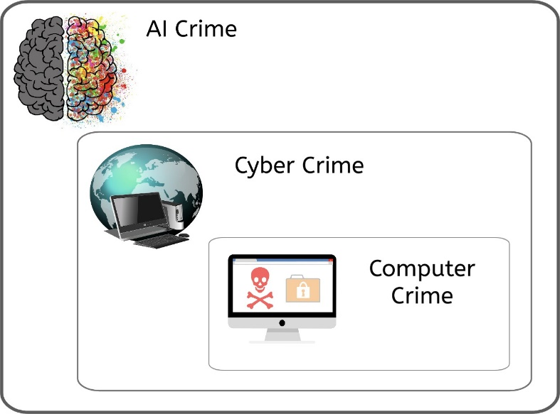

Fig. 1.0. Evolution of computer crime towards the use of ICT and AI technologies.

In order to take the appropriate defensive measures, it is becoming increasingly important to be aware of emerging cybercrime trends. In light of how the wrongdoing is carried out, we can group it as a PC wrongdoing when it is completed with the utilization of a PC and as a digital wrongdoing when it is completed with the utilization of an organization. Along with cybercrime, AI can support cybercriminal activities without human intervention through, for example, automating fraud and data-based learning. In the context of CPS, recent papers discussed advanced threats against CPS from a different level of sophistication: an indirect self-learning attack on well-hardened computing infrastructure by compromising the cyber-physical control systems [9], While another study [10]presented a framework to build cyber-physical botnets attacking a water distribution system (CPS), but without learning aspects involved in this attack model. Therefore, Smart cyber-physical system is a potentially fruitful area for committing artificial intelligence crimes (AIC) [11] due to the decision-making and interconnectivity features.

3. Problem Area
The use of AI has grown rapidly over the past few years, and this growth has been accompanied by an increase in cybersecurity risks. The development and use of AI systems have led to new vulnerabilities and attack vectors that can be exploited by malicious actors. Additionally, AI algorithms can be biased, leading to discrimination and unfair treatment of certain groups. These issues have significant implications for both individuals and organizations and require careful consideration and proactive measures to mitigate the risks.
Adversarial attacks: AI systems are susceptible to No attacks, in which the attacker deliberately modifies input data to influence the system's outputs in a damaging direction. For AI-based security systems like facial recognition or malware detection technologies, this might have major repercussions.
Privacy and protection of sensitive data: Since AI mainly relies on data, maintaining privacy and protection of sensitive data is essential. Data breaches can result in major losses in money and reputation, as well as legal repercussions.
Fairness and bias: AI systems may exhibit biases inherent in the data they are trained on, which may lead to unjust or discriminating conclusions. This is especially problematic when it comes to security-related applications since poor or biased judgment could have catastrophic repercussions.

3.1 Research Questions:
    - What are the most significant cybersecurity risks associated with AI?
    - How do these risks differ across different AI applications and industries?
    - What are the current mitigation strategies for addressing these risks?
    - How effective are these mitigation strategies in practice?

4. Literature Review
AI is a new type of technological science that investigates and develops the theories, methods, technologies and application systems to simulate, improve and upgrade human intelligence. AI is created to enable machines to reason like a human being and to endow them with intelligence. Today, the connotation of AI has been greatly broadened, making it an interdisciplinary subject. As shown by Fig. 2.0

Fig. 2.0 The Concept of Artificial Intelligence
Machine learning (ML) is apparently one of the major focuses of this interdisciplinary subject. According to the definition by Tom Mitchell, the so-called “the godfather of global ML”, machine learning is described as: with respect to certain type of tasks T and performance P, if the performance of a computer program at tasks in T improves with experience E as measured by P, then the computer program is deemed to learn from experience E. It is a relatively simple and abstract definition. However, as our perception on the concept deepened, we may find that the connotation and denotation of machine learning will also change accordingly. It is not easy to define machine learning that precisely in only one or two sentences, not only because that it covers a wide span of fields in terms of theory and application, but also it is developing and transforming quite rapidly.
Generally speaking, the processing system and algorithms of machine learning make predictions mainly by identifying the hidden patterns from data. It is an important sub-field of AI, and AI is intertwined with data mining (DM) and knowledge discovery in database (KDD) in a broader sense. [12]
AI technology is multi-layered, running through technical levels such as applications, algorithms, chips, devices, and processes, as shown in Fig. 2.0. AI technology has achieved the following developments at all technical levels.
- Application-Level Video and Image: face recognition, target detection, image generation, image retouching, searching the image by image, video analysis, video review, and augmented reality (AR). Speech and voice: speech recognition, speech synthesis, voice wake-up, voiceprint recognition, and music generation. Text: text analysis, machine translation, human-machine dialogue, reading comprehension and recommender system. Control: autonomous driving, drones, robots, industrial automation.

- Algorithm Level Machine learning algorithms: neural network, support vector machine, K-nearest neighbour algorithm, Bayesian algorithm, decision tree, hidden Markov model, ensemble learning, etc. Deep learning is one of the most essential technologies for machine learning. The deep neural network is a hotspot of research in this field in recent years.

- Chip Level: Algorithm optimization chips: performance optimization, low power consumption optimization, high-speed optimization, and flexibility optimization such as deep learning accelerator and face recognition chip. Neuromorphic chips: bionic brain, biological brain-inspired intelligence, imitation of brain mechanism.
Programmable chips: taking flexibility, programmability, algorithm compatibility, and general software compatibility into consideration, such as digital signal processing chips, graphics processing units, field programmable gates array.

As it is evident from the definition of AI, machine learning or deep learning, the discussed technologies work on the basis of collected data. These can often constitute personal data, resulting in the application of a legal framework for the protection of personal data. In addition, such a relatively large flow of information may pose a security risk in terms of
cyber security and it is therefore appropriate to place this technology in the legal framework of cyber security [13]. Moreover, AI represents an important asset, which has significant value for the holder (organisation, manufacturer, developer, etc.) and therefore it is necessary to protect it. The cyberattack itself can target AI (e.g., on an autonomous vehicle to obtain the processed data). From another perspective, many cyberattacks are carried out through the use of AI, which means that the AI itself is a threat [14]. The AI can create a new and efficient malicious code (such as malware) that can learn and adapt to mount other attacks. Next to this, an AI based on an incorrect algorithm can also cause a certain level of vulnerability. In other words, an AI can stand as an asset, a threat, and a vulnerability. However, it is questionable to what extent AI ensures the integrity, confidentiality and availability of information and how it can contribute to ensuring a sufficient level of cyber security.

Fig. 3.0 Attack percentages from the total number of records



Injection 9% Ransomware 4%
DDoS 7%
XSS 2%

Password Cracking
8%
Backdoor 9% Scanning 1%
Benign 60%
The IoT dataset is one of the latest generated data- sets in the industry 4.0 world and was released in the year 2020 [15] [16] [17]. The dataset was constructed by the School of Engineering and Information Technology and the Cyber Range and IoT Labs of the University of New South Wales (UNSW) in Canberra, Australia, in cooperation with the Australian Defence Force Academy (ADFA) [18] [19] [20] [21]. The dataset was created for the industry 4.0 network that includes IoT and IIoT networks. The primary purpose of making this type of dataset was to evaluate the fidelity and efficiency of various cyber-security applications based on ML, DL, and AI. Fig.3.0 shows the percentages of each attack instance for all seven IoT devices from a total of 407,932 records. Note that Benign indicates normal traffic where no attack has occurred. [22]

3.1.1 most significant cybersecurity risks associated with AI?
    - Traditional Targeted Cyberattacks and AI-Driven Cyberattacks.
The traditional targeted cyberattack is a simplistic if-then conditional construct where it asks this question; is this a target? And if the answer is “No” the malicious program is going to end, and if the answer is “Yes” the malicious program is going to execute its attack [23]. Figure. 4.0 illustrates the decision logic of the traditional targeted attack. Since cybercriminals realized that cybersecurity experts are using sandboxes to analyse and combat these traditional targeted attacks, they are now transforming this simplistic form of the if-then conditional construct to a very convoluted and complicated decision logic using Deep Neural Networks (DNN). With the concept of DNN, malicious actors can decide whether to attack or not.
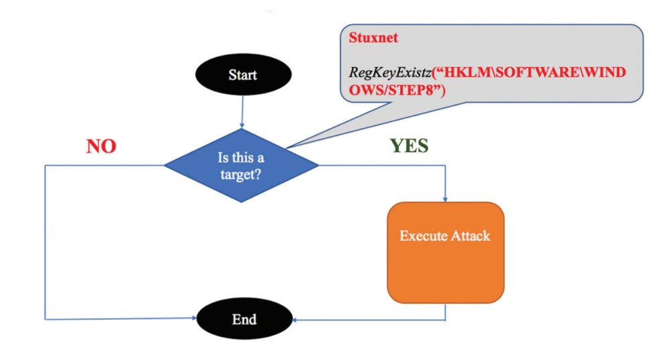
Fig. 4.0. Traditional Targeted Cyberattack Decision Logic.

The problem for the defender is that it will be extremely difficult to figure out what is the actual malicious code and what it is the right target [23]. Figure. 5.0 illustrates a DNN cyberattack decision logic.
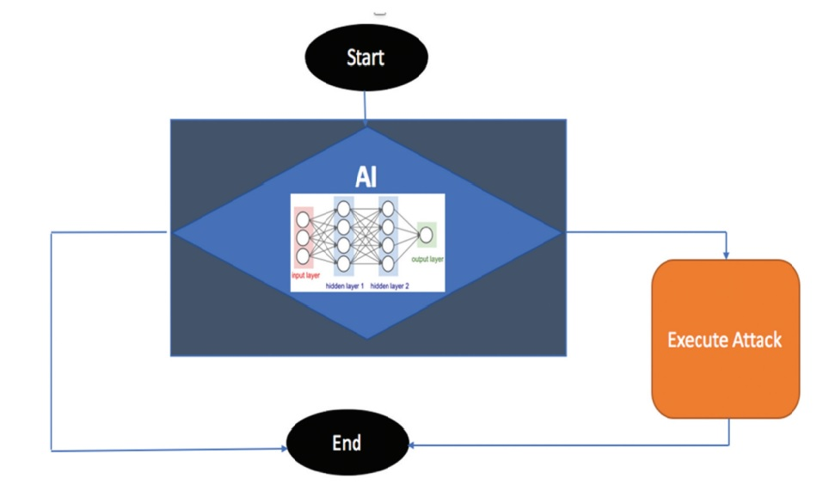
Fig 5.0.DNN Cyberattack Decision Logic.

- There are Different Attacks Describe Below: -

  - Data breaches: AI systems need a lot of data to work properly, and if that data is compromised, there might be serious privacy and security issues.
  - Attacks by malware: AI algorithms are susceptible to malware attacks that take advantage of flaws in the system and steal or lose data.
  - Adversarial attacks: Adversarial attacks entail changing the input data to an AI system in a way that leads to misclassification or inaccurate outputs, which can have major repercussions in sectors like healthcare and finance.
  - Insider attacks: Since AI systems are frequently incorporated into larger IT infrastructures, they may be at risk from insider threats, such as malicious or unintentional system compromises by personnel who have access to sensitive data.
  - Lack of transparency: Because AI algorithms can be complex to interpret and comprehend, it might be difficult for cybersecurity professionals to find potential security flaws and risks.
  - Bias: AI systems can reinforce existing biases in the data they are trained on, which can result in discrimination and other undesirable results. AI systems are only as objective as the data they are trained on.
Overreliance on AI technologies can result in complacency and a delusion of security, which can make businesses more susceptible to cyberattack.

3.1.2 How do these risks differ across different AI applications and industries?
The cybersecurity risks associated with AI can vary depending on the specific AI application and industry. For example, AI used in healthcare may have different risks compared to AI used in finance or manufacturing. The risks may also vary depending on the level of AI's involvement in critical decision-making processes, access to sensitive data, and the potential impact of AI's failure or malfunction.
In healthcare, the risks may include the compromise of sensitive patient data, errors in medical diagnoses or treatment recommendations, and the manipulation of medical devices or systems. In finance, the risks may include fraudulent activities, financial crimes, and the exploitation of vulnerabilities in trading algorithms. In manufacturing, the risks may include the disruption of production processes, compromise of intellectual property, and sabotage of critical infrastructure.
This summary on the cybersecurity status of three critical industrial sectors of the European and global economy: Transportation, Health and Energy.
  - Transportation cybersecurity status:
Although transportation stakeholders do not publish unified figures about their cybersecurity status, data provided by the reports of independent cybersecurity firms attribute the cyber-attacks rise to the lack of adequate training, best practices, and cybersecurity standards with compulsory implementation. Despite the lack of consolidated transportation cybersecurity figures, the qualitative information available confirms that though transportation stakeholders are handling constantly increasing volumes of information, many of them are still working with obsolete legacy ICT systems, which raises their cyber vulnerability. The overall low sense of urgency and cybersecurity awareness in combination with the constantly increasing volumes of information exchanged and the ICT complexity makes transportation stakeholders, particularly, vulnerable to cyber-attacks, which can result in severe transportation services disruptions. Notwithstanding, the transport industry increasingly relies on ICTs to enable essential transportation operations (i.e., navigation, propulsion, freight management, traffic control, etc.) and transportation regulations and policies, considering only the physical aspects of security and safety. This might be partially explained by the low number of known cybersecurity incidents incurred in the transportation sector, which did not create sufficient media exposure to trigger bold reactions from the stakeholders involved. Looking at the bigger picture, when it comes to the global cybersecurity market, the estimated cost of cyber-crime in 2017 amounts to $100bn, whereas in 2014, 81% of large organizations suffered from cyber-attacks, the average cost of which varied from $900 K to $2.3 M. [24]
Considering these facts, attempting to pave the way for the rollout of new products and services for cyber protection across the Member States. [25] In light of this, the European Commission (EC) has proposed the “European Cybersecurity Certification Framework for ICT products and services” aiming to reduce the cost of the cybersecurity certification, improve its effectiveness and make it more commercially attractive for European organisations. Concerning the low maturity
of cybersecurity awareness among the transportation world, most of the stakeholders invest less than the expected in fortifying their digital assets. Only transportation operators, such as the Port of Rotterdam, are able to demonstrate specific cybersecurity investments. However, the effort of the EC to raise cybersecurity awareness paves the way for engaging more transportation stakeholders to devote budgets on cybersecurity solutions.
  - Healthcare cybersecurity status:
According to SANS reports [26]given the highly sensitive nature of data processed, healthcare is among the top 5 vertical industries with the highest spending on cybersecurity with standard annual budgets up to $ 600k. Taking into account the recent impose of GDPR, it is expected that these investments will be increased to meet the stricter requirements of the regulation. Despite these investments, it has been reported that several medical IT systems are severely outdated [27]rendering health CIIs extremely vulnerable to a new class of hackers who target sensitive patients’ information (i.e., medical records, credit cards, etc.). Additionally, reports show that apart from external factors, insiders are responsible for a great number of security incidents, which confirms that insiders are the biggest threat in healthcare. [28]
  - Energy cybersecurity status:
Similarly, to the transportation sector, cybersecurity awareness is also low in the energy industry. According to [29], the booming expansion of IoT technologies entails the interconnection of the energy grids with a constantly increasing number of smart devices [29]. Therefore, the possibility of a cyberattack firing physical damages is higher than ever before. Concerning the abovementioned and that Energy is an asset-intensive industry with many remote and hazardous sites, this sector adopted digitisation rather late. In further detail, although most energy industry executives (76%) have cited that business interruption due to cyber-attacks is the most impactful loss of their organisation, more than half of them could not quantify or did not even know what their worst possible loss exposures could be [30].

- Impact of AI-Driven Cyberattacks
A) Russia- Ukraine Conflict
Today countries with geopolitical conflicts are using AL and ML in cyberattacks, misinformation campaigns to their advantage, this is apparent from the Russia-Ukraine conflict. Russia has been suspected of using asymmetric warfare by involving in AI based cyberattacks, electronic warfare and information weapons on the other country’s infrastructure like electrical grids and communication systems. Russia previously also has been involved in using discreet mode of technology for destabilising its opponent’s infrastructures. Russia is spearheading its AI strategy with heavy investment in its military, state sponsored actors as well as private sector. It is also suspected that with Russia’s more and more adoption in such futuristic technologies and modern battlefield capabilities wit might outmatch US in areas of artillery, armour, air defence, space and cyber space. [31]
AI plays a vital role in the field of information warfare which is evident in the ongoing conflict, as AI helps in analysing vast amount of open-source intelligence from videos to telegram posts on troops and attack, one major issue with use of such technology is deep fakes that uses AI techniques to create realistic videos which can further aid in the launch of disinformation campaigns. However, ML can detect such fake videos and hence been used by various social media platforms as well. Russia has heavily used three from information warfare against Ukraine which are
- Disinformation
- Cyber warfare
- Kinetic warfare
These new cyberattacks that are driven by AI could endanger people's lives and cause a lot of damage. By sabotaging information classification. honesty, exceptionally refined and covert assaults will disintegrate trust in associations and maybe bring about foundational disappointments. Take for instance an oil rig drilling for crude in the wrong location based on incorrect geo-prospecting information, or a medical expert or physician making a diagnosis based on tampered medical data. Scalable, highly targeted, and human-like attacks have ushered in a new era thanks to AI's ability to learn and adapt. [32], an intelligent and hostile offensive AI-driven attack
will be able to adapt as it learns from its surroundings, allowing it to easily infect systems with little chance of detection. an AI-driven attack like PassGAN can generate a large number of effective password guesses without being detected, thereby circumventing the security authentication infrastructures in place.

3.1.3 What are the current mitigation strategies for addressing these risks?
The cybersecurity dangers posed by AI can be reduced by using certain mitigation techniques. To prevent unwanted access to sensitive data and systems, some of these include developing and putting into place strong authentication and access control measures.
- Encryption is used to safeguard data both in transit and at rest.
- frequent penetration testing and vulnerability assessments to find and fix security flaws in AI systems.
- putting in place intrusion detection and prevention systems to quickly identify and address cybersecurity threats.
- ensuring that security is considered during the design and development of AI systems and that security measures are incorporated.
- putting secure coding techniques into practice and regularly reviewing the code to find and fix security flaws.
- educating both end users and employees about cybersecurity
The outcome of this segment is broken down into six stages of the cybersecurity kill chain, which include reconnaissance (AI-targeted attack), access and penetration (AI-aided attack), delivery (AI-concealment attack), exploitation (AI-automated malware), command on control (AI-multi-layered attack), action on objectives (AI-massive attack).

3.1.4 How effective are these mitigation strategies in practice?
There is no straightforward answer to the effectiveness of mitigation strategies for addressing cybersecurity risks in AI. The effectiveness of a mitigation strategy depends on several factors such as the nature and severity of the threat, the specific AI application and industry, and the resources available for implementing and maintaining the strategy. Additionally, the effectiveness of a strategy may vary over time as new threats emerge, and attackers adapt their methods.
- Ethics Guidelines for trustworthy AI
The Ethics Guidelines includes another set of requirements related to the interaction between AI and personal data and privacy.
The first related requirement is the integration of human agency and oversight. The purpose of this requirement is, among other things, to ensure human oversight over compliance with fundamental rights and freedoms in the course of development and use of AI [33]. At the same time, it should be added that the "right to human agency" is already regulated by the GDPR in Article 22 in the context of automated individual decision-making. The Ethics Guidelines specifically emphasize the importance of privacy and data governance and take a broad approach [34]. The document stresses that data processing by the AI includes the information initially provided by the user, as well as the information generated about the user over the course of their interaction with the AI system—such as profiling based on the analyses of user preferences and behaviour.

- The White Paper on Artificial Intelligence: A European approach to excellence and trust
The White Paper reflects, first and foremost, that the European legal culture is built on respect for fundamental rights and freedoms, including the values enshrined in those rights and freedoms [35]. In particular, it mentions the risks associated with the protection of privacy, personal data and non-discrimination, which may result from insufficient human oversight and biased data processed by the AI (European Commission). In addition, when analysing a huge amount of data, the AI might be able to retrace and identify the data subjects from the anonymised data, thus processing the personal data that were originally processed under another legal framework or even in respect to datasets that per se do not include personal data.
Considering that threat incident and intelligence information could potentially contain sensitive data, the proposed CyberSANE approach, employs secure and privacy-aware sharing methods, such as data anonymization, document sanitization and implementation of cryptographic primitives and protocols, to ensure the secure distribution and storage of all forensic artifacts. In this regard, controller/processor
capabilities will be deployed in the context of GDPR allowing security experts to specify all the protection steps that have to be performed along with the required conditions to execute them and to implement incident handling business-logic decisions that will provide the establishment of a secure environment over the heterogeneous and complex interconnected CIIs.
However, some general approaches that are commonly used to mitigate cybersecurity risks in AI include implementing strong access controls and authentication mechanisms, monitoring and logging activities, implementing encryption and secure communication protocols, and conducting regular security audits and assessments. These strategies can be effective in reducing.
the risk of cyberattacks and minimizing the impact of any successful attacks. However, they are not fool proof, and it is important to continuously evaluate and improve these strategies to stay ahead of emerging threats.

5. Methodology
This study will involve a comprehensive review of the literature on cybersecurity risks in AI, with a focus on identifying the most significant risks and mitigation strategies.
In order to understand which methods are required to secure artificial intelligence from cyberattacks. it is fundamental that research be undertaken from reviewed journals and books using reliable sources such as IEEE and Science Direct, Springer Link etc. Another reason a literature review should be conducted is to ascertain what is currently being researched in the field and which actions can stop that types attacks. what actions requires further investigation, and which framework need to do tackle it. Which rules and regulation should implement. The research areas are AI driven cyberattacks prevention techniques. The study will also involve case studies and interviews with experts in the field to gain a better understanding of the practical implementation of these strategies.

6. Time Horizons (Gannt chart)
Time factor plays biggest roll-on project like it will define how much time to complete the task. It will spot on proper way within the time line to complete research approach.
Research topics and the other part of study divided into timely manner which showing in Gantt chart. refer chart for evaluate study.
Time Duration in Week | Start Date | Finish Date | Duration (Days)
3 | 05-04-23 | 25-04-2023 | 20
1 | 26-04-23 | 01-05-2023 | 5
2 | 02-05-23 | 15-05-2023 | 13
3 | 16-05-23 | 04-06-2023 | 19
3 | 05-06-23 | 25-06-2023 | 20
4 | 26-06-23 | 22-07-2023 | 26
5 | 23-07-23 | 29-08-2023 | 37
4 | 30-08-23 | 25-09-2023 | 26
6 | 26-09-23 | 10-11-2023 | 45
1 | 11-11-23 | 15-11-2023 | 4
1 | 16-11-23 | 24-11-2023 | 8

Fig. 6.0 Planning Chart

7. Results
As discussed in this study, malicious actors are beginning to utilize AI advanced data mining capabilities to execute more informed decisions. Learning from contextual data will specifically mimic trusted features of cyberspace or target weak points it discovers. This will enable AI-driven cyberattacks to avoid detection and maximize the damage they inflict on cyberspace.
AI-driven attacks will be able to evolve as they learn from their surroundings, allowing them to effortlessly compromise systems with little possibility of detection. In general, it’s apparent that AI-driven cyberattacks will only worsen, then it will be almost impossible for traditional cybersecurity tools to detect them It’s simply a question of machine efficiency versus human labour. AI-driven threats will harness a multitude of cyberspace and computer resources well beyond what a human could enlist, resulting in an attack that is faster, more unpredictable, more sophisticated than even the strongest cybersecurity team can respond against.
However, by using AI to fight AI, cybersecurity researchers, organizations, cybersecurity experts, and Government institutions can begin to prepare more advanced and sophisticated countermeasures to combat AI-driven attacks. The best method to prepare for this right now is to harden cybersecurity defence infrastructures to the best of their capacity, with the lowest possible number of false positives and negatives. there is a significant effort to establish the regulatory framework for AI at the level of the EU.

8. Evolution
Cybercriminals are constantly changing and improving their attack efficiency, emphasizing the use of AI-driven techniques in the attack process. This study investigates the offensive cyber threats risks in AI. This study reviewed existing literature on AI-driven cyberattacks, the improper use of AI in cyberspace, and the negative impact of AI-driven cyberattacks.
This research will prevent Artificial Intelligence by cyber threats using CyberSANE approach. By making law on A.I framework for the industry uses it will protect to public data and confidential information.
However, it is essential for the security research community, government, and cybersecurity experts to prepare and invest in advanced and sophisticated countermeasures to combat AI-driven cyberattacks and utilize AI to fight offensive AI. A trustworthy AI framework will be applied Artificial Intelligence developed in the future to combat AI-Driven attacks while explaining essential features that influence the detection logic.

9. Conclusion
As per discussion on above Cyberattacks risks in AI proposal, we can assume how cyber risks are different and complex. With the help of cyber tools how it will dangerous to the nation and world like cyberattacks can destroy the nation’s economy. Increasing demand of new approaches take benefits with drawbacks. We can find a way to protect Artificial Intelligence by improving frameworks and implementing strict Law.

Bibliography

[1] | Leadership in enabling and industrail technologies, Horizon 2020, 2020.
[2] | S. Bocetta, “Has an AI cyberattack happened yet?,” 2020.
[3] | C. a. I. Z. Thanh, “ A survey on artificial intelligence in malware as next-generation threats.,” 2019.
[4] | S. A. J. C. H. T. P. E. B. G. A. D. P. S. T. Z. B. F. Miles Brundage, “The malicious use of artificial intelligence,” 2018.
[5] | K. D. Jong, “Machine learning,” in Leraning with genetic algorithms, 1988, pp. 121-138.
[6] | Y. B. a. A. C. Ian Goodfellow, “Deep Learning,” MIT press..
[7] | A. Pradhan, “Support vector machine- A survey.,” no. International Journal Of Emerging Technology and Advanced Enginerring 2,8, pp. 82-85, 2012.
[8] | M. L. L. a. A. W. M. Leslie Pack Kaelbling, “Reinforcement learning:A survey. Journal of artificial intelligence reserch 4,” 1996.
[9] | Z. T. K. a. R. K. I. Keywhan Chung, In Proceedings of the 10th ACM/IEEE International Conference on Cyber-Physical Systems., 2019, pp. 1-12.
[10] | G. B. a. N. O. T. Daniele Antonioli, Taking control: Design and implementation of botnets for cyber-physical attacks with cpsbot., arXiv preprint arXiv:1802.00152(2018)., 2018.
[11] | N. A. M. T. a. L. F. Thomas C King, Artificial Intelligence Crime: An Interdisciplinary Analysis of Foreseeable Threats and Solutions., science and engineering ethics, 2019, pp. 1-32.
[12] | L. Huawei Technologies Co., in ARTIFICIAL INTELLIGENCE TECHNOLOGY, Posts & Telecom Press, Beijing, China, 2023.
[13] | K. C. Kasper A, “Pollution-control in cyberspace: Problem structure and institutional design in international cybersecurity.,” Int Comp Law Rev199, 2019.
[14] | F. G, “A grim reality about the dangers of cyberwarfare.,” in Once Upon a time in cyberspace, 2020, pp. 77-96.
[15] | M. N, “A new distributed architecture for evaluating AIbased security systems at the edge: network TON_IoT datasets,” Sustain Cities Soc 72:102994, 2021.
[16] | M. N. T. Z. M. A. A. A. . Alsaedi A, “IoT telemetry dataset: a new generation dataset of IoT and IIoT for,” in TON, IEEE Access 8:165130–16150, 2020.
[17] | C. I. M. E. M. N. d. H. Booij TM, “ToN_IoT: the role of heterogeneity and the need for standardization of features and attack types in IoT network intrusion datasets.,” IEEE Internet Things J 1–1, 2021.
[18] | K. M. D. E. J. H. Moustafa N, “Federated TON__,” in IoT windows datasets for evaluating AI-based security applications., IEEE Int Conf Trust Secur Privacy Comput Commun (TrustCom), 2020, pp. 848-855.
[19] | A. M. A. S. Moustafa N, “Data analytics-enabled,” in intrusion detection: evaluations of ToN_IoT linux datasets., IEEEInt Conf Trust Secur Privacy Comput Commun (TrustCom), 2020, pp. 727-735.
[20] | Moustafa, “New generations of internet of things datasets for cybersecurity applications based machine learning: TON_IoT datasets. Research Data Australia,” 2019.
[21] | M. N, “A systemic IoT-fog-cloud architecture for big data analytics and cyber security systems: a review of fog computing.,” arXiv:1906.01055, 2019.
[22] | A. J. e. al, “IoTBoT-IDS: A novel statistical learning enabled botnet detection framework for protecting networks of smart cities.,” Sustain Cities Soc 72:103041., 2021.
[23] | D. J. J. a. M. S. Kirat, “DeepLocker concealing targeted attacks with AI locksmithing.,” 2018.
[24] | ENISA, “CSIRTs By Country-interactive map,” 2019.
[25] | Anisha, “MTI Network An MTI network special report: maritime cyber security.,” 2015.
[26] | F. B, “IT Security spending trends.,” no. SANS Institute, Fredericksburg, 2016.
[27] | M. S, “Why hetlth care is especially vulnerable to ransomware attacks.,” 2017.
[28] | W. S, “Introducing the protected health information data breach report.,” 2018.
[29] | S. M, “Energy frms are worried about cyber attacks, but don’t really know what to do.,” 2018 (by Mike Scott).
[30] | M. report, “Could energy industry dynamics be creating an impending cyber storm?,” 2018.
[31] | “Unclassified Summary of the US Army Training and Doctrine Command Russian New Generation Warfare Study”, 2017.
[32] | P. G. Briland Htaj, “A Deep Learning approch for password guessing,” arXiv preprint arXiv:1709.00440 (2017)., 2017.
[33] | “High-Level Expert Group on Artifcial Intelligence,” Ethics Guidelines For Trustworthy AI, no. European Commission..
[34] | “High-Level Expert Group on Artifcial Intelligence.,” Policy and investment recommendations for trustworthy AI. European Commission., 2019a.
[35] | E. Commission., “A European Strategy for Data,” 2020.

