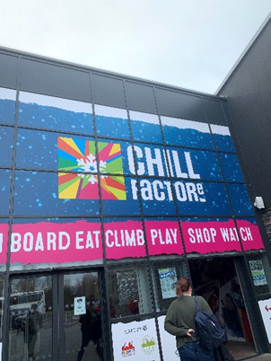
Responsible Tourism.
Starting with Chill Factore I can straight away say that you will have plenty to do from the second you step in, snow tubing to skiing. As it was mentioned before we’re unable to go to Switzerland and enjoy the snow activities due to Corona Virus outbreak. But even as responsible tourists this dint stop us from enjoying the snow activities in the UK and even going on the slopes! All thanks to the amazing experience at Chill Factore.
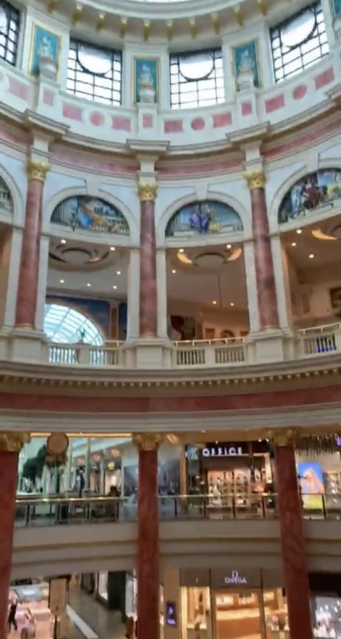
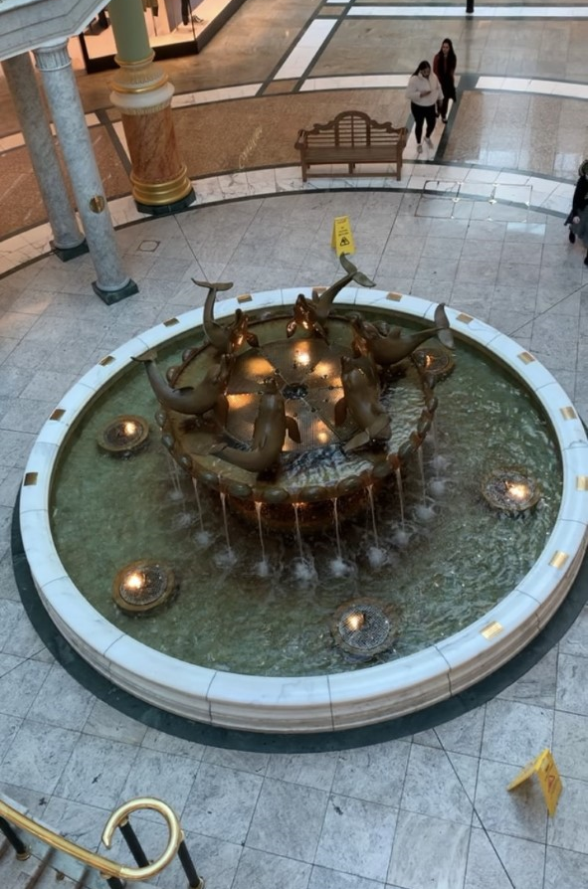
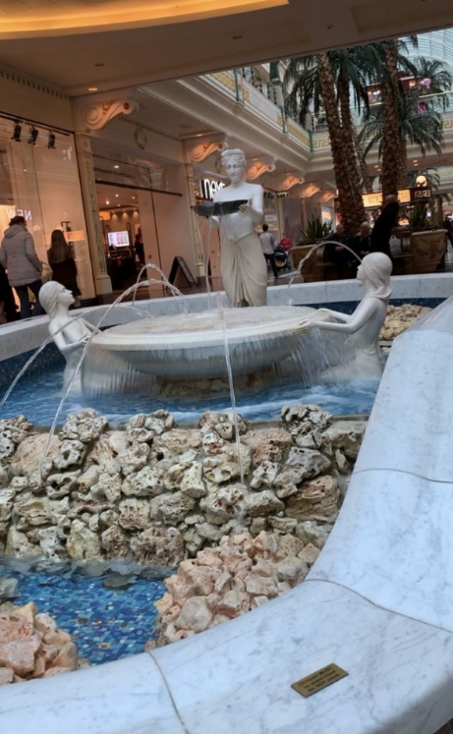
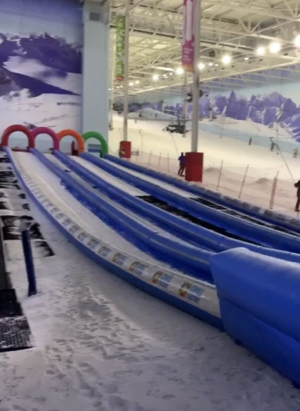
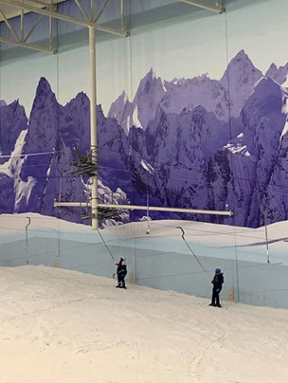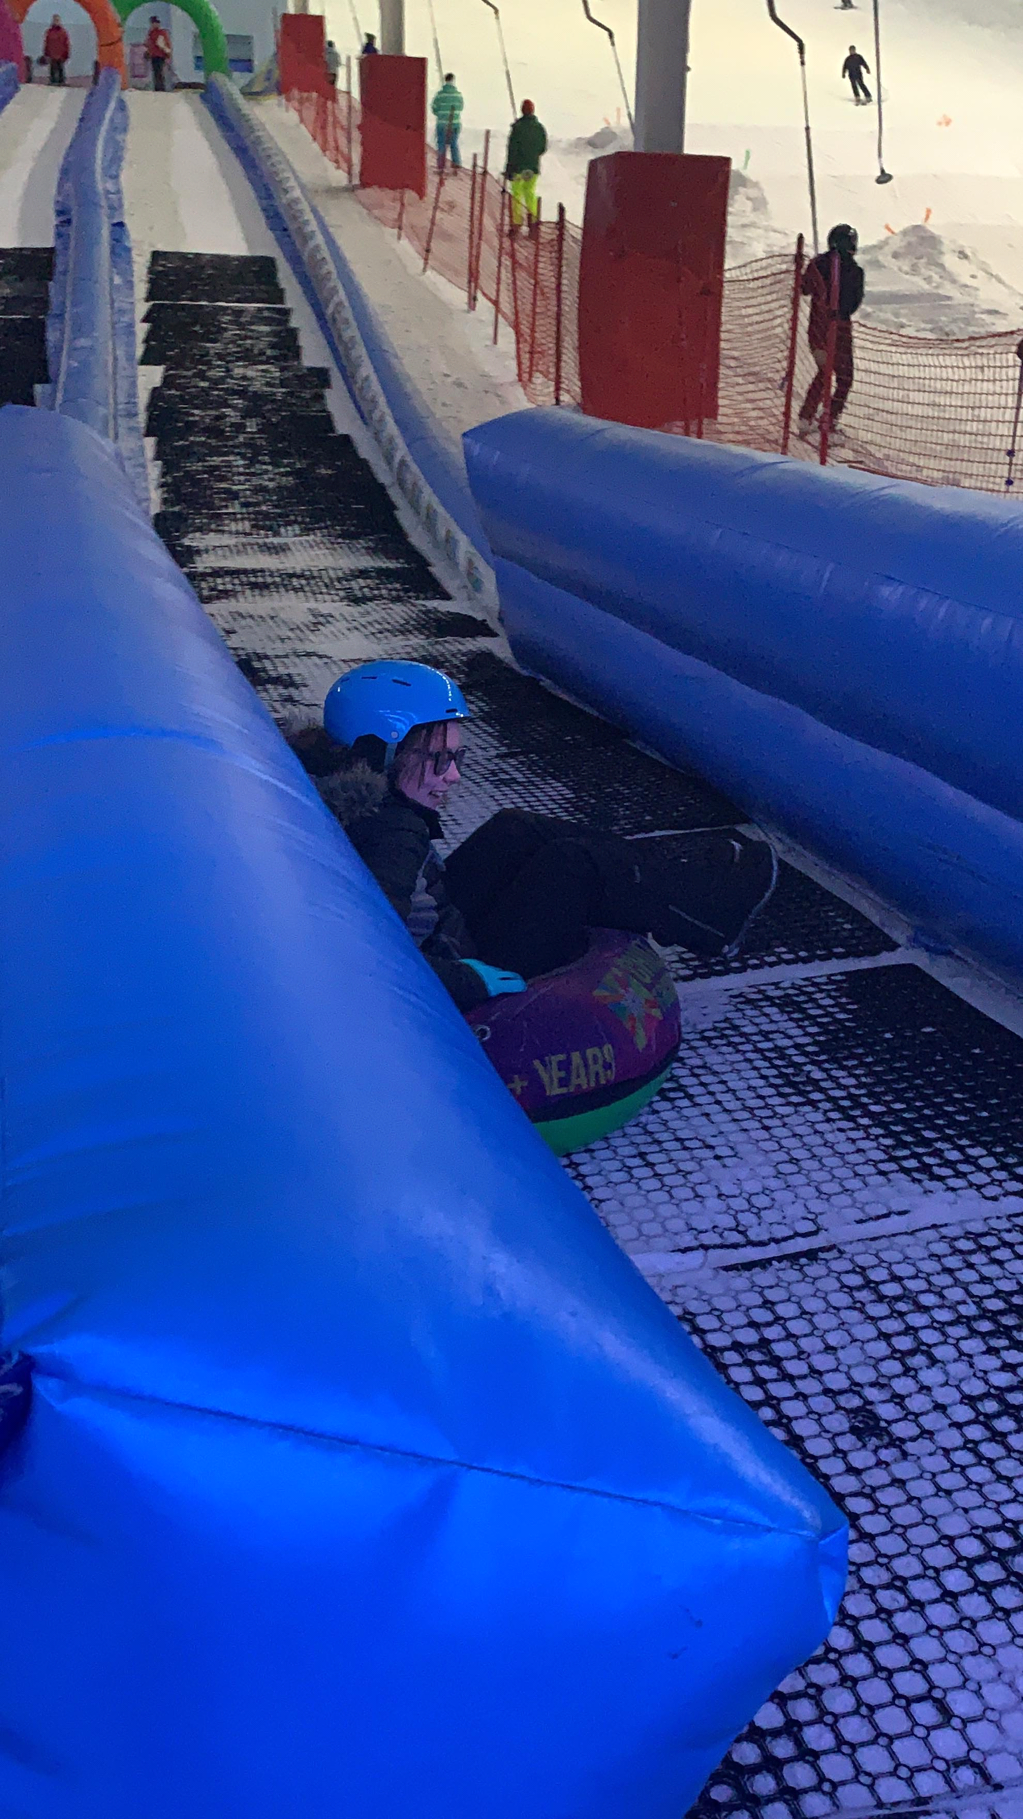
After fun in the snow we headed over to Trafford centre which was about ten min walk away. The size, design and atmosphere were a dream come true for shopaholics. In fact, we did get lost a couple of times but who wouldn’t want to get lost in such a place! There’s loads of fountains, benches and places to eat and look at.
When following Maslow’s theory of needs we know that other stages need to be completed first but once we done our weekly food shopping, paid all our bills and have the secure feeling we are able to go into self-actualization stage. Our needs will grow, and we will have time for leisure which is the perfect time to take a weekend away and enjoy some sports and treat yourself to a shopping spree right after.
SimplyPsychology, (2020), ‘Maslow's Hierarchy of Needs’, [Online], Available: https://www.simplypsychology.org/maslow.html, [Accessed Date: 2020, March, 26].

