Module Name: Professional Development within health and social care
Module Code: LCH4009
Student Name: Anila Mansoor
Student Number: 2433628
Lecturer Name: Hajra Mustasim

Task 01: CV
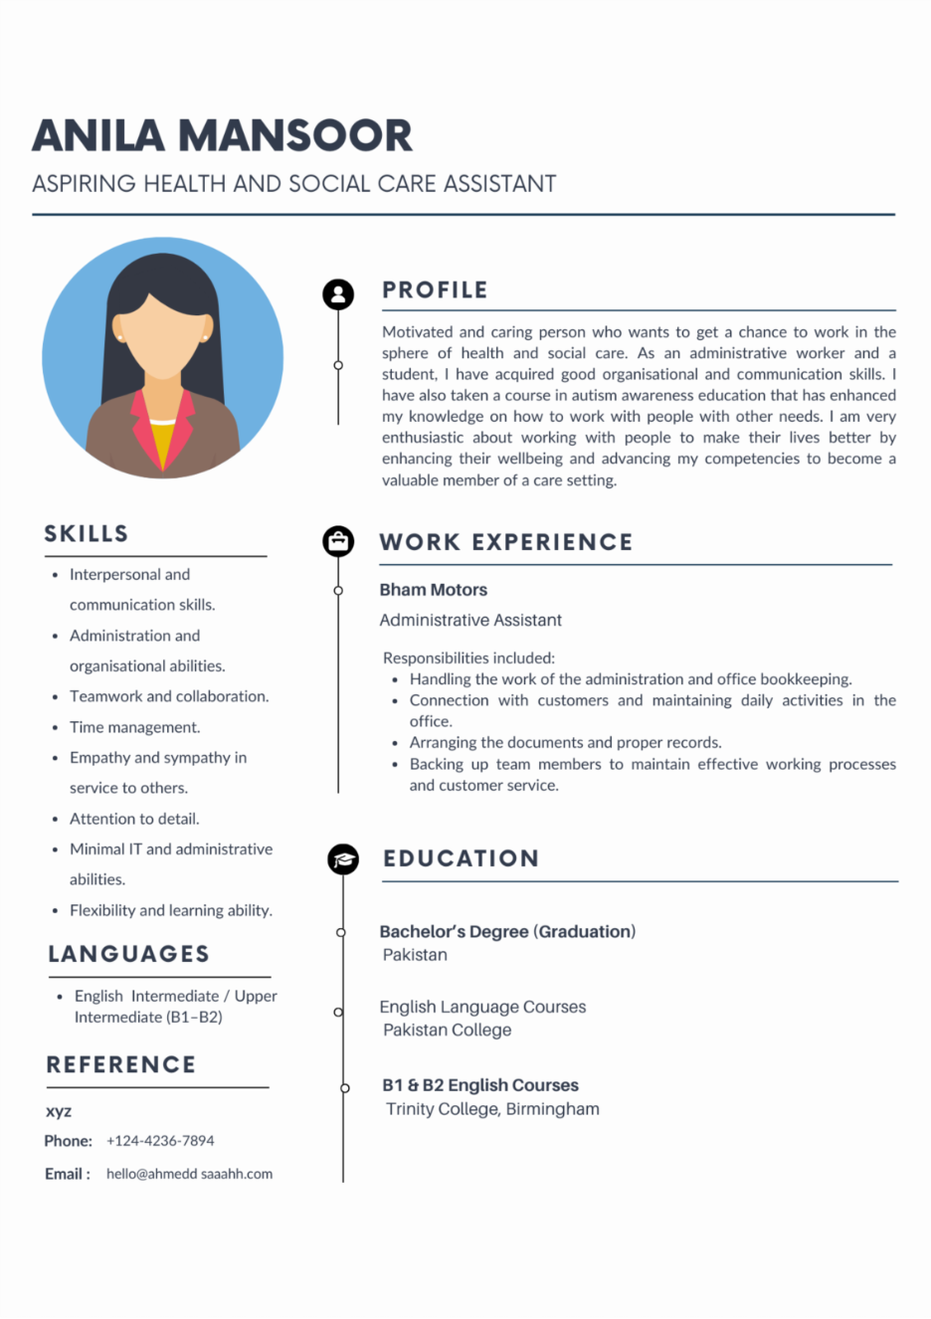
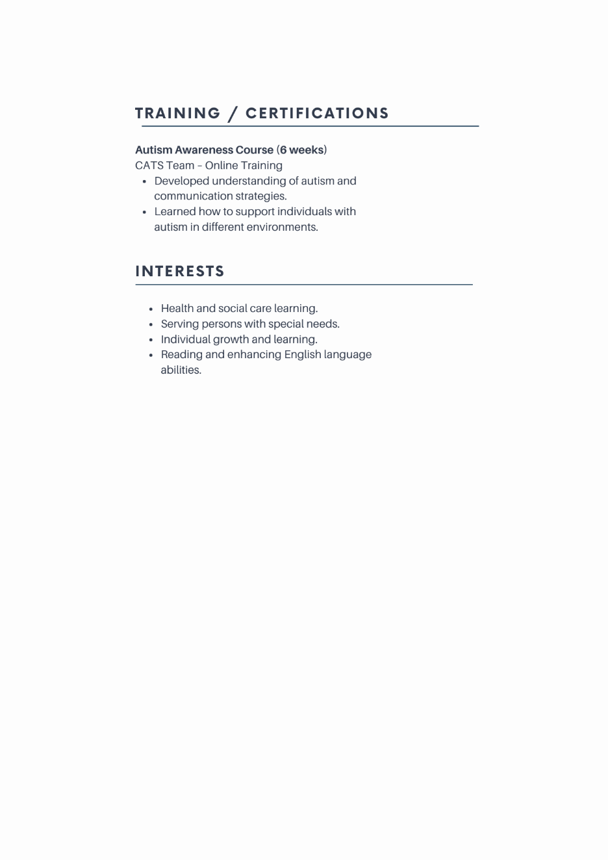

Task 02: Personal Statement
I am a passionate and empathetic person who wants to get a chance to be employed in the health and social care sector as either a Care Assistant or Support Worker. My long-term career objective would be to expand my knowledge and skills on health and social care to ensure that I can offer meaningful contributions to people that need assistance in their lives. My special interest is to take on a position that will assist in enhancing the wellbeing, independence, and quality of life of vulnerable people, including those with other needs.
My learning experience has made me develop effective communication and learning skills. I graduated in Pakistan and took some courses in English language to enhance my communication skills. In Pakistan College, I studied the English language and in Trinity College Birmingham, I took B1 and B2 courses in English. Such courses have made me more confident in my ability to talk to other people and be able to work in a professional setting.
Besides my education, I have also undertaken a six-week course on Autism Awareness with the CATS Team in online learning. This training equipped me with a lot of information on autism such as knowing the needs of individuals with an autism spectrum as well as learning how to communicate with them. This experience made me more interested in assisting people with various needs and made me more empathetic and aware of working with people.
I have also acquired important work experience under Administrative Assistant in Bham Motors. During this position, I had the role of organizing documents, administration, and communication with customers and co-workers. The post enabled me to acquire high organisational skills, attention and ability to work well as a team member. I got to know how to manage duties professionally and make sure they were done effectively.
I have personal strengths of being patient, reliable, and caring. In my opinion, these aspects are needed when dealing with health and social care as users of the services frequently need to be understanding, respected, and supported emotionally. I am also a flexible person who is willing to learn new skills that would make me become a better care professional.
In my opinion, my education, training, and working experience make me ready to contribute positively to a health and social care organization. I will also deliver high-quality services and uphold the dignity of people and constantly uphold my competencies in an attempt to offer caring and effective services.

Task 3a: Personal SWOT Analysis
SWOT analysis assists in determining individual strengths, weaknesses, opportunities, and threats which could affect career development in the health care and social care industry (Gal, 2024). These aspects will make me understand my strengths and weaknesses better as I strive to get a job.
- Strengths:
My key strength is that I have a high level of empathy and compassion towards other people. I am a sincere supporter, and I like to make people feel welcomed and honored. This attribute is highly significant in health and social care in which service users tend to need emotional support in addition to the practical one (Kniazeva and Baskin, 2023).
The other strength is my communication skills. By studying English language in Pakistan college and Trinity College Birmingham, I have gained confidence in using and comprehending English in a professional context. I can also be patient and explanatory, and this is quite useful when dealing with people who might be experiencing different communication requirements.
My experience as an administrative assistant within Bham Motors has also enabled me to acquire organisational and administrative skills. This experience helped me learn how to cope with tasks, keep proper records, and be an effective team worker. These skills can be applied in instances of care plan management, information recording, and proper task completion in the process of health and social care.
One of my distinctive strengths is that I am aware and understand autism due to a six-week Autism Awareness course that I completed with CATS team. This training has taught me useful skills on how to help autistic people and their requirements. Also, my multicultural status enables me to appreciate and embrace individuals of other cultures, which is relevant in delivering person-centered care.
- Weaknesses:
The first weakness is that I do not have direct professional experience of working in a health and social care setting now. Although I was able to acquire valuable knowledge during my training and personal desire, to become a complete master of my skills in care, I require working experience.
The other weakness is that I have yet to develop professional confidence when operating in new settings. Nevertheless, I am trying my best to get rid of this issue through further education and communication enhancement.
- Opportunities:
The opportunities that professional development with regard to health and social care sector offer are numerous. As an illustration, I will be able to acquire additional training including safeguarding training, care certificates or other training on autism and disability support.
It would also enable me to be practical and enhance my interpersonal skills and advance to greater positions like senior care assistant or specialist support worker sometime in future when working in a care role.
- Threats:
The emotional and physical demands of working in health and social care are one of the possible challenges. Being able to help vulnerable people can be a stressful task and demand solid emotional strength.
The other obstacle that can be experienced is the competitive environment of employment opportunities, where several applicants are likely to have experience in care positions. Nonetheless, in my opinion, with constant learning, training, and commitment, I will be capable of overcoming these obstacles and establishing my career.

Task 3b: Personal Development Plan (PDP)
The Personal Development Plan (PDP) is significant to find the aspects of improvement and set specific professional development targets (Jallad and Işık, 2022). To prepare a career in health and social care, I have been able to identify three major goals that I would like to accomplish within the next two years (Fadlan et al., 2023). The objectives will assist me in enhancing knowledge skills and confidence in a care setting.
- Goal 1: Achieve professional qualifications in health and social care.
The acquisition of recognized health and social care qualifications is one of my primary objectives. In the following two years, I will undertake a Care Certificate and other training including safeguarding and first aid. The qualifications will assist me in learning the professional standards, duty of care, and the responsibility of working with vulnerable people.
In my pursuit of this, I will undertake research on available training programs by care organizations, colleges, or web-based learning programs. I will also consult the employers and people who are already employed in the field. The successful completion of the courses and certification will be used as a measure of my progress (Li et al., 2025). I will be able to measure my learning by considering the way that the acquired knowledge will enhance my confidence and competence in delivering safe and effective care.
- Goal 2: Gain hands-on experience in dealing with people with other needs.
The other objective is to acquire practical experience on how to assist individuals with other needs, such as people with autism. I already took an autism awareness course that exposed me to the difficulties that people in the autism spectrum undergo. However, to build a stronger care skill, it is necessary to have a strong experience.
In the following two years, I will seek positions of entry-level care like care assistant or support worker. These positions will allow me to learn how to help people in their daily life, communication, and emotional support. I will also evaluate my performance by asking my supervisors and colleagues to provide feedback and cogitating about my experience at work. This shall assist me in determining areas where I need to improve and have confidence in delivering person centered care.
- Goal 3: Enhance the level of communication and interpersonal skills.
Communication is an important skill in health and social care since care workers can deal with service users, families, and medical practitioners. I would like to keep enhancing my communication and interpersonal abilities to guarantee that I will be able to establish positive relationships with the people I serve.
To do this, I will keep practicing my skills in the English language and attending training sessions or workshops concerning communication within a health and social care environment (Ilmast, 2023). I will also focus on experienced care workers and learn after observing their communication methods. I will use feedback about my colleagues and supervisors, and self-reflection on my interactions with service users to assess my progress.
On the whole, these objectives will assist my growth as a health and social care practitioner. I will be in a more suitable position to deliver quality care and develop the health and social care sector in the next two years by qualifying, developing practical experiences, and enhancing my communication skills.

Task 04: Critical Reflection (Gibbs Model)
Professional development involves reflection since it enables one to assess the performance, note strengths, and areas of development. The Reflective Cycle (1988) model offered by Gibbs offers a framework of the reflection process in 6 steps: description, feelings, evaluation, analysis, conclusion, and action plan (Mukhanova and Seitimova, 2025). This reflection will assess my experience of the completion of LCHS4009 Component 1 presentation.
- Description:
In Component 1 of the module, I presented a presentation that touched on the topic of professional development in the health and social care field. The purpose of the presentation was to show that I have learned the main concepts concerning the skills necessary in health and social care employment and be able to articulate this information to an audience. In the presentation, I made some slides and told the main points orally. I also divided my presentation into parts to ensure that people would find the information simple to comprehend.
- Feelings:
I was a bit nervous prior to making the presentation due to the fact that at times it is not easy to talk before a group of people. One of my fears was whether I would not forget all the information and whether my communication would be concise. Nevertheless, I was also motivated since I had prepared my slides and practiced the presentation before. During the presentation, I started to feel more self-assured since I realized that I could discuss the topic and use my intended structure. I was relieved and content with the fact that I managed to convey the information after doing the presentation (Rowe, 2022).
- Evaluation:
On balance, the presentation was both good and could be improved in a number of ways. The good thing is that my presentation was well structured and organized. The slides facilitated in guiding my explanation and I could explain the major points in logical sequence. I was also calm when making my presentation and tried to present the information in a clear way.
Nevertheless, there were also some spheres, in which my performance could be enhanced. As an illustration, I was at times a bit nervous, and this interfered with my confidence levels of speaking. Moreover, I might have elaborated on some of the points further. As the verbal feedback that my lecturer gave me indicated, the presentation demonstrated a good level of knowledge regarding the subject matter but could use more confidence during the delivery and better elaboration of some points.
- Analysis:
Reflecting on this experience, I understand that preparation was significant in making me able to deliver the presentation successfully. This was due to the fact that I practiced the presentation before and that allowed me to familiarize myself with the content and structure. The nervousness that I felt, however, might have been because of the lack of experience in presenting in academic settings. Speaking to the audience is a skill which gets better with practice and gaining confidence in presenting information is also significant to the professional development, particularly in the sphere of health and social care through which communication is crucial.
The response of the lecturer demonstrated that the confidence and explanation of expansion would enhance the next presentation. This feedback showed that despite the general organization of the presentation being good, I need to concentrate on making more in-depth explanations and speak more comfortably to attract the audience.
- Conclusion:
Finally, the presentation was a great learning experience that enabled me to acquire my communication and presentation skills. I had the opportunity to discuss the topic in an organized manner and show my knowledge in the topic. The experience, however, also revealed that I still need to work on my confidence and be more elaborate in explaining information when presenting it.
- Action Plan:
To enhance my future presentations, I will follow a number of steps. To begin with, I will do more frequent presentations so that I can become more confident when speaking in front of people. Second, I will also work on widening my explanations to enable me to have more detailed information when making the presentation. Lastly, I will keep on getting the opinion of lecturers and peers to know more areas I need to improve. With the implementation of these strategies, I will manage to enhance my presentation skills and increase my professional communication skills in the future.

Bibliography
Fadlan, A., Isma, A.A., Jamrizal, J. and Ridwan, R., (2023). The Influence of the Impact of Education in View of Economic Development Planning and Investment on the Contribution of Islamic Education Institutions. International Journal of Education and Teaching Zone, 2(3), pp.412-420.
Gal, A., (2024). Strengths, weaknesses, opportunities and threats: A SWOT analysis of a long-term Outdoor Environmental Education Program in Israel. Journal of Outdoor and Environmental Education, 27(2), pp.321-339.
Ilmast, M., 2023. Developing a Work Personal Development Process and Personal Development Plan Template for an Engineering Design Company.
Jallad, S.T. and Işık, B., 2022. The effectiveness of virtual reality simulation as learning strategy in the acquisition of medical skills in nursing education: a systematic review. Irish Journal of Medical Science (1971-), 191(3), pp.1407-1426.
Kniazeva, M. and Baskin, E., 2023. Swot analysis. SAGE Publications, Inc..
Li, X., Wei, R., Slatyer, S. and Rappa, N.A., 2025. Extended reality for enhancing communication skills in nursing education: A scoping review. Teaching and Learning in Nursing, 20(2), pp.e587-e595.
Mukhanova, A. and Seitimova, A., 92025. Reimagining Differentiation: A Reflective Inquiry Using Gibbs’ Model.
Rowe, G., 92022. Personal and professional development. The Handbook for Nursing Associates and Assistant Practitioners, p.28.

Appendices
- CV.

