Database Design & Implementation



Name: Jaylan Lee
Student Number: 2220768
Module Code:ACCA5026
Module Title: Databases and Application Development
Lecturer Name: Mohd Syafiq Bin Zolkeply
Assignment Title: Database Design & Implementation

Table of Contents
Introduction 3
Database Design 4
3NF Normalisation 6
Table Creation 7
Sample data insertion 7
Stored Procedure and Transactional Scenario 8
Performance Tuning Enhancement 9
Conclusion and Reflection 9
PART B 10
References 11

Introduction
The aim is to develop a database that enhances the service and improves the management of the system for the private healthcare company MedAssist. This system will allow them to manage patient information, book appointments, and collect patient feedback on services.
In this report, a relational database prototype will be built using SQL that supports secure and consistent access across the organisation for users.

Database Design

ERD entities
Doctor – A medical expert who gives medical care
Patient – Someone receiving medical care
Treatment – A record of diagnosis and treatment
Feedback – Comments given about the care that is received
Department – Parts of the hospital that focus on a speciality
Appointment – A date or time that is agreed upon

Entity Attributes and Description Table

Entity | Attributes | Description
Doctor | DoctorID | FirstName, LastName, MEDnumber, Email, Phonenumber, DepartmentID
Patient | PatientID | FirstName, LastName, DateOfBirth, sex, Email, PhoneNumber, Address
Treatment | TreatmentID | Diagnosis, Prescription, Notes
Feedback | FeedbaclID | Comments
Department | DepartmentID | DepartmentName, Location
Appointment | AppointmentID | AppointmentDateTime, ReasonForVisit

ERD DIAGRAM

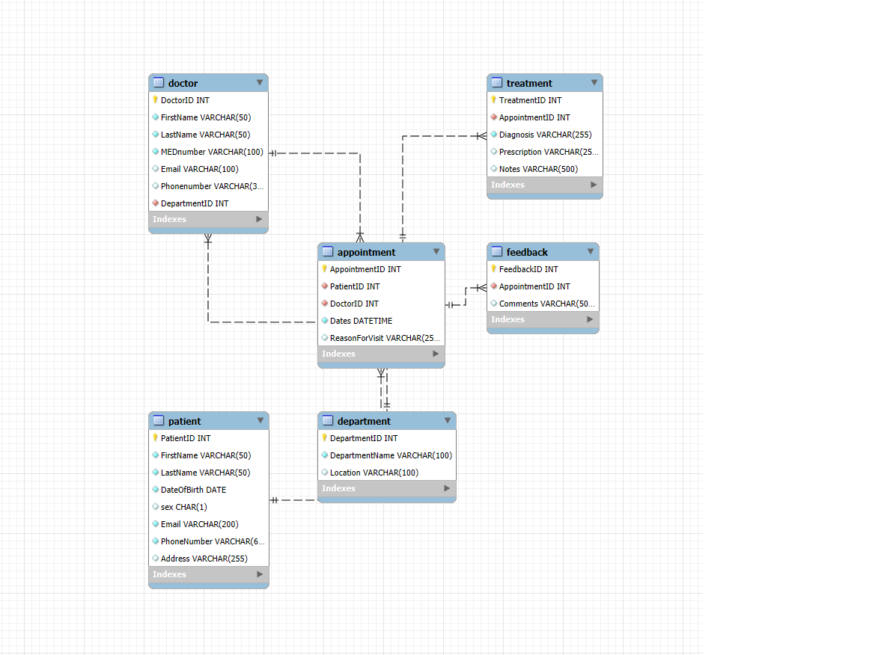

Figure 1 showing the ERD diagram

3NF Normalisation

In relational database systems, database table normalisation is a crucial design technique for lowering data redundancy and enhancing data consistency. [1]

By applying normal forms to the MedAssist database, the normalising process gradually removes update, insertion, and deletion anomalies by breaking down relations into smaller, well-structured tables based on functional dependencies. [2]
Repeating groups are eliminated by the first normal form (1NF), partial dependencies are eliminated by the second normal form (2NF), transitive dependencies are eliminated by the third normal form (3NF), and more intricate dependency patterns are addressed by the higher forms. [2]

Table Creation
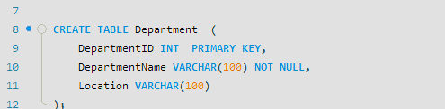
Figure 2 showing a table being created
The create table command was used to create the Department table

Sample data insertion
Figure 3 showing sample data being inserted into the patient table

Stored Procedure and Transactional Scenario
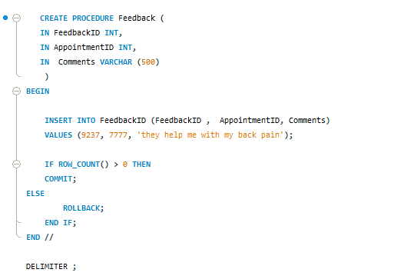
Figure 4 showing a procedure being created
When it comes to procedures, there are four key components. The first feature is the rollback capability, which undoes schema modifications made while the transaction is in progress. [3]Transaction and commit are the second feature. Additionally, in order to undo any modifications that may have been committed during execution, a start transaction and commit must be stated at the beginning and end of the insert queries. [3]

Performance Tuning Enhancement
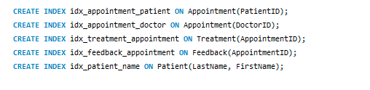
Figure 5: an index being created
Modern relational database systems rely heavily on effective data retrieval, especially as datasets get bigger and more complex. [4] One of the most important optimisation strategies in SQL databases is indexing, which minimises resource usage while facilitating quick access to data. [4] In MedAssets central database, this will facilitate quicker access to Appointments, increase the speed of feedback on particular appointments, increase the efficiency of matching treatments and appointments to make a decision, and improve the search for doctors based on department and speciality.

Conclusion and Reflection
Overall, the goal of this project was accomplished; a rational database was created for MedAssist that isn’t just used for storing data but is used to boost the operational processes of the business. This results in better quality of care for patients and more streamlined medical care functions.

PART B

One of the most significant cyberthreats is the Structured Query Language Injection Attack , which may easily penetrate databases and the majority of web-based applications. These are input validation flaws that can be utilised to attack the system as a whole by exposing and gaining access to privileged data through the use of Structured Query Language (SQL) commands. [5] There are many types of SQL injection attacks that malicious actors use; some of these are Boolean-Based Blind SQL Injection, Error message displayed, Tautologies and Impaired Input.
In the Boolean-Based Blind SQL Injection attack, malicious queries are sent by the attacker, forcing the application to generate true or false conditions. [6] The attacker can retrieve sensitive data or alter the database by examining the application's answers to determine whether the inserted query returned true or false. [6]
When there is an SQL error, the web displays a SQL code error message. The most frequent reasons for this error are setup problems or mistakes made by website programmers. However, with the Error message display attack, SQL Injection can be carried out by attackers using exposed data caused by the error, such as database or table names. [7]
In Impaired Input, cross-site scripting can be used to get around the security feature if a client-side script only controls an input at the front end of the application. Because of this, the attacker can send malicious data to the server without having it verified. [7]
With the Tautologies SQL injection strategy, the code is injected into a query's WHERE conditional using the conditional OR operator, guaranteeing that the query consistently evaluates to TRUE. Because the conditional is a tautology, the query evaluates to true for every row in the table. [7]

References

[1] | S. Pillai, “Database Table Normalization for Reducing Data Redundancy,” Perception, Navigation and Intelligent Devices, vol. 11, pp. 26-30, 2024.
[2] | S. A. S. R. Mardiah, “Relational Database Design Principles: Normalization, Denormalization, and Query Optimization for Database Management Systems,” International Journal of Economics Management and Social Science, vol. 9, no. 1, 2026.
[3] | T. Aila, “Master Data Management System,” Degree Programme in Computer Applicationsspring, 2023.
[4] | H. A. Z. Huma, “Indexing Strategies in SQL: Enhancing Query Efficiency and Scalability,” Baltic Journal of Multidisciplinary Research, vol. 2, no. 2, 2025.
[5] | A. A.-g. M. M. H. R. Mohammed Al-olaqi, “Comprehensive Study of SQL Injection Attacks Mitigation Methods and Future Directions,” Journal of Cyber Security and Risk Auditing, no. 4, pp. 347-365, 2025.
[6] | S. D. P. P. Animesh Kumar, “Analysis of SQL injection attacks in the cloud and in WEB applications,” SECURITY AND PRIVACY, vol. 7, no. 3, 2024.
[7] | M. N. J. Manar Hasan Ali AL-Maliki, “Review of SQL injection attacks: Detection, to enhance the security of the website from client-side attacks,” Semnan University, vol. 13, no. 1, 2022.

