BMIH4002
Assignment 2 Menu Engineering (Practical Task)
Throughout practical placement work

Student Name: Marian Simion
Student ID: 2242476
Table of Contents
Part One: Restaurant Concept 3
Restaurant Concept 3
Target Audience 3
Reason Behind Menu Choice 3
Part Two: Menu Design 3
Conceptualization 3
Menu Items 4
Pricing Strategy 5
Menu Design 6
Menu Description 6
Sustainability and Seasonality 7
References 9

Part One: Restaurant Concept

Restaurant Concept
Epicurean Elegance, the newest addition to the Trinity Hotel chain, is a culinary haven situated within the bustling heart of London. Our restaurant concept is a celebration of refined dining experiences, merging modern gastronomy with classic elegance. The ambiance exudes sophistication, characterized by contemporary design elements that seamlessly blend with the historical charm of the city center. From the moment patrons step through the doors, they embark on a gastronomic journey designed to tantalize their taste buds and elevate their dining expectations.

Target Audience
Epicurean Elegance is a catering company that serves discerning diners in search of extraordinary culinary experiences. The diner desires a culinary experience that proficiently engages and pleases each of their senses. The target demographic comprises individuals who hold a deep appreciation for the artistry involved in culinary creations and the atmosphere that enhances their dining experience. This includes both local inhabitants and tourists. Epicurean Elegance is frequently chosen by professionals, couples, and individuals desiring to commemorate momentous occasions as the preferred venue. The establishment endeavours to appeal to individuals who harbour a profound admiration for haute gastronomy and a preference for the more sophisticated aspects of life. The aim is to attract individuals who value the intricacy and originality associated with culinary craftsmanship and derive enjoyment from the act of consuming food.

Reason Behind Menu Choice
The menu at Epicurean Elegance has been carefully selected to reflect our steadfast dedication to inventive and exceptional gastronomy. Every gastronomic creation is crafted with extraordinary ingenuity and scrupulousness, with the dual purpose of invigorating the senses and creating an enduring impact on the patron. A menu that demonstrates diversity and has been meticulously curated to accommodate a wide range of preferences has been chosen. Our aim is to uphold a sophisticated and sophisticated motif, in accordance with the guidance provided by Davis et al. (2018).
The appetisers comprise an assortment of bite-sized culinary creations sourced from different regions worldwide, thereby offering a tantalising preview of the forthcoming gastronomic encounter. According to Cousins (2020), the presence of a wide range of options ensures that individuals with different tastes can find enjoyable choices to enjoy. The primary courses provided at our establishment showcase a seamless integration of tastes, as each dish is carefully prepared to accentuate the exceptional quality of the ingredients utilised and the culinary expertise of our proficient chefs. The menu features an extensive variety of palatable options, encompassing inventive vegetarian dishes and flavorful proteins. The appreciation for diversity is upheld while simultaneously ensuring the preservation of a pervasive aura of sophistication.
The dessert selection is a grand finale, featuring decadent creations that serve as the perfect conclusion to the Epicurean Elegance experience. Complemented by an extensive wine and cocktail list, the beverages are carefully chosen to enhance and complement the flavors of each dish, elevating the overall dining experience.

Part Two: Menu Design
Crafting a Memorable Dining Experience Menu in Keeping with the Concept

Conceptualization
The conceptualization of the menu at Epicurean Elegance revolves around a meticulous blend of culinary creativity, aesthetic harmony, and an unwavering commitment to providing an unforgettable dining experience. Every element, from menu composition to style of service, is carefully chosen to align seamlessly with the restaurant's concept of refined dining (Johnston, 2012).
The menu is a tapestry of flavors, drawing inspiration from global culinary traditions while infusing each dish with a modern twist. Embracing the ethos of Epicurean Elegance, the starters are crafted as culinary preludes, introducing patrons to an array of small, artfully presented bites that stimulate the palate and set the stage for what follows. The appetisers provided at this establishment are exceptionally delightful. The restaurant's extensive range of culinary options encompasses sophisticated sushi rolls and skillfully crafted tapas. Every dish exemplifies the establishment's steadfast dedication to creating exceptional gastronomic encounters. As stated by Zutshi (2019), the menu features a meticulously curated assortment of main courses that place a premium on precision and excellence, in accordance with the tenets delineated by Motarjemi and Lelieveld (2014). The menu that has been presented exhibits an extensive range of traditional and avant-garde culinary options, thus providing a diverse and harmonious selection of choices. Through the utilisation of seasonally available and locally sourced ingredients, the restaurant elevates the dining experience by infusing its dishes with an increased sense of authenticity and freshness. We extend an invitation to embark on a gastronomic expedition that surpasses traditional dining encounters, wherein patrons can relish a meticulously prepared vegetarian meal or relish a succulent broiled sirloin.
Epicurean Elegance is committed to providing a service manner distinguished by attentive and personalised hospitality, an aspect that we highly value. This action functions as an expression of our dedication to guaranteeing an incredibly remarkable experience for you. The establishment takes great delight in employing a plated service style, in which each dish is served with great attention to detail in order to create the illusion of a visually captivating composition. This not only enhances the visual attractiveness but also provides our guests with a delightful sensory experience. There is a proposition that this approach is consistent with our overarching goal of delivering a holistic experience that extends beyond mere sustenance. Our aim is to offer a gastronomic experience that is extremely carefully curated to stimulate all sensory modalities. In addition, we offer a tasting menu option to accommodate patrons who desire a more comprehensive exploration of our gastronomic offerings. This specific option provides you with the chance to explore a carefully selected collection of our finest dishes, effectively demonstrating the extraordinary culinary prowess exhibited by our exceptionally trained chefs. Brown and his companions conducted research in 2013.
To augment the overall experience, Epicurean Elegance has incorporated an extra component—interactive tableside presentations. Specific culinary preparations involve the live completion or execution of dishes, thereby infusing the dining experience with an element of anticipation and active participation. This unique attribute allows customers to observe the skill and resourcefulness that goes into making their food, thereby nurturing a more profound rapport between the culinary experts and those who are enjoying the meal.

Menu Items
Table 1 Menu Items
Category | Dish Name | Description | Dietary Preferences
Appetizers | Sushi Symphony | Assorted sushi rolls featuring fresh, seasonal fish and vibrant vegetables, served with a wasabi-infused soy reduction | Pescatarian, Gluten-Free
 | Mediterranean Mezze Platter | A selection of hummus, tzatziki, stuffed grape leaves, and marinated olives, accompanied by warm pita bread | Vegetarian
 | Truffle-infused Arancini | Crispy risotto balls filled with a delicate blend of truffle-infused cheese, served with a basil-infused marinara sauce | Vegetarian
Main Courses | Balsamic Glazed Salmon | Grilled salmon fillet drizzled with a balsamic reduction, accompanied by roasted sweet potatoes and sautéed asparagus | Pescatarian, Gluten-Free
 | Portobello Mushroom Wellington | Flaky puff pastry filled with portobello mushrooms, spinach, and vegan cheese, served with a red wine reduction | Vegan, Vegetarian
 | Sous Vide Filet Mignon | Perfectly cooked sous vide filet mignon served with truffle mashed potatoes, sautéed wild mushrooms, and red wine jus | Gluten-Free
Desserts | Chocolate Decadence Tart | Rich chocolate tart with a velvety ganache center, served with a raspberry coulis and a scoop of vanilla bean ice cream | Vegetarian
 | Mango Coconut Panna Cotta | Silky coconut panna cotta infused with fresh mango puree, topped with a mango compote and toasted coconut | Vegan, Gluten-Free
Beverages | Elderflower Sparkler | Elderflower-infused sparkling water with a hint of mint and lime | Vegan, Gluten-Free
 | Bourbon Maple Smash | A blend of bourbon, pure maple syrup, muddled blackberries, and a touch of lemon, served over crushed ice | N/A (Alcoholic)

Pricing Strategy
Epicurean Elegance is a pricing approach that considers the perceived value that clients attribute to their sophisticated dining experience. The menu pricing were adjusted appropriately. The establishment demonstrates a meticulous approach in the meticulous preparation of delectable culinary offerings, accommodating a diverse range of palates, and delivering exceptional customer service. This guarantees that each visitor perceives that they are receiving commensurate value for their expenditure, notwithstanding the potential elevation of prices.
Table 2 Pricing Strategy
Category | Dish Name | Price (£)
Appetizers | Sushi Symphony | 12.99
 | Mediterranean Mezze Platter | 10.99
 | Truffle-infused Arancini | 11.99
Main Courses | Balsamic Glazed Salmon | 23.99
 | Portobello Mushroom Wellington | 18.99
 | Sous Vide Filet Mignon | 29.99
Desserts | Chocolate Decadence Tart | 9.99
 | Mango Coconut Panna Cotta | 10.99
Beverages | Elderflower Sparkler | 4.99
 | Bourbon Maple Smash | 11.99

Menu Design
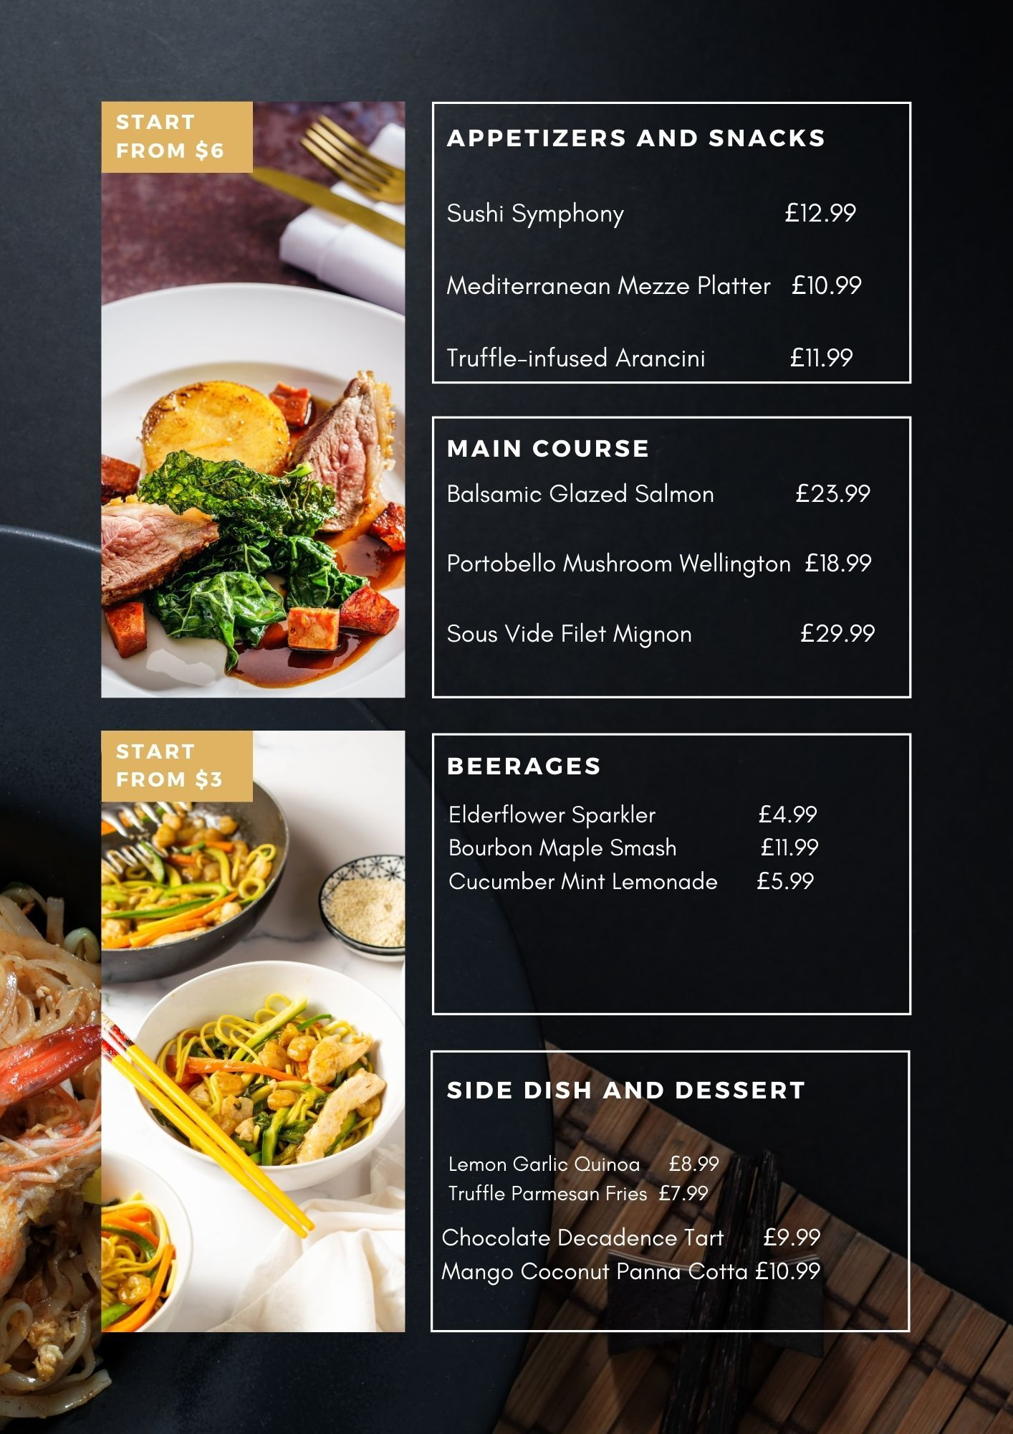
Figure 1 Menu Design

Menu Description
Table 3 Menu Description
Dishes | Flavor | Ingredients | Special Culinary Techniques
Sushi Symphony | Harmonious | Fresh sashimi-grade fish, crisp vegetables, wasabi, soy reduction | Artful rolling, meticulous presentation
Mediterranean Mezze | Vibrant & Rich | Hummus, tzatziki, stuffed grape leaves, marinated olives, pita | Authentic Mediterranean preparation, attention to detail
Truffle Arancini | Savory Elegance | Risotto, truffle-infused cheese, basil-infused marinara sauce | Precision frying, delicate rolling, infusion of truffle flavors
Balsamic Glazed | Sublime Mélange | Grilled salmon, balsamic reduction, roasted sweet potatoes | Expert grilling, balsamic reduction expertise, vegetable pairing
Portobello | Earthy Opulence | Portobello mushrooms, puff pastry, vegan cheese, red wine reduction | Flaky pastry preparation, intricate mushroom layering
Sous Vide Filet | Culinary Bliss | Filet mignon, truffle mashed potatoes, sautéed wild mushroom | Sous vide precision, truffle infusion, meticulous sauce creation
Lemon Garlic Quinoa | Zesty Freshness | Quinoa, lemon, garlic, fresh herbs | Fluffy quinoa preparation, lemon-garlic infusion, herb garnishing
Truffle Parmesan | Luxurious Crunch | Shoestring fries, truffle oil, Parmesan, truffle aioli | Crispy frying, truffle oil coating, Parmesan dusting
Chocolate Decadence | Velvety Indulgence | Chocolate tart, ganache, raspberry coulis, vanilla ice cream | Rich chocolate crafting, ganache center, fruity coulis
Mango Coconut Panna | Tropical Euphoria | Coconut panna cotta, fresh mango puree, mango compote, coconut | Silky panna cotta preparation, tropical fruit infusion, coconut garnishing
Elderflower Sparkler | Crisp Elegance | Elderflower-infused sparkling water, mint, lime | Elegant elderflower infusion, mint and lime balance
Bourbon Maple Smash | Robust Sweetness | Bourbon, maple syrup, muddled blackberries, lemon, crushed ice | Mixologist's blend, muddled fruit infusion, balanced sweetness
Cucumber Mint | Refreshing Zest | Lemonade, cucumber, mint, ice | Fresh lemonade crafting, crisp cucumber, invigorating mint

Sustainability and Seasonality
Epicurean Elegance is committed to environmental stewardship, incorporating sustainable and seasonal ingredients into our menu. The respective restaurant prioritizes partnerships with local suppliers to minimize the carbon footprint and support the community. By adhering to stringent environmental regulations, it ensures responsible sourcing, reducing waste, and promoting eco-friendly practices. The dedication to sustainability not only aligns with current environmental trends, but also reflects a conscious effort to contribute positively to the planet while delivering a culinary experience that resonates with values and those of the discerning patrons.

References
Brown, D. R., TotalBoox and TBX (2013) The Restaurant Manager’s Handbook : How to Set Up, Operate, and Manage a Financially Successful Food Service Operation. 4th Edition. Atlantic Publishing Group
Cousins, J. (2020) Food and beverage service. 9th ed. London: Hodder Education Group.
Davis, B et al. (2018) Food and Beverage Management. 6 edn London: Routledge.
Johnston, R. (2012) Service operations management : improving service delivery. 4th ed. Harlow, England: Pearson.
Motarjemi, Y and Lelieveld, H (2014) Food safety management : a practical guide for the food industry. Illustrated edition. Amsterdam: Academic Press.
Zutshi, A. (2019) ‘How to develop well-informed and assured teams to embed food safety compliance in the UK catering and hospitality industry’, Perspectives in Public Health, 139(6), pp. 294–295.

