

BSc (Hons) Professional Police Practice

LEVEL 5 - 40 Credits

Workbook title: Competency Based Workbook 3 (PCDA)

(SOUTH WALES POLICE, GWENT POLICE AND UWTSD)

Learner name: Dylan Griffiths__________

Learner’s University Registration Number:
__1910669_______________

FACULTY OF BUSINESS AND MANAGEMENT
PUBLIC SERVICE PROGRAMME

Module title: Professional Police Practice 2 (PCDA) BMPP5000D

Task 1

Relevant areas of the National Policing Curriculum:
Wellbeing and Resilience

Having achieved Independent Patrol Status, reflect on the impact of organisation culture within policing on your wellbeing and resilience (organisation change, retaining personal values in a wider organisational culture).

Consider the risks of conforming to organisational culture.

Illustrate your strategies for maintaining wellbeing and resilience.

1000 words (+/- 10%: include your actual word count at the end of each section)

ANSWER:

Before joining south-wales police I notched up 17 years’ within the prison service and 4 years’ service with HM Armed forces so I was relatively expecting the transition to a police constable to be relatively smooth due to them both being large government organisations,
I found the police Organisation was a lot bigger than anything else that I had been involved in where the staff were valued and it was encouraged that they all had a voice and is a privilege to be part of it.

Achieving independent patrol status was a massive milestone in not just policing but a personal goal that I had set myself when I first started this journey, It was a massive gamble for me to leave a job I was comfortable in and enter the unfamiliar world of police training and university lectures.
When I passed my independent status it lit a spark of self-belief that I can actually do this and that I was finally a police officer, I can now help people in need and actually make a difference.
All my life I have dedicated my employment to protecting the vulnerable from real life monsters and this is what motivates me and gives me self-worth.

What I have noticed about the police service is everyone has a voice and an opinion, also what I have found is there are a lot of officers who try to voice their opinion in a negative way, some older staff always introduce themselves and say how long they have left until they can retire and pick faults with the service.
Some staff ask why I have joined and say that I will regret my decision in time.

This would have had an impact if I had listened to these negative remarks and may have put me on a negative path that can sometimes be formed as part of negative Organisational culture.

This sort of negative pressure can result in new staff falling foul and following learnt behaviour from their colleagues who have been doing the job for years and think their way is best and who are not open to change.
I always take a strong stance at staff who moan about the job and always throw a challenge at them when they speak negative by saying “if you don’t like the job why don’t you leave!”

One thing I have always noticed about the more negative employees is they think their role is the most important role in the force and nobody could do their job if they left, another type of employee I have noticed is the ones who wants to see what they can get out of the job rather what they can give the job.

I wish positivity was catching and the world would be a better place.

I read an interesting quote on a business page that I think captures the positives and negatives of organisational culture in a few powerful short lines

- Organisational cultures can have varying impacts on employee performance and motivation levels, employees work harder to achieve organisational goals if they consider themselves to be part of the corporate environment.
- Different cultures operating in one company can impact employee performance and the overall goal of the company.
Anonymous.(2021). Organisational culture business balls webpage

https://www.buisnessballs/organisational-culture/organisational-culture-and-employee-performance

I am luckily to be a strong minded character and would make my own assumptions and values up that fall in line with the policing principles and the code of ethics.
If I work to these simple but effective statements this allows me to conform to how the organisation would like me to behave and create my own organisational culture that hopefully people would break the mould.

As stated in the college of policing there are nine policing principles. They are built around the 7 Nolan principles for public life, they are the basis of the ethical standards expected of public office holders with the addition of ‘Fairness’ and ‘Respect’. Our nine policing principles are:

1, Accountability 6 Leadership
2 Integrity 7 Respect
3 Openness 8 Honesty
4 Fairness 9 Objectivity
9 Selflessness

Bryant,R,B. (2020)Blackstones handbook for policing students oxford p.76.

https://www.college.police.uk/What-we-do/Ethics/Documents/Code_of_Ethics.pdf

I found if I base my own beliefs and values to these principles and use them in not just my policing but my life’s journeys I can’t go far wrong and it will make me a better person.

It is hard for me to express how much I love the job and how lucky and privileged I am to be given this opportunity and I am taking it with both hands open.
I know that the role can be stressful and upsetting on times but I found if I implement a few strategies that I found helpful for maintaining my wellbeing and resilience it makes the struggles easier.

One of the strategies I am familiar with and I have used in the past is written by the American born British psychologist Sir Cary Cooper who came up with 10 ways to help combat stress

https://www.nhs.uk/conditions/stress-anxiety-depression/reduce-stress/

Cooper,C (2020) 10 ways to reduce stress. NHS web page

The guide gives 10 stress busters broken down into smaller challenges that I try and implement into my daily life, I find sticking to these help me identify and overcome stress before it becomes an issue.

The categories are as follows

- Be active
- Take control
- Connect with people
- Have some ‘me time’
- Challenge yourself
- Avoid unhealthy habits
- Help other people
- Work smarter not harder
- Try to be positive
- Accept the things you can’t change

Stress is an inevitable by-product of a police constables working environment due to some of the calls that we attend and I feel it is very important to identify the early signs and seek advice if overcome by it.
Bryant,R,B. (2020)Blackstones handbook for policing students oxford p.110

Below I have found a helpful page from the NHS website that shows some symptoms of stress, I feel that if I put these signs into my reports along with a hyperlink it may help somebody reading it and unknowingly feeling the symptoms of stress.

I also have the opinion that healthier employees who can identify and manage their own stress to a healthy level will be more productive for the organisation.

http://www.thepracticeofhealth.wales.nhs.uk/news/48000

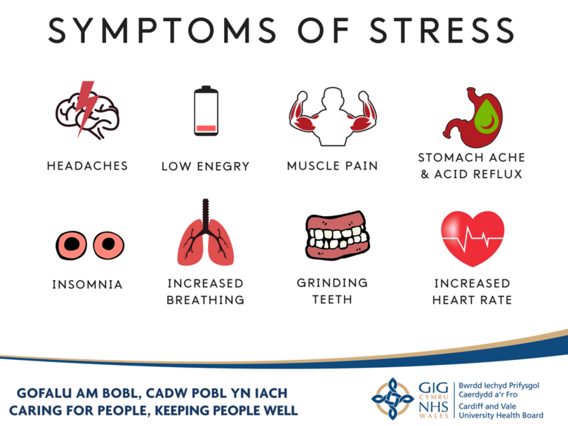

Word count for Task 1 1047 words.

Task 2

Relevant areas of the National Policing Curriculum:
Decision-making and Discretion, Vulnerability and Risk, Public Protection.

You must choose an incident, for example a domestic related incident, and reflect on how you made decisions in complex and unpredictable circumstances using dynamic risk assessment.

Give a brief description of the problem including social and legislative contexts and any relevant cultural, ethnicity and language issues.

Evaluate decisions made during the incident and your use (or otherwise) of the National Decision Model. Explain the rationale behind your decisions and your considerations when recording details of the incident. Consider your ethical approach to the decision. Outline the consequences of your decision making.

1500 words (+/- 10%: include your actual word count at the end of each section)

ANSWER:

The Incident I am writing about is one of the most difficult domestic abuse cases that I have been involved in due to the fact it was a third party report and the victim did not want to engage with police.
This posed difficulty in evidence gathering and creating a case against the perpetrator, during this task it details how I used the National Decision making model and the threshold test to gain a decision on what action I should take.
During the task I will not use real names or places, the nationality of the perpetrator will also be masked to run in accordance to the data protection act 2018.

I was on mobile patrol in a marked police vehicle whilst in full uniform when I received a call to attend a property as there had been a report from the ambulance service that a female had called saying she had fallen whilst walking home from the shop and sustained a large cut on her head.
The Ambulance operator could hear a disturbance and an argumentative male in the background so they decided to task a police response

The call was graded by the police PSC (public service centre) operator and as it fell into the following category it was graded as a grade 1 emergency

To determine if the call falls into the Grade one response category it must be in one of the following categories.

- There is an immediate threat to life or of serious injury to any person or there is the risk that this may happen
- There is a serious risk of harm or loss of property
- A serious crime has just occurred or is imminently likely to occur
- A person, due to their vulnerability, is at risk of serious/life threatening harm
- A suspect is identified as being at the scene or has just been disturbed and there is serious harm or risk in delaying the police response.
Bryant,R,B. (2020)Blackstones handbook for policing students oxford p.552
When the PSC allocates a call to the unit the operator will also pass any relevant information and warning markers they may have on file for the persons involved in the alleged incident.
On this occasion the warning markers stated that the female who had reported the fall was a serial victim of domestic abuse so instantly when hearing this information I am conducting an initial risk assessment in my head.

On arriving at the address I could see a male through the downstairs window cleaning the floor with some sort of cloth, instantly this aroused my suspicion as it was late evening and potentially he could be trying to contaminate / erase evidence.
I knocked the door and there was no answer, knowing that there had potentially been a crime takin place and I needed to check the welfare of the female,
I used my powers of entry under code B of PACE and entered the dwelling and started engaging with the male inside.
Bryant,R,B. (2020)Blackstones handbook for policing students oxford p.70
Whilst I was engaging with the male my colleague searched the house for the female so he check on her welfare, my colleague came back and said that she was not at the address so left the male with myself while he went outside to ring her.

Whilst I was speaking to the male I could see blood splatter on the wall by the radiator and a trail of blood spots leading to the door, I then could see a mop with blooded water in and used household cleaning wipes discarded on a coffee table, It was clear that something had gone on in the property so I asked the male to account for the blood present in his house.

The male gave an account that his partner was heavily drunk and started attacking him for no reason, during one of the attacks he deflected her and she slipped and banged her head on the corner of the radiator, the male seemed confident with his account but knowing the history of the male being a repeat domestic violence aggressor I was sceptical of his account and was keeping an open mind.

My colleague came back in from speaking to the female via telephone and he told me that she was adamant her injury was caused by a fall while walking home from the shop where she tripped over and the bottle of wine she was carrying smashed on the floor and caused the injury to her head.
It was then I decided to use the National decision making model, (NDM) the graph below shows how it works but I shall try and explain my rational and how I came to the decision of how to deal with the call.
The model shall be broken down into explanations
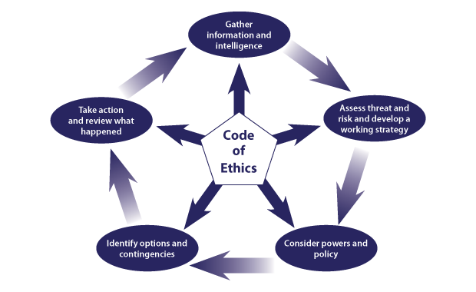

Bryant,R,B. (2020)Blackstones handbook for policing students oxford p.79

https://www.app.college.police.uk/wp-content/uploads/2014/12/NEW-National-decision-model1.png

Code of Ethics
These lay at the heart of every police officer and all decisions must include the following.
Accountability – You are answerable for your decisions and actions.
Fairness – You should always treat people fairly
Honesty – You are truthful trustworthy ad honest.
Integrity – You must always do the right thing.
Leadership – You lead by good example.
Objectivity – You must make choices on evidence and your best professional judgement.
Openness – You are open and transparent in your actions and decisions
Respect – You must always treat everyone with respect
Selflessness – You always act in the public interest.

(2019 NDM student lesson notes college of policing)

Gather information and intelligence
The information and intelligence available to me at the time was the suspect male had warning markers as a domestic abuse aggressor on the police national computer, there were obvious signs that a person had been injured and the male is admitting to being in some sort of incident with his partner.
His partner was refusing to cooperate with police and gave an account that did not match evidence presented to officers at scene.

Assess threat and risk and develop a working strategy
I considered all the information that I had and the risks posed to the female if I did not take positive action, I was also thinking without her cooperation it would be hard to present a case to the Crown Prosecution service.
The only evidence was the blood stained floor and a trail that led to the front door, there was also the account from the male saying that the female had gone to attack him and hit her head on the radiator.
I then developed a strategy and as there is clear discrepancies in both the male and females accounts I suspected that a crime may have taken place.
I asked a unit to make contact with the female and attend her location so they could check on her welfare and see if she could add to her account.

Consider powers and policies
I used all the information that I had gathered and felt that it had reached the threshold test for arrest
Bryant,R,B. (2020)Blackstones handbook for policing students oxford p.611

I know under section 24 of pace I could arrest the male as I had reasonable grounds for suspecting that an offence had been committed.
I felt that further questioning was needed so I knew PACE code C covered the detention, treatment and questioning of the suspect male.

Bryant,R,B. (2020)Blackstones handbook for policing students pace codes oxford p.70

Identify options and contingencies
I knew that part of my role as a police constable I had an obligation and duty of care to the public so I needed to make a decision of what best to do to protect the female victim,
South wales police has a local policy where positive action must be taken relating to all domestic cases.

Take action and review what happened
By using the National decision making model (NDM) I had made my mind up that I would be arresting the suspect male as there were lots of questions I needed to put to him and he needed to be under caution with a chance of having legal advice.
The male was arrested and taken to the local police station where he was booked in and processed.
As he male was foreign there was a language barrier so I needed to get the translator / language line to aid in booking the male into custody so that he had a clear idea why he had been arrested and also what rights he is entitled to.
During the interview questions were put to the male where he made a full admission to assaulting his partner by hitting her over the head with a wine bottle.

Conclusion
By gathering all information available at the time I was able to use the National decision making model to come to a decision on what best action and powers to take, By using this model it guided me to make the arrested where a full admission was obtained during an interview.
The CPS advised a charge against the male mainly through the evidence the police obtained during golden hour investigations and the admission in interview.
The male was remanded where he attended court and pleaded guilty and received a custodial sentence.
This has allowed the victim to receive all the support she needed and escape of her abusive relationship.

Word count 1550.

Task 3

Relevant areas of the National Policing Curriculum:
Maintaining Professional Standards, Leadership and Team-working

Evaluate theories of team dynamics as a means of developing team cohesion (reasons why some teams cannot function, theories and models relating to team dynamics, ways to improve team cohesion).

Consider why inter-personal conflict can occur within a team and outline what strategies can be adopted to enhance individual and team performance.

Consider how team dynamics within the police service can result in failing to comply with professional standards requirements (Code of Ethics, policies, procedures, protocols or legislation).

1500 words (+/- 10%: include your actual word count at the end of each section)

ANSWER:

During this task I shall talk about what a team is, how a team is formed and discuss team cohesion and dynamics and what makes a successful team.
I know there is heavily documented resources available surrounding Bruce Tuckman’s Model “Forming, Storming, Norming, performing, Adjourning” however I will be going against the “norm” and taking a leap of faith where I will be refereeing to Professor Raymond Meredith Belbin and how his theories are still being used today in team dynamics.
I shall also cover conflict between team members and look at the positive and negative effects of conflict within a team.
During this task I shall also go into detail surrounding team dynamics within the police service.

Firstly I will describe in my own words what a team is,

“A team is a small group of people who come together to achieve a shared goal or desired aim, teams can be within the workplace sporting or found within military organisations, teams are usually between 4 – 20 people”.



Just a few fun facts on the most successful teams throughout history.

1, Rangers FC, are the most successful performing football team in modern history with 50 league titles.

2, US Navy seal team 6 are documented as the most successful military team in history, they are credited for the capture of Osama bin laden, the rescue of Captain Phillips from Somali pirates and cleared the way for over 5000 vessels during the invasion of Omaha beach during D-Day.

3, New Zealand all blacks are the most dominant Rugby team throughout history with them notching up an astonishing win rate of 77.41%.

Britannica (2020) encyclopaedia

All these teams have found the winning formula and below we shall look at what makes a good performing team.

Team dynamics and Cohesion
To create a successful and performing team firstly you must understand how a team is created and the dynamics of a functional and dysfunctional team.
Dr Belbin has created a theory where he identified nine different roles that fall into three distant categories, each role had clear behavioural and interpersonal strengths and weaknesses, Dr Belbin believed that a successful team would need to have a mixture of individuals made up from each of these roles.

Dr Belbin described that a team would be unbalanced if all the team members had similar styles of behaviour.

Belbin,RM.(2004) management teams: team dynamics, London

Belbin’s 3 distinct categories

1. Action oriented roles
For example shapers and implanter roles, these team members can bring self-discipline to the team and want to get things done, it is recorded that shapers and implanters may be resistant to change.

2. People Oriented roles
These are team members who draw together people and ideas, they usually are the ones who listen, organise and delegate to other members of the team.

3. Thought Orientated roles,
These team members are usually the lone workers who could come up with innovated ideas and solutions, these members could sometimes seem detached and a type of lone wolf.

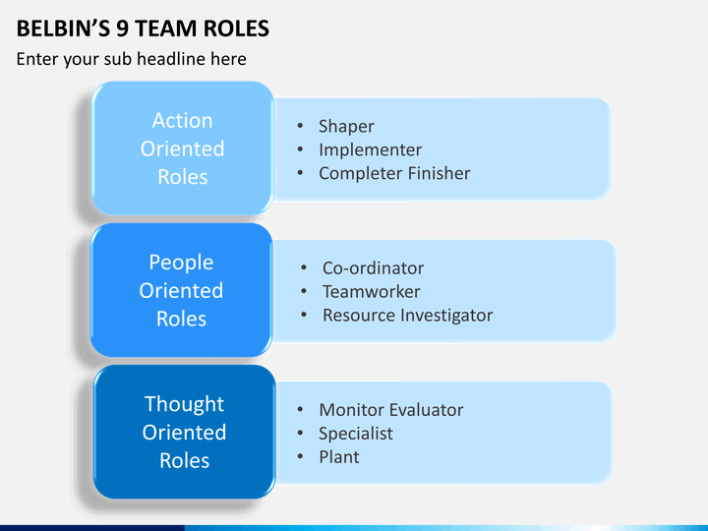

From the three distinct categories team members will adopt at least one of the nine team roles from the following graph below,
Belbin describes that you must have all 9 roles within your team to have a functional organised and performing team.
Team members may carry more than one role within the team.

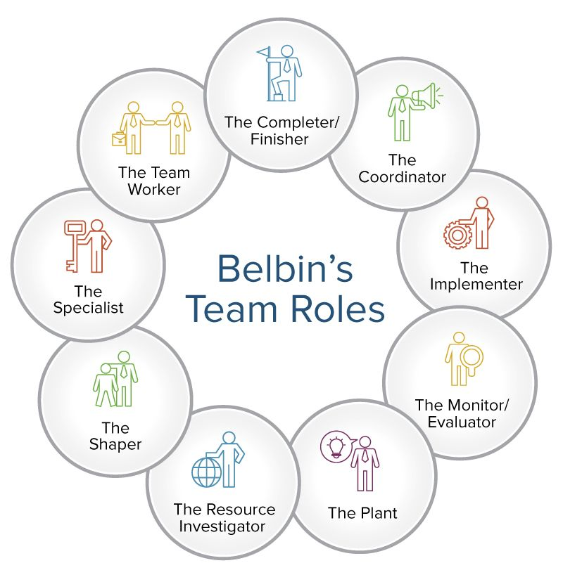

1. The resource investigator
These are the team members who explore opportunities, they are inquisitive, outgoing and develop contacts outside the organisation.

2. The team worker
These are team members who are good listeners, flexible, popular, provide support, and good at getting other members to work together.

3. The co-ordinator
These are the workers who focus on objectives and guide the team, they clarify the goals and get resources and recognise talent of other team members.

4. The Plant
These are creative roles who have great ideas and they often work on their own to come up with better strategies at how to achieve tem goals.

5. The monitor / evaluator
These team members are critical thinkers, who monitor and evaluate other member’s performance.

6. The specialist
These have specialised knowledge and are experts in a specific area and are highly committed to the team in that area.

7. The shaper
These members are dynamic and challenge the team to improve, they are driven and put pressure on other members to maintain focus and they often see obstacles as a challenge.

8. The Implementer
These members get things done, practical, driven, and disciplined organised and reliable.

9. The completer finisher
These members are perfectionists, focused on deadlines, they want to polish the final project, focused at avoiding errors.

Belbin,RM. (2004) Management teams: why they succeed or fail 2nd edition

My personal opinion to a successful team is down to a good manager, a good manager will identify the team roles and delegate work best to suit them, if a team is happy and function to a high standard team members will enjoy their work and create a positive vibe,
This will also have a positive effect on their home lives and children’s development.

If you have a poor manager they also have a big impact on the lives of the team members but in a negative way, this will have a knock on effect in their attitude towards work and could possibly affect your company’s goals,
If you are not happy in your work you may take your troubles home and this could start to impact your personal and family life.

Effects of conflict within a team

So now we know what you need to create a functional team that can perform, now I will look at and consider why inter-personal conflict can occur within a team and what effects it may have.
I have searched different forums and literature and found the following to be the best definition to explain team conflict

“Team conflict is an interpersonal problem that occurs between two or more members of a team, and affects results of teamwork, so the team does not perform at optimum levels. Team conflicts are caused by the situation when the balance between perceptions, goals, or/and values of the team is upset, therefore people can no more work together and no shared goals can be achieved in the team environment

Lewinson,M (2010) Definition and types of conflict web page [accessed 20th January 2021]

Conflict within a team can be down to team member’s differences and how they view the world and how they interpret the behaviour of others.
I think it is safe to say that not everyone is the same and sometimes conflict is inevitable but it is how people deal with conflict that makes the difference.

Now we know what team conflict is I think firstly we should look at the negative results of having conflict within a team.

Conflict between team members can take a toll on other members and bring the morale of the team down.
Conflicts can be time consuming and draining, they may also take up your manager’s time and attention as they will have to address the situation, and most importantly People cannot work efficiently if they are angry or upset.

On the flip side we can look at the positives of a team in conflict,
Disagreements between team members can bring new ideas and add a fresh prospective on set tasks, it can also add personal pride where members want to perform better than the team member they are in conflict with.


Team dynamics within the police service
It is important that police officers work well in a team so they can be efficient and safe, they often work closely with other teams and it is essential that they perform to provide the best service to the public.

Police constables have a unique role where they all should be confident at challenging negative behaviour, this could be members of the public or their own team members,
Police officers sometimes adopt the CUDSA Model and this model is about resolving and confronting conflict where you identify and understand the problem.
Below it is broken down into five steps of conflict resolution if you use this simple model when confronting an issue you should come up with a fair solution.

C- Confront the issue
U- Understand other position
D- Define the problem
S- Seek a solution
A- Agree action to resolve

Cinardo,S (2019) multilingual toolbox, web page [accessed 31st January 2021]
Conclusion
During my working life I have worked within many teams throughout the military, prison service and now the police, What I have found is the teams within the police are all made up of individuals who are encouraged to have a voice, this sometimes can cause friction between team members and unfortunately this friction can lead to breaching the backbone of every police officer and that is the code of ethics.
Some teams that are performing highly adopt a sort of invincibility feeling where they feel that they are above their role and start thinking that the police force would not function without them.
Sadly this causes friction between teams and management and can lead to loosing focus or their original goal, I find that it is sometimes better to move a team member when this happens as it disrupts the performing stage of the group and sets them back to the forming stage where individuals reorganise and subconsciously pick up some of the nine roles of Belbin’s model.

Word count 1572

Task 4
Relevant areas of the National Policing Curriculum:
Policing the roads, information and intelligence and conducting investigations.

Explain how information and intelligence can be used in the disruption of the more prevalent criminal activity (e.g. drug smuggling, human trafficking, child sexual exploitation, counterfeit goods, organised crime groups and ‘county lines’) by effective policing of the roads.

Outline how ANPR can be used as investigative resource when disrupting criminal activity.

1500 words (+/- 10%: include your actual word count at the end of each section)

ANSWER:

Introduction

During this task I shall explain how information and intelligence can be used in the disruption of criminal activity such as drug smuggling, human trafficking and county lines gangs,
It shall look at the history of the highways, the UK road network and how policing the roads has evolved throughout the years, I shall use old case law and refer to the earliest road crimes recorded and how these crimes were conducted.
The task will also explore the National police chief’s council three year strategy on policing the roads and their main objectives and what technology is available to the modern day police force and government agencies to gather information and address issues on the highways.
The technology that I will cover and explain during this task will be the use of CCTV and traffic cameras, vehicle tracking, roadside fingerprinting, facial recognition and the use of Automatic Number Plate Recognition.
I do hope that you find this task interesting and informative with an unconventional approach and some fun history facts included.

The United Kingdom mainland road network comprises of 262,300 miles of paved roads and they span from Scotland through England and Wales and are used by some four million users each day, the earliest engineered roads in Britain were built during the Iron Age and then later engineered and expanded during the roman occupation where some of these roads still remain to this day.

The UK roads were heavy developed from the 1950s through to the mid-1990s to meet the demand of modern traffic where they now provide a link to every town and city, the road network is continually being developed and improved by local authorities to make journey times quicker and safer, our roads are vital to the country’s economy and society.
History of roads and Highways England - Highways England

Anonymous, (2021) Highways England, [accessed 31st January2021]

Since the established network of roads in the United Kingdom criminals and terrorists have exploited their use, the first reported group of criminals who used the roads to aid their crimes were in the 18th century and they were called the Highway men.

With the increase of roads being built saw an increase in people using them, the Highway men would be on horseback that would target vulnerable people on sections of isolated roads where they would hold up carriages and rob the people of their valuables, this is where the saying highway robbery came from, The robbers who conducted robberies on foot were called footpads.

The most famous and successful Highwayman was Dick Turpin, Turpin was a member of the Gregory gang who operated in Lincolnshire during the 17th century, Dick Turpin was eventually caught and tried for horse theft and was hung in 1739.
Dick Turpin – The Spurious Highwayman – Stand and Deliver

Duval,D (1999) Stand and deliver Highwayman & highway robbery [ accessed 6th March 2021]

Fun Fact - The earliest form of policing the roads were bodyguards who would sit next to the driver of stage coaches armed with a shotgun to ward off bandits and highwaymen attempting to rob the stagecoach and their occupants, this is where the saying “riding shotgun” comes from.

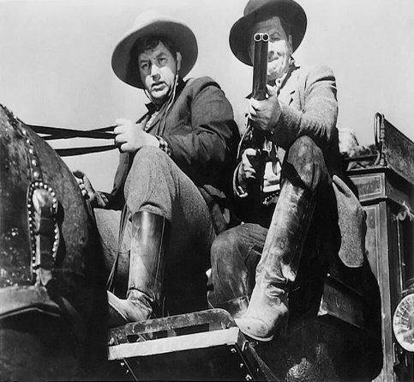
Photo (historygarage.com)

I think it is safe to say that policing the roads have come a long way since the Dick Turpin days, policing and technology is always evolving to combat the ever increasing criminal activities and gangs who use the UK road network to distribute such items like drugs, counterfeit goods, money and even humans for sexual exploitation and modern day slavery.

According to the statistics from the National crime agency there are around 4600 serious and organised crime gangs operating in the UK, these gangs make their money by delivering a product i.e. drugs, counterfeit goods, or people to the buyer in exchange for a gain that is usually money, these gangs use the vast network of roads in the UK to deliver these products and it is down the agencies such as the police and NCA to police them.

Anonymous, (2020) National crime agency [accessed 2nd February 2021]

In 2018 the National police chief’s council (NPCC) implemented and published a three year strategy on policing the roads, the police have a vital part in ensuring that the road network operates efficiently and the people who use it can do so safely, the NPCC has set out three main objectives

- Safe roads, free from harm
- Secure roads free from threat of serious crime and terrorism
- Efficient roads that promote public confidence and satisfaction.
Home (npcc.police.uk)

Anonymous (2018) National Police chiefs’ council web page [accessed 4th February 2021]

The NPCC plays a role in bringing UK police forces together to help coordinate operations and police the roads, some of the way police forces police these roads are by using technology and intelligence, some of the technology available to police forces across the country are

CCTV / Traffic cameras
Highways England / Wales state they have more than 1,700 traffic cameras that monitor major trunk roads across the countries where they are monitored and used for several types of uses spanning from road congestion to criminal movements, this is a good example how other agencies work with police forces to give the road user the safest and best service.

Anonymous, (2021) Highways England, [accessed 31st January2021]

Vehicle tracking
Tracking devices can be fitted to vehicles by manufacturers or the public. Some of these devices allow vehicles to be immobilised remotely, tracking can aid police forces to monitor the movement of target cars and build intelligence that will aid combating travelling criminals and cross boarder crime.
Roadside fingerprinting (project lantern)
There are two types of fingerprint databases used in the UK and they both aid officers to check the identity of unknown persons within less than a minute, the first system is called IDENTI, this system involves fingerprinting of suspects when they are brought into police custody and is done as part of the booking in process, for people who are not charged with an offence their fingerprints are only stored on the data base for five years and then erased.
The second fingerprint database is called IBAS and this contains fingerprints collected from non UK-citizens when they enter the country legally as part of their visa applications, both these databases used right can aid in policing crime and terrorism.
Facial recognition
Facial recognition is relatively new and is a method of identifying and verifying the identities of people by using a computer algorithm that that picks out distinctive details about peoples face, eyes and chins, it is then converted into mathematical representation and stored in a database, this software can be used against CCTV traffic cameras, camera vans and even photos published on social media.
Disrupting criminality (college.police.uk)
Anonymous, (last modified 2019) roads policing, disrupting criminality [accessed 1st March 2021]
Automatic Number Plate Recognition
The most beneficial and productive technology and information tool that the Police have in its arsenal is the Automatic Number Plate Recognition or (ANPR) for short.
ANPR is used in three key ways, to gather intelligence, to identify and disrupt criminals and to investigate crime, ANPR consists of a camera linked to a number plate reading device that takes a photograph and feeds it into a number plate reader where it is compared against records held on a database, the date time and location is then recorded for further intelligence
ANPR is a proactive tool that can help identify, target and gather intelligence of traveling criminals using the UK road networks to commit crime.
ANPR cameras can be deployed in several ways such as fixed, static, multi-lane and on border controls.
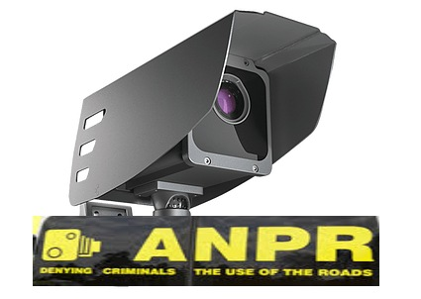
It can also can be used as part of a pre-planned operation where teams react to an indication when a traveling criminal triggers an ANPR camera, this gives the roads policing unit’s time and intelligence on the route used enabling a plan to be created that will reduce the risk of a pursuit, ANPR is also a valued asset when policing cross border crime as it allows different forces to come together and manage the threat.
When considering the deployment of ANPR you must make sure that you balance public protection with the individual rights and privacy.
Assessments should take account of:
- national security and counter terrorism
- serious, organised and major crime
- local crime
- community confidence and reassurance, crime prevention and reduction
ANPR technology (npcc.police.uk)
Anonymous, (last modified 2013) ANPR college of policing accessed 1st March 2021
Conclusion
I think it is safe to say that roads throughout the UK have been dramatically developed since the days of the Romans and Dick Turpin, the UK road network is used by some four million drivers daily, roads have also seen an increase in organised crime gangs and criminals using them to conduct illegal activities and get their product to their market / buyer.
The technology and strategies used by the police have also had to be developed to combat the increase of organised gangs and their ever changing tactics
Looking at the technology used today such as the highly affective Automatic Number Plate Recognition cameras this provides police forces across the country and other agencies with invaluable intelligence gathering and policing capabilities.
This road gathered intelligence is not only used for a policing purpose but also by Highways England and Wales to identify accident hotspots and make the roads safer as part of the 2018 National police chief’s council strategy where the direction is to make roads safer, free from harm and secure from the threat of serious organised crime and terrorism.
This will make the roads efficient and will promote public confidence and satisfaction.

Word count1607

Task 5
Individual Learning Plan

The second learning outcome identified in the accompanying module descriptor (BMPP 5000D) asks that you create an individual learning plan to meet your identified needs through reflection upon your continuing practice. This shows confidence in your ability to manage your own learning in response to evolving circumstances in the workplace.

This task differs from the PDPs that you have completed in your previous workbooks in that this learning plan allows you to assess what level you believe you are in key knowledge, skills and experience against where you believe you (and the force) consider you should be – now and in the coming 6 to 12 months of your placement. This should then be used to target future development need.

1500 words equivalent. Please note that this is not the actual number of words used in completing the table, the count reflects the thought and research behind it.

It will count towards the overall equivalent word count of 8000 words expected from this module.

ANSWER:

Knowledge, Skills and Experience Assessment

 | REQUIRED |  |  | RATING |  |  | DEVELOPMENT NEED
KNOWLEDGE  Over the past 18 months being employed as a police constable it has been a steep learning curve, the amount of definitions of offences that I have had to learn has been astronomical.  The Knowledge of general policing duties that a constable has to know to complete their duties such as the custody, interview / VA process  The knowledge of general questions that the public ask is an important part of policing, often the public look to the police for answers and could be damaging on public perception if officers don’t know the answers | Low  1-4 | Med  5-7 | High  8-10  8  8  8 | Low  1-4 | Med  5-7  6  7  7 | High  8-10 | I feel confident that I know the definitions I use more often however there are still a lot that I need to know,  I should read Blackstones and access the university library more often to expand my knowladge  It is overwhelming the amount of policies and procedure’s there are, I feel that my confidence plays a big part and I often get through on confidence alone, I am happy to ask for help when needed  I feel that the police officers are representatives of the communities and should know answers when questioned by the general public.  I feel confident that if I do not know the answers I can point them in the right direction.
SKILLS  The skills required by police constables can range from interpersonal skills to conflict management, this, I will break them down and reflect individually  Interpersonal skills needed by a police officer is a huge part of policing, officers need to be calm and professional when dealing with incidents and confident when making decisions  Conflict management and use of force techniques have to be at a high standard as dealing with violent offenders can be dangerous, also thrown in that the trend of people filming incidents and posting on social media trying to tarnish the police force.  Once independent patrol status is reached there are numerous skills available to a police officer to help them develop, such skills are response driving, Taser course and method of entry.  There are computer skills also available such as the Police national computer training, | Low  1-4 | Med  5-7 | High  8-10  10  8  8 | Low  1-4 | Med  5-7  5 | High  8-10  8  8 | This is a skill that I have been lucky to develop throughout my working life, all my jobs have involved conflict and speaking to people and making tough decisions, I am aware that not everyone is a suspect so I am conscious to be assertive and militant when dealing with vulnerable,  The conflict management and officer safety side of the job is my strongest skill, I am always trying to develop and strive for perfection, I used to be the officer safety trainer for the prison service where the tactics I taught were similar but not identical to the police, I have to be mindful not revert back to old tactics as some are not approved.  I am developing my skill set quite nicely, since gaining my independent status I have completed and achieved my response driving and Taser carry course.  I strongly believe that the more courses and qualifications you gain make you a better operator.  I know I have to work harder on the computer side of my role with forms that keep changing.  I am a strong believer that self-development is a must and officers need to keep developing, I feel I will never have enough training and courses so this is why my self-reflection score is so low.
EXPERIENCE  I think it is safe to say that you need some experience to complete your duties as a police officer however there are so many aids within the police force such as guides built in to your Samsung phone devices, a sergeant or experienced colleague on duty that you can contact for advice.  I feel that the best experience is when officers have a go at something they haven’t experienced before and to do this you need self-belief and confidence. | Low  1-4 | Med  5-7 | High  8-10  8 | Low  1-4 | Med  5-7  5 | High  8-10 | I am a firm believer that experience is an important part of policing as it helps you keep calm and be effective during incidents.  I have only 18 months experience in the role so I am a long way off and the old saying every day is a learning day is true as some incidents we deal with stump even the most decorated and experienced operator.  I always stay proactive and keen where I often volunteer to take the more challenging calls.

Task 6
Recognition and confirmation of progress on the Occupational Competency Portfolio (OCP).

By signing the section below you are acknowledging your continuing progress on O.C.P.

This is recognised by the university as work that is fully supporting this module BMPP 5000D; Professional Police Practice 2 and in signing it will be equivalent to 1000 words towards the 8000 words equivalent total.

Confirmation of the progress on the Occupational Competency Portfolio (OCP).

I confirm that I am progressing with the Occupational Competency Portfolio (OCP) in accordance to the regulations.

Signed: Dylan Griffiths _ _ _ _ _ _ _ _ (Learner – electronic signature accepted.)

Date: _ 1st April 2021 _ _ _ _

Bibliography
The bibliography should only include sources referenced within the workbook using the Harvard referencing system. Information about referencing in written assignments and how to avoid plagiarism can be found on Moodle. It is important that you are aware of the importance of ensuring that the work submitted is your original work.

Task 1
Organisational culture
Anonymous. (2021). Organisational culture business balls webpage accessed 10th February 2021
Code of ethics
Bryant,R,B. (2020)Blackstones handbook for policing students oxford p.76.
NHS 10 ways to reduce stress
Cooper,C (2020) 10 ways to reduce stress. NHS web page

Stress is a by product of policing
Bryant,R,B. (2020)Blackstones handbook for policing students oxford p.110

Task 2
Call grading
Bryant,R,B. (2020)Blackstones handbook for policing students oxford p.552

Power of entry
Bryant,R,B. (2020)Blackstones handbook for policing students oxford p.70

The national decision making model (NDM)
Bryant,R,B. (2020)Blackstones handbook for policing students oxford p.79

The threshold test
Bryant,R,B. (2020)Blackstones handbook for policing students oxford p.611

Pace codes
Bryant,R,B. (2020)Blackstones handbook for policing students pace codes oxford p.70
Task 3

Team dynamics and cohesion
Belbin,RM.(2004) management teams: team dynamics, London

Team roles

Belbin, RM (2004) Management teams: why they succeed or fail 2nd ed

Types of conflict

Lewinson,M (2010) Definition and types of conflict web page [accessed 20th January 2021]

CUDSA model

Cinardo,S (2019) multilingual toolbox, web page [accessed 31st January 2021]

Task 4

Histroy of the Highways

Anonymous,, (2021) Highways England, [accessed 31st January2021]
Stand and deliver
Duval,D (1999) Stand and deliver Highwayman & highway robbery [ accessed 6th March 2021]

Riding shotgun Photo

Photo (historygarage.com)

NCA crime statistics
Anonymous, (2020) National crime agency [accessed 2nd February 2021]

National police chiefs council three year strategy
Anonymous (2018) National Police chiefs council web page [accessed 4th February 2021]

CCTV Traffic cameras

Anonymous, (2021) Highways England, [accessed 31st January2021]

Roads policing disrupting criminality
Anonymous, (last modified 2019) roads policing, disrupting criminality [accessed 1st March 2021]

ANPR technology
Anonymous, (last modified 2013)ANPR college of policing accessed 1st March 2021

End

