
Geographical Information Systems
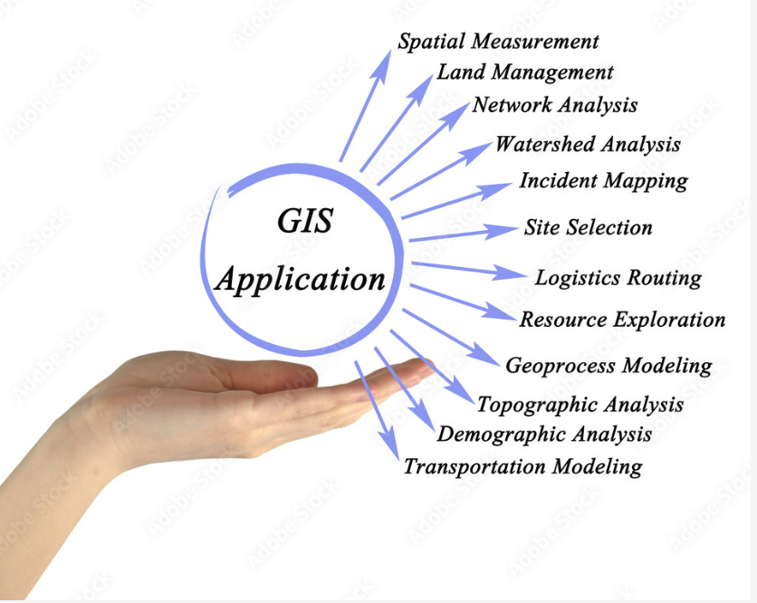
^{[1]}
School of Applied Computing | Assignment Title:  Geodemographic Analysis Using GIS Software | Code: ACCA 5027
Module:
Geographical Information Systems

Student:  Theresa Darzins  No 1909721 | Programme: Computing Portfolio  BSc Computing | Lecturer: Beverley Holland  Date: 15th May 2022

Contents
1.0 INTRODUCTION - 1 -
1.1 Report structure - 1 -
1.2 Aims - 2 -
1.3 Objectives - 2 -
2.0 TASK 1 – DEVELOPMENT LOG - 3 -
2.1 UK Regions - 3 -
2.2 Wales Local Health Boards - 5 -
2.3 Case Study Carmarthenshire Output Area - Hywel Dda LHB - 7 -
2.3.1 Categorisation of Residents - 8 -
2.3.2 Deprivation Index - 8 -
2.3.3 Levels of Health - 10 -
2.3.4 Covid Cases Just Carmarthenshire Area - 13 -
2.3.5 Overlaid with Very Bad Health - 14 -
2.4 Covid Data for Wales by Local Health Board (LHB) - 15 -
2.4.1 Covid Deaths in Wales - 16 -
2.4.2 Covid Vaccination Centres in Wales - 17 -
2.5 Data, File Types and Reasons Used - 20 -
2.5.1 Data Sets - 20 -
2.5.2 File Types - 20 -
2.5.3 Reasons - 21 -
3.0 TASK 2 – RESULTS OF GEOGRAPHICAL INFORMATION SYSTEMS BUILD - 23 -
3.1 Wales LHB Deaths Proportionate to Population - 23 -
3.2 Wales LHB Vaccinations Proportionate to Population - 24 -
3.2.1 Herd Immunity - 25 -
3.3 Combined Rankings for Low Deaths and High Vaccination Rates by LHB - 26 -
3.4 Vaccination Centres - 27 -
3.4.1 Locations of Vaccination Centres - Categorised by LHB - 28 -
3.4.2 Number of Vaccination Centres Categorised by LHB with Population - 29 -
Alphabetically Sorted - 29 -
3.4.3 Number of Vaccination Centres Categorised by LHB with Population in Size Order - 29 -
3.4.4 Vaccination Centres Categorised by LHB – Ranked by which Serving Least/Most - 30 -
3.5 Possible Reasons for Individual LHB’s Success or Failure - 31 -
3.5.1 Powys’ Success with Both High Vaccination and Low Death Rate - 31 -
3.5.2 Highest Death Rate - Cwm Taf Morgannwg - 32 -
3.5.3 Lowest Vaccinations - Swansea Bay - 32 -
3.6 Carmarthenshire Case Study – Hywel Dda’s Ranking on LHB’s - 32 -
3.6.1 Least Deaths and Most Vaccinations - 32 -
3.6.2 Vaccination Centres - 33 -
3.7 What the Carmarthenshire Case Study Revealed - 33 -
3.7.1 Urban and Crowded = More Covid Cases - 33 -
3.7.3 Countryside and Least Populated = Less Covid Cases - 33 -
3.7.4 The More Deprived and Bad Health Areas = More Covid Cases - 33 -
3.8 Summary of Whole of Wales LHB Performance - 34 -
3.9 Thematic Maps Used to Highlight Findings - 35 -
4.0 CONCLUSION - 36 -
4.1 Best LHB For Least Deaths and Most Vaccinations - Powys - 36 -
4.2 Worst LHB for Deaths – Cwm Taf Morgannwg - 36 -
4.3 Worst LHB for Vaccinations – Swansea Bay - 36 -
4.4 Most Vaccination Centres Per Head of Population – Betsi Cadwaladr - 36 -
4.5 Least Vaccination Centres Per Head of Population – Cardiff & Vale - 36 -
4.6 Recommendations - 37 -
5.0 REFERENCES - 38 -

Figure 1 UK Regions Map - 3 -
Figure 2 Wales Only Map - 3 -
Figure 3 Motorways Wales - 4 -
Figure 4 Wales Local Health Boards - 5 -
Figure 5 Wales Local Health Boards with Legend - 6 -
Figure 6 Carmarthenshire Output Area in Hywel Dda - 7 -
Figure 7 Carmarthenshire OA (without motorways) - 7 -
Figure 8 Carmarthenshire Residents Status and Legend - 8 -
Figure 9 Carmarthenshire Output Area (Blank) - 9 -
Figure 10 Carmarthenshire Levels of Deprivation - 9 -
Figure 11 Carmarthenshire Levels of Health 0-4 - 11 -
Figure 12 Carmarthenshire Health Levels Very Good to Very Bad - 11 -
Figure 13 Carmarthenshire Residents Deprived in all 4 Areas - 12 -
Figure 14 Carmarthenshire Covid Cases - 13 -
Figure 15 Carmarthenshire Covid Cases Overlaid with Very Bad Health - 14 -
Figure 16 Covid Vaccination Percentages for Wales by Local Health Board - 15 -
Figure 17 Covid Death in Wales Categorised by Percentage of LHB - 16 -
Figure 18 Covid Vaccination Centres per head of Population by LHB - 17 -
Figure 19 Reminder of the Deaths (underneath previous map) - 18 -
Figure 20 Deaths by LHB Ranked in Proportion to Population - 23 -
Figure 21 Vaccinations by Local Health Board (Percentages) - 24 -
Figure 22 Levels of Immunity - Best, Worst and If No Vaccines Administered - 25 -
Figure 23 Locations of Vaccination Centres in Wales - 27 -
Figure 24 Vaccination Centres per head of Population by LHB - 30 -

Table 1 Browser for Local Health Boards - 5 -
Table 2 Carmarthenshire Deprivation Browser - 8 -
Table 3 Data Health Carms Browser - 10 -
Table 4 Covid Cases Browser CarmsCovidCasesByLocation - 13 -
Table 5 AllWalesDeathsByLHB Browser - 16 -
Table 6 VaxCentres Browser - 17 -
Table 7 Excel Chart Showing How Many Each Vaccination Centre Serves per LHB - 17 -
Table 8 All Wales Population By Local Health Board - 18 -
Table 9 All Wales Covid Deaths Ranked Proportionate to Population of Local Health Board - 19 -
Table 10 Summary of Files Used and Why - 22 -
Table 11 All Wales Covid Deaths Ranked by LHB Proportionate to Population - 23 -
Table 12 All Wales Vaccinations Ranked Proportionate to LHB Population - 24 -
Table 13 Vaccinations by LHB Browser - 24 -
Table 14 Wales Immunity If Immunity Wanes After 2+ years/2 Years % of Immunity - 25 -
Table 15 Highest and Lowest Immunity in Wales by Age Group - 25 -
Table 16 Vaccinations Ranked Proportionate to LHB Population - 26 -
Table 17 Combined Rankings for Low Death/High Vaccination per % of LHB Population - 26 -
Table 18 Locations of Vaccination Centres by LHB - 28 -
Table 19 No. of Vaccination Centres by LHB with Population in Alphabetical Order - 29 -
Table 20 No. of Vaccination Centres by LHB with Population Size Order - 29 -
Table 21 Vaccination Centres by LHB Ranked by which Serving Least to Most - 30 -
Table 22 Possible Reasons for LHB's Success/Failure - 31 -
Table 23 Least Deaths/Most Vaccinations by % Population of LHB - 32 -
Table 24 – See the Ranking of Hywel Dda (Carmarthenshire) - 33 -
Table 25 Summary of Whole of Wales Local Health Boards Performance (Rankings) - 34 -
Table 26 Vaccination Centre Rankings - 34 -
Table 27 Thematic Maps Used to Highlight Findings - 35 -
Table 28 Recommendations by Areas of Concern - 37 -

INTRODUCTION

Report structure

    - Introduction

    - Task 1 – Development Log

- Log
  - UK Regions
  - Wales Local Health Boards (LHB)
  - Case Study - Carmarthenshire Output Area
  - Covid Data for Wales

- Data Sets, File Types and Reasons Used
  - Data Sets
  - File Types
  - Reasons

    - Task 2 - Results of Geographical Information Systems Build

- Ranked Local Health Boards According to:
  - Deaths
  - Vaccinations
  - Vaccination Centres

- Possible Reasons for LHB’s Success or Failure

- Carmarthenshire Case Study - Hywel Dda’s Ranking
  - Deaths and Vaccinations
  - Number of Vaccination Centres
  - What the Carmarthenshire Case Study Revealed

- Summary of Performance of Wales LHB’s
- Thematic Maps Used to Highlight Findings (Recap)

    - Conclusion
- Best LHB For Least Deaths and Most Vaccinations
- Worst LHB for Deaths
- Worst LHB for Vaccinations
- Best LHB for Vaccination Centres Per Head of Population
- Worst LHB for Vaccination Centres Per Head of Population
- Recommendations

    - References

Aims

To showcase the science and technology, and management of Geographical Information Systems.

Objectives

Develop critical understanding of underlying theories of GIS through examination of current GIS software trends through:
- Construction of a System to inform healthcare professionals on:

  - uptake of the Covid-19 Vaccination Programme in Wales, using latest data set provided.

- Highlighting:

  - one Local Authority area where uptake of vaccination is high/low.

- Pose:
  - possible reasons for this high/low uptake.

TASK 1 – DEVELOPMENT LOG

2.1 UK Regions

Figure 1 UK Regions Map
UK_Regions Map
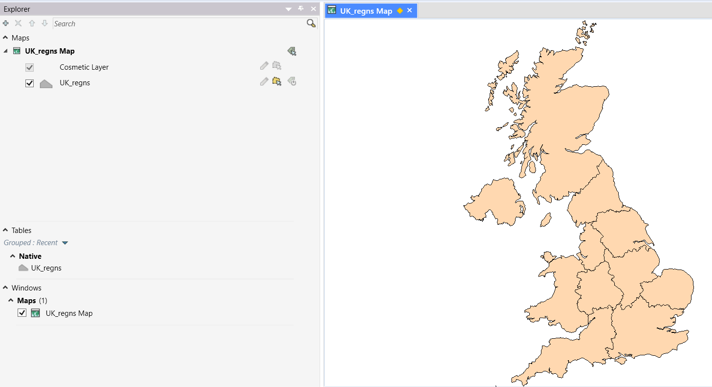
Figure 2 Wales Only Map
Wales_only, regns Map
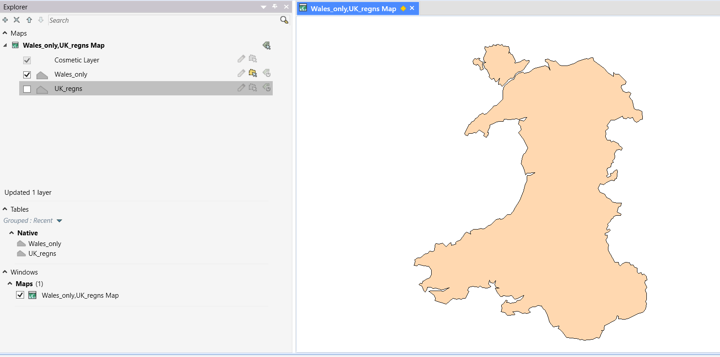

Figure 3 Motorways Wales
M_ways,Wales_only, regns Map
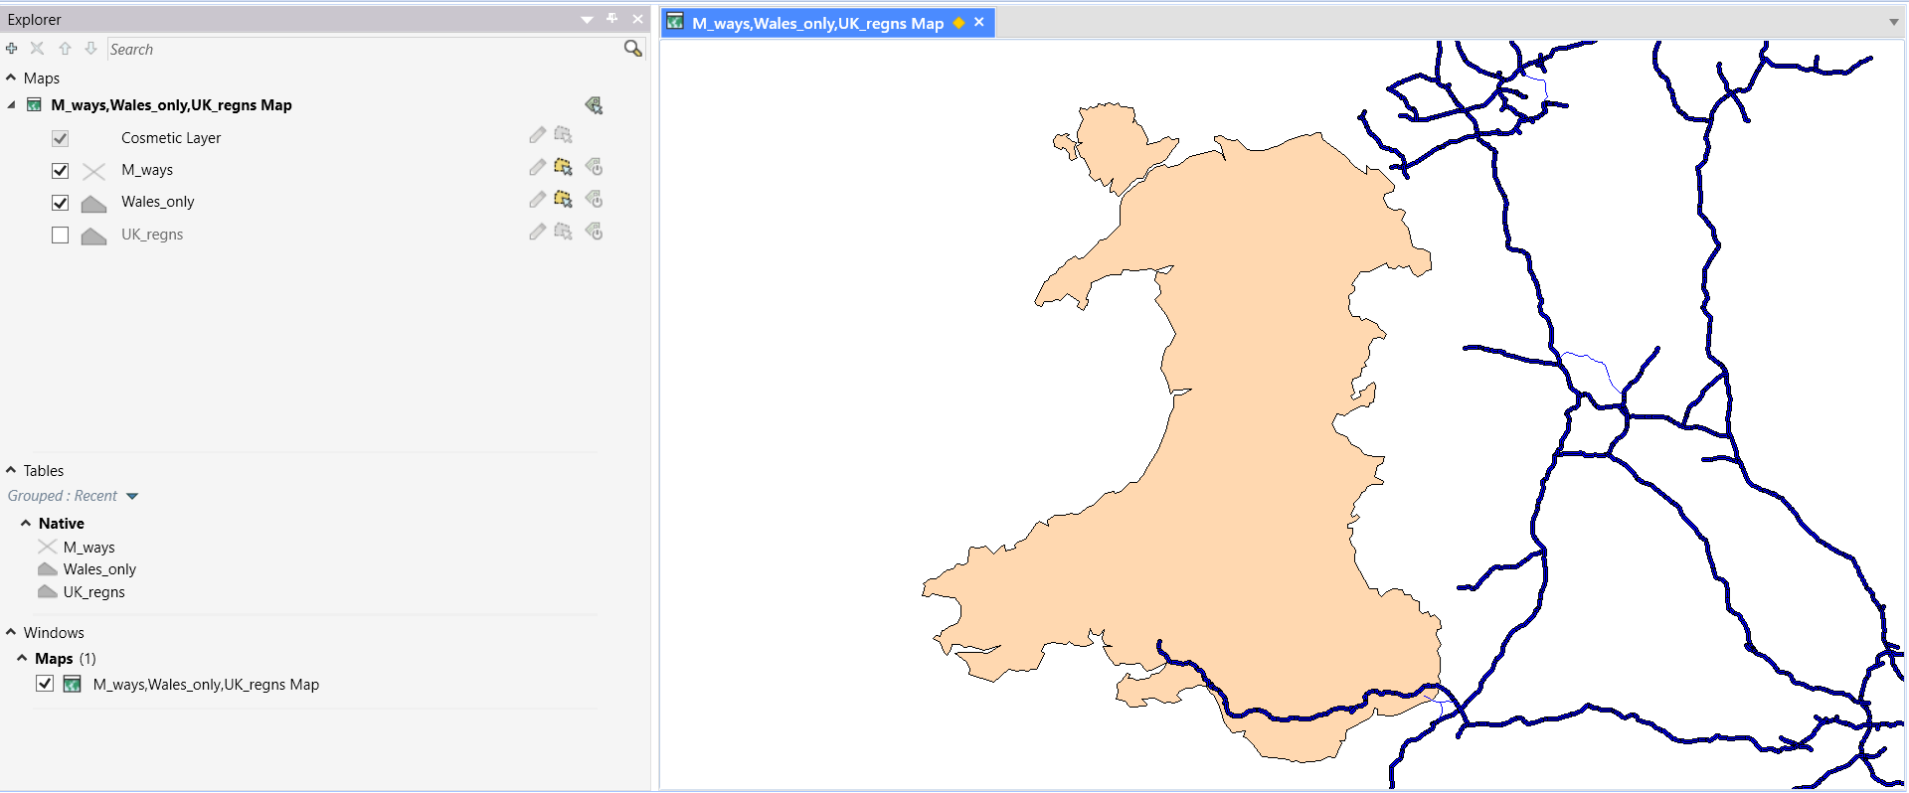

2.2 Wales Local Health Boards
Figure 4 Wales Local Health Boards
local_health_boards.TAB
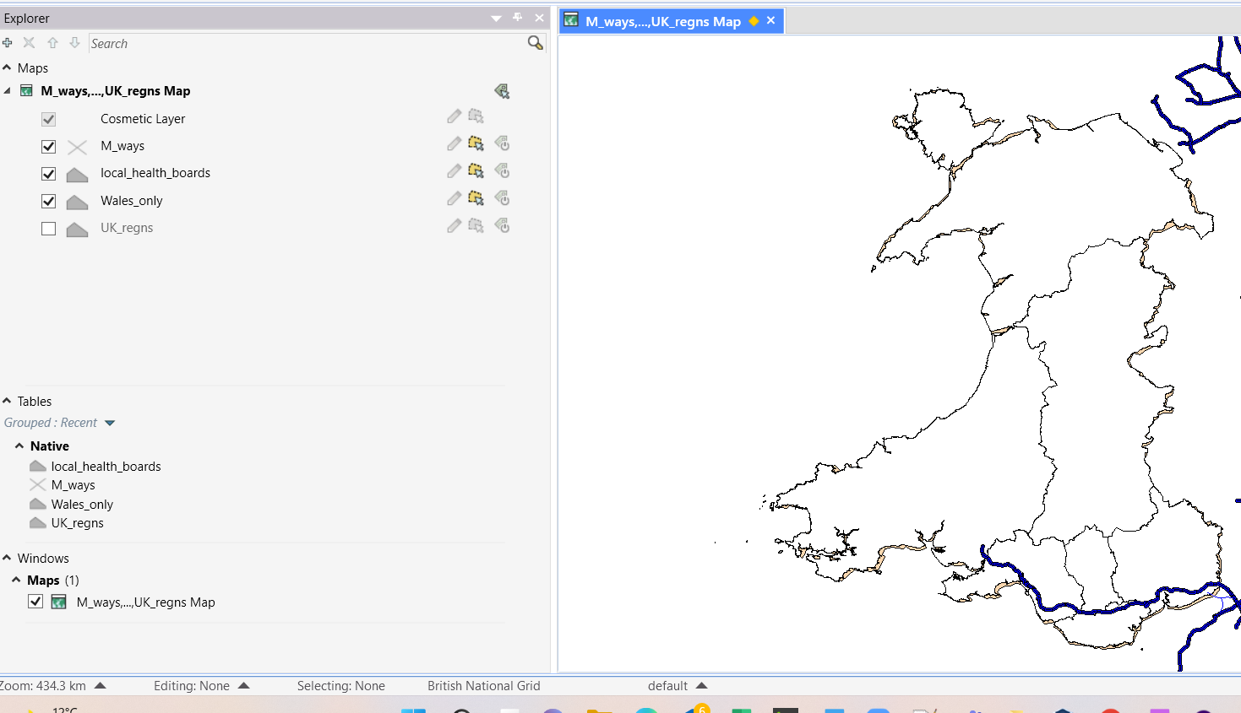

Browser for local_health_boards
Table 1 Browser for Local Health Boards
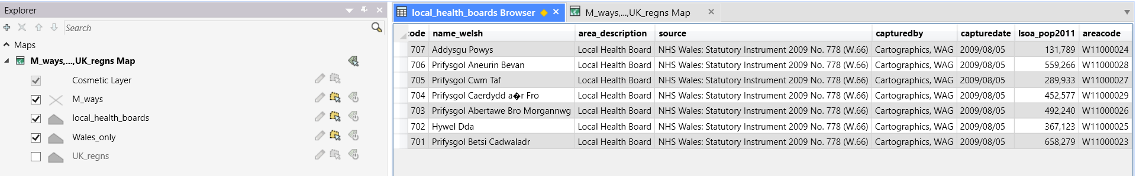

Figure 5 Wales Local Health Boards with Legend
After adding theme for above: (using areacode and name)
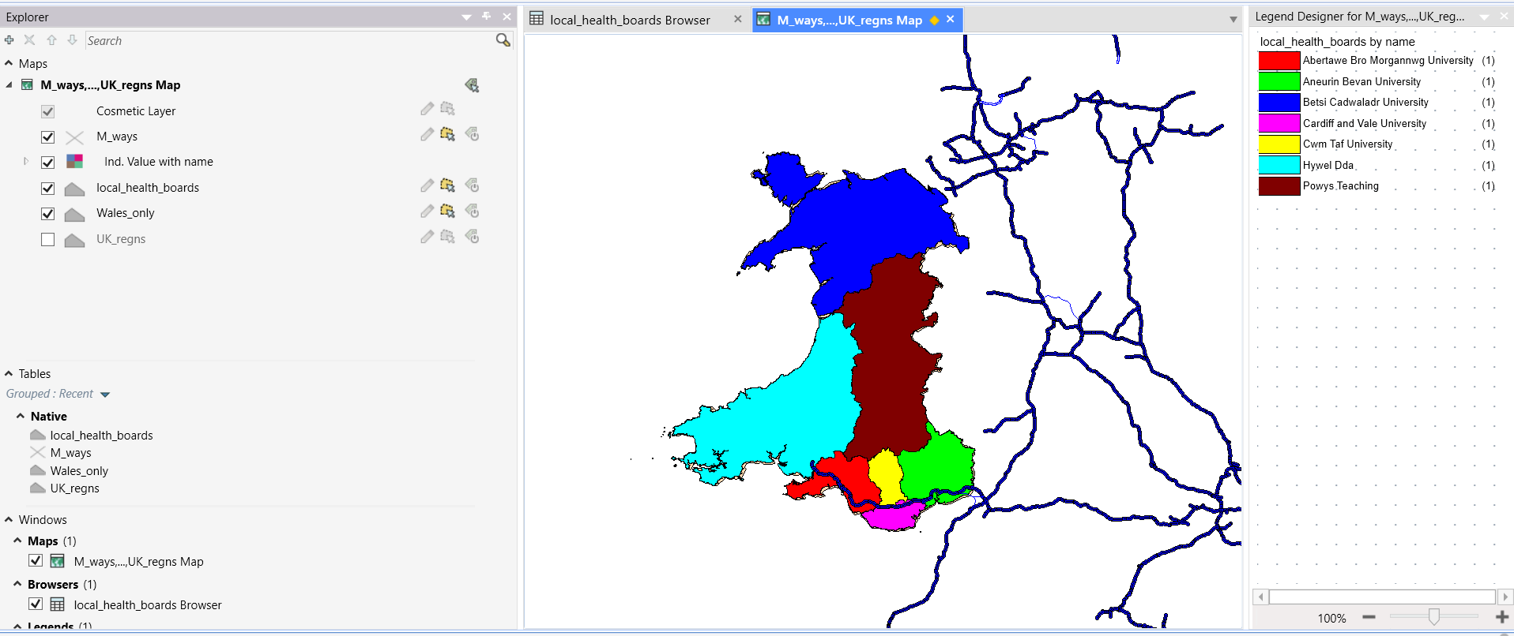

2.3 Case Study Carmarthenshire Output Area - Hywel Dda LHB

Figure 6 Carmarthenshire Output Area in Hywel Dda
CarmarthenshireBoundaryData.TAB
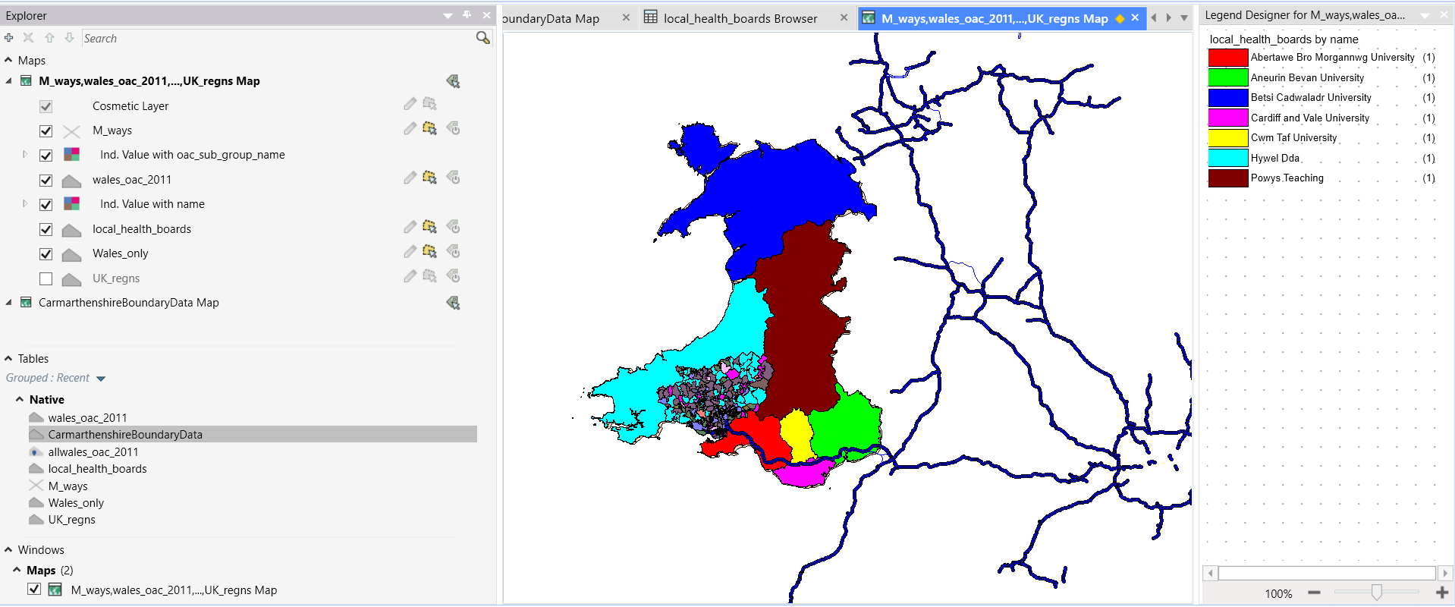
Turned off motorways view (distracting) CarmarthenshireBoundaryData

Figure 7 Carmarthenshire OA (without motorways)
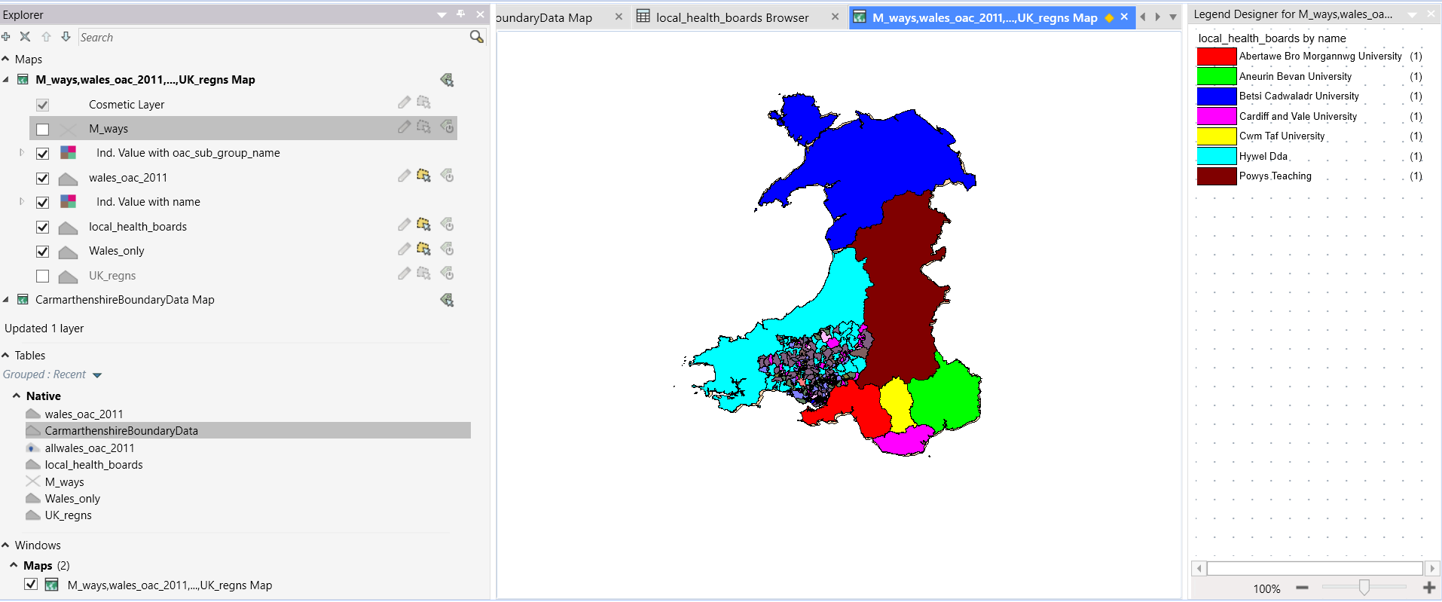

2.3.1 Categorisation of Residents
Figure 8 Carmarthenshire Residents Status and Legend
Turned off other maps so just Carmarthenshire and Residents Status with a Legend
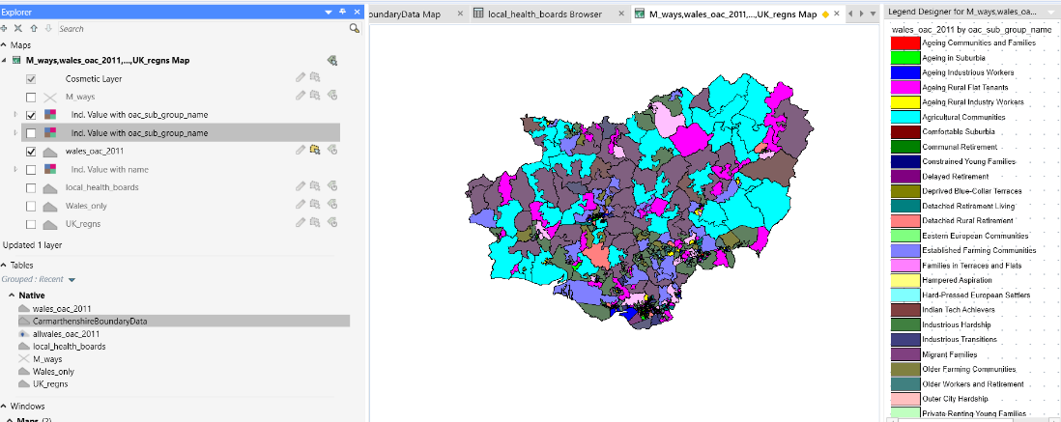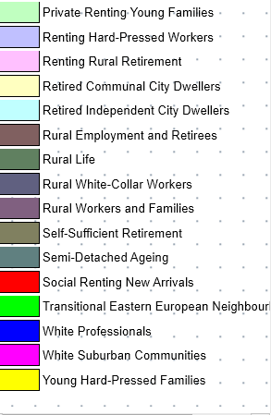

2.3.2 Deprivation Index
Opened New Browser with Carmarthenshire Deprivation
Table 2 Carmarthenshire Deprivation Browser
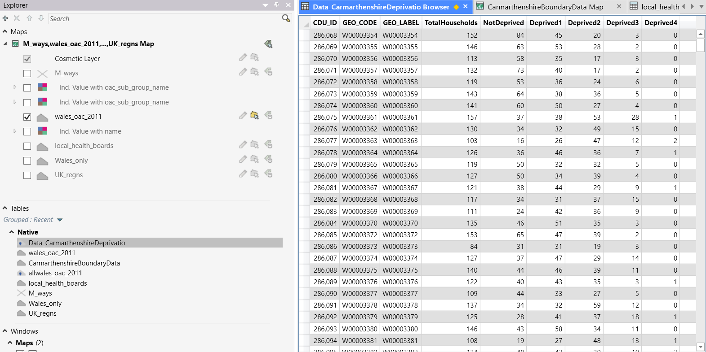

Figure 9 Carmarthenshire Output Area (Blank)
Get the Basic Carmarthen map back on screen to layer with Carmarthen Deprivation (CarmarthenshireBoundaryData.TAB)
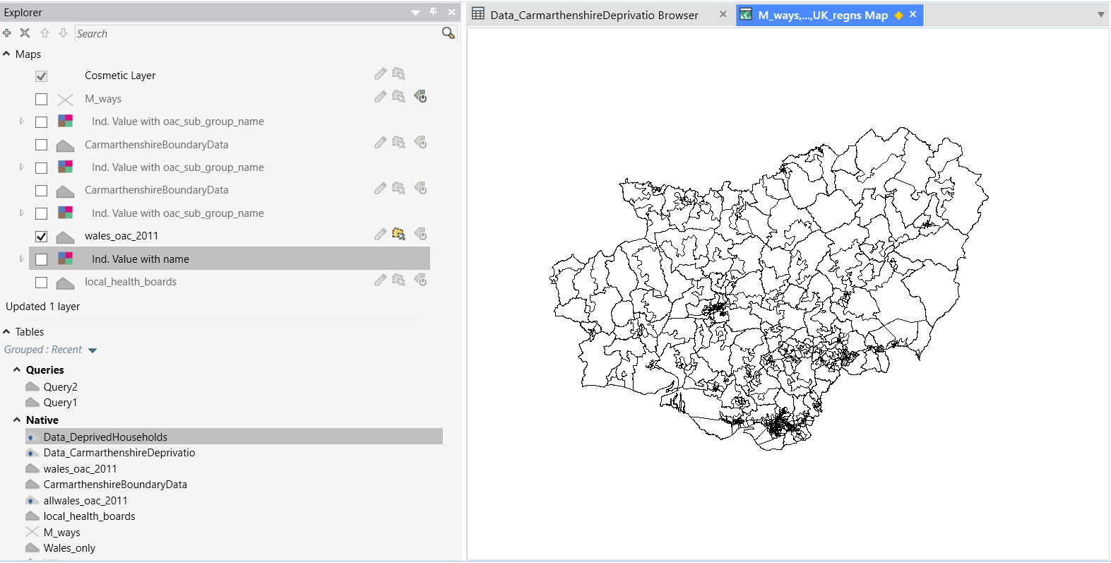
Add the levels of Deprivation so can compare (by joining Carmarthenshire blank as above to Deprivation)
Figure 10 Carmarthenshire Levels of Deprivation
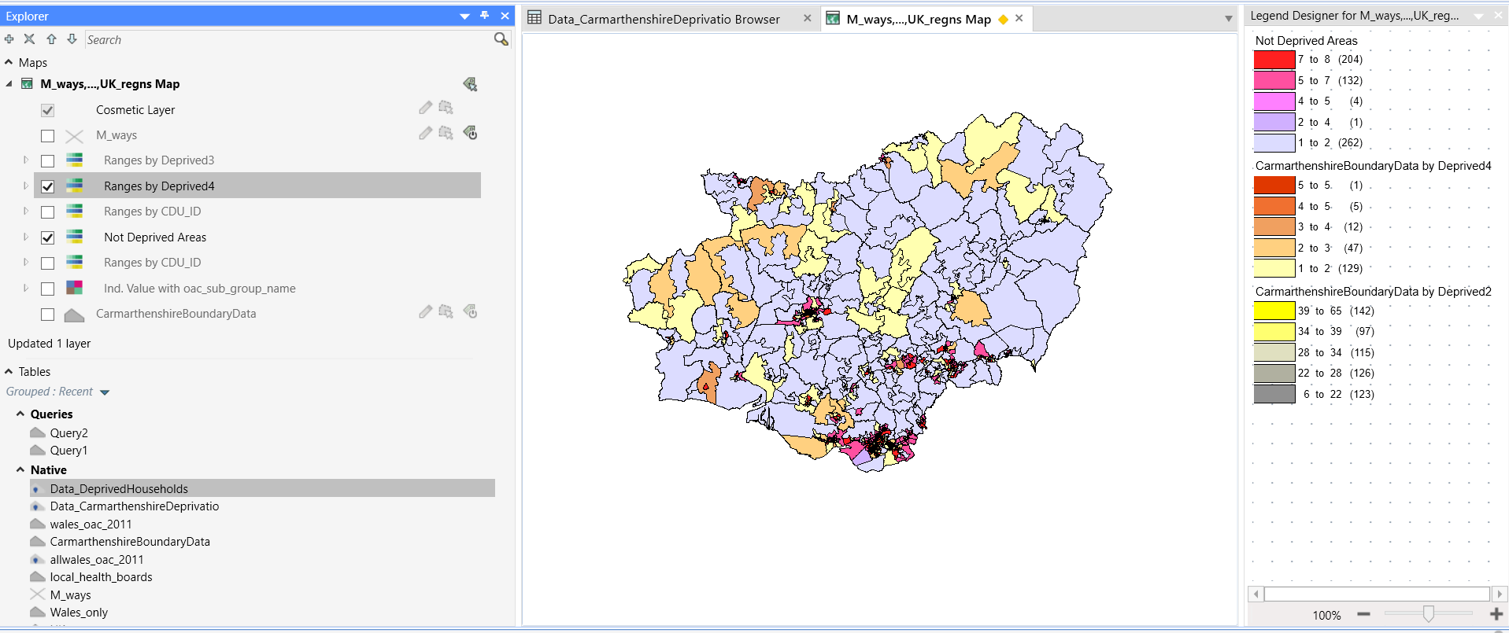

2.3.3 Levels of Health
Add Levels of Health in so can compare those in deprived areas and those in not deprived areas
Data_HealthCarms.xls
Table 3 Data Health Carms Browser
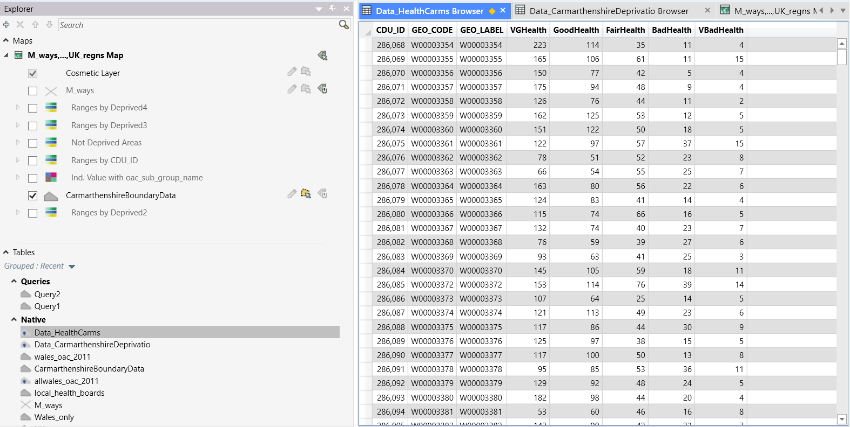

Figure 11 Carmarthenshire Levels of Health 0-4
see if the Deprivation relates to Health
Deprivation Levels = from 0 to 4 (0 is darker and 4 is lighter)
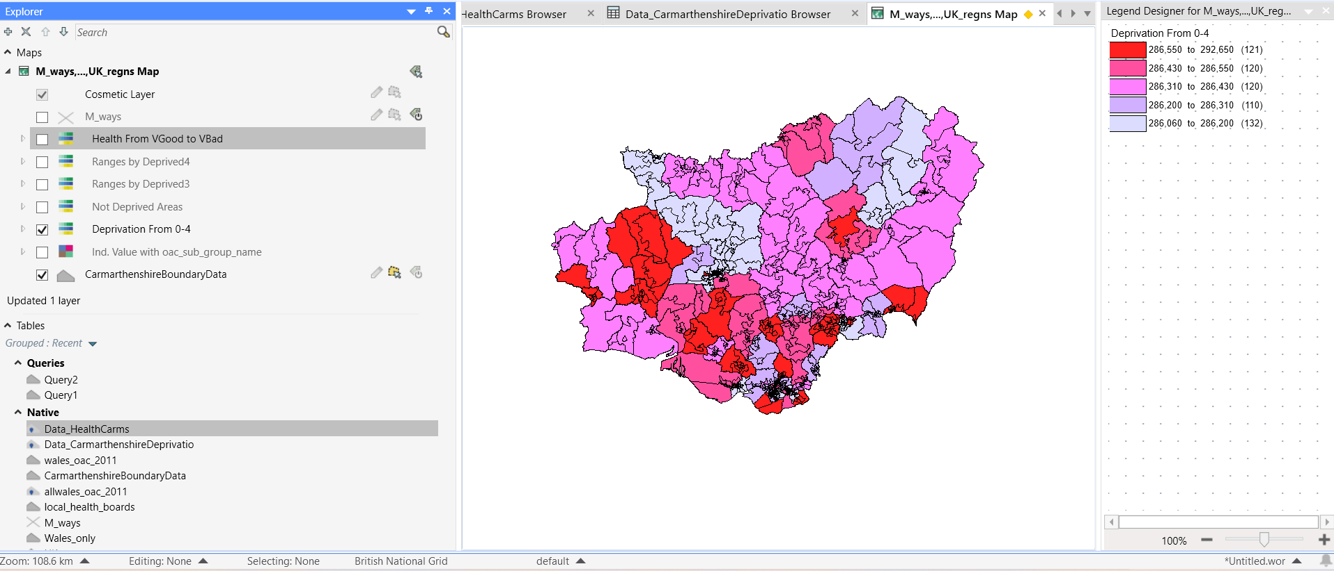
Figure 12 Carmarthenshire Health Levels Very Good to Very Bad
Health levels
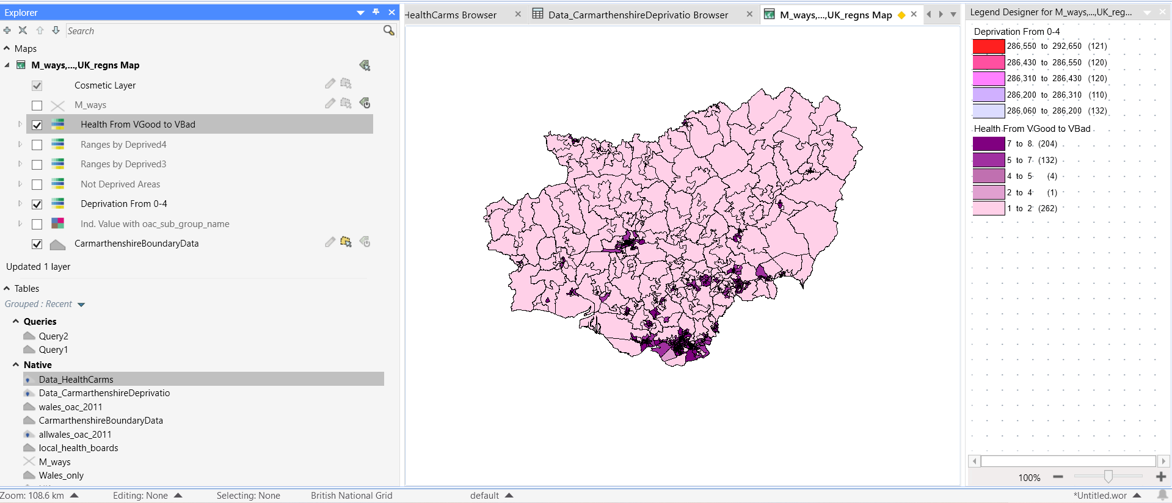

Figure 13 Carmarthenshire Residents Deprived in all 4 Areas
Those Deprived in all 4 Areas:
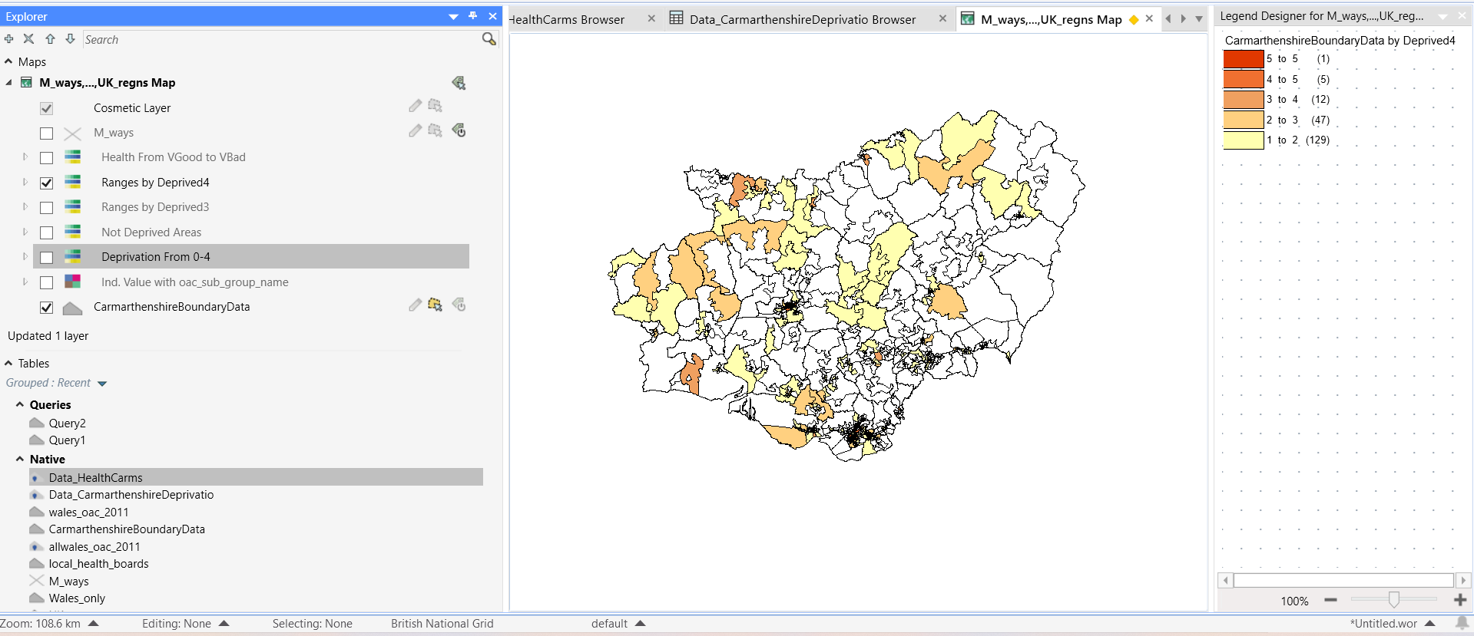

2.3.4 Covid Cases Just Carmarthenshire Area
Load Covid Cases (Browser) CarmsCovidCasesByLocation
Table 4 Covid Cases Browser CarmsCovidCasesByLocation
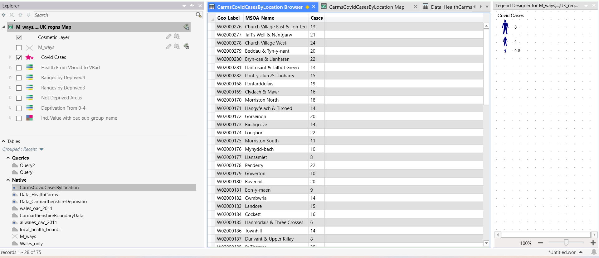
Figure 14 Carmarthenshire Covid Cases
And see mainly in urban deprived areas
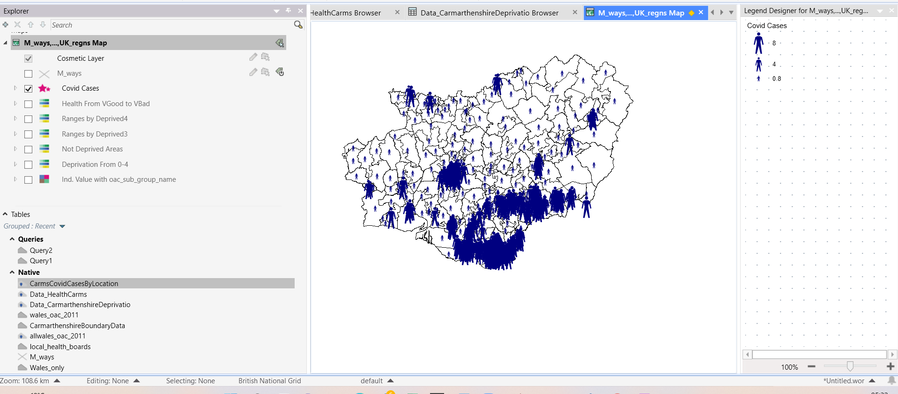

2.3.5 Overlaid with Very Bad Health
And see those in Very Bad Health Overlaid on top
Figure 15 Carmarthenshire Covid Cases Overlaid with Very Bad Health
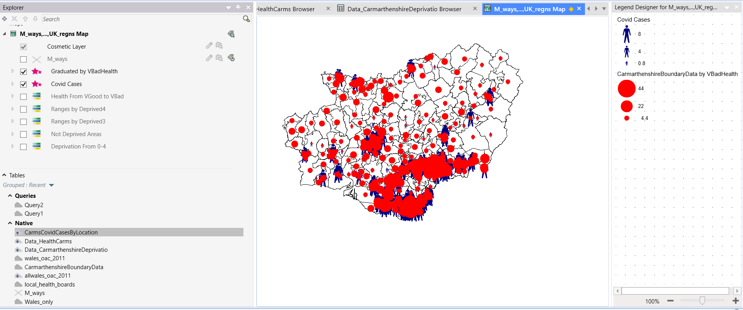

2.4 Covid Data for Wales by Local Health Board (LHB)

To categorise the % Vaccination levels for all 7 Wales Local Health Boards
local_health_boards and overlay with 7 different boards with Legend:
Figure 16 Covid Vaccination Percentages for Wales by Local Health Board
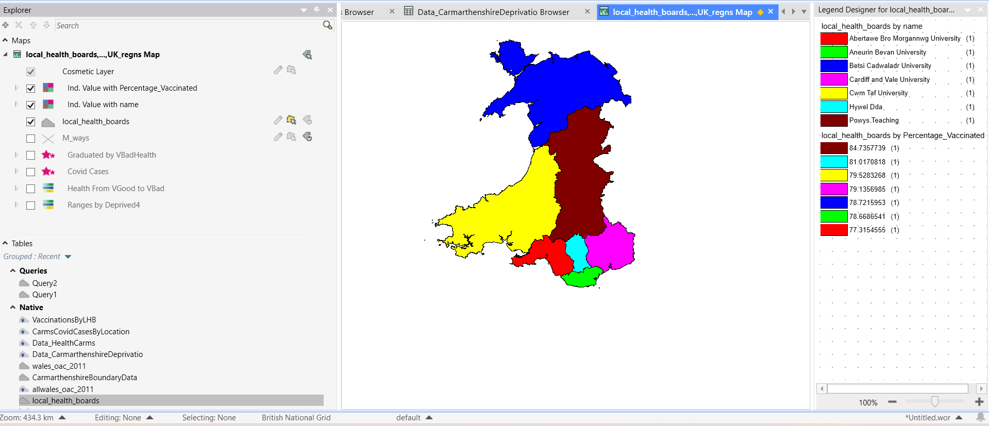

2.4.1 Covid Deaths in Wales

Show the Deaths by Local Health Board (WalesLHBDeathsAll.xls)
Figure 17 Covid Death in Wales Categorised by Percentage of LHB
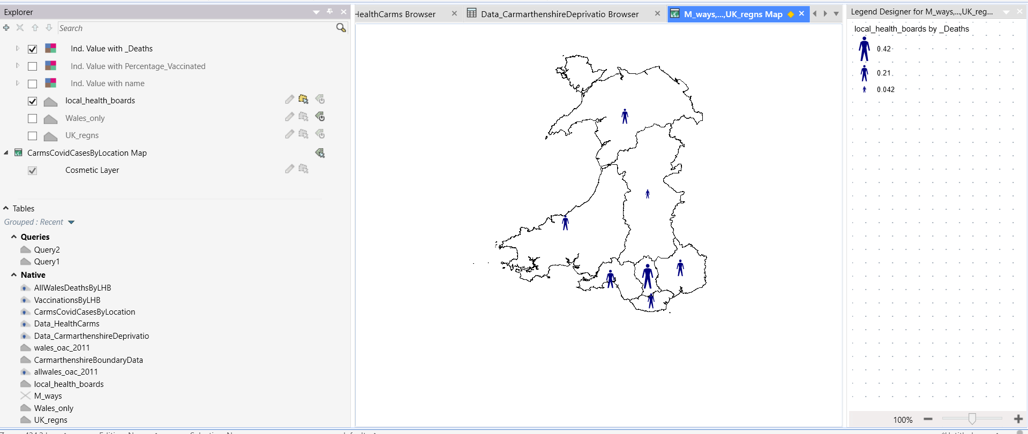
Table 5 AllWalesDeathsByLHB Browser
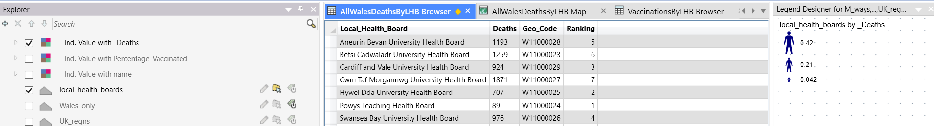

2.4.2 Covid Vaccination Centres in Wales
show Vaccinations Centres per head of population (Deaths underneath)
Figure 18 Covid Vaccination Centres per head of Population by LHB
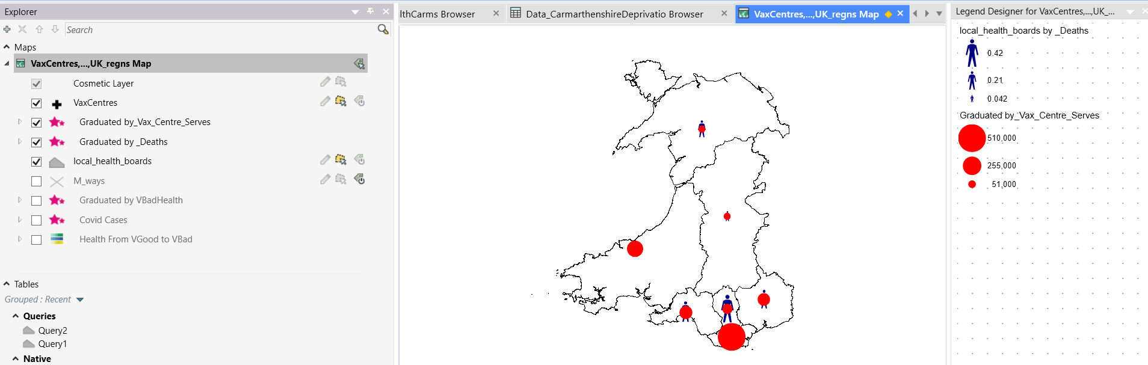
Browser: VaxCentres
Table 6 VaxCentres Browser
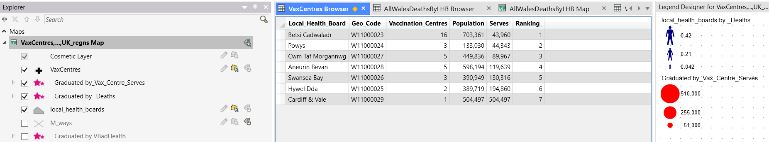

VaxCentres.xls
Cardiff & Vale only had one to cater to whole 504,497
Betsi Cadwaladr had 16 to cater for 703,361
Table 7 Excel Chart Showing How Many Each Vaccination Centre Serves per LHB
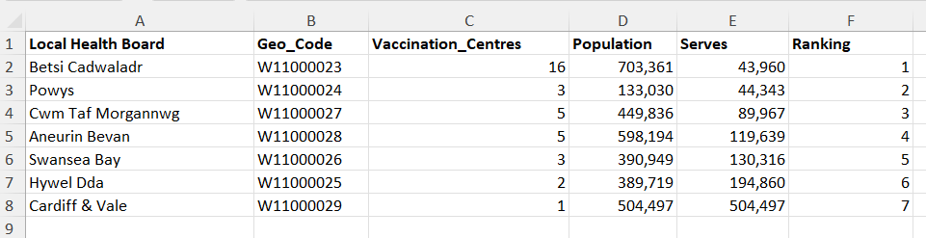

Reminder of the previous layer of Death percentages (underneath Vax Centres)
WalesLHBDeathsAll.xls
Figure 19 Reminder of the Deaths (underneath previous map)
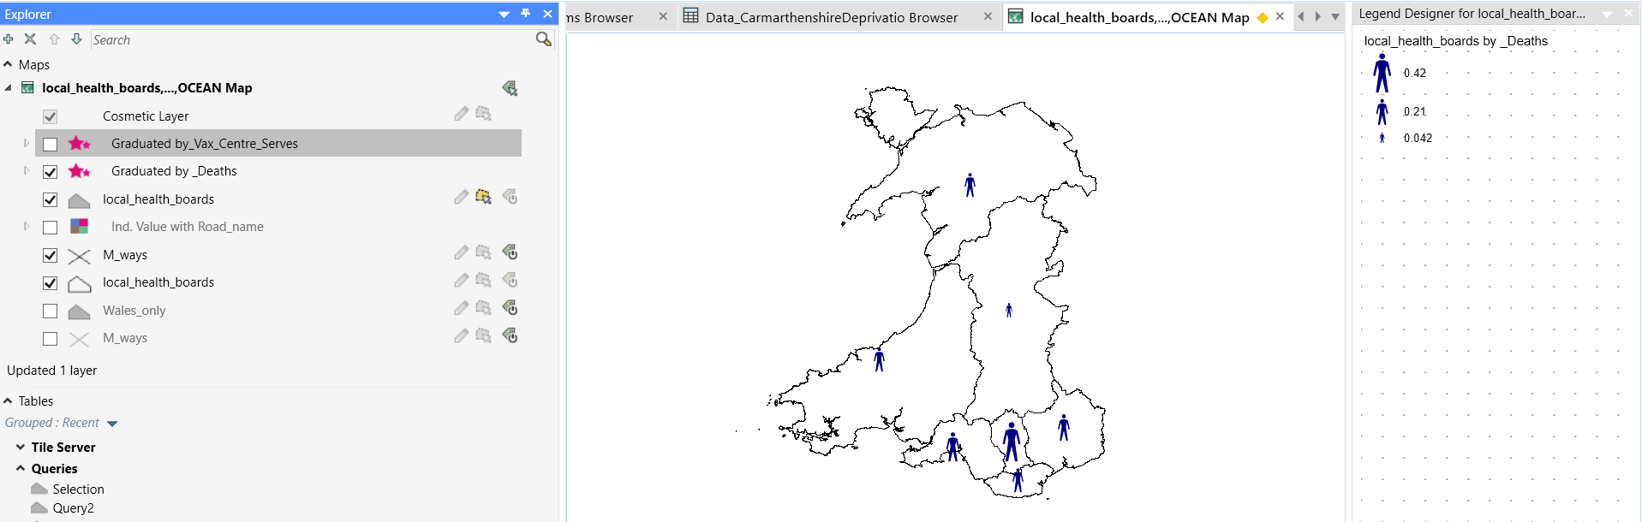

show the number of Vaccination Centres per LHB
Added in Ocean layer (last) with labelling

- Powys has largest area and smallest population.
- It is more likely that the more densely populated areas suffered due to high transmission.
- Ranking by percentage of population who died/vaccinations given shows more accurate picture (hence these figures used):

^{[3]}
Table 8 All Wales Population By Local Health Board
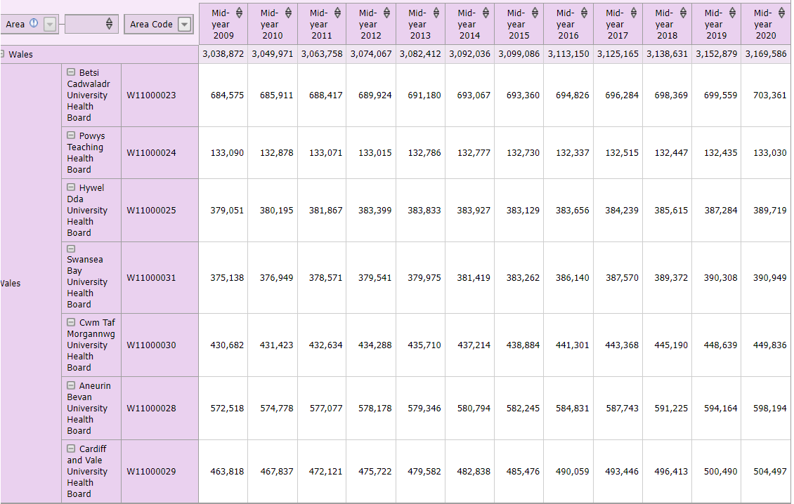
Table 9 All Wales Covid Deaths Ranked Proportionate to Population of Local Health Board
Local Health Boards - Deaths Ranked Least to Most Proportionate to Population
Local_Health_Board | Deaths | Geo_Code | Raw_Ranking | Population | % Deaths | Placed (Low to High)
Powys | 89 | W11000024 | 1 | 133030 | 0.07 | 1
Hywel Dda | 707 | W11000025 | 2 | 389719 | 0.18 | 2
Cardiff and Vale | 924 | W11000029 | 3 | 504497 | 0.18 | 3
Betsi Cadwaladr | 1259 | W11000023 | 6 | 703361 | 0.18 | 4
Aneurin Bevan | 1193 | W11000028 | 5 | 598194 | 0.20 | 5
Swansea Bay | 976 | W11000026 | 4 | 390949 | 0.25 | 6
Cwm Taf Morgannwg | 1871 | W11000027 | 7 | 449836 | 0.42 | 7

2.5 Data, File Types and Reasons Used

2.5.1 Data Sets
Workspace saved in GISExamination.WOR
Data Sets Used
- Total Vaccinations given by organisations in Wales
- Total Covid Cases in Carmarthenshire
- Deaths by Local Health Board
- Lle website to show the Local Health Boards
- .gov website used to show Population by Welsh Local Health Boards
- Carmarthenshire Boundary Data
- Carmarthenshire Deprivation in 5 Areas (Not Deprived, Deprived in 1 aspect, 2 aspects, 3 aspects and 4 aspects)

2.5.2 File Types
- .WOR (for whole Map Info Pro Project)
- .xls (93-2007 Excel)
- Bing Hybrid (for terrain with town names)
- Bing Aerial (for terrain)
- Maps
- Browsers
- Legends
- The various other file types listed over page

2.5.3 Reasons
The following data sets were chosen out of all the Covid Data, as they were specific to Local Health Boards/County (Carmarthenshire).
- Total Vaccinations given by organisations in Wales
- Total Covid Cases in Carmarthenshire
- Deaths by Local Health Board
Also chosen:
- Lle website to show the Local Health Boards
- .gov website used to show Population by Welsh Local Health Boards
Summary of Files used and reasons in table over
Table 10 Summary of Files Used and Why
 | Description | Thumbnail | Fig | Reason
1 | UK Regions Map  UK_regns Map | 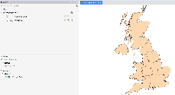 | 1 | Show UK Regions
2 | Wales LHB’s (with Legend) and Motorways overlaid  Local_health_boards Map | 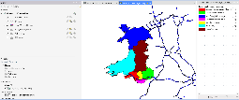 | 5 | Separate into 7 LHB’s with Motorways overlaid
3 | Wales LHB’s with Carmarthenshire Overlaid  As above | 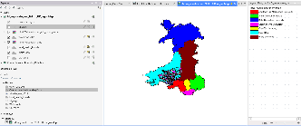 | 7 | Show Carmarthenshire location
4 | Carmarthenshire Categorised by Population  CarmarthenshireBoundaryData.TAB | 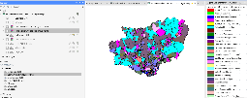 | 8 | Classification of Carmarthenshire residents
5 | Carmarthenshire Categorised by Deprivation  Data_CarmarthenshireDeprivation.xls | 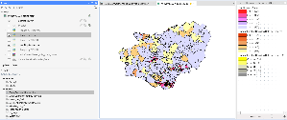 | 10 | Separate Level of deprivation maps 0,3,4
6 | Carmarthenshire Categorised by Deprivation 0-4  As above | 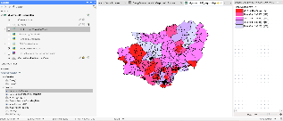 | 11 | Show Levels of deprivation 0—4 (Overall)
7 | Carmarthenshire Categorised by  Very Good Health to Very Bad Health  Data_HealthCarms.xls | 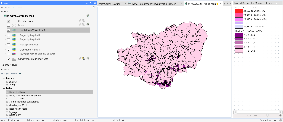 | 12 | Categorise Health by Very Good to Very Bad Health locations
8 | Carmarthenshire Residents Deprived in all 4 Areas  Data_CarmarthenshireDeprivation.xls | 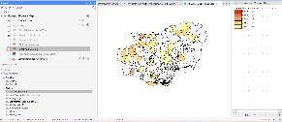 | 13 | Show just those Deprived in all 4 Areas
9 | Carmarthenshire OA – No of Covid Cases in Carmarthenshire by MSOA 10 Jan 21 to 27 Feb 2022  CarmsCovidCasesByLocation.xls | 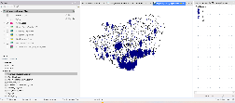 | 14 | Show spread of Covid Areas
10 | Carmarthenshire OA – Correlation of VBad Health Overlaid onto Covid Cases by Area  Data_HealthCarms.xls | 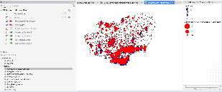 | 15 | Above overlaid with those with Very Bad Health
11 | Wales Vaccination Percentages by LHB  VaxCentres.xls | 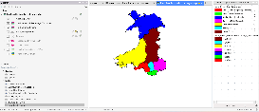 | 16 | Proportionate to Population % Vaccinated by LHB
12 | Wales Covid Deaths Percentages by LHB  DeathsRankedByWalesLHBAndPopulation.xls | 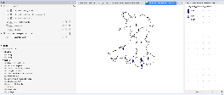 | 17 | Proportionate to Population % Covid Deaths by LHB
13 | Wales Vaccination Centres per head of Population  As above 2 (Deaths per LHB underneath) | 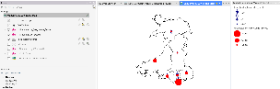 | 18 | Proportionate to Population % Vaccination Centres by LHB

TASK 2 – RESULTS OF GEOGRAPHICAL INFORMATION SYSTEMS BUILD

When identifying factors involved, in assessing each region’s efficacy, i.e.:
- Deaths
- Vaccinations
- Vaccination Centres
considered the population of each Local Health Board, to rank the Health Boards proportionately.

Wales LHB Deaths Proportionate to Population

Table 11 All Wales Covid Deaths Ranked by LHB Proportionate to Population
Local Health Boards - Deaths Ranked Least to Most, Proportionate to Population

Local_Health_Board | Deaths | Geo_Code | Raw_Ranking | Population | % Deaths | Placed (Low to High)
Powys | 89 | W11000024 | 1 | 133030 | 0.07 | 1
Hywel Dda | 707 | W11000025 | 2 | 389719 | 0.18 | 2
Cardiff and Vale | 924 | W11000029 | 3 | 504497 | 0.18 | 3
Betsi Cadwaladr | 1259 | W11000023 | 6 | 703361 | 0.18 | 4
Aneurin Bevan | 1193 | W11000028 | 5 | 598194 | 0.20 | 5
Swansea Bay | 976 | W11000026 | 4 | 390949 | 0.25 | 6
Cwm Taf Morgannwg | 1871 | W11000027 | 7 | 449836 | 0.42 | 7

Figure 20 Deaths by LHB Ranked in Proportion to Population

Wales LHB Vaccinations Proportionate to Population

Table 12 All Wales Vaccinations Ranked Proportionate to LHB Population
NB: one Vaccination considered to be vaccinated
Local_Health_Board | Geo_Code | First_Vaccination | Total_Population | Percentage_Vaccinated
Powys Teaching Health Board | W11000024 | 112724 | 133030 | 85
Cwm Taf Morgannwg University Health Board | W11000027 | 364444 | 449836 | 81
Hywel Dda University Health Board | W11000025 | 309937 | 389719 | 80
Aneurin Bevan University Health Board | W11000028 | 473385 | 598194 | 79
Betsi Cadwaladr University Health Board | W11000023 | 553697 | 703361 | 79
Cardiff and Vale University Health Board | W11000029 | 396881 | 504497 | 79
Swansea Bay University Health Board | W11000026 | 302264 | 390949 | 77

Figure 21 Vaccinations by Local Health Board (Percentages)
local_health_boards Map/local_health_boards by Percentage_Vaccinated

Table 13 Vaccinations by LHB Browser
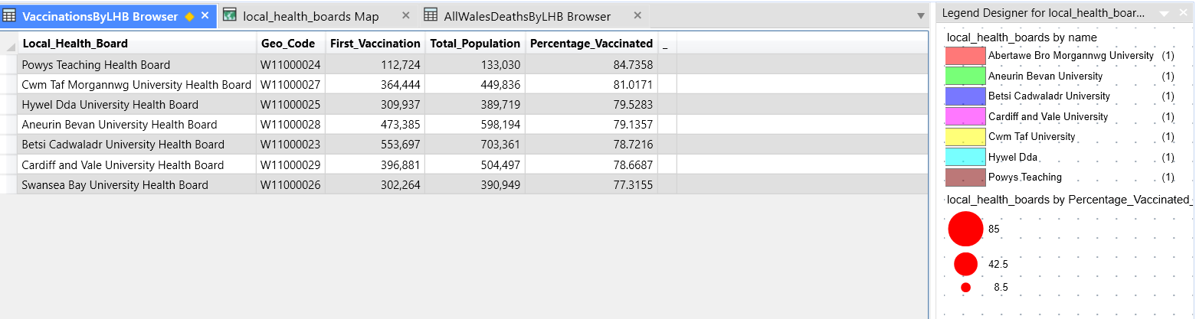

Herd Immunity
^{[4]} According to the World Health Organisation, although herd immunity of 80% is needed for measles, and for polio it is 80%, the percentage needed to achieve herd immunity for Covid 19, remains unclear.
^{[5]} The analysis of the population in Wales:
Table 14 Wales Immunity If Immunity Wanes After 2+ years/2 Years % of Immunity
If immunity wanes after | Age Group | Will have some immunity
2+ years | 16+ | 88%
2 years | All | 75%

Table 15 Highest and Lowest Immunity in Wales by Age Group
Highest/Lowest Immunity | Agre Group | Percentage immunity
Highest Immunity | 80+ | 97%
Lowest Immunity | 16-17 | 53%

Although immunity levels are increased by use of vaccines, if none had been administered, 41% (39% of the population) 16+ would have had some immunity against Covid 19.
Figure 22 Levels of Immunity - Best, Worst and If No Vaccines Administered
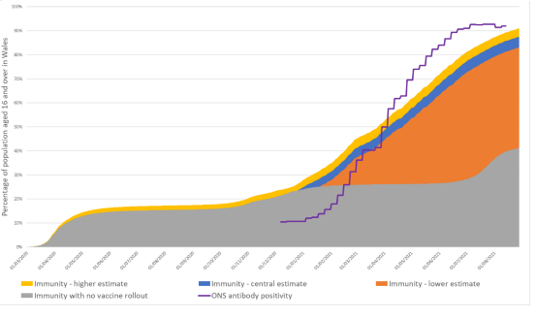
^{[6]} Health professionals estimate 70-90% of the population need immunity to achieve herd immunity.
However, some cannot take the vaccine:
- Those with weak immune systems
- If going through chemotherapy treatments
- New born babies and elderly persons
- Those living with HIV
- Vaccination refusers

Table 16 Vaccinations Ranked Proportionate to LHB Population
 | Vaccinations Proportionate to Population | % | Herd Immunity  Achieved
1. | Powys | 85 | 
2. | Cwm Taf Morgannwg | 81
3. | Hywel Dda | 79 | 1% short
4. | Aneurin Bevan | 79 | “
5. | Betsi Cadwaladr | 79 | “
6. | Cardiff & Vale | 79 | “
7. | Swansea Bay | 77 | 3% short

Herd Immunity: If it is assumed the middle ground between 70-90% is 80% (similar to measles), to achieve the above then:
- Achieved: Powys and Cwm Taf Morgannwg have surpassed the benchmark
- 1% short
  - Hywel Dda
  - Aneurin Bevan
  - Betsi Cadwaladr
  - Cardiff and Vale

- Swansea Bay being the lowest at 77% are only 3% away.

Combined Rankings for Low Deaths and High Vaccination Rates by LHB

Table 17 Combined Rankings for Low Death/High Vaccination per % of LHB Population
 | Ranked by Least Deaths | Population | % |  | Ranked by Highest % of Vaccination  Using 1 dose as standard | % | Population
1 | Powys | 133,030 | 0.07 | 1 | Powys | 85 | 133,030
2 | Hywel Dda | 389,719 | 0.18 | 2 | Cwm Taf Morgannwg | 81 | 449,836
2 | Cardiff and Vale | 504,497 | 0.18 | 3 | Hywel Dda | 79 | 389,719
2 | Betsi Cadwaladr | 703,361 | 0.18 | 3 | Aneurin Bevan | 79 | 598,194
3 | Aneurin Bevan | 598,194 | 0.20 | 3 | Betsi Cadwaladr | 79 | 703,361
4 | Swansea Bay | 390,949 | 0.25 | 3 | Cardiff & Vale | 79 | 504,497
5 | Cwm Taf Morgannwg | 449,836 | 0.42 | 4 | Swansea Bay | 77 | 302,264

Carmarthen being part of Hywel Dda:
- Came Joint 2nd in the Least Deaths with 0.18% (with 2 other LHB’s)
- Came Joint 3rd in the Highest Vaccination Percentage with 79% (with 3 other LHB’s)

3.4 Vaccination Centres

Figure 23 Locations of Vaccination Centres in Wales
^{[4]}
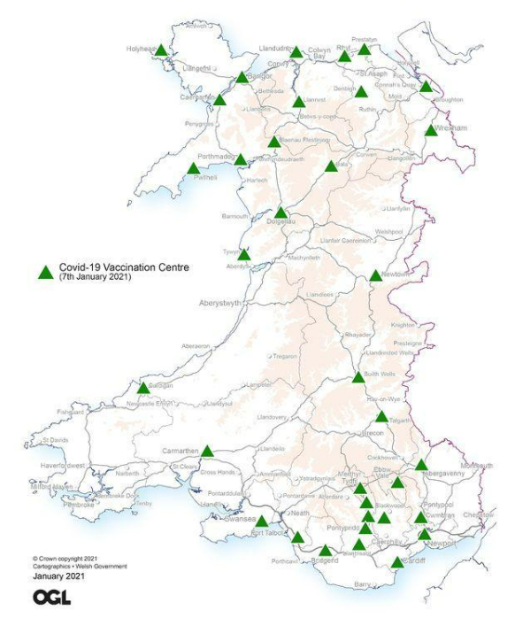

3.4.1 Locations of Vaccination Centres - Categorised by LHB
Table 18 Locations of Vaccination Centres by LHB
^{[7-29]}

 | ^{[5-26]}  Latitude | ^{[5-26]}  Longitude | Local Health Board | ^{[4]}  No. of Vaccination Centres
Newport | 41.490101 | -71.312828 | Aneurin Bevan
Bargoed | 51.683552 | -3.229210 | Aneurin Bevan
Cwmbran | 51.653 | -3.021 | Aneurin Bevan
Pontypool | 51.70111 | -3.04444 | Aneurin Bevan
Abergavenny | 51.825366 | -3.019423 | Aneurin Bevan | 5
Tywyn | 52.586113 | -4.0551 | Betsi Cadwaladr
Dolgelau | 52.7391137102 | -3.883579799 | Betsi Cadwaladr
Bala | 52.9111100 | -3.5972200 | Betsi Cadwaladr
Wrexham | 53.04664 | -2.99132 | Betsi Cadwaladr
Pwlhelli | 52.8899 | -4.41451 | Betsi Cadwaladr
Porthmadog | 52.925266 | -4.130193 | Betsi Cadwaladr
Blaenau Ffestiniog | 52.998337 | -3.944894 | Betsi Cadwaladr
Caernarfon | 53.14126 | -4.27016 | Betsi Cadwaladr
Llanrwst | 53.14021 | -3.79527 | Betsi Cadwaladr
Denbigh | 53.18333 | -3.41667 | Betsi Cadwaladr
Connah’s Quay | 53.21839 | -3.05496 | Betsi Cadwaladr
Holyhead | 53.31281 | -4.63281 | Betsi Cadwaladr
Bangor | 53.227390 | -4129263 | Betsi Cadwaladr
Llandudno | 53.32498 | -383148 | Betsi Cadwaladr
Rhyl | 53.31929 | -3.49228 | Betsi Cadwaladr
Prestatyn | 53.33748 | -3.40776 | Betsi Cadwaladr | 16
Cardiff | 51.483707 | -3.1680962 | Cardiff & Vale | 1
Llantrisant | 51.5429188 | -3.3749525 | Cwm Taf
Pontypridd | 51.601151 | -3.349900 | Cwm Taf
Rhondda | 51.650661 | -3.493790 | Cwm Taf
Mountain Ash | 51.683521 | -3.379690 | Cwm Taf
Merthyr Tydfil | 51.74794 | -3.37779 | Cwm Taf | 5
Cardigan | 52.0681917 | -4.6574333 | Hywel Dda
Carmarthen | 51.8561996 | -4.3051558 | Hywel Dda | 2
Talgarth | 51.99557 | -3.23288 | Powys
Builth Wells | 52.14911 | -3.40208 | Powys
Newtown | 52.5121120 | -3.3131060 | Powys | 3
Swansea | 51.6210919 | -3.9438179 | Swansea Bay
Port Talbot | 51.5953016 | -3.7829294 | Swansea Bay
Bridgend | 51.504286 | -3.576945 | Swansea Bay | 3

NB: As Long/Lat subscription only could not map

3.4.2 Number of Vaccination Centres Categorised by LHB with Population

Alphabetically Sorted
Table 19 No. of Vaccination Centres by LHB with Population in Alphabetical Order
 | Local Health Board | Vaccination Centres | Population
1 | Aneurin Bevan | 5 | 598,194
2 | Betsi Cadwaladr | 16 | 703,361
3 | Cardiff | 1 | 504,497
4 | Cwm Taf | 5 | 449,836
5 | Hywel Dda | 2 | 389,719
6 | Powys | 3 | 133,030
7 | Swansea | 3 | 390,949

3.4.3 Number of Vaccination Centres Categorised by LHB with Population in Size Order
Table 20 No. of Vaccination Centres by LHB with Population Size Order
 | Local Health Board | Vaccination Centres | Population
6 | Powys | 3 | 133,030
5 | Hywel Dda | 2 | 389,719
7 | Swansea | 3 | 390,949
4 | Cwm Taf | 5 | 449,836
3 | Cardiff | 1 | 504,497
1 | Aneurin Bevan | 5 | 598,194
2 | Betsi Cadwaladr | 16 | 703,361

3.4.4 Vaccination Centres Categorised by LHB – Ranked by which Serving Least/Most
Table 21 Vaccination Centres by LHB Ranked by which Serving Least to Most
Local Health Board | Geo_Code | Vaccination_Centres | Population | Serves | Ranking
Betsi Cadwaladr | W11000023 | 16 | 703,361 | 43,960 | 1
Powys | W11000024 | 3 | 133,030 | 44,343 | 2
Cwm Taf Morgannwg | W11000027 | 5 | 449,836 | 89,967 | 3
Aneurin Bevan | W11000028 | 5 | 598,194 | 119,639 | 4
Swansea Bay | W11000026 | 3 | 390,949 | 130,316 | 5
Hywel Dda | W11000025 | 2 | 389,719 | 194,860 | 6
Cardiff & Vale | W11000029 | 1 | 504,497 | 504,497 | 7

Figure 24 Vaccination Centres per head of Population by LHB

3.5 Possible Reasons for Individual LHB’s Success or Failure

Table 22 Possible Reasons for LHB's Success/Failure
Good Performance |  | Poor Performance
Least Deaths | Possible Reasons | Most Deaths | Possible Reasons
Powys | Smaller Aged Population?  More Rural so less transmission? | Cwm Taf Morgannwg | Larger Aged Population?  More Care Homes?  More urban so more transmission?  High Deprivation:  - no access to transport/car  - overcrowded households  - unemployment  - lack of education
Most Vaccinations | Possible Reasons | Least Vaccinations | Possible Reasons
Powys | Less People to Vaccinate | Swansea Bay | Younger Student Population  (not prioritized for vaccines)  Students may have been counted, but left to study remotely from home  Smaller Aged Population (more employment)  More Urban (crowded)
Most Vaccination Centres per head |  | Least Vaccination Centres per head
Betsi Cadwaladr | 16  Most Well catered for  Rural  Sparsely Populated | Cardiff & Vale | 1  Least Well Catered for  Urban  Highly Populated

3.5.1 Powys’ Success with Both High Vaccination and Low Death Rate
- Powys coped well on both fronts as highest Percentage of population vaccinated and the lowest deaths.

Possible Reasons for Powys Success:
  - Powys has smallest population so less to vaccinate
  - Powys populace is spread over wide area and mostly rural (less transmission)
  - With 3 vaccination centres it came 2nd in Vaccination Centres per head – Population spread over wide area.

3.5.2 Highest Death Rate - Cwm Taf Morgannwg
- Cwm Taf Morgannwg had worst Deaths per Population than all the rest

Possible Reasons:
  - There may be larger proportion of aged population (care homes?)
  - There may be more urban (overcrowded) areas

3.5.3 Lowest Vaccinations - Swansea Bay
Most of the rest of Local Health Boards had 77-79% of population Vaccinated

  - There was marginal difference in percentages vaccinated

3.6 Carmarthenshire Case Study – Hywel Dda’s Ranking on LHB’s

Carmarthenshire being part of Hywel Dda Local Health Board:

3.6.1 Least Deaths and Most Vaccinations
Hywel Dda was 2nd least populated Local Health Board and:
Table 23 Least Deaths/Most Vaccinations by % Population of LHB
 | Ranked by Least Deaths | Population | % |  | Ranked by Highest % of Vaccination  Using 1 dose as standard | % | Population
1 | Powys | 133,030 | 0.07 | 1 | Powys | 85 | 133,030
2 | Hywel Dda | 389,719 | 0.18 | 2 | Cwm Taf Morgannwg | 81 | 449,836
2 | Cardiff and Vale | 504,497 | 0.18 | 3 | Hywel Dda | 79 | 389,719
2 | Betsi Cadwaladr | 703,361 | 0.18 | 3 | Aneurin Bevan | 79 | 598,194
3 | Aneurin Bevan | 598,194 | 0.20 | 3 | Betsi Cadwaladr | 79 | 703,361
4 | Swansea Bay | 390,949 | 0.25 | 3 | Cardiff & Vale | 79 | 504,497
5 | Cwm Taf Morgannwg | 449,836 | 0.42 | 4 | Swansea Bay | 77 | 302,264

- For Covid Deaths placed Joint 2nd Least Deaths at 0.18%
- For Covid Vaccinations placed Joint 3rd at 79%

- For Vaccination Centres placed 6th for the most population served with just 2 centres.

3.6.2 Vaccination Centres
- For Vaccination Centres per head of population, Hywel Dda came 6th with 2 Vaccination Centres to serve 194,860 people
Table 24 – See the Ranking of Hywel Dda (Carmarthenshire)
Local Health Board | Geo_Code | Vaccination_Centres | Population | Serves | Ranking
Betsi Cadwaladr | W11000023 | 16 | 703,361 | 43,960 | 1
Powys | W11000024 | 3 | 133,030 | 44,343 | 2
Cwm Taf Morgannwg | W11000027 | 5 | 449,836 | 89,967 | 3
Aneurin Bevan | W11000028 | 5 | 598,194 | 119,639 | 4
Swansea Bay | W11000026 | 3 | 390,949 | 130,316 | 5
Hywel Dda | W11000025 | 2 | 389,719 | 194,860 | 6
Cardiff & Vale | W11000029 | 1 | 504,497 | 504,497 | 7

3.7 What the Carmarthenshire Case Study Revealed

Insights revealed:

3.7.1 Urban and Crowded = More Covid Cases

- it highlighted the more urban and crowded, the more covid cases there were.

3.7.3 Countryside and Least Populated = Less Covid Cases

- The Farming community, on the other hand, being more spread out were less afflicted.

3.7.4 The More Deprived and Bad Health Areas = More Covid Cases
- The more deprived areas suffered Covid infections possibly due to overcrowding and poor health.

3.8 Summary of Whole of Wales LHB Performance

Table 25 Summary of Whole of Wales Local Health Boards Performance (Rankings)

 | Ranked by Least % Deaths | Population | % |  | Ranked by Highest % of Vaccination  Using 1 dose as standard | % | Population | Raw Rank  Population  Highest to Lowest |  | No of Vaccination  Centres (VC) |  | VC’s Serving the Least to the Most
1 | Powys | 133,030 | 0.07 | 1 | Powys | 85 | 133,030 | 1 | Betsi Cadwaladr | 16 | 1 | Betsi Cadwaladr
2 | Hywel Dda | 389,719 | 0.18 | 2 | Cwm Taf Morgannwg | 81 | 449,836 | 2 | Aneurin Bevan | 5 | 2 | Powys
2 | Cardiff and Vale | 504,497 | 0.18 | 3 | Hywel Dda | 79 | 389,719 | 3 | Cardiff & Vale | 1 | 3 | Cwm Taf
2 | Betsi Cadwaladr | 703,361 | 0.18 | 3 | Aneurin Bevan | 79 | 598,194 | 4 | Cwm Taff | 5 | 4 | Aneurin Bevan
3 | Aneurin Bevan | 598,194 | 0.20 | 3 | Betsi Cadwaladr | 79 | 703,361 | 5 | Hywel Dda | 2 | 5 | Swansea Bay
4 | Swansea Bay | 390,949 | 0.25 | 3 | Cardiff & Vale | 79 | 504,497 | 6 | Swansea Bay | 3 | 6 | Hywel Dda
5 | Cwm Taf Morgannwg | 449,836 | 0.42 | 4 | Swansea Bay | 77 | 302,264 | 7 | Powys | 3 | 7 | Cardiff & Vale

The mostly rural area of Betsi Cadwaladr got the most vaccination centres whilst Cardiff & Vale, the capital, got the least. The reasoning seems to be because of the sizes.
- Betsi Cadwaladr much larger area,
- although Cardiff has 3rd largest population – and denser.
- Cardiff being the capital has more transient population being the capital of Wales and therefore a hub of activity (and transmission).
Table 26 Vaccination Centre Rankings
Local Health Board | Geo_Code | Vaccination_Centres | Population | Serves | Ranking
Betsi Cadwaladr | W11000023 | 16 | 703,361 | 43,960 | 1
Powys | W11000024 | 3 | 133,030 | 44,343 | 2
Cwm Taf Morgannwg | W11000027 | 5 | 449,836 | 89,967 | 3
Aneurin Bevan | W11000028 | 5 | 598,194 | 119,639 | 4
Swansea Bay | W11000026 | 3 | 390,949 | 130,316 | 5
Hywel Dda | W11000025 | 2 | 389,719 | 194,860 | 6
Cardiff & Vale | W11000029 | 1 | 504,497 | 504,497 | 7

3.9 Thematic Maps Used to Highlight Findings
Table 27 Thematic Maps Used to Highlight Findings
 | Map to Show: | Thumbnail | Fig | Shows
1 | UK Regions Map |  | 1 | UK Regions
2 | Wales LHB’s (with Legend) and Motorways overlaid |  | 5 | The 7 LHB’s with Motorways overlaid
3 | Wales LHB’s with Carmarthenshire Overlaid |  | 7 | Carmarthenshire location
4 | Carmarthenshire Categorised by Population |  | 8 | Carmarthenshire residents
5 | Carmarthenshire Categorised by Deprivation |  | 10 | Separate Level of deprivation maps 0,3,4
6 | Carmarthenshire Categorised by Deprivation 0-4 |  | 11 | Levels of deprivation 0—4 (Overall)
7 | Carmarthenshire Categorised by  Very Good Health to Very Bad Health |  | 12 | Those with Very Good Health locations
8 | Carmarthenshire Residents Deprived in all 4 Areas |  | 13 | Those Deprived in all 4 Areas
9 | Carmarthenshire OA – No of Covid Cases in Carmarthenshire by MSOA 10 Jan 21 to 27 Feb 2022 |  | 14 | Spread of Covid Areas
10 | Carmarthenshire OA – Correlation of VBad Health Overlaid onto Covid Cases by Area |  | 15 | Above overlaid with those with Very Bad Health
11 | Wales Vaccination Percentages by LHB |  | 16 | Proportionate to Population % Vaccinated by LHB
12 | Wales Covid Deaths Percentages by LHB |  | 17 | Proportionate to Population % Covid Deaths by LHB
13 | Wales Vaccination Centres per head of Population  (Deaths per LHB underneath) |  | 18 | Proportionate to Population % Vaccination Centres by LHB

4.0 CONCLUSION

4.1 Best LHB For Least Deaths and Most Vaccinations - Powys

  - Deaths were fewer as low transmission rate, as area mainly rural
  - Vaccinations highest as has smallest population, which is easier to manage
  - Achieved over 80% Vaccination so Herd Immunity reached

4.2 Worst LHB for Deaths – Cwm Taf Morgannwg

  - Area urban, so likely had a high transmission rate
  - Could have been because it has large percentage of older people/those in bad health and/or crowded deprived conditions
  - 1% away from assumed 80% target to Herd Immunity having achieved 79%

4.3 Worst LHB for Vaccinations – Swansea Bay

  - Large Town with outskirts crowded suburbs housing workers and students
  - Students may have left to go back to parents, but been counted as residents
  - Insufficient Vaccination Centres
  - 3% away from the assumed target threshold of herd immunity of 80% having achieved 77%

4.4 Most Vaccination Centres Per Head of Population – Betsi Cadwaladr

  - Betsi Cadwaladr had by far the most Vaccination Centres in Wales at 16, each centre catered for the least (43,960), but still only came joint 3rd in the Vaccination Ranking.
  - Betsi Cadwaladr had the highest population at 703,361
  - 1% away from the assumed target threshold of herd immunity of 80% having achieved 79%

4.5 Least Vaccination Centres Per Head of Population – Cardiff & Vale

  - Cardiff & Vale had the least Vaccination Centres (by far) in Wales at 1 Vaccination centre, which catered for the most (504,497) but still came joint 3rd in the Vaccination Ranking.
  - 1% away from the assumed target threshold of herd immunity of 80% having achieved 79%

4.6 Recommendations

There was little difference in percentages vaccinated and death rates, however, the number of Vaccination Centres differed widely.

Maximum efficacy could be achieved if Vaccination Centres were provided proportionate to:
  - Population, appropriately weighted for:

- Amount in crowded Urban Areas
- Amount with Deprivation
- Amount in Very Bad Health
- Amount of transient visitors
Table 28 Recommendations by Areas of Concern

 | Area of Concern | Recommendation…because
1 | Deaths | Prioritize Vaccinations for those in:  - Crowded accommodation  - deprived areas  - very bad health
2 | Cases | More prevalent in crowded areas so more preventative measures needed in highly populated areas (more Vaccination Centres)
3 | Vaccinations | Prioritize Vaccinations:  - according to highest population of LHB’s allowing for:  - those in urban areas  - those in deprived areas  - those in very bad health
4 | Vaccination Centres | Provide more Vaccination Centres  - Insufficient in densely populated areas where deprivation and very bad health high  - Insufficient in high traffic areas (i.e., capital Cardiff and Swansea – near M4 motorway)

5.0 REFERENCES

[1] | GIS Is Being Applied Around the World Stock Photo Adobe Stock – Free image [Online] Available:https//GIS Is Being Applied Around the World Stock Photo | Adobe Stock [Accessed 29 April 2022
[2] | Lle – Local Health Boards (gov.wales) [Online] Available: https//Lle - Local Health Boards (gov.wales) [Accessed 6 May 2022]
[3] | Population estimates by local health boards and year (gov.wales) [Online] Available:https//Population estimates by local health boards and year (gov.wales) [Accessed 6 May 2022]
[4] | 30 Dec 2020, Coronavirus disease (COVID-19): Herd immunity, lockdowns and COVID-19 (who.int) [Online] Available: https//Coronavirus disease (COVID-19): Herd immunity, lockdowns and COVID-19 (who.int) [Accessed 14 May 2022]
[5] | Welsh Government Technical Advisory Cell (TAG), 8 Sept 2021, Advice from tag for the 17 september restriction review.pdf(gov.wales) [Online] Available: https//advice-from-tag-for-the-17-september-restriction-review.pdf (gov.wales) [Accessed 14 May 2022]
[6] | 9 Apr 2021, The Relationship Between Vaccines and Herd Immunity, Columbia Public Health [Online] Available:https//The Relationship Between Vaccines and Herd Immunity | Columbia Public Health
[7] | J. Hill, 12 Jan 2021, Why Welsh Government will not reveal Covid vaccination sites, South Wales Argus [Online] Available: https//Why Welsh Government will not reveal Covid vaccination sites | South Wales Argus[Accessed 6 May 2022]
[8] | Latitude and Longitude Finder on Map Get Coordinates(latlong.net) [Online] Available:https//Latitude and Longitude Finder on Map Get Coordinates (latlong.net) [Accessed 7 May 2022]
[9] | Latitude, Longitude and GPS coordinates of Cwmbran (gps-latitude-longitude.com) [Online] Available: https//Latitude, Longitude and GPS coordinates of Cwmbran (gps-latitude-longitude.com) [Accessed 7 May 2022]
[10] | GPS coordinates of Merthyr Tydfil, United Kingdom. Latitude 51.7479 Longitude -3.3778 [Online] Available: https//GPS coordinates of Merthyr Tydfil, United Kingdom. Latitude: 51.7479 Longitude: -3.3778 [Accessed 7 May 2022]
[11] | GPS coordinates of Pontypool, United Kingdom, Latitude: 51.7011 Longitude: -3.0444 [Online] Available: https//GPS coordinates of Pontypool, United Kingdom. Latitude: 51.7011 Longitude: -3.0444 [Accessed 7 May 2022]
[12] | GPS coordinates of Abergavenny, United Kingdom, DMS, UTM, GeoHash – CountryCoordinate.com [Online] Available: https//GPS coordinates of Abergavenny, United Kingdom, DMS, UTM, GeoHash - CountryCoordinate.com [Accessed 7 May 2022]
[13] | Where is Talgarth? Talgarth on a map (getthedata.com) [Online] Available: https//Where is Talgarth? Talgarth on a map (getthedata.com) [Accessed 7 May 2022]
[14] | Where is Builth Wells? Builth Wells on a map (getthedata.com) [Online] Available:https//Where is Builth Wells? Builth Wells on a map (getthedata.com) [Accessed 7 May 2022]
[15] | Where is Newtown Powys, Wales United Kingdom (roadonmap.com) [Online] Available:https//Where is Newtown Powys, Wales United Kingdom (roadonmap.com) [Accessed 7 May 2022]
[16] | Tywyn Map Great Britain Latitude & Longitude: Free Wales Maps (freecountrymaps.com) [Online] Available https://Tywyn Map Great Britain Latitude & Longitude: Free Wales Maps (freecountrymaps.com) [Accessed 7 May 2022]
[17] | GPS coordinates of Dolgellau, United Kingdom. Latitude: 52.7391 Longitude: -38836 [Online] Available: https//GPS coordinates of Dolgellau, United Kingdom. Latitude: 52.7391 Longitude: -3.8836 [Accessed 7 May 2022]
[18] | Geographic coordinates of Bala, Latitude, longitude, and elevation above sea level of Bala, United Kingdom (dateandtime.info) [Online] Available: https//Geographic coordinates of Bala. Latitude, longitude, and elevation above sea level of Bala, United Kingdom (dateandtime.info) [Accessed 7 May 2022]
[19] | GPs coordinates of Wrexham, United Kingdom. Latitude: 53.0466 Longitude:-29913 [Online] Available: https//GPS coordinates of Wrexham, United Kingdom. Latitude: 53.0466 Longitude: -2.9913 [Accessed 7 May 2022]
[20] | GPS coordinates of Pwlheli, United Kingdom, Latitude: 52.8899 Longitude: -4.4145 [Online] Available: https//GPS coordinates of Pwllheli, United Kingdom. Latitude: 52.8899 Longitude: -4.4145 [Accessed 7 May 2022]
[21] | GPS coordinates of Caernarfon, United Kingdom. Latitude: 53.1413 Longitude: -4.2702 [Online] Available: https//GPS coordinates of Caernarfon, United Kingdom. Latitude: 53.1413 Longitude: -4.2702 [Accessed 7 May 2022]
[22] | GPS coordinates of Llanrwst, United Kingdom. Latitude: 53.1402 Longitude: -3.7953 [Online] Available: https//GPS coordinates of Llanrwst, United Kingdom. Latitude: 53.1402 Longitude: -3.7953 [Accessed 7 May 2022]
[23] | GPS coordinates of Denbigh, United Kingdom. Latitude: 53.1833 Longitude: -3.4167 [Online] Available: https//GPS coordinates of Denbigh, United Kingdom. Latitude: 53.1833 Longitude: -3.4167 [Accessed 7 May 2022]
[24] | Where is Connah’s Quay? Connah’s Quay on a map (getthedata.com) [Online] Available: https//Where is Connah's Quay? Connah's Quay on a map (getthedata.com) [Accessed 7 May 2022]
[25] | Latitude and longitude of Holyhead wales – Yahoo Search Results [Online] Available: https//latitude and longitude of Holyhead wales - Yahoo Search Results [Accessed 7 May 2022]
[26] | Latitude, Longitude and GPS coordinates of Bangor, Wales (gps-latitude-longitude.com) [Online] Available: https//Latitude, Longitude and GPS coordinates of Bangor, Wales (gps-latitude-longitude.com) [Accessed 7 May 2022]
[27] | GPS coordinates of Llandudno, United Kingdom. Latitude: 53.3250 Longitude: -3.8315 [Online] Available: https//GPS coordinates of Llandudno, United Kingdom. Latitude: 53.3250 Longitude: -3.8315 [Accessed 7 May 2022]
[28] | GPS coordinates of Rhyl, United Kingdom. Latitude: 53.3193 Longitude: -3.4923 [Online] Available: //GPS coordinates of Rhyl, United Kingdom. Latitude: 53.3193 Longitude: -3.4923 [Accessed 7 May 2022]
[29] | Latitude.to map gb united kingdom cities Prestatyn [Online] Available: https://latitude.to/map/gb/united-kingdom/cities/prestatyn [Accessed 7 May 2022]
- Word Count of Tables of Figures 603
- Word count 3,937- 603 = total net of 3,334
- 4,000 allowed.

