A report into the effectiveness of the current structure of the NHS in Wales.
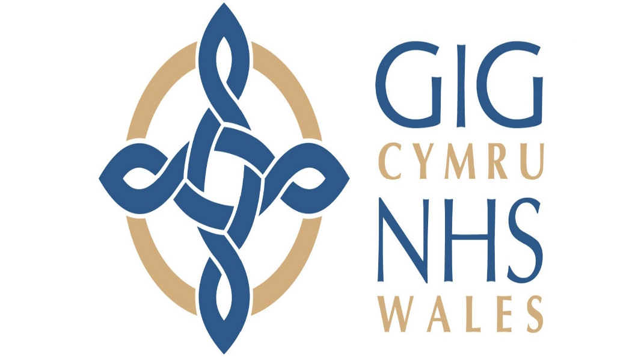

Elen Roch James (1900139)
Jayne Griffith-Parry

Contents

Abstract …………………………………………….. 2

Introduction ………………………………………. 3

Information, Statistics & Guides …………… 4

Evaluation …………………………………………. 7

Conclusion ………………………………………… 8

Recommendations ……………………………. 8

Reference list …………………………………….. 10

Abstract
This report in an overview of the NHS Wales observing the current structure and whether it is effective. This will include how the NHS is formed along with how the management structures work. This report will also look at the NHS Wales funding and what influences it. And finally highlight the issues or concerns with the NHS Wales by discussing the possibly recommendations and improvements.

NHS Wales is the publicly funded National Health Service of Wales delivering healthcare to 3 million people who live in the country. The NHS has a significant belief which is that ‘good healthcare should be available to all, regardless of wealth’ (NHS, Wales, 2019). NHS Wales provides services ranging from antenatal screening, routine treatments for coughs and colds to open heart surgery, accident and emergency treatment and end of life care. The aim of the NHS was to promote "the establishment of a comprehensive health service designed to secure improvement in the physical and mental health of the people of Wales and the prevention, diagnosis and treatment of illness” (NHS Act, 1946).
The seven local health boards in Wales were put into place on October 1st 2009, the individual health boards are responsible for delivering all healthcare services within a geographical area. The seven health boards are:
- Aneurin Bevan Health Board
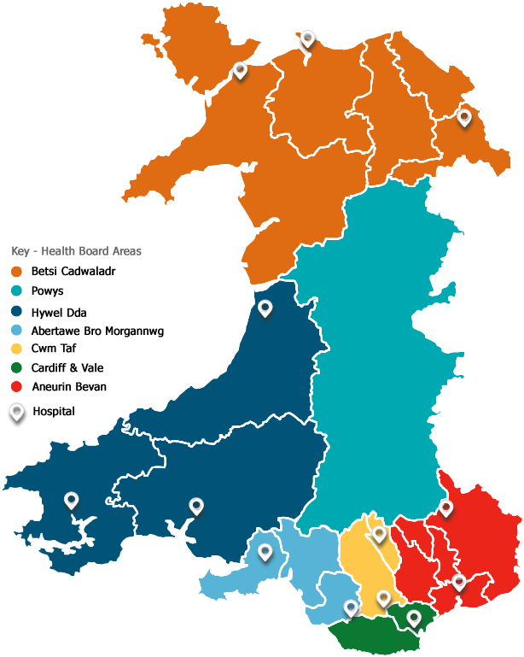
- Abertawe Bro Morgannwg University Health Board
- Hywel Dda Health Board
- Cwm Taf Health Board
- Betsi Cadwaladr University Health Board
- Powys Teaching Health Board
- Cardiff and Vale University Health Board
(NHS Wales Direct, 2019)
With aims to build a higher standard of service with the main focus being patient care, and the efficiency of running the NHS across Wales. (NHS Direct, 2020). These Health Boards are required to meet the standards of good governance set for the NHS in Wales. These are centred around the Welsh Government’s Citizen Centred Governance Principles. (Welsh Government, 2013)
(NHS Wales Direct, 2019)
There are four NHS Trusts that currently operate in wales these are, the Welsh Ambulance Service Trust for emergency services, Velindre Trust offering specialist services in the cancer care department and the Public Wales National Health Service Trust. Recently in 2018 a new statutory body Health Education and Improvement Wales (HEIW) was included alongside the other three trusts. The role of HEIW is educating, developing, training and shaping of the health care workforce in Wales. (NHS Wales, 2018).
The 7 Health Boards are legally responsible to the Minister via the Chief Executive, NHS Wales. The Health Boards are responsible for planning which helps identify future goals, designing enables the message to be portrayed in the best way which enables service users and staff members to use the establishment more efficiently. Thus, expanding and ensuring the delivery of high-quality care to services within the primary, secondary and community sectors. Additionally, the delivery of care must meet the local needs identified within the national policy and standards framework. Within the NHS Wales there are four groups for the different health services. The Health Advisory Committee advises the Welsh Government on health issues relating to healthcare professions in Wales. The National Delivery Group, is where the chief executive of NHS Wales, is accountable for supplying the minister with ‘policy advice and for exercising strategic leadership and management of the NHS’ (NHS Governance, 2019). This group is responsible for managing the development and delivery of the NHS services in Wales. (Welsh Government, 2019). The Community Health Councils are statutory lay bodies that represent the concerns of the general public in the health service in their area. The Chief Medical Officer (CMO) offers independent professional recommendations and advice to the First Minister and Welsh Government Ministers. The CMO leads the medical contribution in Wales to increasing the quality of healthcare and patient outcomes. (Welsh Government, 2019). The NHS is known to have a ‘tall’ structure. The term tall structure meaning the hierarchy of an establishment is split into numerous different stages with a ‘large chain of command’ (Organisational structures of Tesco and the NHS, 2015).

The NHS is primarily funded from taxation, with a little amount raised through national insurance contributions. NHS Wales gets its share as part of the process of negotiation between Westminster and the Welsh Government. The amount offered for health and health services in Wales forms part of the ‘block grant’ which is the ‘total amount of money for all the areas for which the Welsh Government has responsibility since devolution’ (Welsh Government, 2019). The Welsh Government invests £6bn a year in health and social services. A Lot of this is immediately distributed to the Local Health Boards and Trusts. The Welsh Government gives resources each year to Local Health Boards and the Welsh Health Specialised Services Team (WHSST) to pay for the costs of hospital treatments provided by NHS Trusts and Health Boards.

Statistics show that individuals use NHS Wales more than 20 million times each year, this being 80% of individuals using GP practices or community health services. (BBC News, 2018)
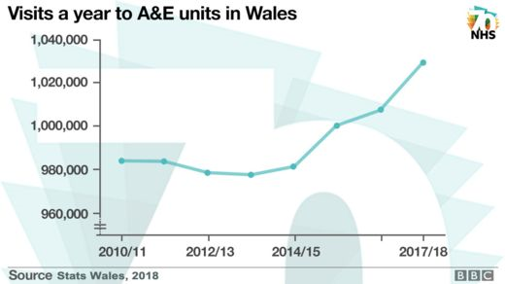
More than 1 million people are seen in the Accident and Emergency department each year.
(BBC News, 2018)

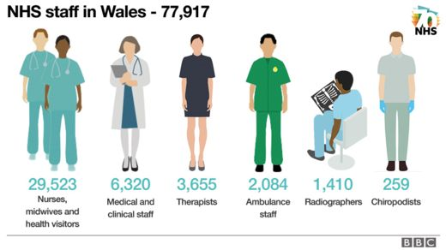
Currently there are 77,917 staff working for the NHS wales. Over the last 21 years numbers of directly employed staff has risen by 45.6%.
(BBC News, 2018)
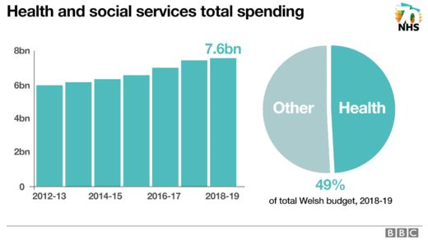
The NHS Wales total spending has increased from more than 6 billion a year in 2012-2013 to more than 7.6 billion in 2018-2019.
(BBC News, 2018)

Surveys suggest that people are very satisfied with the NHS Wales service, however with health care being a government responsibility, most people want to see more money being spent on it. (BBC News, 2018). The populations of Wales are estimated to have been 3,139 million in 2019. The Office for National Statistics (ONS) state that around 3,119 individuals with a Welsh residence are registered with a general practice in Wales, which is the majority of the population (National Statistics, 2017). New Welsh Government figures indicate 77 patients died due to an "unintended or unexpected" safety incident between June 2018 and May 2019. These safety incidents were due to drug miscalculation, errors during medical procedures and paperwork blunders (Wales Online, 2019).
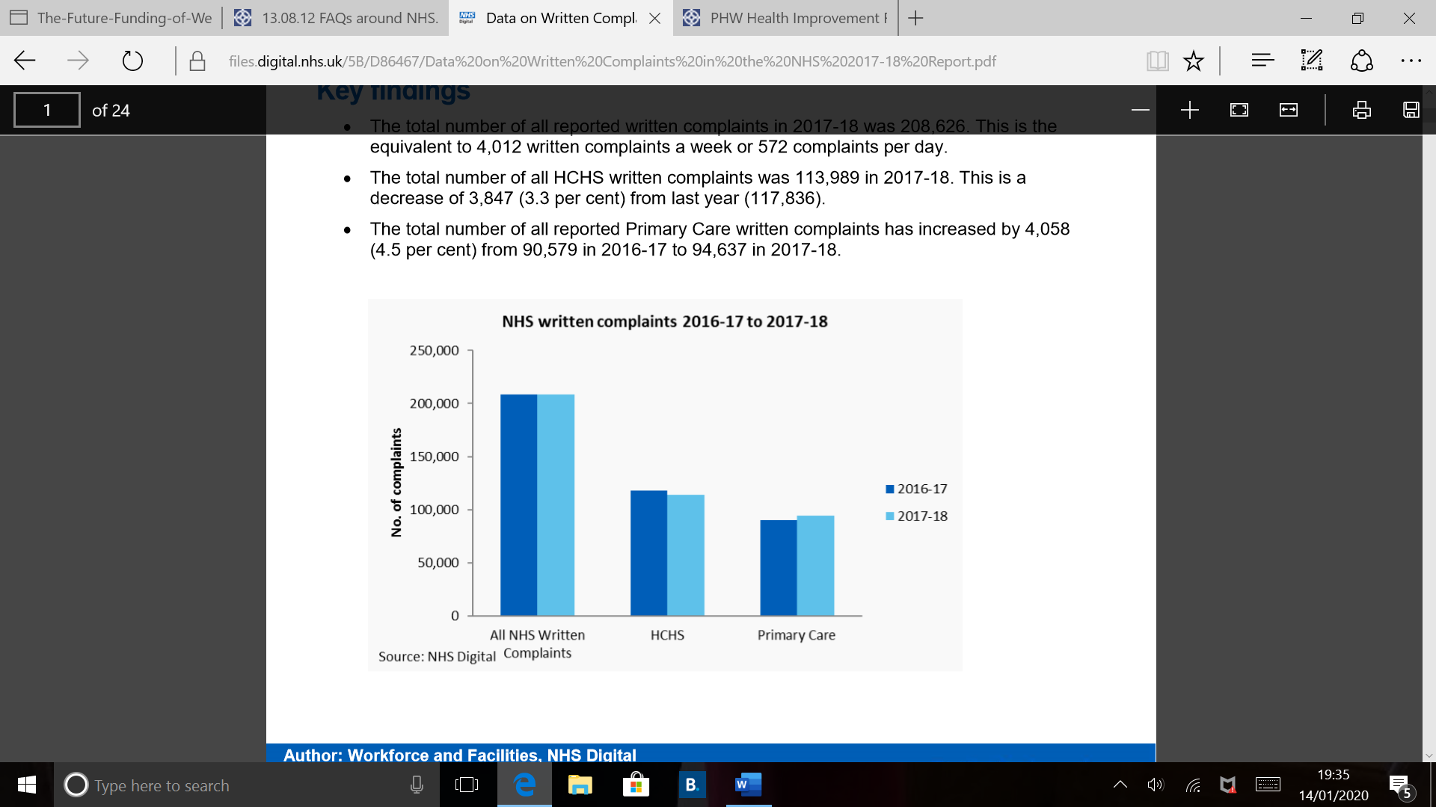
The number of written complaints in 2017-1028 was 208,626. The total numbers of HCHS complaints in 2017-2018 was 113,989. The number of reported primary care written complaints in 2017-2018 was 4,058.
(NHS Digital, 2018

The National Health Service is free and available for all members of the public to access regardless of their background. In 2018 a service was launched called Sore Throat Test and Treat, instead of waiting for a GP appointment for a niggling sore throat, patients can see a community pharmacist. A survey of patients showed that an overpowering majority (98%) were satisfied with the service and would use it again, according to the NHS Wales Informatics Service (NWIS, 2018), whose health record software underpins the initiative.

For the past couple of years, the NHS has really struggled with staff shortages. The biggest shortages being in Paediatrics, Surgery, Obstetrics and Gynaecology and Psychiatry. Not having enough staff members makes it very difficult to maintain safe medical rotas. Neath Port Talbot Hospital has been targeted the most with staff shortages due not being able to recruit enough doctors to keep a safe critical medicine service, they urgently moved the service to another hospital. In 2008 the Minor Injury Unit at Singleton Hospital were closing at very short notice due to the lack of A&E doctors, GP’s then had to step in to provide a vital service to the public. (NHS Wales, 2019). A local news report states that ‘A&E waiting times in Wales hit worst-ever levels’ (BBC News, 2019) NHS Wales A&E department had their busiest year in 2019, with patients being left waiting between 4-12 hours in urgent care units. Darren Hughes, director of the Welsh NHS Confederation suggested that the ‘public have an important role to play’. (BBC News, 2019) By making sure repeat prescriptions are up to date, taking advantage of local pharmacies to help with coughs or colds. The NHS encourages people to look at the ‘Choose Well’ website so that individuals and families get the best treatment possible. A main NHS concern has been rescheduled transfers of care, also known as “bed blocking” (Wales Online, 2016) which regularly appears due to delays getting social care packages set up for when patients are ready to leave hospital.
Overall, the NHS Wales provides healthcare to roughly 3 million people who live in the country. The NHS has a key principle which is good healthcare should be available to any individual regardless of wealth. The NHS sticks to the key principle as it offers a wide range of care, such as pharmacies which offer repeat and free prescriptions, sexual health is available to support abortion counselling, smear consultations, contraception report and pregnancy wellbeing advice. Health and Wellbeing support service which provides support and advice on a wide range of conditions, such as arthritis. The accident and Emergency department which is provided for patients which need life saving medical attention and support. There are many more services which NHS Wales provide. Hospitals across Wales provide a range of services within their area and have all the necessary equipment and staff waiting to be at service. However, only certain hospitals have certain equipment such as cardiac surgery or certain departments such as burns and plastics services which are only provided at limited hospitals around Wales, due to lack of funding or staff shortages. Finally, the NHS has a huge amount of support of the seven local health boards in Wales which plan to deliver primary, community, secondary and specialist care services within certain areas of Wales. The NHS is providing healthcare and support to the best of its ability and has been for the last 70 years. With the continuous service that has changed throughout time with help of technology and a breakthrough within medical science has enabled to provide a high standard of quality of care with support from the Welsh Government.
From extensive research I have found that the NHS is a crucial service for the general public of Wales. Without this free health service individuals would not receive the correct care and treatments. The NHS Wales does better than health systems in comparable countries at protecting people from heavy financial costs when they are ill. People in the UK are also less likely than in other countries to be put off from seeking medical help due to costs. However, despite NHS funding having increased steadily above the level of inflation since its inception, the burden on the NHS has far outstripped it's funding. There are multiple causes of this, a larger population, an aging population, increased patient demands and expectations, and difficulties seeing GPs. Services users are somewhat happy with their National Health Service however, every service user has an experience, but the experience does not always result in a satisfied person from personal experiences.
The NHS face other issues within their organisation as the funding provided by the Welsh Government can only offer a certain level of quality of care. ‘One in four NHS Wales wards have unsafe staffing levels’ (Wales Online, 2019). This could be due to a dilution in mixed skills across the NHS wards, where health care assistants are used to cover up staffing numbers. Most NHS complaints are from long waiting times and the ambulance service. ‘A&E record low performance as ambulance service struggles’ (BBC News, 2019). This comes as the Welsh Ambulance service failed to meet its response time target. An acute GP unit is now working with the Welsh Ambulance Service to try to relieve the pressures on Morriston Hospital. The general public could help this service by not taking advantage of it. Insufficient communication is a massive concern in NHS Wales today. A report reveals ‘People at risk of harm because of poor communication in the NHS’ (Wales Online, 2018). Although heath boards and trusts had the correct discharge policies, there seemed to be a lack of understanding and awareness on hospital wards. Ageing Population presents challenges for the NHS. People are living longer with more complex health problems. Will the current structure of the NHS cope with the demand of this? We need to look after our population as they get older, with a sustainable care sector. Training centres for home care should be created, and clear pathways into nursing, making these careers attractive. All of these issues come down to lack of funding and staff training, with the recommendations stated it would enhance the NHS Wales to provide better patient care and welfare. I personally think that the NHS should charge drunk people for using services, or fine people for missing appointments and centralise key services such as procurement. Bringing back training bursaries for nurses and given a pay rise will increase employability. Introduce a £1 charge for using services and inform the public how much their care is costing the NHS. By opening doctors’ surgeries for longer will decrease the amount of people that would go to A&E for minor ailments.

Word Count – 2,132

Reference list
BBC News, (2019) NHS Wales: A&E record low performance as ambulance service struggles. Available at: https://www.bbc.co.uk/news/uk-wales-50812953
{accessed 19th November 2019}
BBC News, (2018) NHS 70: The health service in Wales- in 10 charts. Available at: https://www.bbc.co.uk/news/uk-wales-44482582
{accessed 19th November}
BBC News, (2019) A&E waiting times in Wales hit worst-ever levels. Available at: https://www.bbc.co.uk/news/uk-wales-50073839
{accessed 18th December}
National Statistics, (2017) Population estimates. A short guide to population estimates. Available at: http://www.publichealthwalesobservatory.wales.nhs.uk/wales-local-health-boards-demography-profile
{accessed 14th December 2019}
National Health Service Act, (1946). Available at: http://www.legislation.gov.uk/ukpga/1946/81/pdfs/ukpga_19460081_en.pdf
{accessed 19th November 2019}
NHS Digital, (2018) Data on Written Complaints in the NHS. Available at: https://files.digital.nhs.uk/5B/D86467/Data%20on%20Written%20Complaints%20in%20the%20NHS%202017-18%20Report.pdf
{accessed 12th November 2019}
NHS Direct Wales, (2020) Health Board. Available at: https://www.nhsdirect.wales.nhs.uk/localservices/localhealthboards/
{accessed 12th November 2019}
NHS Governance, (2019) Governance – Leadership. Available at: http://www.wales.nhs.uk/governance-emanual/leadership-1
{accessed 20th November 2019}
NHS Wales Direct, (2019) Local Services : Health Boards. Available at: https://www.nhsdirect.wales.nhs.uk/localservices/localhealthboards
{accessed 18th November 2019}
NHS Wales, (2019) What’s the matter with the NHS in Wales? Available at: http://www.wales.nhs.uk/sitesplus/documents/863/13.08.12%20FAQs%20around%20NHS.pdf
{accessed 20th December 2019}
NHS Wales, (2019) Health in wales. NHS – About us. Available at: https://www.wales.nhs.uk/nhswalesaboutus
{accessed 21st November 2019}
NHS Wales, (2018) Health Education and Improvement. Welcome to Health Education and Improvement Wales (HEIW). Available at: https://heiw.nhs.wales/
{assessed on 12th November 2019}
NWIS, (2018) For patients and citizens of Wales. Available at: https://nwis.nhs.wales/systems-and-services/for-patients-and-citizens-of-wales/
{accessed 19th December 2019}
Prezi, (2015) Organisational Structure of Tesco and the NHS. Available at: https://prezi.com/4syqsth1pqqa/organisational-structure-of-tesco-and-the-nhs/
{accessed 10th December 2019}
Wales Online, (2019) The huge numbers of patients dying or being harmed due to mistakes made by the Welsh NHS. Available at: https://www.walesonline.co.uk/news/health/huge-numbers-patients-dying-due-16487840
{accessed 18th December 2019)
Wales Online, (2016) These are the key challenges facing the Welsh NHS according to our new health secretary. Available at: https://www.walesonline.co.uk/news/health/key-challenges-facing-welsh-nhs-11446395
{accessed 13th December 2019]
Wales Online, (2019) One in four NHS wards have unsafe staffing levels – report. Available at: https://www.walesonline.co.uk/news/uk-news/one-four-nhs-wards-unsafe-16134376
{accessed 19th December 2019}
Wales Online, (2018) People at risk of harm because of poor communication in the NHS, says report. Available at: https://www.walesonline.co.uk/news/health/people-risk-harm-because-poor-15028860
{accessed 19th December 2019}
Welsh Government, (2019) Chief Health Professionals. Health and social care strategy and health workforce report. Available at: https://gov.wales/chief-health-professionals
{accessed 19th December 2019}
Welsh Government, (2019) Law Wales: How is devolved government in Wales financed? Available at: https://law.gov.wales/constitution-government/government-in-wales/finance/?lang=en#/constitution-government/government-in-wales/finance/?tab=overview&lang=en
{accessed 19th December 2019}
Welsh Government, (2013) Academi Wales. The Good Governance Guide for NHS Wales Boards. Available at: www.cymru.gov.uk
{accessed on 12th November 2019}
Welsh Government, (2019) NHS Wales Delivery Framework and Reporting Guidance 2019-2020. Available at: www.cymru.gov.uk
{accessed on 12th November 2019}

