BMSW4008 - Digital Skills for Personal and
Professional Growth
Assignment Title - Evidence of Learning (E-Portfolio)
Student Name -Nicolae Gheorghica
Student ID -2330417

Table of Contents
Task 3: Financial analysis of small business 3
Introduction 3
Discussion 3
Conclusion 5
Task 4: Advertisement of Waytrails (Travel experiences for elderly people using VR and AR) 6
References 13

Task 3: Financial analysis of small business
Topic: Importance of Excel in the digital era
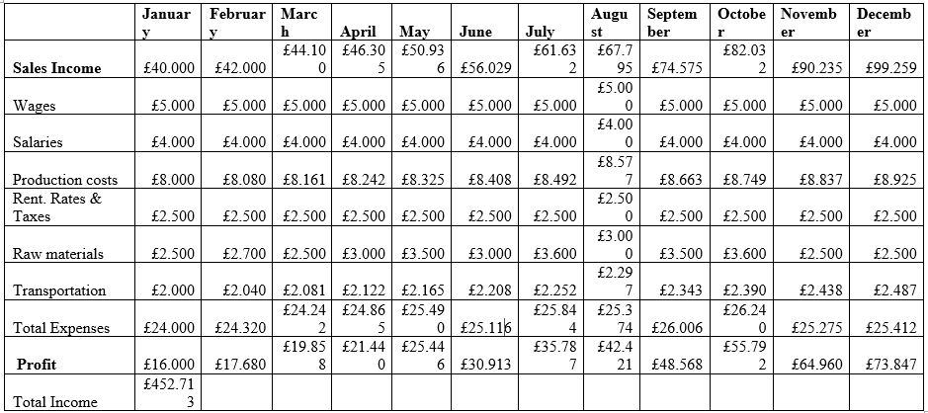
Figure 1: Income and expenses of Waytrails over a year
(Source: Self-developed)
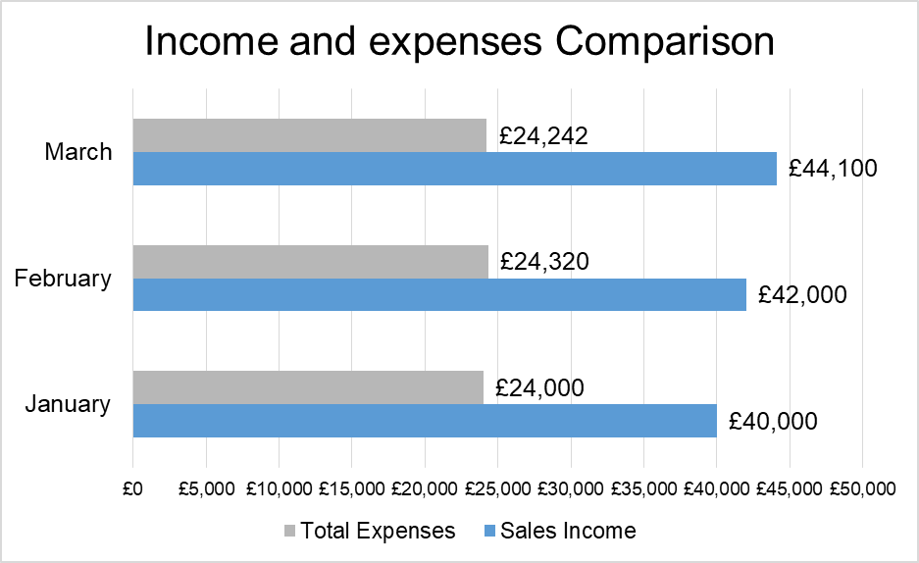
Figure 1: Comparison of Income and expenses of Waytrails for three months
(Source: Self-developed)

Introduction
As mentioned by Ibarra (2024), technology development is the centre of business progression in the contemporary era, with digital technologies assisting in the automation of business processes. A key software program, which is widely used across organisations, refers to MS Excel, which assists in accounting, data recording, analysis, and visualisation. The current study entails a detailed description of the significance of Excel in the present digital era of businesses.

Discussion
As stated by Quirk et al., (2021), Excel as an inherent tool is versatile in nature as it assists in data management, analysis, as well as visualisation. These attributes make it essential for businesses across industries and thus useful in organising, calculating, and interpreting large datasets, which assist in informed decision-making in a data-driven world. The software incorporates a user-friendly interface along with a wide range of functions that enable professionals across backgrounds and utilise it effectively for tasks like budgeting, performance reporting, and forecasting and project management. Excel finds a range of utility within business organisations including assistance in terms of data organisation and manipulation. By using Excel business users can store, classify categorise and manipulate large amounts of data efficiently using spreadsheets. This helps the management to track inventory, and customer information, and maintain employee databases and financial records. Excel is useful across business departments including, operations, finance, sales and marketing as well as human resources.
According to Remenyi et al., (2022), the software helps business users to perform complex calculations using in-built formulas such as SUM, Product, CountIf, CountA and similar others. Each of these formulas has a different utility, for instance, the sum function helps to calculate the total sales or the total of any quantity. Similarly, the CountIf and CountA functions help to calculate the number of a quantity and thus find applicability based on the business situation. Excel proves efficient in other complex mathematical calculations such as statistical modelling, financial analysis, correlation analysis, and trend analysis. These attributes make the software program beneficial for the management, as they are able to perform data analysis on large sets of data to inform their decision-making practice (Bobkowski and Etheridge, 2023, p. 115). Excel includes tools that support data visualisation using graphical illustration, which makes it easier to visualise complex insights and information making it easier to communicate with stakeholders.
As per the views of Salkind and Frey (2021), excel forms the basis against which further analytical and visualisation tools are built, current era digital tools like Power BI or Tableau rely on Excel to meet their data storage and analysis support needs. Subsequently, Microsoft Fabric which is a new software program launched by Microsoft to support business analysis processes has Excel as its main component. In addition to it, Excel includes Macros functions that enable users to automate daily or repetitive tasks, which enhance their efficiency and productivity. By integrating macros in business functions organisations are able to automate certain business processes which require daily updates such as employee attendance records, sales aggregate at the end of the day and similar others (Kumar et al., 2022, p. 223). The software program is beneficial in supporting the analysis of marketing campaigns based on the measure of key metrics such as consumer retention score and sales volume. Subsequently, human resources utilises analytics to track employee performance and develop workforce relations strategy.
As asserted by Church et al., (2022, p. 216), the application of Excel to business settings reveals in the above-given images of financial projections and graphical illustrations. The images include a record of income and expenses for a year of Waytrails operations, where various functions of sum, difference, and product have been utilised. The data shows the manner in which tabular representation of information makes comprehension of information easier as well as ensures efficient analysis for decision-making. Similarly, using the data visualisation tools of Excel the bar chart represents a comparison between the two attributes of income and expenses for the firm elucidate for the first three months. The graph shows that the sales income of the company has increased month-on-month for the three months thereby making interpretation easier.

Conclusion
The essay depicts that Excel is an important tool in businesses as it ensures efficient data analysis and recording to meet organisational functionality. It is evident from the discussions that the inbuilt functions of Excel that support mathematical evaluations and data visualisation are crucial in supporting business decision-making processes.

Task 4: Advertisement of Waytrails (Travel experiences for elderly people using VR and AR)
Slide 1: Title slide

Slide 2: Introduction (Brand Overview and the offered product)
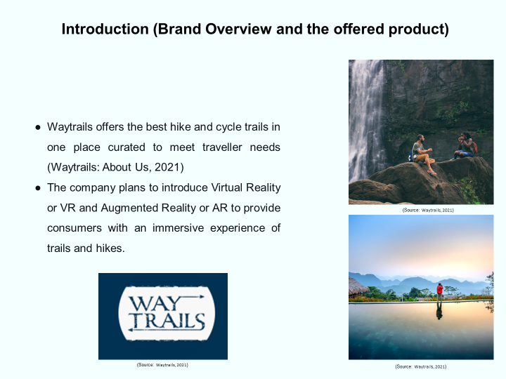
- Waytrails offers the best hike and cycle trails in one place curated to meet traveller needs (Waytrails: About Us, 2021)
- The company plans to introduce Virtual Reality or VR and Augmented Reality or AR to provide consumers with an immersive experience of trails and hikes.
Speaker Notes
The company functions within the tourism industry and its services are directed at making it easy to experience the most unforgettable trail experiences across the globe. The primary target consumers of the business are people that belong to the younger age group; however, it envisages broadening its target consumer base to include people of 44+ age. The company is to deploy VR and AR to provide trial experiences to the concerned age group in the comfort of their homes.
Slide 3: Steps to Guide Advertisement Plan Development
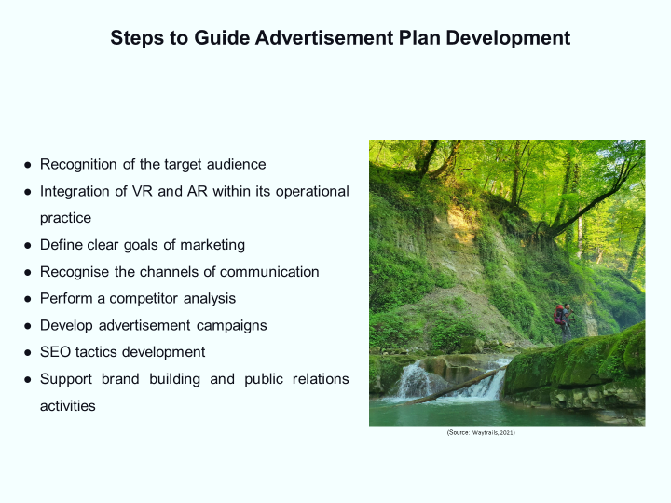
- Recognition of the target audience
- Integration of VR and AR within its operational practice
- Define clear goals of marketing
- Recognise the channels of communication
- Perform a competitor analysis
- Develop advertisement campaigns
- SEO tactics development
- Support brand building and public relations activities
Speaker Notes
The process of business development involves adherence to sequential methods of market analysis, product testing, and marketing strategy development. At Waytrails, the company’s progress towards its new AR or VR services starts with the recognition of the target audience followed by the integration of VR and AR within its operational practice. It includes emphasising user experience, performing a data-driven analysis, and integrating automation and machine learning within the business purview to ensure an immersive experience for the customers (Kundu, 2021). This step follows the development of an advertisement plan for the business where it is to define clear goals of marketing, recognise the channels of communication for its target audience, as well as perform a competitor analysis. Based on the insights gained the marketing team will develop advertisement campaigns that carry clear messages and the tagline of the company: “Trust Our Experience.” The latter stages involve SEO tactics development, using keywords to optimise content, and thus support brand building and public relations activities.
Slide 4: Advertisement Strategies for the brand
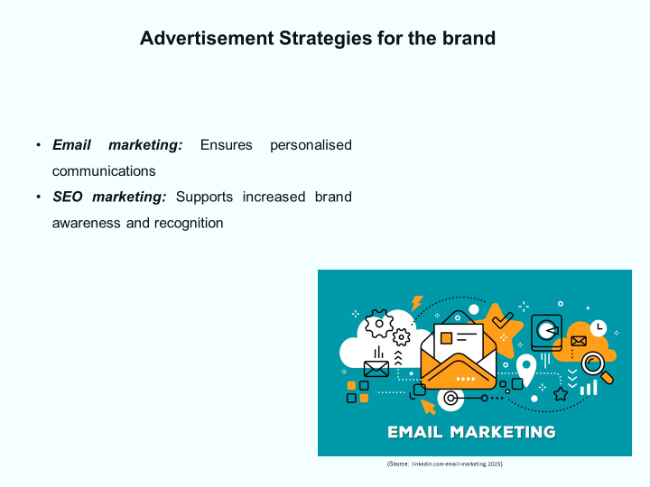
Email marketing: Ensures personalised communications
SEO marketing: Supports increased brand awareness and recognition
Speaker Notes
I believe that in order to communicate with the target audience to advertise its new product or service the company needs to adopt email and SEO marketing imperatives. Email marketing includes in its premise an approach directly communicate with the target audience and thus offers a personalisation to the marketing approach (Rosário and Raimundo, 2021, p. 3011). Subsequently, SEO marketing gives the business the advantage of gaining higher brand visibility through the deployment of keyword-based techniques. The combined use of these strategies can ensure that the brand is able to efficiently build consumer relations and track its efficiency in meeting its marketing goals in relevance to AR and VR services of hiking and trails.
Slide 5: Conclusion
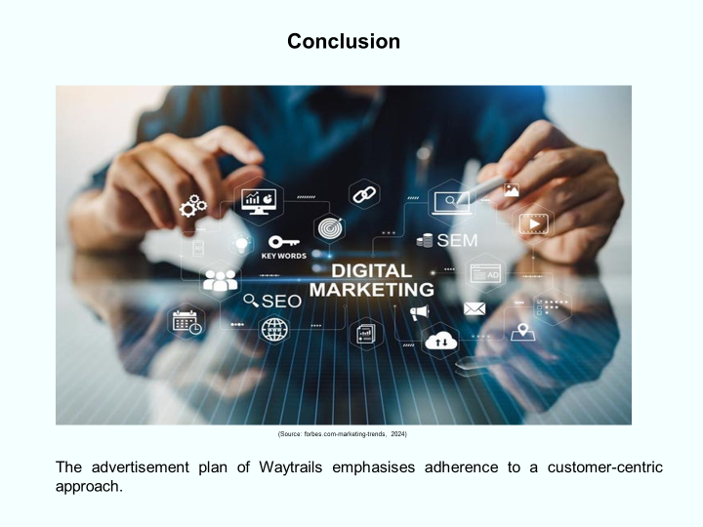
The advertisement plan of Waytrails emphasises adherence to a customer-centric approach.
Speaker Notes
The study depicts the manner in which Waytrails plans to meet its advertisement needs for its AR and VR services for the elderly. It asserts that SEO and email marketing are the key channels that the business is to rely on for meeting its advertising needs.
Slide 6: References
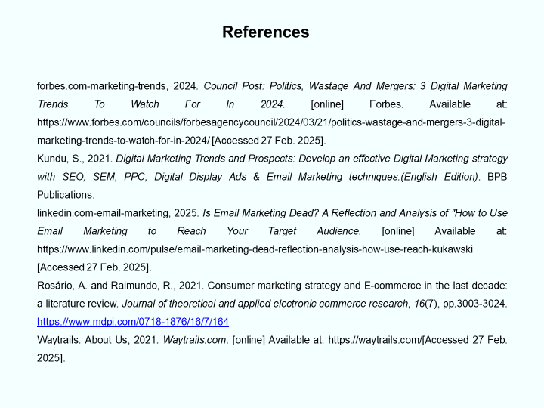
Slide 7: Thank You

https://youtube.com/watch?v=U1NwE9ALoiw&si=jUBia1lUFM0bkfO9

References
Task 3
Bobkowski, P.S. and Etheridge, C.E., 2023. Spreadsheets, software, storytelling, visualization, lifelong learning: Essential data skills for journalism and strategic communication students. Science Communication, 45(1), pp.95-116. https://journals.sagepub.com/doi/abs/10.1177/10755470221147887
Church, K.S., Riley, J. and Schmidt, P.J., 2022. Has excel become a “golden hammer”: The paradox of data analytics in SME clusters. Journal of Emerging Technologies in Accounting, 19(2), pp.211-234. https://publications.aaahq.org/jeta/article-abstract/19/2/211/175
Ibarra, L.F., 2024. Simulation and Statistics with Excel: An Introduction to Business Students. CRC Press.
Kumar, A., Singh, P.N., Ansari, S.N. and Pandey, S., 2022. Importance of soft skills and its improving factors. World Journal of English Language, 12(3), pp.220-227. https://www.academia.edu/download/109286690/21801-72393-1-SM.pdf
Quirk, T.J., Quirk, M.H. and Horton, H.F., 2021. Excel 2019 for Environmental Sciences Statistics. Springer International Publishing.
Remenyi, D., Onofrei, G. and English, J., 2022. An introduction to statistics using Microsoft Excel. UJ Press.
Salkind, N.J. and Frey, B.B., 2021. Statistics for people who (think they) hate statistics: Using Microsoft Excel. Sage publications.
Task 4
Kundu, S., 2021. Digital Marketing Trends and Prospects: Develop an effective Digital Marketing strategy with SEO, SEM, PPC, Digital Display Ads & Email Marketing techniques.(English Edition). BPB Publications.
Rosário, A. and Raimundo, R., 2021. Consumer marketing strategy and E-commerce in the last decade: a literature review. Journal of theoretical and applied electronic commerce research, 16(7), pp.3003-3024. https://www.mdpi.com/0718-1876/16/7/164
Waytrails: About Us, 2021. Waytrails.com. [online] Available at: https://waytrails.com/[Accessed 27 Feb. 2025].

