SHABANA KAUSER
2332882
MODULE CODE: BMHP5014
COMPONENT 2: WRITTEN ASSIGNMENT (REPORT)
LECTURER: TOMY ADATTU CHACKO

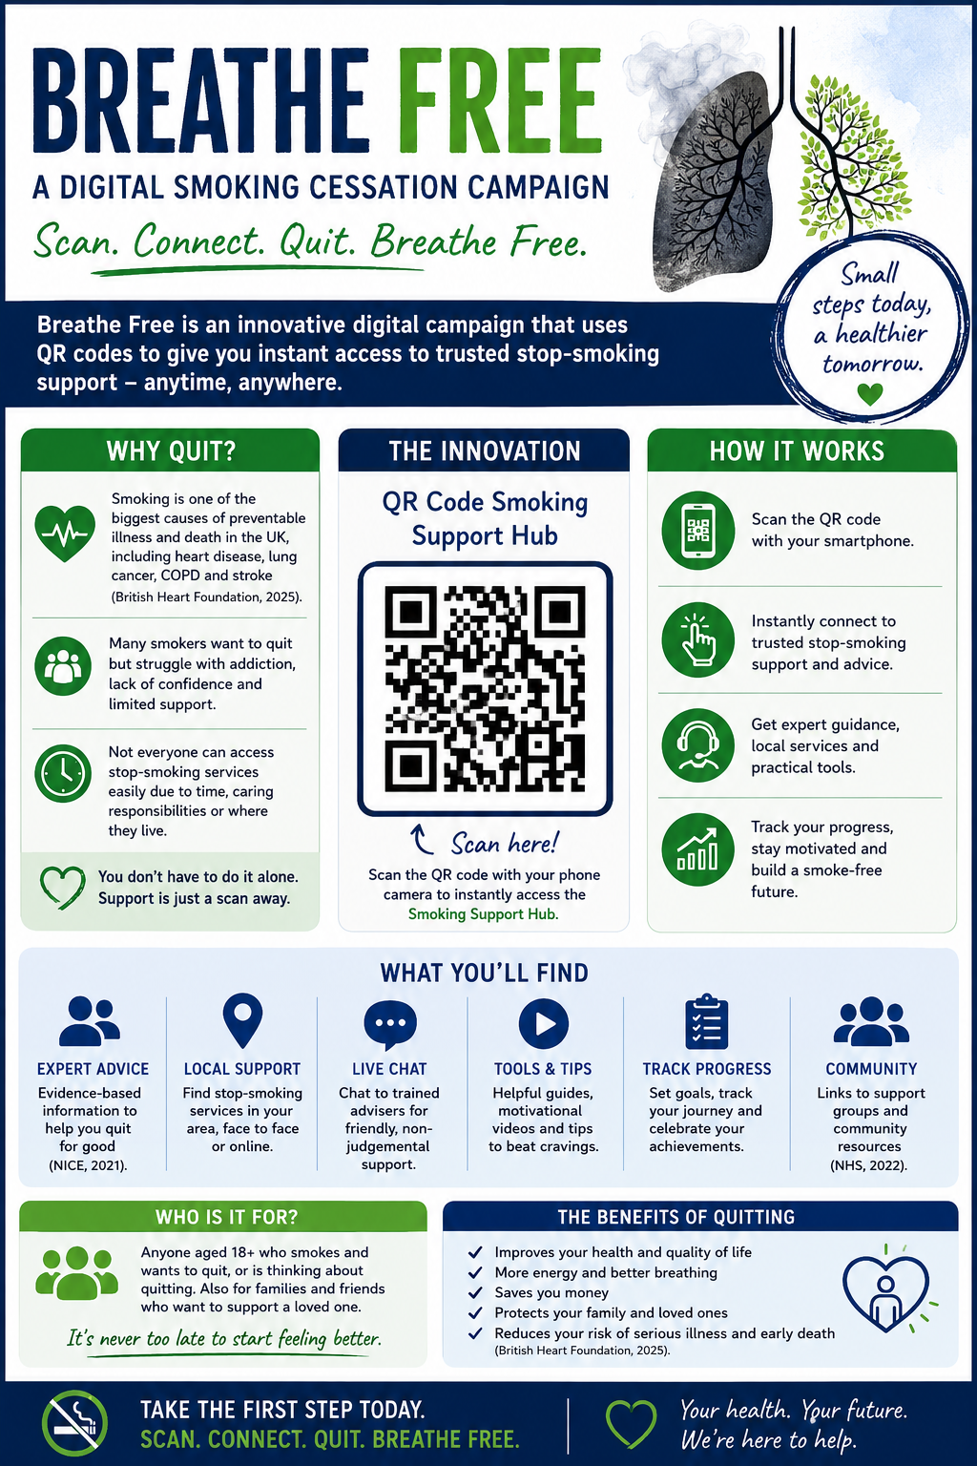BREATH FREE – A DIGITAL SMOKING CESSATION CAMPAIGN

INTRODUCTION
Smoking remains one of the most significant public health challenges in the United Kingdom. Despite declining smoking rates over recent decades, millions of adults continue to smoke, contributing to preventable illnesses, around 10,000 deaths in under a year, and substantial costs to the NHS. Smoking is associated with numerous health conditions, including lung cancer, chronic obstructive pulmonary disease (COPD), heart disease, and stroke (British Heart Foundation,2025). Therefore, innovative approaches are required to support individuals in quitting smoking and improving their long-term health outcomes.
This pitch proposes Breath Free, an innovative smoking cessation campaign designed to increase access to support through a digital QR Code Smoking Support Hub. The campaign combines traditional health promotion methods with digital technology to provide smokers with immediate access to evidence-based resources, local support services, motivational content, and practical tools to support their quit journey (NICE,2021).

IDENTIFYING THE PROBLEM
Smoking continues to be one of the greatest preventable causes of disease in the UK. Despite ongoing public health campaigns and smoking cessation services, millions of adults continue to smoke, increasing their risk of developing life-threatening illnesses (WHO, 2026). Smoking causes at least 16 different types of cancer (Cancer Research UK), and it also contributes significantly to health inequalities, with smoking prevalence generally being higher among people living in more deprived communities (British Heart Foundation, 2025).
Many smokers express a desire to quit but often experience barriers that prevent them from doing so successfully. These barriers include nicotine addiction, fear of withdrawal symptoms, low confidence, limited motivation, and lack of awareness of the support available. Research by Action on Smoking and Health (ASH, 2025) shows that while many smokers attempt to quit each year, long term success is more likely when behavioural support is combined with evidence-based treatments.
Although NHS Stop Smoking Services offer effective support, which is free and is staffed by expert advisers, not everyone accesses these services. Increasing awareness of the support available and making it easier to access evidence-based advice can encourage more smokers to make successful quit attempts (NHS, 2022). This highlights the need for innovative approaches that improve access to smoking cessation support at the point of need.

THE INNOVATION: BREATH FREE
The proposed innovation is Breath Free, a digital smoking cessation campaign designed to make professional support more accessible. The campaign combines printed health promotion materials with digital technology through the use of QR codes.
Eye catching posters would be displayed in GP surgeries, pharmacies, hospitals, workplaces, colleges, and community centres. The poster would include a QR code that users can scan with their smartphone. Once scanned, individuals would be taken directly to the Smoking Support Hub, providing immediate access to:
- NHS stop smoking advice
- Local smoking cessation services
- Information about nicotine replacement therapy
- Success stories from former smokers
- Motivational videos
- Weekly quit smoking challenges
- Advice on managing cravings and withdrawal symptoms
- Links to support groups and helplines

Unlike traditional health promotion campaigns that mainly provide information, Breath Free creates an immediate pathway to support. Instead of searching independently for reliable advice, people can access trusted resources within seconds. This makes the campaign practical, user friendly, and accessible while encouraging greater engagement with existing NHS services.
The campaign also reflects the increasing role of digital technology within healthcare. Digital health interventions have become increasingly important in supporting behaviour change, improving patient engagement, and increasing access to healthcare information (NICE,2021).

CAMPAIGN OBJECTIVES
The overall aim of Breath Free is to encourage smoking cessation and improve public health by making support easier to access.
The campaign has five key objectives:
- Increase awareness of the health risks associated with smoking.
- Encourage smokers to access professional smoking cessation services.
- Increase successful quit attempts.
- Improve long term smoking cessation rates.
- Reduce the impact of smoking related illnesses on healthcare services.

These objectives support the recommendations outlined by NICE (2021), which emphasise the importance of preventing tobacco use, promoting smoking cessation and ensuring people have access to effective treatment and behavioral support,

TARGET AUDIENCE
The primary target audience for Breath Free is adults aged 18 years and over who currently smoke. However, the campaign is also designed to reach:
- Teenagers who may be at risk of developing smoking habits.
- Individuals who are considering quitting smoking.
- Family members who wish to support loved ones through the quitting process.
- Communities where smoking rates remain higher than the national average.
Using the QR codes makes the campaign particularly accessible because almost everyone owns a smartphone. Many people regularly use their phones to access health information, making digital health promotion an effective way of reaching large numbers of people quickly and conveniently (National Library of Medicine, 2022).

VALUE CREATION
The Breath Free campaign creates value for individuals, healthcare organisations and wider society by improving access to smoking cessation support and encouraging healthier lifestyle choices.
Value for Individuals
The campaign empowers smokers by providing immediate access to trusted and evidence-based information. By scanning a QR code, users can quickly find advice, local services and practical tools to support their quitting journey. Successful smoking cessation can improve physical health, mental wellbeing, quality of life and financial circumstances, and most importantly reduce the risk of developing smoking-related diseases (NHS, 2022).
Value for Healthcare Services
Smoking related illnesses places considerable pressure on healthcare services. Increasing smoking cessation rates has the potential to reduce GP appointments, hospital admissions and long-term treatment costs associated with smoking related diseases. Supporting more people to quit smoking contributes to improved population health and enables NHS resources to be used more efficiently (Department of Health and Social Care,2023).
Value for Society
Smoking affects not only individuals but also families and communities. Reducing smoking prevalence can decrease exposure to secondhand smoke, improve workplace productivity, and reduce health inequalities, particularly in disadvantaged communities where smoking rates are often higher (NHS, 2023).

STAKEHOLDERS
The success of Breath Free depends on collaboration between a range of stakeholders. NHS Stop Smoking Services, GP surgeries, pharmacies and local public health teams would promote the campaign and encourage referrals. Local authorities, employers, colleges, and community organisations could display campaign posters and share digital resources to increase awareness. Former smokers could also contribute by sharing personal experiences to encourage and motivate others. Working collaboratively would increase the campaigns reach while ensuring people receive consistent, evidence-based support throughout their smoking cessation journey (Department of Health and Social Care, 2023).

IMPLEMENTATION PLAN
The campaign would be introduced in four stages.
Stage one – Development
A dedicated website and QR Code Smoking Support Hub would be developed in partnership with NHS Stop Smoking Services and local public health teams. The information would be evidence based, regularly updated and accessible to all users, following NICE guidelines (2021) guidelines.
Stage 2 – Promotion
Campaign posters would be displayed in GP surgeries, pharmacies, hospitals, workplaces, colleges and community centres. Social media platforms such as facebook, instagram, TikTok and X would also be used to promote the campaign and increase engagement.
Stage 3 – Engagement
Users would be encouraged to access the online support hub, participate in quit smoking challenges and contact local smoking cessation services. Health professionals could also recommend the campaign during routine appointments to encourage participation.
Stage 4 - Monitoring and Evaluation
Campaign performance would be monitored regularly to assess effectiveness and identify opportunities for improvement.

EVALUATION
The effectiveness of the campaign would be measured using both quantitative and qualitative methods. Success indicators would include the number of QR code scans, websites visits, referrals to stop smoking services, social media engagement and user feedback. Surveys could also be used to evaluate participants experiences and identify areas for improvement. Continuous evaluation would ensure the campaign remains effective and responsive to users needs while supporting long term public health goals (WHO, 2026).

POTENTIAL CHALLENGES
- One potential challenge is that some people may have limited access to smartphones or digital technology. To reduce this barrier, posters would also include website addresses and telephone numbers for local stop smoking services. Maintaining engagement over time may also be challenging, however regular updates, motivational content and interactive quit smoking challenges could encourage continued participation. In addition, any personal information collected through the digital platform would comply with UK GDPR requirements to protect users privacy and confidentiality (Legislation.gov.uk, 2021).

CONCLUSION
Breath Free is an innovative smoking cessation campaign that combines traditional health promotion with digital technology to improve access to stop smoking support. By using QR codes to connect individuals directly with trusted information, local services and evidence based resources, the campaign removes barriers to accessing help and encourages positive behaviour change.
The campaign has the potential to improve health outcomes, reduce smoking related illnesses and ease pressure on NHS services while supporting the UK Governments ambition to create a smoke free generation (Department of Health and Social Care, 2023). Through collaboration with healthcare professionals, community organisations and public health services, Breath Free offers a practical accessible and sustainable approach to improving public health.

REFERNCES
Action on Smoking and Health (ASH) 2025, Smoking statistics. Available at: https://ash.org.uk/resources/view/smoking-statistics (Accessed 04/07/2026)
British Heart Foundation 2025, 40 lives are lost daily to smoking related cardiovascular disease. Available at: https://www.bhf.org.uk/what-we-do/news-from-the-bhf/news-archive/2025/september/40-lives-are-lost-each-day-to-smoking-related-cardiovascular-disease (Accessed 04/07/2026).
Cancer Research UK (2024) Smoking, tobacco and cancer. Available at: https://www.cancerresearchuk.org/about-cancer/causes-of-cancer/smoking-and-cancer (Accessed 08/07/2026).
Department of Health and Social Care 2023, Stopping the start: our new plan to create a smokefree generation. Available at: https://www.gov.uk/government/publications/stopping-the-start-our-new-plan-to-create-a-smokefree-generation/stopping-the-start-our-new-plan-to-create-a-smokefree-generation (Accessed 08/07/2026)
Legislation.gov.uk (2021) Regulation (EU) 2016/679 of the European Parliament and of the Council of 27 April 2016 on the protection of natural persons with regard to the processing of personal data and on the free movement of such data (United Kingdom General Data Protection Regulation). Available at: Legislation.gov.ukhttps://www.legislation.gov.uk/eur/2016/679/contents (Accessed 09/07/2026).
Legislation.gov.ukhttps://www.legislation.gov.uk/eur/2016/679/contents
National Institute for Health and Care Excellence (NICE) (2021) Tobacco: preventing uptake, promoting quitting and treating dependence. Available at: https://www.nice.org.uk/guidance/ng209 (Accessed 04/07/2026).
National Library of Medicine 2022, Digital Health Promotion and Prevention in Settings: Scoping Review. Available at:https://pmc.ncbi.nlm.nih.gov/articles/PMC8838600/ (Accessed 08/07/2026).
NHS 2022, NHS stop smoking services help you quit. Available at: https://www.nhs.uk/live-well/quit-smoking/nhs-stop-smoking-services-help-you-quit/ (Accessed 05/07/2026)
NHS 2023, Understanding the true impact on smoking. Available at: https://www.nhs.uk/better-health/quit-smoking/why-quit-smoking/understanding-the-true-impact-of-smoking/#smoking-loved-ones (Accessed 08/07/2026).
WHO 2026, Tobacco and nicotine. Available at: https://www.who.int/news-room/fact-sheets/detail/tobacco (Accessed 05/07/2026).

