Coursework Title
Module Name: Computer Architecture & OS
Module Code: ACCA4022
Student Name: Sumon Miah
Student ID: 2519478
Lecturer Name: Dr Md Shantanu Islam

Submission date:

Contents
Introduction 4
Key functions of general Operating Systems 4
Task Management: 4
Application/Program Management: 4
File/Directory Management: 5
Device Management: 5
Security Management: 6
Use of Windows OS CLI commands 7
Example 1: 7
Example 2: 7
Example 3: 8
Example 4: 8
Example 5: 8
Example 6: 9
Example 7: 9
Example 8: 10
Example 9: 10
Example 10: 11
Use of Linux OS CLI commands 11
Example 1: 11
Example 2: 12
Example 3: 12
Example 4: 13
Example 5: 13
Example 6: 14
Example 7: 14
Example 8: 15
Example 9: 15
Example 10: 16
Use of Windows OS scripts 16
Example 1: 16
Example 2: 17
Use of Linux OS scripts 18
Example 1: 18
Example 2: 19
Conclusion 20
References 20
Appendices 21

Introduction
This coursework explores the fundamental relationship between computer hardware and software control. Computer architecture defines the physical structure, organization, and instruction set of a processing system, focusing on components like the CPU, memory, and input/output channels. Complementing this, the operating system acts as the vital abstraction layer, managing resources, scheduling tasks, and ensuring efficient execution of software instructions on the underlying hardware. Understanding this integration is essential for optimizing system performance, security, and reliability. This assignment analyses how these core components interact to create functional, efficient, and scalable modern computing environments.

Key functions of general Operating Systems
First released in 1985, Microsoft windows evolved from a basic graphical interface into the worlds most dominant personal operating system. Its immense importance stems from providing intuitive user-friendly interactions. Essential functions include memory allocation, file system oversight, hardware device coordination, and scheduling software applications to execute smoothly and securely.

Task Management:
Task management in windows is a core subsystem responsible for supervising system processes and active applications. Managed primarily through the native task manager utility, it monitors real time CPU utilization, memory allocation, disk activity, and network bandwidth across all active tasks. It allows users and administrators to identify resource heavy applications, troubleshoot frozen programs, and forcibly terminate non-responsive processes to stabilize the operating environment.
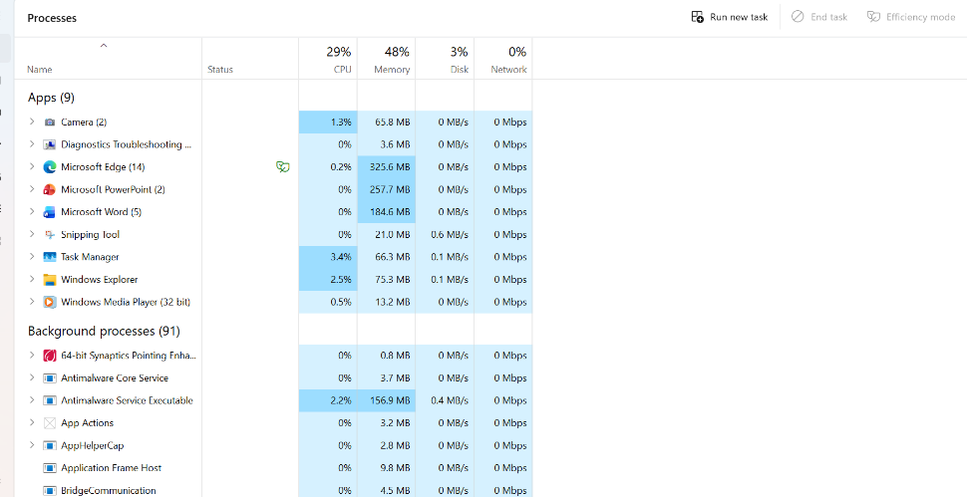
Figure 1: Description

Application/Program Management:
Application management in windows controls the complete lifecycle of software programs, from installation and configuration to optimization and uninstallation. Handled through native interfaces like “installed apps” in windows settings, the system tracks program files, registry entry allocations, and user permissions.
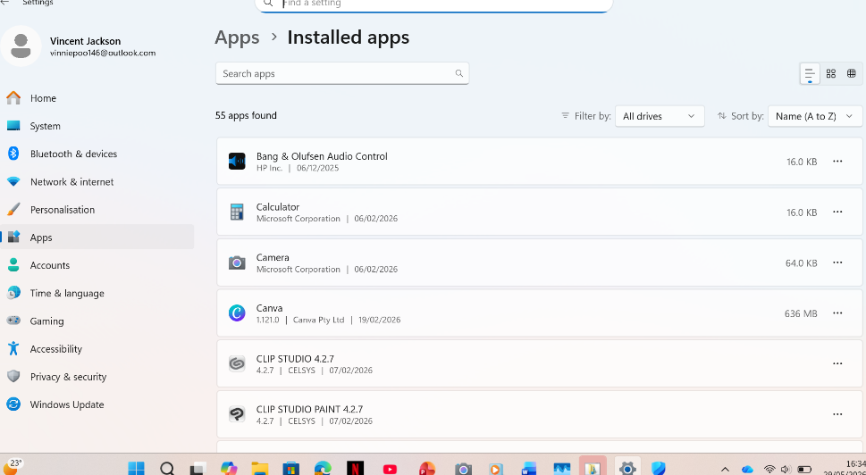
Figure 2: Description

File/Directory Management:
File and directory management n windows organizes, stores, and retrieves digital data using structured systems like NTFS. Managed primarily through file explorer, it allows users and applications to create, copy, move, rename, and delete files or folders systematically.
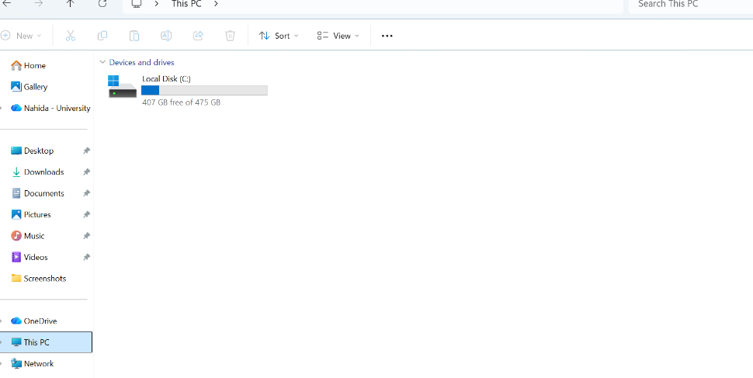
Figure 3: Description

Device Management:
Device management in windows coordinates communication between the operating system and peripheral hardware components. Managed primarily through device manager, windows uses specialized software programs called device drivers to translate OS instructions into specific hardware actions.
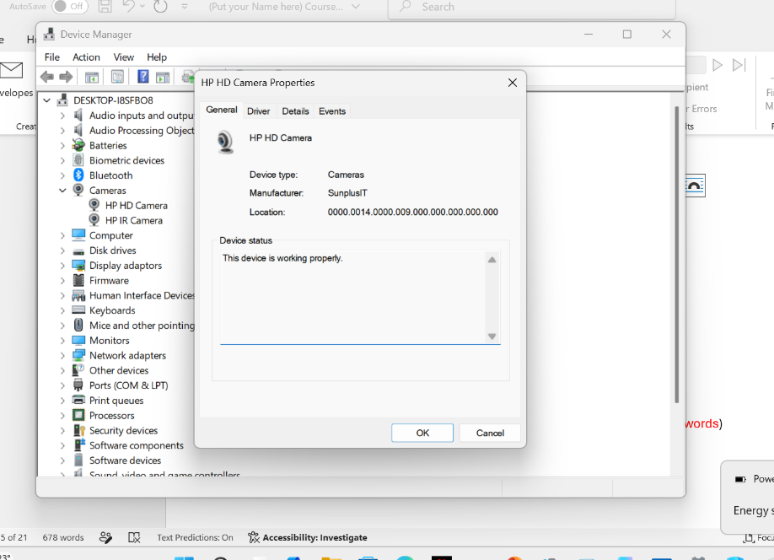
Figure 4: Description

Security Management:
Security management in windows protects system integrity, user data, and privacy against unauthorised access and malicious threats. Controlled primarily through the integrated windows security suite, it manages essential components like windows defender antivirus, a built in firewall, and smart app control protocols.

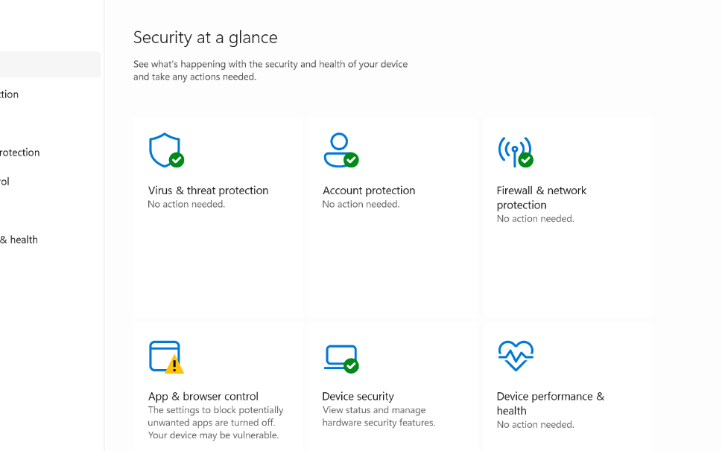
Figure 5: Description

Use of Windows OS CLI commands
The windows command line interface (CLI) primarily utilizing command prompt (cmd.exe) and Powershell, provides a text based environment for direct operating system interaction. It allows administrators and advanced users to execute tasks more efficiently than a graphical interface.

Example 1:
The dir command displays a list of files and subdirectories. The output shows the contents of c:\users\systems, including folder names, timestamps, and total free disk space.
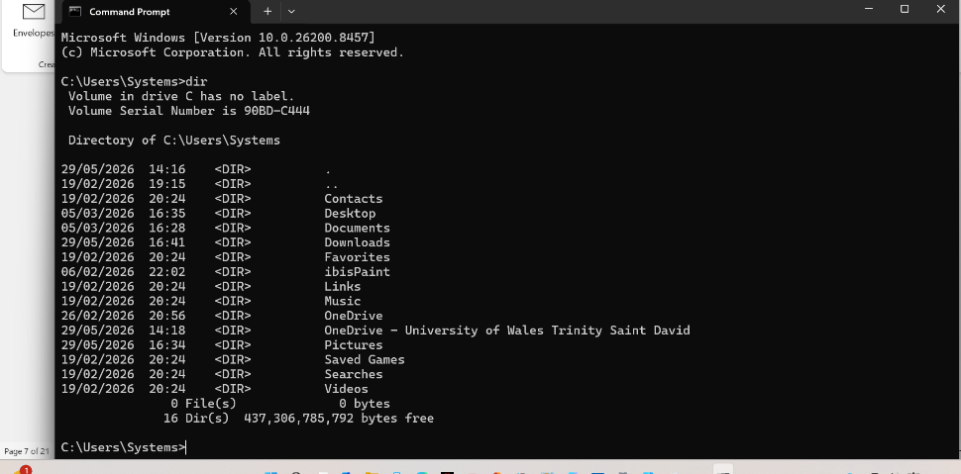
Figure 6: Description

Example 2:
The image shows a user navigating directories in windows command prompt using cd .. and cd commands. The dir command lists thee directories (public, systems, and a hidden system entry) under c:\users.
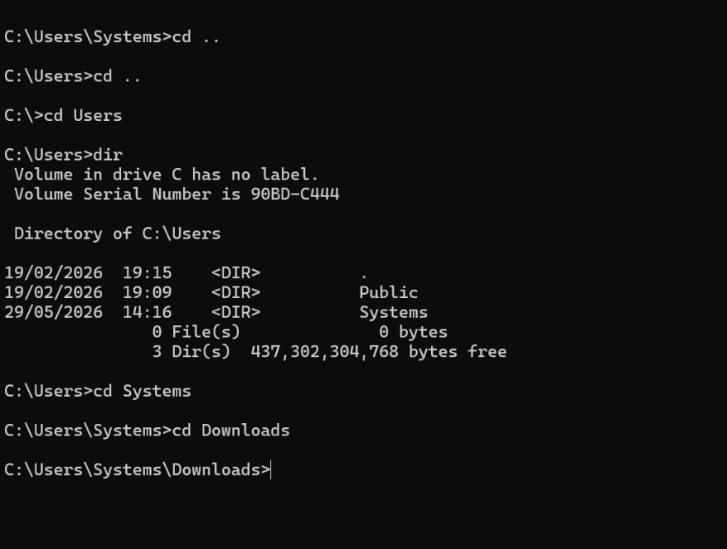
Figure 7: Description

Example 3:
The mdkir sumon command creates a new folder named “sumon”. The subsequent dir command lists the contents of the new directory, confirming the successful creation of the new subdirectory.
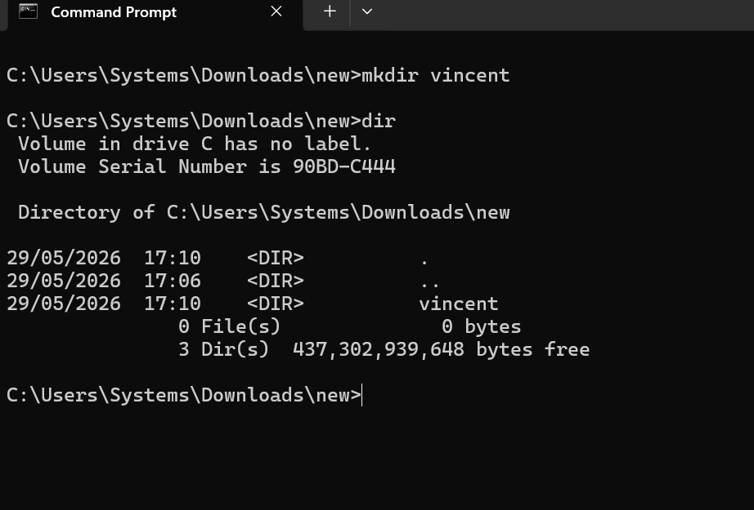
sumon
sumon
Figure 8: Description

Example 4:
The user executes mkdir new inside the c:\users\systems\downloads directory to create a new subdirectory named “new”. Running the dir command inside the newly created directory (…\downloads\new) lists its contents, showing it is currently empty. It contains 0 files and only 3 default directory entries ( … , and an empty subfolder)
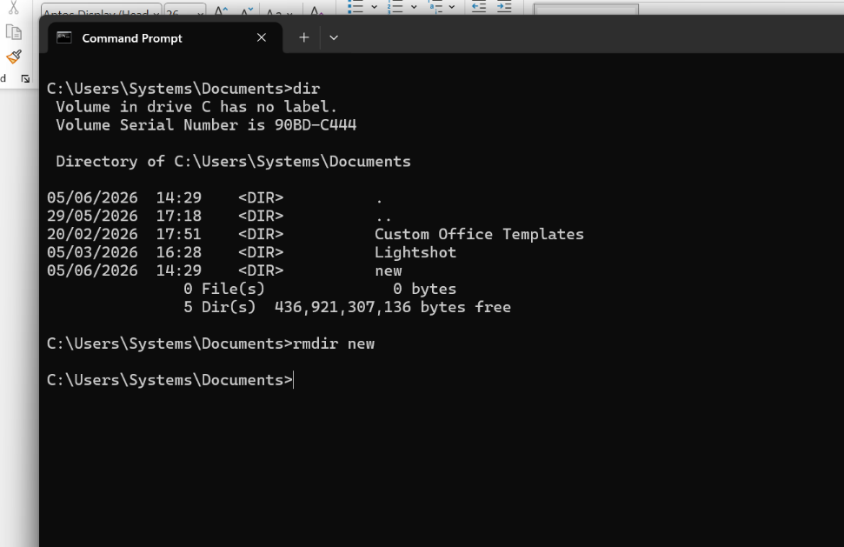
Figure 9: Description

Example 5:
The initial dir command lists the contents of c:\users\systems\documents, showing three folders: “custom office templates”, “lightshot”, and “new”. The user then runs mkdir new to create a directory named “new”. Because a folder named “new” already exists in this location, the system creates it without an error, but it remains a single folder.
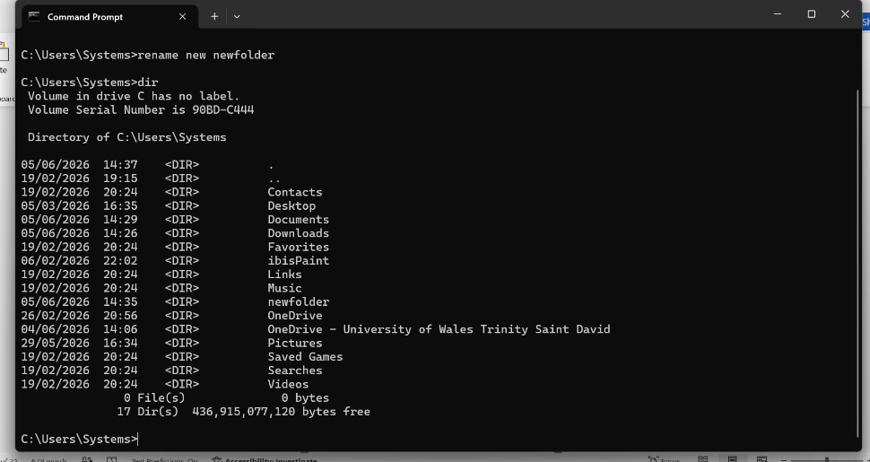
Figure 10: Description

Example 6:
The dir command is executed within the c:\users\systems directory to display its contents. It lists all 27 subdirectories inside the user profile, including standard folders (like desktop and documents) and custom folders (like newfolder).
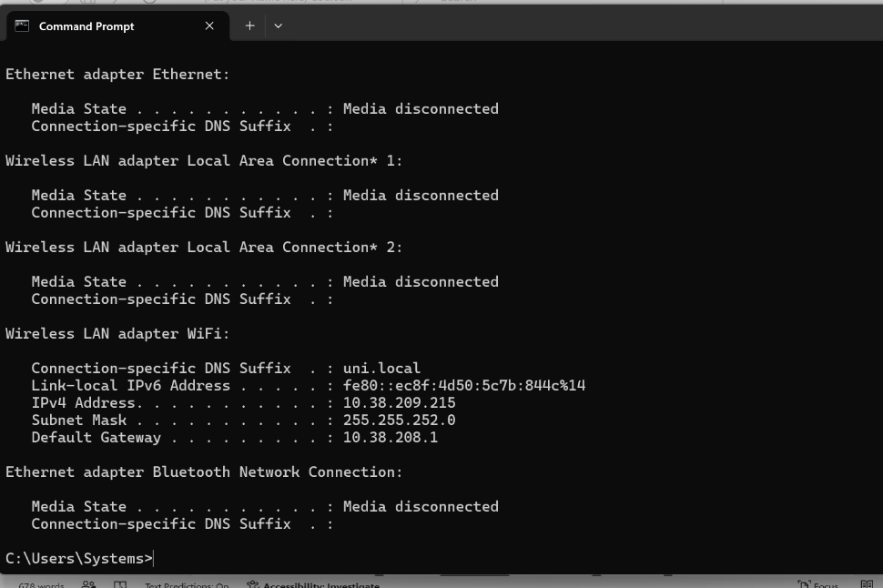
Figure 11: Description

Example 7:
The network configuration command displays the IP address settings for all active and inactive network adaptors on the computer. It shows that most adapters are disconnected, but the active wireless LAN adapter (WiFi) displays its locals IPv4 address, subnet mask, and default giveaway.
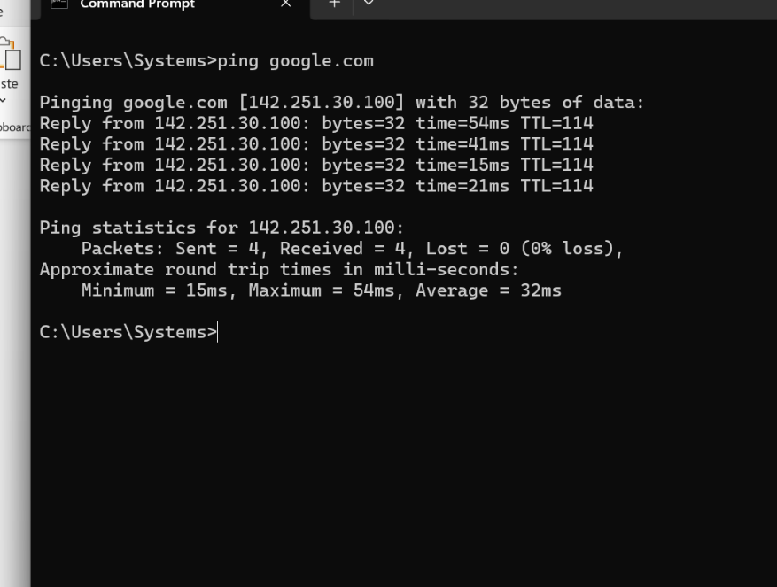
Figure 12: Description

Example 8:
This command tests network connectivity by ending data packets to google server to check if it is reachable over the network. Four packets were sent and successfully received with 0% loss. The response highlights an average round- trip connection time of 32 milliseconds, confirming a stable connection.
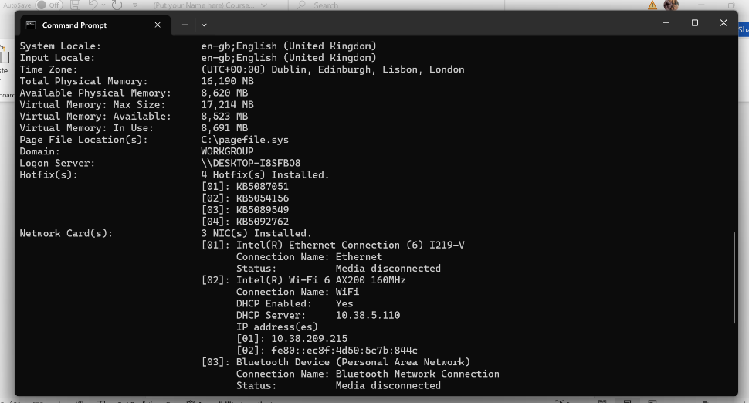
Figure 13: Description

Example 9:
This command tests network connectivity by sending data packets to googles server to check if its reachable over the network.
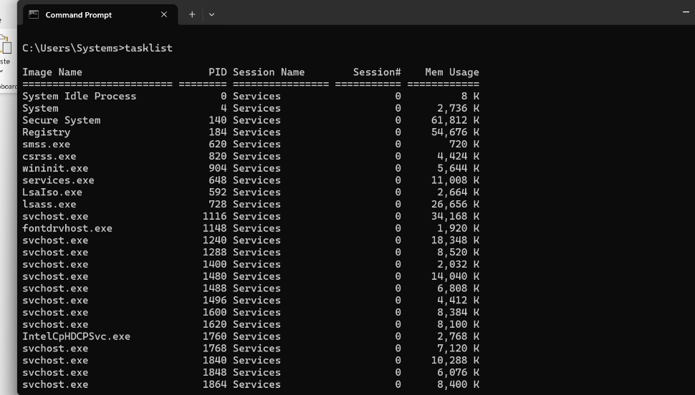
Figure 14: Description

Example 10:
This command tests network connectivity by sending data packets to google server to check if it is reachable over the network. Four packets were sent and successfully received with 0% loss. The response highlights an average round-trip connection time of 32 milliseconds, confirming a stable connection.
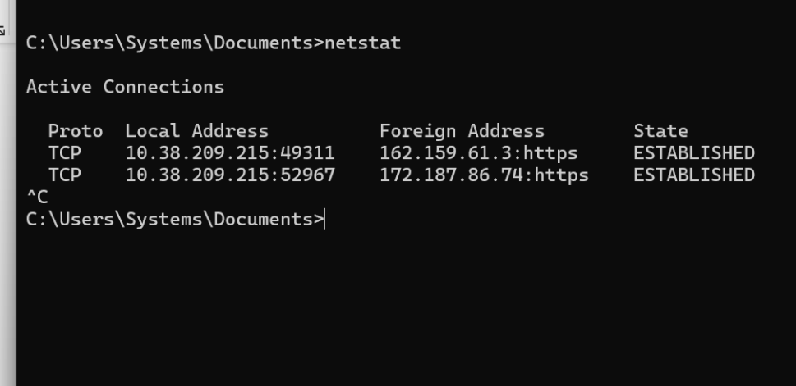
Figure 15: Description

Use of Linux OS CLI commands
The Linux command line interface allows users to directly interact with the operating system kernel via text commands. It is primarily used for system administration, automating repetitive tasks via scripting, managing files, and deploying network services efficiently without graphical overhead (Shotts, 2019; Ward, 2014).

Example 1:
The terminal snippet demonstrates switching user identities within the Linux shell using the su command.
Su requests switch to root user
Authentication failure: incorrect password entered
root@localhost: successful login as root
su sysadmin: reverts back to regular user
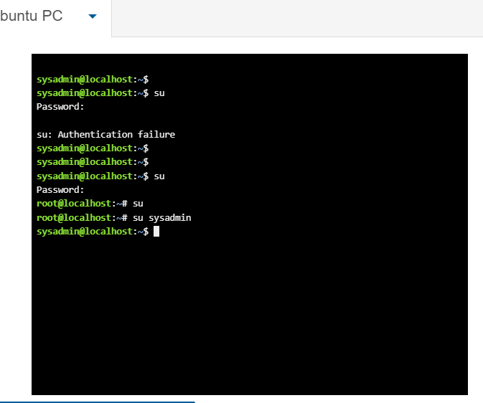
Figure 16: Description

Example 2:
The ls command lists visible directory contents. Using ls -a reveals hidden files,a typo (ls_l) causes an error, and ls -l displays detailed metadata like file permissions, ownership, and sizes.
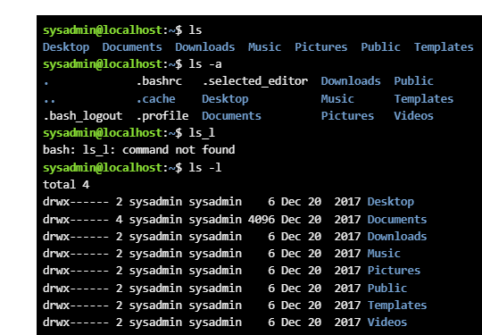
Figure 17: Description

Example 3:
The cd desktop/ command navigates the shell into the “desktop” directory. The updated prompt (~/desktop) verifies the working directory changed successfully from the home folder to the desktop.
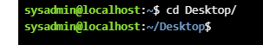
Figure 18: Description

Example 4:
The pwd command prints the absolute path of the current working directory. The output verifies that the user is currently located inside the /home/sysadmin/desktop folder.
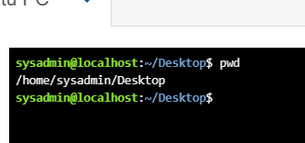
Figure 19: Description

Example 5:
The mkdir new command creates a new directory named “new” inside the current folder. The subsequent ls command lists the contents, confirming the folder was successfully created.
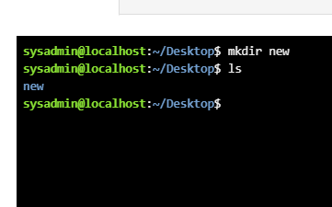
Figure 20: Description

Example 6:
The rmdir new command deletes an empty directory named “new”. The lack of output and return to the prompt indicatesthat the directory was successfully deleted without errors.
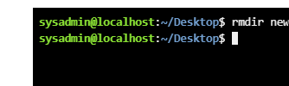
Figure 21: Description

Example 7:
The touch new.txt command creates an empty file named “new.txt”. Running ls lists the contents of the current directory, displaying “new.txt” to confirm the file was successfully created.
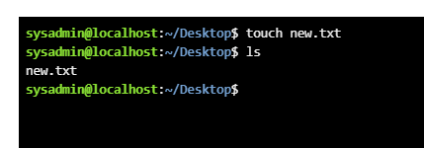
Figure 22: Description

Example 8:
The echo hello > new.txt command writes “hello” into new.txt, overwriting its content. Running cat new.txt prints the files contents, outputting “hello” to confirm the text was saved.
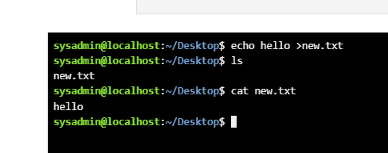
Figure 23: Description

Example 9:
The ifconfig command displays active network configuration details. The output shows parameters for the Ethernet interfac (eth0) with IP 192.168.1.2 and the local loopback interface (lo) with IP 127.0.0.1.
Xdvccccc 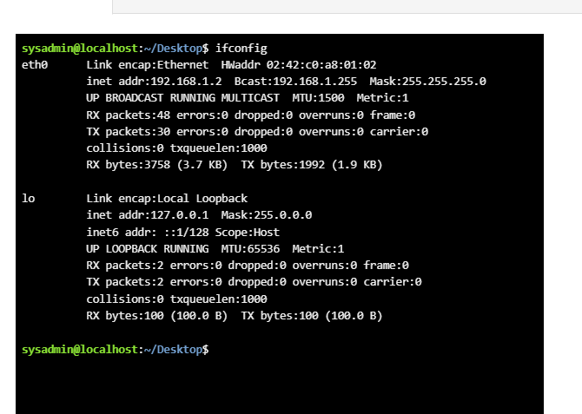
Figure 24: Description

Example 10:
The whoami command displays the current logged in username, outputting sysadmin. The date command prints the current system day, date,time, and UTC timezone details.
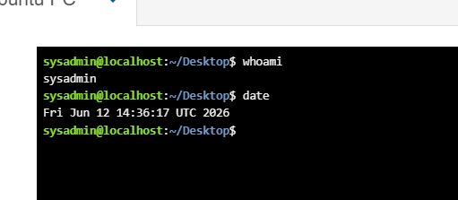
Figure 25: Description

Use of Windows OS scripts
Batch scripting automates tasks on windows operating systems. It uses text files with .bat extensions to execute command line actions Wikipedia. The system command interpreter processes these instructions sequentially without user intervention. Core applications include managing routine data backups, automating repetitive administrative setups, and performing bulk file modifications efficiently.

Example 1:
This batch script prompts a user for two numbers, calculates their sum, and displays the result in the windows command prompt. Ech0 off hides the command text from displaying on the screen o keep the output clean. Set /p pauses execution to accept keyboard input from the user, saving the values into variables num1 and num2. Set /a performs an arithmetic operation, the result in total. Echo prints the text string along with the final evaluated value of %total%. Pause suspends script execution and displays a “press any key to continue” message to prevent the window from closing instantly.
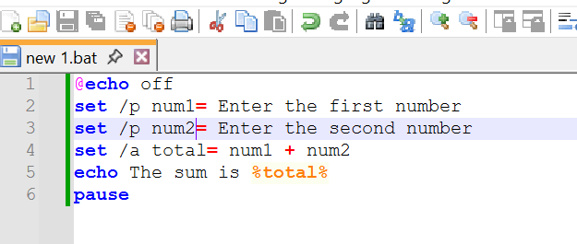
Figure 26: Description
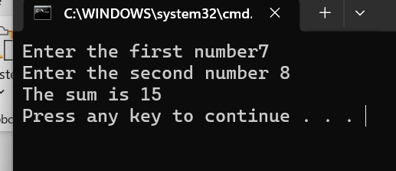
Figure 27: Description

Example 2:

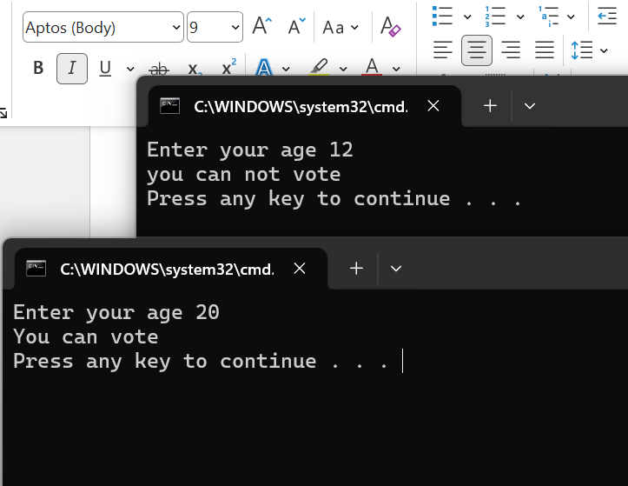
Figure 28: Description
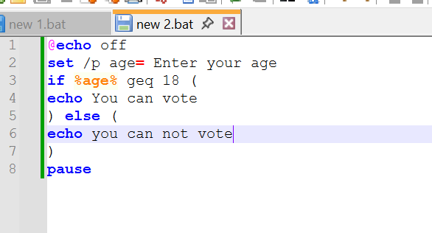
Figure 29: Description

Use of Linux OS scripts
Bash scripting automates repetitive tasks in Linux operating systems by executing sequential commands stored in a text file. It is widely used for a system administration, automated backups, user management, and software developoyment. Scripting improves operational efficiency, minimizes human rror, and streamlines complex infrastructure workflows.

Example 1:
That provided script is a basic bash program designed to calculate the sum of two user inputted numbers. It is begins by prompting the user to enter a first number using the echo command, and captures the input into a variable using the read command. Tjis process is repeated for a second number. The script then utilizes arithmetic expansion $((…)) to compute the total and displays the result. In the terminal output, the user creates the file using nano script.sh. They modify the permissions with chmod +x script.sh to make the script executable. Upon running it via ./script.sh, the interactive prompts appear appear. The user enters 76 and 45. The script accurately processes and addition mathematically and returns the final output: sum is 121.
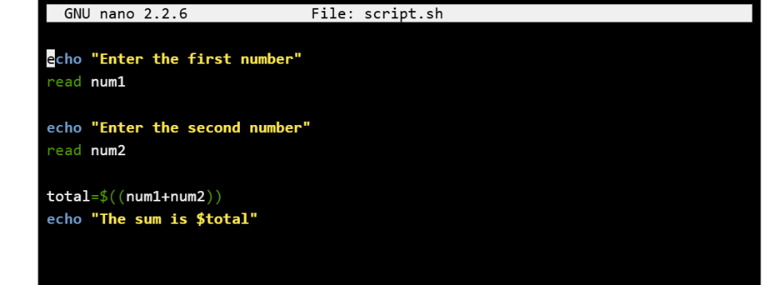
Figure 30: Description
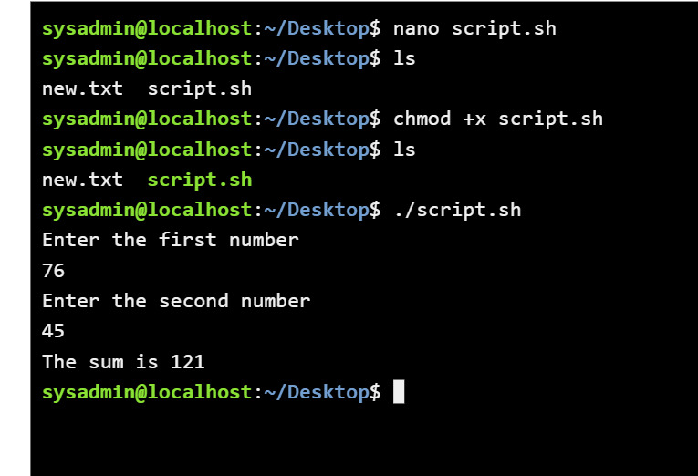
Figure 31: Description

Example 2:
The provided script utulizes a standard c cycle for loop in bash to print a sequence of numbers based on user input. It begins by prompting the user with echo to specify how many times they want to count. The read command stores this value in the count variable. The loop initializes an index variable I at 0 and continues incrementing by it one (I ++) as long as I is strictly less than the users input. Inside the loop, echo “si” outputs the current index value.
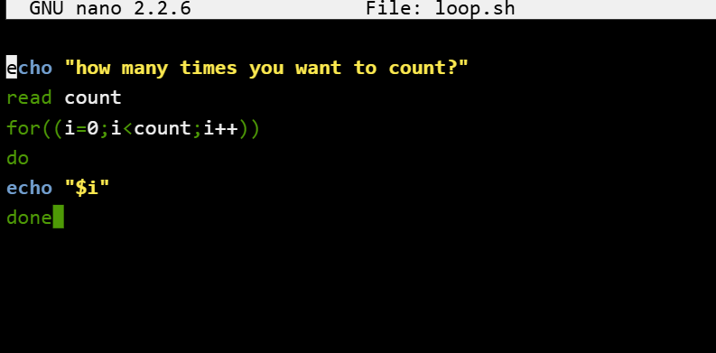
Figure 32: Description
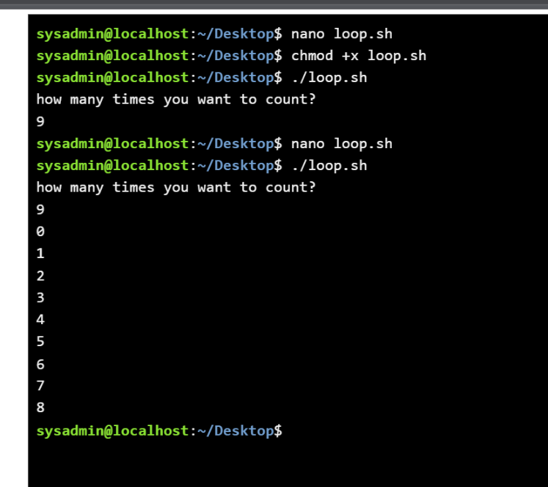
Figure 33: Description

Conclusion
This report demonstrates the practical application of linux bash scripting for basic arithmetic operations and loop automation. Through these tasks, I developed a clear understanding of capturing user input, executing conditional loops,and modifying file permissions to run scripts directly in the terminal environment. These foundational skills are essential for streamlining systems administration workflows and automating complex, repetitive command line tasks efficiently.

References
Newham, C, & Rosenblatt, B. (2005). Learning the Bash Shell: Unix Shell Programming. O’ Reily Media.
Shotts, W. (2019). The linux Command Line: A Complete Introduction . No Starch Press.

Appendices
Online Course name:
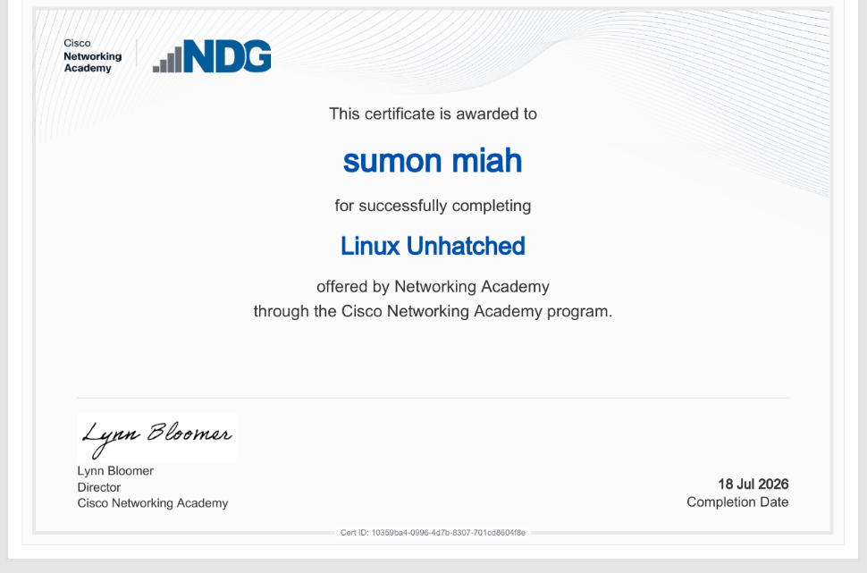
Figure 34: Certificate of completion

