Global Business Environment
New business opportunities and product life cycle

“Electric vehicles in Europe: gearing up for a new phase?”

Student: Viorel Badale - 1909486
Module: LCBB4005 Global Business Environment A2
Module Lecturer: Dr. Keny Tang

Table of Contents
Introduction 3
Task 3
Conclusion 12
Reference List 13

Introduction
Business Environment involves all the external and internal variables influencing the business operations of a company, for instance employees, demand, supply, innovation etc are micro-environmental factors while political scenario, economic changes, social trend, market scenario and technology are macro-environmental factors. This study would focus upon the macro environmental factors through affecting the growth and business development of electric vehicles. Moreover, this study would also highlight the business opportunities for Electric cars in the current market.
The Swedish company Volvo was established in 1927 with the headquarters in Gothenburg. The company manufactures, sells and distributes buses, trucks, cars and constructional equipments. Around 40% of the total sale of the company comes from Europe. Volvo Group is also one of the largest truck manufacturers across the globe.

Task
a) Identify new and emerging business opportunities that the production and marketing of electric cars may present to entrepreneurs and business executives.
The industry of electric car has been evolving with the emergence of high technology, offering wide range of cars with electric and automated engines. However, the car companies like Volvo need to enhance their innovation and technology, which raises the operational cost, pressurising their financial resources. The Electric Car industry focuses upon making the most of the available technological resources for introducing highly automated and quality features in cars with low price for the target customers.
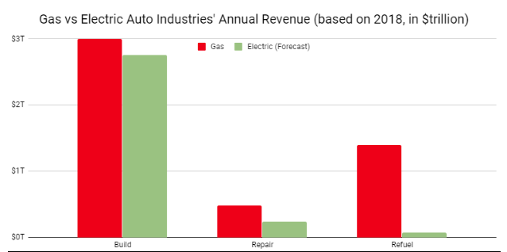
Figure 1: Gas vs. electric cars usage
(Source: Contributor, 2019)
It can be evaluated from various resources that customer demand and changing market trend are also driving the technological development in EV industry (Engelken et al, 2016). The innovative features of the electric vehicles enable the companies to create a product distinction with the competitors. A major reason behind the vision of creating electric cars was prevention of pollution and conservation of the environment. Various automotive companies, like the Volvo Group are adapting innovation for manufacturing vehicles operated by electric batteries for decreasing the emission carbon dioxide. In context to reducing the emission of harmful gases, the EU has implemented some major regulations ensuring 20% reduction of greenhouse-gas, develop 20% of energy efficiency and enhance 20% EU energy level (europa.eu, 2016).
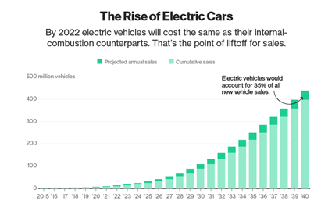
Figure 2: The rise of electric cars
(Source: Coren, 2019)
The emergence of cars with electric engines and batteries are highly beneficial in context to achieving these objectives of EU. Moreover, ETS has been highly contributing to reduction of greenhouse emissions covering about 45% of EU’s emissions. The rise of electric cars has been highly effective in lowering the pollution level through preventing emission of harmful gases, which is common for the vehicles with combustion engines (Madlener and Specht, 2018).
The following strategies can be beneficial for understating the need and demand of electric cars in the present market.
Integrated Architecture: As per the current market trend, the customers have high demand for innovation and automated features in the cars with budget friendly prices. Therefore, the automotive industry concentrates on manufacturing vehicles with highly integrated architecture that would offer features like more spaces, automated locks and innovative systems fulfilling the requirements of the buyers. The electric car industry can look up to the 2030 EU energy framework for bringing all the required innovations in their vehicles. The EU framework of energy can be utilised for reducing 40% of the carbon emission level and increasing the renewable energy source by 32%. Improvement in energy efficiency also needs to be achieved by around 32% for driving change in the automotive industry.
Industry Adoption 4.0: The adoption of various technologies highly contributes to the growth and expansion of business in all the sectors. The electric car industry adapted innovations and high technology using machines, automations and innovation with augmented sensors and AI solutions. The technique of Industry adoption 4.0 has become highly beneficial for many large organisations like Volvo in the EV industry, introducing electric engines and automated features in the vehicles. The manufactures of EV industry uses the technique of Industry Adoption for locating and understanding various connections along with sharing data through the overall operation and venture. According to Hecht (2018), the manufacturers in the automotive sector understand the changing market demand of the industry and hence, starting to adapt electric cars as their newly innovated products. This highly drives the advancement and success of the electric cars and automotive innovation, achieving the EU objectives related to energy conservation.
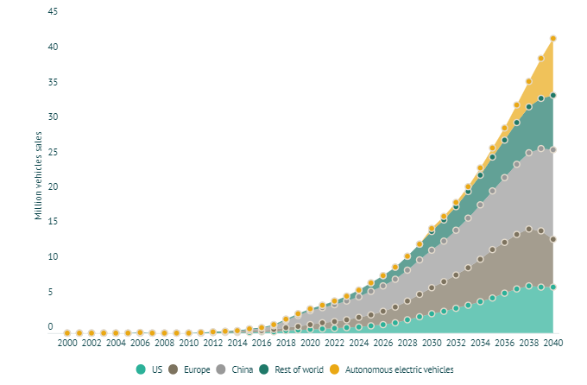
Figure 3: Predicted electric vehicle sales by 2040
(Source: Woodmac.com. 2019)
The global market for the automotive industry has been evolving with the introduction of electric cars and battery engines. The automotive industry has planned to completely replace using combustion engine with electric engines and renewable power source by manufacturing only electric vehicles, aiming to offer estimated 300 million electric cars by 2040.
b) In your discussions, identify and critically assess other businesses currently linked to the global automotive industry that you think it may not be profitable in the long run to invest in.
Improvement in the area of energy efficiency has been of high concern for the EU and other nations as well. The US government invested around $80 billion for improving the level of energy efficiency. This highly affected many companies of the automotive industry as the profit margin of electric cars is quite low (5%) when compared to that of the cars operating through combustion engines (20%) running by gas (cleantechnica.com, 2019). Though the profitability is low in manufacturing electric cars and moreover, the products need to be affordable for increasing sale among the buyers, the companies like Volvo still understands the priority of preservation of environment and green house gases for the future. Therefore, the company plans to manufacture all their vehicles with electric battery engines instead of combustion engines anymore. However, there are certain important theories and business models that would be beneficial for the electric car industry based organisations for business expansion and growth with launching their new electric vehicles.
Porter’s five forces
This tool supports analysis of business strategy and industry analysis with the help of current developments, competitors and organisational competitiveness. The automotive sector can analyse this competitive position with this model. Moreover, the tool is also beneficial in context to understand customer demand and expectations and develop strategies accordingly for product innovation, position and promotion (Nielsen et al., 2017). The electric vehicle industry can use this tool to understand the completion level, market trend, customer expectations and business risks related to the business and develop suitable strategies for handing the threats.

Figure 4: Porters Five Force Model
(Source: Created by Learner)
Competitive Rivalry
The automotive industry has large number of business organisations offering similar products with high innovative features for attractive price. There are various automobile companies like Volvo Group, BMW, Volkswagen and Mercedes Benz offering highly innovated features like automated brakes, electric batteries and other automated systems for fulfilling the needs of the buyers along with aiming to reduce the level of carbon emission. Emergence of new entrants and the existence of the large car manufacturers increase the competition in both local and the global market of automotive industry. Moreover, competition also increases due to customers tend to switch brands based on price and features. All the companies tend to make the best use of technology for bringing high innovation and excellent quality features for their vehicles, which also enhances the level of market competition among the manufacturers.
Power of Buyers (High)
In context to the electric car industry, the buyers enjoy more power than the manufacturers. This is due to large number of options available from the competitors and similar car features available with varied price ranges. When the buyers find similar features from multirole vehicle providers, they are likely to switch brands as per their choice and expectations. The EV industry needs to assess the needs, requirements, preferences and expectations of the clients in order to develop and design the innovative features of their vehicles in way that would surpass the competitiveness of the rival manufacturers. The buyers enjoy the power of choosing and availing the products as per their choice and need driving the market trend in automotive industry.
Bargaining Power of Suppliers: (High)
The suppliers enjoy high power over the automotive industry based organisations. The manufacturers cannot deliver a vehicle without the support from the suppliers. The supplier teams of the vehicle manufacturers cater them raw materials for manufacturing the vehicles. The car companies need various supplies for instance, engine parts, electronic devices and other hardware equipments for manufacturing the complete vehicles (Stark, 2020). In case there is any conflict between the automobile companies and the suppliers, there can be issue with getting the resources like raw materials and hardware required for car manufacture. Therefore, the industry needs to have favourable contracts and agreements along with maintaining friendly bonding with the supplier teams.
Threats of Substitute: (High)
There is high competition among the market of EV industry as all the large car manufacturers are working upon presenting the best features and automation systems fulfilling the demand of the customers. The new entrants enhance the competition level with manufacturing cars with similar features compared to the innovative ones (Stock and Seliger, 2016). This poses threat of substitute product upon the manufacturers offering the original products. Furthermore, the new entrants offer the cars with similar features and innovations for a lower price, which attracts the customers and drive them to switch brands.
Threats of New Entrants: (Moderate)
There are new entrants entering the market of automotive industry, but the factor has moderate power as manufacturing of vehicles requires high financial resource and entering the global market needs various procedures with the governmental regulations etc. moreover, the market demand, customer expectations and technological requirements are quite high, which keeps the new entrants number moderate in this sector.
Porter’s value chain
The Value Chain comprises of various components like the business operations, sales, marketing process and logistics. The following stages discusses the Porter’s value chain in details.
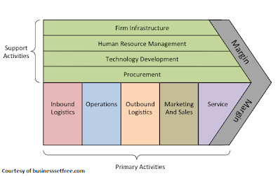
Figure 5: Porter’s Value Chain
(Source: Amara et al., 2016)
Inbound Logistics: Inbound logistics refer to the supply of spare parts from the suppliers of the automotive companies. This section of the value chain also comprises maintaining of inventories by the car manufacturers. As the EV industry deals with technological equipments and machineries, the manufacturers often require importing equipments and spare parts for their vehicles from other nations (Donoghue et al., 2019).
Operations: This part refers to the researcher team assembling the spare parts and machineries for developing innovative features for the vehicles. The EV industry deals in innovativeness and hence, the manufacturers highly require special teams for designing the innovative features like electric engines, automated brakes and other systems in their cars.
Outbound Logistics: This section comes after the assembling of the parts and completion of the design and manufacturing. The manufacturers of EV industry send their newly designed vehicles to different locations to their venture experts for analysing the product value.
Sales and Marketing: This part comprises the promotional activities and product positioning by the venture experts through advertising the new models of EV vehicles on social media sites, newspapers and other advertising grounds (Holligan et al., 2017). This helps the EV industry to connect with the clients and enhance sale and profit margin.
Services: The Electric Car industry based services include post sale services, client complaint handling, analysing the car’s performance etc. this part involves connecting the clients with the outlets of the manufacturers of the vehicles.
The product life cycle
The EV industry uses the model of ‘product life cycle’ for analysing the spare parts purchased from the supplier teams. The stages of the model are discussed below:
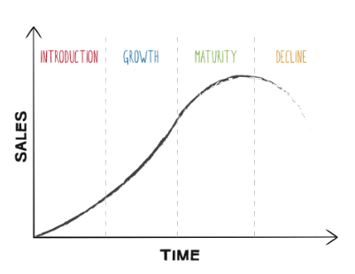
Figure 6: Product life cycle
(Source: Svahn et al., 2017)
Introduction:
This stage directs the manufacturers to develop and enhance awareness regarding their newly designed electric cars for attracting target group of clients and initiate sale.
Growth:
This stage involves creating brand image and enhancing brand awareness of the manufacturers of EV industry (Collier et al., 2017). This helps to influence the purchasing behaviour of the clients.
Maturity:
This stage comes after application of the suitable promotional strategies and sharing all the manufacturing details of the vehicles. The manufacturers of EV industry concentrate upon conducting marketing campaigns for attracting more clients for the newly launched vehicles.
Decline:
This stage involves fall in price of the electric cars in the market. Sometimes, manufacturers of Electric cars face issue in manufacturing new innovated features resulting in fall in sale and profit.

Conclusion
This study concludes that proper strategy development is highly essential for offering innovative products in the market of Electric vehicle industry. The industry aims to offer highly innovative features like automated systems, automated brakes and electric engines for offering more comfortable vehicles to their clients. Moreover, the industry also concentrates upon the EU regulations for prevention of carbon emission and enhances sustainability. The clients look for innovative features while purchasing cars, therefore, the Electric Vehicle industry has high scope for growth and business success in the international market.

Reference List
Amara, N., Halilem, N. and Traoré, N., 2016. Adding value to companies' value chain: Role of business schools scholars. Journal of Business Research, 69(5), pp.1661-1668.
Collier, Z.A., Connelly, E.B., Polmateer, T.L. and Lambert, J.H., 2017. Value chain for next-generation biofuels: Resilience and sustainability of the product life cycle. Environment Systems and Decisions, 37(1), pp.22-33.
Contributor, G. (2019). The Business Of Electric Vehicles | CleanTechnica. [online] CleanTechnica. Available at: https://cleantechnica.com/2019/09/25/the-business-of-electric-vehicles/ [Accessed 30 Apr. 2020].
Coren, M. (2019). The median electric car in the US is getting cheaper. Quartz. Available at: https://qz.com/1695602/the-average-electric-vehicle-is-getting-cheaper-in-the-us/ [Accessed 27 Apr. 2020].
Donoghue, I., Hannola, L. and Papinniemi, J., 2019. Product Lifecycle Management Business Transformation in an Engineering Technology Company. In Product Lifecycle Management (Volume 4): The Case Studies (pp. 185-200). Springer, Cham.
Engelken, M., Römer, B., Drescher, M., Welpe, I.M. and Picot, A., 2016. Comparing drivers, barriers, and opportunities of business models for renewable energies: A review. Renewable and Sustainable Energy Reviews, 60, pp.795-809.

europa.eu 2016. Climate Action - European Commission. (2016). Climate strategies & targets - Climate Action - European Commission. [Online] Available at: https://ec.europa.eu/clima/policies/strategies [Accessed 27 Apr. 2020].
Hecht, J., 2018. Lidar for self-driving cars. Optics and Photonics News, 29(1), pp.26-33.
Holligan, C., Hargaden, V. and Papakostas, N., 2017, June. Product lifecycle management and digital manufacturing technologies in the era of cloud computing. In 2017 International Conference on Engineering, Technology and Innovation (ICE/ITMC) (pp. 909-918). IEEE.
Madlener, R. and Specht, J.M., 2018. Business Opportunities and the Regulatory Framework. Energy Storage Options and Their Environmental Impact, 46, p.296.
Nielsen, S.L., Christensen, P.R., Heidemann Lassen, A. and Mikkelsen, M., 2017. Hunting the Opportunity: The promising nexus of Design and Entrepreneurship. The Design Journal, 20(5), pp.617-638.
Stark, J., 2020. Product Lifecycle Management (PLM). In Product Lifecycle Management (Volume 1) (pp. 1-33). Springer, Cham.

statista.com 2020. Topic: Volvo Group [Online] Available at: https://www.statista.com/topics/2581/volvo-group/ [Accessed: 30 April 2020]
Stock, T. and Seliger, G., 2016. Opportunities of sustainable manufacturing in industry 4.0. Procedia Cirp, 40, pp.536-541.
Svahn, F., Mathiassen, L. and Lindgren, R., 2017. Embracing Digital Innovation in Incumbent Firms: How Volvo Cars Managed Competing Concerns. Mis Quarterly, 41(1).
Woodmac.com. (2019). Electric car forecast to 2040. [online] Available at: https://www.woodmac.com/our-expertise/capabilities/electric-vehicles/2040-forecast/ [Accessed 27 Apr. 2020].

