

Student name: | Munir Hussain | Student ID number: | 2531367
Programme: | CertHE Computing Skill for Workplace
Module: | Learning in the Digital Era
Module code: | ACCA4025 | Contribution to Overall Module Assessment (%): | 50%
Lecturer: | Martin Svejda, Malik Mehmood | Internal Verifier: | Sadhana Jha
Assignment Title: | Assignment 1: E-Portfolio | Word count (or equivalent): | See 4 tasks below

Site Link: https://sites.google.com/view/level-4-e-portfolio/task-1-academic-and-employment-skills

Contents
1. E-Portfolio Homepage Link and Screenshot 3
2. Task 1 - Written Summary Evidence 4
2.1 Screenshot Evidence 4
3. Task 2 - Mind Map and Academic Poster Evidence 6
3.1 Team Activity and Collaboration Tools 6
4. Task 3 - Automatic Referencing Tool Evidence 8
5. Task 4 - E-Portfolio Creation and Review Evidence 11

1. E-Portfolio Homepage Link and Screenshot
Online e-portfolio homepage: https://sites.google.com/view/level-4-e-portfolio/home
The homepage identifies the student, course, module and e-portfolio navigation structure. The site contains separate pages for Task 1, Task 2, Task 3 and Task 4.
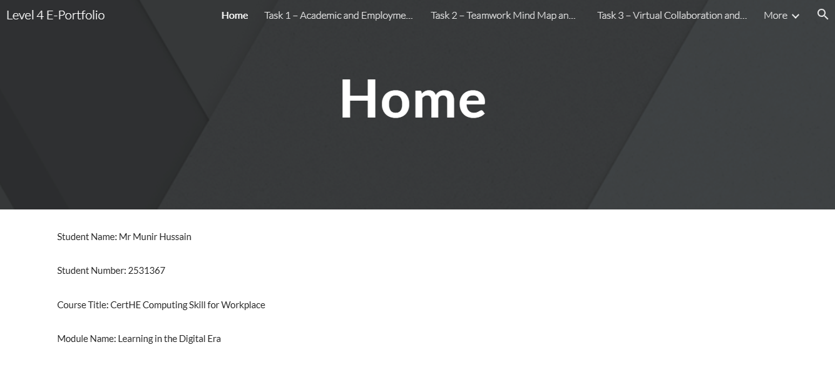
Screenshot - Home Page
Screenshot - Google Sites Homepage Design / Editing Evidence

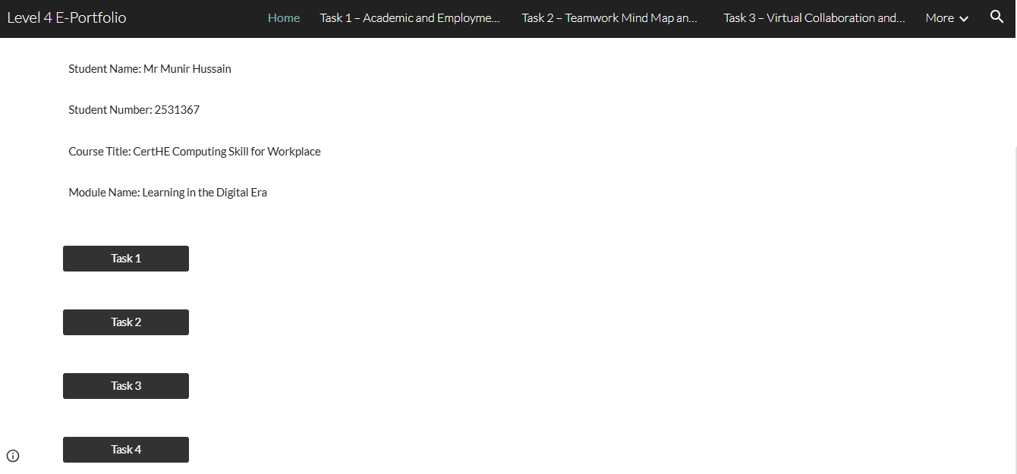
Screenshot - Published Site Access Test in Incognito/Private Browser

2. Task 1 - Written Summary Evidence
Task 1 page link: https://sites.google.com/view/level-4-e-portfolio/task-1-academic-and-employment-skills

2.1 Screenshot Evidence
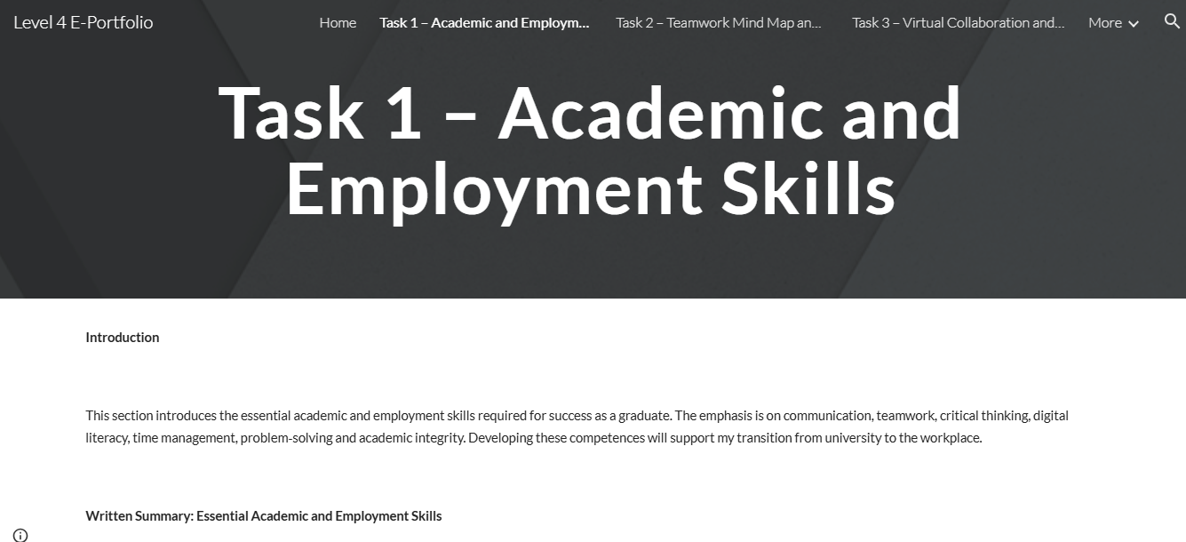
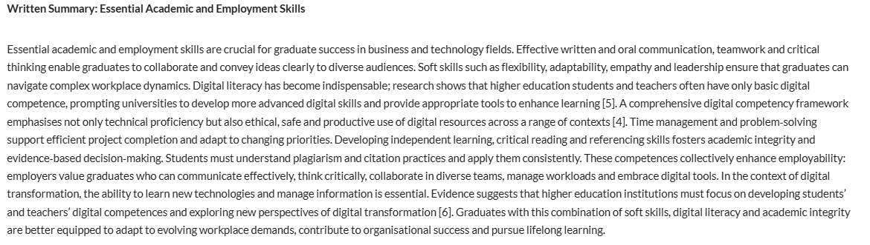
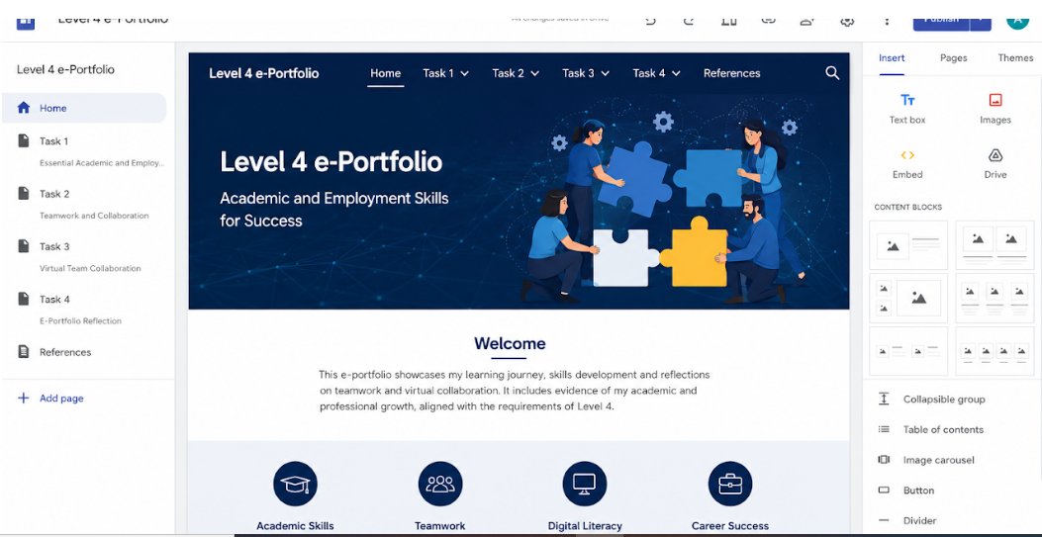
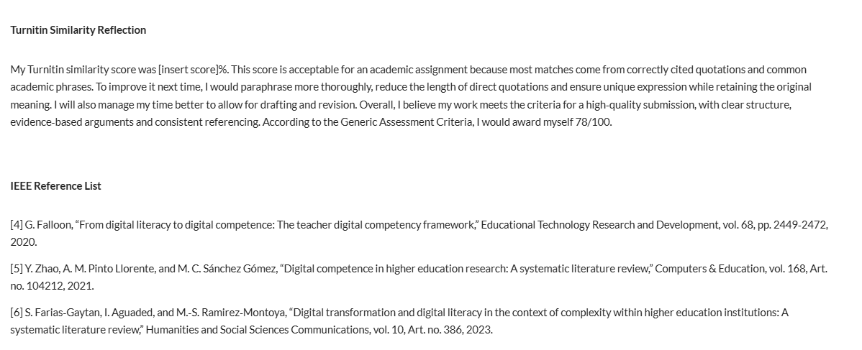
Screenshot - Task 1 Page: Academic and Employment Skills

3. Task 2 - Mind Map and Academic Poster Evidence
Task 2-page link: https://sites.google.com/view/level-4-e-portfolio/task-2-teamwork-mind-map-and-academic-poster

3.1 Team Activity and Collaboration Tools
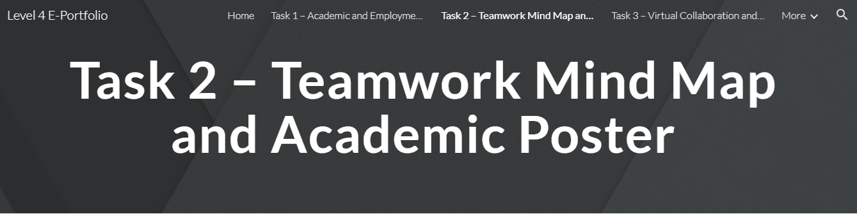
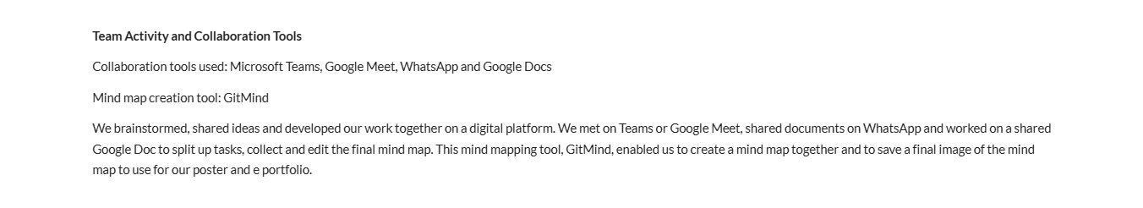
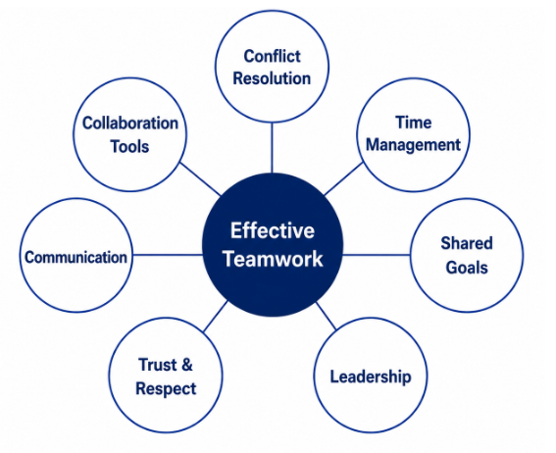

Mind Map Link: https://drive.google.com/file/d/1AbQr29psKBLfoMEafhH-P4A147e__9CP/view?usp=sharing
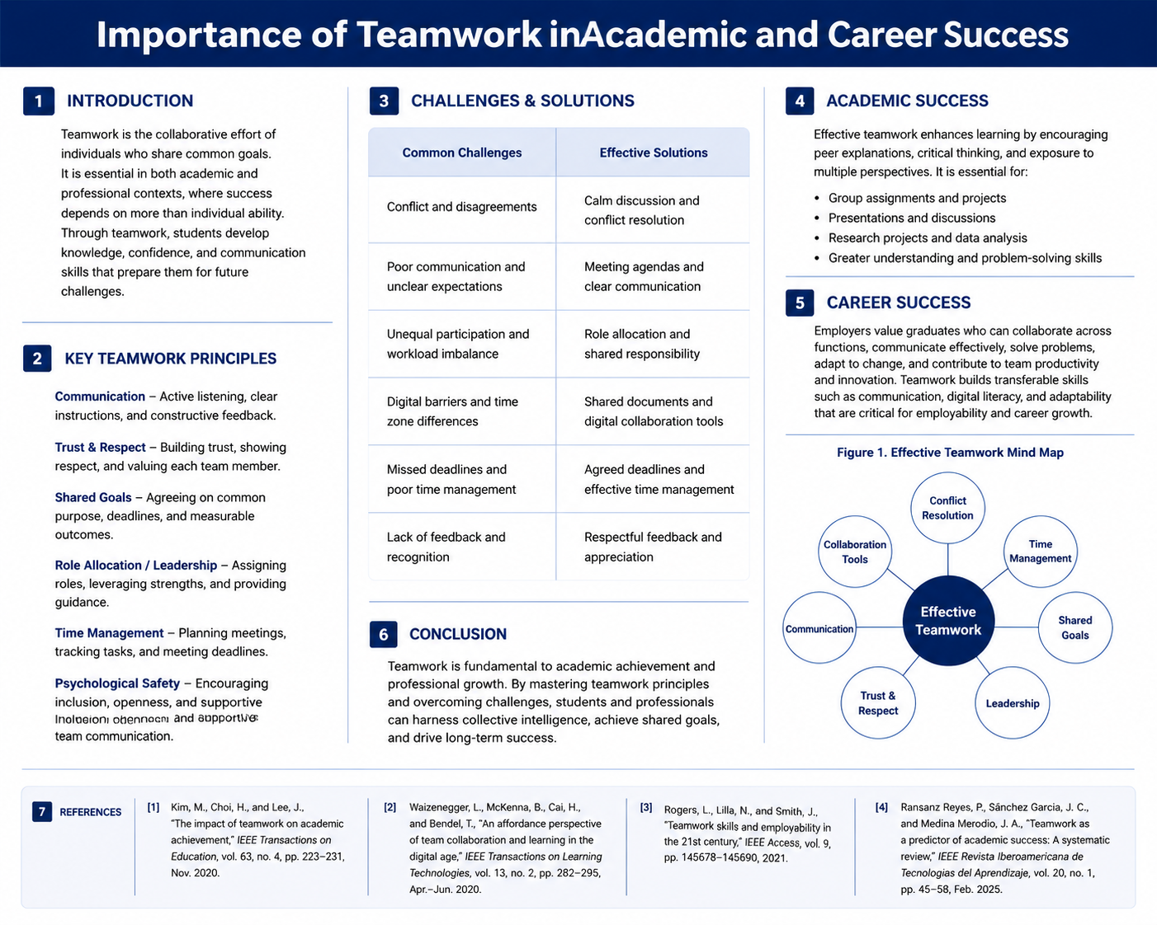
Poster Link: https://drive.google.com/file/d/1pknW0LZPCT-8xipEyoJywfHZipHQ-Hw1/view?usp=sharing

4. Task 3 - Automatic Referencing Tool Evidence
Task 3-page link: https://sites.google.com/view/level-4-e-portfolio/task-3-virtual-collaboration-and-refworks
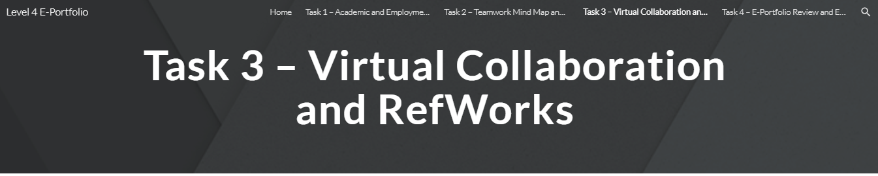
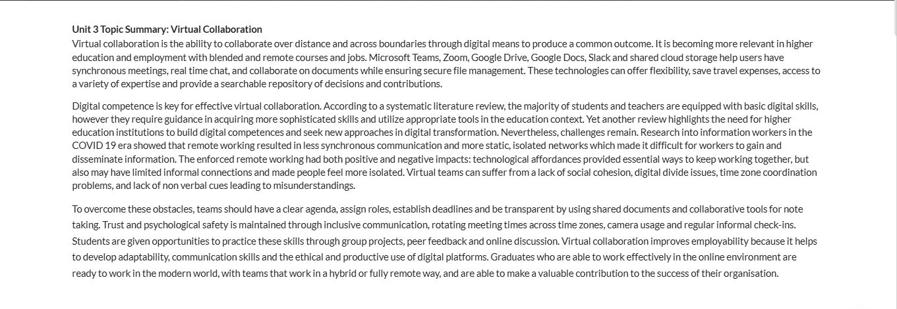
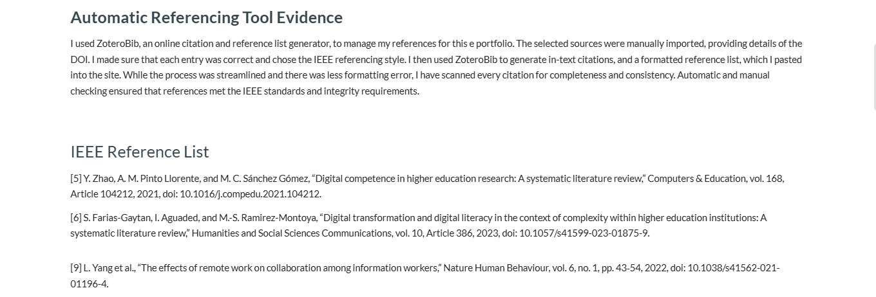
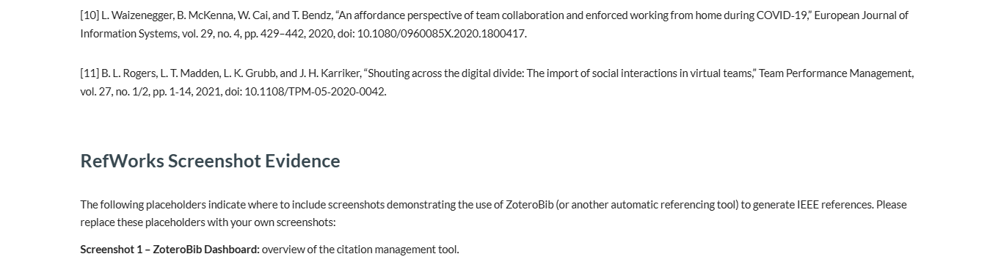
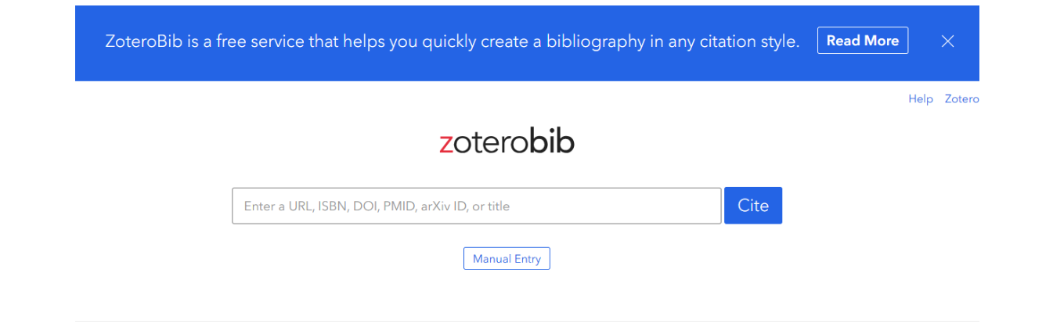
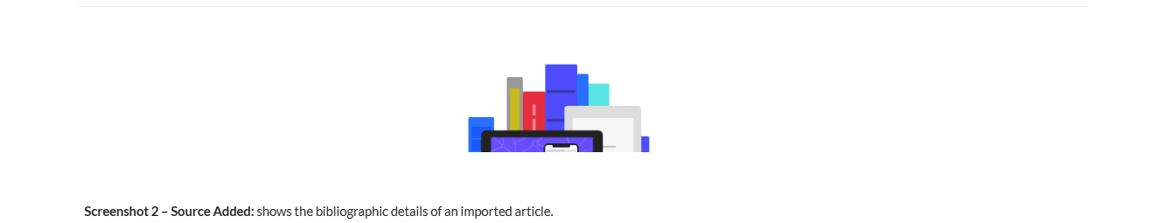
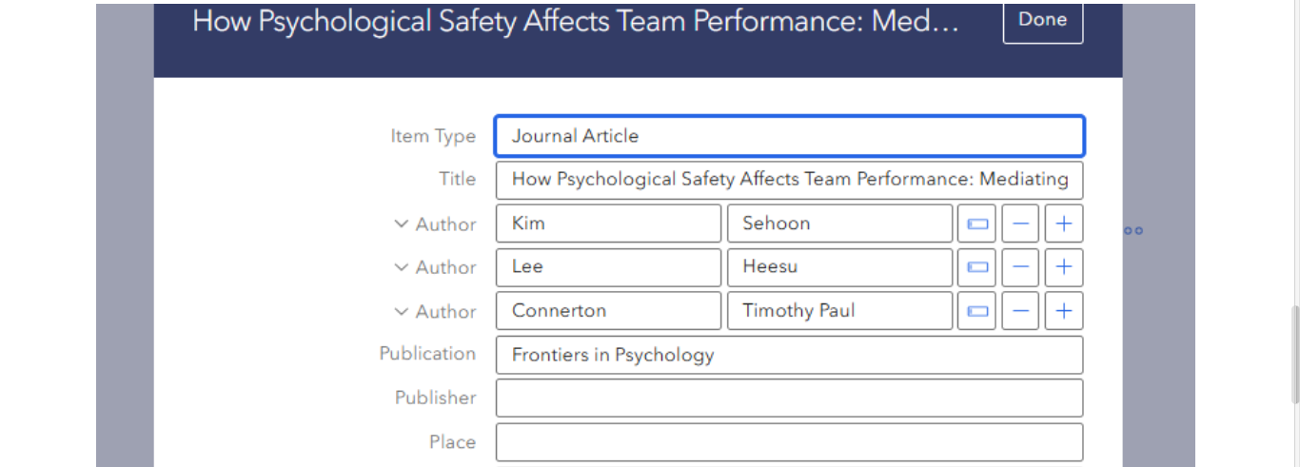
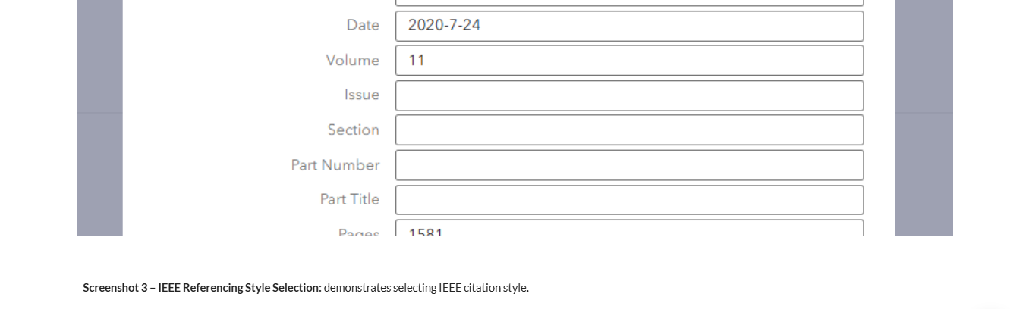
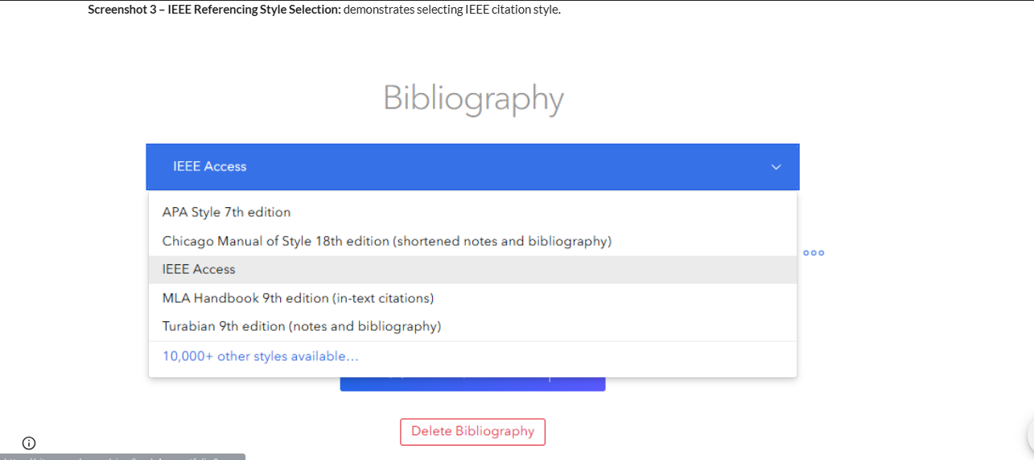
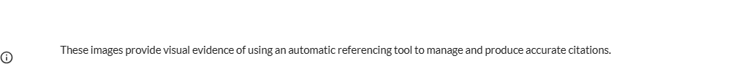

5. Task 4 - E-Portfolio Creation and Review Evidence
Task 4-page link: https://sites.google.com/view/level-4-e-portfolio/task-4-e-portfolio-review-and-evidence


