

LOCATION: Swansea | LLEOLIAD: abertawe
LEVEL 5 | LEFEL 5
EXAMINATION PERIOD | CYFNOD ARHOLIADAU
January 2024 | IONAWR 2024
MODULE CODE: ACDA5006
Transducers and Signal Conditioning
TIME: 2 HOURS
answer all questions

Equipment or materials required. Please select from the following:
Adnoddau neu ddefnyddiau sydd eu hangen.

Cyfrifiannell/Calculator

Llyfr Agored/Open Book

Arall/Other Nodwch/Please Note …Graph Paper….

ANSWER ALL QUESTIONS

- The calibration of a pressure sensor with a range of 0-8 bar is checked by applying known inputs to it in steps of 0.2 bar. The following measurements were obtained:

Known input pressure (bar) | 0 | 1 | 2 | 3 | 4 | 5 | 6 | 7 | 8
Output reading (V) | 0.00 | 0.55 | 1.25 | 1.70 | 2.35 | 3.30 | 3.65 | 4.05 | 4.85

- Draw a graph by plotting the data points on the graph paper provided and draw a best-fit straight line through the data points.
[2 Marks]

- Use the graph to calculate the measurement sensitivity of the pressure sensor.
[4 Marks]
$$Sensetivity=\frac{Δoutput}{Δinput}=\frac{4.85-0}{8-0}=0.60625 V/Bar$$
- Use the graph to calculate the maximum non-linearity apparent in the measurements as a percentage of the full-scale deflection.
[4 Marks]
Max Non-linearity occurs at a pressure of 5 Bar. From the graph, the output voltage should be 3V at 5 Bar, but a voltage of 3.3V is present on the output at that pressure.

$$Max NL=\frac{3.3-3}{4.85}×100\%=6.186 \%$$

- A digital voltmeter has a resistance of 100kΩ and is connected in parallel with the 1MΩ resistor in figure Q2.
  - What would the true voltage across the 1MΩ resistor be if the voltmeter was not connected?
[2 Marks]
$$V_{Out}=V_{in}\frac{R_{B}}{R_{A}+R_{B}}$$

$$V_{Out}=10×\frac{1M}{500k+1M}=6.\dot{6} V$$

  - Assuming the voltmeter is calibrated correctly, what is the reading shown by the voltmeter?
[3 Marks]
The voltmeter will appear as a 100kΩ resistor in parallel with the 1MΩ resistor reducing the overall resistance of the bottom resistor.

$$R_{equiv}=\frac{1M×100k}{1M+100k}=90.909 kΩ$$

$$V_{Meas}=10×\frac{90.909k}{500k+90.909k}=1.538 V$$

- State one method of making the voltmeter more accurate.
[5 Marks]
Any argument to support increasing the resistance of the voltmeter thus reducing the loading on the circuit, causing the reading on the voltmeter to be closer to the actual value of voltage.

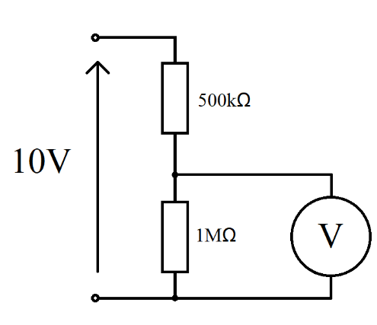
Figure Q2

- Describe the key specifications you would consider when selecting a flow sensor. Compare the flow sensor requirements for:
  - Measuring and controlling the amount of highly reactive chemicals added to a process in a petrochemical manufacturing plant.
  - Domestic gas smart meter allowing the customer to see how much gas is being used in their home.
[10 Marks]
Marks will be given for – sensor range (Physical flow rate range, electrical range), sensitivity, linearity, fluid compatibility – liquid / gas sensor, aggressive environments etc, response time, likely cost. This is not a comprehensive list and other answers are also acceptable.

- The circuit shown in Fig Q4 is used to measure strain. The circuit is supplied by a constant 2.5 V, the resistors have the following values R1 = 110 kΩ, R2 = 2000 Ω, R3 = 1200 Ω. Calculate the resistance of the strain gauge if the measured voltage is
-0.253V

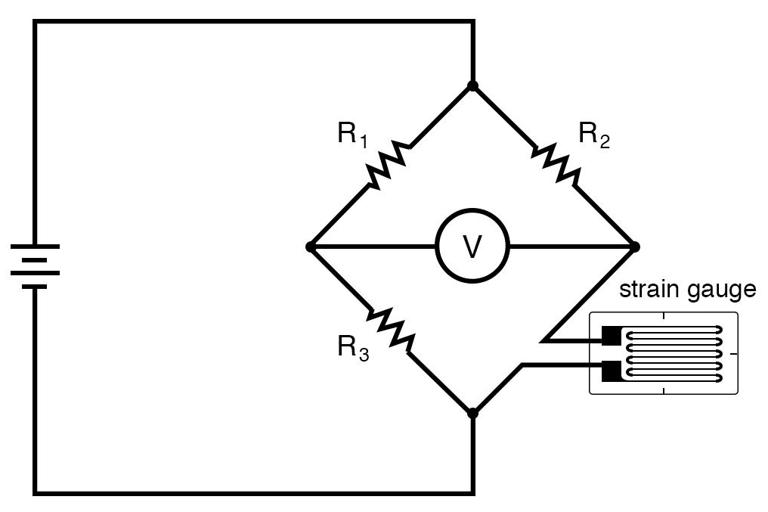
+
Fig Q4

[10 Marks]
As a Wheatstone bridge is effectively two potential dividers, we can use the potential divider equation to analyse this circuit.
$$V_{Out}=V_{in}\frac{R_{B}}{R_{A}+R_{B}}$$

Substituting in values for the left-hand side of the bridge we get:
$$V_{Left}=2.5×\frac{1200}{110000+1200}=0.026978417 V$$

If the voltage on the right-hand side of the bridge is 0.253V higher, this gives:

$$V_{Right}=V_{Left}+0.253=0.026978417+0.253=0.279978417 V$$

$$V_{Right}=V_{in}\frac{R_{Gauge}}{R_{2}+R_{Gauge}}$$
$$V_{Right}(R_{2}+R_{Gauge})=V_{in}×R_{Gauge}$$
$$V_{Right}×R_{2}+V_{Right}×R_{Gauge}=V_{in}×R_{Gauge}$$
$$V_{Right}×R_{Gauge}=V_{in}×R_{Gauge}-V_{Right}×R_{2}$$
$$V_{Right}×R_{Gauge}-V_{in}×R_{Gauge}=-V_{Right}×R_{2}$$
$$R_{Gauge}\left(V_{Right}-V_{in}\right)=-V_{Right}×R_{2}$$
$$R_{Gauge}=\frac{-V_{Right}×R_{2}}{V_{Right}-V_{in}}$$
Substituting Values
$$R_{Gauge}=\frac{-0.279978417×2000}{0.279978417-2.5}=252.2303 Ω$$

- Compare and contrast the use of an instrumentation amplifier against the use of a difference amplifier for removing noise from a balanced transducer connected with shielded twisted pair. Explain which is best and why. You should consider including circuit diagrams to help explain your answers.
[10 Marks]

Both are amplifiers with differential inputs which produce a voltage proportional to the difference between the input voltages. The instrumentation amplifier has a far higher input impedance than the difference amplifier due to the non-inverting amplifiers buffering the inputs, this increases the input impedance reducing the loading effect of the amplifier on the signal source. The gain of the instrumentation amplifier is set using one resistor, whereas the difference amplifier requires the gain to be set using the ratio of two resistors for each input. This could mean that the amplifier sees different impedances on each input leading to an offset in the output voltage. The balanced design of the instrumentation amplifier also improves the Common Mode Rejection Ratio and minimises the output offset voltage. This would make the instrumentation amplifier a better choice for removing common mode noise from a balanced transducer connected with shielded twisted pair cable.
Parameter | Instrumentation Amp | Difference Amplifier
CMRR | Very high | High
Output Impedance | Low | Low
Input Impedance | Very high | Medium
Output Offset Voltage | Very low | Depends on how balanced the design is.
Gain | Set by one resistor | Set by ratio of two resistors for each input.

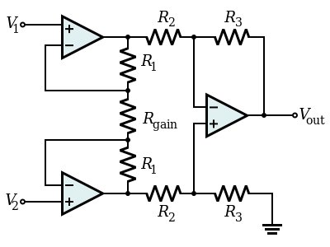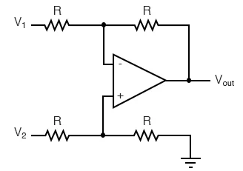
Instrumentation Amplifier Difference Amplifier

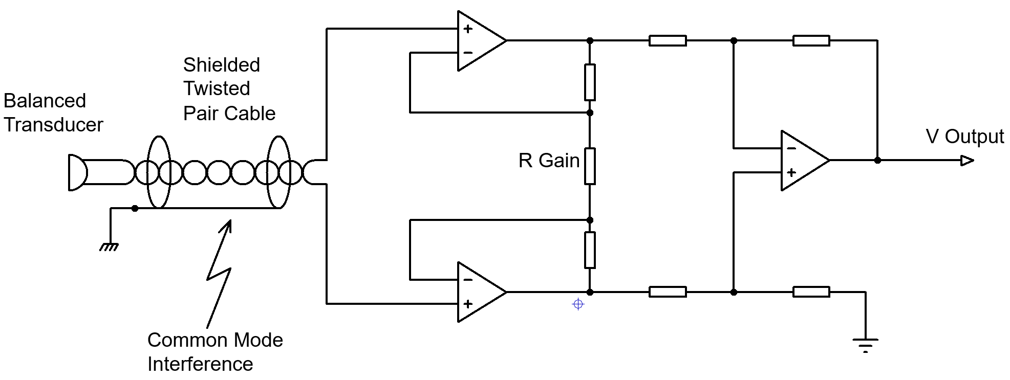
Connection of instrumentation amplifier to remove common mode noise from a balanced transducer connected with shielded twisted pair cable.

Diwedd/End

