BMIH4004

HOTEL PLACEMENT – HOTEL ADMINISTRATION & FRONT OFFICE OPERATIONS
Table of Contents
Component 1 3
Gibbs reflective model 3
Component 2 6
Trip Advisor review 6
Letter of complaint 6
Component 3: Portfolio – 4 elements 8
Key Skill 1 – Customer service skills 8
Key Skill 2 – Communication skills 8
Key Skill 3 – Organisational skills 9
Key Skill 4 - Problem-solving skills 10
Reference list 11

Component 1

Gibbs reflective model
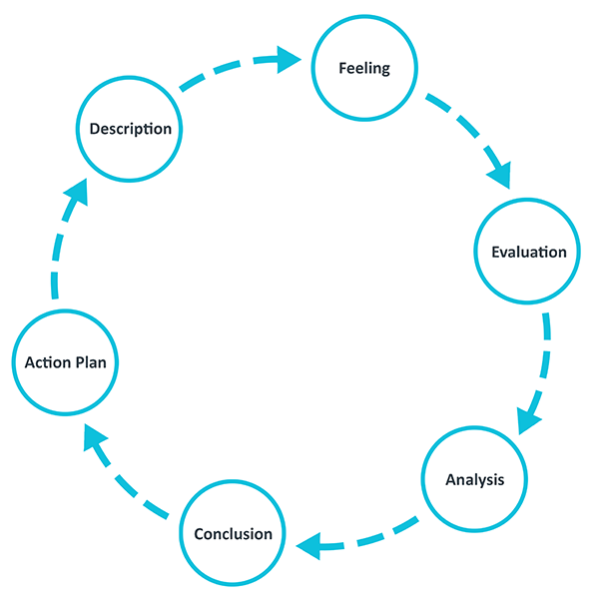
Figure 1: Gibs reflective model
(Source: The University of Edinburgh, 2020)
Description: During my tenure working in the hotel, I was assigned a variety of operations relating to hotel administration front desk and customer service tasks. I have noted that in front office operations, individuals assigned to this position represent the hotel in the first place. In that term, I have learnt that personal presentation skills, keeping a smiley face, using STUC (Show that U care) communication skills and others are required. In the front desk operations, I was tasked with checking the guest’s reservations, operating as a cashier, checking room availability and others. During those tasks, I noted that my key strengths lie in teamwork, critical thinking or thinking out-of-the-box, problem analysis and solving skills, and active listening skills amongst others.
Contrarily, as I was tasked with other departments such as kitchen, and room service operations, I learnt that my communication skills were not appropriate. Additionally, I lacked the knowledge to present myself in front of the guests and customers.
Feeling: I feel that the identified gaps and weaknesses (communication skills, lack of anger and stress management abilities) can restrict my self-development. My inability to verbally convey my perspectives to the guests, staff, managers and others had often led to misunderstanding situations. These kinds of situations and challenges can, in my opinion, be mitigated by professional growth and self-improvement initiatives that focus on weaknesses. Contrarily, in my outlook, if I am able to effectively work upon my weakness, my future self will help me to be professionally developed and help me to be proficient in tasks, thus helping me to climb the hierarchy of the hotel.
Evaluation: I evaluated that to hone my skills, I must address my improving areas. As I mentioned above, I was not able to manage my time, which often led to my not completing the assigned tasks for room service and kitchen areas. Employees working in hotels should know ways to present themselves (Ramos-Maçães and Román-Portas, 2022). Self-presentation entails communication with the guests, self-grooming, a warm and welcoming approach, and STUC amongst others (Yan et al., 2023). Working in the hotel, I evaluated and learnt that front desk employees who possess self-regulation, in my opinion, are better able to remain composed under pressure and present themselves to guests in a more appealing manner. I evaluated that these self-presentation abilities along eith communication skills are essential for front-desk executives to guide the guest with necessary information as well as serve them with optimal services. While conducting the tasks, I also evaluated that my strengths were significantly helpful for me to improve the hotel’s interaction with the guest as well as enhance the experience during their accommodation.
Analysis: Gonzalez et al. (2020), state that communication skills are the key to presenting an organisation (hotel) in front of the guests and conveying the ways the hotel can serve the guests with adequate amenities. Since, I learned that my verbal communication was not proficient, during the tasks; I used the SMCR (“sender-message-channel-receiver”) theory of communication. Using this theory, one can receive a message from the sender via different channels (McLeod and Howie, 2018). The channel can be an organisational hierarchy, face-to-face communication, visual communication and others. The receiver can understand the message as it has been passed via a more convenient channel.
Using SMCR communication theory, I noted that I was gradually able to express my feelings to others. Additionally, to improve my communication, I evaluated that participating in group discussions in any forum or talking with peers can help to express viewers.
Moreover, by developing a personal development plan, I was able to improve my behaviours at work and become more well-groomed, communicate with warm gestures, have a proper body posture, and maintain a smiley and welcoming approach while booking the rooms and others.
Conclusion: I conclude the above reflection by noting that during the given tasks in the hotel, I was able to identify my strengths and weaknesses. I noted that communication skills and self-presentation abilities were my weaknesses. To improve these, I used the SMCR theory of communication along with becoming more self-regulated by creating a PDP.
Action plan:
Objectives | Key skills needed | Action to develop the skills | Resources required | Time
To enhance my communication skills | Reasoning and active listening skills | I will listen to what my peers are conveying, and use my reasonable skills. | - Online communication tools | 7 months
To understand ways t self-present | Self-analysis and critical assessment skills. Grooming skills. | Learn how to present myself in front of the guests, grooming, being neat and clean. | - Grooming tools  - PDP  - Self-assessment tools | 7 months

Table 1: Action plan
(Source: Self-developed)

Component 2

Trip Advisor review
Thank you, James, we would like to express the company's gratitude for the kind words that you have posted about the experiences that you have had during your stay at the hotel. Additionally, we are happy to hear that you have had a pleasant experience with the hotel and enjoyed your stay and meal here. We strive to provide superior quality customer service and an enjoyable stay to our customers here. Receiving positive feedback from our customers has also had a positive impact on the employees of our company as it has been a motivating factor for them. These kinds of positive responses motivate the employees to give their best and positively engage with all the customers.
Thank you very much! We are grateful to have you as our client and hope to see you back again and provide you with better customer service. Have a nice day ahead!
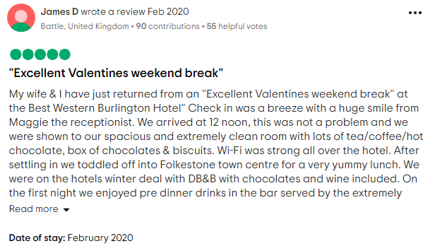
Figure 1: Tripe advisor review
(Source: Tripadvisor, 2024)

Letter of complaint
Madam, we are extremely regretful that you have had such a negative experience with staying at our hotel. We ensure that we will revisit all the issues faced by you or other customers which have led to them having an unsatisfactory experience of their stay at our hotel and we shall ensure that a majority, if not all, of the problems are solved in the most efficient manner within the shortest possible term. Firstly, we will make sure to consider the most constructive decisions regarding all the issues and apply strategies for mitigation of the observed risks and the solving the most commonly observed problems. Problem-solving skills can work in tandem with critical-thinking skills and aid in the decision-making processes (Khoiriyah and Husamah, 2019, p. 155). We will ensure that your feedback will be paid the utmost attention, we will focus on training the employees in terms of customer service to improve the service for the customers. We will also focus on switching the providers for the internet connection in our hotel to improve the provision of the WiFi connection. Moreover, utilising abilities for problem-solving skills might also help us in addressing the noise complaint issues by improving the governance of the hotel staff and guests.
We are feeling very sorry and apologising the same for the experience that you have faced during your visit. We will try to focus on the development of employability skills. Within the same, we will make sure that we develop effective skills of communication. With the development of communication skills, the problem that you faced covering the aspect of unresponsiveness that has been encountered by you at the time of the visit will be overcome. For the same, Lasswell's model of communication will be utilised. This is because Foran and Lee (2022, p.1) articulate that the stated model focuses on verbal communication more and states five elements within the theory namely who?, what?, which channel?, to whom? and which effect? If an individual develops this theory in themself, it will become easy for them to develop effective communication with every person building effective skills of communication. This will help us in developing the skills so that the issue does not arise the next time with any of the clients that visit our hotel. Apart from that, we are also sorry for the lack of effective management issues that have been faced by you during the visit. This will be linked to ownership skills covering planning and management skills. We agree to the facet that in the industry of hospitality, the notion of planning and management creates the utmost importance. With the development of planning and management skills, the employees will be able to plan the tasks being done by them as per the highest priority required. Through the development of planning and management skills, the aspect of improved decision-making can be witnessed (Mitsea et al., p. 4).

Component 3: Portfolio – 4 elements

Key Skill 1 – Customer service skills
When working within the hotel’s front office operations various skills would be beneficial as well as essential to have by the individual. It is known that the front office workers do engage with the customers and they are the first ones that the consumers engage with when they enter a hotel (Akgunduz et al., 2022, p.9). It is well known that the first contact is of utmost importance for developing a first impression regarding the hotel. Therefore, one of the key skills that the employee should have who is working at the front office is customer service skills. The great service is the holy grail of the business. Customer service skills refer to the abilities and expertise which support the business to ensure that the customers are satisfied (Lestari et al., 2020, p. 369). Moreover, it is also helpful in building long-term relationships with customers. Customer service skills include both the technical know-how and the soft skills. When dealing with diverse and sometimes difficult customers, the employees would need to have good problem-solving skills as well as interpersonal skills. In addition to it, patience and empathy are also the essential customer service skills which are required. Effective customer service skills help in understanding the needs and expectations of the customers (Tien et al., 202, p.47). This would help in providing a satisfactory and prompt solution for the issues that the customer might face. One such real-life example of customer service is what happened with Steven Weinsteit who is an employee at Zappos and in a call, he had spent 10 hours and 43 minutes with the customer (Nicasio, 2020). Therefore, by providing better customer service the employee was able to keep the customer engaged in the communications. Therefore, this shows that with better interpersonal skills businesses can keep their employees connected with the offering of the company and gain customer loyalty.

Key Skill 2 – Communication skills
Communication skills are also one more skill that is essential for a hotel front office operator as it has been identified earlier that the front desk employees are the ones who first interact with the individuals and customers who visit the hotel. Communication skills refer to the ability to convey or share feelings and ideas effectively with others (Dimbleby and Burton, 2020). Therefore, the front desk employee has the communication skills there can effectively communicate and interact with different people and convey the information politely and clearly. Within communication skills, two major abilities one needs to have are written and verbal skills. In addition, listening and non-verbal skills are also attributes that benefit the employees a lot as it allows them to understand the customer without communicating with them directly. According to Solomon and Theiss (2022), several studies have agreed that communication skills include the conveying of a message without any misinterpretation or misleading others. Hence, being a front desk employee it is expected by them to greet the visitors, answer the phone calls, reply to the messages and respond to the emails in a manner that is considered professional and courteous. With effective communication, the employee would be able to effectively understand what the person is conveying and respond adequately. One such real-life example can be seen in the customer reviews of Marriot customer which stated that the front desk employees greeted them with a smile and had great communication with me (Marriott, 2023).

Key Skill 3 – Organisational skills
Organisational skills play an essential role in improving the business operations through the promotion of efficiency, effectiveness as well as productivity of the company. The skills include the ability of managing time, people as well as resources in an effective way. In the case of Toyota Motor Corporation, effective organisational skills have been used for transforming business operations (Toyota Finance, 2023). The renowned production system of Toyota demonstrates the lean manufacturing as well as effective organisational practices. The firm organised its production processes through optimising inventory levels as well as fostering a culture of continuous improvement. As a result, the firm has been able to minimise its waste, reduce its costs along with the delivery of high-quality products in an efficient manner. Therefore, the majority of the automotive firms are taking the example and considering enhancing their organisational skills along with improved operations management.
Toyota practised certain aspects for maintaining its organisational skills. This includes the application of Just-in-Time manufacturing and Kaizen for continuous improvement in the firm’s operations (Toyota Finance, 2023). As a result of effective organisational skills, the firm’s operations can become more streamlined along with smoother workflows. With the application of organisational skills, a business firm can improve its operations along with sustaining its competitive advantage.

Key Skill 4 - Problem-solving skills
Solving problems is generally considered among the most critical skills for developing the employability of any individual or improving the performance levels of an organisation. Furthermore, it is important to note that problem-solving skills and critical-thinking skills often work in an interrelated manner to help in the identification of risks or challenges and framing solutions to different existing challenges. As per Rahman (2019, p. 72), different constraints in any observed scenario can count as problems, and rational solutions to such scenarios as well as the ability to develop a critical thought process to find accurate answers to the problems can define the skill of problem-solving. Generally, problem-solving is directed towards satisfying objectives. From the perspective of a frontline employees within the hospitality industry, the application of problem-solving skills would be effective as it helps to mitigate risks and challenging situations.

Reference list
Component 1
Gonzalez, R., Gasco, J. and Llopis, J., 2020. Information and communication technologies and human resources in hospitality and tourism. International Journal of Contemporary Hospitality Management, 32(11), pp.3545-3579.
McLeod, M. and Howie, S., 2018. Public Relations Videography: A Classroom Case Study in the Production and Dissemination of Digital Content. The Journal of Communication and Media Studies, 3(3), p.25.
Ramos-Maçães, M.A. and Román-Portas, M., 2022. The effects of organizational communication, leadership, and employee commitment in organizational change in the hospitality sector.
The University of Edinburgh (2020). Gibbs’ reflective cycle. [online] The University of Edinburgh. Available at: https://www.ed.ac.uk/reflection/reflectors-toolkit/reflecting-on-experience/gibbs-reflective-cycle.[Accessed on 8 February 2024]
Yan, Y., Lu, B. and Xu, T., 2023. Exploring the Relationship between Host Self-Description and Consumer Purchase Behavior Using a Self-Presentation Strategy. Systems, 11(8), p.430.
Component 2
Foran, K. and Lee, D., (2022). Developing effective communications (2022).
Khoiriyah, A.J. and Husamah, H. (2018) Problem-based learning: Creative thinking skills, problem-solving skills, and learning outcome of seventh grade students. JPBI (Jurnal Pendidikan Biologi Indonesia), 4(2), pp.151-160.
Mitsea, E., Drigas, A. and Mantas, P., (2021). Soft Skills & Metacognition as Inclusion Amplifiers in the 21st Century. International Journal of Online & Biomedical Engineering, 17(4).
Tripadvisor, (2024) Burlington Hotel Available at: https://www.tripadvisor.com/Hotel_Review-g190749-d209897-Reviews-Burlington_Hotel-Folkestone_Kent_England.html [Accessed on: 08 February 2024]
Component 3
Akgunduz, Y., Alkan, C. and Adan Gök, Ö., (2022). How are the exchange relationships of front office employees reflected on customers?. The Service Industries Journal, 42(9-10), pp.798-821.
Dimbleby, R. and Burton, G., (2020). More than words: An introduction to communication. Routledge.
Lestari, S.D., Leon, F.M., Widyastuti, S., Brabo, N.A. and Putra, A.H.P.K., (2020). Antecedents and consequences of innovation and business strategy on performance and competitive advantage of SMEs. The Journal of Asian Finance, Economics and Business, 7(6), pp.365-378.
Marriott, (2023) What It’s Like to Work at the Front Desk as Your First Hotel Job Available at: https://careers.marriott.com/blog/caroline-guest-experience/ [Accessed on: 07 February 2024]
Nicasio, (2020) 14 Real-Life Examples of Amazing Customer Service in Retail Available at: https://www.getdor.com/blog/2020/03/23/real-life-examples-of-amazing-customer-service/ [Accessed on: 07 February 2024]
Rahman, M.M. (2019) 21st century skill'problem solving': Defining the concept. Rahman, MM (2019). 21st Century Skill “Problem Solving”: Defining the Concept. Asian Journal of Interdisciplinary Research, 2(1), pp.64-74.
Solomon, D. and Theiss, J., (2022). Interpersonal communication: Putting theory into practice. Routledge.
Tien, N.H., Anh, N., Dung, H., On, P., Anh, V., Dat, N. and Tam, B., (2021). Factors impacting customer satisfaction at Vietcombank in Vietnam. Himal. J. Econ. Bus. Manag, 2, pp.44-51.
Toyota Finance, (2023). TWELFTH ANNUAL REPORT 2022‐23. Available from: https://www.toyotafinance.co.in/downloads/12th-annual-report-fy-2022-23.pdf [available on 7 February 2024]

