

Improvements to the bullion production process to improve quality, increase production levels and to improve safety by implementing a dual channel safety system for the conveyor.

by
Scott Thomas

Supervisor: Dr. Stalin Jacob Wilson Packia Dhas

Project submitted as part of the requirements for the award of
BEng (Hons) Electrical and Electronics Engineering

April 2024

Declaration

The work of this report is competed under the supervision of Mr. Stalin Jacob Wilson Packia Dhas and Dr. Steve Mosey. I Scott Thomas declare that this report is the product of my own work and is not being submitted for any other degree etc.
Signed: Scott Thomas

Acknowledgements
Firstly, I would like to thank my project supervisors Dr. Stalin Jacob Wilson Packia Dhas and Dr. Steve Mosey for their supervision and guidance through the project.
I would also like to thank my colleagues at The Royal Mint such as Engineering Manager, Neil Brooke Smith and Improvements Engineer, Gareth Thwaite for their support throughout this project.
I would also like to give credit and acknowledgement to Gareth Twaite for his help in creating the electrical diagrams and Required Performance Level Document submitted for this project.

Table of figures

Figure 1 – Silver bullion image
Figure 2 – Number of defects at different stages of the bullion coin pressing process
Figure 3 – Original defect locations during the transfer of coins from the press to the packaging equipment
Figure 4 – Uplift conveyor
Figure 5 – packaging equipment
Figure 6 - Risk assessment process.
Figure 7 - Performance Level Calculation chart
Figure 8 - Safety Relay Diagram
Figure 9 - Schneider Electric Safety Relay XPSCM1144
Figure 10 - Rockwell Automation Safety Relay MSR127
Figure 11 – Pilz Safety Relay (PNOZ X3)
Figure 12 – Research Onion
Figure 13 – Safety Function Block Diagram
Figure 14 – Lane shuffling device
Figure 15 – Lane shuffling device
Figure 16 - Lane shuffling device installed on conveyor.
Figure 17 – MADLER Motor Controller diagram
Figure 18 – Electrical Diagram – Lane Shuffling Device.
Figure 19 – MADLER Motor Controller Wire Connections
Figure 20 – Existing Panel Connections
Figure 21 – Connection To Safety Contactor
Figure 22 – PLC Ladder Diagram
Figure 23 – Power control system
Figure 24 – Level Control Actuation
Figure 25 – Safety circuit diagram
Figure 26 – Physical build of electrical panel
Figure 27 – Electrical connection to press.
Figure 28 – Bowl level sensor

Table of Tables
Table 1 – Comparison of Safety Relays Available
Table 2 – Project Costings

Appendices
Appendix A – Gannt Chart
Appendix B – Risk Assessment
Appendix C1 – Hardware datasheets – Allen-Bradley MSR127
Appendix C2 – MADLER Motor Controller
Appendix D - Quotation
Appendix E - MOC
Appendix F – Required Performance Level document
Appendix G - PID
Appendix H – Electrical drawing – lane shuffling device
Appendix H1 – Electrical drawing – MADLER motor controller drawing
Appendix I – Electrical drawing Safety control system

Abstract
The overall aim of this project is to upgrade the Bullion production process to reduce damage occurring to coins and to improve the conveyor system to ensure the coins do not wedge together forcing the production process to stop losing time and money in the production process.
Another important part of the project is to design and install a conveyor system to feed blank coins into the press as they were being loaded by hand by the operator which is not efficient or safe.
The importance of the project is to improve quality of the bullion coins to prevent customer complaints; improve the production process to ensure increased production levels to keep up with the demands of the customer; and to ensure the conveyor system is safe to use by designing a dual channel safety system complying with all relevant health and safety regulations.
An investigative approach is applied to this project to find where the damage to coins was occurring during the production process so that new systems can be implemented to ensure the product is of the highest possible quality.
The major findings of the project after completing the project was that the conveyor system operated as desired with safety being upgraded to include overloads and emergency stop features to ensure the safety of the operator and the capability to load the press with blank coins far more efficiently.
The new system to transport coins from the press to the packaging equipment removes all damage that was occurring to the coins which were leading to lost production time and customer complaints.
The newly designed system now operates to the specification and allows the bullion production line to operate much more efficiently without stoppages occurring due to manually loading the bullion press, stopping the production process due to damage occurring to coins and without stoppages occurring due to coins wedging together on the conveyor leading to the packing equipment.

Chapter 1 – Introduction
  - Project Background
During the economic uncertainty caused by the Coronavirus pandemic, many people started investing in precious metals and The Royal Mint saw an increase in demand for silver bullion as seen in figure 1. Demand for silver bullion increased during these times of uncertainty as investors consider silver bullion as a very safe investment. It was found that the silver bullion production line was struggling to keep up with this new demand.
Figure 1 – Silver bullion image


[1]

There were several issues with the bullion production line which included:
- Manually loading the bullion press, which was slow and unsafe to the operator.
- Coins wedging on the conveyor feeding the packing equipment due to lane congestion causing stoppages with the operator needing to stop the process and manually dislodge the blockages.
- Damage occurring to the bullion coins between the striking process and the packing equipment requiring sorting by quality assurance personnel, leading to stoppages and sorting which leads to lost production time.
Quality issues
The graph shown below in figure 2 shows the number of defects at different stages of the bullion coins production process:
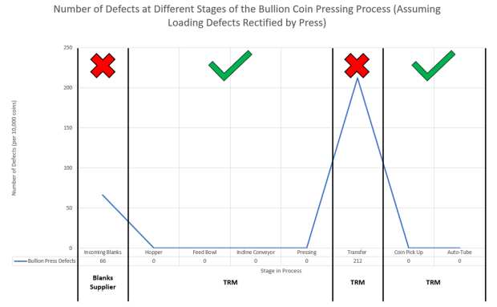
Figure 2 – Number of defects at different stages of the bullion coin pressing process

Through studying the bullion production process, it was found that the majority of the damage occurring to the bullion coins was caused by the transfer process between the press and the packaging equipment as can be seen in figure 1. The damage that can be seen from the blank supplier is inconsequential as during the pressing process, due to the force exerting during striking, or pressing of the coin, any scratches or dents are removed, or ‘struck out’. Therefore, the focus of this project was to determine how to remove the damage that was occurring to the coins during the transfer of coins from the press to the packaging equipment.
Below in figure 3, it can be seen where the damage to the coins are occurring or the ‘defect locations’.
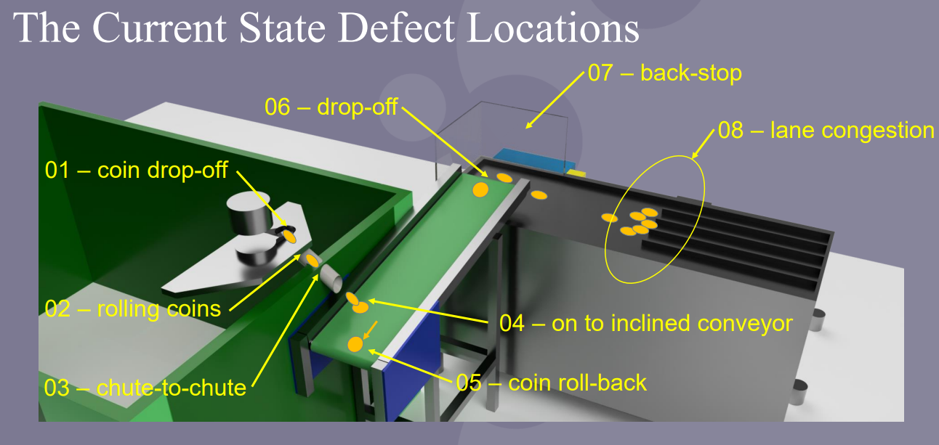
Figure 3 – Original defect locations during the transfer of coins from the press to the packaging equipment.

As can be seen in figure 2, damage is occurring in several locations which are:
- Coin drop off. Where coins drop out of the press into the tube causing possible dents and scratches.
- Rolling coins. Where coins are rolling down the tube causing scratches.
- Chute-to-chute. Where coins are catching to the transfer between the internal chute and the external chute.
- Dropping onto inclined conveyor. This was causing damage to occur to multiple coins as the coins were exiting the press and dropping onto other coins.
- Coins rolling back. Due to the incline of the conveyor, coins were rolling back and causing wear on the edges.
- Coin drop off. Coins dropping off the inclined conveyor onto other coins causing dents and scratches.
- Back stop. Coins hitting the back stop causing damage.
- Lane congestion. Due to lane congestion, the coins wear rubbing against each other causing wear and damage to the coins edges. This issue also had another outcome as lane congestion was causing the packaging equipment to be starved of production and therefore losing production time. The operator therefore had to stop the press and removed the wedged coins before they could start the process back up.
Safety issues
To load the blank silver coins into the press, the operator would need to pick these bags of blank silver coins and manually load them into the press. The health and safety department deemed this an unnecessary risk to the operator. The solution to this problem was to instal a conveyor to load these blank silver coins into the press automatically therefore removing the risk of repetitive strain injuries and muscle strains from the operator. The conveyor seen in figure 4 was purchased.

Figure 4 – Uplift conveyor
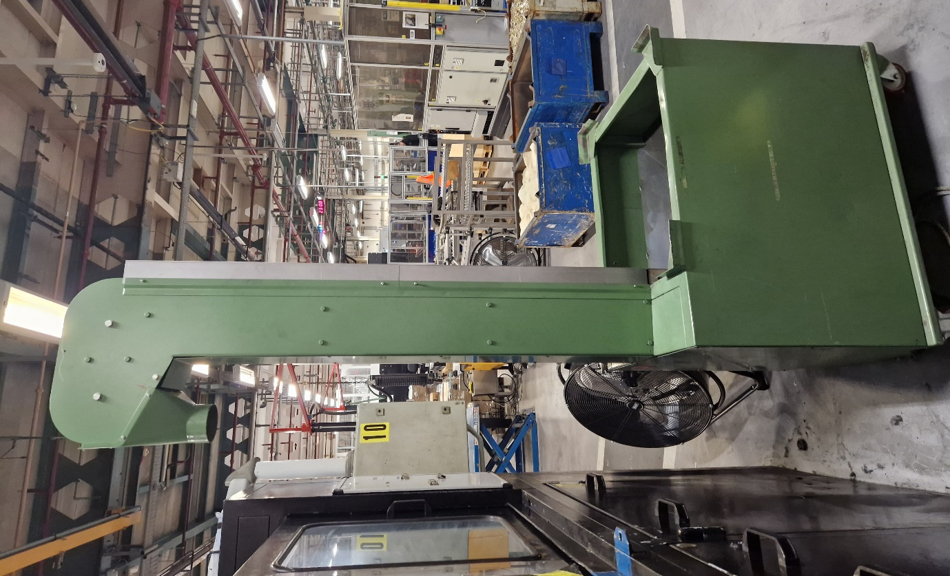
The conveyor as seen in figure 4 was purchased as a bare model with just a belt installed with no electrical components. For our requirements, there needed to be a motor installed, an electrical control panel and a safety system implementing dual channel safety inputs including an emergency stop switch to ensure that it met all safety requirements for use in a factory environment to ensure that the operators of the machine would be safe at all times. The conveyor would also need to work automatically to feed blank silver coins into the press when required.
  - Previous work related to the problem.
Previously, the management team purchased a packing robot to pack silver bullion coins into containers. This was done as the bottle neck of the process was using packing personnel to pack all silver bullion coins by hand. This system works very efficiently, and it has been found by studying the production process that the bottle neck of the production process is now the transfer of silver bullion coin from the press to the packaging equipment which is why this project has been implemented.
Figure 5 shows the packaging equipment. The packaging equipment picks up five coins at a time to pack into boxes of one hundred and twenty-five. When the coins reach a sensor at the end of the conveyor, the robotic head comes down to pick the coins up with pneumatic suckers and places the coins into the box. The lanes in which the congestion occurs, which have been previously discussed, are shown hear and one of the aims of this project is to remove the need for these lane dividers to reduce congestion and damage occurring to the silver bullion coins, therefore, improving quality and increasing production levels.

Figure 5 – packaging equipment
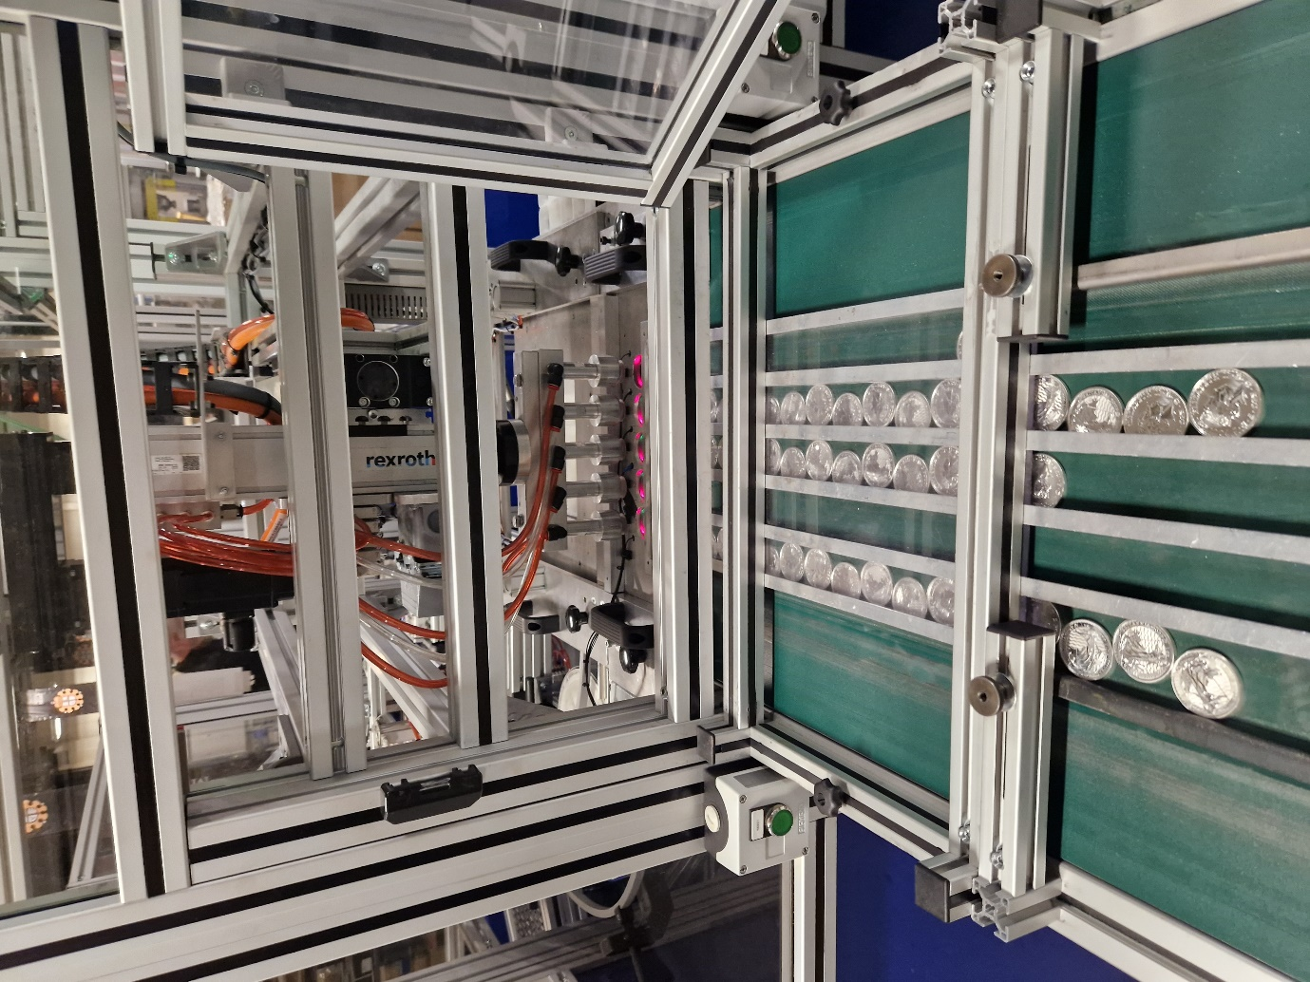

  - Aims and Objectives
The main aim of the project

‘Improvements to the bullion production process to improve quality, increase production levels and to improve safety by implementing a dual channel safety system for the conveyor’.
A Gannt chart has been produced to indicate each task that has been completed (See Appendix A)

Project objectives

- Install a sorting device on the conveyor leading to the packaging equipment to ensure that the coins do not wedge together, causing damage occurring to the silver bullion coins and causing lost production time by starving the packaging equipment of product and requiring the operator to manually remove the blockage.
- Remove all points of damage occurring between the silver bullion press and the packaging equipment as seen in figure 3.
- Install the electrical system on the conveyor that feeds blank silver bullion coins into the press, implementing a dual channel safety system to ensure that the conveyor is safe to use and complies with all relevant health and safety regulations such as, PUWER 1998 Regulations (Provision and Use of Work Equipment Regulations) and Electricity at Work Regulations 1998.

Chapter 2 – Background Research
Through this research activity, research has been carried out to:
- Obtain information on the effect that quality of product has on the customer experience.
- Research relevant regulations and legislation relating to conveyor systems.
- Research Electrical safety system control for the conveyor system.
- Research into different electrical motors for use on the conveyor system.

2.1 The effect of quality on customer experience
A major part of this project is to improve the quality of the silver bullion coins so that The Royal Mint has less customer complaints, less time spent re-producing orders. Product quality is one of the key factors in driving business performance and achieving competitive advantage. Customer perceptions of our product quality is of upmost importance. The product quality will influence their future purchases, their willingness to pay for the product we are offering and if they would recommend the product to other potential customers. [2] In simple terms, higher quality products leads to higher customer satisfaction which is what we must strive towards.
In a study by Professor Paulson and Dr Das Guru, which began with exploratory research into the factors that influence customers’ quality experience for durable products, online surveys with customers were carried out. These surveys identified the importance of eight aspects of quality which were important to customers. These were:
- Aesthetics
- Durability
- Ease of use
- Features
- Performance
- Reliability
- Serviceability
- Material [3]
The two main aspects of quality that effects customer satisfaction when it comes to the silver bullion coins is the aesthetics of the coin and the material of the product.
The material of the product we use is verified by the laboratories in The Royal Mint and confirmed by the King’s Assay Master. ‘The King’s Assay master is appointed to serve the reigning monarch and to ensure the integrity of the British coinage and has existed for hundreds of years. The Assay master role tests the quality of the coins and precious metals, underpinned by the traditional craftsmanship and innovation at The Royal Mint.’ [4] This process ensures that the materials used to produce silver bullion coins is pure silver and the testing procedure gives confidence that the silver is of the highest quality to the customers.
The other aspect that is important to our customers is aesthetics. As the silver bullion coin is a premium product, the customers expects high quality product, free from scratches and dents. This is where The Royal Mint has fallen short when producing silver bullion coins and why this project is very relevant to the customers and to the business to ensure customers are happy. If the customers are happy then they are more likely to order more products in the future and are also more likely to recommend us to other potential customers.

2.2 Relevant regulations and legislation relating to conveyor systems.
The conveyor used during this project is covered in several regulations. The main piece of legislation that must be implemented to ensure that the conveyor is safe to operate is: ‘Continuous handling equipment and systems – Safety requirements for mechanical handling of bulk materials, BS EN 618’ [5]
The conveyor used in this project can be defined as a conveyor as it uses a moving belt with a continuous rubber surface for conveying medium. The conveyor system has many hazards associated with them. These include:
- Entanglement – a workers hands or fingers becoming caught in nip points on conveyors which could occur during cleaning or maintenance.
- Abrasion – moving belts can cause abrasions to workers whose body parts could come into contact with the belt.
- Crushing – belt tensioning devices create a crushing hazard under tensioning mechanisms.
- Severing - conveyors can have sheer points on them with can create severing hazards. [6]
Controls that must be in place:
- Install guards for all chains, rollers, sprockets, belts, and other moving parts. Guarding ensures that any moving parts are moved away from the employees to prevent accidental contact with the hazard point.
- Ensure that conveyor controls/power sources can be isolated and locked off to ensure maintenance activities can be carried out safely.
- Install interlocking devices or overload devices to shut them sown when an electrical or mechanical overload occurs. This is so that if the conveyor is jammed, the power will cut out. This is important because if on employee frees the conveyor then the conveyor will not start automatically until someone resets the overload device.
- Install emergency stop buttons which are marks and unobstructed so that the operator can safely shut the conveyor down if an emergency occurs. [7]
When designing and installing the conveyor used in this project it is of upmost importance that all the controls listed above are implemented to ensure that the conveyor is as safe as possible for the operators to use.

2.3 Electrical safety system control for the conveyor system
Before designing an electrical safety system, a risk assessment must be carried out to find all the potential dangers linked with the normal operation of the equipment in question. The regulation that is relevant to this system design is ‘ISO 12100 Safety of machinery – General Principles for Design – Risk assessment and risk reduction.
This ISO standard is designed to aid with carrying out risk assessments and therefore find any risks that could be associated with the machine/equipment in question. Figure 6 shows the risk assessment process to eliminate any hazards.
Figure 6 - Risk assessment process
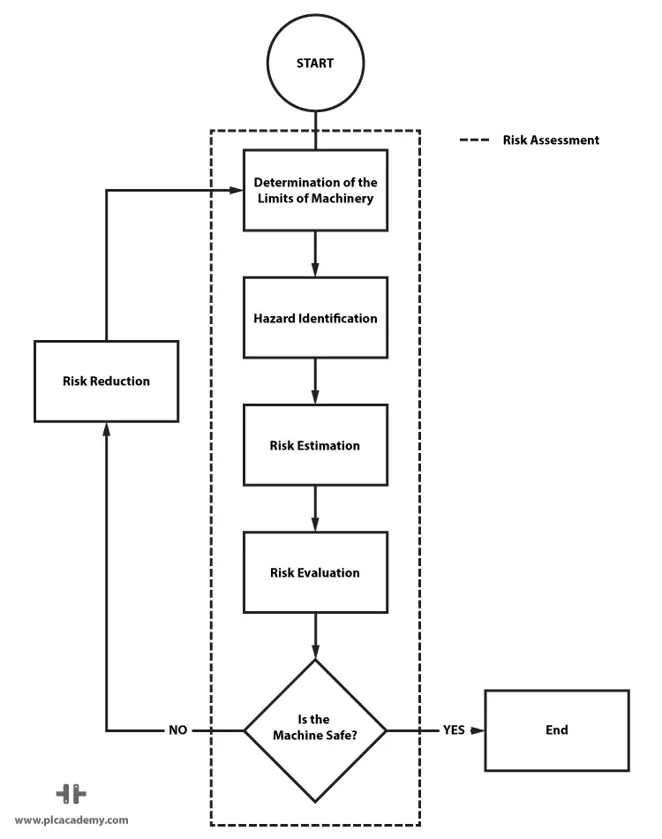[8]
A risk assessment for the design of the conveyor system has been completed prior to starting the task, please see appendix B.
The main risk associated with the operation of the conveyor is trapping injuries. According to Provision and Use of Work Equipment Regulations 1998 (PUWER), emergency stop devices must be installed on the conveyor in question. To integrate an emergency stop safety component into the control system of the conveyor, a safety relay must be installed to the control system for the conveyor.
2.3.1 Performance level requirements of the electrical safety system.
After a risk assessment has been completed, the Required Performance Level (PLr) of the machine can now be calculated. Required Performance Levels are covered under the regulation ISO 13849-1 and must be complied with during the design of safety control systems involving moving parts/ machinery.
The performance level is a level used to specify the ability of safety related parts of the safety control system to perform safety functions under regular conditions. The required performance level (PLr) is the mandatory performance level of a machine to reduce risk. The Performance Level must be greater than or equal to the Required Performance Level. The Performance Level ranges from Pla to Ple with a being the lowest and e being the highest. [18]
Required Performance Level (PLr) calculation.
Figure 7 shows the table used to calculate the Required Performance Level.
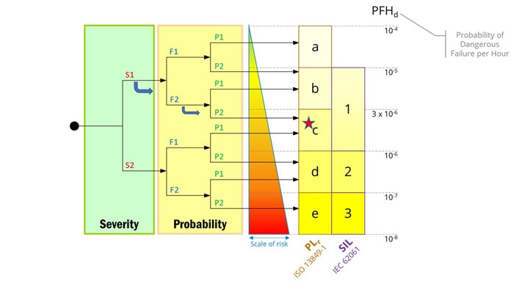
Figure 7 - Performance Level Calculation chart

[19]

The table is split into three sections:
- Severity of injury
  - S1 – Slight, normally reversible injury.
  - S2 – Serious, normally irreversible injury.
- Frequency and/or exposure to hazard
  - F1 – Seldom/less often and/or exposure time is short.
  - F2 – Frequent/continuous and/or exposure time is long.
- Possibility of avoiding hazard or limiting harm
  - P1 – possible under specific conditions.
  - P2 – Scarcely possible.
In conclusion, performance levels help identify what type of protective measure should be put in place to make the machinery as safe to operate as possible. Before selecting components for the safety control system, it is vital to carry out a risk assessment to identify the Required Performance Level and therefore ensure that the components of the safety control system provide adequate protection to the operator of the machinery.
2.4 Safety relay research
Safety relays are essential electrical components that are used in conjunction with other electrical components, such as, emergency stop switches and guard switches to reduce the risks associated with machinery and equipment that are hazardous to the user.
The safety relay is considered a fail-safe device that will remain effective even in the event of a failure of the component. The safety relay monitors components and provide feedback on whether the machine in in a safe condition to operate. Safety relays should be found on any machine that uses electrical motors and there for perform some sort of mechanical movement. The safety relay operation is covered under ISO 1349 – Safety of machinery – Related parts of control systems. [14]
The safety relay several key benefits. The main benefit of using a safety relay is their ability to detects fault before putting the operator in danger. The safety relay can detect wire breaks, faulty safety actuators, timing, and faulty contactors.
A safety relay detects faulty contactors, faulty actuators and wire breaks by measuring flow of current by transmitting electrical pulses through the wiring. The safety relay can then check for welded contacts on the contactors and wire breaks. [15]
The diagram shown in figure 7 illustrated how a safety relay is connected. If the safety switch is operated, then contactor K1 will disengage, therefore cutting power to the load, in most cases, the motor. The safety relay will not reset until the safety switch is in a healthy condition and the reset button is pressed, ensuring that the machine is once again in a safe condition to operate. If the safety relay detects a fault on the circuit, such as, a wire break or a welded contact, then again then the contactor will disengage and the power to the load will be cut to ensure that the machinery is not operated in an unsafe condition.
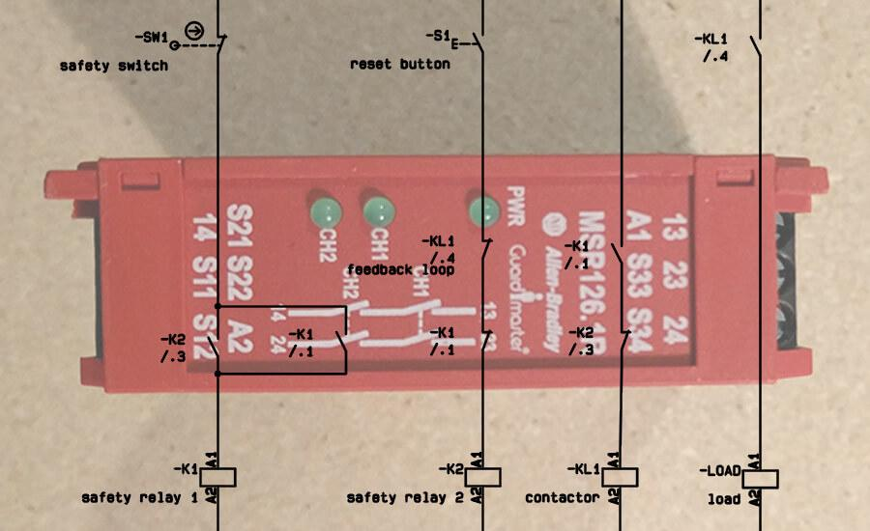
Figure 8 – Safety Relay Diagram

[16]

In conclusion, the safety relay is a vital component in the operation of machinery and must be included in the design of the conveyor to ensure the safe operation of the machinery to reduce the associated risk of mechanical movement.
2.4.1 Research on different safety relays
There are a variety of safety relays available on the market, supplied by different manufacturers with a variety of different applications. Safety relays must be compared to find the appropriate model for the application required for the conveyor system and if their Performance Level meets the required standard after risk assessment is carried out.
2.4.1.1 Schneider Electric Safety Relay XPSCM1144
The Schneider Electric safety relay, shown in figure 9, includes 2 safety contacts and operates on a 24V dc supply. The relay includes redundancy principal microprocessor technology providing the user with advanced functionality.
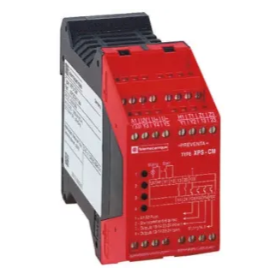
Figure 9 - Schneider Electric Safety Relay XPSCM1144

[20]
The Schneider Electric safety relay, shown in figure 9, has LEDs on the front of the unit to display internal fuse status, safety output status and function restarting. The unit is designed to a Performance Level ISO 13849-1-C and is primarily design to function with light beams/light curtains and costs £335.52 per unit.
2.4.1.2 Rockwell Automation Safety Relay MSR127
The Rockwell Automation (Allen-Bradley) Safety Relay, shown in figure 10, provides dependable fault detection that will minimise downtime and keep operations running smoothly. The MSR127 safety relay is ideal for relatively small applications with single zone control.
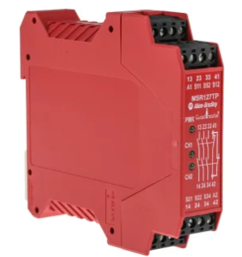
Figure 10 - Rockwell Automation Safety Relay MSR127

[21]
The MSR127 safety relay features an automatic/manual reset function which can be changed to an unmonitored manual reset with the addition of a normally open switch in the monitoring loop. This safety relay has manual reset which can be used to check the output monitoring circuit for faults. This safety relay can be used for a variety of safety applications including emergency stop circuits, light curtains or safety gate applications.
The unit is designed to a Performance Level ISO 13849-1-C and operates on a supply of 24V ac/dc and costs £241.70 per unit.
2.4.1.3 Pilz Safety Relay (PNOZ X3)
The PNOZ X3 range, as shown in figure 11, of safety relays introduces the circuit to safety related interruption where the primary applications are typically in potential hazards workplaces where quick power removal is required.
Figure 11 – Pilz Safety Relay (PNOZ X3)
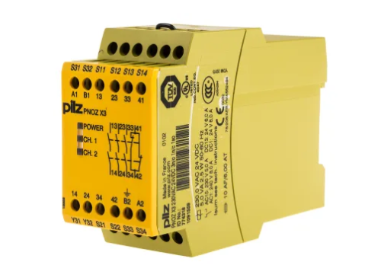

The Pilz PNOZ X3 features a dual channel safety system, and features LED indicators to show the statuses of the two channels and for monitoring the supply voltage to the relay; three safety contacts and one auxiliary contact and monitored manual reset. This Safety unit is used to integrate emergency stop switches to a safety control circuit.
The unit is designed to a Performance Level ISO 13849-1-C and operates on a supply of 230V ac and costs £255.52 per unit.
2.4.1.4 Comparison of Safety Relays Available
A table has been constructed to compare the key attributes of the safety relays research in section 2.4.1.3. The results of this research can be seen below in table 1.
Table 1 – Comparison of Safety Relays Available
 | Schneider Electric Safety Relay XPSCM1144 | Rockwell Automation Safety Relay MSR127 | Pilz Safety Relay (PNOZ X3)
Supply Voltage | 24 dc | 24V ac/dc | 230V ac
Performance Level | C | E | E
Intended Function | Light beams & light curtains | Emergency stop, light curtains & safety gates | Emergency stop switches
Cost | £335.52 | £241.70 | £255.52

Conclusion
In conclusion to the research carried out on safety relays, the safety relay that will be used in this project is the Rockwell Automation Safety Relay MSR127 (See appendix C for data sheet). The Rockwell Automation Safety Relay operates on a supply voltage of 24V ac/dc which is ideal for the application and safer that operating on a 230V ac supply, which is what the Pilz safety relay is supplied with. The Performance Level is E which provides a better level of protection than the Schneider Electric safety relay which provides a Performance Level of C. The Rockwell Automation Safety Relay provides the best level of functionality, it can be used for emergency stop switches, light curtains and safety gates, so if in the future the conveyor needs to be added onto it will be possible. The Rockwell Automation safety relay is also the cheapest of the three options.

2.5 Research into different electrical motors for use on the conveyor system
Electrical motors are machines that convert electrical energy into mechanical energy. They are used to move objects, lift loads and for many other examples of exerting mechanical work by generating torque. There are several types of electrical motors each with its own unique characteristics and applications. This section of research will consist of the different types of electrical motor with the aim of coming to a conclusion on the best motor for use on the conveyor system. [9]
The three main types of electrical motors are:
- AC motors
- DC motors
- Speciality motors
As the workplace where the project is taking place has alternating current supply, the motor that will be used to power the conveyor will be a type of AC motor.
AC Motors
An AC motor is defined as an electrical machine that converts alternating current (AC) into mechanical rotation. The fundamental principle of the operation of an AC motor is electromagnetism. A magnetic field is generated when current flows through a piece of wire which is how an AC motor gets its rotation. The magnetic field interacts with the current in the motor windings to produce a force which results in rotational motion. [10]
Types of AC motors
There are two main types of electrical AC motors which are induction motors and synchronous motors:
- Induction motor: These types of motors are the most commonly used AC motors. They work on the principle of electromagnetic induction. When a rotating magnetic field in the stator induces current in the rotor, torque is generated. They are used in many applications including pumps, fans and conveyor belts. These motors are popular as they are easy to install, low maintenance, relatively cheap and easy to control. The speed of these motors can be set if the engineer knows the frequency and voltage of the supply and the resistance of the motor. [11]
- Synchronous motor: In the synchronous motor, the rotor will rotate at the same speed as the rotating field in the stator. They require an external rotating field I the stator, such as DC excitation source or a constant speed drive. The synchronous motor is used in applications where precise control is required often used in precision machinery. [12]
Key differences between an induction motor and a synchronous motor
Electrical supply required:
A synchronous motor requires an AC source to be connected to its armature winding and a DC source to be connected to its field winding. An induction motor requires just am AC source to energise its stator winding.
Starting mechanism:
The synchronous motor is not self-starting, it requires external means for starting whereas the induction motor has self-starting torque.
Cost:
Due to the synchronous motor having a more complicated design, the induction motor is cheaper to purchase. [13]
Conclusion:
Due to these factors, an induction motor will be used in the design of the conveyor. The induction motor will be cheaper, will only require an AC supply and the induction motor is self-starting whereas the synchronous motor is not.
Chapter 3 - Methodology
3.1 – Research Onion
To ensure research is done thoroughly during this project, the ‘research onion’ model of Saunders et al. 2007 will be followed.
Research methodology is a fundamental aspect of research. It can be described as a general research strategy which sets out the way research should be conducted and is an essential part of research task.
The Research onion, as illustrated in figure 12, can be described as a systematic approach to designing research methodology of a research dissertation or thesis. The research onion model is comprised of six layers with each layer being assigned to a detailed research process. The onion metaphor is designed so that the user ‘peels’ back each layer of the onion during the research task, starting with the outer layer and working in towards the centre as the research task progresses. [22]
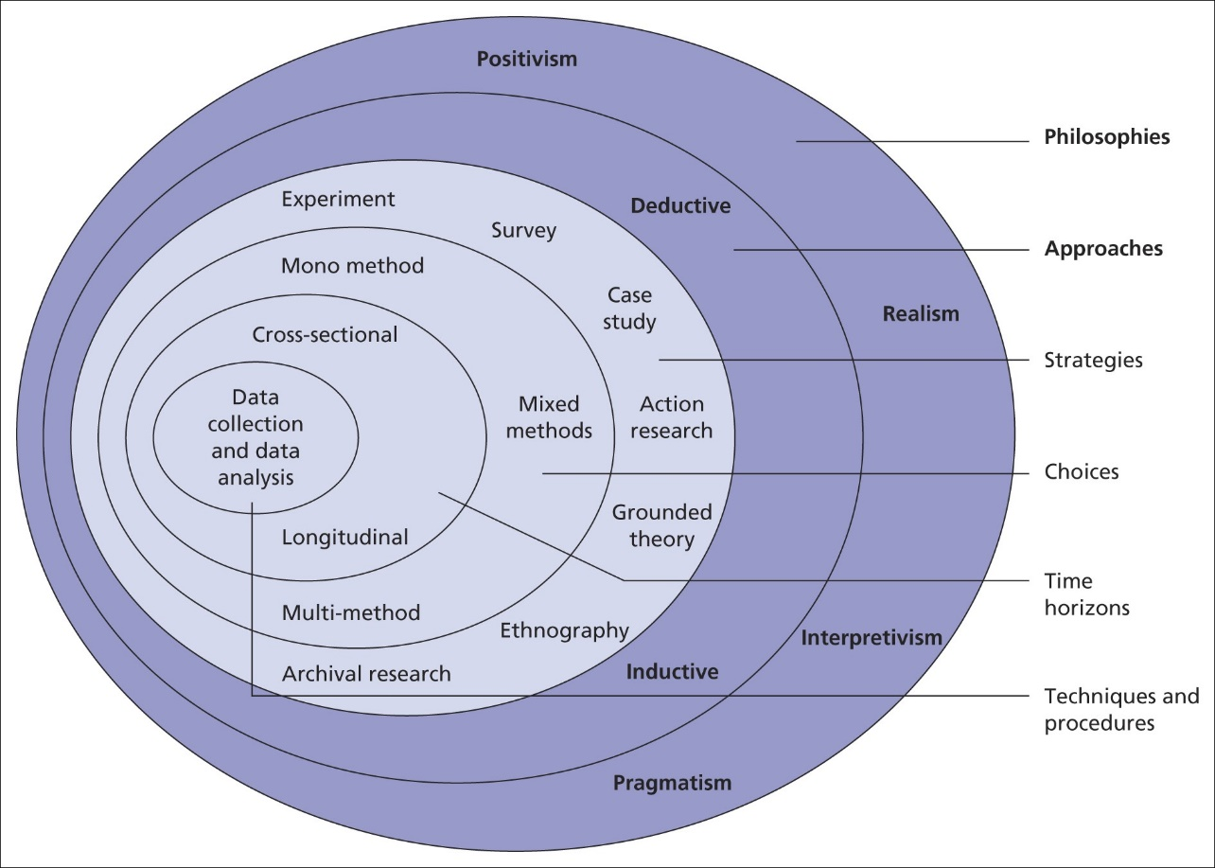
Figure 12 – Research Onion

[23]

3.1.1 Positivism
As the research onion is designed so that the user starts with the outer layer and works their way towards the centre, the first method that will be followed is positivism. Positivism is a philosophical system that is deeply rooted in science and mathematics. Positivist research means that whatever is being studied can only be done so objectively so it cannot include personal viewpoints or opinions. In the positivist method, knowledge can only be based on observation, measurement, or experience. This means that knowledge is not reliant on opinion but is based on research which is what is expected of an engineering research task. [24]
Advantages of positivism
- Positivism relies on quantitative data. Quantitative research is scientific in its methods and therefore can be seen to be trustworthy. Quantitative data provides objective information that a researcher can use to make more scientific assumptions that with other methods such as qualitative research.
- Structure. Positivism utilises a well-defined structure during research studies. As there are a set of rules to follow, room for error is minimised. The structure set out with positivism means that there is less room for variance in a research study. The research study can therefore be more accurate when used for applications and experiments as there are rules to follow using scientific tools. [26]
Disadvantages of positivism
- Inflexibility. Some believe that as positivist believe that everything can be measured and calculated they can be inflexible. This means that positivists see things as they are and can therefore disregard unexplained phenomena. This method can therefore eliminate lateral thinking which can be used to creatively find solutions to problems.
- Human Behaviour. Positivism encourages the researcher to follow a scientific approach to research studies, but there is no guarantee that this will occur during each stage of a research activity. [26]

3.1.2 Deductive approach
In the second layer of the research onion, a deductive approach will be applied. The reason that a deductive approach will be applied is that as the project is based on a positivism philosophy, where the outcome will be based on facts, the confirmation of the project resulting in a functioning process can be confirmed when the project is completed. [25]
Advantages of deductive approach
- Certainty. The deductive approach allows the researcher to come to certain conclusions based on a logical approach based on aspects that are known to be true.
- Logical. Deductive research approach is clear and easy to follow. This makes the reasoning behind a conclusion easy to understand and process. This method also makes it easier for mistakes to be identified in the research process.
- Efficiency. The deductive research approach can be used to arrive at a conclusion efficiently making it a useful tool when needing to solve a problem.
- Testability. The deductive research approach can be tested by checking the logical steps used to reach a certain conclusion. This is useful to readers of the research so that then can be tested and verified. [27]
Disadvantages of deductive approach
- Lack of creativity – The deductive research approach can be seen to be inflexible as this method follows a set of procedures and rules. This may reduce creativity.
- Limited to logical subjects – The deductive research approach is most effective in subjects that are based on logical reasoning and therefore will not be effective on subjects that rely more on intuition.
- Not useful for discovering new information. The deductive reasoning approach is reliant on existing knowledge to reach a conclusion. This method is therefore not useful for discovering new information. [27]

3.1.3 Action research
In the third layer of the research onion, action research will be the chosen strategy. Action research is most appropriately done in a practical setting such as a workplace, or in this case, a factory production area as opposed to a controlled environment such as a laboratory. Action research provides researchers with information about problems related to interactions with the physical real-world environment. As the project takes place in the workplace, this is the most appropriate selection for this layer.
Advantages of action research
- The action research technique is very adaptable. This allows the researcher to adapt the analysis to implement practical change.
- The action research method can allow the researcher to carryout meaningful changes when utilised correctly.
- The action research method allows the researcher to set out an actionable and immediate path forward to solving problems. [28]
Disadvantages of action research
- As action research is a flexibly model of research, the research can be very difficult to replicate.
- The action research technique can cause ethical problems as the participants of research may feel pressured to participate in a certain way. [28]

3.1.4 Multi method approach
In the fourth layer of the research onion, multi method approach will be taken. As this project will include multiple input from a number of people in the workplace, as advice will be taken by the experienced engineering and management team, therefore, information will come from a number of sources.

Advantages of multi method approach
- Enhanced research validity. The multi method approach to research can enhance overall validity of a research study by addressing limitations of each approach.
- Comprehensive data collection. The mixed method approach to the research task allows the researcher to combine both qualitative and quantitative data. This therefore provides a more comprehensive understanding of the research topic. Both methods can be combined to gain a greater insight into the research subject.
- Increased flexibility. The multimethod approach to a research task can lead to the researcher being able to adapt their approach as the study evolves. [29]
Disadvantages of multi method approach
- Complexity. The multi method approach requires careful planning due to the combination of different analysis and variety of data collection methods. This complexity can be challenging for the researcher.
- Time consuming. The multi method approach requires more time and effort than using a single source of research material.
- Integration difficulties. Combining different sources can be challenging. [29]
3.1.5 Cross sectional research
In the fifth layer of the research onion, cross-sectional research method will be applied throughout this project as the information gained will be at one point in time, not over a period of time.
Advantages of cross-sectional research
- Study takes place during a specific moment in time. As the research takes place at a specific moment in time, there are fewer risks to manage if variety in data develop.
- The research can observe several useful characteristics a at one time.
- The cross-sectional research method provides relevant information in real-time updates. This type of research method provide the researcher with a snapshot at a particular point in time. This, therefore, means that data collected is immediately relevant. [30]
Disadvantages of cross-sectional research
- Personal bias can influence the data. In the cross-sectional approach to research, personality, and general perspectives on life from the researcher can bias the result of the research task.
- Large samples are required. A large sample size is often required for the cross-sectional research method.
- Duplication of results can be challenging. As the cross-sectional research method provides the researcher with a snapshot at a particular point in time, replicating the study in the future may lead to a different set of results. [30]

3.1.6 Data collection and data analysis
Finally, In the last layer of the research onion, data collection and data analysis methods will be implemented. A sample of silver bullion coin will be taken after the changes have been implemented and the project has been completed to evaluate whether improvements have been made to the quality of coins being produced to ensure less damage is being caused to the coins and therefore, customers experiences would have been improved. A safety commissioning document will be completed to ensure that the conveyor system operates as intended and all safety improvements have been successful and therefore improved the safety of the operators using the machinery and reduced the associated hazards.
Advantages of data collection and data analysis
- Identifies trends and patterns. When data is collected, trends and patterns can be identified which is useful to the researcher when implementing a solution to a problem.
- Guides effective strategies. Acquiring data and analysing data can allow the researcher to implement effective strategies.
- Measures performance accurately. By collecting data and analysing the data, the researcher can keep track of how things are going.
Disadvantages of data collection and data analysis
- Potential for inaccuracy. When data is collected, mistakes can be made. For example, data can be entered incorrectly and therefore incorrect data analysis can take place.
- Time consuming process. Gathering data can be a time-consuming process and often takes time due to planning requirements and having to sort through information.
  - Costings
Table 2 – Project Costings
Component | Number of components | Cost | Total cost
Allen Bradley 100S-C Contactor | 2 | £104.23 | £108.46
Rockwel automation MSR127TP | 1 | £216.85 | £216.85
Finder DIN Rail Single Function Timer Relay | 1 | £61.20 | £61.20
Schneider Electric TeSys K LP1K Contactor | 1 | £41.29 | £41.29
Schneider Electric Thermal Overload Relay | 1 | £45.29 | £45.29
3 phase 2A MCBs | 1 | £85.29 | £85.29
6A MCB | 1 | £24.25 | £24.25
Siemens Sitop psu300s | 1 | £304.80 | £304.80
Eaton 3 phase Isolator | 1 | £49.54 | £49.54
Schneider push button | 2 | £36.54 | £72.08
Schneider emergency stop button | 1 | £35.74 | £35.74
Schneider electrical enclosure | 1 | £106.76 | £106.76
Shuffling Device | 1 | £17,890 | £17,890
Pobjoy conveyor |  | £12,000 | £12,000
 |  | Total Cost | £31,041.55

Chapter 4 – Design, Implementation, Testing and Analysis
4.1 – Design Process
This project will be done in two parts. The first part is the introduction of a lane shuffling device that will be used to manage the congestion of coins on the conveyor. This device will be used to reduce damage occurring to coins due to the coins coming into contact with each other. The shuffling device will also stop coins wedging against each other causing the production process to stop and requiring the operator to unblock the blockage causing lost time and therefore lost profits.
The second part of the project will be the design of a safety control system to operate a conveyor system to feed blank coins into the bullion press. This conveyor system will improve safety, as the operator will no longer have to load the blank coins into the press which will cause repetitive strain injury and possible muscular injuries. The new conveyor system will also make the process far more efficient as the conveyor system will operate when the press requires blank coins utilizing a sensor in the feed bowl.
When designing a system, modifying equipment, or introducing a new system in The Royal Mint, The Royal Mint requires that a management of change document to be carried out. This document highlights the description of the change; the reasons and benefits of the change and the risks associated with the change. Please see appendix E to view the management of change for the requirements of the lane shuffling device installed to manage the lane shuffling device installed.
An electrical diagram has been completed to integrate the lane shuffling device with the packaging equipment machine and can be view in appendix H.
For the conveyor system, a Required Performance Level document will be completed to acquire the desired performance level of the safety system so that the appropriate level of control can be implemented, and the correct safety relay can be selected. Please see appendix F to view the Required Performance Level document.

4.1.1 – Project Requirements - Improvements to the bullion production process to improve quality, increase production levels
In this part of the project, the damage occurring to coins will be eliminated to improve the quality of the bullion coins. This will be done by introducing a conveyor to transport the coins from the press to the packaging equipment conveyor. A lane shuffling device will also be installed to ensure that the coins do not wedge together and cause damage. This device will also prevent the coins wedging together and therefore causing production to stop and the operator having to stop the production process and remove the blockage before being able to restart the production process. The key deliverables of this part of the project are improved quality performance, reputational credibility, brand protection and process performance.
The quality improvement will require the eight points of mechanical damage shown in figure 3, and separation of the bullion coins on the conveyor leading to the packaging equipment by introducing the lane shuffling device.
The process performance improvement element will be implemented in the form of introducing the lane shuffling device to ensure blockages do not occur leading to lost production time. Please see appendix E to view the Project Initiation Document (PID) completed prior to commencing the project.
4.1.2 Project Requirements – Design and implement a safety control system for the conveyor system.
This part of the project requires the design and implementation of a safety control system to ensure that the conveyor system is safe for the operator to use. As discussed in the research section, the conveyor system must comply with several regulations including the Provision and Use of Workplace Equipment 1998 regulations; Continuous handling equipment and systems, safety requirements for mechanical handling of bulk materials, BS EN 618 and regulation ISO 13849-1 which discusses the Required Performance Level of components in a safety control circuit.
The safety control circuit for the conveyor must incorporate an emergency stop switch so that the mechanical rotation of the motor, and therefore the conveyor can be stopped by cutting the electrical supply to the motor. The conveyor system will require a three-phase power supply to power the motor and a 24V dc power supply to power the control aspects of the safety control system.
Before designing the electrical control system for the conveyor, a Software Requirement Specification has been completed and can be viewed in appendix J.
Software Requirement Specification (Appendix J)
The Software Requirement Specification is comprised of three main parts. The safety function, independence requirements and safety function integrity. The summary of these aspects are:
Safety Function: Activation of the Emergency Stop will cause the conveyor supply to be removed, resulting in conveyor movement to cease.
Independence: Input, logic and output is independent from the Basic Process Control System (BPCS), and required to remove supply from the run motor, as per BS EN ISO 16092-2. Due to the required quantity of inputs and outputs and complexity of function (logic), a programmable safety relay is considered necessary.
Safety Function Integrity: As per BS EN ISO 16092-2 a safety function for an emergency stop push button to disengage the supply to the motor and therefore removing mechanical rotation requires a minimum of a PLr C and a minimum of Category 1 architecture. A PLr C has been calculated as per the BS EN ISO 12100 Machinery Risk Assessment conducted on the equipment, hence it is this performance level that must be achieved. As per IEC 60204-1 a category 0 architecture will be deployed to allow total removal of supply when E-Stop is activated. Architecture is such that PLe has been achieved due to availability of components and ease of design. Requires dual-channel input and output signals. Logic to receive feedback from the final element not required.
A safety Function Block Diagram was then designed to highlight the key elements and can be seen in figure 13.
Figure 13 – Safety Function Block Diagram
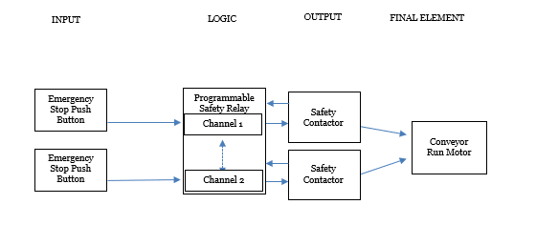

The safety function block diagram shown in figure 13 highlights the key elements of the safety control circuit for the conveyor system. The key elements are the inputs, the logic, the outputs, and the final element. The First stage is the input. The two inputs come from the emergency stop switch. The two inputs to the safety relay indicated the dual channel aspect of the safety control system. The emergency stop switch uses two switches to give failure protection. If one of the switch contacts fail, then the other one is available providing a fail-safe. The input is then fed into the logic which is the connections for channel 1 and channel 2 of the safety relay. The output of the safety relay is then fed into the safety contactors. The safety relay used has monitoring software build in so that the safety relay can monitor the status of the contactor so that if there is a fault, such as one of the contacts have welded in, the safety relay will go into fault condition and the safety relay will not reset and therefore the power to the motor will be disengaged. The final element of the safety function block diagram is the conveyor run motor which will be supplied through the two safety contactors.

Required Performance Level (PLr)
Through a risk assessment, the conveyor system was found to have Required Performance Level C.
- The severity of injury was identified as S1 - Slight, normally reversible injury.
- The Frequency and/or exposure to hazard was identified as F2- Frequent/continuous and/or exposure time is long.
- The possibility of avoiding hazard or limiting harm was identified as P1 – possible under specific conditions.

Following the guidance shown in figure 7, the Required Performance Level (PLr) identified was category C. This means that the safety relay device used must be able to achieve Performance Level C or higher to comply with regulations. The Required Performance Level document can be viewed in appendix F.

4.2 – Project Design Implementation
4.2.1 – Lane shuffling device
The lane shuffling device shown in figure 14, 15 & 16 was purchased from Spaleck to ensure that blockages do not occur on the conveyor feeding the packing equipment. The shuffling device consists of a 24V dc motor which is capable of running clockwise and anticlockwise. The motor a set of wheels underneath the unit which come into contact with the bullion coins. The wheels rotate so that the coins are evenly distributed. The wheels will rotate clockwise for a set amount of time and then rotate anticlockwise. This is set from a timer output in the PLC.

Figure 14 – Lane shuffling device
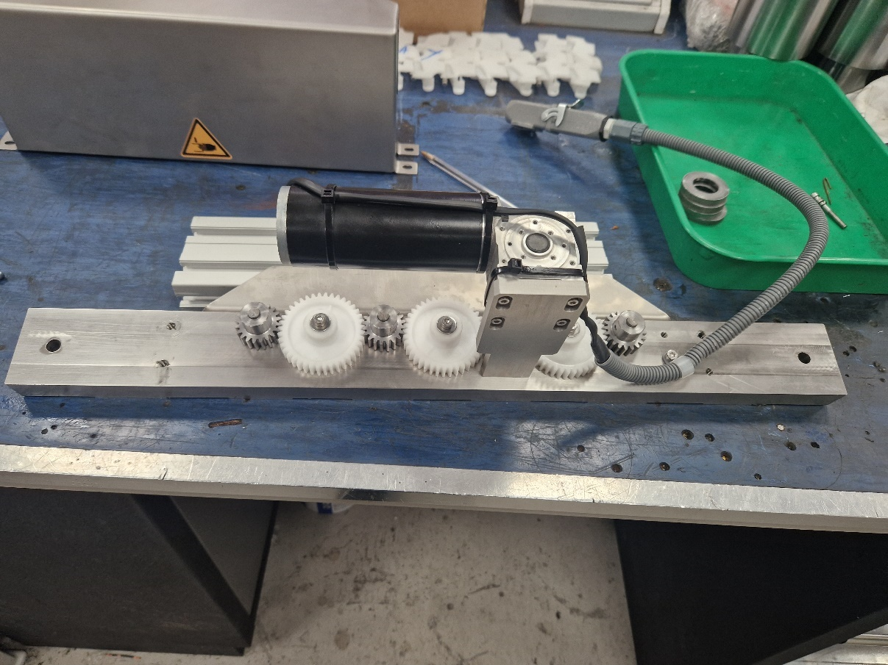

Figure 15 – Lane shuffling device
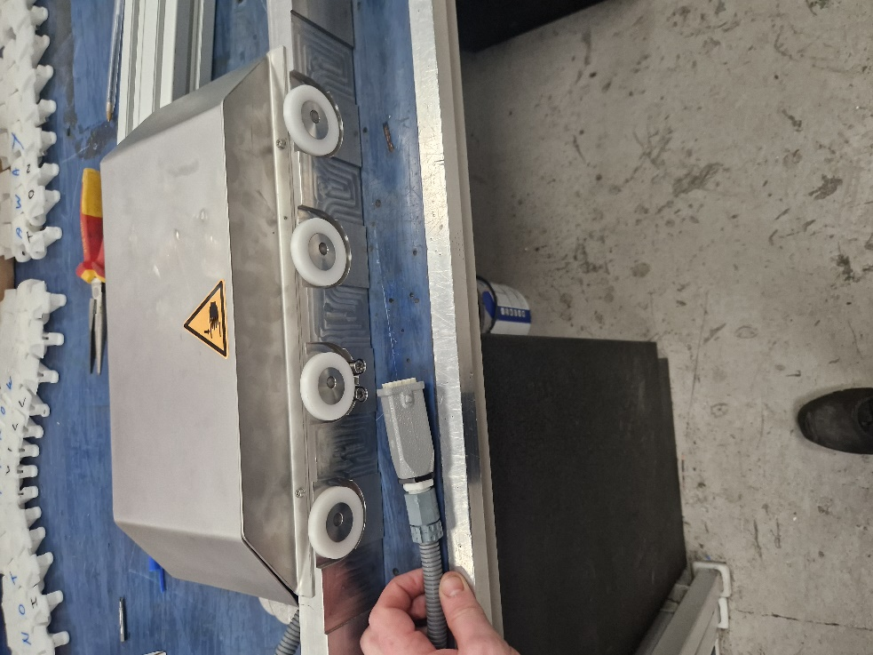

Figure 16 - Lane shuffling device installed on conveyor.

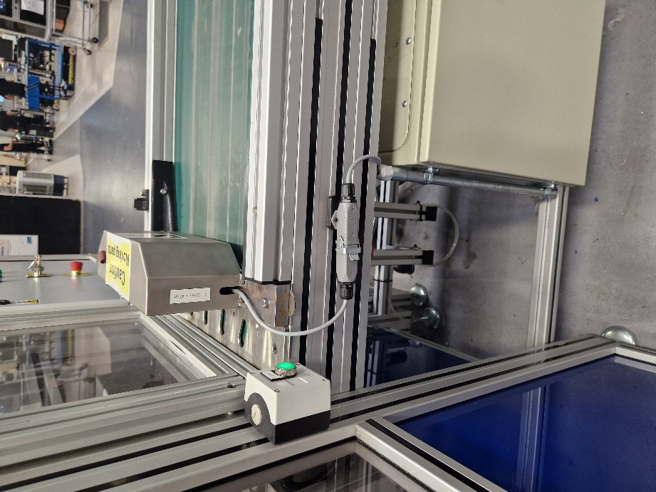

Spaleck supplied a motor controller which is the MADLER MAE-4Q-5-30. The datasheet for this motor controller can be viewed in appendix C2. Spaleck also supplied a drawing for how the motor controller should be connected to the shuffling device as seen in figure 17 and can be viewed in more detail in appendix H1.
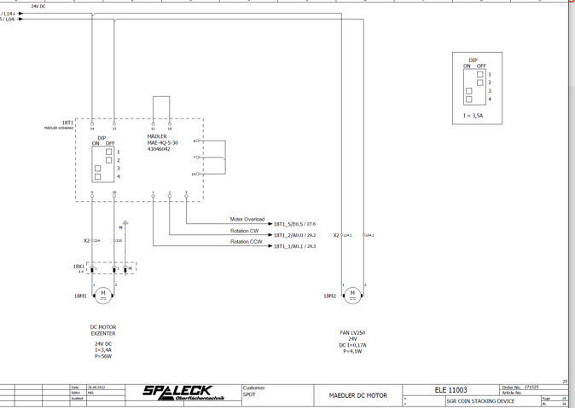
Figure 17 – MADLER Motor Controller diagram

From this diagram, it was possible to complete an electrical diagram for integration with the existing machinery as can be seen in figure 18.

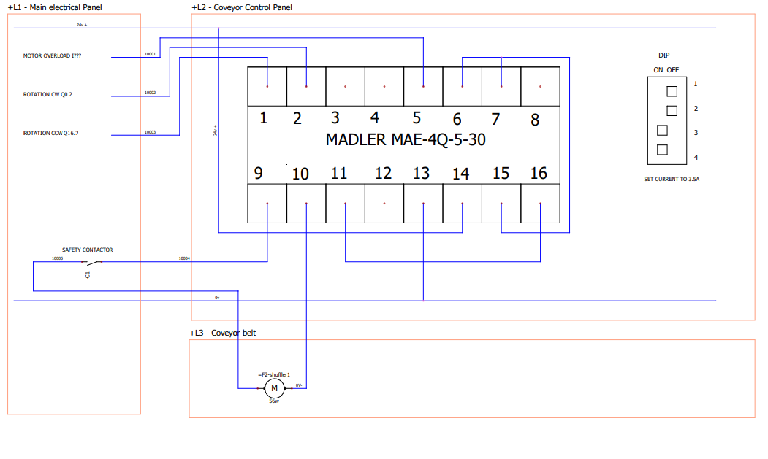
Figure 18 – Electrical Diagram – Lane Shuffling Device.
Figure 18 shows the electrical drawing complete to integrate the MADLER motor controller, the motor for the shuffling device and the existing equipment. This drawing is done in accordance with the MADLER MAE-4Q-5-30 motor controller data sheet seen in appendix C2 and the electrical drawing supplied shown in appendix H2. The complete electrical diagram is included in appendix H. The drawing illustrates the components connected to the MADLER motor controller:
- The 24V dc supply will be connected to port 14 of the MADLER motor controller.
- The motor overload (wire 10001) is connected to port 5 of the MADLER motor controller.
- Port 9 of the MADLER motor controller is connected to the safety controller, which in is then connected to the positive side of the motor. The 0V side of the motor is then connected to port 10 of the MADLER motor controller.
- The output port Q0.2 of the packaging equipment PLC is connected to port 2 of the MADLER motor controller through wire 10002. This output is given through a timer output of the PLC and gives the signal for the shuffling device to rotate in a clockwise direction as shown in figure 20.
- The output port Q16.7 of the packaging equipment PLC is connected to port 1 of the MADLER motor controller through wire 10003. This output is given through a timer output of the PLC and gives the signal for the shuffling device to rotate in a counterclockwise direction as shown in figure 20.
- The DIP switch illustrates that the that switches 1 and 2 should be switched to the off position and switches 3 and 4 should be switched to the on position. This will give an output of 3.5 amps.
The connections to the MADLER motor controller described above can be seen in figure 19. Below the motor controller are the outgoing connections to the existing packaging equipment.
Figure 19 – MADLER Motor Controller Wire Connections
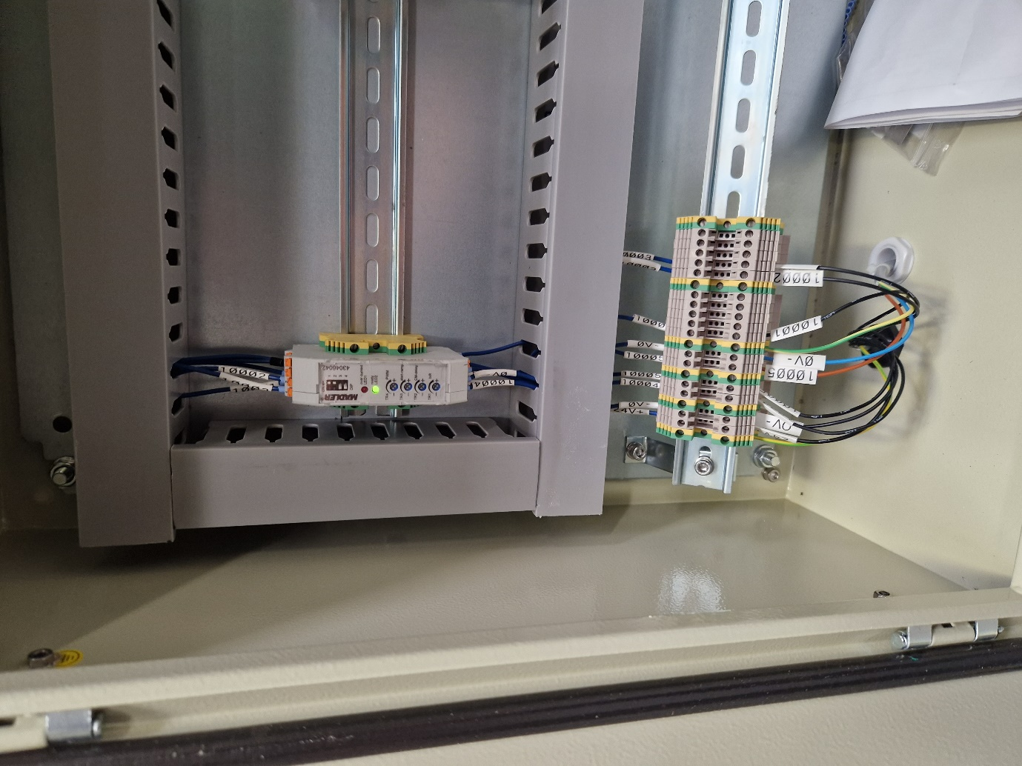

Figure 20 and 21 shows the connections to the existing electrical panel of the packaging equipment. Shown is where the wires that are connected between the motor controller and the existing electrical control panel as described in figure 18 – Electrical Diagram – Lane Shuffling Device.
- Wire 10001 is connected to I12.7
- Wire 10002 is connected to Q0.02
- Wire 10003 is connected to Q16.7
- Wire 10004 and 10005 are connected across the safety contactor C1.
Figure 20 – Existing Panel Connections
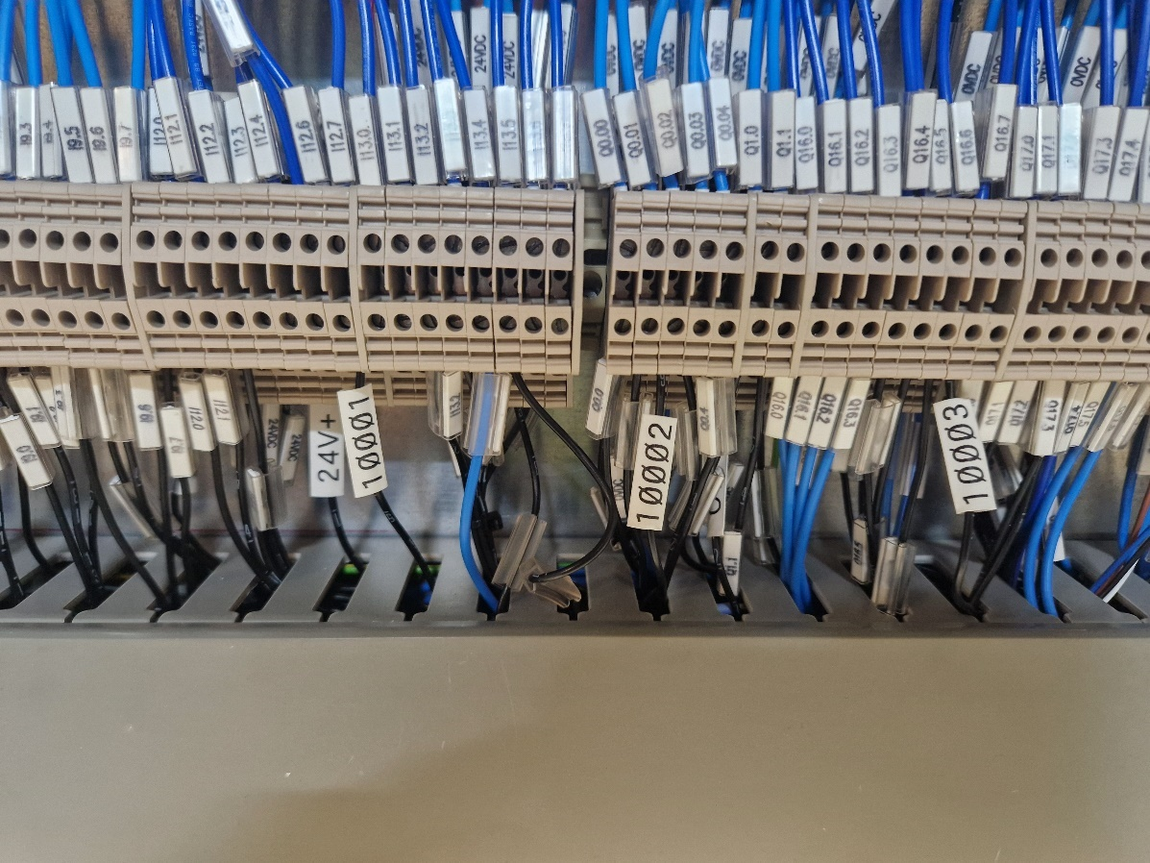

Figure 21 – Connection To Safety Contactor
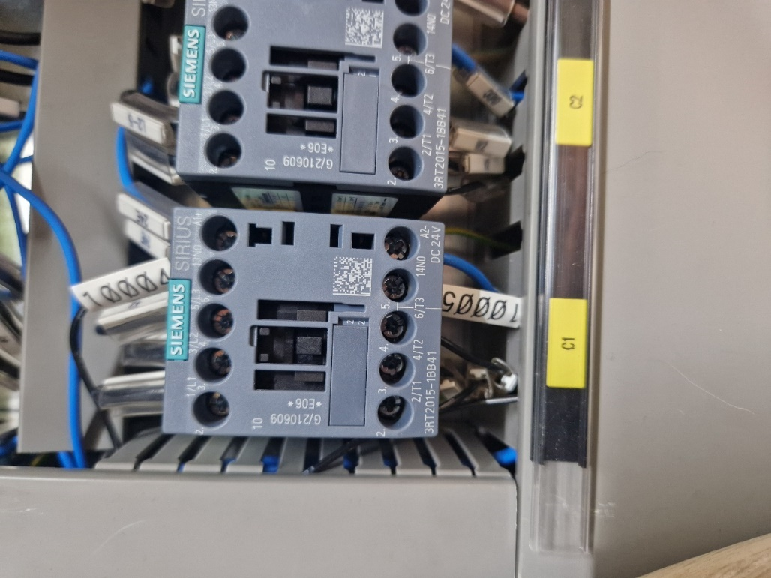

The PLC ladder diagram can be seen in figure 21.
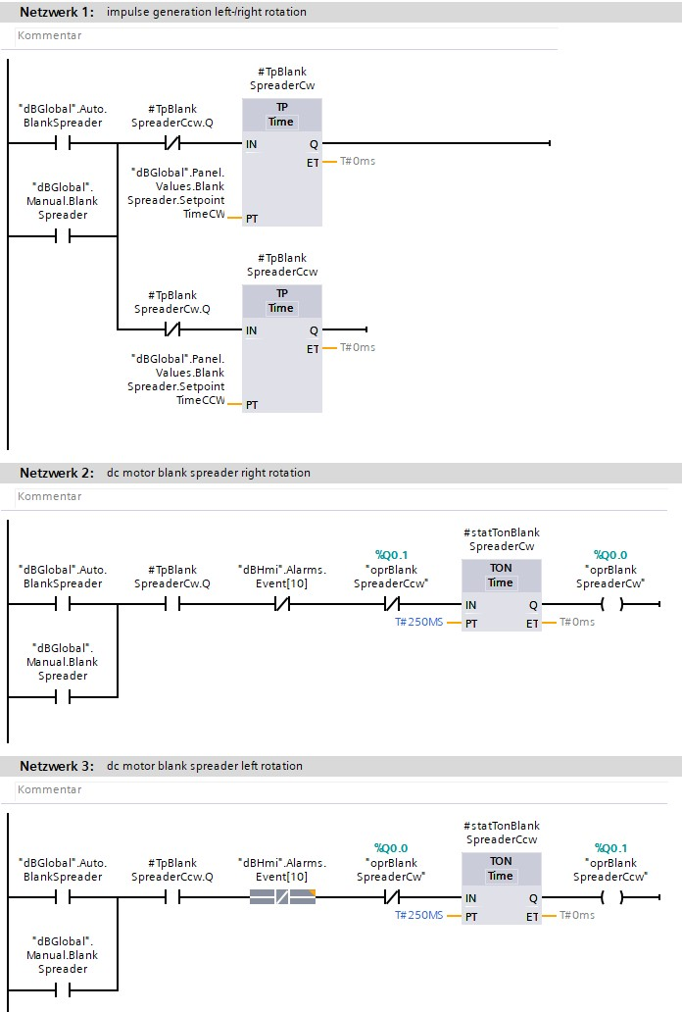
Figure 22 – PLC Ladder Diagram

Figure 20 illustrates how the PLC the PLC program works. The PLC program supplied the signal to the MADLER motor controller. The first timer supplies a signal to port 2 of the motor controller so that it rotates in a clockwise direction for a set amount of time. When the first timer is finished, the second timer operates for the same amount of time giving a signal to port 1 of the motor controller so that the motor operates in the counterclockwise direction. In line with the timer functions are normally closed switches which are switched from the opposite timers. These are in place so that the two timers can never be on at the same time which would cause a fault condition for the shuffling device.

An electrical diagram has been completed for the design of the safety control system for the conveyor system and can be view in appendix I.
4.2.2 Control panel for conveyor system
The conveyor shown in figure 4 was purchased from Pobjoy mint as a bare unit, with just the conveyor belt and the body of the conveyor. An electrical control circuit was required to control the conveyor system and ensure that it was safe to operate and that it complied with all relevant regulations.
The complete electrical diagram for the control panel can be viewed in appendix I.
Figure 23 shows the power side of the control system for the conveyor.
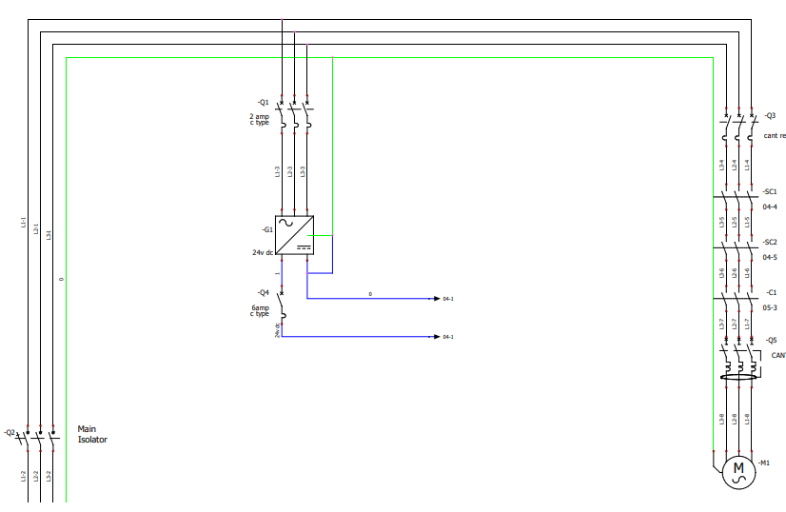
Figure 23 – Power control system

As illustrated in figure 23, the power is first supplied with a lockable main isolator (Q2). The 24V dc power supply, which is required for the control circuit is then supplied through a 2 Amp Miniature Circuit Breaker (MCB)(Q2) to protect the power supply from overload current. The 24V dc power is then supplied to the control circuit through a 6 Amp MCB (Q4). The three phase, 400V power supply is then fed through Q3 which is connected in series with safety contactors SC1 & SC2. These safety contactors are operated by the safety relay. If the emergency stop is pressed or there is a fault condition detected, the safety contactors will disengage and therefore power to the motor will be cut out so that mechanical rotation will stop. Contactor C1 is operated when the level probe sensor is actuated as shown in figure 24. This is actuated through the timer relay shown in figure 24. The timer relay is set in the desired position, so that when the level probe is actuated, contactor C1 will be actuated, and the conveyor will run for a set amount of time. C1 also utilizes a normally open contactor so that LED H1 will illuminate when the conveyor is in operation. Another button (F2-S3) has been incorporated to the design of the conveyor system so that the operator can operate the conveyor manually. They might do this at the start of the run to ensure that there are blanks in the press ready to start production.
Figure 24 – Level Control Actuation
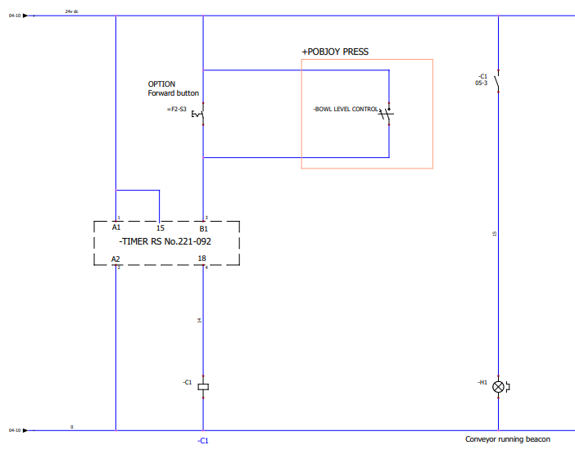

Safety control system
The safety control system utilizes the safety relay chosen during the research stage of the project, Rockwell Automation Safety Relay MSR127, and is connected as shown in figure 25.
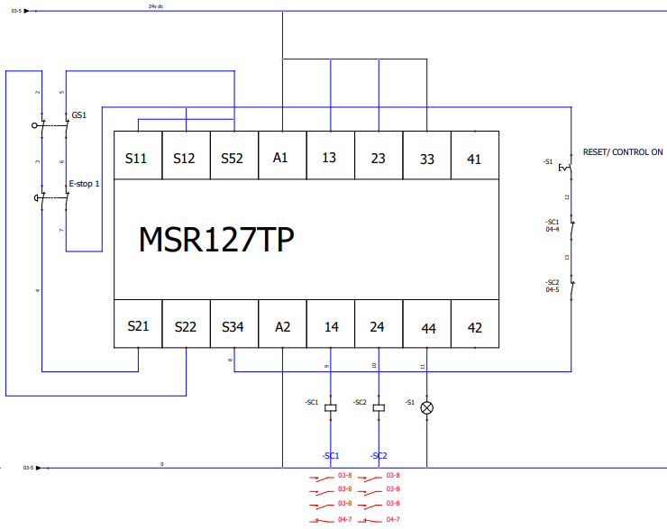
Figure 25 – Safety circuit diagram

The electrical drawing shown in figure 25 illustrates how the safety circuit will operate. If the emergency stop button is pressed, then the safety relay will go into fault condition. In this case, safety contactors SC1 and SC2 will disengage and power to the motor will be cut out ensuring that there will be no power going to the motor and there for no physical movement will take place. The emergency stop switch needs to be released before the safety circuit will reset. With the emergency stop switch disengaged the reset button S1 needs to be pressed. If there is a fault with one of the contactors, the reset button will be ineffective as the reset button is connected in series with safety contactors SC1 and SC2. This give the safety control system another layer of safety.

Figure 26 – Physical build of electrical panel
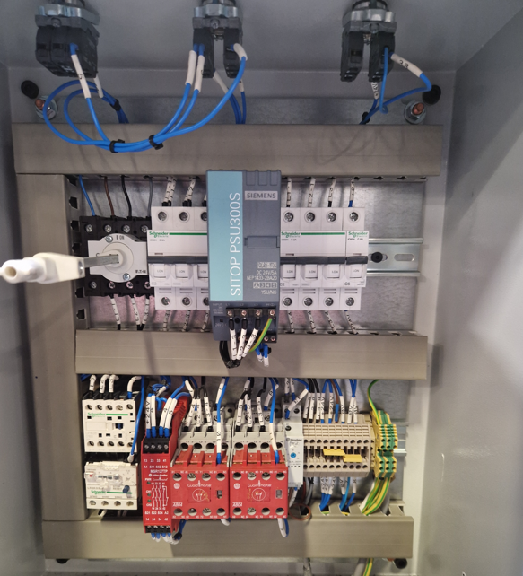

Figure 26 shows the physical build of the electrical control panel in accordance with the electrical diagram shown in Appendix I. The components utilised in this design are:
- A three-phase isolator
- 1 2 amp MCBs
- 1 6 amp MCB
- 1 24V/5amp three-phase supplied power supply
- 1 contactor
- 1 motor overload device
- 1 Rockwell Automation MSR127 Safety Relay
- 2 Guardmaster safety contactors
- 1 Finder timer relay.
- 1 emergency stop switch
- 2 normally open push button switches
The cost of all the components used in this installation are shown in costings section, chapter 3.2.
Figure 27 – Electrical connection to press.
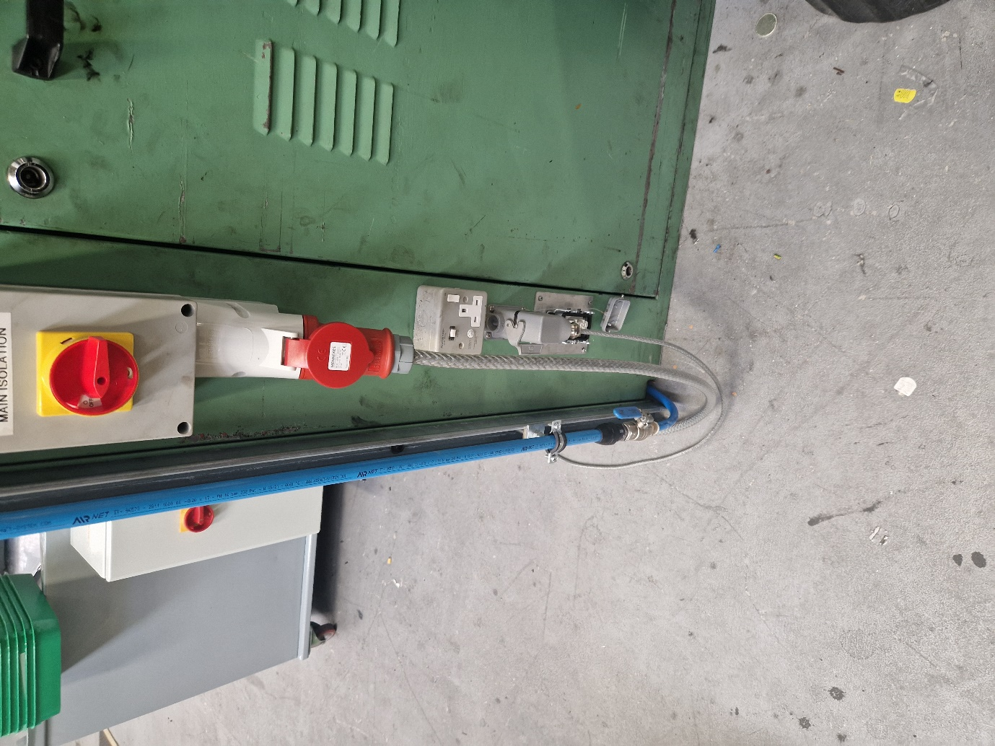

Figure 27 shows the electrical connection to the bullion press. The electrical supply is connected using a three-phase 400V 16 amp plug and the Harting plug below is the connection to the bowl level sensor which is used to detect when blank coins are required and to switch the conveyor on.
Figure 28 – Bowl level sensor

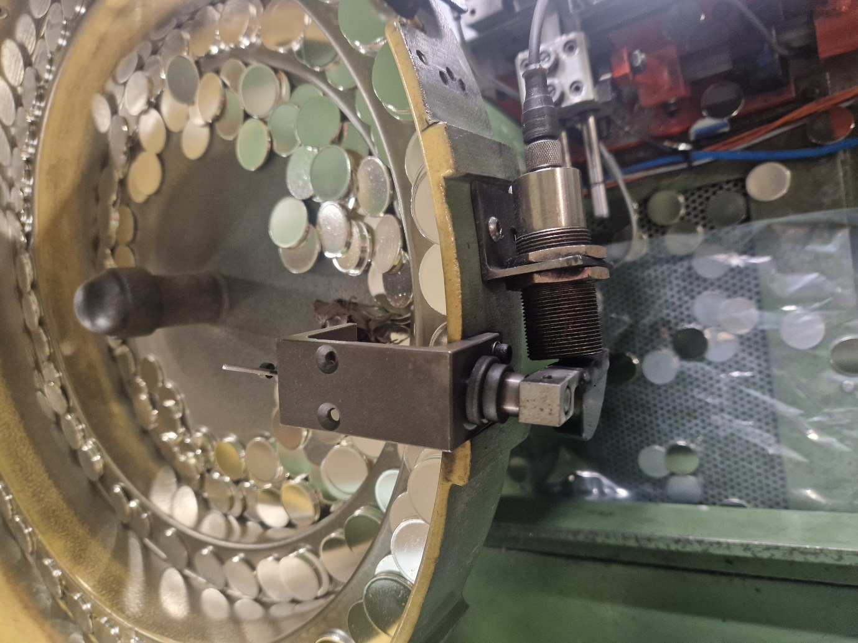

Figure 28 shows the bowl level sensor. When the bowl is full of blank coins, the padel is moved away from the sensor. When the bowl is empty, there is no resistance on the padel and the PNP sensor will be actuated. The timer relay will then be actuated and a signal for the contactor to come on would be sent. The contactor will then engage and the motor will run for a time set on the timer.
Chapter 5 – Evaluation
5.1 – Quality of products
Through a study by the quality team, it was found that the quality of products were improved with a reduced number of complaints being submitted.
5.2 – Production rates
Through a study of the production rates, day by hour records that the production manager keeps track of, the rates of production increased by 25% which is a massive increase on the rates of production which will have a significant result on profitability of the silver bullion production area.
5.3 – Safety of the conveyor
Through risk assessment, the conclusion was made that the conveyor is as safe as possible for the operators to use. The Required Performance Level of the conveyor system was calculated to be to the level of C. The final design of the conveyor system complied with ISO 13849-1 to the level of E. This means that the conveyor system offers more protection than is required.

Chapter 6 – Conclusions and Recommendations
To conclude the report, the studies that were carried out after the project had taken place indicate that the quality of silver bullion coin was increased, with fewer rejects and fewer customer complaints. This was done by carrying out extensive research about the problem areas associated with the silver bullion production line and ensuring any areas that produced damage were removed.
The risk assessments carried out by the Health and Safety department clearly show that the conveyor system complied with all relevant regulations and standards, including the Provision of Workplace Equipment 1998, required in a production factory.
Production rates were dramatically. The production rates were improved by introducing a conveyor system to load blank coins into the press instead of loading them by hand. The production rates were also improved by introducing a shuffling system so stop coins becoming wedged on the conveyor feeding the packaging equipment.
6.1 – Suggestions for further work
Due to the success of the shuffling system for sorting the silver bullion coins, I believe that this machine can be utilized of other equipment in the area. This would further improve our production capacity in the area.
The conveyor system could be improved further by introducing a guard switch on the panel that gains entry to the moving parts of the motor. Although this panel is secured using bolts, if maintenance staff take the panel off to access the motor, sprocket or chain for routine maintenance it is possible that they will forget to replace the panel. This could lead to a dangerous situation where the operator could gain access to the moving components of the conveyor. To improve the design of the conveyor system, a guard switch could be added to improve the safety of the conveyor system.

Chapter 7 – Reflection
Through the project of improving quality, production levels and the safety of the conveyor system many lessons have been learnt. Information has been through the research of problem areas of the bullion production line due to quality issues and reasons for production stoppages.
Information has been gained in how to manage a project through from the starting position to the final product. As well as the lessons that have been learnt in project management, lessons have been learnt in the technical requirements in safety control systems and how to design a safety control system that complies with all the relevant regulations.

Chapter 8 - References
[1] https://www.royalmint.com/invest/popular-bullion/silver/
[2] https://researchoutreach.org/articles/customer-experience-product-quality-new-metric/#:~:text=Customers%E2%80%99%20perceptions%20count.%20Their%20experience%20of%20product%20quality,would%20recommend%20a%20product%20to%20another%20potential%20purchaser.
[3] https://researchoutreach.org/articles/customer-experience-product-quality-new-metric/#:~:text=Customers%E2%80%99%20perceptions%20count.%20Their%20experience%20of%20product%20quality,would%20recommend%20a%20product%20to%20another%20potential%20purchaser.
[4] https://production.royalmintmuseum.org.uk/aboutus/press-centre/the-royal-mint-announces-new-appointment-to-traditional-role-of-kings-assay-master/
[5] https://machinerysafety101.com/2020/11/25/conveyor-system-safety/
[6] https://machinerysafety101.com/2020/11/25/conveyor-system-safety/
[7] https://machinerysafety101.com/2020/11/25/conveyor-system-safety/
[8] https://www.plcacademy.com/safety-relay/
[9] https://www.electricaltechnology.org/2021/01/types-of-electric-motors.html
[10 https://www.electricity-magnetism.org/alternating-current-ac-motors/
[11] https://theengineeringmindset.com/induction-motor-basics/
[12] https://www.electrical4u.com/synchronous-motor-working-principle/
[13] https://www.tutorialspoint.com/difference-between-synchronous-motor-and-induction-motor
[14] https://engineerfix.com/electrical/safety-relays/a-complete-guide-to-safety-relay/
[15] https://www.plcacademy.com/safety-relay/
[16] https://www.plcacademy.com/safety-relay/
[17] https://literature.rockwellautomation.com/idc/groups/literature/documents/in/440r-in079_-en-p.pdf
[18] https://www.sick.com/us/en/what-are-performance-levels/w/blog-safety-standard-performance-levels/
[19] https://www.sick.com/us/en/what-are-performance-levels/w/blog-safety-standard-performance-levels/
[21] https://uk.rs-online.com/web/p/safety-relays/4475688?gb=s
[22]https://www.researchgate.net/publication/368874144_Research_Onion_A_Systematic_Approach_for_Designing_Research_Methodology_Part_One
[23] https://15writers.com/research-onion/
[24] https://gradcoach.com/saunders-research-onion/
[25] https://gradcoach.com/saunders-research-onion/
[26] https://classroom.synonym.com/advantages-disadvantages-positivism-12088541.html
[27] https://numberdyslexia.com/advantages-and-disadvantages-of-the-deductive-method/
[28] https://www.scribbr.com/methodology/action-research/
[29] https://www.ablison.com/pros-and-cons-of-mixed-methods-research/
[30] https://vittana.org/19-advantages-and-disadvantages-of-cross-sectional-studies
[31] https://aspiringyouths.com/advantages-disadvantages/data-collection/
[32] https://smarthost.maedler.de/datenblaetter/MAE_4Q_5_30_EN.pdf

Appendix B – Risk Assessment

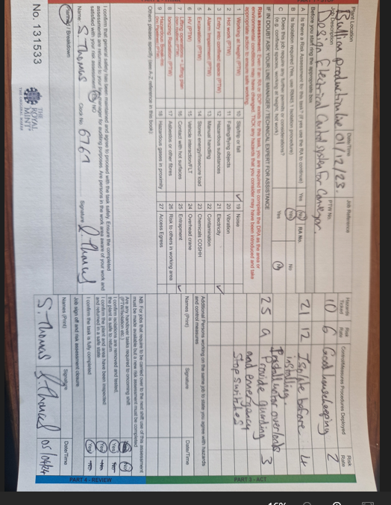

Appendix C1 – Hardware datasheets – Allen-Bradley MSR127 Safety Relay

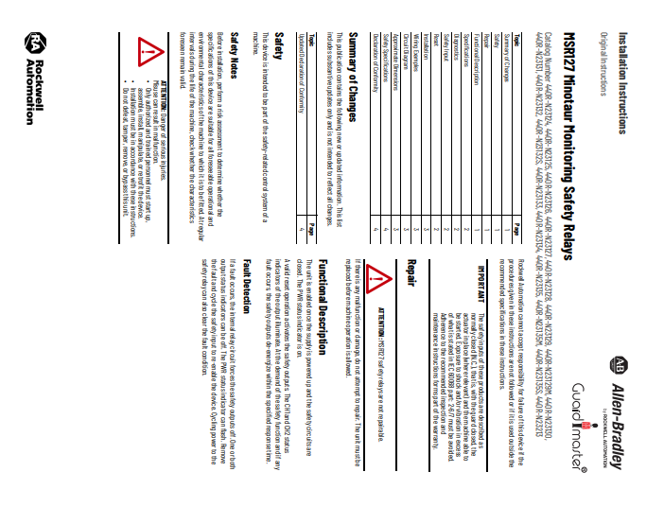

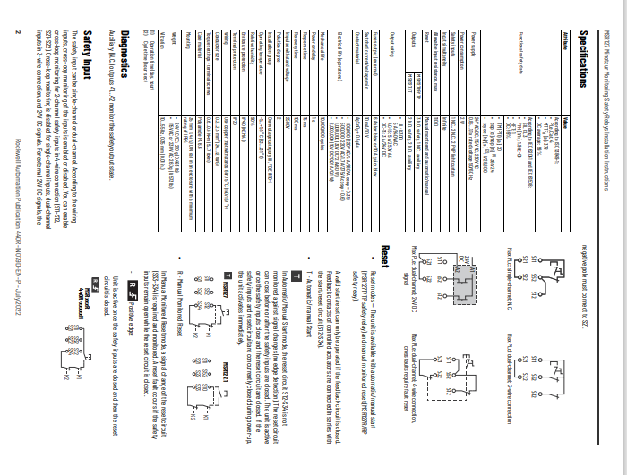

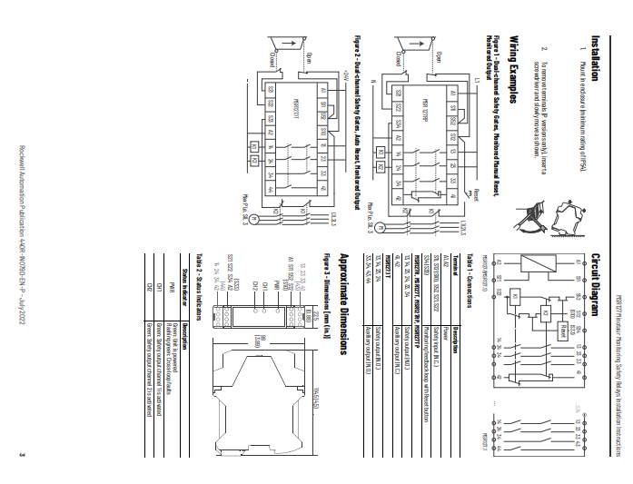
[17]

Appendix C2 – Hardware datasheets – MADLER MAE-4Q-5-30 Motor Controller
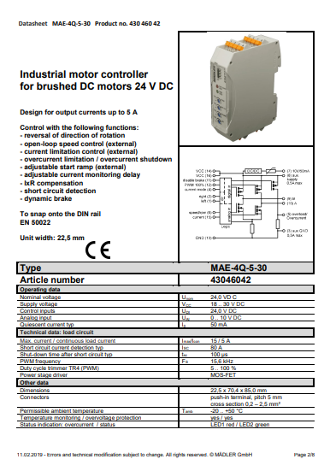
[32]
Appendix D – Quotation



Appendix E – Management of Change

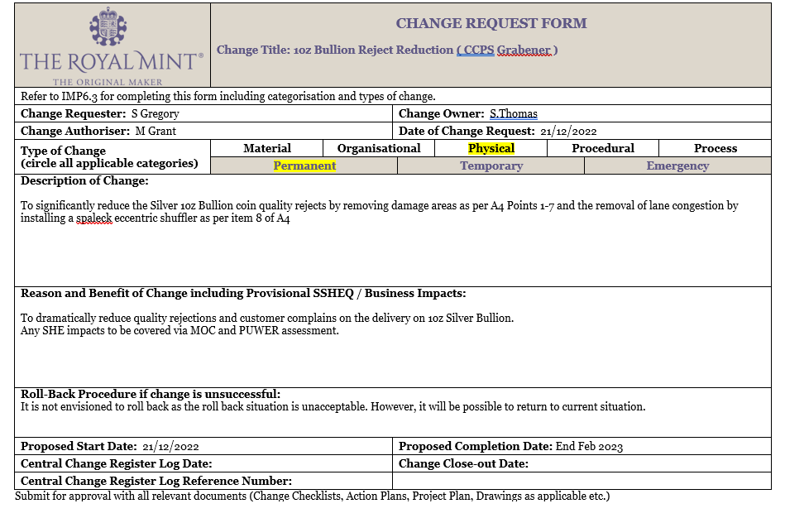

Appendix F -Required Performance Level documentation

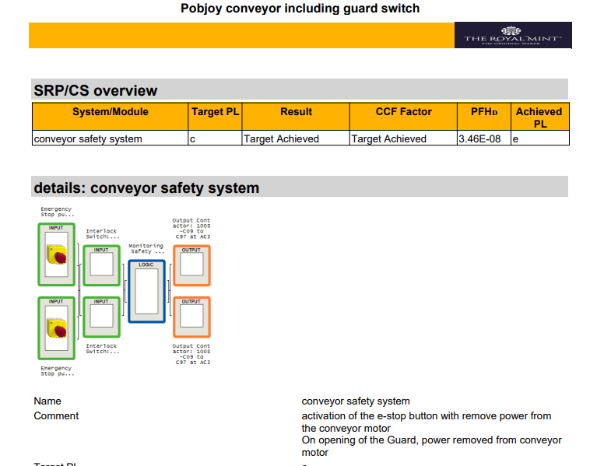

Appendix H – Electrical Drawing Lane shuffling device

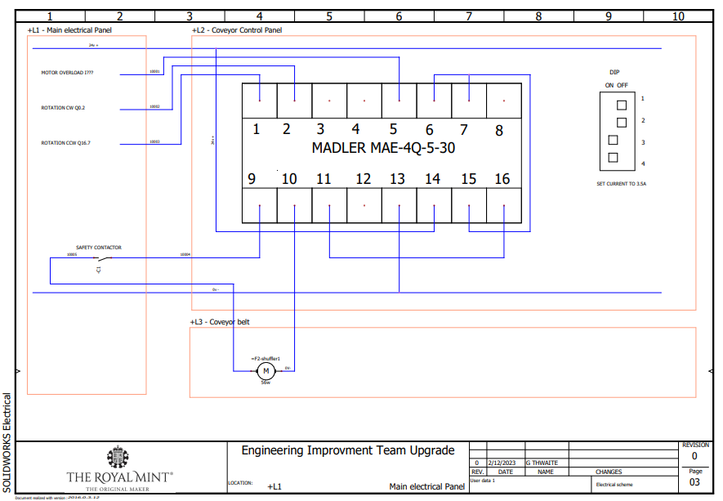

Appendix I – Safety control drawing for conveyor





