University of Wales Trinity Saint David
Wales Institute of Science and Art


Stress Analysis and Dynamics

Analysis and Simulation of Centrifugal Clutch
ACMA5010

Dewi Miller
2112045
November 2023
Contents
Introduction Task A 1
Historical Perspective: 1
Design and Materials: 1
Advantages of Centrifugal Clutches: 2
Contemporary Use of Electromagnetic Clutches: 3
Conclusion: 4
Task B 5
References 8

Introduction Task A
Evolution of Centrifugal Friction Clutches
Centrifugal clutches have undergone significant development over the past century, particularly in the context of small motor equipment. These clutches operate based on the principle of centrifugal force, whereas rotation speed increases, outward forces cause engagement with the clutch mechanism. This innovation has proven crucial in various applications, offering a reliable and automatic means of transmitting power.

Historical Perspective:
The concept of centrifugal clutches can be traced back to the early 20th century when small, motorized equipment requires a simple, efficient, and automatic clutches mechanism. Before the widespread adoption of fluid mechanical clutches, engineers sought a solution that would engage and disengage based on the rotational speed of the equipment.

Design and Materials:
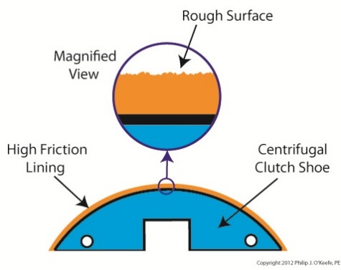
The fundamental design of a centrifugal clutch involves a set of shoes or arms that are mounted within the clutch housing. These shoes are typically equipped with friction material, such as composite materials containing fibres and resins, to ensure effective engagement. As rotational speed increases, centrifugal forces push these shoes outwards, when engaged causing them to contact clutch drum or bell, thereby transmitting power.
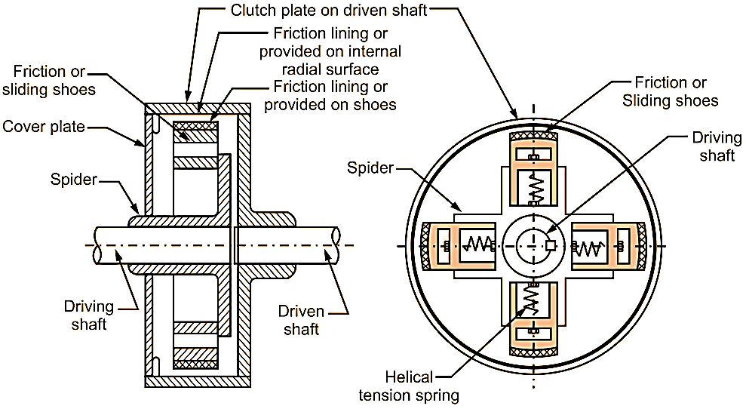
Diagram 1: Schematic representation of a centrifugal clutch mechanism.
The choice of materials for the friction surfaces is critical to ensure durability, head resistance, and efficiency power transfer. Common materials include high-friction ceramic compounds.

Application and Operating conditions:
Centrifugal clutches find applications in a variety of small motor equipment, such as chainsaws, go-karts, mopeds, and some lawnmowers. The automatic engagement and disengagement streamline user operation, with operating conditions dependent on rotational speed triggering clutch engagement.

Advantages of Centrifugal Clutches:
- Simplicity: Centrifugal clutches are boasting a straightforward design with fewer components compared to alternative systems.
- Automatic operation: The automatic operation of centrifugal clutches is a paramount feature, epitomizing user convenience. Its self-engaging nature obviates the requirement for manual intervention, offering a seamless and user-friendly experience. Users are spared the hassle of constantly managing clutch engagement and disengagement, particularly in scenarios where frequent speed variations occur. This not only simplifies the operation of small motor equipment but also reduces the cognitive load on the user, allowing them to focus on the primary task at hand. The inherent simplicity and efficiency of this self-engaging mechanism contribute significantly to the overall accessibility and ease of use for operators and enthusiasts alike.
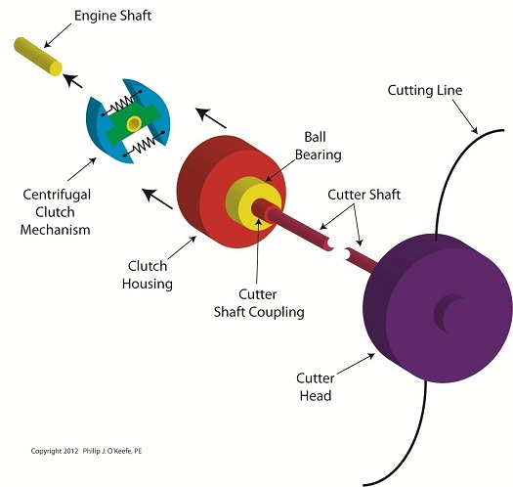
Diagram 2. Exploded view of centrifugal clutch in a strimmer

Contemporary Use of Electromagnetic Clutches:
As manufacturing processes advance, clutch technologies have followed suit. Electromagnetic clutches play a pivotal role in modern automation systems, providing precise control over power transmission, in contrast to the mechanical nature of centrifugal clutches.
- Operating principles:
Electromagnetic clutches comprise an electromagnetic coil and an armature plate. Application of an electrical current to the coil generates a magnetic field, attracting the armature plate and causing clutch engagement. This dynamic mechanism allows for swift and precise control over power transmission.

- Applications in Modern automation:
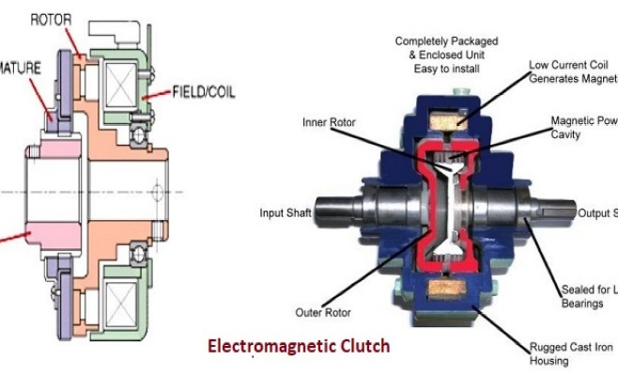
Electromagnetic clutches have become integral components across diverse industries, showcasing their versatility and reliability. In the realm of industrial machinery, these clutches find extensive use in crucial applications such as conveyors, where precise control over material handling is paramount. Moreover, in printing presses, electromagnetic clutches facilitate seamless engagement and disengagement, contributing to the precision required for intricate printing processes. Packaging equipment benefits from their adaptable nature, ensuring efficient and synchronised movements essential for packaging operations. Diagram 3. Electromagnetic Clutch

  - Industrial Machinery Utilization:
Electromagnetic clutches play a pivotal role in industrial machinery, finding extensive application in conveyors, where their precise engagement ensures smooth material handling. Moreover, their integration into printing presses enhances operational control during intricate printing processes. In packaging equipment, electromagnetic clutches contribute to efficient and accurate packaging, allowing for timely and synchronized movements.
  - Automotive Integration:
Within automotive systems, electromagnetic clutches prove indispensable. They feature prominently in air conditioning compressors, enabling on-demand operation for enhanced energy efficiency. Additionally, in engine cooling fans, these clutches provide dynamic control over fan speed, optimizing thermal management for improved vehicle performance and longevity.
  - Robotic Advancements:
In the realm of robotics, electromagnetic clutches are integral to automation in manufacturing. They empower robotic systems with precise control over movement and power transmission, facilitating intricate tasks with accuracy. This results in enhanced productivity and reliability in diverse manufacturing processes.
- Advantages of Electrical Clutches:
  - Precision control:
Electromagnetic clutches facilitate finely tuned control over engagement and disengagement for power manipulation.
  - Rapid Responsiveness:
The electromagnetic mechanism allows quick response times, crucial in applications requiring swift adjustments.
  - High Torque Capable:
Capable of handling substantial torque loads, making them suitable for heavy- duty industrial applications.

Conclusion:
In conclusion, the century-long evolution of centrifugal clutches has profoundly shaped the landscape of small motor equipment, offering a robust and straightforward solution for power transmission. This enduring technology has simplified operations and enhanced user experiences across various applications. Concurrently, the adoption of electromagnetic clutches in contemporary automation marks a paradigm shift, reflecting strides in control and precision. These advanced clutches cater to the intricacies of modern manufacturing, epitomizing the industry's pursuit of efficiency. Together, these clutch technologies represent a dynamic interplay between tradition and innovation, ensuring the seamless functioning of diverse machinery across the spectrum of mechanical evolution.

Task B


5) Using either MatLab or MS Excel, calculate and plot on a suitable graph the transmitted torque at the driven shaft against driving shaft speed, from 450 RPM to 700 RPM in increments of 25 RPM.
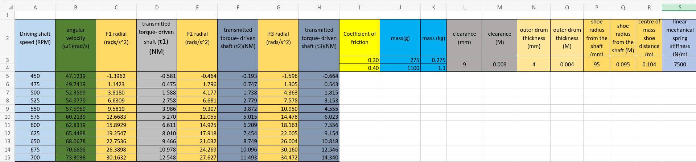MS Excel- calculation
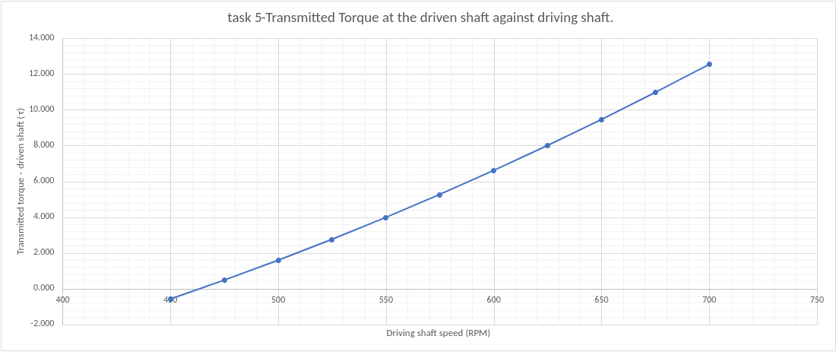
Graph 1- transmitted torque at the driven shaft against driving shaft.

6) Undertake the same analysis as in point 5 above but adopt a coefficient of friction of 0.3 and 0.4. Discuss the effect of changing the coefficient of friction of the shoe material on the torque transmitted when comparing the three values of coefficient of friction.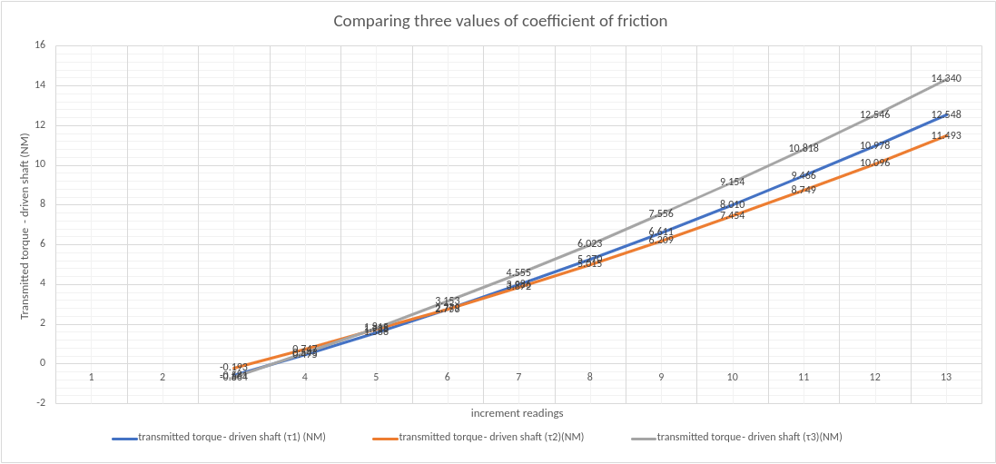
Graph 2- Transmitted Torque at the driven shaft,
(τ1- 0.35 coefficient of friction) (τ2- 0.30 coefficient of friction) (τ3- 0.40 coefficient of friction)
The coefficient of friction plays a crucial role in the performance of a centrifugal clutch, affecting the torque transmitted during its operation. A centrifugal clutch is a mechanical device used in various applications, such as small engine systems and vehicles, to engage and disengage the transmission of torque between the engine and the load. The torque transmission mechanism relies on the interaction between the clutch shoes and the clutch drum, with the coefficient of friction being a key parameter influencing this interaction.
When the coefficient of friction is altered, as in the case of comparing values of 0.3, 0.35, and 0.40, it directly impacts the efficiency and effectiveness of torque transmission. The coefficient of friction represents the level of resistance encountered between two surfaces in contact, in this scenario, the clutch shoes and drum. As the coefficient of friction increases, the resistance to sliding or relative motion between these surfaces also rises.

A higher coefficient of friction, such as 0.40, results in increased gripping force between the clutch shoes and drum. This enhanced grip leads to a more efficient transfer of torque, as a larger force is required to overcome the frictional resistance, ensuring a greater amount of torque is transmitted. Consequently, the engagement of the clutch occurs more rapidly and securely, contributing to improved overall performance. Conversely, when the coefficient of friction is lower, such as 0.3, the gripping force is reduced. This can lead to slippage between the clutch shoes and drum, resulting in a less effective transmission of torque. The engagement may be slower, and the overall efficiency of the centrifugal clutch is compromised. The intermediate value of 0.35 represents a balance between the extremes. It offers a moderate level of gripping force, providing a compromise between efficient torque transmission, and avoiding excessive wear and heat generation.

In practical terms, selecting the appropriate coefficient of friction for a centrifugal clutch involves considering the specific application requirements. Factors such as load, speed, and desired engagement characteristics must be taken into account. Engineers and designers aim to optimize the coefficient of friction to achieve the desired balance between efficient torque transmission, durability, and overall performance in each application.
7) For the maximum possible transmitted torque determined from either point 5 or 6 above, and given that the mass of the drum is 750 grams and can be considered as a solid disc, what is the angular acceleration of the drum to achieve the maximum possible torque?



References
(Philip J.O'Keefe, 2013)
(A., 2020)
(Smith, 2019)
(Institute, 2021)
(Smith J. , 2008)
(Kalyani, 2021)

