

Full name: Raja Kaleem
Student ID
Programme: CertHE Computing Skills for Workplace
Module name: Software Solutions for Business
Module code: ACCA4026
Lecturer name: Martin Svejda, Osman Elgawi
University + campus
Submission date: 10-march-2026

Table of Contents
Introduction 3
Task 1- E-Commerce Web Builders 3
Shopify 3
Wix eCommerce 4
Task 2 -Mind Mapping in Business 4
Task 3 – Office Applications for Business Operations 6
Microsoft Word 6
Microsoft Excel 7
Microsoft PowerPoint 9
Microsoft Access 10
Task 4 Communication and Collaboration applications 11
Zoom – Communication Tool 11
Google Docs – Collaboration Tool 13
Integration and Practical Applications 15
Conclusion 15
References 16

Introduction
The use of digital technologies and software networks to enhance productivity, information management and communication within the workplace is currently becoming a crucial aspect in modern organisations. Application of the information technology in the business operation allows organisations to computerize their daily operations, enhance decision-making, and enhance their overall efficiency. The digital economy heavily depends on the various types of software applications such as office productivity solutions, communication, collaboration, and e-commerce used by businesses to compete in the digital economy [1].
The software solutions also enable organisations to process large amount of information and raw data to useful information. As an example, spreadsheet apps can assist organisations to analyze financial data, whereas communication software can provide the employees with an opportunity to work remotely and exchange knowledge effectively. The implementation of these technologies can gain special significance nowadays within the work environment where the digital transformation and remote working strategies are becoming more frequent [2].
This report is aimed at analysing some of the software solutions that could be helpful in supporting the modern business operations. The report assesses e-commerce web site constructors, mind mapping software, Office productivity software and communication and collaboration software. Besides theoretical explanation, practical examples are also provided to show how the tools could be effectively utilized in a business context.

Task 1- E-Commerce Web Builders

Shopify
Shopify is among the most popular e-commerce web site builders which allows the companies to design and operate online stores without any special technical skills. The application offers a cloud solution upon which organisations develop professional websites, handle inventory, make payments, and monitor orders through the same dashboard. Small and medium-sized enterprises have found Shopify to be an easy way to start an online business, as it provides robust prebuilt features of digital business ventures [3].
Shopify has one of the most critical attributes in the form of a user-friendly interface that enables users to develop websites by using ready-to-use templates and themes. The templates enable the business to build attractive online shops without putting in much effort. Integrated payment gateways like Shopify Payments, PayPal and credit card processing systems are also available in Shopify where customers can make transactions with a system that is secure. Moreover, the site has marketing tools that will assist with search engine optimisation (SEO), email marketing campaigns and social media integration. These tools assist the companies in reaching out to customers and making more sales online [4].
Shopify also has its limitations in spite of its advantages. The platform will have a subscription fee that needs billed on a monthly basis which would be expensive to small start-ups. Moreover, the high-level customisation may also call on the familiarity with the proprietary programming language of Shopify called Liquid. Nonetheless, Shopify is among the most efficient e-commerce solutions that are in use today.

Wix eCommerce
The other popular site builder, which allows businesses to have e-commerce features is Wix. It has a drag-and-drop element, which enables users to create websites without knowing how to code. The Wix platform is especially appropriate in the case of small companies, freelancers, and businesspeople who wish to create an online store swiftly and affordably [5].
Wix platform includes numerous functionalities that allow running of a business online. They will be able to create product catalogues and also handle inventory and even make payments to their customers using the platform. Wix also has in-built marketing features which are used to advertise products in businesses by using email marketing, search engine optimisation and social media advertising. The tools can help organisations to reach potential customers and raise brand awareness.
Nevertheless, there are also some drawbacks of Wix when compared to specialised e-commerce applications such as Shopify. Examples include large organisations with large inventory products and therefore Wix might not be as scalable. Moreover, there are features that are available with the premium subscription plans. Even with such shortcomings, Wix is still a good option when it comes to a business that has to use a simple and cheap website building tool.

Task 2 -Mind Mapping in Business
Mind mapping is a diagrammatic thinking method that is applied to arrange information and thoughts in a systematic manner. A mind map starts with a central point that is in the middle of a diagram and this forms the center where the branches spread out representing related ideas, concepts or sub topics. Both branches can include keywords, pictures, or symbols, which aid in illustrating certain ideas, which are related to the topic of the central theme. This graphic system helps people to see how various pieces of information relate to each other. In comparison with the conventional ways of taking notes, mind mapping has a more dynamic and a visual presentation of information that may be more productive in learning and recalling information [6].
Mind mapping is a very popular tool of brainstorming, planning, problem solving and knowledge management in business settings. During a meeting or workshop, organisations can take mind maps to come up with new ideas and evaluate sources of solutions to business problems. With the help of visual arrangement of thoughts, the employees may realise the connections between various ideas in the shortest period and create new strategies. This has given mind mapping a specific applicability in such aspects as strategic planning, product development, and marketing campaigns. When mind maps are created as teams, it becomes interactive and collaborative as the members of the team can offer ideas at the same time.
Project planning and management is another significant application of mind mapping to the business world. Mind maps are often used by project managers to define the goals of projects, resources needed, and stages of work to be handled. As is observed, a project manager may draw the project title in the mid-point of the diagram, and then draw branches of project goals, timelines, resources, risks, and deliverables. This method enables the team members to have a clear picture of their functions and how various functions relate. Consequently, mind mapping will be able to enhance communication between team members and make sure that everything in a project is taken into account at the planning phase.
Generally speaking, mind mapping is an effective tool that promotes creativity, teamwork, and proper management of information in business organisations. Mind maps allow the teams to come up with innovative solutions, structure complex projects and enhance communication by allowing individuals to visualise relationships between ideas. As businesses continue to operate in increasingly complex environments, visual tools such as mind mapping can play an important role in enhancing productivity and decision-making processes.
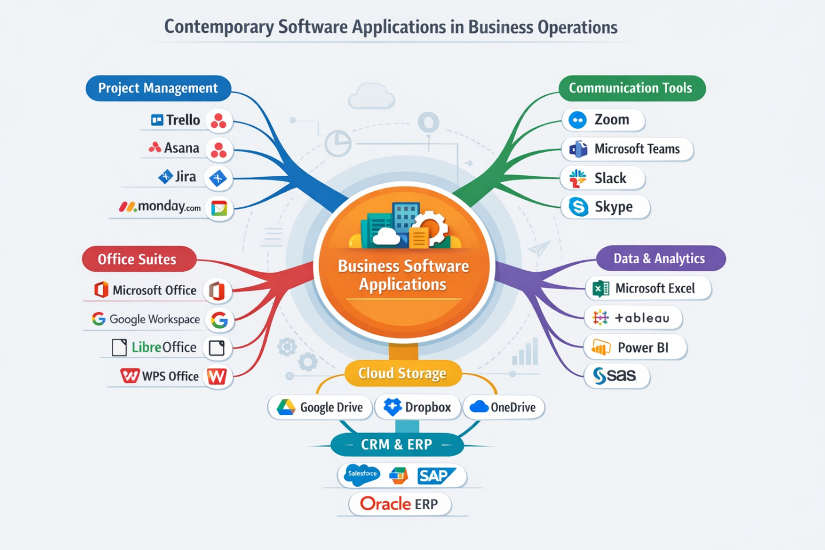
Figure 1: Mind Map of Contemporary Software Applications Used in Business Operations.

Task 3 – Office Applications for Business Operations

Microsoft Word
One of the most common word processing applications in the business world is the Microsoft Word. It allows users to develop, edit and format professional documents like reports, business proposals, contracts and official correspondence. The organisations also depend on Microsoft Word as it offers effective formatting features, which enable workers to make organised and attractive documents. Written communication in the modern workplaces is the fundamental aspect of the functioning of the organization, and software such as the Microsoft Word enables the staff to create precise and professional writings in the most effective way possible [7].
The Microsoft word has a lot of features of the formatting and editing capabilities that enhance the quality of documents. The fonts, paragraph alignment, margins and space can be easily changed by users to make sure that documents are of professional standard. These formatting software assist organisations to be consistent in business documents (reports, meeting minutes, internal communications, etc.). Moreover, Word also has templates which enable one to easily build frequently used documents, like resumes, reports, letters and project proposals. Templates are time-saving and will be in a normal structure.
The other important aspect of the Microsoft Word is that it facilitates teamwork and document inspection. Documents are in most organisations prepared and examined by a number of people before they are finalised. The Microsoft word has functions like the Track Changes, comments and document comparison tools that enable the team members to check the edits and give feedback. These assist in communication among the employees and accuracy of the documents is guaranteed before it is circulated.
Word contains also built-in tools which enhance the quality of writing and minimize mistakes. Such as the spell checking and grammar checking can assist users to detect errors in the documents. The program also gives recommendations on how to fix the sentence structure and readability. Besides this, Microsoft word has accessibility features that allow users to develop easier to understand and read documents.
The other significant attribute of Microsoft word is the Mail Merge which enables organisations to automatically produce personalised documents. Mail Merge is an integration process involving a normal document template and data contained in a database or a spreadsheet. In addition to that, by automatically adding the names and addresses of the customers, business people are able to produce hundreds of personalised letters, invoices, or email messages. This aspect is especially handy in the marketing campaign, communication with the customers, and administration. Mail Merge is time-saving and more efficient by automating repetitive actions.
All in all, Microsoft word will continue to be a very critical document creation and management tool in the contemporary organisation. It has an incredible power of formatting, collaboration tools, and automation features that make it an essential tool of businesses that need writing-based communication on a professional level.

Microsoft Excel
Microsoft Excel is a spreadsheet application that is popularly employed in data examination, money calculations and in business reporting. The software enables organisations to archive high amounts of numerical data in tables and to do complicated calculations using formulas and functions. Some of the common tasks done using Excel in businesses include budgeting, sales forecasting, inventory control and financial analysis. Due to its flexibility and analytical features, Excel has become among the most critical tools in the contemporary business setup [8].
Microsoft Excel can sort and analyse big data which is one of its strongest qualities. Information can be typed in rows and columns and this gives the user the opportunity to classify information easily. Excel also enables the users to sort, filter and search data within a short period of time. These characteristics facilitate easier handling of huge volumes of information and make it easy to derive valuable insights using raw data by organisations.
A mostly employed functionality of Excel is the IF function which carries logical comparisons and gives various results on whether or not a particular condition is true or false. As an example, the IF function can be used by a company to classify sales performance. In case the sales are higher than a set target then the outcome may be termed as High Performance, and the outcome may be termed as Low Performance. This role assists the organisations to analyze performance and make wise choices based on the analysis of data.

Figure 2: IF Function used in Microsoft Excel to categorise Sales Performance
The other strong feature of Excel is Pivot Table which enables users to summarise huge data sets within a short time and effectively as well. Pivot tables help users rearrange and analyse the data with respect to alternate views without altering the data set. As an example, a firm may analyse sales performance by region, product category or time period using a pivot table.
Pivot tables are also effective in determining trends and patterns in massive data. Managers can summarise the information into valuable categories using pivot tables instead of manually analysing hundreds or even thousands of rows of data. This assists organisations to make improved decisions informed with proper and systematic data analysis.
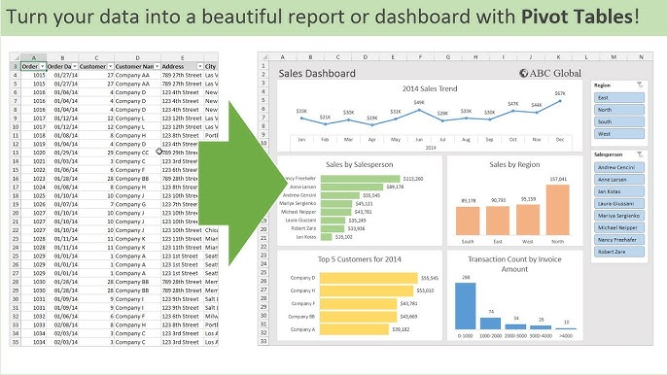
Figure 3: Pivot Table that was created in Microsoft Excel to summarise the sales data.
On the whole, Microsoft Excel is a vital part of the business processes since it helps organisations to store, analyse, and interpret information. Its analysis is able to assist business to make good decisions and enhance operation performance.

Microsoft PowerPoint
Microsoft Powerpoint is an application in presentation that is utilized in business meetings, training, and marketing activities. The software enables users to produce visual slides in terms of text, pictures, charts, and multimedia features. Good presentations make organisations deliver ideas in a better and understandable manner to the audiences. In this way, PowerPoint has become an ordinary tool of presenting information in the workplace setting [9].
PowerPoint has extensive design templates and themes that enable the user to design presentations that are visually appealing and at a minimal time. These templates have prepared colour schemes, fonts and slide layouts which are consistent throughout the presentation. Templates also save time since the user does not have to draw every slide separately.
The other valuable feature of PowerPoint is that it supports using visual kinds of chunks like charts, diagrams, and images. Illustrations facilitate comprehension of complicated information by the audiences. As an example, a report on the financial report can contain graphs, which can show the increase of revenues or market trends. In the same vein, complex ideas can be made easier with diagrams and infographics and enhance the interest of the audience.
Animations and slide transitions are also supported by PowerPoint which make presentations look much better. Animations also enable presenters to regulate the way the information is presented on the screen, which may be used to underline the key points. Slide transitioning will ensure that there is a smooth flow between the slides, which will make the presentation look more professional. These features are, however, to be applied sparingly since a lot of animations will distract the audience.
The other handy tool about power point is that it can support multimedia like audio and video. Marketing presentation, such as the use of promotional videos to demonstrate a product or service, can be used. The training sessions can also consist of tape lectures or demonstrations. Such multimedia capabilities allow making presentations more interactive and interesting.
The use of PowerPoint presentations has numerous business applications. They are used by managers to discuss strategic plans, financial performance and project reports. Marketing groups make use of PowerPoint to show advertisement campaigns and product introduction. Presentations are also used in the human resource departments to train employees. Due to its flexibility, PowerPoint can be applied in numerous business processes.

Microsoft Access
The Microsoft access database management system is a database management system that is used to store, organise and retrieve structured information. Access is used by businesses to store extensive information like the customer records, inventory data, employee data and sales records. In contrast to the spreadsheet packages that store information as simple tables, Access enables the user to build relational databases that can interlink various tables [10].
There are a number of tools offered by access that allow users to easily interact with databases. In one case example; with forms, users are able to work and edit data within easy to use interfaces as opposed to having to go and edit tables. Forms are widely applied in business since they are easy to use due to simplification of data entry and minimisation of errors.
The other significant attribute of Access is query creation. Interrogatives enable the users to find certain information in the database. As an example, a firm may come up with a query indicating all orders done during a given month or customers who have purchased above a set value. Inquiries assist companies to represent the fast retrieval of information and aid in the decision making process.
There is also access to reporting features where organisations are able to produce professional report based on information stored in the database. Data can be summarised with reports, presented as charts and important trends can be identified. As an example, a company can produce sales reports each month that include revenue by product type or geographic area. The reports assist managers to trace the performance and area to be improved.
The other benefit of Microsoft access is that it can be integrated with other Microsoft office programs like excel and word. Information contained in Access can be migrated to Excel to be analysed or create Word files to report on the same. This integration enhances better working and enables organisations to utilise different tools in conjunction.

Task 4 Communication and Collaboration applications

Zoom – Communication Tool
Zoom is the common platform of communication used by organisations to hold video conferences, webinars, and virtual meetings. In the last ten years, Zoom has been an essential part of the present-day working environment, yet its popularity soared much higher during the COVID-19 pandemic where remote work became a requirement in most organisations. Opening the possibility of communication despite the geographical distance, Zoom becomes an outstanding way to increase the flexibility of organisations, save on travel expenses, and enable businesses to operate even in crisis or disruption situations [11].
Screen sharing is one of the most important features of Zoom that enables their participants to share documents, slides, or applications in real time. This is a highly applicable feature especially during a business meeting where team members have to go through spread sheets, reports or a presentation together. As an illustration, in a sales strategy meeting, one of the team members can present a market analysis spreadsheet and others can give feedback in real-time. Screen sharing makes the process more effective as everybody pays attention to the same material and information is conveyed in a clear manner.
The Zoom also offers chat messaging, which can be used during meetings or webinars to enable the participants ask questions, offer further feedback, or share links and files. This capability allows an asynchronous communication within live sessions so that all people will be able to participate and not to disrupt the agenda of the meeting. Moreover, the chat logs could be saved and used later to have the history of the conversations and decisions.
Meeting recording is another important characteristic of Zoom that enables the whole session to be recorded and watched again in the future. The taped meetings are useful when the employees cannot participate in real-time sessions, when training is needed or when it is required to record the compliance. Recordings enable organisations to establish a storage facility of training resources, which is used to pass knowledge amongst teams and departments.
Breakout rooms are also supported in Zoom, and they separate the participants into smaller groups to discuss the issue in a more narrow scope. The breakout rooms can be used especially in collaborative tasks, team building workshops or brainstorming. Through the application of breakout rooms, organisations can guarantee that employees are actively involved and so complicated tasks are tackled in smaller groups which are manageable. The attribute endorses creativity, problem solving and collaboration as a team [12].

Figure 4: Example of Zoom Video Meeting Interface Used for Business Communication.

Google Docs – Collaboration Tool
Google Docs is a web-based editor which enables other users to collaborate on a document at the same time. Google Docs, in contrast to the conventional office applications, stores the documents in the cloud, in the Google drive. This allows users to view and edit documents on any internet-connected device, which can be mobile and remote working conditions [13].
Real-time collaboration is one of the most important benefits of the Google Docs. The same document can be modified by more than one team member at the same time and the changes can be seen immediately by the rest. This will remove the necessity to exchange documents via email forwarding and backward the version conflicts will be avoided and the workflow efficiency will be enhanced. As an example, a marketing team handling a campaign brief can edit, comment on thoughts and see changes made in real time, guaranteeing the quicker completion of the paper.
The Google Docs enables one to trace the changes and comment on the document as well. After making changes, users are able to propose corrections, comment and correct their comments. The feature facilitates collaborative editing and also ensures the transparency of document revisions. It is specifically handy to the project managers and team leads who should revise the input of several team members and endorse the changes in a logical manner.
The other important feature of Google Docs is the version history of the document, whereby the user can view all the past edits and revert to the previous versions in case the need arises. This is essential in business where accountability and record keeping is a factor of concern. As an example, the legal or financial teams can check the changes that occurred to a document to guarantee the adherence and keep the audit trails.
Google Docs is based on the concept of integrating multimedia and third-party tools, including images, charts, tables, hyperlinks, and Google Forms. This makes teams to develop rich, interactive documents, which are a blend of text, and visual and interactive contents. As a case in point, one can add charts of budgetary breakdowns to a project proposal and use tables highlighting important measures to enhance its clarity and attention.
Google Docs also has security and access control provisions. The user has permission to create individual or group permission where rights can be viewed, comment or edited. This provides security to sensitive information, as well as facilitating teamwork among approved teams. High end administrative controls enable the IT departments to conduct document monitoring, maintenance of user accounts and implement compliance policies [14].
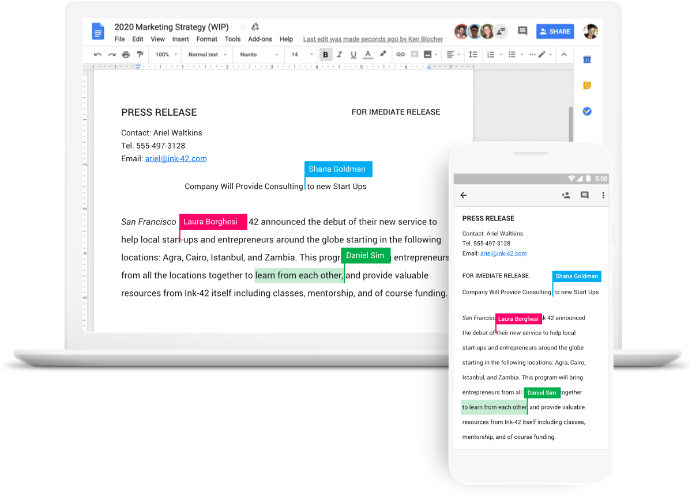
Figure 5:Google Docs Collaboration in Real Time

Integration and Practical Applications
The integration of Zoom and Google Docs is a prime example of how communication tools and collaboration tools can work together in the present business. As an example, during a Zoom meeting, a team can talk about a project strategy but at the same time, the team will be writing the project document on Google Docs. This integration promotes optimal use of workflow, minimized miscommunication, and that every person in the team agrees on the project deliverables. These tools are also combined with cloud storage and project management systems like Trello, Asana, or Microsoft Teams to make the work environment seamless in many organisations.

Conclusion
This report has discussed some of the software solutions that can be used in supporting the modern business operations. Shopify and Wix are e-commerce sites where companies can open online shops and sell online products effectively. Mind mapping methods can be used to help organisations organise ideas, plan projects and enhance problem-solving methods.
Programs such as Microsoft Word, Excel, PowerPoint and Access are very crucial to creation of documents, analysis of data, presentation and control of information. Moreover, Zoom and Google Docs are communication and collaboration tools, which allow organisations to ensure effective team work and information sharing in remote working conditions.
Altogether, modern software solution development contributes to the productivity, communication, and decision-making of organisations in the most effective way. Companies that successfully adopt these technologies are in a better position to respond to the market dynamics and attain success in the long run.

References
[1] K. C. Laudon and J. P. Laudon, Management Information Systems: Managing the Digital Firm, 16th ed. Pearson, 2022.
https://www.pearson.com/en-us/subject-catalog/p/management-information-systems-managing-the-digital-firm/P200000003417
[2] R. Stair and G. Reynolds, Principles of Information Systems, 14th ed. Cengage Learning, 2020.
https://www.cengage.com/c/principles-of-information-systems-14e-stair/
[3] Shopify Inc., “What is Shopify and how does it work,” 2024.
https://www.shopify.com/what-is-shopify
[4] Shopify Inc., “E-commerce business guide,” 2024.
https://www.shopify.com/learn/ecommerce
[5] Wix.com, “Create an eCommerce Website,” 2024.
https://www.wix.com/ecommerce/website
[6] T. Buzan and B. Buzan, The Mind Map Book, BBC Active, 2018.
https://www.tonybuzan.com/about/mind-mapping/
[7] Microsoft, “Microsoft Word documentation,” 2024.
https://support.microsoft.com/word
[8] Microsoft, “Microsoft Excel functions and formulas,” 2024.
https://support.microsoft.com/excel
[9] Microsoft, “Microsoft PowerPoint overview,” 2024.
https://support.microsoft.com/powerpoint
[10] Microsoft, “Introduction to Microsoft Access,” 2024.
https://support.microsoft.com/access
[11] Zoom Video Communications, “Zoom Meetings features,” 2024.
https://explore.zoom.us/en/products/meetings/
[12] T. Rowe, “Remote Work Collaboration Tools in the COVID Era,” Journal of Business Communication, vol. 61, no. 3, pp. 245–263, 2021.
https://doi.org/10.1177/00219436211008912
[13] Google Workspace, “Google Docs collaboration features,” 2024.
https://workspace.google.com/products/docs/
[14] A. Smith and L. Johnson, Cloud Collaboration and Productivity Tools, 2nd ed., New York: Springer, 2022.
https://www.springer.com/gp/book/9783030934567

