
Academic Discipline of Hospitality and Tourism Management

Programme: International Hotel Management (BA)
Module: International Meetings Management for the Hotel Industry
Module Code: BMIH6007

Assignment Title: Assignment 2: Event Strategic Planning and Delivery Considerations for an International Meeting

Student Name: A K M Amdadul Hoque
Student ID:2107424

AI Acknowledgement
I confirm that I have not used any AI tools in the research and creation of this assignment and have not presented any AI-generated materials as my own work. I confirm that I have copies of my drafts, notes, and other resources I used, which I may be asked to provide in evidence.
Table of Contents
1. Introduction 4
2. The Event Cycle 5
3. Event Concept 6
4. Aim and Objectives of the Meeting/Event 7
5. Event Management 8
6. Event Budget 10
7. Industry Trends / Issues / Impacts 11
8. Situational and Cultural Considerations 13
9. Conclusion 14
References 16

1. Introduction
The report will outline the strategic planning and delivery to execute a 3-day winter-themed leadership retreat for senior leaders within the hotel and restaurant sector in the UK, which will hopefully be held at Lake District, generating teamwork, industry insight, and personal wellbeing. According to the opinion of Fox et al. (2014), Armathwaite Hall Hotel and Spa is selected as it offers luxurious hospitality with outdoor activities in a calm, winter environment that offers quality immersion experiences and combines business with leisure.
With the unfolding trends of post-pandemic meetings, incentives, conferences, and exhibitions (MICE) trends, most prefer hybrid event formats and seasonalized events aligned with attendee health and sustainability practices in the environment (Pavluković et al., 2020; Rogers and Wynn-Moylan, 2022). These trends will be addressed through the incorporation of green practices such as providing catering from local sources and using digital media for communication, which would save on paper waste, aligning with Getz and Page’s (2019) suggestions. The meeting event shall also take advantage of winter to support tourism in an off-peak time, hence contributing to the regional economy. The retreat, given strategic event planning, is designed to enlighten the attendees with valuable insights into leadership, networking, and rejuvenating winter activities, placing it atop events in the hospitality sector’s calendar.
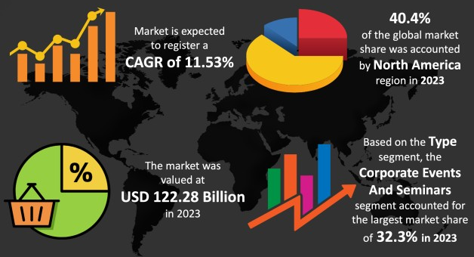
Fig 1: The Event Industry Market
(Source: The Brainy Insights, 2024)

2. The Event Cycle
The EMBOK framework offers a structured approach to managing the event cycle, from initiation to closure, for effective planning, successful implementation, and continuous improvement (EMBOK, 2003b). The five phases of initiation, planning, implementation, event, and closure are crucial for organising a winter-themed leadership retreat in the Lake District, addressing seasonal, logistical, and operational challenges, as opined by Getz and Page (2019).
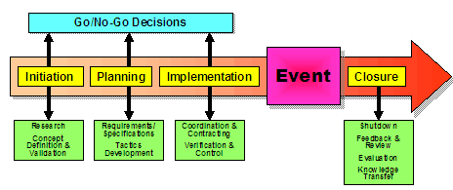
Fig 2: Phases in EMBOK
(Source: EMBOK, 2003b)
In the initiation stage, research was conducted to gauge market demand and feasibility, which proved that an off-season, wellness-based event could attract senior leaders and maximise benefits from reduced venue costs and exclusivity, based on the opinion of Mair and Jago (2010). This stage confirmed the concept and objectives of the retreat with respect to the needs of UK hospitality leaders (Dowson et al., 2023).
The planning stage would involve logistics, like booking of Armathwaite Hall, coordination of transportation, and assembling hospitality and event staff. Strategic schedule keynotes, panel discussions, and winter-themed activities, all carefully tailored for senior leaders to engage with meaningful, relevant ways of doing things, according to Fox et al. (2014).
Implementation includes all those coordinated operational elements, such as AV set-up, digital information dispersion, and venue preparation, in which every little detail is executed flawlessly to support a high-quality attendee experience. Meredith (2022) highlights that in this phase accurate coordination is crucial for ensuring operational success.
Event and closure deal with the event execution and its follow-up evaluation. Management during the meeting should be immediate; however, in the closure, it deals with post-meeting surveys and assessments on impact so that the retreat’s satisfaction can be evaluated and areas for improvement to enhance the value of the next event may be provided, as per Rogers and Wynn-Moylan (2022). From the EMBOK phases, there is ample ability for retreat planners to make the best resource allocation and handle each aspect of the retreat systemically.

3. Event Concept
The UK hospitality industry is offering a winter leadership retreat event, combining work and play in a seasonally themed setting. The retreat, set in the serene Lake District, focuses on senior leadership development, networking, and industry insights. It aims to inspire and rejuvenate participants, meeting post-pandemic demands for hybrid experiences combining relaxation and purposeful engagement, aligning with the opinions of Fox et al. (2014)and Getz and Page (2019).
The event will last for three days with a reception day that starts with an opening keynote and fireside networking to set the mood for cooperation. Each day has thematic keynote addresses, panel discussions, and breakout sessions on urgent industry issues, such as sustainability, innovation, and leadership in hospitality, according to Lyck (2013). These sessions are designed to foster knowledge sharing and discussion of how one can adapt to changing industry challenges (Rogers and Wynn-Moylan, 2022). Breakout groups allow participants to concentrate on specific topics, thereby giving them the opportunity to have more individualised, smaller-scale discussions that facilitate more intimate networking and idea exchange, as per O’Toole (2011).
The programmewill incorporate seasonal activities like guided hikes, outdoor yoga, and ice skating to promote mental wellness and decompress leaders. Leaders can interact in a relaxed setting, while informal networking over campfires provides personal growth and professional development, as Mair and Jago (2010) opined. The winter theme aligns with the program’s focus on mental wellness, allowing leaders to decompress and interact with peers in a natural setting.The retreat concept, combining industry talks with wellness-focused experiences, aligns with the sustainability trend, promoting digital information sharing and local produce for eco-friendly catering, making it a distinctive event in the hospitality sector, according to Smith (2012) and Getz and Page (2019). The event’s commitment to professional development, sustainability, and experiential engagement is evident in its unique combination of elements, aligning with industry leaders’ expectations and distinguishing it from traditional conferences.

4. Aim and Objectives of the Meeting/Event
The themed winter leadership retreat for the hospitality sector in the UK will be able to engage, share knowledge, and understand the industry insights of senior leaders with sustainable practices and innovation (Tassiopoulos, 2010). This is blended professional development and wellness-focused experiences that strengthen professional networks and enhance strategic capabilities.
In achieving this aim, the retreat will follow three SMART (specific, measurable, achievable, relevant, and time-bound) objectives:
- Promotion of strategic industry discussions, which will facilitate knowledge-sharing on emerging trends in hospitality, such as sustainability and wellness
- Encouragement of sustainable and experiential learning that can integrate wellness activities, including guided hiking trips and outdoor exercises, for promoting sustainability and wellness
- Enhancement of networking opportunities, for provision of structured networking sessions that can strengthen connections among attendees
Objectives | Specific | Measurable | Achievable | Realistic | Time-bound
Promotion of strategic industry discussions | Focusing on discussions on trends in the industry | 75% participation of attendees in sessions | Structured through panels, keynotes and breakout sessions | Alignment with leadership needs in the sector | 3 days
Encouragement of sustainable and experiential learning | Emphasising on sustainability through nature-based activities | Participation of at least 88% attendees in at least one activity | Easily accessible outdoor facilities | Addressing current wellness and sustainability trends | Completion by the end of the meeting
Enhancement of networking opportunities | Targeting the networking events | Every attendee’s engagement in at least 3 networking activities | Fireside chats, shared meals, group hiking trips etc. designed for interaction | Support for building professional relationship | Last 2 days of the retreat

5. Event Management
The EMBOK Model shall be implemented in an event management environment for the leadership retreat of the winter theme as it incorporates the domains of operation, administration, marketing, and risk (EMBOK, 2003a).
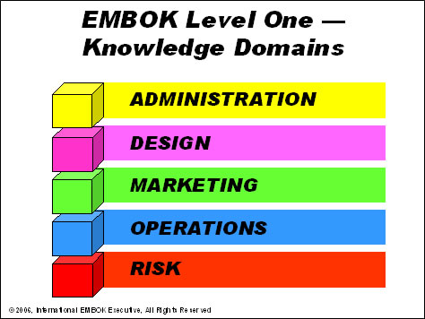
Fig 3: Domains of EMBOK
(Source: EMBOK, 2003b)
The administration domain emphasises skilled staffing for smooth event delivery. A team of event coordinators, hospitality staff, and local activity facilitators will manage the retreat, including venue preparation, post-event assessments, catering, guest support, and winter-themed activities offered by local tour operators, as opined by Fox et al. (2014). Technical support staff will handle AV setups and digital platforms to facilitate hybrid participation, consistent with the contemporary industry trends in virtual and hybrid engagement.
Winter events at Lake District require logistics management under the operations domain of EMBOK, including shuttle services and designated parking. Outdoor activities are offered indoors due to extreme unpredictability, offering flexibility and an unbroken programme for participants, as per Rogers and Wynn-Moylan (2022). The selection was done considering the Armathwaite Hall Hotel and Spa based on its winter-friendly indoor and outdoor structures that create an ideal environment for professional and leisurely engagement, strengthening the concept of the meeting.
EMBOK’s marketing domain focuses on strategic outreach to attract and engage senior leaders through digital channels, direct emails, and social media platforms, offering early bird discounts and exclusive sponsorship opportunities. Personalised digital communication not only upholds sustainability by reducing paper usage but also encourages participants in discussion, which is valuable to the retreat experience (Getz and Page, 2019).
In the risk domain, safety measures are crucial for outdoor winter activities, focusing on weather-related protocols and health guidelines to manage risk and protect attendees. This comprehensive approach, as per O’Toole (2011), addresses operational and environmental concerns, ensuring a balance between safety and a great event experience, as expected by senior hospitality leaders.

6. Event Budget
This is a winter-themed leadership retreat with income and expense projections so the organisation can always be in a financial position that sustains quality service. Revenue sources come from ticket sales, sponsorships, and premium activities:
Income Source | Amount (£)
Ticket sales (100 attendees) | 120,000
Sponsorship deals | 30,000
Sponsorship packages (3 sponsors) | 10,000
Total Income | 160,000
Expenditure | Amount (£)
Venue rental | 20,000
Catering and dining | 15,000
Accommodation | 30,000
Marketing and advertising | 10,000
Staffing and logistics | 12,000
Miscellaneous | 5,000
Total Expenditure | 92,000
Income Analysis
The major source of income will be through ticket sales at £120,000 since they will sell entry on the night for 100 attendees. Vendor fees will be an additional £10,000, while the sponsorship packages will amount to £30,000 in total. Premium winter activities that the sponsors will enjoy include private guided hikes.
Expenditure Analysis
Key costs are £30,000 for accommodation, £20,000 for venue rental, and £15,000 for catering and dining. All of these will be lavished on the guests. Other costs are marketing, logistics, and miscellaneous to make sure everything runs smoothly and the event is properly publicised.

7. Industry Trends / Issues / Impacts
This winter-themed leadership retreat would align to the post-pandemic changes along with digital innovation, changing sustainability demands, and meeting changing expectations of attendees.
Emphasis on Attendee Wellness
This industry saw booming wellness-centred experiences through the period of the pandemic. Wellness tourism refers to travelling with the intent to improve personal wellness. Despite a decline in wellness tourism from $720 billion in 2019 to $351 billion in 2020, the sector has recovered since then and has reached $651 billion in 2022. The wellness industry will continue growing at 16.6% per annum and is expected to reach $1.4 trillion by 2027. Secondary wellness travellers constituted 88% of wellness trips and 85% of tourism expenditure in 2022, as it deals with trips wherein wellness is not the primary motive (Global Wellness Institute, 2022). Wellness-themed retreats, winter activities, and guided hikes include fireside chats with senior leaders to update physical and mental wellbeing.
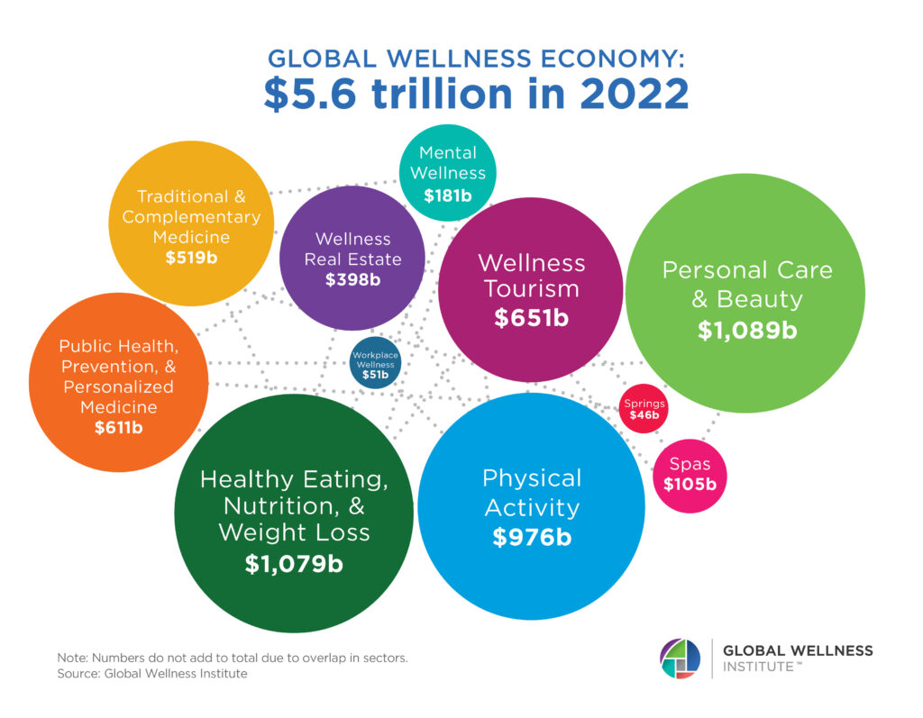
Fig 4: Global Wellness Economy 2022
(Source: Global Wellness Institute, 2022)
Hybrid and Virtual Event Integration
The popularity of hybrid and virtual components is on the increase with the preference of attendees who prefer flexible participation options. Hybrid events allow attendees to decide whether they want to participate in person or virtually; thus, they can easily reach a wider audience through such events. This trend presents an opportunity for organisers to address a wider global audience with more flexibility for remote participation (The Brainy Insights, 2024). Furthermore, the retreat will utilise digital platforms in this context.
Sustainability Focus
Due to environmental awareness making sustainability a buzzword, it becomes evident that events include these practices, such as getting rid of single-use items, digital communication, and sourcing locally for the catering (Mair and Jago, 2010). The International Congress and Convention Association (ICCA) has reduced its carbon footprint and is looking at environmentally friendly practices (ICCA, 2024). Sustainable retreats include local catering, digital event guides, and ecologically conscious activity planning, which resonate with the core values.
Personalisation and Data-driven Insights
Data analytics is driving a growing trend in personalised experiences, and organisers can create unique events tailored to specific interests or industries through data analytics. As per Stewart (2023), they can collect data on attendee preferences and move toward increased engagement and satisfaction. For example, at a retreat, according to The Brainy Insights (2024), attendees are given the opportunity to provide feedback during registration and on post-meeting surveys to guide the customisation of sessions and inform future events, ensuring content remains relevant to participants’ evolving needs.

8. Situational and Cultural Considerations
The winter-themed leadership retreat’s success relies on optimising situational and cultural factors using the SWOT analysis tool, ensuring a positive experience for UK hospitality industry senior leaders (Clarke & Chen, 2007). Such strategic planning in the Lake District can enhance the retreat experience by leveraging situational benefits and addressing potential risks.
Strengths | Weaknesses
The Lake District, known for its natural beauty, offers a unique winter retreat experience. This peaceful environment promotes wellness, leadership, reflection, and networking. The venue aligns with the trend of combining professional events with nature-based wellness experiences, enhancing attendee engagement and satisfaction (Spracklen & Lamond, 2016). The retreat’s focus on sustainable practices, such as local catering and reduced paper usage, appeals to eco-conscious industry leaders and thus improves the relevance and marketability of the event. | Winter attractions in off-site locations like the Lake District face logistical challenges due to weather uncertainty, potentially leading to postponements or cancellations. An effective contingency plan is needed, incorporating indoor-safe outdoor functions and adaptive programme schedules. Some attendees may not be conversant with winter navigation, and hence, there would have to be careful fine-tuning of shuttle service coordination and accommodation logistics (Maley, 2012).
Opportunities | Threats
Winter off-peak retreats in the Lake District boost local tourism and economy by attracting high-level hospitality leaders. These retreats are ideal for team building and reflective leadership sessions, balancing professional development with wellness. The hybrid format widens the event’s reach and encourages accessible, flexible models, benefiting the local community. | Extreme weather and health risks during winter pose significant threats to outdoor events and travel logistics. EMBOK’s risk domain emphasises safety in outdoor events, including weather monitoring, safe transport, and participant health preparation. The MICE industry faces competition due to sustainability and wellness, forcing them to constantly adapt their packages.
(Source: Smith, 2012; Getz and Page, 2019; Global Wellness Institute, 2022; ICCA, 2022; Rogers and Wynn-Moylan, 2022; The Brainy Insights 2024)

9. Conclusion
Using strategic event management principles, especially the EMBOK framework, the winter-based leadership retreat would create a unique and high-quality meeting event for senior hospitality industry leaders in the UK. The core elements of sustainable practice—activities well incorporated with a central focus on wellbeing, along with immersive winter sensations—would also consider modern trends in the MICE industry and accommodate logistical and cultural nuances of off-peak events in the Lake District. From initiation to closure, each stage is crafted to maximise attendee involvement, facilitate better knowledge sharing, and enable meaningful networking in a serene nature-based environment. The hybrid model and eco-friendliness of the meeting also align with the shift in attendee expectations in regards to flexibility and sustainability. This retreat therefore presents itself as a unique addition to the hospitality industry, instead with its issues of leadership and innovation, in addition to regional tourist profiles, while planning for future events in conformity to the advances in the industry.

References
Clarke, A. and Chen, W. (2007) International Hospitality Management: Concepts and cases. Amsterdam: Elsevier/Butterworth-Heinemann.
Dowson, R., Albert, B. and Lomax, D. (2023) Event planning and management: Principles, planning, and Practice. London, United Kingdom: Kogan Page.
EMBOK (2003a) Domains, EMBOK. Available at: https://www.embok.org/index.php/domains-page (Accessed: 28 October 2024).
EMBOK (2003b) Domains, EMBOK. Available at: https://www.embok.org/index.php/phases-page (Accessed: 28 October 2024).
Fox, D. et al. (2014) Doing events research: from theory to practice. Routledge: Oxford
Getz, D. and Page, S. (2019) Event studies: theory, research and policy for planned events. 3rd Edition. Routledge: Oxford
Global Wellness Institute, (2022). Wellness Economy Statistics & Facts. [online] Available at: https://globalwellnessinstitute.org/press-room/statistics-and-facts/ [Accessed on: 26th October, 2024]
ICCA, (2024). ICCA Congress 2023 Sustainability Report. [online] Available at: https://www.iccaworld.org/news/post/sustainability-report-congress-2023/ [Accessed on: 26th October, 2024]
Lyck, L., (2013). Sustainability in the meetings industry.
Mair, J. and Jago, L., (2010. The development of a conceptual model of greening in the business events tourism sector. Journal of Sustainable tourism, 18(1), pp.77-94.
Maley, C.H. (2012) Project Management Concepts, methods, and Techniques. Boca Raton, Fla: CRC Press.
Meredith, J. (2022) Project management: a managerial approach
O’Toole, W. (2011) Events feasibility and development: from strategy to operations. Elsevier: Oxford
Pavluković, V., Vujičić, M., Kennell, J. and Cimbaljević, M., (2020). Sustainability in the meetings industry.
Rogers, T. Wynn-Moylan, P (2022) Conferences and conventions: a global industry. 4th Edition. Routledge: Oxford
Smith, A. (2012) Events and urban regeneration: the strategic use of events to revitalise cities. Routledge: Oxford
Spracklen, K. and Lamond, I.R. (2016) Critical event studies. London: Routledge.
Stewart, M., (2023). Leveraging Data Analytics for Event Success. [online] Available at: https://hub.theeventplannerexpo.com/technology/leveraging-data-analytics-for-event-success [Accessed on: 26th October, 2024]
Tassiopoulos, D. (2010) Events management: A developmental and managerial approach. Claremont, South Africa: Juta Publ.
The Brainy Insights (2024) Events industry market, The Brainy Insights. Available at: https://www.thebrainyinsights.com/report/events-industry-market-13893 (Accessed: 28 October 2024).

