

A CRITICAL EVALUATION OF HOW MANAGERS MOTIVATE THE EMPLOYEES TO INCREASE PRODUCTIVITY AT WORK IN AN ORGANIZATION

Irina Tanase
192088
Table of Contents
Introduction 3
Research Problem 3
Prevalence, scope of problem 3
Rationale of the study 3
Aim, objectives and research questions 4
Literature Review 5
Overview of the research Variables 5
Theories related to the research completion 5
Key Points and literature 6
Literature Gap 8
Methodology 9
A. Research Design 9
B.Sample and procedures 9
Study population and proposed sample 9
Sampling Method 9
C. Measurement 10
Instrument 10
D. Ethical Issues 10
E. Gantt Chart 10
F. Limitations 10
References 12
Appendix 14

Introduction

Research Problem
This research problem focuses on an empirical analysis of motivational theories including, but not limited to, the following: Maslow’s hierarchy of needs, Herzberg’s two-factor theory and Vroom’s expectancy theory in real life environment or in an authentic workplace. As well, it looks into the searching the relevance of intrinsic and extrinsic rewards, leadership type and organizational culture on employees’ motivation (Kalogiannidis, 2021). This way it becomes easy to find out where managers might be doing something right which can be copied or where they may be going wrong which needs improvement thus helping managers to encourage their employees towards high productivity.

Prevalence, scope of problem
The fact that the issue regarding how managers encourage increased worker performance is extensive and has a substantial degree of occurrence and coverage pertains to being true. Workers’ motivation is always a big problem that many organizations encounter whereby workers are unmotivated and these results in low productivity rates, high disparity rates and low satisfaction levels (Kalogiannidis, 2021). The scope of the problem shows that this is an issue that impacts organizations of all sizes, in both the public and private sectors, including small businesses as well as the biggest companies. It is quite important to understand those factors which usually affect motivation and to distinguish the most important managerial practices to boost performance, to develop employees’ good health, and ultimately, to stay competitive in the modern world environment.

Rationale of the study
The purpose of this study is to respond to the research questions that explain the lack of proper employee motivation and ways to minimize it among organizations since several organizations lack ways to encourage staff through proper management. Subsequently, research has focused on Motivational theories many times however the knowledge gap that is prevailing in literature is how these theories are embraced and taken practically into working environments (Paais and Pattiruhu, 2020). This study seeks to critically assess the current practices and its effects, in a bid to offer a fresh perspective and real-life management heeds for managing professionals. In conclusion, the observations made potentially can help organizations promote the motivated, engaged, and productive workforce resulting in a high level of performance, satisfaction, and organizational success due to the increasing competitiveness of the business environment.

Aim, objectives and research questions
The aim of the study to assess the behavior and management approaches of managers in entailing staff commitment and enhancing organizational performance.
Objectives
- To identify the most commonly used motivational strategies by managers in various organizational settings.
- To assess the effectiveness of these motivational strategies on employee productivity and job satisfaction.
- To examine leadership behavior, organizational culture and motivation Human Resource Management.
Research Questions
- What are the most prevalent motivational strategies used by managers in different industries?
- How do these motivational strategies impact employee productivity and job satisfaction?
- In what ways do leadership styles and organizational culture influence the effectiveness of managerial motivational strategies?

Literature Review

Overview of the research Variables
The research focuses on two primary variables: The probability relationship for the theoretical model was such that it had the potential for addressing the issues of employee motivation and employee productivity. It is processes by which several internal and external factors are used on employees to encourage them perform activities that make it possible to achieve laid down objectives in an organization (Dangol, 2021). These include: internal drive, interest, and satisfaction, organizational identity and status, and external drive, compensation, and promotion opportunities, security respectively. Employee productivity, in the other hand, is the ability of employees dealing with organizational assignments and providing value added in relation to the main goals of an organization. It focuses on examining various aspects of managerial practices that include setting of goals, provision of feedback, use of incentives, and leadership styles as the factors that affect such variables. Thus, while outlining the correlation between motivation and productivity, the research will discuss about the effective practices that need to be followed by the managers for increasing both motivation and productivity in order to enhance performance of the organization (Hajiali et al., 2022). It is important to identify these variables and how they moderate each other in order to make a direction and appropriate strategy on the desired kind of motivation in the workforce.

Theories related to the research completion
Maslow's Hierarchy of Needs
As per Cui et al. (2021), Maslow's theory posits that employees have five levels of needs that must be met for them to be motivated and productive: These are the autonomy, affiliation and identify, and can further de-divided into the physiological, the safety, the social, the esteem and the self-actualization. Self-actualization needs entail the acquisition of a basic employees’ standard of living such as income, which could be met through offering reasonable wages stated by Basalamah, (2021). Cui et al. (2021) also states that the safety needs include; structural or uncertainty meaning safety in the workplace, and Freedom from physical danger. Social needs are self-actualization, achievement, and affiliation, which can be maintained through, employee relations and group formation exercises. Esteem needs refer to the human’s desire for recognition by other people and a sense of respect that comes with the confirmations of the achievements and significant responsibilities.
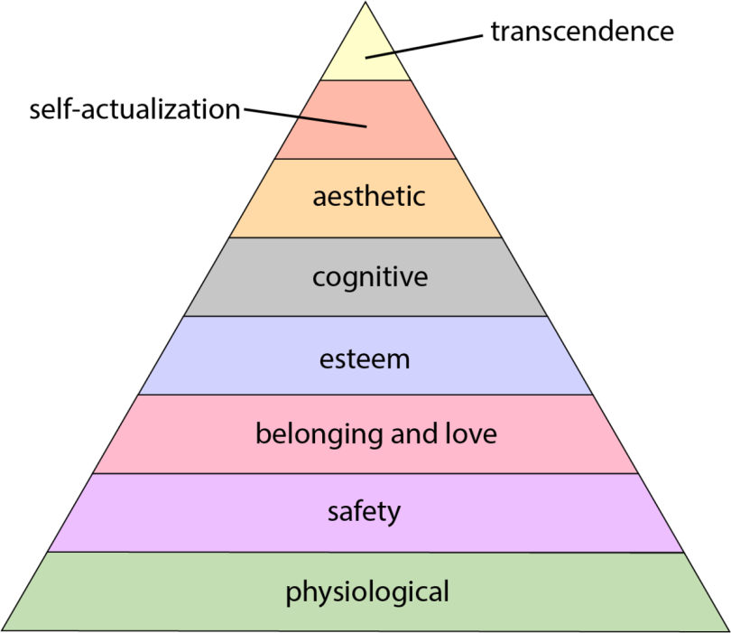
Figure 1: Maslow's Hierarchy of Needs

(Source: Anuyah et al., 2023)

Herzberg's Two-Factor Theory
According to Herzberg's Two-Factor Theory the factors are divided into two categories, namely Hygiene Factors and Motivators. Hygiene factors comprise of conditions such as pay, the working environment, policies, and security of job. While these factors may not positively drive employees, they may lead to dissatisfaction if so addressed. For example, low wages and dangerous working conditions are becoming sources of job contentment. While desirers are what one can refer to as rewards that really encourage employees and lead to enhanced performance and satisfaction at the workplace (Bhatt et al. 2020).

Key Points and literature
Identify the most commonly used motivational strategies by managers in various organizational settings.
The research Hongal and Kinange, (2020), carried out to find out which motivational techniques are widely used among managers in different companies and settings, state several frequently used methods. These include giving monetary rewards like bonuses and raises, training the employees to enhance their career growth, and rewarding and celebrating them through awards and any other form of appreciation. On the other hand, Cherian et al., (2022) states that there is often the application of goal setting with regards to their practice, it is made sure that the goals set can indeed be achieved and that practitioners understand what is expected out of them; also, the maintenance of a healthy work relationship with their subordinates and peers through organizational activities such as team building and other exercises which include the free flow of communication. Another key factor that has contributed considerable influence towards employee’s performance is working conditions which include among them remote working and working at different times. Altogether, these strategies goals are to improve job satisfaction, productivity, and organizational commitment.
Effectiveness of these motivational strategies on employee productivity and job satisfaction
According to Cherian et al., (2022), Motivational strategies enhanced total employee productivity and overall job satisfaction that can help to examine the result of these motivational strategies on the employees. There are always rewards in promotions, monetary benefits, alongside growth in an individual’s career. Reward mechanisms, and particularly the aims and objectives are important in ensuring that morale and the desire to work is encouraged, as people feel they have conquered something, and they are working towards something. As per da Cruz Carvalho et al. (2020), the flexible working conditions and organizational settings proved helpful with increased job satisfaction since such conditions help to balance between work and the outside world. In combination, these are beneficial since they increase efficiency in placing expectations and outcomes from an employee’s work while at the same time guaranteeing high retention rates since committed employees are loyal to organizations as per Kuswati, (2020).
Examine leadership behavior, organizational culture and motivation Human Resource Management
Paais and Pattiruhu (2020) argues that examining these critical areas, such as leadership behaviour, organizational culture, and motivation within the context of Human Resource Management, requires an understanding of how they are related. Many soft behavioral employee coping strategies, particularly transformational and participative subcategories are strongly related to organizational culture because they lead to enhanced organizational trust, collaboration, and innovation. Thus organizational culture, on the other hand plays a positive role in the employee motivation through the belief system, procedures, and feelings of togetherness. As per Keegan and Meijerink, (2023), the HRM practices are important in supporting these dynamics by putting in place policies and programmers that facilitate leadership training, corporate culture sensing and employee synergy. Knowledge of these relationships is significant to the directionality of strategies for organizational performance enhancement as well as the wellness of the employees.

Literature Gap
While a great amount of consideration and effort have been given to theories of motivation in the workplace, there is still very limited comprehension of how such theories are put into use as workplace practices across different types of organizations of the world and kinds of industries. Moreover, lack of researches have been done in deep to go in depth of the problems.

Methodology

A. Research Design

The research method used in this study is basically a survey research design with a primary reliance on quantitative data collection instruments. Self-administered questionnaires will be given out to employees in different organizations to capture their views on motivational measures as well as their efficacy in increasing organizational performance. This is specifically due to its quantitative characteristic, making the exploration of correlations between two or more variables possible and, for instance, various types of motivation and their efficiency (Duckett, 2021).

B.Sample and procedures

Study population and proposed sample
The research undertaken involves a sample of employees of Unilever, which is a multinational company that has earned a reputation for its ability to embrace Diversity and being present in many parts of the world. The sample envisioned for the proposed study involved 50 employees recruited from different departments and organizational ranks.

Sampling Method
The research will entail random sampling methods for 50 employees of Unilever. The respondents will be sending a Google Form survey and employees will be invited to participate. This approach helps in organization of data collection and at the same time facilitates people across functions and geographical regions in the company to contribute spontaneously. The main advantage of the survey’s structure is that the insight into the managerial practices can be collected systematically and the outcomes’ relation to the motivation and productivity of employees can be identified (Gao et al. 2020).

C. Measurement

Instrument

The Google Form structures develop a survey with questions structured to measure motivational aspects affecting Employee Productivity at Unilever while gathering perceptions of their implementation (Srivastav et al. 2021). The survey is set 50 demographic questions for 50 employees of Unilever Whose aim is to gather quantitative data that can be later evaluated and analyzed statistically. Another advantage of using the Google Forms tool is that it is convenient to distribute and collect surveys electronically, and at the same time, maintain the anonymity and convenience for the employees.

D. Ethical Issues
Participants’ information was gathered based on informed consents of the clients. Their responses were kept confidential. Every participant was locked from identification. Cordiality should be maintained throughout the study process and refusal to be examined as well as withdrawal from the study should not be coerced. Finally, data collected processes must also adhere to the requirements of data protection laws and taint the participant’s privacy.

E. Gantt Chart
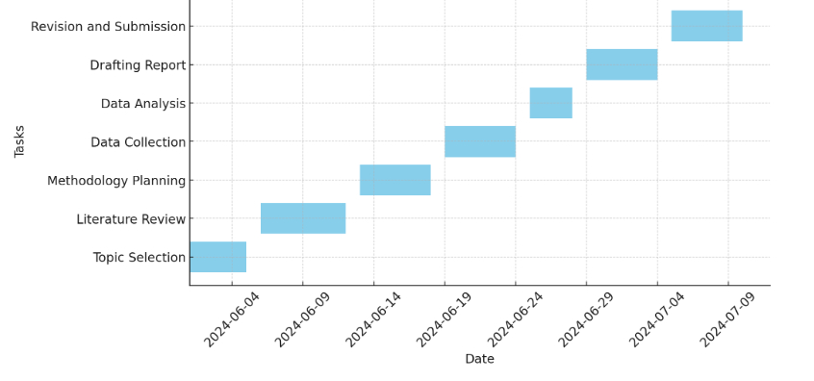

F. Limitations
The limitation of this research is use of surveys exclusively because of lack of time and financial constraints thereby possibly reducing chances of carrying out more detailed qualitative ones with live observations or interviews that ultimately leads to lack of proper information in some portion or biased answers.

References
Ali, B.J. and Anwar, G., 2021. An empirical study of employees’ motivation and its influence job satisfaction. Ali, BJ, & Anwar, G.(2021). An Empirical Study of Employees’ Motivation and its Influence Job Satisfaction. International Journal of Engineering, Business and Management, 5(2), pp.21-30.
Anuyah, O., Badillo-Urquiola, K. and Metoyer, R., 2023, April. Characterizing the technology needs of vulnerable populations for participation in research and design by adopting Maslow’s hierarchy of needs. In Proceedings of the 2023 CHI Conference on Human Factors in Computing Systems (pp. 1-20).
Basalamah, S.A., 2021. The role of work motivation and work environment in improving job satisfaction. Golden Ratio of Human Resource Management, 1(2), pp.94-103.
Bhatt, N., Chitranshi, J. and Mehta, M., 2022. Testing Herzberg's two factor theory on millennials. Cardiometry, (22), pp.231-236.
Cherian, J., Gaikar, V., Paul, R. and Pech, R., 2021. Corporate culture and its impact on employees’ attitude, performance, productivity, and behavior: An investigative analysis from selected organizations of the United Arab Emirates (UAE). Journal of Open Innovation: Technology, Market, and Complexity, 7(1), p.45.
Cui, L., Wang, Y., Chen, W., Wen, W. and Han, M.S., 2021. Predicting determinants of consumers' purchase motivation for electric vehicles: An application of Maslow's hierarchy of needs model. Energy Policy, 151, p.112167.
da Cruz Carvalho, A., Riana, I.G. and Soares, A.D.C., 2020. Motivation on job satisfaction and employee performance. International research journal of management, IT and social sciences, 7(5), pp.13-23.
Dangol, P., 2021. Role of performance appraisal system and its impact on employees motivation. Quantitative Economics and Management Studies, 2(1), pp.13-26.
Duckett, L.J., 2021. Quantitative research excellence: Study design and reliable and valid measurement of variables. Journal of human Lactation, 37(3), pp.456-463.
Gao, B., Yang, Q., Peng, Z., Xie, W., Jin, H. and Meng, S., 2020. A direct random sampling method for the Fourier amplitude sensitivity test of nonuniformly distributed uncertainty inputs and its application in C/C nozzles. Aerospace Science and Technology, 100, p.105830.
Hajiali, I., Kessi, A.M.F., Budiandriani, B., Prihatin, E. and Sufri, M.M., 2022. Determination of work motivation, leadership style, employee competence on job satisfaction and employee performance. Golden Ratio of Human Resource Management, 2(1), pp.57-69.
Hongal, P. and Kinange, U., 2020. A study on talent management and its impact on organization performance-an empirical review. International Journal of Engineering and Management Research, 10.
Kalogiannidis, S., 2021. Impact of employee motivation on organizational performance. A scoping review paper for public sector. The Strategic Journal of Business & Change Management, 8 (3), 984, 996(3).
Keegan, A. and Meijerink, J., 2023. Dynamism and realignment in the HR architecture: Online labor platform ecosystems and the key role of contractors. Human Resource Management, 62(1), pp.15-29.
Kuswati, Y., 2020. The effect of motivation on employee performance. Budapest International Research and Critics Institute-Journal (BIRCI-Journal), 3(2), pp.995-1002.
Paais, M. and Pattiruhu, J.R., 2020. Effect of motivation, leadership, and organizational culture on satisfaction and employee performance. The Journal of Asian Finance, Economics and Business, 7(8), pp.577-588.
Paais, M. and Pattiruhu, J.R., 2020. Effect of motivation, leadership, and organizational culture on satisfaction and employee performance. The Journal of Asian Finance, Economics and Business, 7(8), pp.577-588.
Sitopu, Y.B., Sitinjak, K.A. and Marpaung, F.K., 2021. The influence of motivation, work discipline, and compensation on employee performance. Golden Ratio of Human Resource Management, 1(2), pp.72-83.
Srivastav, A.K., Sharma, N. and Samuel, A.J., 2021. Impact of Coronavirus disease-19 (COVID-19) lockdown on physical activity and energy expenditure among physiotherapy professionals and students using web-based open E-survey sent through WhatsApp, Facebook and Instagram messengers. Clinical epidemiology and global health, 9, pp.78-84.
Stratton, S.J., 2021. Population research: convenience sampling strategies. Prehospital and disaster Medicine, 36(4), pp.373-374.

Appendix
Questionnaire
What is your age group?
- a) Under 25
- b) 25-34
- c) 35-44
- d) 45-54
- e) 55 and above
Which of the following motivational strategies does your manager use most frequently?
- a) Financial incentives (bonuses, raises)
- b) Recognition and rewards (awards, employee of the month)
- c) Professional development opportunities (training, workshops)
- d) Flexible work arrangements (remote work, flexible hours)
- e) Regular feedback and communication
How effective do you find financial incentives in increasing your productivity?
- a) Very effective
- b) Effective
- c) Neutral
- d) Ineffective
- e) Very ineffective
How does recognition and rewards impact your job satisfaction?
- a) Significantly increases
- b) Moderately increases
- c) No impact
- d) Moderately decreases
- e) Significantly decreases
How often does your manager provide opportunities for professional development?
- a) Very often
- b) Often
- c) Sometimes
- d) Rarely
- e) Never
To what extent do flexible work arrangements improve your work-life balance?
- a) Greatly improve
- b) Moderately improve
- c) No impact
- d) Moderately worsen
- e) Greatly worsen
How regularly does your manager provide constructive feedback on your performance?
- a) Very regularly
- b) Regularly
- c) Occasionally
- d) Rarely
- e) Never
How does your manager's leadership style affect your motivation at work?
- a) Significantly increases motivation
- b) Moderately increases motivation
- c) No impact
- d) Moderately decreases motivation
- e) Significantly decreases motivation
How would you rate the overall organizational culture in terms of supporting employee motivation?
- a) Very supportive
- b) Supportive
- c) Neutral
- d) Unsupportive
- e) Very unsupportive
How satisfied are you with the current motivational strategies used by your manager?
- a) Very satisfied
- b) Satisfied
- c) Neutral
- d) Dissatisfied
- e) Very dissatisfied
How likely are you to stay with the organization due to the motivational strategies employed by your manager?
- a) Very likely
- b) Likely
- c) Neutral
- d) Unlikely
- e) Very unlikely

