University of Wales Trinity Saint David
KNOWLEDGE AND INFORMATION MANAGEMENT AT AMAZON
Knowledge and Information Management skills for the Workplace
Vasilka Nikolova
Lecturer: Zainab Atta

Executive Summary
Introduction
Knowledge management entails generating, obtaining, capturing, allocating, and using knowledge to support learning in an organisation. Its primary goal is to enhance the efficiency of an organisation and save knowledge. Usually, it includes the learning and training of employees to understand the market effectively. Sharing, storing, and accumulation of knowledge are the essential aspects of knowledge management. On the other hand, information management includes managing information resources in an organisation to enhance its performance. To be successful in the market, an organisation must effectively manage its information. Amazon is the most prominent internet-based organisation globally. It was first started in 1994 by Jeff Bezos, as an online book store. Currently, the organisation sells everything ranging from groceries to book and shipping containers. Its rapid growth and success can be attributed to its effective implementation of knowledge and information management approaches. Undeaniably, Amazon has appropriately used knowledge and information management to realize a competitive edge in the market. With the ever-competitive and changing business environment, one of the unsurpassed ways to remain ahead of the curve is to model an organisation flexibly and intelligently.
An organisation must be able to identify problems and trends in the market early to make strategic decisions which favour its operations quickly. This is only possible with the help of knowledge and information management. Knowledge and information management are crucial in any business organisation. It is attributable to the fact that it improves an organisation's efficiency, especially when it comes to decision-making capacity. Besides, it supports a more competent workforce and ensures an innovative workplace, improving customer satisfaction and minimizing employee turnover.

Table of Contents
Executive Summary 1
Introduction 3
Section 1: Knowledge and Information Management 4
Section 2: Evaluation of Knowledge and Information Management Models/Theories 7
Section 3: Investigating the KM techniques used by Amazon.com 11
Conclusions and Recommendations 14
References 17
References 18
Appendix.1: Amazon Business Logo 19
Appendix 2: Typical Knowledge ecology within an organization 20
Appendix 3: KM Implementation framework 21

Knowledge and Information Management at Amazon

Introduction
The report will detail the use of knowledge and information management to support an organisation's quest to realise a competitive edge in the market. Knowledge management is the process of searching, documenting and sharing the knowledge between the people in the organization. Entails generating, obtaining, capturing, allocating, and using knowledge to support learning in an organisation. Major Knowledge Management Models are The Nonaka and Takeuchi Knowledge Spiral Model (1995), SECI model described how tacit knowledge and explicit knowledge can be transformed in an organization. The von Krogh and Roos Model that clearly distinguishes between individual knowledge and social knowledge, analysed why and how the knowledge gets to the employees of a company, why and how the knowledge reaches the organization, what are the barriers for organizational knowledge management. The Choo Sense-Making KM Model is a process that allows an organization to create or acquire, organize and process information to generate new knowledge through organizational learning.
Its primary goal is to enhance the efficiency of an organisation and save or otherwise keep the knowledge. Usually, it includes the learning and training of employees to understand the market effectively. Sharing, storing, and accumulation of knowledge are the essential aspects of knowledge management. On the other hand, information management is the process to store and analyse information using hardware and software, includes managing information resources in an organisation to enhance its performance.
To be successful in the market, an organisation must effectively manage its information. Amazon is considered the most prominent internet-based organisation globally. It was first started in 1994 by Jeff Bezos, as an online bookstore. Currently, the organisation sells everything ranging from groceries to book and shipping containers. Its rapid growth and success can be attributed to its effective implementation of knowledge and information management approaches. Undeniably, Amazon has appropriately used knowledge and information management to realize a competitive edge in the market. With the ever-competitive and changing business environment, one of the unsurpassed ways to remain ahead of the curve is to model an organisation flexibly and intelligently.
An organisation must be able to identify problems and trends in the market early to make strategic decisions which favour its operations quickly, for example cashflow, excessive competition, customer returns. This is only possible with the help of knowledge and information management. Knowledge and information management are crucial in any business organisation. It is attributable to the fact that it improves an organisation's efficiency, especially when it comes to decision-making capacity. Besides, it supports a more competent workforce and ensures an innovative workplace, improving customer satisfaction and minimizing employee turnover. To effectively understand the role of knowledge and information management in an organisation, evaluating different knowledge management theories is imperative. The analysis focuses on the three main knowledge management theories. They include Organisational KM theory, which emphasizes organisational structures and how they are modelled hierarchically and culturally to manage information, knowledge, and related processes. Techno-centric KM theory which emphasises technology and how to use it to facilitate the flow of knowledge and information storage. Lastly, Ecological KM theory which focuses on the learning communities, relationships, and people, including the relevant interactions among people and organisations.

Section 1: Knowledge and Information Management

Amazon.com Inc. is a multinational tech company based in Washington its business is specialized in digital streaming, cloud computing and generally e-commerce. It forms part of the big five tech companies in U.S alongside Facebook, Google, Microsoft and Apple (Miller and Rabolt, 2018). Amazon is a very influential cultural and economic force around the globe. It was founded by its CEO, Jeff Bezos in 1994 as an online marketer for books which later expanded to be a big store for software, electronics, food, furniture, toys, jewellery, apparel, and video games. Over time, Amazon has become a fast online delivery of everything from grocery, videos and electronics. The company offers online retail services to consumers, business enterprises, content creators and sellers. In addition, it also offers promotional and marketing services including advertising and agreements on co-branded credit cards. Amazon serves customers via retail websites with a great focus on convenience, price and consumer preference.
The company strives to offer its customers the lowest prices possible through low daily pricing and free offers on shipping facilitated by Amazon Prime (Aaiden and Ellen, 2019). After its foundation, it was spurred by a model which its founder called the ‘regret minimization framework;’ meant to cut off any regrets arising as to why he had no ventured into the online business earlier. Bezos was encouraged by a report on the future of the internet with a projected 2300% web growth in commerce. The company was then launched as an online bookstore. Bezos also searched for a named that began with letter ‘A’ for it to appear early in the order of alphabets. The company since its inception uses a simple business model which can be copied over time, but still maintains its lead. Its logo features a curved arrow pointing from ‘A’ to ‘Z’ as a symbol that Amazon carries every product by which ever name in the alphabets (Appendix 1). The company released its initial public offering of stock in 1997 and traded under NASDAQ stock exchange as AMZN (Galloway, 2017). At the hit of 21st Century, the era of the internet was full-blown and Amazon survived growing beyond its expectations becoming a huge player in online business. It got popular through its appeal for convenience. This meant that a potential customer did not need to go physically to a bookstore to acquire a book but could still acquire and possess the same book via Amazon’s online channel. Amazon eased the search navigation and the purchase experience where customers would acquire products from the comfort of their homes (Miler, and Rabolt, 2018). This was quite an amazing innovation at the time Amazon was getting popular. The company also heightened the experience through delivery of products to the customer. With the addition of customer, feedback and reviews helped in fostering a customer community which made the site quite appealing to potential customers. In recent years, Amazon has scaled up to the heights of becoming the second ever 1 dollar trillion market cap organisation in history after Apple. Today, Amazon is a business behemoth which links customers to their preferred products as well as businesses to the customers who need them (Amazon.com, 2020). o
Knowledge Management (KM) refers to the process of creation, distribution, utilisation and handling the information and knowledge within an organisation. KM is a multi-faceted discipline geared towards the realisation of organisational goals by making the best out of company’s knowledge and information. KM helps to heighten the efficiency of an organisation in terms of decision-making. KM helps in sharing perspectives, information, experience and ideas (Becerra-Fernandez and Sabherwal, 2014). The main goal of KM is to enhance efficiency and secure company’s information.
Knowledge management is very important for any organisation including Amazon. It boosts company’s efficiency and more particularly in ensuring that all employees have got the right access to general expertise which is held within the company by building a workforce which is smarter and well capacitated to make decisions which are quick and well-informed. Additionally, KM makes innovation an easy process to foster within the company with consumers reaping benefits from better access to good practices as well as diminished employee turnover. With the market place becoming advanced and more competitive, the best way to stay ahead is by building the company’s intelligence and flexibility (Brito, et.al, 2020). Organisations like Amazon have a well-spurred knowledge management system for efficient work environments, faster, and well-informed decision-making, increased collaborative fronts, better ways to acquire and utilise organisational knowledge, better training optimisation and employee on boarding as well as increased employee retention and satisfaction. KM enables employees to benefit from colleagues expertise and knowledge of getting things done in the best way. Knowledge management makes workers to feel appreciated and so they can make better utilisation of in-house expertise.
Businesses such as Amazon.com collects and absorbs the appropriate information regarding its consumers and becomes better placed to internalise changes by taking advantage of the many opportunities emerging in the market place. With KM in place, organisations tend to minimise their time of search and the efforts of consolidating information concerning customers. This is to mean that KM makes it easier to access and use customer information such as changing preferences, demands and desires (Becerra-Fernandez and Sabherwal, 2014). The KM tools are important in the compilation of customer information across many points where customer interact with the business such as through social medial, email, phone or in-store. Businesses such as Amazon use the different types of KM tools in receiving detailed information about consumers’ purchase behaviour, their concerns as well as buying experiences which they use to help them serve their customers effectively and efficiently.
Through customer feedback, tools which are used in optimising knowledge management such as opinion polls, online surveys, and organisations can better serve customers. Through accurate and faster communication created by effective KM, employee procedures and corporate policies become eased up which gives an organisation a competitive edge. Further, KM facilitates quicker settlement of problems as they arise in an organisation and further helps to embed the necessary knowledge to staff, services, projects, processes, and clients which altogether cushions the information access process for realisation of critical decisions (Chen, and Liang, 2016). Further, KM creates an organisational competitive edge by helping employees to find quick innovative solutions to problems and be able to quickly share the useful experience. Whenever the quality of tacit or explicit knowledge of employees is high, this increases the competitive edge of the organisation (Wilde, 2011).

Section 2: Evaluation of Knowledge and Information Management Models/Theories

There are several methods and applicability of knowledge and information management with each theory varying according to its author, scholar or practitioner. The major three key theories of Knowledge management are categorised as organisational KM theory, the ecological KM theory and finally the techno-centric theory. The organisational theory is more hinged upon the structures within an organisation and how the organisation is made culturally and hierarchically in managing knowledge and the processes involved (Grant, 2016). The theory aims at how an organisation improves itself all the time via gaining the necessary experience of creating knowledge which is then passed on within the organisation.. The theory considers three actions of conceiving an idea or a product where a company creates the product or the product where the company reflects the process and outcome. Under organisational theory, learning is meant to take place whenever people interact whenever finding and getting solutions to problems (Chen, and Liang, 2016). Under organisational KM theory, organisations should have the realisation of a culture which gives priority to the sharing of knowledge. They should also utilise time to get the appropriate lessons from failures, and as such, organisations must encourage employees of every level to advance their education regularly and organisations should be able to permit teams and individuals to challenge the organisational status quo (Hislop, Bosua, and Helms, 2018).
Organisational KM theory creates a learning culture which creates key benefits such as better worker-job satisfactions, lower rates in turnover, efficiency, profitability and productivity, development of leaders at every level and enhanced adaptability across the organisation. The heightened ability to react fast to the dynamic business environment is just one single emphasis of the importance of organisational KM theory. Any organisation which embraces the learning outcomes from its history of failure and at the same time masters its own processes is one organisation which contains much knowledge regarding the best practices and is set to a better position for adapting to changes
Secondly, the ecological KM theory is anchored upon people, learning communities, and different relationships inclusive of interactions among persons and organisations as well as the internal and external factors which bring people close to each other to share knowledge and information. The ecological theory of knowledge management is composed of four areas- knowledge, external environment, communities and organisational resources (Chen, Liang, and Lin, 2010). The diverse types of knowledge within the organisation are then understood as different knowledge populations and then categorized as a knowledge community within the model (appendix 2). The knowledge communities are built on top of organisational resources such as culture, structure, process and staff. All these maintain a state of equilibrium with the external environment to maximize on their interests via evolution, competition, interaction and distribution. All these four elements are known to interact with one another to evolve in a manner which helps to maintain ecology of healthy knowledge within the specific organisation. The way an organisation selects the configuration of knowledge to meet the needs of the environment calls for an understanding in knowledge intensity and diversity. Interaction can be internal or external. Internal interaction allows knowledge to be shared by different entities within the same organisation. External interaction means that knowledge from outside sources can access the organisation. Environmental variability yields pressures to organisations which dictate knowledge evolution so that an organisation can build, integrate, and reconfigure their competencies under a fast-changing environment.
Techno-centric theory is another value system which is concerned with technology and its capability to exercise control and protection of the environment. Techno-centric KM theory is more focused on technology as well as the process of designing tech enablers to ease the flow and storage of information and knowledge (Al‐Hakim, and Hassan, 2013). Technology through its ability to solve problems, managerial means and efficiency is regarded to be able to address different ecological issues. Problems arising from the business environment are viewed as issues which can be solved using rational technological and scientific methods. An organisation considers technical solutions to be the ultimate and sufficient to environmental problems. In a real-life example, sustainability is regarded as changing the minds and hearts of people (Dirk and Alexandros, 2012).
All these KM theories are very instrumental in helping organisations to create and manage different knowledge assets. Knowledge assets refer to the organisation’s accumulated intellectual resources such as information, ideas, insights, technical skills, learning. Tadejko, (2020) argues that the global economy has become knowledge driven in every sense. It has become rapidly growing which is subject to how an organisation utilizes its knowledge. Organisational KM theory helps organisations to create and manage knowledge assets by keeping the learning of the organisation alive. This increases efficiency of the organisation’s ability to make decisions. Additionally, organisational KM theory ensures that all employees have access to the general expertise held within the company building a smart workforce who can make fast and well informed decisions. Amazon has remained quite innovative yet utilising a simple business model by giving purpose to content and utilising every chance (Galloway, 2017). The ecological KM theory encourages an interactive score with the business environment. The knowledge obtained such as best practices, intellectual property and codified explicit information is used for the betterment of Amazon stores (Tou et al., 2019). The techno-centric theory is centred on technology as a solution giver. Amazon’s tech-knowledge includes web service, networking, middle and group ware with enterprise systems integrated with HR, accounting and logistics as key pillars of information management. This forms part of the larger Amazon’s accumulated intellectual resources (Oleg, and Girault, 2018).

Section 3: Investigating the KM techniques used by Amazon.com

Amazon is among the leading multinational e-commerce having a vast scope of clientele as well as customer base. The company uses specialized knowledge and information systems in its business processes to achieve competitive landscape by means of improved efficiency in its storage, collection and analytics of client personalised information. Amazon.com has well-integrated systems of information and knowledge management. Amazon uses KM as a vibrant tool in streamlining its activities in management which has helped the company to offer customers services which are diversified (Castelli et al., 2017). The main theoretical models employed by Amazon include the Organisational KM theory, Techno-centric KM theory, and the Ecological KM theory. The Organisational KM model is observable in Amazon’s organisational structure which is hierarchically and extensively structured to exert control on Amazon’s e-commerce operations. Through its corporate structure, Amazon establishes a good system and design of interacting among the workforce of the organisation. Its corporate structure is a key determinant of the way its managers influence and give direction in operational activities in the different business areas. The hierarchical modelling of the firm facilitates the way knowledge and information is held within the firm. Additionally, Amazon incorporates the ecological KM model in its interactions with communities, suppliers, customers, partners, third-party sellers who use the Amazon platform to sell their products among many others (Zamri et al., 2020). When sellers join Amazon, their products attracts even more buyers. Eventually, Amazon dominates the downstream retail market and gains tremendous bargaining power and the ability to set rules in its favour over the upstream sellers. As a global and leading online retail business, Amazon maintains a structure of interaction and leadership which offers adequate support in the global market reach. Complemented by a strong ever evolving corporate structure, Amazon benefits its clientele through diversification and giving the necessary feedback via customer interactive platforms which it offers. Moreover, the techno-centric KM theoretical model is quite evident through scrupulous innovative technology. The design of Amazon’s corporate structure matches the business technological foundation. It is this technological move which makes it to increase its productive agility and stand out of its competitors such as Google, Walmart, Apple, and Microsoft. Amazon’s technocentrism gives it the appropriate aggressiveness in strengthening the organisational online success. The way Amazon preserves its tech-aggressive and innovative knowledge and innovation makes it stand tall in the market (Meyer, 2019).
Amazon has achieved many outcomes by the utilization of organisational, ecological and the techno-centric KM theoretical techniques in engaging with knowledge and information. The whole scenario and the big success of Amazon has been made possible through advanced techniques of knowledge-management (Moore, and Tambini, 2018). From its inception, Amazon has been determined to bring into operation an exceptional user experience which is the ability of its consumers to be able to find what they desire, such user experience has been determined as a key to the success of its business.
Amazon has been operating on two major technologies acting as the drivers of its growth. These are information management and integration of customer relations management (Moore, and Tambini, 2018). Amazon’s IT infrastructure is built in a way that it can handle millions of operations and queries. Through customer relationship module, Amazon can store personalised information as well as trends in purchase integrated together with the marketing campaigns of the firm. Amazon’s strategy of sales is unique and reflects its Knowledge management system. Its operations have taken a transition from one level sales strategy to a multi-level e-commerce strategy. Its recent e-commerce development has caused improvements in the manner of interactions between the business and the customer enabling Amazon to be able to offer more priority to IT while respecting the customer reviews as part of the operations of the business. Apart from this experience, different KM principles and practices have played a big role in different ways. First, Amazon offers single portal-single interface. This is to mean that every purchase customers makes from Amazon is via the same portal whether it be books, electronics, and food. With a one stop shopping experience, the user experience remains the same for all (Castelli et al., 2017).
Right from specifications of products to reviews, Amazon is known to display information concerning each product in a way which is similar and in the same order. This emanates from the exceptional management of content where information is composed and published to consumers in a way which reflects consistency. As a result, employees do not have to keep on reading and taking time to interpret content. Moreover, through modular content, Amazon organises its pages in easy-to-read sections which enables workers to have a quick access to only right content and saves their time (Zamri et al., 2020). According to Tou et al., (2019) Amazon also incorporates distributed upstream creation of content. Amazon does not control everything; it lets the real product company with expertise to generate content, which must match the design standards, policies and practices as given by Amazon. By doing so, the company encourages content relevancy, accuracy and completeness. Through a kind of magical personalisation, the more customers use the Amazon Website, the better the site seems to know the customers.
With features like reviews, ratings, and images, Amazon can build sufficient knowledge as well as awareness among users. Different online sites have copied Amazon’s business model and particularly the archetype of most of the social features. Further Amazon facilitates quite consistent and easy transaction. Becerra-Fernandez, and Sabherwal (2014) argues that the usability of content is a very critical part of KM efforts in any organisation. Through constant reminders and alerts, the system keeps giving awareness to users regarding subscriptions. This enhances efficiency and productivity where the KM system can make users aware without any repetitive and exhaustive search. Other areas where Amazon is highly achieving through KM principles include offering feedback to customers regarding value content which is one of the most effective ways on effective KM effectiveness, reduced servicing via call centre by making its site user friendly, and performance-cantered with exceptional mobility (Tou et al., 2019).
The key areas where Amazon.com can still improve in the future to overcome any potential challenges include the need to keep an inventory which is balanced, improve the area of customer reviews since most of the feedback given to customers is not timely as well as keep the rating of its sellers high via better communication strategies.

Conclusions and Recommendations

Knowledge management calls for several steps in the identification, collection, storage and sharing of implicit, explicit and tacit information to personnel with an organisation. Amazon uses its corporate intranet website with virtually stored information regarding its products and services which ranges from grocery, online bookstore, electronics and almost anything else. Through an information management system, Amazon runs dual piece software of KM comprising the simple service storage which is linked to its integrated database and then the Amazon website which promotes a big access to the Amazon e-commerce platform. The information and knowledge management of Amazon has achieved value addition through enhancing customer care, availing limitless inventory and having high profit margins and considerably low prices. It is evident that Amazon is doing great via its KM established fronts and there is a big scope for the organisation to improve its client connection management via its enterprise resource planning.
By use of the data and information as well as the knowledge from online trends of purchase, Amazon should analyse other potential markets considering demographics (Ferraris et al., 2019). Amazon should customise its campaigns on marketing. These campaigns should be tailored to the customer needs. The use of customer data from a specific community will aid in promoting the practice and then giving out newsletters which are more customised towards the needs of the community. Amazon should make the best use of all information which is available. Amazon should bridge the gap between its sales activities and marketing. This can easily be achieved via standardised Management information systems (Hislop, Bosua, and Helms, 2018). With a well-endowed information system, Amazon must strive to integrate it with more knowledge management and the existing infrastructure. An attractive part of the implementation of the virtual agents in Amazon is in the bringing the technology to functionality in combination with other web based applications.
The timelines required in the implementations of the recommendations for Amazon KM framework (Appendix 3) will be dependent with people, processes, culture, structure, and technology. However, with well-established KM program objectives, little resistance for change, with a priority to technology needs and a carefully drawn KM implementation roadmap, the framework should be completed with three years.

References
Aaiden & Ellen (2019). Global Strategic Business Management: Focusing On the Strategic Business Unit of Amazon Whole Foods. Journal of Research on the Lepidoptera.
Al‐Hakim, L.A.Y. and Hassan, S., 2013. Knowledge management strategies, innovation, and organisational performance. Journal of Advances in Management Research.
Amazon.com. (2020, February 8). Companies History - The Biggest Companies in the World. Retrieved March 15, 2021, from https://www.companieshistory.com/amazon-com/
Becerra-Fernandez, I., & Sabherwal, R. (2014). Knowledge management: Systems and processes. Routledge.
Brito, E., Pais, L., dos Santos, N.R. and Figueiredo, C. (2020), "Knowledge management, customer satisfaction and organizational image discriminating certified from non-certified (ISO 9001) municipalities", International Journal of Quality & Reliability Management, Vol. 37 No. 3, pp. 451-469.
Castelli, M., Manzoni, L., Vanneschi, L. and Popovič, A., (2017). An expert system for extracting knowledge from customers’ reviews: The case of Amazon. com, Inc. Expert Systems with Applications, 84, pp.117-126.
Chen, D.N., Liang, T.P. and Lin, B., (2010). An ecological model for organizational knowledge management. Journal of Computer Information Systems, 50(3), pp.11-22.
Chen, D., & Liang, T. (2016). Knowledge diversity and firm performance: An ecological view. Journal of Knowledge Management, 20(4), 671-686.
Ferraris, A., Mazzoleni, A., Devalle, A. and Couturier, J., (2019). Big data analytics capabilities and knowledge management: impact on firm performance. Management Decision.
Galloway, S. (2017). The four: the hidden DNA of Amazon, Apple, Facebook and Google. Random House.
Grant R. (2016) Knowledge Management Theories. In: Augier M., Teece D. (eds) The Palgrave Encyclopedia of Strategic Management. Palgrave Macmillan, London.
Hislop, D., Bosua, R. and Helms, R., (2018). Knowledge management in organizations: A critical introduction. Oxford university press.
Meyer P. (2019, February 16). Amazon.com Inc.’s organizational structure characteristics (An analysis). Panmore Institute. https://panmore.com/amazon-com-inc-organizational-structure-characteristics-analysis
Miler, J. K., and Rabolt, N. J. (2018). Amazon the Innovator. Bloomsbury Fashion Business Cases.
Zamri, N.E., Mansor, M., Mohd Kasihmuddin, M.S., Alway, A., Mohd Jamaludin, S.Z. and Alzaeemi, S.A., (2020). Amazon Employees Resources Access Data Extraction via Clonal Selection Algorithm and Logic Mining Approach. Entropy, 22(6), p.596.

Appendices

Appendix.1: Amazon Business Logo
 or 

Appendix 2: Typical Knowledge ecology within an organization
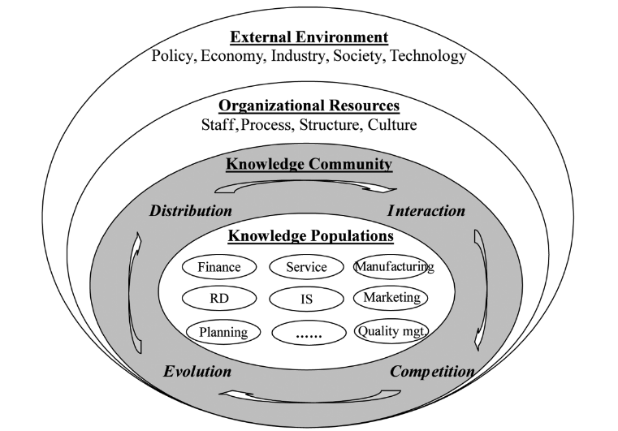

Appendix 3: KM Implementation framework
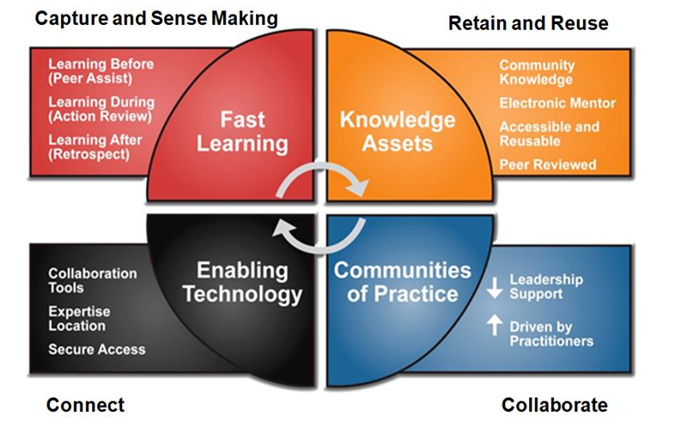

Appendix 4: The Nonaka and Takeuchi Knowledge Spiral Model (1995)
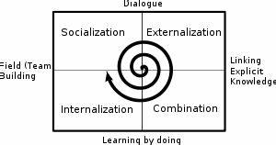

Appendix 5: The von Krogh and Roos Model
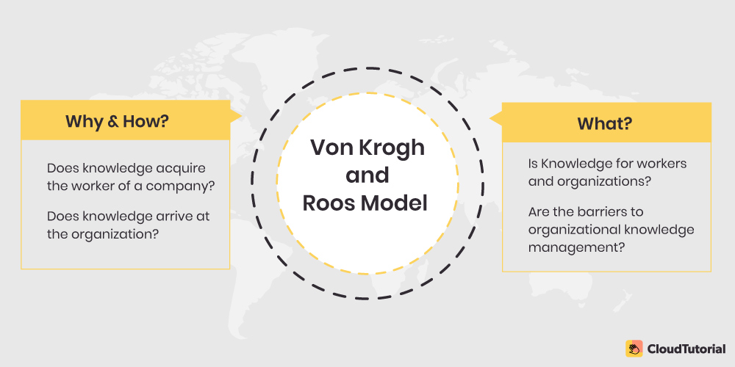

Appendix 6: The Choo Sense-Making KM Model


