A report evaluating the critical approaches when studying management theory and practice

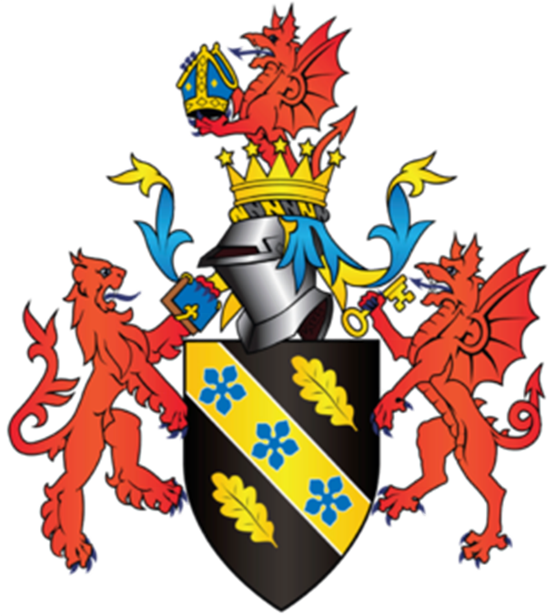

Module Name: Management Ethics
Student Name: Ella Williams
Student Number: 1707424
Executive Summary
This report gives the reader an understanding of how important it is for organisations to operate in a sustainably. Coca-Cola were clearly only thinking how much profit they could make from producing their beverages from an LEDC country (India), instead of thinking about who else needed their water.
Theories such as the CSR Pyramid, and Circles and Pillars of Sustainability will be used to explain what Coca-Cola did to improve on their situation and become sustainable.
The purpose of this report is to show the reader how organisations will always think about what the cheapest process will be to make more profit, instead of thinking about the consequences.
The reader will find that Coca-Cola notice the affects they make on India and how they are unable to continue to use their water anymore. This helps the organisation realise that they cannot operate this way anymore and must take responsibility for their actions. By using the CSR responsibility template organisations become aware that they need to take on four responsibilities to make relationships with the community, as well as being sustainable whilst following the law.
This report concludes by stating how the organisation has adapted to the changes they have made and have stuck by their CSR annual reports. Coca-Cola have become more sustainable, by helping communities, operating in an environmentally friendly way and still making a profit.

Table of Contents

- Introduction…………………………………………………………………….……………………………4
  - Report Remit
  - Background on Coca Cola
  - Sustainability and CSR
- Main Findings……………………………………………………………………….……..……………6-11
  - Coca-Cola’s Water Crisis
  - Sustainability Development
  - What Coca-Cola did to Improve
- Conclusion………………………………………………………………………………………………….……12

List of Figures

Figure 2.2.1: Circles of Sustainability………………………………………………………...……8
Figure 2.2.2: Pillars of Sustainability……………………….………..…………………………….8
Figure2.3.3: Carroll's CSR Pyramid……………………………………………………………….….9
Figure 2.3.4: Coca-Cola donations…………………………………………………………….……11

- Introduction

  - Report Remit
This report evaluates critical approaches Coca Cola undertakes when studying management theory and practice. Judgements will be made throughout this report to show the differences between mainstream and critical theories of management and develop critical assessments of concepts underpinning management theories.

  - Background on Coca Cola
In 1886, an Atlanta pharmacist, Dr. John S. Pemberton, created a new tasting soft drink. Two years later Pemberton past away, but he had sold shares of his business to many parties. However, most of the business was sold to an Atlanta businessman, Asa G. Candler. By 1899, large scale bottling was made possible. Due to the company getting bigger and bigger it was decided that Coca Cola needed a distinctive bottle. By the year 1916, it was approved that the bottle of unique and was easily recognised (Coca-Cola, 2018).
To promote the company even more Woodruff who was a marketing genius expanded the company overseas, introducing Coca-Cola to the Olympic Games in 1928. Coca-Cola continue to build relationships with global sports events such as UEFA EURO, FIFA World Cup and Rugby World Cup.
There were only nine drinks sold a day when Coca-Cola first started and now it is the world’s most universal brand serving 1.9 billion drinks every day worldwide (Journey-Staff, 2017).

  - Sustainability and CSR
According to Crane and Matten (2007), “Sustainability refers to the long-term maintenance of systems according to environmental, economic and social considerations”.
A relationship or organisation is not sustainable if it challenges the social, economic, or environmental conditions of its own practicability (Thiele, 2016). Organisations tend to operate their businesses in LEDC’s as it is cheaper for the organisation. However, organisations tend to use a lot of the country’s resources unsustainably, which will affect them in the long term. To avoid this from happening organisations need to plan before they operate, so they will not face environmental, social and economic problems (Thiele, 2016).
Organisations will also need to follow corporate social responsibilities (CSR) which look at the relationships between businesses and societies they work in (Chandler, 2006). This includes economical, legal, ethical, and generous actions that an organisation must take on for society (Buchholtz, 2009).

- Main Findings

  - Coca-Cola’s Water Crisis
In the modern world we live in today we are facing a lot of sustainability issues such as climate change, water scarcity, food waste, water scarcity and more. Businesses are to blame for a lot of the sustainability issues that effect our planet today. This is because organisations believed that they can do as they please to make a profit. This means that some businesses follow the Milton Friedman’s shareholder theory which is how every business only has one responsibility and that is to increase their profits (Friedman, 1970). This encourages social responsibility to society because when profits increase in an organisation it benefits the local economy. Coca Cola followed this theory.
In 2003, Coca Cola were ordered to stop taking water from the ground from a bottling plant that supplied mostly all of India after a court noticed it was destroying the environment (Brown, 2003). Thousands of local families protested to stop Coca-Cola from ruining the environment they lived in as an environment correspondent, Paul Brown (2003), states “it was turning their land into a desert and killing their coconut palms”. This shows how it took thousands of local families to protest just for Coca-Cola to stop unethically draining water out of the ground to make their product, creating a profit.
In 1995, local people in India were not impressed with Coca-Cola’s arrival as they noticed changes. However, official government’s water ministry documents showed the water levels were stable until 2000, when the Coca-Cola water plant started working 24/7. The farmers who lived in India were struggling to grow their crops to eat or sell to make a living, putting their lives at danger. Also, other communities near India who lived and worked close were affected as they were experiencing extreme water shortages and environmental damage (War-on-want, 2007).
The village council refused to renew Coca-Cola’s water plant licence, which meant that it was shut down in March 2004. It came to light that it was illegal for Coca-Cola to have been taking their groundwater and the organisation were immediately told to find an alternative source (War-on-want, 2007). According to the Water Foot Print Network, it has been estimated that Coca-Cola needed 442 litres of water to make one litre of Coca-Cola (India-Resource, 2015). Leslie Thiele (2016), believes “it is unsustainable to extract water from rivers, lakes, and aquifers at a faster rate than they can be naturally recharged by rain”. This shows how Coca-Cola were operating their business unsustainably and only thinking about making a profit, instead of the environment and the local community.
During the water crisis in India, the Centre for Science and Environment (CSE) discovered high levels of toxic insecticides and pesticides in Coca-Cola drinks. It was high enough to cause cancer, birth defects, severe disruption of the immune system and more (CSE, 2010). This shows how Coca-Cola failed to meet Health and Safety standard, but still considered safe under the local standards. After years of researching, in 2008 The Energy and Resources Institute (TERI) concluded that the water Coca-Cola used in India is now free of pesticides (Cristina A. Cedillo Torres, 2012).

  - Sustainability Development
Sustainability relates to the reduction of environmental impact by reducing the amount of impact and waste on the environment. This can be helped with an efficient CSR plan. Environmental damages are still increasing but organisations are now trying to plan ways to prevent more damages from occurring by creating sustainable developments.
According to Brundtland Commissions (1987), “sustainable development is development that meets the needs of today’s lifestyle without damaging the ability of future generations to meet their own needs”. Organisations must undertake the CSR responsibilities to protect the world whilst operating successfully. Colbert and Kurucz (2007) back that statement up by defining sustainability as helping to “keep the business going” as well as “future proofing” an organisation. This just shows how the way organisations act today has a huge impact on what the world is going to become in the future.
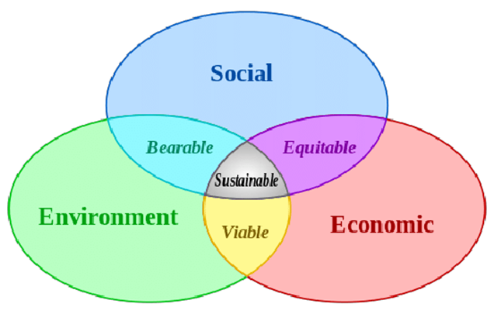
Figure 2.2.1: Circles of Sustainability

Figure 2.2.1 shows the three factors of sustainability which organisations must meet efficiently for a healthy sustainable development. Businesses can meet sustainable economic and development goals, but managers of an organisation need to be aware of the environment’s limitations for society and organisations. If organisations only focus on one of the three circles’ then they will not become a sustainable organisation (Lynch, 2016). For example, Coca-Cola did not think about how the environment would be affected if they used India’s water, as well as the community as they were only focused on their organisation. This shows how Coca-Cola did not undertake their social and environment responsibilities which would have been to look after the community and make them happy, as well as not using as much water as they should have been.

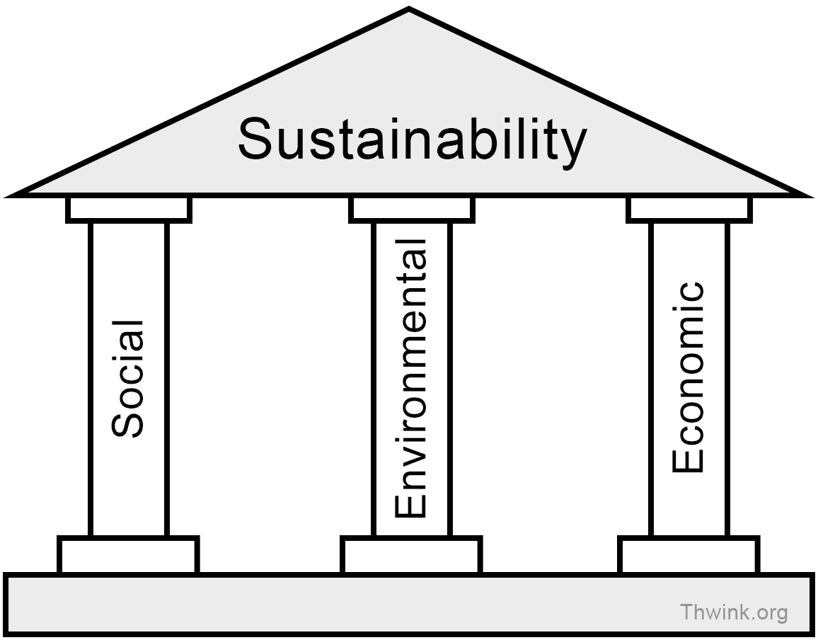
Figure 2.2.2: Pillars of Sustainability
Organisations must achieve a balance in environmental protection, social and economic development. Just like figure 2.2.1, if one pillar is not met then it means an organisation is not sustainable. Organisations can face fines or legal penalties, giving the organisation a bad image.

  - What Coca-Cola did to improve
Edward Freeman (1999) believed laws were put in place due to society limiting its sustainability. This shows Friedman’s, theory is false as he states how there are no moral hazards from only thinking about profits. Freeman created his theory after he recognised important CSR elements that are used in the world we live in today.
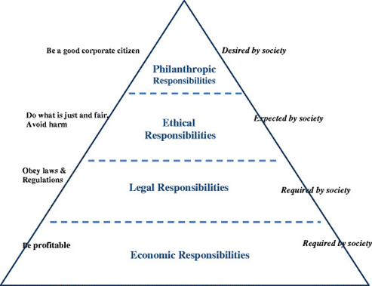
Figure2.3.3: Carroll's CSR Pyramid

Coca-Cola is the world’s largest beverage company which means a lot of consumers enjoy what the company offer. However, when an organisation commits an unethical offence they are then immediately breaking their CSR responsibilities. Coca-Cola did not obey their CSR responsibilities during the water crisis, but as laws and regulations get stricter organisations now follow CSR to continue to be a successful organisation.
The main factor of the CSR program is sustainability, whether that’s for consumers health, recycling, packaging, employee, energy and climate development, and water stewardship (Coca-Cola-Enterprises, 2015).
Coca-Cola created their first sustainability framework report in 2007, showing their performance in the workplace, marketplace, community and environment. To prove that their organisation is improving their sustainability it will be shown through an annual report. In the past Coca-Cola had denied to producing beverages containing pesticides as well as taking full responsibility for over-using India’s water (Colbert, 2007).
Coca-Cola have adapted over the years and investigated what they could change within their CSR responsibilities. The organisation has clearly taken responsibility for the economy. In 2009, Coca-Cola started sustainable packaging as they opened the world’s largest bottle recycling plant which will help the organisation reuse bottles. More than 35% of bottles and cans have been recovered and resold (The-Coca-Cola-Company, 2008).
Coca-Cola have also undertaken Legal responsibilities and stated on their website that they “aim to lead by example and learn from experience” (The-Coca-Cola-Company, 2016). The organisation follows the Health and Safety Act 1974 by have operating requirements in which they train their employees well, create up to date risk-assessments, safer working conditions and human rights (The-Coca-Cola-Company, Sustainability Report, 2017).
Although Coca-Cola was unethical they have proved they want to change that and become ethical in a sustainable way. The organisation wants to improve their water efficiency in manufacturing operations by 25% compared to their 2010 starting point (Coca-Cola-Journey, 2018). Coca-Cola have also stated how they want to help communities access water they need” as they are working towards conserving water for nature, agriculture and communities because it is the “right thing to do”. This shows the organisation want to improve on their mistake in the past and help people whilst being sustainable. In 2017, 248 billion litres (100%) of the water used in finished beverages was given back to nature and communities. This was done through 281 water projects world-wide (The-Coca-Cola-Company, 2017). Coca-Cola also partnered up with the World Wildlife Fund, as well as becoming a member of the CEO Water Mandate to aim to:
- Reduce CO2 emissions within a drink by 25%
- Create plant-based materials for packaging
- Sustainably source ingredients to create Coca-Cola
- Replace 100% of water used
- Reuse 75% bottles and cans.
Undertaking all of these responsibilities will contribute to helping the environment and the organisation will become more sustainable and ethical (Moye, 2013).

Within the Philanthropic responsibilities Coca-Cola have invested in the future a lot. Since 1984, Coca-Cola have given back $1 billion to local communities globally, including women’s economic empowerment, community recycling, and global water leadership programmes.
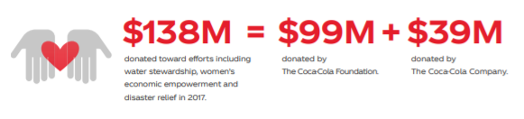
Figure 2.3.4: Coca-Cola donations

Also, Coca-Cola help charities such as supporting water and environmental programs, empowering women and bring communities together. In 2016, Coca-Cola calculated the amount they had given to charities and it came to $106 million, 1.2% of their operating income (The-Coca-Cola-Company, 2017).

- Conclusion
To conclude, Coca-Cola were very selfish and unethical when the organisation used nearly all of India’s water to contribute to making their soda drink. However, the organisation knew they needed to improve in a sustainable way as it had a huge effect on the organisation, environment and community. So, instead of taking things Coca-Cola have taken on their Economic, Ethical, Legal and Philanthropic responsibilities and are not adapting to the world and giving back to the environment and community sustainably.

References

Andrew Crane, D. M. (2007). Corporate social responsibility as a field of scholarship.
Brown, P. (2003, December 19). Coca-Cola plant must stop draining water . Retrieved from The Guardian : https://www.theguardian.com/world/2003/dec/19/india.sciencenews
Brundtland. (1987). World Commission on Enviornment and Development. Berlin.
Buchholtz, A. B. (2009). In A. B. Buchholtz, Business and Society: Ethics, Sustainability, and Stakeholder Management (p. 44).
Chandler, W. B. (2006). Strategic Corporate Social Responsibility. USA.
Coca-Cola. (2018). About Us. Retrieved from World of Coca Cola : https://www.coca-colacompany.com/history
Coca-Cola-Enterprises. (2015). Corporate Responsibility and Sustainability Report .
Coca-Cola-Journey. (2018, August 29). Improving Our Water Efficiency. Retrieved from Coca Cola : https://www.coca-colacompany.com/stories/setting-a-new-goal-for-water-efficiency
Colbert, B. A. (2007). Three conceptions of triple bottom line business sustainability and the role for HRM .
Cristina A. Cedillo Torres, M. G.-F. (2012). Four Case Studies on Corporate Social Responsibility: Do Conflicts Affect a Company’s Corporate Social Responsibility Policy? .
CSE. (2010, March 12). Pesticides in soft drinks. Retrieved from Centre for Science and Enviornment : https://www.cseindia.org/pesticides-in-soft-drinks-1158
Freeman, R. E. (1999). Divergent stakeholder theory .
Friedman, M. (1970). The Social Responsibility of Business is to Increase its Profits. The New York Times Magazine, 1.
India-Resource. (2015, August 25). Coca-Cola's Water Replenishment Claims Mislead. Retrieved from India Resource Center: http://www.indiaresource.org/news/2015/1025.html
Journey-Staff. (2017). Our story . Retrieved from Coca Cola Journey: https://www.coca-cola.co.uk/stories/our-story-2000-to-now-living-positively-125-years-on
Lynch, S. L. (2016). Business Case Studies in Sustainability Practices. Florida.
Moye, J. (2013, July 9). Beyond Water: Coca-Cola Expands Partnership with WWF, Announces Ambitious Enviornmental Goals. Retrieved from Coca Cola Journey : https://www.coca-colacompany.com/stories/beyond-water-coca-cola-expands-partnership-with-wwf-announces-ambitious-environmental-goals
The-Coca-Cola-Company. (2008). Sustainability Review.
The-Coca-Cola-Company. (2016, September 20). Goverance and Ethics. Retrieved from Our Company: https://www.coca-colacompany.com/our-company/workplace-overview/governance-ethics/governance-and-ethics
The-Coca-Cola-Company. (2017). Sustainability Report.
The-Coca-Cola-Company. (2017, August 18). Sustainability Report: Giving Back. Retrieved from Coca-Cola Journey : https://www.coca-colacompany.com/stories/2016-giving-back
Thiele, L. P. (2016). Sustainability . John Wiley & Sons.
War-on-want. (2007, November 19). Coca-Cola: Drinking the world dry. Retrieved from War on want: https://waronwant.org/media/coca-cola-drinking-world-dry

