Hospitality and Guest Service Management
MODULE CODE: M4X01915
STUDENT NAME: Cristina Raluca Urloi
STUDENT NUMBER: 1905716
LECTURER: ABDI RAHMAN

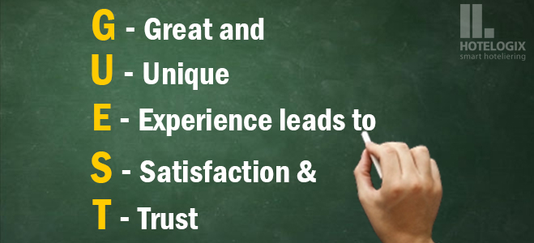

Table of contents

Introduction…………………………………2
Discussion and critical analysis…………….4-6 Conclusion……………………………………… 7 References…………………………………………8



Introduction
In this assignment I have been asked to analyse the service provided in the Drayton Court hotel, quality management, how the Drayton Court hotel adapts to changing consumer preference and how these changes impact guest service management.
As the Collins definition says, a guest services manager at a hotel is responsible for the services and facilities that the hotel provides for its guests. (Collins English Dictionary. Copyright © HarperCollins Publishers). This quote brings into evidence the fact that management of the hotel is very important because it controls the entire way that the hotel runs through what it provides. The managers are playing important roles in each department as they are collecting and controlling everything on that department.Total Quality Management is defined as being the system that is “managing the entire organization so that it excels in all dimensions of products and services that are important to the customer”. TQM is a process approach and it is a management strategy. When managers use a process approach, it means that they manage the processes that make up their organization, the interaction between these processes, and the input and output that join these processes together (Kachru,2007). The mentioned strategy is very useful because it helps the managers out to put all the information together and to take consistent decision considering what people are aspiring for.
When we are thinking about the chosen hotel, knowing that it is placed in a quite area in an old town, it has quite better than expected evolution. This is clearly seen through the fact that there are around 300 positive feedback which is saying how good the services, the location and simply the hotel is. In the staff’s opinion it is very surprising that a hotel which is not opening doors to tons of locations and is not providing the guests with the most luxury elements, collects most of the reviews positive. This hotel is very much using the Disney S.E.R.V.I.C.E. Model Strategy to be able to attract customers and to be able to maintain continuous improvements of the hotel. The Disney S.E.R.V.I.C.E Model is based on Smile, Eye contact, Respect, Value, Initiate guest contact, End with thank you and all these abbreviations are supporting the members of staff to keep giving out to people the most wanted services are giving comfortability to the guests.

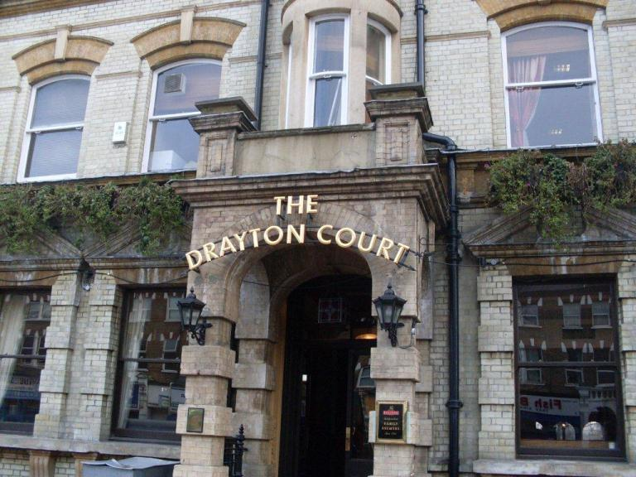
Discussion and Critical Analysis
The Drayton Court Hotel is Situated in the quiet town of Fazeley and from its location, guests can lead themselves to either just places to walk and have a good time or kids places as well. It is 5 minutes’ drive from Tamworth. Is 8 miles away, and Twycross Zoo and West Midlands Safari Park is 20 miles from the property. Birmingham and Wolverhampton are between 20- and 30-minutes’ drive from the hotel. As a result, the Drayton Court Hotel is quite good localised even if it is a quite town which does not give as many touristic points, the surroundings are making the guests change their opinion in an even more positive one. Each room at Drayton Court Hotel features and a suite bathroom, a flat-screen TV, and tea/coffee making facilities. Some rooms also boast a private patio, a seating area, and garden views. The hotel’s very strong point is that it is organising weddings so therefore it does have venues as well. When it comes to weddings, the hotel is working with a variety of venues and together they can offer packages with accommodation included and many people use to go here because of its relaxing atmosphere. The atmosphere is very important when thinking about attracting more and more people and the people that are employed to offer this are very important as well and this because, as Brown said, the training of the employers is very important when thinking about ensuring the best quality of service and meeting these objectives (2009). This again, shows the importance of the people that are working to maintain the constant improvement of the hotel.
In a hotel the ones that are working at the management of the hotel are having the biggest responsibilities because the way they are taking decisions and the way they are using the marketing and business strategies to do in everything in a way that satisfies the customers at a maximum level. Some of the managers are collecting information all the time about the guest’s experiences at the hotel and then the rest of the people in charge are analysing the data and the process is then followed by the last step which is based the decision-making which always can be considerate as being the key to improving and to initiate things in the hotel that are satisfying the customers very much.
The managers obviously, to be able to improve services and change them depending on what the customers are coming with, need to use strategies. To make the services look better than they are and to convey to the customers the friendly attitude and to make the guest feel that relationship that is building with professional boundaries, of course, the people in charge of the hotel are using the DISNEY S.E.R.V.I.C.E MODEL and this model includes the following aspects:
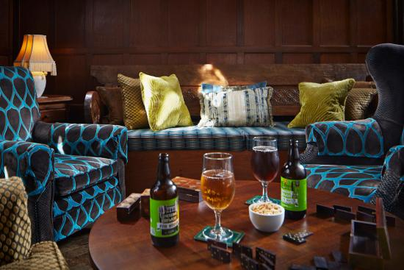
Smile: a smile from an employer is makes a huge difference in a conversation and this because a smile brings another smile and then guests are leaving a conversation with their smile on their face, thing that is very important in a hotel especially if is not visited by 1000 people. In the Drayton Court Hotel, people are always smiling, and they are showing the idea of enjoying what they are doing
Eye Contact: the eye contact is an easy way of showing confidence on what you are saying and, in this way,, people may trust in your words and suggestions more than they used to do with other people they went to and did not make eye contact. As Subramony said in 2004, there is a positive relationship between employees’ internal service effectiveness and customers service quality perceptions. Therefore, referring to the Drayton Court hotel, the staff is always trying to show empathy and trust through the eye contact and through the way they look into the person’s eyes.
Respect- As mentioned in the Customer Service Policy (2005), each guest must receive respect in any siruarion and it should be allowed to have accessibility and flexibility to adapt behviour and actions in a way that is accetablle fot the guest. The respect given to the guest is very important and necessary because when they are respected the are having that idea of them not being treated as nothings because they are the ones using the facilities not the one being in charge of working with them. In the chosen hotel all the members of staff are showing respect through many aspects such as speaking nicely with all the customers using a calm tone, thorugh the fact that people are receiveing their rmoney back in a short amount of time if they changed their mind and they do not want to come any longer. Respect is also shown to the guests through the fact that all the members of staff are taking into consideration the customer’s whishes and this is very important because it makes the customers feel like they have their own confidentiality.
Value the magic- Is very important that in a hotel you always find positive aspects in which to engage the customers as well. For example, when good weather comes up, the people in charge of the hotel could organise outside activities for either kids or adults. This is only one way through which small details can be eventuated and appreciated by lots of guests and customers. There are some other ways to use to value the magic in a hotel but the most basic one is based on keeping the wanted atmosphere in the hotel without disturbing anyone. In the Drayton Court Hotel, the staff is valuing the magic mostly through their sense of humour and through the empathy they are sharing with all the guests coming into the hotel.
Initiate guest contact- Any type of contact with the guests is important and this because it shows even more reliability and it increases the level that a person trust in the services. One type of contact that influences customers a lot is the body language which needs to convey empathy and commitments to make sure that the guests are receiving next to the paid service’s nice words. The contact could also be based on communication with the guest this meaning that you as a worker should ask the guest how its day is or what are they doing in the holiday and any stuff like that. In the Drayton Court Hotel, each member of staff is engaging with guests and they are always trying to have a laugh with the guests because in these ways people are catching more trust and, in this way, they will feel like home in the hotel.
End with thank you- When a conversation is ended with a thank you and greetings the guest is feeling respected and appreciated by the employee. The nice ending on the conversation is a necessary part of the people’s that are having a job and any environments that requires customer service. Thinking about the Drayton Court Hotel, each employee is communicating with the guests in a very educated manner and the employee are expecting the same thing. Therefore, in the chosen hotel guests are very much respected because most of them during their stay they are working with the members of staff to maintain atmosphere, cleanliness, silence... and this is why most of the customers deserve the thank you and the greetings every time they are stepping in and out of our hotel,
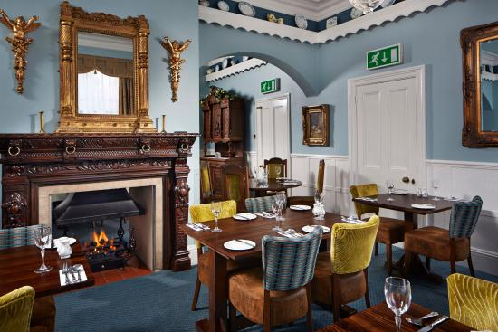
SWOT Analysis
The purpose of SWOT is to test and adjust and individual’s qualities and shortcomings to the chances and dangers to create new options. SWOT stays for the abbreviation of Strenghts, Weaknesses, Opportunities, Threats.
Thinking about the Drayton Court Hotel the SWOT can be tested as follows:
Strenghts- variety of products and services, quite and relaxing atmosphere Weaknesses- not too popular location which can be very easy for the guests to find Opportunities- share posters around the town showing what they offer to attract customers Threats- Competitors that might give more accessibility to the town centre
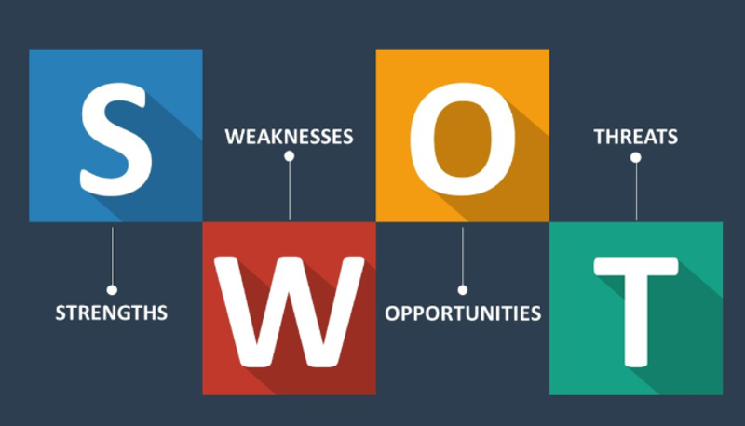
Conclusion
As a conclusion all the managers are working very hard in providing the needed services and products to customers and the impact over them is a positive one because the amount of people coming into the hotel is getting bigger and bigger. The strategy they are using in mostly based on behaviour, but it does still make a huge difference as long as people are happy with all the other services that they are paying for. The hotel that has been used as a model during this report is very much appreciated by people and they are always stating in the feedback sections that the staff is very friendly and that the way they are using to provide the services and products is a very nice one because is based on touching the highest level of satisfaction of the customers,


REFERENCES

Oakland, J, Total Quality Management Butterworth-Heinemann, London, 1989
Customer Service Policy May 2015
Kachru, Braj B. “Standards, codification and sociolinguist realism: the English language in the outer circle… in R. Quirk and H. Widdowson, Cambridge university press (1985)
https://www.draytoncourthotel.co.uk/
https://www.tripadvisor.co.uk/LastMinute-g504160-Tamworth_Staffordshire_England-Hotels.html
Subramony M. Beehr A. and Johnson, C. (2004) “Employee and Customer Perceptions of Service Quality in an Indian Firm”. Applied Psychology: An International Review,52 2, 311 – 327
Bowen, J. and Shoemaker, S. 1998 ‘Loyalty: A strategic commitment’ Cornell Hotel and Restaurant Administration quarterly, 35, 3, 12-25



