Group work completed by:

- David Mafuta (2007846)
- Gabriela Bikarova (2010123)
- Mina Carmen Iacobescu (2010126)
- Mohamed Osman Sesay (1905636)
- Vanessa Gonzales Hernandez (2011622)

Amazon.com, the world of modern technology
Amazon, the Amazing Story of Online Shopping

Cadabra then Relentless.com ten Amazon.com

The everything store Stone (2013)


Contents

- Background of Amazon.com
- Prior Challenges of Amazon
- What new technology introduced
- The impact of the technology introduced
- Insights to the modern technology introduced
- The lessons that can be drawn from the case study



Background
Logo since 1995-2000
The Amazon Spheres, part of the Amazon headquarters campus in Seattle,
Industry | Cloud computing e-commerce artificial intelligence consumer electronics digital distribution self-driving cars
Founded | July 5, 1994 Bellevue, Washington, U.S.
Founder | Jeff Bezos

- 150.6 million mobile users accessing the Amazon app in September 2019 (Statista 2019)

- 150 million Amazon prime subscribers (Bezos 2019).
- https://www.oberlo.com/blog
/amazon-statistics

Background (2)
Top 10 Fastest Growing E-retailers in the 2001 holiday shopping season (Source: Nielsen Net
Ratings)

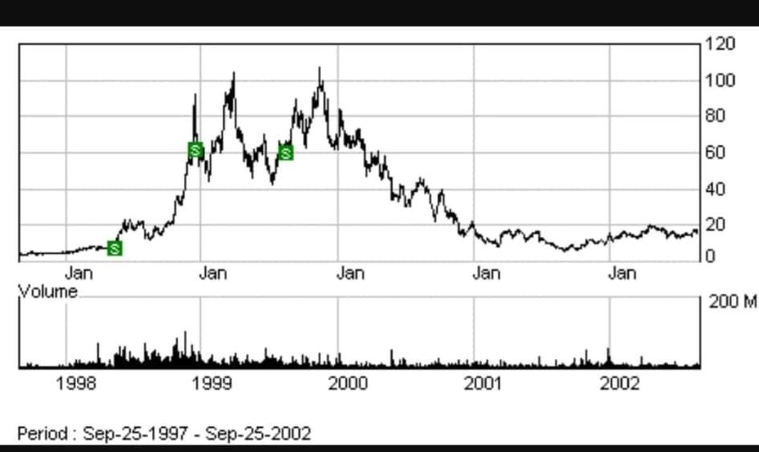
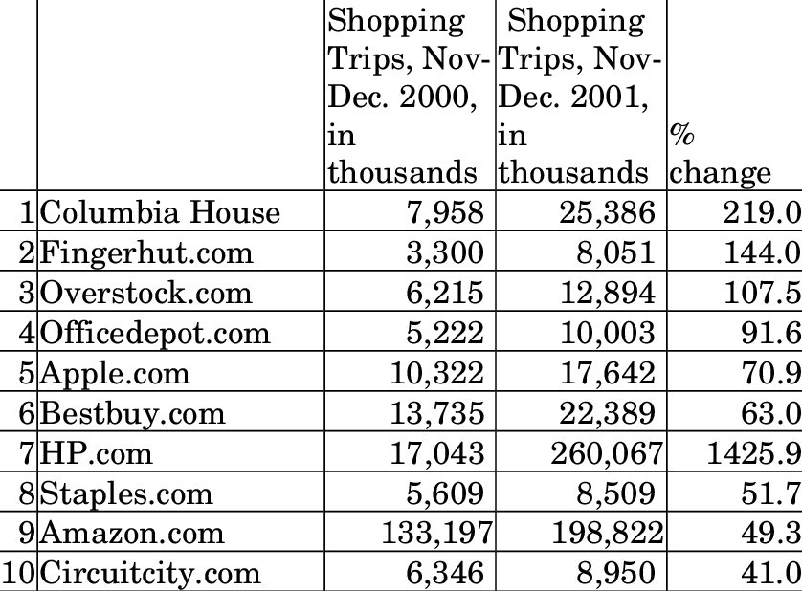

Amazon present market share
www.emarket.com

  - In 2020 Amazon sales will rise 17.2% to $260.86 billion
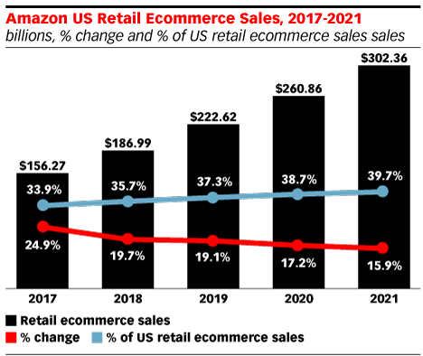
  - 4 percentage points higher than the expected overall growth rate for US e-retailer's sales.
  - Will increase from 37.3% in 2019 to 38.7% 2021 expectation will reach 39.7% market share. Source:



Prior Challenges of Amazon

    - The company was dramatically under- staffed
    - Other retailers had their own brands
    - Own label credibility
    - Delivery delay, only post delivery
    - Data storage
    - No online presence

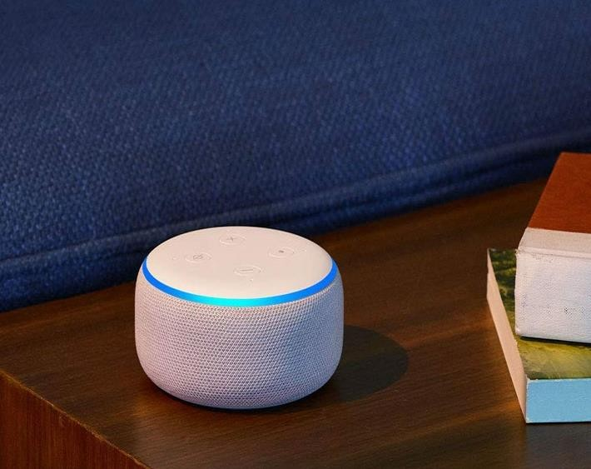

What new technology was introduced

- The new Amazon Echo Dot with clock
- Amazon robotics in Warehouses
- Amazon (Virtual) Dash Button
- AmazonFresh
- Amazon Prime Air
- Amazon Fire TV



The impact of the technology introduced

- The business grows bigger
- They extended the business internationally
- They created more jobs
- Amazon Prime

Insights to the modern technology
  - Customer obsession
  - Willingness to invent
  - Long-term thinking
  - Operational excellence

  - Jeff Bezos credits four principles within Amazon's core values, his interview in 2018.

    - Cashier-free stores

The future of Amazon.com
    - Biometric payments
    - Investing in India
- Food delivery service
    - Reinventing the department store

    - AI-powered home robots

The future of Amazon.com (2)
- Game streaming services
    - Innovative healthcare
    - Amazon Prime Air

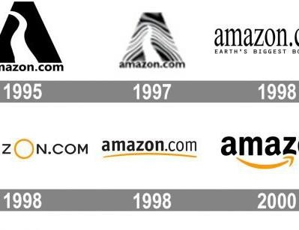
Logos
“From A to Z,” the Motto of Amazon said Jeff Bezos,2019.
Amazon's slogan is “Work Hard (Bezos 2019)

The lessons that can be drawn

  - Importance of modern technology
  - How to extend a business Globally
  - How to cope with challenges and concurrence
  - Strategies to grow a business
  - Creativity makes a difference

References
  - Pears, R. & Shields, G. (2016) Cite them right: the essential referencing guide. 10th edn. London: Palgrave.

  - Statt, N. (2018) A guide to all the industries, product categories, and markets Amazon has dominated over the years. Amazon.com

  - Wells, J., Weinstock, B., Ellsworth, G. & Danskin , G. "Amazon.com, 2019." Harvard Business School Case 716-402, August 2015. (Revised October 2019.)

