
Student Name: Toni Dimovski
Student Number: 1917694
Lecture Name: Akinseye Aluko
Effective Team Working and Communication

EFFECTIVE COMMUNICATION AND TEAMWORK

1 Introduction
The communication is basically a process the involves transmitting a message using many channels and media versions. This can be done verbally, or non-verbally, formally or informally, with the essence of delivering a thoughtful message that will provoke the generation of an idea or an action. Therefore, being able to communicate is in fact a developed skill, rather than an innate one, because even when the majority of people are born with the ability to speak, they still have to learn on the ways of communicating effectively. Usually this process of learning develops through observing others and attempting to integrate their behaviour in ours. However, it is important to note that the process of communication is not considered successful except when the message transmitted is delivered to or received by the person who needs it. Hence, the definition of communication can be highlighted as the successful transmission of information from one individual at one spot to another individual in a different spot. At another level, the communication process involves the exchange of information mutually, rather than just a transmission of the information in one way (Markovic and Salamzadeh, 2018).
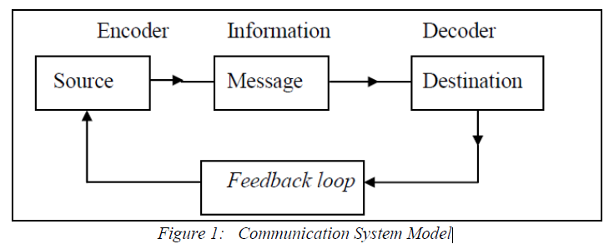
For the communication process to take place, four main components should be present: the source or the encoder at one end, the receiver or the decoder at another end, the message transmitted and the feedback from the receiver to the sender, as shown in the picture below. The corporate communication can occur at the same working level, or between hierarchical levels within the same organisation, and in both ways (Zerfass and Viertmann, 2017).

2 Literature

a Impact of communication
Developing communication skills has been the interest of employers, researchers and universities. Employees, being previously students, learn how to write essays and reports, abiding by the deadline, and making their reports understandable and readable. This constitutes the first exposure of employees to the significance of communication. This significance increases further and expands within the organisation, especially at the team level. Most organisations nowadays operate in collective efforts, rather than individual efforts, assigning the major organisational functions to teams rather than individuals given the great contribution of the collective work. However, the effectiveness of teamwork is usually threatened by the lack of proper communication among team members. Therefore, if organisations do not proact on the teamwork level in terms of training and developing effective communication process and channels, teams might end up being ineffective, risking the achievement of the organisational goals (Walvoord, 2008).
A real example is my workplace, Fentons Ice Cream. My employer is a small company that employs 20 people across its 3 branches within the UK. While being the supervisor at the Stratford branch for 2 years now, I can affirmatively assume that the organisation is critically struggling with proper communication within the sales team, and between the team and the organisational management. The company does not stress the importance of communication to its staff and does not invest time or effort in strengthening the confidence built in this communicative process. many conflicts arose over my employment period, and they all emerged from the lack of proper communication from the management to the employees. This lack of improper delivery of corporate messages result in confusion in task assignment, unclarity in task description and inadequate guidance on the hierarchical structure. Out of the 20 staffs working there, we are only three old staffs, while the others keep on being hired and fired (or quitting) due to that improper communication. Therefore, the company is risking its image and reputation because of its reluctance in investing properly in the communication process (Markovic, 2011).
By the end of this report, recommendations will be given to the context of the company given the main struggles that the company is facing.

b Advantages of communication in working environment
Corporate communication, as already mentioned, plays a critical role within the organisation, as it assumes on the team level the proper assignment of tasks with clear guidance and support which leads eventually to the achievement of teamwork objectives. The team is usually assigned to work on a certain project with expected outcomes over a limited period of time. If team members are not aware of each one’s contribution into the collective efforts and are lacking guidance and support and do not know where or how to get it from, the team effectiveness is likely to be reduced. On another level, if the team’s expected outcomes were not well communicated and explained, the resulting efforts would be irrelevant to the project under progress. Therefore, the success of any corporate projects, campaigns or plans is tightly related and dependent on the effectiveness of the communication implemented herein. Moreover, implementing and stressing on the effective communication, the organisation would enhance the levels of motivation and dedication in employees, reflecting organisational care in listening and communicating properly with the staff. When the organisation exhibits care and efforts in explaining the tasks, whether for individuals or for teams, in providing guidance on where to seek help when needed, and in detailing the expected outcomes employees will therefore develop trust, confidence and interest in the communication process, hence, acting properly as expected. This increased morale of employees boosts individual performance and contribute to the greater good of the organisation (O’Daniel & Rosenstein, 2008; Markovic and Salamzadeh, 2018).
The corporate communication does not only involve communicating within the organisation, but it also involves communicating with all the major stakeholders for a company. Therefore, establishing proper and effective communication with the suppliers assist the company in developing trustworthy relationships that might result in further cost saving or efficient production (Markaki, Sakas, Chadjipantelis, 2013). The same applies where the organisation can strengthen its image and reputation by ensuring transparent and effective communication with its clients. Listening to complaints and feedback and taking them into consideration while getting back to customers reflect the organisational devotion to its market. On a third level, ensuring a proper and effective with the organisation’s shareholders, the organisation can improve their trust in the organisation’s management and direction, opening further windows for greater funding opportunities and support (Lerbinger, 2018).

c Success factors
The success of the communication process depends on many factors such as: the channels used to transmit the message and to receive the feedback, the training and knowledge of the senders, the norms for the communication process, the support provided for the receiver and the technical investment for the communication process. These factors determine the success of the communication process whether it was downward or upward streamed. Other factors as outlined in the picture below outlines more factors to take into consideration.
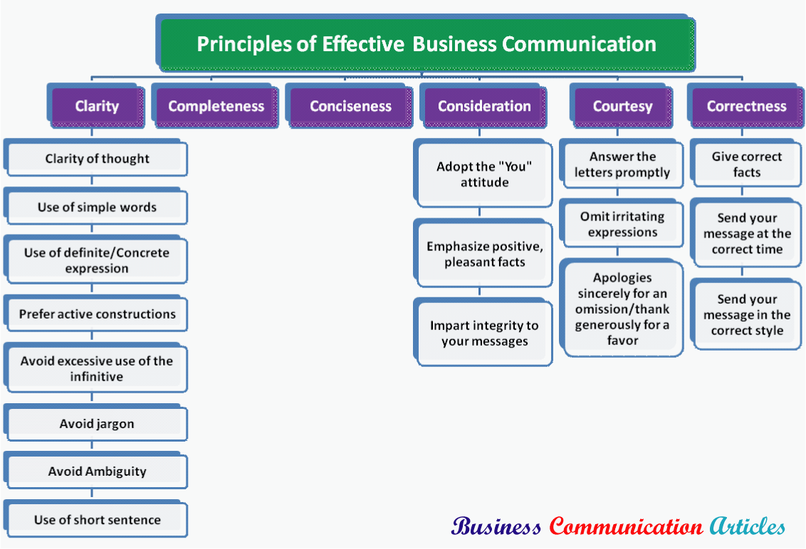Therefore, it is crucial for organisations to train its managers and seniors on the methods to effectively process the communication to the employees, who in turn should also train the employees and explain the criticality of the communication process. the norms of the communication process involve the rules that guide the process and allows the interaction of the sender and the receiver. Accordingly, two styles emerge which differ according to the time and/or the spatial location of the receiver and the sender. In other words, the communication would be defined as synchronous if it occurred at the same time, either in the same location or in different locations (i.e. video conferencing, instant messaging, face-to-face…), and asynchronous if it occurred at varying places and times, or at least same place but different timings (i.e. emails, posts, websites, announcements…) (Otter and Emmitt, 2007).

d Communication channels
The communication occurs through one of the communication channels classified as formal and informal channels. The formal channels involve sending the messages in a clear, outlined format that can be used as referrals or an accurate source of information. These include the radio, newspapers, manuals, announcements, corporate websites, fax, posts, memos, textbooks… (Markovic and Salamzadeh, 2018)
These means of communication exist in almost every context and every industry, outlining the importance of transmitting messages formally and accurately.
On the other hand, the informal channels also always co-exist with the formal channels, and therefore they don’t substitute each other, even though the formal channels exhibit higher accuracy and relevance. This kind of communication evolves from the social interactions and can be described as having the grapevine shape. Informal channels are usually the resort of employees and managers to receive information that was not received completely from the formal ones. Therefore, the emergence and strength of informal channels depend on the completeness of information provided by the formal channels. Under the grapevine concept of the informal channels, four are considered the main descriptions of informal communication: the single strand form (where one person transmits the information to another, who transmits to another which also creates higher risk of receiving distorted message), the gossip form (where one person tells others about the message), the probability form (where the random transmission occurs from one person to another) and the cluster form (where the message or the information is transmitted selectively, most of the time based on strong social connections). Therefore, it is obvious that the channels of communication can take many forms, oral, verbal, written, printed, electronic, audible without any limitation to the form through which the message can be communicated to others (Markovic and Salamzadeh, 2018).

e Obstacles and barriers
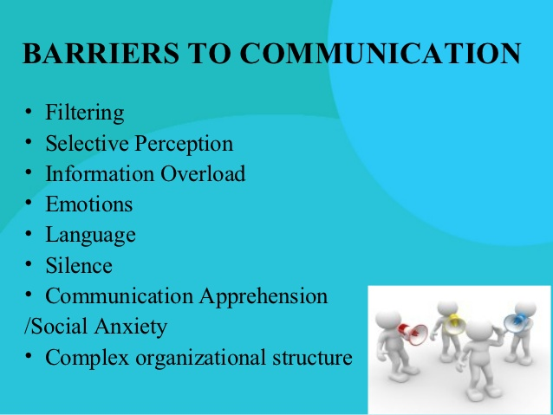
The communication process just like any other corporate process struggles with obstacles and barriers that hinder the effectiveness of the process and probably the achievement of organisational objectives. Within the team, several barriers might arise and therefore, organisations should proact and handle them before they threat the team effectiveness. The first barrier starts with the cultural diversity: this factor can be classified as a two-edge factor that can be advantageous and disadvantageous. Within the team, the cultural diversity brings various backgrounds and perspectives, ideas, creativity and innovation, however, it also brings various languages, and cultural and communicative norms. Communicating in one way could be very acceptable by one culture while being very disrespectful in another. Therefore, the cultural diversity within teams can be a major problem for corporate teams, unless organisations strive to train and enlighten their team members and managers about the process and norms of communication (Vavra, 1957).
The next set of barrier includes the physical hardware. In other words, for the process of communication to occur, it needs channels which can be transmitted through hardware and software. And this hardware and software requires investments, knowledge and training. This barrier even escalates when the organisation has various branches and the staff are physically dispersed, where a structural fault in the system can cause a great delay and a probable damage. Another barrier that might emerge is the attitudes of the staff. This might occur mostly when the staff had negative communication experiences earlier and therefore do not trust the system or are confused with the nature of the task assigned to them. This takes us to another barrier which is the poor managerial skills in managing the communication process. when the managers are not equipped and fully aware of the importance of the communication process and how to train their teams and members, the result can be an ineffective teamwork, and a compromise of the team goals (Neil, 2018).

3 Recommendations and conclusion
Going back to my employer, and as previously mentioned the company lacks the proper implementation of the communication process which leads to demotivated sales team and an ineffective teamwork, compromising the company’s target sales and image.
Following on the discussion above, the main barrier for the company is the poor management of the communication process and the cultural diversity of the team. In our team, we have at least 15 different nationalities with different cultural backgrounds and norms. Yet, the management, being English, communicates in a different way that the majority of the staff come to me complaining that it is rude. Objectively speaking, he doesn’t use any bad or rude words, nor does he insult anyone, but the attitude with which he conveys the information is passively and negatively perceived by the employees. Moreover, this type of downward communication is most of the times rare and infrequent, keeping a rigid and extremely formal and uncomfortable platform with the staff (Palazzo, Foroudi, Kitchen, and Siano, 2018). Therefore, I would recommend the company’s management to apply the following recommendations:
- apply more frequent downward communication with the staff, building more smooth and comforting working environment
- develop proper communication training so that employees and mangers would find a common ground for communication
- develop formal task descriptions for the position and hierarchy of each staff, outlining the expected performance of each staff
- communicate formal SMART targets for the staff on a weekly basis rather than blaming them at the end of the week about missing the target when they didn’t know how much they should achieve
- understand the various cultural backgrounds of the staff and how can cultural diversity can misunderstand some words and non-verbal communication
As outlined during the in-class activities, properly developing formal communication helps in conveying the message more effectively, as well as taking into consideration the perception of people towards the practiced way of communication. Therefore, it is important for the sender of the message to understand the audience towards he/she is delivering, especially in the workplace. All the activities conducted in class highlighted the importance of considering the employees whenever communication is occurring, and this what Fentons’ management should do.
To summarise, the business environment has changed the ways of communication and imposed new patterns and new considerations especially in terms of teamwork. The effectiveness of teamwork leads to the successful achievement of the organisational objectives, therefore outlining the major contribution of teams. Hence, with the lack of proper communication, the team won’t be able to operate effectively, jeopardising the outcomes.

4 References

- Lerbinger, O., 2018. Corporate communication: An international and management perspective. John Wiley & Sons.

- Markaki, E., Sakas, D., Chadjipantelis, T. 2013. Communication Management In Business.The Latent Power For Career Development, Procedia -Social and Behavioral Sciences, 73 ( 2013 ),pp. 319 –326
- Markovic, M. 2011. Organisation Behaviour and Culture: Globalization and the changing environment of organizations, VDM Verllag Dr Muller, p.348.
- Markovic, M. and Salamzadeh, A., 2018. THE IMPORTANCE OF COMMUNICATION IN BUSINESS MANAGEMENT. In: M. Markovic, S. Vujičić and I. Kyaruzi, ed., BUSINESS MANAGEMENT, ENTREPRENEURSHIP AND ENTREPRENEURIAL TENDENCIES. London: Silver and Smith Publishers.
- Neill, M.S., 2018. Change management communication: barriers, strategies & messaging. Public Relations Journal, 12(1), pp.1-26.

- Otter, A. and Emmitt, S., 2007. Exploring effectiveness of team communication. Engineering, Construction and Architectural Management, 14(5), pp.408-419.

- Palazzo, M., Foroudi, P., Kitchen, P.J. and Siano, A., 2018. Developing corporate communications: an exploratory study. Qualitative Market Research: An International Journal.

- Vavra, C., 1957. BARRIERS TO COMMUNICATION. Journal of School Health, 27(2), pp.58-60.
- Walvoord, B. E., 2008.Teaching and Learning in College Introductory Religion Courses.Malden, Mass.: Blackwell Publishing.
- Zerfass, A. and Viertmann, C., 2017. Creating business value through corporate communication. Journal of Communication Management, 21(1), pp.68-81.

Appendix
This appendix includes pictures of the study notes taken during sessions and in class activities



