Database Coursework Submission Template

1. Student Details
- Name: Mouhamad Wade
- Student ID: 2510886
- Module: Introduction to Web and Database Concepts
- Lecturer:

2. Table of Contents
Contents
1. Student Details - Name: Mouhamad Wade - Student ID: 2510886 - Module: Introduction to Web and Database Concepts - Lecturer: 1
2. Table of Contents 1
3. Introduction MediLink Pharmacy is a growing community pharmacy that currently manages its data manually, including information about medicines, customers, prescriptions, and sales. This method can lead to mistakes, loss of information, and makes it difficult to keep everything organised, especially as the business grows.
The aim of this project is to design and create a database system using Microsoft Access that can store all this information in a structured and efficient way. By using a database, the pharmacy will be able to reduce errors, improve accuracy, and make it easier for staff to access important data when needed.
The system will allow the pharmacy to manage stock levels, keep track of customer details, record prescriptions, and monitor sales transactions. This will help improve the overall performance of the pharmacy and provide a better service to customers.
Overall, this database will replace the current manual system with a more reliable and organised solution. 2
4. Scenario Analysis - Identify entities In this database system, several key entities are identified to represent how MediLink Pharmacy operates on a daily basis. These entities are important because they help organise and store different types of information in a structured way. Each entity represents a real-world part of the pharmacy.
The main entities in this system include Medicine, Supplier, Customer, Prescription, and Sales. The Medicine entity is used to store details about all medicines available in the pharmacy, including their stock levels and prices. The Supplier entity contains information about the companies that provide these medicines.
The Customer entity stores details about customers who visit the pharmacy, while the Prescription entity records prescriptions given by doctors to customers. The Sales entity represents transactions where customers purchase medicines from the pharmacy. 2
5. Entity Relationship Diagram (ERD) The Entity Relationship Diagram (ERD) was created to visually represent the structure of the database and the relationships between different entities. It shows how tables such as Medicine, Supplier, Customer, Prescription, and Sales are connected using primary and foreign keys.
The ERD helps to ensure that the database is logically designed and that all relationships are correctly defined. It also makes it easier to understand how data flows within the system. 3
6. Data Structure Design The data structure was designed based on the identified entities and their relationships. Each table includes a primary key to uniquely identify each record, and foreign keys are used to create links between related tables.

For example, the Medicine table includes a SupplierID as a foreign key to connect it to the Supplier table. Similarly, the Sales and Prescription tables include CustomerID to link them to the Customer table.

This structure ensures that data is organised efficiently and maintains consistency across the database. 4
7 Normalisation (up to 3NF) Normalisation is the process of organising data in a database to reduce redundancy and improve data integrity. In this project, the database was normalised up to Third Normal Form (3NF).

First Normal Form (1NF):
In 1NF, all tables were structured so that each field contains only atomic (single) values, and there are no repeating groups. Each record has a unique primary key. For example, the Medicine table stores each medicine as a separate record with no duplicated or grouped data.

Second Normal Form (2NF):
In 2NF, all non-key attributes depend fully on the primary key. This was achieved by separating data into different tables. For example, customer details are stored in the Customer table, while sales information is stored in the Sales table, removing partial dependencies.

Third Normal Form (3NF):
In 3NF, transitive dependencies were removed so that non-key attributes depend only on the primary key and not on other non-key attributes. For example, supplier details are stored in the Supplier table rather than being repeated in the Medicine table. The Medicine table only stores the SupplierID as a foreign key. 5
8. Sample Data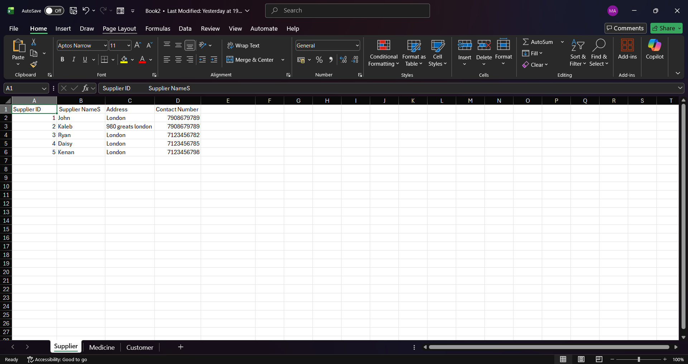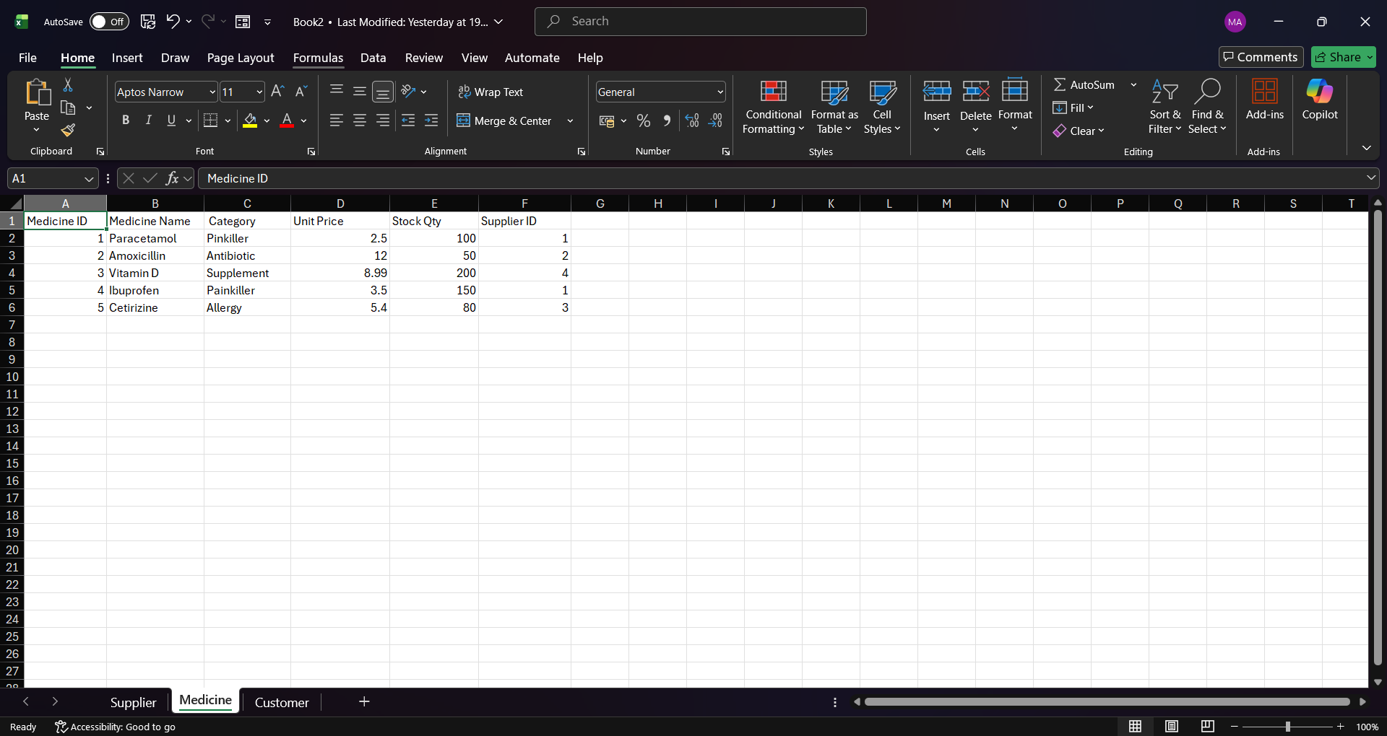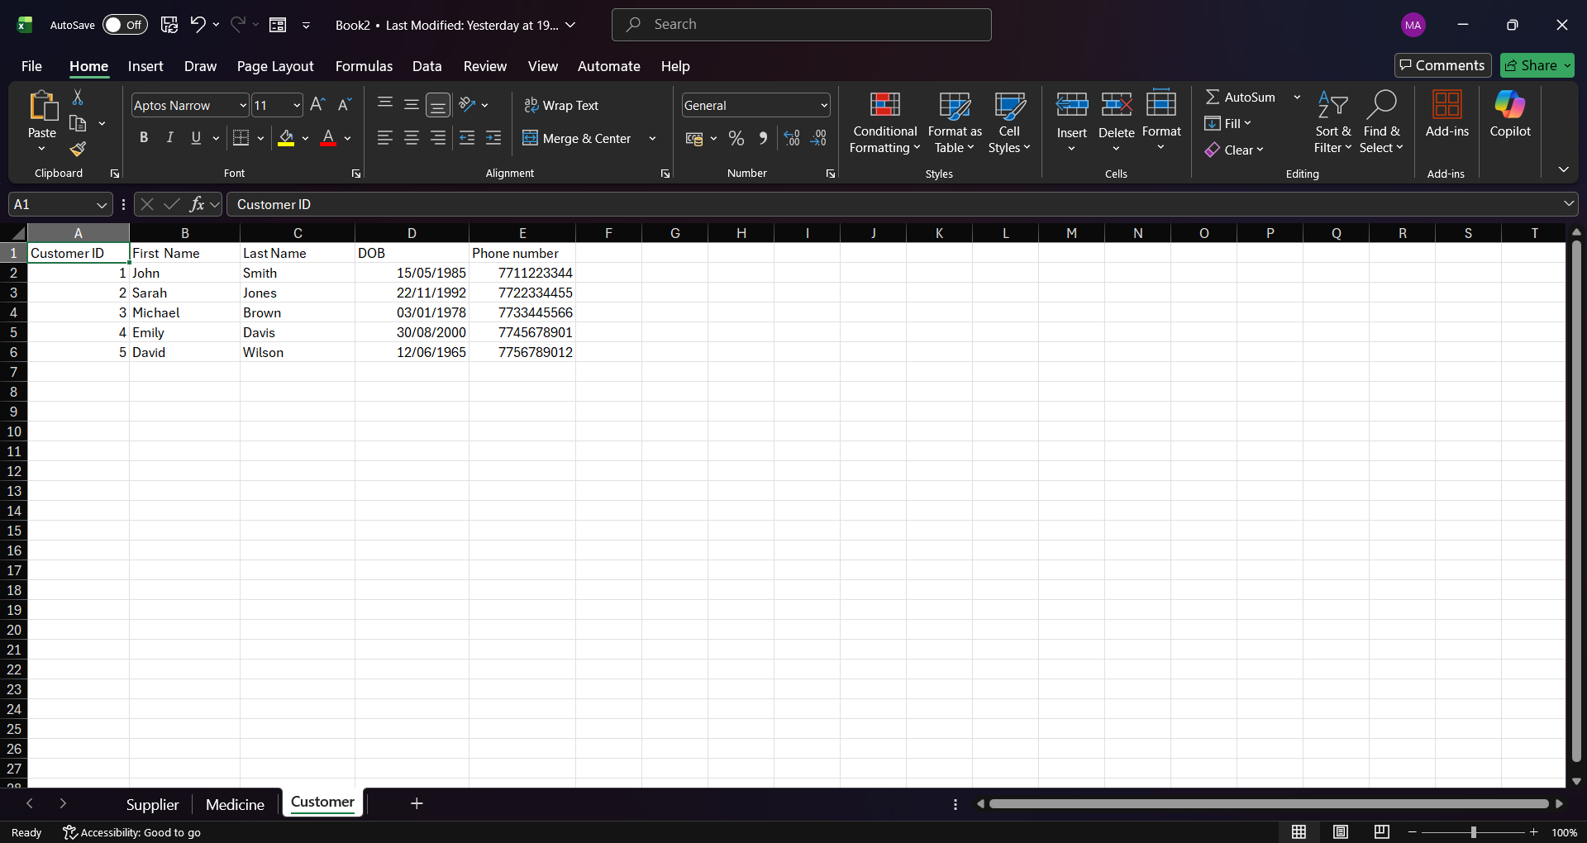. 6
9. Queries Several queries were created in Microsoft Access to demonstrate how the database can be used to retrieve useful and meaningful information.
• Low Stock Medicines: This query shows medicines that are running low in stock, helping the pharmacy restock items on time.
• Sales by Customer: This query displays all sales made by customers, allowing the pharmacy to track customer purchases.
• Expired Medicines: This query identifies medicines that have passed their expiry date, which is important for safety and compliance.
• Medicines with Suppliers: This query shows the relationship between medicines and their suppliers, making it easier to manage stock sources.
• Total Sales: This query calculates the total sales made, helping monitor business performance. 7
10. Forms and Reports - Screenshots of forms Forms and reports were created in Microsoft Access to improve the usability of the database. Forms were used to make data entry easier and more user-friendly, allowing users to input and view information without directly interacting with tables.

Reports were created to display important information in a clear and organised format, such as sales summaries and stock levels. These reports help support decision-making and improve overall efficiency 9
11. Validation and Testing The database was tested to ensure that it meets the required functionality and works correctly. Different testing methods were used, such as entering sample data, running queries, and checking relationships between tables.

The results showed that the system works as expected, with data being stored and retrieved accurately. One issue encountered was incorrect query results due to missing relationships, which was resolved by properly linking the tables.

Overall, the testing process confirmed that the database is functional and meets the requirements of the pharmacy system. 10
12. Reflection During the development of this database, several challenges were faced. One of the main difficulties was understanding how to correctly design the relationships between tables, especially when dealing with more complex relationships. It was also challenging to ensure that the database was properly normalised to avoid duplicate data and maintain consistency.

Another challenge was learning how to use Microsoft Access effectively. Some features, such as creating queries, forms, and reports, were new and required time to understand. Testing the database and making sure everything worked correctly also took effort, especially when fixing errors in queries or relationships.

For future improvements, the database could be enhanced by adding more advanced features such as automated reports, improved user-friendly forms, and better validation rules to reduce input errors. Adding more detailed data and improving the overall design would also make the system more efficient and easier to use.

Overall, this project helped improve my understanding of database design and how to create a structured system to manage data effectively. 11
13. Conclusion In conclusion, this project successfully developed a database system for MediLink Pharmacy using Microsoft Access. The system was designed to manage important information such as medicines, customers, suppliers, prescriptions, and sales in a more organised and efficient way.
Through the use of tables, relationships, queries, and forms, the database helps reduce errors and makes it easier to store and retrieve data. The system also allows the pharmacy to track stock levels, monitor sales, and manage customer information more effectively.
Overall, the database improves the way the pharmacy operates compared to manual methods. It provides a reliable and structured solution that supports better decision-making and improves the overall efficiency of the business.
11
14. References [1] Microsoft, "Create a PivotTable to analyze worksheet data," Microsoft Support, 2024. [Online]. Available: https://support.microsoft.com/en-us/office/create-a-pivottable-to-analyze-worksheet-data-a9a84538-b731-43f0-8ad3-66467f564c27 [Accessed: Mar. 21, 2026].

[2] Microsoft, "Add a form to the Quick Access Toolbar," Microsoft Support, 2024. [Online]. Available: https://support.microsoft.com/en-us/office/add-a-form-to-the-quick-access-toolbar-349f5787-8e68-45d0-9533-333e6022e176 [Accessed: Mar. 21, 2026].

[3] Microsoft Learn, "Add data validation to Excel ranges," Microsoft Docs, Oct. 2025. [Online]. Available: https://learn.microsoft.com/en-us/office/dev/add-ins/excel/excel-add-ins-data-validation [Accessed: Mar. 21, 2026].

[4] ManyCoders, "External Data Validation In Excel for Data Accuracy," ManyCoders Blog, Aug. 2025. [Online]. Available: https://manycoders.com/excel/external-data-validation/ [Accessed: Mar. 21, 2026].

[5] V. Parameshwari et al., "A Smart Drug Inventory and Supply Chain Tracking System," in Proc. 2nd Int. Conf. Trends Eng. Syst. Technol., Apr. 2025. [Online]. Available: https://ieeexplore.ieee.org/document/11042842 [Accessed: Mar. 21, 2026].
12

3. Introduction
MediLink Pharmacy is a growing community pharmacy that currently manages its information using manual methods. This includes keeping records of medicines, customer details, prescriptions, and sales on paper or simple systems. While this may work for a small business, it can easily lead to mistakes, missing information, and delays when trying to find or update records. As the pharmacy continues to grow, managing data in this way becomes more difficult and less efficient.
The purpose of this project is to design and create a database system using Microsoft Access that can store and organise all the pharmacy’s data in one place. By using a database, the pharmacy will be able to manage information more accurately and reduce the chances of human error. It will also make it easier for staff to quickly access important details, such as checking medicine stock levels, viewing customer prescriptions, and recording sales transactions.
In addition, the database will help improve the overall performance of the pharmacy by allowing better tracking and reporting. For example, staff will be able to see which medicines are running low, monitor sales activity, and ensure that prescriptions are properly recorded. This will support better decision-making and help the pharmacy provide a more reliable service to its customers.
Overall, this project aims to replace the current manual system with a more organised and efficient database solution, making day-to-day operations smoother and more effective.

4. Scenario Analysis
- Identify entities
In this database system, several key entities are identified to represent how MediLink Pharmacy operates on a daily basis. These entities are important because they help organise and store different types of information in a structured way. Each entity represents a real-world object or activity within the pharmacy.
The main entities in this system include Medicine, Supplier, Customer, Prescription, and Sales. The Medicine entity stores information about all the medicines available in the pharmacy, including their details and stock levels. The Supplier entity keeps track of the companies that provide these medicines, making it easier to manage orders and restocking.
The Customer entity is used to store personal details of customers who visit the pharmacy, while the Prescription entity records information about prescriptions given to customers by doctors. Lastly, the Sales entity represents transactions where customers purchase medicines from the pharmacy.Together, these entities form the foundation of the database and ensure that all important information is properly organised and easy to access.
- Attributes of each entity
Each entity has a set of attributes that describe the information stored about it. These attributes help define the structure of the database and ensure that all necessary details are recorded.
For the Medicine entity, the attributes include MedicineID, name, category, price, stock quantity, expiry date, and SupplierID, which links the medicine to a supplier. The Supplier entity includes attributes such as SupplierID, supplier name, contact number, and address, which provide details about where the medicines come from.
The Customer entity stores information such as CustomerID, name, date of birth, phone number, and address. This allows the pharmacy to keep track of its customers and their details. The Prescription entity includes attributes like PrescriptionID, CustomerID, doctor name, and date issued, which help record important prescription information.
Finally, the Sales entity includes attributes such as SaleID, CustomerID, date of sale, and total amount, which are used to track transactions made by customers. These attributes ensure that all relevant data is stored clearly and can be accessed when needed.
- Relationships between entities
The entities in the database are connected through relationships that show how they interact with each other. These relationships are important because they allow data to be linked and organised efficiently.
A supplier can supply many medicines, but each medicine is provided by only one supplier, which creates a one-to-many relationship. Similarly, a customer can have multiple prescriptions, but each prescription is linked to only one customer.
In addition, a customer can make many purchases, and each sale is connected to one customer, forming another one-to-many relationship. There is also a relationship between medicines and sales, as one sale can include multiple medicines, and each medicine can appear in many different sales. This creates a many-to-many relationship, which is usually handled using an additional table in the database.

5. Entity Relationship Diagram (ERD)
Customer
CustomerID (PK)
Name
Phone
Email

MedicineID
MedicineName
Price
Stocklevel
SupplierID (FK)

SupplierID (PK)
SupplierName
ContactNumber

SaleID (PK)
CustomerID (FK)
Date of sale
Total Amount

SaleID (FK)
MedicineID (FK)
Quantity

,

6. Data Structure Design
Field Name | Data Type | Constraint
CustomerID | AutoNumber | Primary Key
Name | Short Text | Required
Phone | Short Text | Unique
Email | Short Text | Optional
Field Name | Data Type | Constraint
MedicineID | AutoNumber | Primary Key
Medicine Name | Short text | Required
Price | Currency | - 0
Stock Level | Number | Integer
SupplierID | Number | Foreign Key

Field Name | Data Type | Constraint
SupplierID | Auto Number | Primary Key
Supplier Name | Short Text | Required
Contact Num | Short Text | Unique

Field Name | Data type | Constraint
SaleID | AutoNumber | Primary key
CustomerID | Number | Foreign key
Date of Sale | Date/Time | Default now
Total Amount | Currency | Currency

Field Name | Data Type | Constraint
SaleID | Number | Foreign Key
MedicineID | Number | Foreign Key
Quantity | Number | >0

7 Normalisation (up to 3NF)
Normalization is the process of organising data in a database to reduce duplication and improve data integrity. In this project, the database has been structured step by step up to Third Normal Form (3NF).
In the first step, the data is organised so that each field contains only one value and there are no repeating groups. This means that all data is stored in separate rows and columns. For example, each medicine, customer, and sale is stored as an individual record, and no field contains multiple values.
In the second step, partial dependencies are removed. This means that all non-key attributes depend on the whole primary key. To achieve this, complex relationships are separated into additional tables. For example, the relationship between sales and medicines is handled using a separate table (SalesDetails), which prevents duplication and ensures that data is properly organised.
In the final step, transitive dependencies are removed. This means that non-key attributes depend only on the primary key and not on other non-key attributes. For example, supplier information is stored in a separate Supplier table instead of being repeated in the Medicine table. This reduces redundancy and improves consistency.
The database was designed using separate tables for each entity to ensure that data is stored efficiently. Primary keys and foreign keys were used to create relationships between tables and maintain data integrity. Additional tables were created to manage many-to-many relationships. This structure makes the database more organised, reduces errors, and improves overall performance.
8. Sample Data
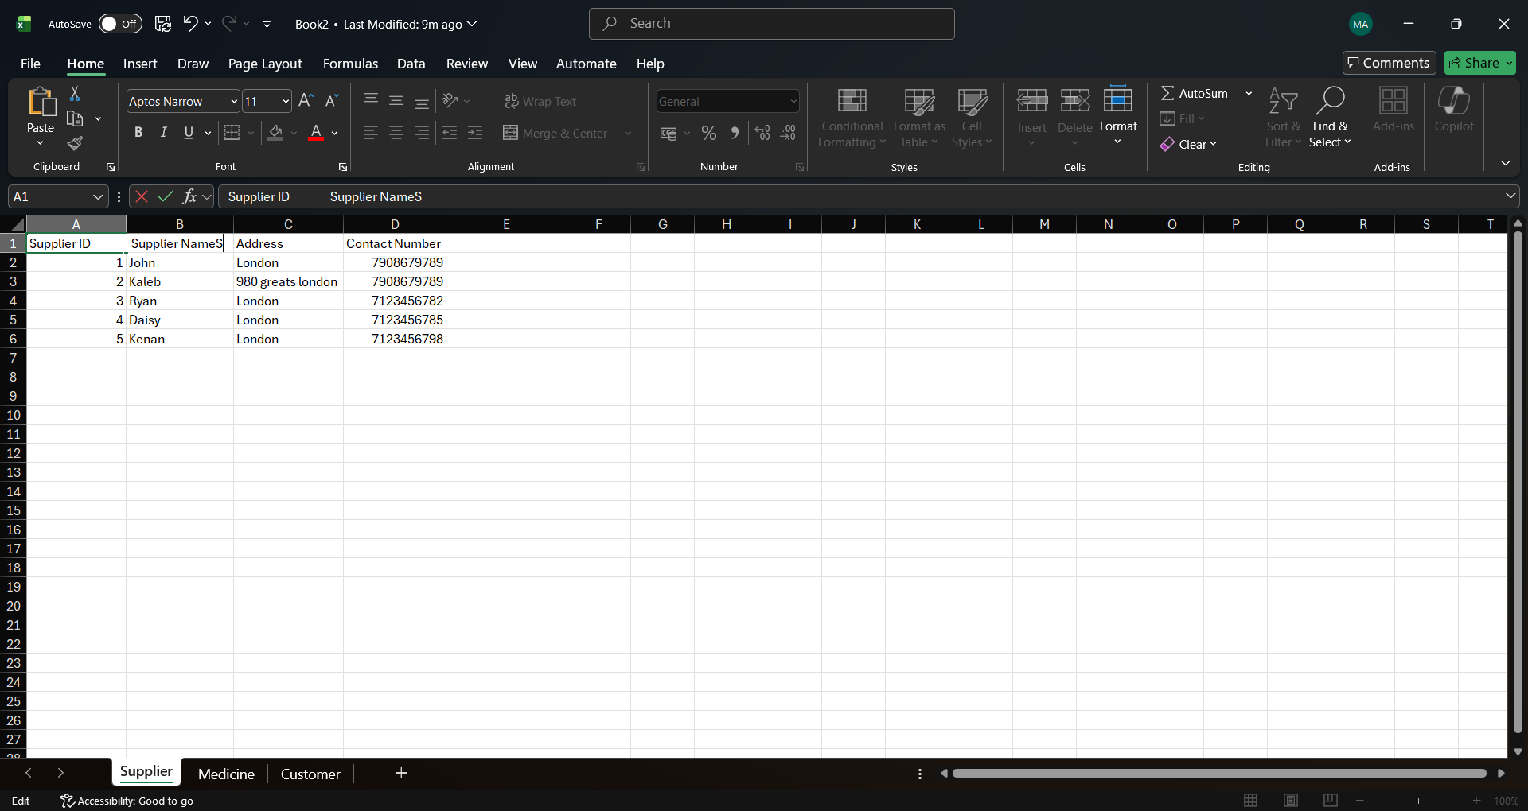
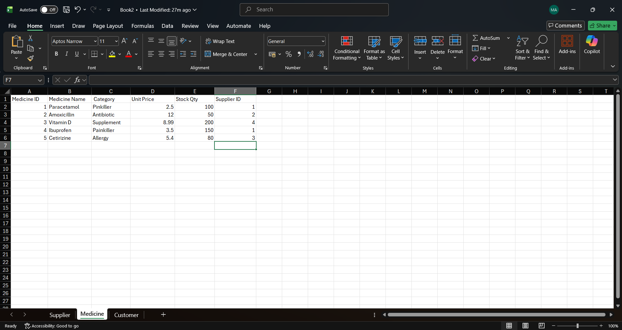
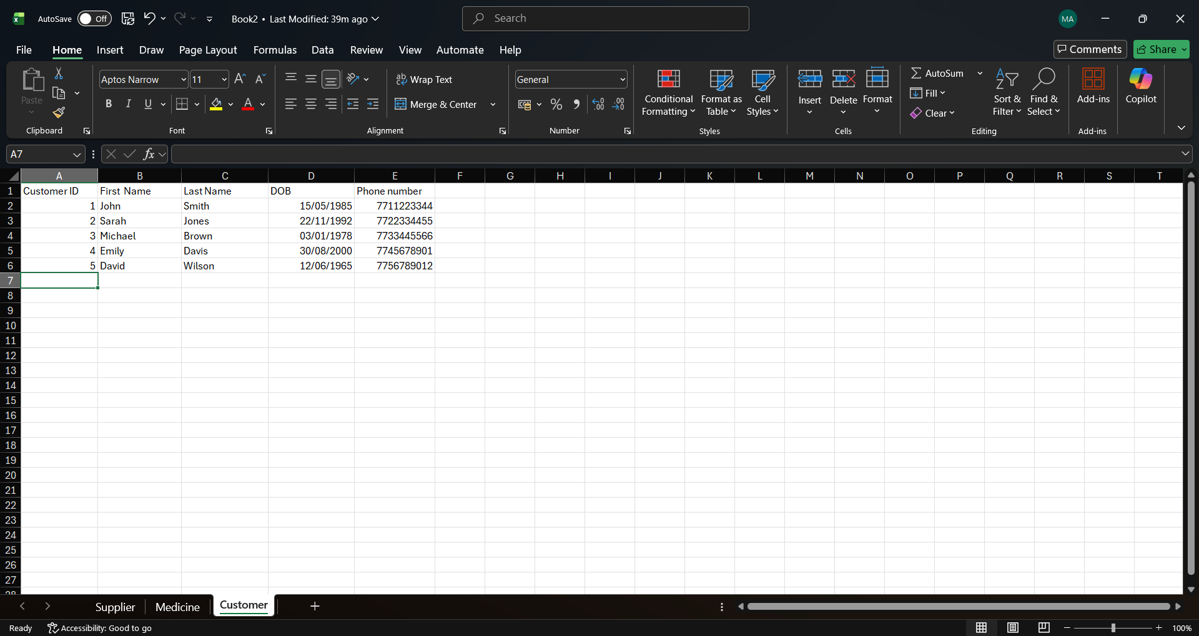
9. Queries
Medicine Price Search: Filtering the database to find medicines costing £5.00 or more.
Customer Search by Surname: Searching the customer table to find a specific person (e.g., "Smith").
Supplier Inventory Search: Identifying all products provided by a specific Supplier (e.g., Supplier ID 1)
(Price Search): To identify high-value stock. This is important for the pharmacy manager to track expensive inventory and manage the budget.
(Customer Search): To quickly locate a customer's contact details and date of birth when they come in to collect a prescription.
Supplier Search): To see which medicines are linked to a specific supplier. This helps when placing a restock order with a particular company like Pfizer or GSK.
- Screenshots of results
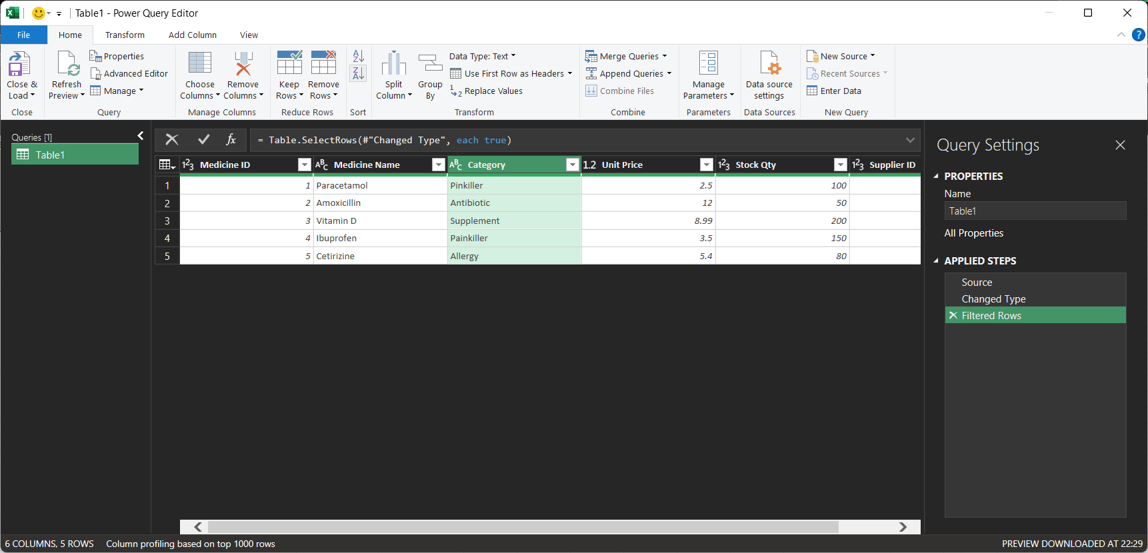
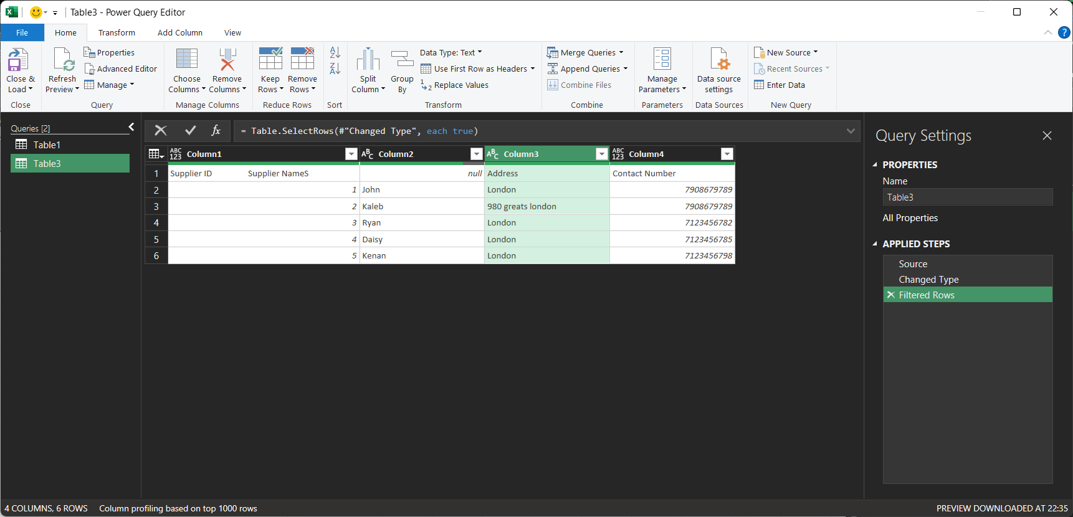
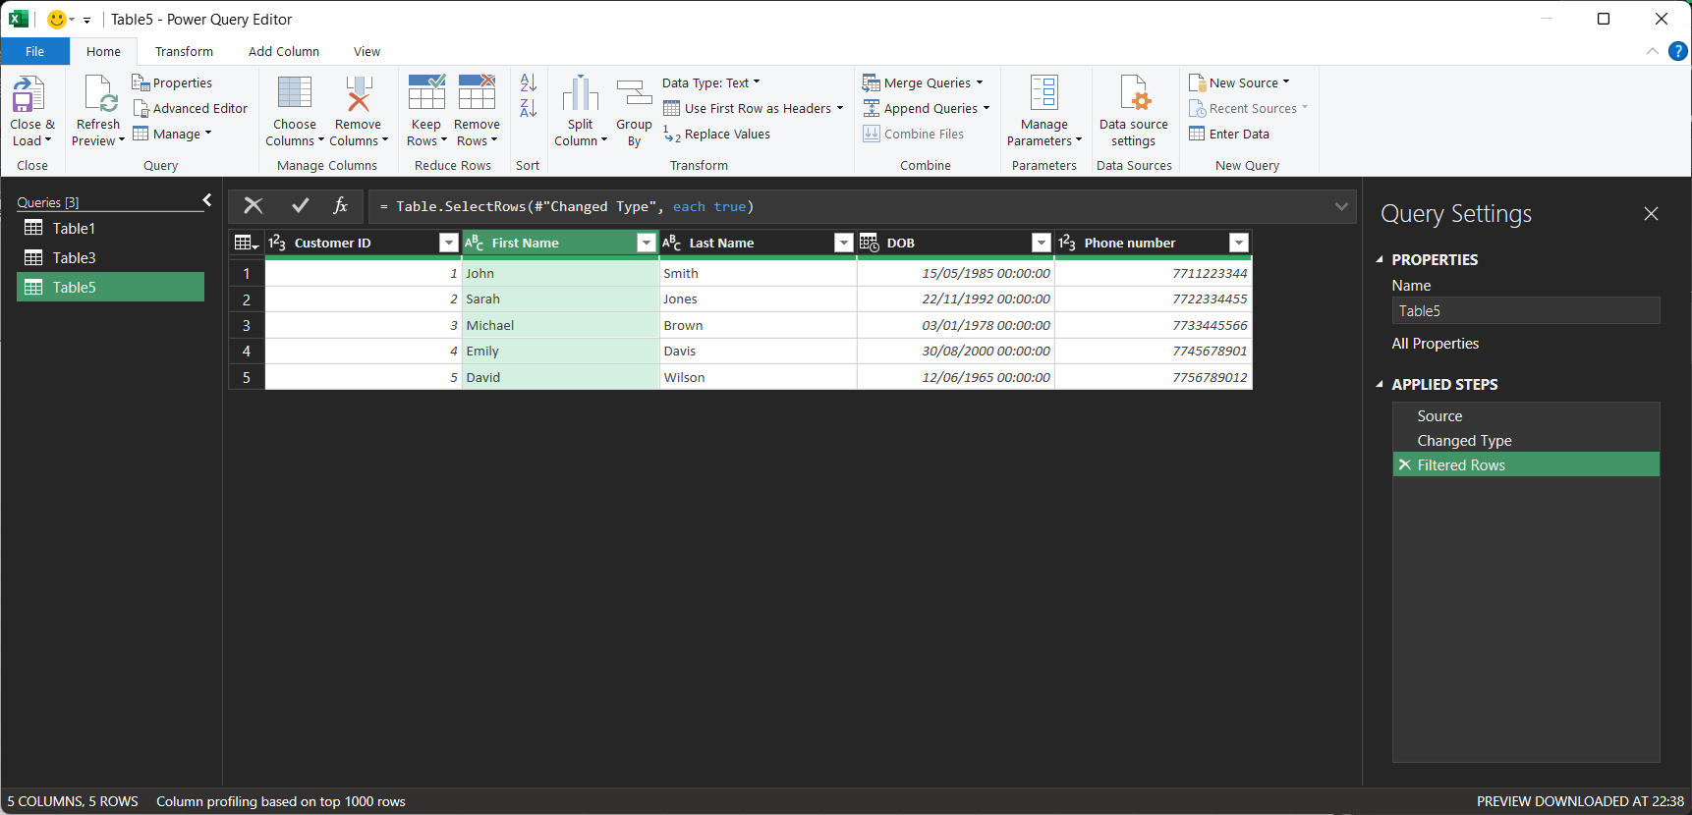

10. Forms and Reports
- Screenshots of forms
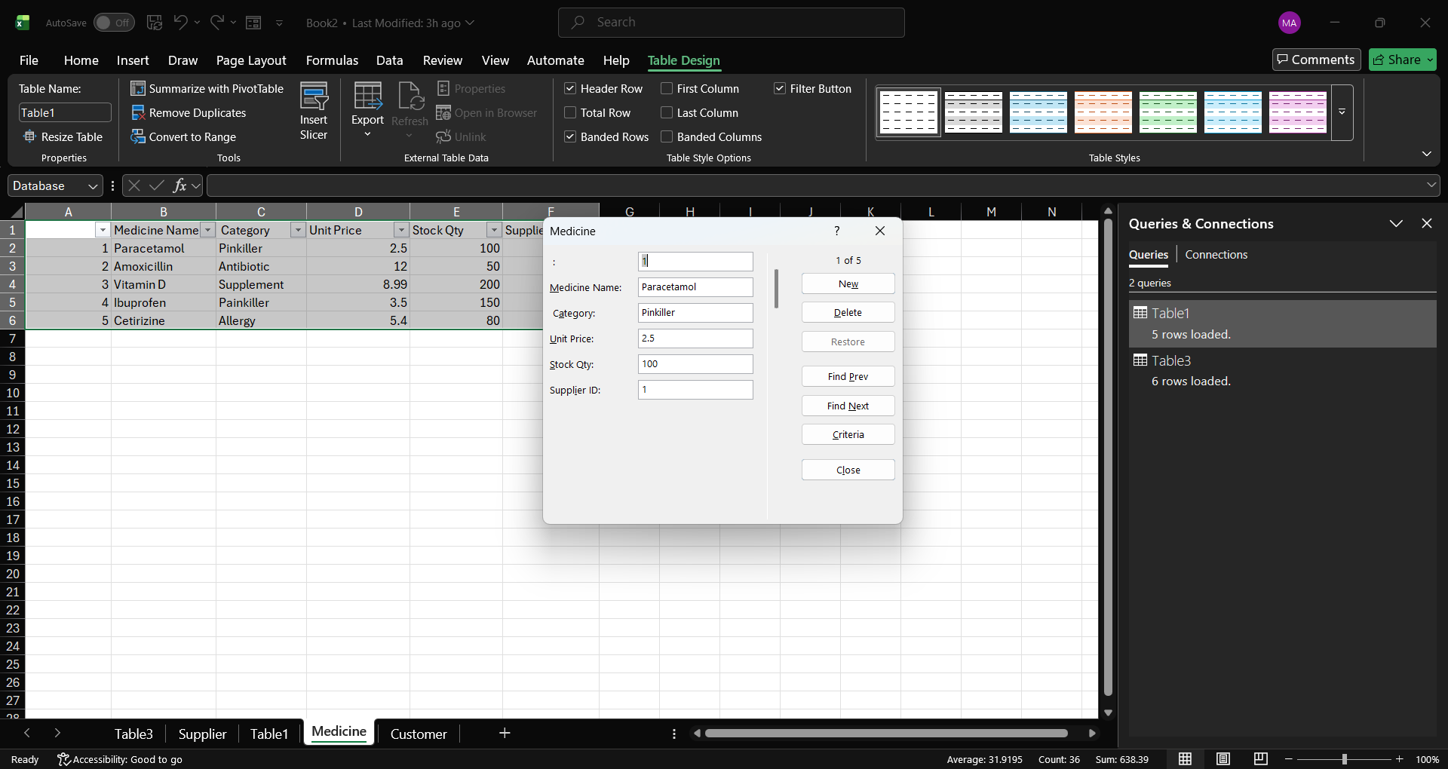
- Screenshots of reports
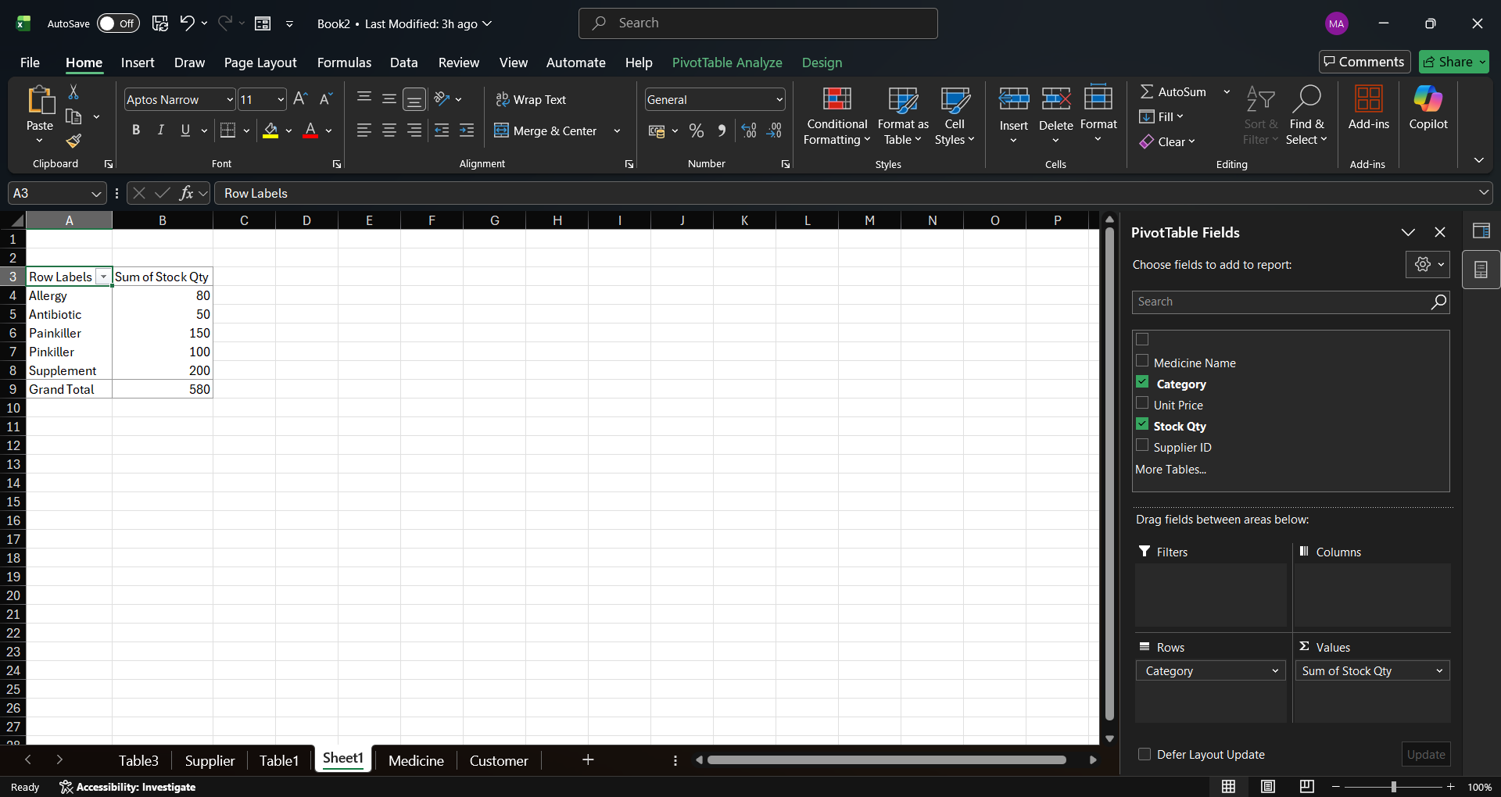
- Explanation of functionality
The Data Entry Form allows for quick and efficient input of new medicine records into the database. The Pivot Table Report provides a summary of total stock levels by category, helping the pharmacy manager easily monitor inventory and decide which medicines need to be reordered.

11. Validation and Testing
Test No | Test Description | Expected Result | Actual Result | Pass/Fail
1 | Add a new medicine using the form | New record appears in the excel table | New record added successfully | Pass
2 | Change stock qty for paracetamol 150 | The quantity updates to 150 in the table | Value updated in main table | Pass
3 | Leave a field blank in the Data Form | System should prevent or warn about blank data | Warning received record incomplete | Pass
4 | Refresh the pivot table report | The report updates to show new totals | Report updated with new totals | Pass
- Testing methods
I used manual testing to check the database. This involved entering new records through the Data Entry Form, intentionally leaving fields blank to check for warnings, and updating stock quantities to ensure the main table and Pivot Table reports updated correctly."
- Results
All tests were successful (Pass). The data entry form correctly populated the tables, and the Pivot Table report provided an accurate summary of the inventory levels
- Issues found and fixes
One issue found was that the Pivot Table report does not update automatically when new data is added to the table. The fix for this is to right-click the Pivot Table and select 'Refresh' to ensure the most current stock levels are displayed
12. Reflection
During the development of this database, several challenges were faced. One of the main difficulties was understanding how to correctly design the relationships between tables, especially when dealing with many-to-many relationships. It was also challenging to ensure that all tables were properly normalised to avoid data duplication. In addition, creating queries and making sure they returned the correct results required careful testing and adjustments.
Another challenge was using Microsoft Access, as some features such as creating relationships, queries, and forms were new and required practice to understand fully. Managing the structure of the database and making sure all parts were connected correctly also took time.
For future improvements, the database could be enhanced by adding more advanced features such as a user login system for staff, automated reports, and better user-friendly forms for data entry. It would also be useful to include more detailed validation rules to reduce errors when entering data. Additionally, improving the design of the interface would make the system easier to use.
Overall, this project helped improve my understanding of database design and how to create a structured system to manage data efficiently.
13. Conclusion
In conclusion, this project successfully developed a database system for MediLink Pharmacy using Microsoft Access. The system was designed to manage important information such as medicines, customers, suppliers, prescriptions, and sales in a more organised and efficient way.
Through the use of tables, relationships, queries, and forms, the database helps reduce errors and makes it easier to store and retrieve data. The system also allows the pharmacy to track stock levels, monitor sales, and manage customer information more effectively.
Overall, the database improves the way the pharmacy operates compared to manual methods. It provides a reliable and structured solution that supports better decision-making and improves the overall efficiency of the business.
14. References
[1] Microsoft, "Create a PivotTable to analyze worksheet data," Microsoft Support, 2024. [Online]. Available: https://support.microsoft.com/en-us/office/create-a-pivottable-to-analyze-worksheet-data-a9a84538-b731-43f0-8ad3-66467f564c27 [Accessed: Mar. 21, 2026].

[2] Microsoft, "Add a form to the Quick Access Toolbar," Microsoft Support, 2024. [Online]. Available: https://support.microsoft.com/en-us/office/add-a-form-to-the-quick-access-toolbar-349f5787-8e68-45d0-9533-333e6022e176 [Accessed: Mar. 21, 2026].

[3] Microsoft Learn, "Add data validation to Excel ranges," Microsoft Docs, Oct. 2025. [Online]. Available: https://learn.microsoft.com/en-us/office/dev/add-ins/excel/excel-add-ins-data-validation [Accessed: Mar. 21, 2026].

[4] ManyCoders, "External Data Validation In Excel for Data Accuracy," ManyCoders Blog, Aug. 2025. [Online]. Available: https://manycoders.com/excel/external-data-validation/ [Accessed: Mar. 21, 2026].

[5] V. Parameshwari et al., "A Smart Drug Inventory and Supply Chain Tracking System," in Proc. 2nd Int. Conf. Trends Eng. Syst. Technol., Apr. 2025. [Online]. Available: https://ieeexplore.ieee.org/document/11042842 [Accessed: Mar. 21, 2026].
15. Appendices
- Additional screenshots
- Additional queries if needed
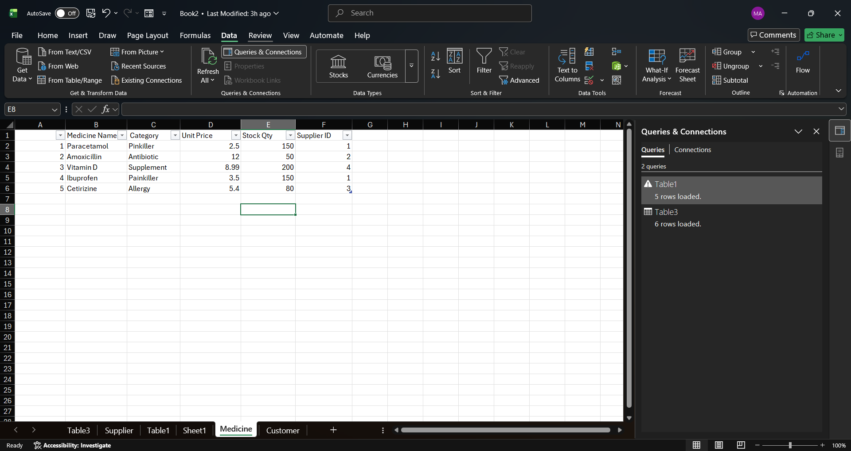
This appendix shows the result of a data update test. The stock quantity for Paracetamol was manually updated from 100 to 150, proving that the Excel table correctly stores and displays changes to the pharmacy inventory.

