
Current challenges that children, young people and families are facing in the UK

Alina Elena Radu 2018723 | Children, Young People and Families BMHP 5004_BIRM | Dr Mohammad Hossain

Contents
Introduction 1
Poverty 2
Covid-19 3
Obesity 4
Abuse 6
Bullying 7
Conclusion 7
References 8

Introduction

We often talk about children referring to the future of a society or a nation, and sometimes we forget that the most important thing is every child in himself, with his right to have a healthy life, to live in human conditions, to have food to eat, to receive medical care when needed, to go to school, not to be discriminated against, not to be abused. It is the right of children to be loved, it is their right for adults and society to take care of them and make them feel safe.
We often realize that beyond an individual case, it is a problem of an entire system that we need to change, but it takes a joint effort of the authorities, civil society, the school and the media for this change.
This essay presents some of the current challenges facing children, young people and families in the UK. Poverty, obesity, abuse, mental problems, bullying and the pandemic crisis that the whole world is still facing.

Poverty

Poverty is a global problem that we are facing more and more, unfortunately. It is hard to believe that in 2022 we can still starve, but statistics show that it is one of the leading causes of death globally.
A child in poverty is one who is born into or raised by a poor family or is an orphan who has been reared with little or no support from the state. According to UNICEF, 356 million children are living in extreme poverty. About one in every two children in the globe does not have access to at least one basic necessity, such as adequate housing, regular food or clean water. Poverty affects both children and adults, and impoverished children are twice as likely to die before the age of five as their affluent counterparts.
In most nations, "those under the age of eighteen" are considered children, whereas the onset of puberty is considered the biological transition from childhood to adulthood. When it comes to cultural definitions of when childhood comes to an end, there are many variables to consider, such as the onset of adulthood, the completion of formal education, and the beginning of a family.
According to the United Nations Children's Fund (UNICEF), children living in poverty are deprived of the material, spiritual and emotional resources needed to survive, develop and thrive, leaving them to enjoy their rights, to reach their full potential, and to participate as full and equal members of society.
Pay special attention to children and address the current high rate children living in poverty are vital to an economy based on poverty knowledge, sustainable, efficient and competitive, and a level playing field intergenerational. Various studies have repeatedly pointed out that investing in a relatively low financial cost during childhood can lead to gains throughout
for life, not only for those people, but also for societies and economies. The economic benefits of investing in children far outweigh the costs of investment financing.
The most exposed are children with disabilities, children of underage mothers. According to statistics, the children most affected by poverty are those who grow up in single-parent families, who come from immigrant families, who belong to an ethnic minority, and those who come from rural areas or other disadvantaged areas.
“On March 31 2019 there were 78,150 looked after children in England.7 While majority of looked after children live with foster families, some of the most vulnerable live in children’s homes.” (Children society .org)

Covid-19

The COVID-19 pandemic is the first of its kind in the modern era to affect the whole world. The pandemic affects everyone, especially children, regardless of where they live. For a variety of reasons, including poverty or their ethnicity, religion, or colour, many children around the world lack access to basic health care, education, and safety measures. For many years to come, the pandemic will have a significant influence on society, economy, and health. The pandemic has exacerbated the material problems of disadvantaged families. Children are the first victims of this dramatic situation. More and more children have reached the poverty line in the first year of the pandemic.
The coronavirus pandemic is causing children of all ages to feel anxiety, tension, and uncertainty, which they experience more acutely. When schools are closed, events are cancelled, and friends aren't around, youngsters need extra love and support to cope with their feelings of sadness and anxiety. We are not experiencing children's emotional problems for the first time now. But the first to help are parents, who may notice changes in their children's behavior. Talking to a mental health professional, such as a psychologist, psychiatrist, who can help them understand and cope with their emotions can do them good.
Not only children suffer from this pandemic, but also parents. Most of them deal with problems as a couple. During this period, more stressors were gathered than the couple is able to manage, so the relationship ends up showing an imbalance. No matter how easily people adapt to new situations, some have been severely affected by separation from loved ones, unemployment, and financial problems.
According to the analysis made by Science Directly in their article: “We found significant associations between loneliness and concurrent mental health difficulties in UK adolescents at the beginning of the COVID-19 pandemic and lockdown.”

Obesity

Most mothers and relatives of a baby believe that if they see him chubby, that is why he is healthy because he eats well. In addition, they comments on phrases such as "he will lose weight when he grows up" or "let him eat what he wants and how much he wants." However, if there is no cure for obesity in children, health problems may arise in the future. If the baby is up to 20% overweight by age, it will be considered an obese baby, with its corresponding consequences. One of them is difficulty moving, when the baby is more tired than usual when running and also when sitting, if he does not control his stability.
The World Health Organization states that childhood obesity is a serious global problem of this 21st century and that it is progressively affecting many countries. For this reason, he proclaims that this disease must be a priority and prevented as soon as possible. Obese children tend to follow the same "unhealthy habits" in adulthood and, as a result, contract much earlier diseases, such as diabetes and cardiovascular disease.
This overweight at such a young age is due to poor eating habits by parents. A healthy diet rich in fruits and vegetables should be followed, accompanied by daily exercise, not only to help the mother at birth, but also to avoid feeding the baby unhealthy foods. There are 3 factors in this global problem. These factors are: Genetic - If the parents are obese, the baby is more likely to be born with this health problem. Also, because of the lifestyle of the family, that is, the foods they eat (high-calorie), the way they cook and their low energy consumption. Environmental - A high-calorie diet brings with it an increase in body fat. A sedentary lifestyle is a big problem for today's children. Both the TV, the computer and the consoles are elements that occupy the free time, thus avoiding the physical exercises, causing this inactivity. Psychological - Sometimes there are children who eat foods with high nutritional value for certain reasons, including stress, insecurity, boredom or to alleviate their frustrations. Another disease that can be triggered by obesity is the thyroid or endocrine gland.
The graph below shows a significant increase (among boys and girls) between the ages of 2-10 years and 11-15 years.

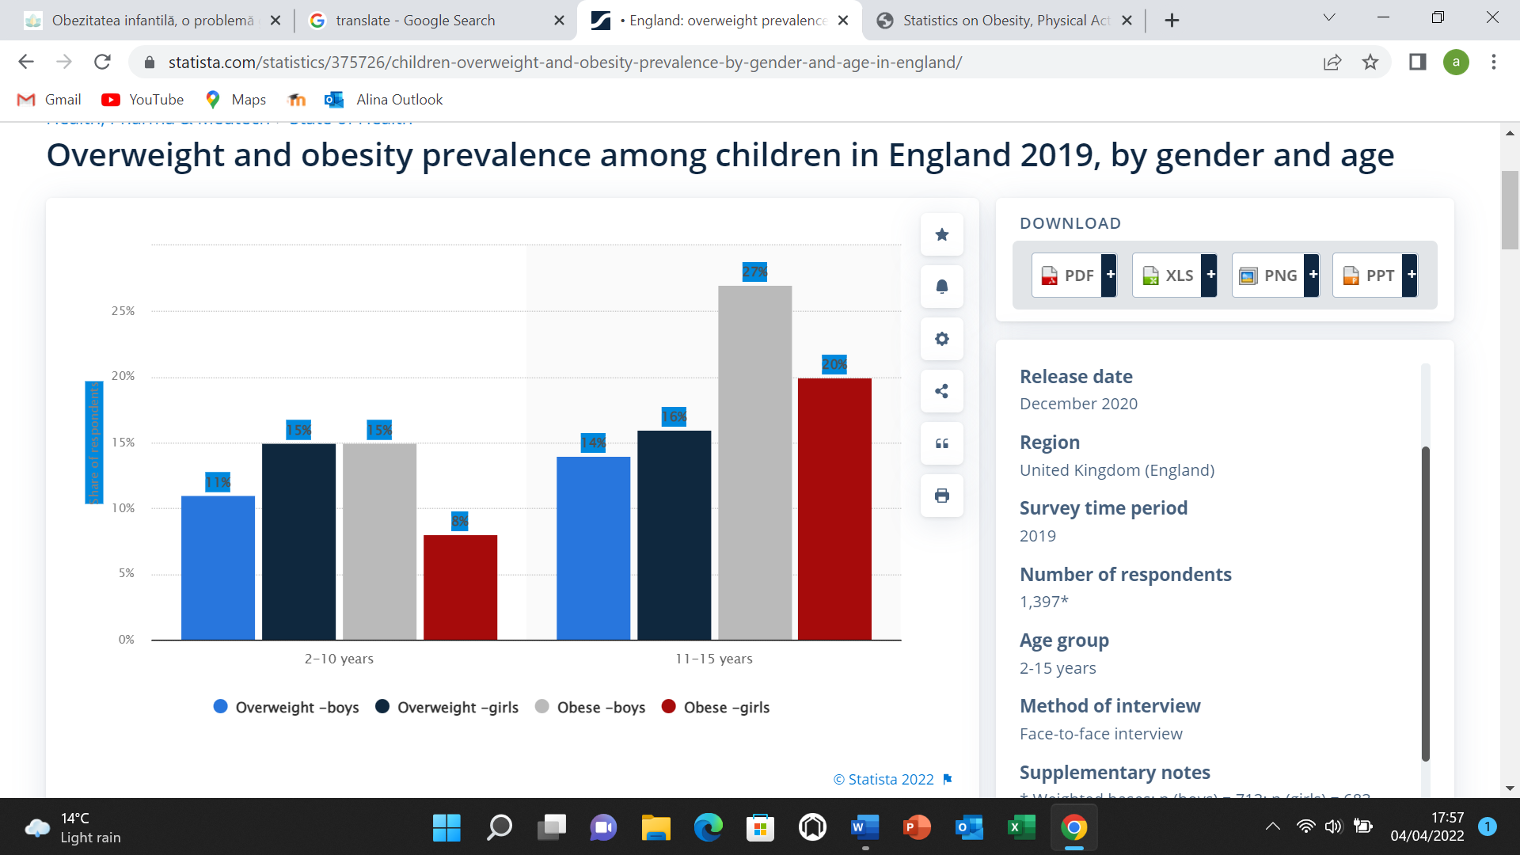
(Stewart, 2022)

Abuse

Child abuse and neglect are problems major public and social health issues that they may have devastating consequences. Although reporting the prevalence of child abuse differs greatly different countries and / or studies, children are generally recognized as a vulnerable group of the population, which requires protection from abuse or neglect on the part of parents or other adults.
Worldwide, it is estimated that one billion of children are victims of violence, annually.
There is a well-known overestimate of child abuse based on these figures because most abuse and neglect is not reported. For the World Health Organization, child abuse encompasses a wide range of behaviours that impair a child's health, development, or dignity, including physical and emotional abuse, sexual abuse, and other forms of abuse. The most common forms of abuse include neglect, physical, psychological, and sexual. The most prevalent kind of child abuse, neglect, is the inability to attend to a kid's needs on a regular basis.
Qualified staff have ethical responsibilities, important moral and legal measures regarding the prevention, diagnosis and treatment of child neglect and abuse. The nurse is therein the key position of being the first member of the profession who makes contact with the child and the family in a protective, therapeutic and rehabilitation context. During home visits, assistants may initially assess the risk to which they are subject family and can provide support in identifying and resolving existing problems. Risks can be identified by assessing family characteristics, such as unwanted pregnancy, out-of-wedlock births, young parents, health mental health and disability during the pre- and postpartum.
Cases of abuse can lead to serious injury, disability or even death. The issues are very important both medically and legally, as well as psycho-social development and inclusion. For these reasons, awareness of the phenomenon is becoming very important, with a focus on preventive activities, especially for health workers.

Bullying

The phenomenon of bullying is widespread worldwide. This refers to physical or verbal aggression or harassment, which is repeated over a period of time and involves an imbalance of power between two people, most often children. Unfortunately, bullying can have dangerous consequences on a person's normal development.
Although the phenomenon is more prevalent among children, bullying can also occur in the case of adults: another colleague from school; intimidating boss or coworker; the partner who controls the other; a neighbor; a business partner; a family member; another person involved in an abusive relationship.
Bullying can take many forms: verbal bullying: it is characterized by malicious verbal or written actions, such as: bullying, Injuries, inappropriate sexual comments, use of sarcasm, threats,
criticism, inappropriate language. Physical bullying involves the use of physical contact to intimidate others, through: physical intimidation, threats, harassment, harm, simulating violence, raising the fist, hit, push, destroying the other's things, obscene gestures, domestic violence, marital rape, sexual harassment at work, personal space breach, sprouting a person in the middle of a group. Social bullying refers to the damage to one's reputation or relationships and includes: gossiping, spreading and spreading rumors about someone, for example at work, putting a person in an embarrassing situation in public, the use of formal power, title / function or financial power as forms of intimidation, threat, harassment and / or harm, using sarcasm against someone, intentionally provoking a feeling of embarrassment and insecurity, socially or professionally excluding and isolating a person, intentionally sabotaging a person's well-being, happiness or success.
Bullying has negative effects on the health of the victim and her family, both in the short and long term. For this phenomenon to be stopped, it is crucial that people really understand how traumatic bullying can be. The effects of this phenomenon can be: social isolation, physical injuries and their effects on the mental level: strokes, contusions, which contribute to a high level of stress, anxiety, depression, skin conditions, stomach and heart problems, which can be aggravated by stress when a child is abused, a weakened immune system, ulcers and other conditions caused by anxiety and stress, a feeling of shame, sleep disorders, changes in eating habits, low self-esteem, headache, stomach pain, muscle aches (may be psychosomatic symptoms that have no known medical cause), reduced school performance due to decreased ability to concentrate.
Children who are harassed suffer both emotionally and socially because it is difficult for them to make friends, so they will have low self-esteem: they will begin to believe that what is being said about them is true.
Victims of bullying can experience many emotions: sadness, grief, frustration, loneliness and isolation. Moreover, the parents of the victims may experience a sense of failure regarding the upbringing and care of their child and may be overwhelmed by the whole situation.
Because childhood experiences shape us as adults, it is easy to understand why the effects of bullying persist into adulthood, influencing a person's perception of themselves and others. Bullying is a real, widespread phenomenon that negatively affects both the victim and the abuser. That is why it must not be tolerated in any way.
"It took a long time for [researchers] to start considering bullying behaviour as something that can be really harmful." (Robson, 2022)

Mental health

According to studies conducted in the United Kingdom, one in every five children suffers from a mental disorder. Furthermore, the mental health of the child is just as important as the physical health of the child. And even if you are unable to prevent all mental health problems in your child, you can take steps to ensure that your child remains mentally healthy.
When parents suffer from untreated mental health issues, their children are more likely to suffer from the same issues as their parents. When both parents suffer from mental illnesses, children are at an even greater risk of developing mental illnesses themselves. When a parent's mental illness is left untreated, it can cause family life to become inconsistent or unpredictable. It can also have an impact on a parent's ability to discipline their children, as well as on the relationship between the couple. These factors have an impact on the psychological well-being of the child. If you have a problem with your mental health, see a doctor right away! According to research, when a parent is receiving therapy or medication to cope with a mental illness, the symptoms of their child's mental illness improve.
Taking a youngster to see a mental health expert may seem extreme, but it is never too early. In fact, if a child exhibits symptoms, the entire family may be invited to engage in counselling. Helping the child's mental health as well as providing parents with resources and assistance are both possible benefits of seeing a child mental health specialist.

Conclusion

An analysis of the child's situation and rights highlights the fact that progress in the last decade is either modest (infant mortality rate, protection against violence, combating poverty, protection system) or zero (education, medical protection, protection of children with disabilities).
Although any form of physical or emotional abuse is prohibited by law, studies show an increased level of violence (parents use beatings or verbal violence in their relationships with their children), and the incidence of child abuse remains an underreported phenomenon. A serious problem that keeps this phenomenon high is tolerance for so-called "slight abuse" (slapping, teasing, insults) and the cultural perception that corporal punishment is useful in disciplining the child.
The final conclusions highlight the need for a responsible approach to the issue of children's rights. Ultimately, the interests of the child that public authorities are obliged, morally and legally, to place, at every moment of their actions, above political or economic interests.

References

- Baracz, S. (2018). How childhood trauma changes our mental health into adulthood Available at: https://psychlopaedia.org/health/republished/how-childhood-trauma-changes-our-hormones-and-thus-our-mental-health-into-adulthood/ [Accessed: 05/04/2022].
- Cooper, K. et al. (2021). Loneliness, social relationships, and mental health in adolescents during the Covid-19 pandemic Available at: https://www.sciencedirect.com/science/article/pii/S0165032721003402 [Accessed: 04/04/2022].
- Fuller, K. (2019). Mental health conditions seen in childhood Available at: https://www.nami.org/Blogs/NAMI-Blog/October-2019/Mental-Health-Conditions-Seen-in-Childhood [Accessed: 05/04/2022].
- GOV.UK (2020). Childhood obesity: applying all our health Available at: https://www.gov.uk/government/publications/childhood-obesity-applying-all-our-health/childhood-obesity-applying-all-our-health [Accessed: 04/04/2022].
- GOV.UK (2021). What is bullying? Available at: https://www.education.vic.gov.au/about/programs/bullystoppers/Pages/what.aspx [Accessed: 05/04/2022].
- GOV.UK (2021). What is bullying? Available at: https://www.stopbullying.gov/bullying/what-is-bullying [Accessed: 05/04/2022].
- GOV.UK (2021) What is children’s mental health? Available at: https://www.cdc.gov/childrensmentalhealth/basics.html [Accessed: 05/04/2022].
- GOV.UK (2021). Children and young people Available at: https://www.gov.uk/government/publications/covid-19-mental-health-and-wellbeing-surveillance-report/7-children-and-young-people [Accessed: 03/04/2022]
- Marques de Miranda, D. et al. (2020). How is Covid-19 pandemic impacting mental health of children and adolescents? Available at: https://www.sciencedirect.com/science/article/pii/S2212420920313479 [Accessed: 04/04/2022].
- Mayo Clinic, (2021). Child abuse Available at: https://www.mayoclinic.org/diseases-conditions/child-abuse/symptoms-causes/syc-20370864 [Accessed: 05/04/2022].
- NHS (2020). Statistics on obesity, physical activity and diet, England, 2020 Available at: https://digital.nhs.uk/data-and-information/publications/statistical/statistics-on-obesity-physical-activity-and-diet/england-2020# [Accessed: 04/04/2022].
- NHS, Domestic violence and abuse Available at: https://www.nhs.uk/live-well/getting-help-for-domestic-violence/ [Accessed: 05/04/2022].
- Peterson, A.C. (2014). Consequences of child abuse and neglect Available at: https://www.ncbi.nlm.nih.gov/books/NBK195987/ [Accessed: 05/04/2022].
- Robson, D. (2022). The Nordic way to stop bullying Available at: https://www.bbc.com/future/article/20220307-the-best-way-to-stop-bullying [Accessed: 05/04/2022].
- Russell-Mayhew, S. et al. (2012). Mental health, wellness and childhood overweight/ obesity Available at: https://www.hindawi.com/journals/jobe/2012/281801/ [Accessed: 05/04/2022].
- Stewart, C. (2022). Overweight and obesity prevalence among children in England 2019, by gender and age Available at: https://www.statista.com/statistics/375726/children-overweight-and-obesity-prev alence-by-gender-and-age-in-england/ [Accessed: 04/04/2022].
- The children’s society. The impact of covid-19 on children and young people Available at: https://www.childrenssociety.org.uk/sites/default/files/2021-01/the-impact-of-covid-19-on-children-and-young-people-briefing.pdf [Accessed: 04/04/2022].

