
Submitted by: Smarandoiu Denisa-Maria-1816244
Module Title : The Global Business Environment (LCBB4005)
Assignment Title :" The Global Business Environment (LCBB4005)a1
Module Lecturer`s Name: Dr Kenny Tang

Table of Contents
Global Business Environment 1
Introduction 3
Part-1: External Forces 4
PESTEL Analysis 4
Porter’s Five Forces Model 5
Organizational Changes 7
Part-2: New Opportunities 9
Porter’s Value Chain 9
New Opportunities 11
Dis-continued Businesses 12
Conclusion 15
References 16

Introduction

Globalization brings new era of communication and technology. People now can communicate all over the world within a short span of time. This advancement also influenced in automobile industry. Thinking of electric vehicle (EV) comes true. Tesla, BMW, NISSAN, Volkswagen and many others now manufacturing electricity run vehicles. This industry is booming in last few years. Though there are some challenges ahead. Such as low speed, short time backup, high charging time, unavailability of charging stations, high cost etc. (Dave, 2015). Experts are working on these issues and it is expected these will be addressed very soon. People are becoming aware about environmental issues. They look forward to environmentally sustainable business development. The EV is gaining rapid popularity due to its eco-friendly nature. Though debate remains that how the necessary electricity will be produced for these vehicles. This expanding industry impacts the conventional automobile industry. Despite some business models will be obsolete, it will open new doors of business. Primarily, this industry can face some issues such as distribution, ensuring after sales service, government policy, tax and tariff issues, etc. in international market.

Part-1: External Forces

In the highly competitive world market, every industry performance depends on some factors. Those factors can be internal as well as external. All the key factors should be identified and analysed prior to start operating a business. Lack of proper analysis, a business model can fail.

PESTEL Analysis

Political Factors:
A business environment is mostly depending on its political environments or its factors. The government, its motive, vision, political agenda, etc. are parts of political factors. Electrical vehicle has opened a new door of business that is welcomed by modern citizens and government regardless of group or party. Though, changing government, business policy, subsidies or tax pattern can be changed which can deeply influence in EV business.
Economic Factors:
Economic factors include exchange rate, customer income, disposal income, etc. those affect customer behavior. In this case, EV is a costly purchase and its manufacturers primarily target the high valued customers who have high level of income. So, it can be assumed that customer will have less impact on slight changes in exchange rates.
Socio Cultural Factors:
Socio cultural factors are considered with importance as it influences the customer buying behaviour. Number of people, work trend, social norms, religious beliefs, etc. is main factors here (PESTLE Analysis, 2020).

Technological Factors:
Changes in technology are one of the major factors to be considered in EV perspective. EV is a totally technological product and within few years, we have been experienced radical development in it. For example, battery, the most important part of EV, is developed so fast that now an EV car can run more than 400 km with charging once(Alankus, 2017).
Legal Factors:
Every business organization has to follow national as well as international rules and regulations related to its business. Here, EV business must also comply with some rules, for example safety rules, transportation acts, etc. (Sharma, 2017).
Environmental Factors:
Behind the development of EV, environmental factors are vital. The concept of EV is to make the world free from carbon emission and keep the environment pollution free. Though the question remains, the fuel of EV is electricity and to produce electricity, some form of environmental impact is involved.

Porter’s Five Forces Model

Porter’s five forces model is a well-developed business strategy tool to analyse a firm’s market position and its competitiveness. Developed by Michael Porter in 1979, this is a popular model that has five factors to consider by a firm.
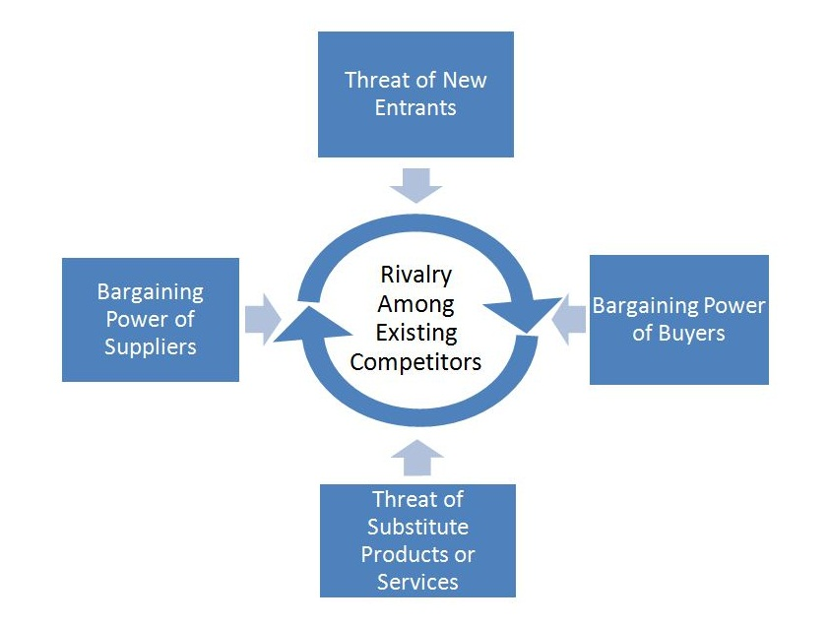

Figure: Porter’s Five Forces Model
Source: (Campbell, 2015).

Supplier Power:
Supplier is an important part for any business organization. For a manufacturer, raw material has to keep supplying, for wholesaler or retailer final product needs to be supplied. So, in every perspective, supplier has vital role to play. In this case of EV, battery, electric engine or other parts need to be supplied. As there are a small number of suppliers, they hold more bargaining power (Campbell, 2015). So, they should be maintained carefully.
Buyer Power:
Buyer or consumer of product is aimed to be reached and served. Their demands, income level, buying behaviour are considered while manufacturing goods (Koen and Mason, 2005). As the customer base is small in size for EV due to its cost, customers also have a good bargaining power as there are other choices, the Internal Combustion Engine (ICE) vehicle.
Competitive Rivalry:
It requires advanced technological infrastructure which costs high, there is small number of competitors in the market presently. But with time, the number of competitors is also rising. High end car manufacturers are inclined to manufacturing EV as there is a high possibility with environmentally low impacts.
The Threat of Substitution:
Substitution is always a threat for a product. Here, both passenger cars and commercial transportation have been targeted. As it is new and in the development stage, customers are not fully aware of its services. Moreover, there is a high possibility of introducing new technologies in battery, charging technology, etc.
The Threat of New Entry:
No firm can be in safe position forever. So, before new competitor enters into the market, more competitive position should be established (Koen and Mason, 2005). Research and development should keep going. There should always be focused on increasing efficiency with low cost. And economies of scale must be ensured.

Organizational Changes

EVs are widely accepted for several reasons. It ensures zero carbon emission which is the best part of this vehicle. Moreover, several governments are providing tax benefits, subsidies to encourage people to move electric vehicles. Many countries in European Union are also influencing in different way such as imposing carbon tax to public to discourage conventional vehicle usage. So, this newly and rapidly growing industry shapes its own organizational design (Puranam and Maciejovsky, 2017). For example, it requires a new supply chain structure development. Organizational changes denote the change in operational process, organization structure, technological changes, etc. It can be done over time. The drivers of organizational changes depend on customer demand, income level, invention of new technology number of competitors, government policy, organizational size and so on. It has a vital impact on every organization (Beddi and Nivoix, 2017). Such changes should be clearly communicated with its stakeholders. There are a lot of scopes of organizational changes in EV industry. Because, this industry is growing over time. Moreover, it will be changed with technological advancement.
- The main change here is its fuel. Presently, the battery used, take more time to fully charged, 4-8 hours in some cases. In addition, the efficiency is also comparatively low. So, development of battery is obvious. EV manufacturers can invest in battery development or they can outsource.
- In another case, charging methods are also different. Fuel Cell Electric Vehicle (FCEV) can generate its required electricity by itself. On the other hand, a Battery Electric Vehicle (BEV) or Plug-in Hybrid Electrical Vehicle (PHEV) or a Range Extended Electric Vehicle (REEV) has different form of gathering its required electricity. So, there is a scope of changes and development which can lead to organizational changes.
- EV cannot be manufactured by every country. It requires advanced technology, IT knowledge or technological expertise, high investment, etc. A few developed countries are producing EV now. But over time, it might be distributed all over the world. So, to assemble an EV will require a well-structured supply chain.
It will not only impact in vehicle or transport industry, but also impact on many other relevant organizations. For example, as this industry will require a high investment, here mobility of money will increase. So, for financial integration, system can be revised.
To analyse a firm’s business environment, these assessments are necessary. While a firm thinks to be international, these assessments will lead to the firm’s steps to success. These will help to formulate right strategies to enter into the market and to grow there.

Part-2: New Opportunities

Use of electric engine in automobile industry is new. Though there was use of electricity in some specific functions in a vehicle. It opens new window of possibility. Previously long-distance vehicles cost high which now become low due to EV. Moreover, those vehicles can be more capable of weight lifting. This invention also broader our thinking on the development of vehicle. Recently, the market of EV is expanding very fast. In 2013, NISSAN has sold around one hundred thousand units of EV. So, it is obvious that the future of EV is welcoming.

Porter’s Value Chain

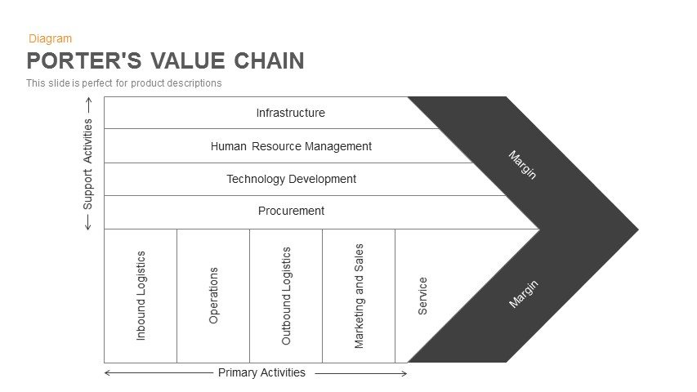
Value is something for what one is willing to pay. Value chain refers to a set of activities that add value to a product or services. For example, ore is not worth of payment to general people, but, when it becomes a ship or a bus, it is worth of money. If we consider the value chain process, we will find several layers or business entities that made add the value in different levels. Michael Porter has developed a value chain model.
Source: (Koen, 2005).
This model has two parts. One shows primary activities, and another shows the supporting activities usually done in value chain process. The primary activities include input logistics which is ensured by supplier. Next is operation in where final goods are made. Then, the goods are transferred to wholesaler which is known as output logistics. At fourth stage, marketing and sales are performed. And finally, the sold goods can be ensured further services. To do so, the supporting activities needed are infrastructure development for the whole process, recruit people to organize and manufacture the goods, develop technology to manufacture and finally procure the goods. The whole process is interrelated. So, no process can be ignored. Some goods may not be provided servicing, or some products can be sold at the point of manufacture. These are different in some cases. For EV, a value chain network should be developed. Parts of EV can be provided by different manufacturers. For example, battery can be developed by one firm; engine can be manufactured by another firm and so on. The EV manufacturer will collect all the necessary parts and assemble (Wells, 2010). Then he will find his wholesales or distributor to reach its final product to customer doorstep. The manufacturer can ensure marketing activities. In international market, this value chain sometimes seems difficult as suppliers are not located in a single place or the place where the manufacturer locates. Sometimes, manufacturers become its own supplier by manufacturing some of its parts needed for EV. Present situation is that the target customers are located in the developed countries like USA, UK, France, Germany etc. And these countries are technologically developed to manufacture their necessary parts. But to become cost efficient, some parts are manufactured in China or other countries.

New Opportunities

There are a lot of opportunities for EV industry.
- Battery Charging Stations:
High number of EVs will require huge number of charging stations. In Europe, thousands of such charging stations are planned to be set up. It is not possible for the EV manufacturers or government to install such stations to fulfil the demand. So, there is an opportunity for private firms to work with it.
- Spoiled Battery Recycling:
A large number of batteries will be outdated over time. Those will require managing without environmental impact. If these are buried, soil pollution will take place and one day it will be difficult to find place to throw the spared batteries. So, it can be an opportunity to recycle those batteries for further use. Those may not be used in the cars again but can be used in household or other purposes.
- Battery Manufacturing:
Demand for fast charging battery is increasing day by day. Battery is an important part in EV industry. Hybrid vehicles also require batteries. So, it is imminent that battery with high efficiency and fast charging can be next successful business model.
- Establish Charging Station for Others:
If we think deeply, charging station set up need expertise and technology. some new organizations that will set up charging stations for others.
- Spare Parts Manufacturing:
Volkswagen is one of the biggest competitors in EV manufacturing and sales in Europe. It sold 51528 units of EV in 2015. And this number is increasing day by day. Like Volkswagen, Tesla, Audi, Volvo etc. have plan to manufacture huge number of cars within few years. They need spare parts to produce. Moreover, as EV will run on electricity, conventional parts must be replaced or developed. So, there will be new production technology and process. Here is new business opportunity.

Dis-continued Businesses

Change in technology brings changes in automotive industry as well. It results in changes of conventional vehicles and related businesses. Some business model will become obsolete and some will need to be modified. Many small and large, national and multinational corporations are in manufacturing those parts. It also requires involvement of thousands of people. It is a big part of industrial sector in some countries. So, change in automotive industry will surely bring major changes in economic activities in some countries like China, Japan, Korea, United Kingdom, United States, Germany and so on. Most of branded automobile producers are thinking of new technologies. EV is the result of such move. This change impacts on conventional automobile industry. Here are some examples of such businesses.
- Production of diesel engine or CNG run engine for vehicle will be decreased over time. though there are some challenges in the development of EV fully, but these will be addressed. So, those diesel engines or CNG engines will be obsolete one day.
- There are a number ofrefuelling stations around the world. Though those serve not only the vehicle refuelling, but also other types of machines, major share is in vehicle refuelling. Those refuelling stations will also be decreased over time as its demand will fall due to electric vehicles. Newly battery charging stations will take the place.
- A vehicle needs different types of parts to assemble. All of them cannot be manufactured by a single manufacturer. Here lots of small and large firms are engaged in production. Business of manufacturing parts used in diesel or petrol engines for example smoke emission, silencer or other purposes will be hampered. Those will have to change their business model or shut down.
While something comes new, old goes behind. Like that, growing EV market share will decrease the market of ICE. As the European Commission shows support to EV industry, it will grow in Europe very fast along with the other developed and developing countries of the world.

Conclusion

It can be said that development of EV was demand of time. People crave to get a fuel efficient and environment friendly transport solution. This type of vehicle will not only ensure zero carbon emission, but also stop sound pollution. Though this technology is expensive primarily, but there is possibility to become affordable for middle income people in future.

References

Alankus, O. (2017). Technology Forecast for Electrical Vehicle Battery Technology and Future Electric Vehicle Market Estimation. Advances in Automobile Engineering, 06(02).
Beddi, H. and Nivoix, S. (2017). Management international. Paris: Vuibert.
Campbell, D., Stonehouse, G. and Houston, B. (2015). Business strategy.
Dave, M. (2015). Sustainability Takes on a Key Role in the Auto Industry. Auto Tech Review, 4(11), pp.44-47.
Industry Reviews the Automotive Mission Plan 2006–2016. (2014). Auto Tech Review, 3(11), pp.18-23.
Koen, C. and Mason, K. (2005). Comparative management. Maidenhead, Berks.: McGraw-Hill Education.
GroupMap - Collaborative Brainstorming and Decision Making. (2020). PESTLE Analysis, PESTLE Analysis Template - GroupMap. [online] Available at: https://www.groupmap.com/map-templates/pestle-analysis/ [Accessed 1 Jan. 2020].
Mindtools.com. (2020). Porter's Five Forces: - Understanding Competitive Forces to Maximize Profitability. [online] Available at: https://www.mindtools.com/pages/article/newTMC_08.htm [Accessed 1 Jan. 2020].
Puranam, P. and Maciejovsky, B. (2017). Organizational Structure and Organizational Learning. SSRN Electronic Journal.
Sharma, A. (2017). ISO Implementation & Survey for Automobile Industry. International journal of Emerging Trends in Science and Technology, 04(06), pp.5275-5281.
Wells, P. (2010). Creating new value-added configurations in the electric vehicle industry. World Electric Vehicle Journal, 4(4), pp.823-834.
PESTLE Analysis. (2020). What is PESTLE Analysis? A Tool for Business Analysis. [online] Available at: https://pestleanalysis.com/what-is-pestle-analysis/ [Accessed 1 Jan. 2020].

