Primary Source Evaluation- Quran Manuscripts
The Birmingham Quran manuscript and the British Library’s early Quran manuscript are two amongst the first Quranic manuscripts in the world. The Birmingham Quran manuscript was held by the Cadbury Research Library at the University of Birmingham (Birmingham University 2018). The manuscript was written on parchments with Hijazi Arabic scripts, the early writing of the Hijaz in the western side of current Kingdom of Saudi Arabia (Birmingham University 2018). On the other hand, the British Library’s earliest Quran manuscript was from the Hijaz and it is written in Hijazi as well (British Library 2018). In this essay, I will analyse each manuscript, compare them to each other, and then compare them to other Quran versions.
First of all, the Birmingham manuscript was dated by radiocarbon dating at a laboratory at the University of Oxford. The dating analysis showed that the manuscript is from 568 - 645 CE with an accuracy of 95.5% (Birmingham University 2018). The only problem with the resulted date is that it would strongly contradict with the historical claim in which the Islam’s prophet Mohammed was born in 570 CE, received and died in 632 CE (Brockopp 2010). If these were the exact dates of Mohammed’s life, then who did write the manuscript? The question itself have created divisions between Muslim scholars and theology professors on whether the parchments were older than the script itself. It is perhaps impossible to be certain without separately dating the ink by forensic archaeologists, and it would remain indefinite until further analysis. However, if it was written in 645 CE as it has shown by radiocarbon dating, then it would be at the time of the third Rashidun Caliph ‘Uthman Ibn Affan’ (Esposito 2003). Uthman have ruled from 644 CE to 656 CE and he was the first Muslim leader to request the Quran manuscripts to be collected and compiled into one book (McAuliffe 2006). Shortly after Uthman completed the book, he sent copies to the Muslim cities and demanded that all the other resources and different versions to be burned (Baker and Saldanha 2011). This again would rise a question whether the Birmingham Quran was amongst the surviving manuscripts that Uthman collected or is it one of the first Uthmanic Quran versions? Even though that the Birmingham manuscript have been combined with the Paris Quran Hijazi manuscript at the University’s Mingana collection, there is no evidence that it has been written in the same era. That is because the Paris manuscript have not been dated (Birmingham University 2018). This again would not be determined without the dating of the manuscript’s ink too.
Secondly, following the script’s details could help with identifying the real period of it. Looking at the Taha chapter of the Birmingham Quran, it appears that there is a separation between the beginning of it and the ending of the Maryam chapter. There are also few diacritical marks, dotting and distinctive slanting letters. It also appears that the script was written with more than one colour. The only problem is that the Arabic dotting ‘vowel point’ were invented in 688 CE by Abu Al-Aswad Al-Dua’ali (Owens 2013). This means that the prior Qurans did not contain any dotting at the time of Uthman nor at the time of Mohammed (Owens 2013). As N.U. Ahmed have explained,
While people found difficulty in the perusal of letters and other writings and felt the Arabic script as handicap to understand, the Umayyad Caliph 'Abdu'l-Malik Ibn Marwan (685–705 AD) gave an order to the Governor of Iraq, Hajjaj b.Yûsuf (d.714 AD), to remove the obscurity and modify the script. Then he took an initiative for getting script dotted in similar letters and promoting the use of vowel points with the help of some scholars like Nasr b. Hakim, Khalil b. Ahmad and so on.
(2018: 143)
So, when was the Birmingham Quran manuscript really written? To be able to answer this question it is important to compare it to a Quran manuscript from the time of Caliph Abdu-Al-Malek Ibn Marwan. The Caliph has ruled from the late 7th century until the early 8th century (Esposito 2003). The British Library’s earliest Quran was dated to be from the 8th century, the closest time to Abdu-Al-Malek’s ruling (British Library 2018). Having to look at the same chapter ‘Taha’, it appears to be that there are other problems. The British Library’s Quran does not contain vowel points as much as the Birmingham Quran, which may indicate that the British Library’s Quran was written in the early 8th century. This means that there is a great chance that the Birmingham Quran was written after the British Library’s Quran by using old parchments.
. 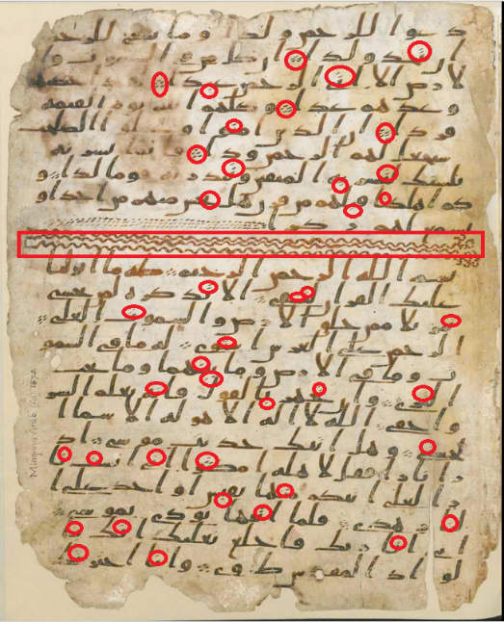
Figure 1- Vowel Point on the Birmingham Quran Manuscript
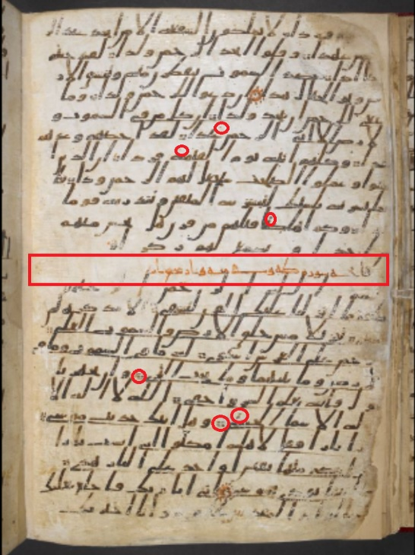
Figure 2- Vowel Points on the British Library's 8th century Quran Manuscript
Amongst the Birmingham Quran manuscript was the ‘Kahf’ chapter (Birmingham University 2018). If the manuscript was written at the time of Mohammed, then it would be far dated than Taha, and would be written in different parchments or tablets with perhaps a different handwriting. That is because the chronological order of the Quran chapters puts the Kahf as the 69th and Taha as the 45th chapter, that is because the Quran was written in a period of 23 years (McAuliffe 2006). However, the British Library’s Quran has the Kahf as the 18th, Taha as the 20th and the Maryam in between. This could play as an evidence about the time when the Birmingham Quran was written. Especially that both Quran manuscripts have the Maryam chapter ending above the beginning of Taha’s and the Kahf close to them. The new Quran order was imposed by the Caliph Abd-Al-Malek Ibn Marwan in the 8th century, when he as well collected and combined the Quran. Historical resources have quoted on Abd-Al-Malek saying ‘'I fear death in the month of Ramadan, in it I was born, in it I was weaned, in it I have collected the Qur'an’ (Sawma 2006: 87). Abd-Al-Malek have called Al-Hajjaj and ordered him to revise the Quran, send the new copies to the Muslim cities and -as Uthman did before him- he demanded the old Quran copies to be burned (McAuliffe 2006). In my opinion, Abd-Al-Malek have done that in favour of his family’s political agendas. Since his father Marwan I – whom ruled for one year (684 - 685)- have shifted the lineage of the Umayyad dynasty from descendants of Abu Sufyan to his descendants of Marwanids. This have made Abd-Al-Malek as the ruler after the death of his father. That was not the only reason behind imposing a new version of the Quran, but at the time of Abd-Al-Malek’s reign, he was historically known for being a Faqih (Crone and Hinds 2003). According to Patricia Crone and Martin Hinds ‘Marwan I and Abd-Al-Malek are cast as faqihs, legal scholars, and as traditionists in their own right’ (2003: 49-50). This type of knowledge and legal power would only be in his advantage if there were no Quran verses that would condemn his actions. Hence, the Uthman’s Qurans have disappeared when Abd-Al-Malek’s qurans have appeared (Kotob 2002). Which again would suggest that the Birmingham Quran is a manuscript of the 8th century.
Thirdly, Does the Birmingham Quran differ from the British Library’s Quran? Although the rest of the Taha chapter was not found with the Birmingham Quran manuscripts, many differences have been found. Apart from the vowel points, I have identified missing words from the British Library’s Quran such as ‘him هو, I amأنا , to whom you fearلمن تخشى , fire نار’ and more. In this matter, the Birmingham Quran seems to have more completed and adjusted phrases than the other one. Moreover, I have chosen a 19th century Quran manuscript from the British Library to compare it with the 8th century’s Quran manuscript. I have compared the Taha chapter of the 8th century Quran to the 19th century’s Quran. The first thing that I have noticed is that it clearly stated above the 8th century’s Taha chapter that it has 140 verses. While the Taha of the 19th century’s Quran has 150 verses. Now, when I have compared them both to a 21st century Quran, it shows that the current version has 135 verses in the Taha chapter (The Holy Quran 2018). After carefully analysing each word of the three Qurans, I have discovered that many of the verses were emerged with other verses and some of the verses were separated from other verses too.
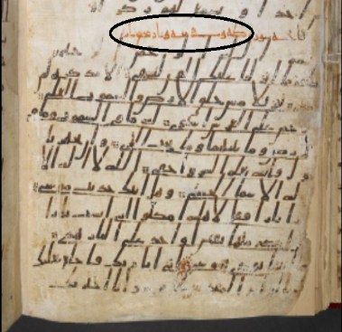
Figure 3- 8th Century Taha- 140 verses
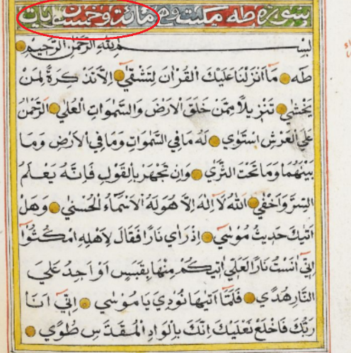
Figure 4- 19th Century Taha- 150 verses
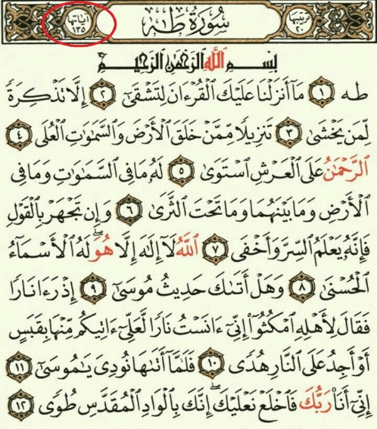
Figure 5- Current Quran Taha- 135 verses
Fourthly, during the analysis of the Taha chapter of the 8th century’s manuscript, I have found many issues regarding the verses’ words. The first issue was that the script does not contain many vowel points. It is an issue because dotting is what differentiates between similar shapes of Arabic letters (Owens 2013). Not only would the words be incomprehensible without them, but it would change the meaning of the verse entirely. This means that between 28 Arabic letters, only 6 were recognizable (Owens 2013). For example, it was hard to differentiate letters such as غ ع- ح ج خ- د ذ etc, without dotting. Also, it was hard to distinguish the letter سـ and the letter شـfrom the letters بينـ in any word without dotting. The second issue was the lack of short vowel marks (Harakat). The Harakat are important to avoid ambiguity (Owens 2013). For instance, (عبر) can be understood in multiple ways, but only applying Harakat on them would differentiate the definition and the parts of speech. to clarify, عِبَر means wisdoms and عَبَر means he crossed etc (Baker and Saldanha 2011). The third issue was, the possibility of misinterpreted words. Returning to the script on its original form would help identifying possible misinterpreted words as being Arabic words. It is well known that the Quran has hundreds of interpretations (Tafaseer) that would suggest the definitions of many unfamiliar words. That is because many Muslim scholars have tried to support the theory of which the Quran was firstly written in Arabic language alone. While reading the script repeatedly, I have found that many words can be traced to have a foreign origin. For example, the word Taha, cannot be traced to an Arabic origin and it has many interpretations in the Tafaseer books. In further research, I have found that it has a Syriac origin that translates to ‘oh man’ (Baker and Saldanha 2011). Moreover, some words have clearly been misidentified and would not make any sense in their current positions of the verses. To clarify, I have found in the verse 22 of Taha a description of one of Moses’ stories that says, ‘lower you hand down to your wing, it will come out white without a disease’ (Quran 20: 22). What does ‘your wing’ mean in the verse? It does not belong to the verse context nor to the story of Exodus. I think that the word has been misidentified by the latest Quran writers and it should be ‘your pocket- your cloak جيبك’ instead. This word would match Moses story of Exodus (Noegel and Wheeler 2010).
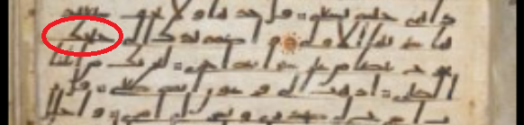
Figure 6- The misidentified word as ‘your wing’- verse 22 of Taha- 8th century's Quran
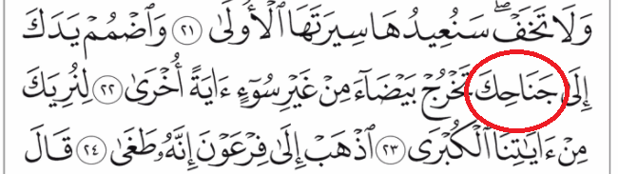
Figure 7- The word 'your wing' in the current Quran version.
In conclusion, it seems like the mentioned Quran manuscripts have their matches and differences. In my opinion, the provided data along with the comparisons of the Birmingham Quran and the British Library’s 8th century Quran would suggest that the Birmingham Quran manuscript could have been written in the 8th. In addition, the numbers of misplaced verses and missing words from the early Quran manuscripts demonstrated in this essay suggests that the Quran have been changed frequently. Furthermore, the history behind the combining of the Quran may mean that there are no surviving Quran manuscripts earlier than the 8th from the Hijaz. Moreover, analysing and comparing the four versions of the Quran have helped in identifying misinterpreted words as well as misidentified words. Finally, the Birmingham Quran manuscript’s ink needs to be dated separately and the previous observations needs to be analysed for further studies.

Reference List
AHMED, N. 2018. Arabic Language and Its Linguistics. 1st ed. Chennai: Notion Press.
Baker, M. & Saldanha, G. 2011. Routledge Encyclopedia of Translation Studies. 2nd ed. Abingdon: Routledge.
Birmingham University. 7th Century Quran Manuscript. [Online]
Available at: https://www.birmingham.ac.uk/facilities/cadbury/birmingham-quran-mingana-collection/birmingham-quran/faqs.aspx
[Accessed 19 March 2018].
British Library. 8th Century Quran Manuscript. [Online]
Available at: http://www.bl.uk/manuscripts/Viewer.aspx?ref=or_2165_fs001r
[Accessed 19 March 2018].
Brockopp, J. E. 2010. The Cambridge Companion to Muhammad. 1st ed. Cambridge: Cambridge University Press.
Crone, P. & Hinds, M. 2003. God's Caliph: Religious Authority in the First Centuries of Islam. 1st ed. Cambridge: Cambridge University Press..
Esposito, J. L. 2003. Oxford Dictionary of Islam. 1st ed. New York: Oxford University Press.
Kotob, I. 2002. Al-Masahif. 2nd ed. Beirut: Dar Al-Athaar Al-Islamiya.
McAuliffe, J. D. 2006. The Cambridge Companion to the Qur'ān. 1st ed. Cambridge: Cmbridge University Press.
Noegel, S. B. & Wheeler, B. M. 2010. The A to Z of Prophets in Islam and Judaism. 1st ed. Plymouth: Scarecrow Press..
Owens, J. 2013. The Oxford Handbook of Arabic Linguistics. 1st ed. Oxford: Oxford University Press.
Sawma, G. 2006. The Qur'an, Misinterpreted, Mistranslated, and Misread.. 1st ed. Plainsboro: Gabriel Sawma.
The Holy Quran, 2018. The Surah of Taha. [Online]
Available at: http://www.islamicbook.ws/6/312.html
[Accessed 20 March 2018].

