ACADEMIC AND EMPLOYBILITY SKILLS

Executive Summary:
In this report the self-analysis and employability skills are going to be presented through paying attention to the electronic portfolio. However, being a student of bachelor of science specializing on cloud computing I am going to take consideration into the modern aspects of cloud computing including machine learning, database management system, virtualization, artificial intelligence, security and disaster recovery and so on and so forth. In addition to that I would end up listing my professional and personal strengths besides potential drawbacks with producing an action planning to overcoming my weaknesses and thus to accelerate my strengths.

Table of Contents
Section 1: 4
Providing a brief personal overview: 4
The 4 screengrabs from the initial PPT that introduced myself: 4
The key points which I learnt while trying to deliver and produce a successful PowerPoint presentation: 6
Section 2: The skill evaluation: 7
Identification and explanation of the skills needed to effectual HE learning and employability: 7
The cloud-based security: 7
The database management system: 7
The API and web services: 7
The programming skills: 7
The machine learning and artificial intelligence: 8
Disaster recovery and security in cloud computing: 8
Virtualisation: 8
Networking: 8
DevOps: 8
Conducting an exercise of self-evaluation for discovering my strengths, weaknesses, suitable professional suggestions and personality traits etc: 8
The personal strengths: 8
The professional strengths: 8
The significant weaknesses: 9
Personality traits: 9
Suitable professional suggestions: 9
Section 3: The action plan: 9
Listing both my long and the short-term goals: 9
The long-term goals: 9
The short-term goals: 9
Developing an action planning for the professional, personal and the academic skills that I require to improve or attain: 10
Section 4: Application: 11
Describing the backup strategies which I have created: 11
Listing all the probable disaster situations that I could think of: 11
Evaluating the effectuality of my selected strategy in terms of confronting the disaster situations: 11
Time management and organisation: 11
Providing a synopsis associated with the key parameters presented in the lectures of time management: 11
Describing the steps which I have taken or intend to take for enhancing my own productivity with reducing my stress levels: 12
Section 5: Conclusion and evaluation: 12
Recommendations: 12
References: 14
Section. 6: Appendices: 15
Appendix 1: 15
Appendix 2: 15
Appendix 3: 16
Appendix.4: 16
Appendix 5: 17

Section 1:

Providing a brief personal overview:
I am student of Bachelors of Cloud Computing and have been learning the way cloud computing can be used in the modern business world in order to intensify the cyber security of the highly confidential organisational and consumer information stored in the systems of the business associations. I additionally, have learnt a number of aspects and method associated with cloud computing in which a shared set of resources like the web servers, the file or information storage and information processing along with the applications would be accessed through an internet.
Moving on to my personal skills and traits, I would like to mention that I am a studious and self-managed individual and I am very eager to learn new and modernised skills related to the academic subject which I have been persuading right now. In addition to that I strongly believe in managing time since it would impact a large extent in my professional development besides helping me learning and memorising the skills within the decided time interval. On the other hand, my professional skills would include goal orientation, team management, leadership capabilities, professionalism, team working, adaptability, realism, change adopting, conflict management, flexibility, effective decision-making, self-initiation and coordinative working approach.
Furthermore, the potential personal strengths which I possess would include quick learning, time management, adaptation, high level of academic skills and technical knowledge. In addition to that the academic strengths I have would be excellent academic performance throughout my academics, effective written communication skills, programming languages and high level of prudence. Be that like it may, the significant weaknesses I got would include lack of self-motivation, lack of multilinguistic skills which would be highly essential for me to sustain in the dynamic and globalised and hyper-connected international industry and the skill of smart working. However, I have taken relevant steps along with designing SMART strategies to adopt these skills in order to add value to my career and thus to avail my professional, personal and academic skills successfully in my future professional journey.

The 4 screengrabs from the initial PPT that introduced myself:
Slide 1:

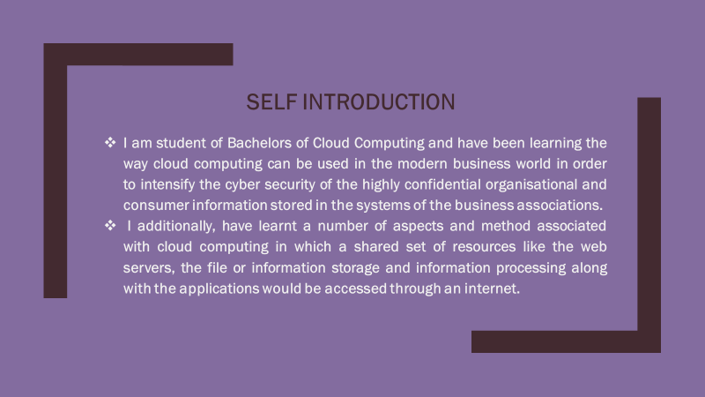
Slide 2:
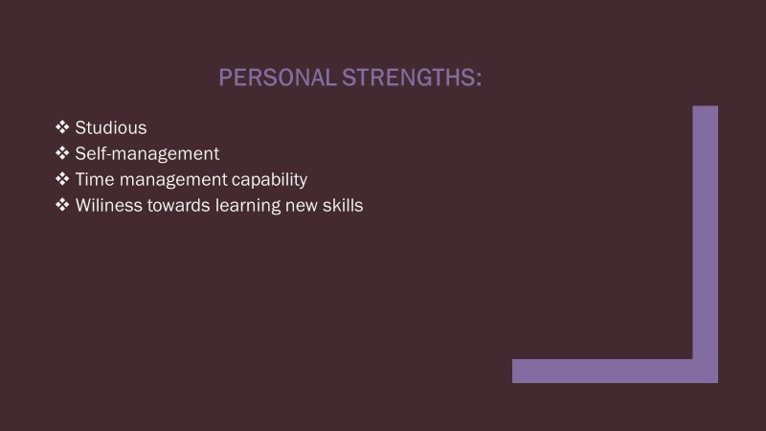
Slide 3:
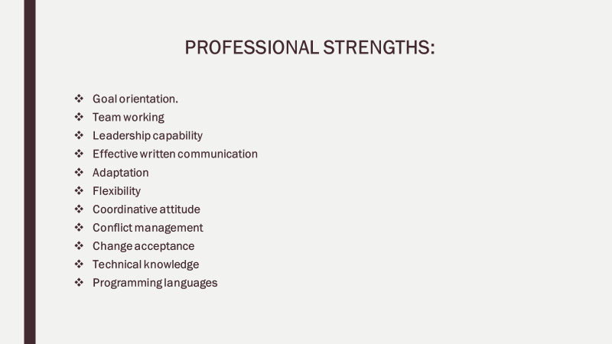
Slide 4:
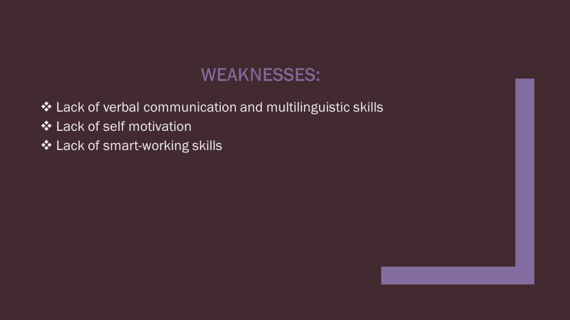

The key points which I learnt while trying to deliver and produce a successful PowerPoint presentation:
- The key points which I got to learn while trying to deliver and produce a successful PowerPoint presentation would include:
- I tried to limit and simplify the number of words I used on each of the screen.
- Additionally, I emphasise limiting the punctuations along with avoiding putting the words in all the capital letters.
- In addition to that in order to make the presentation attractive I tried to utilise the contrasting fonts and colours of the text and attractive and bright colour for the backgrounds.
- Moreover, I avoided using of the flashy transitions like the fly-ins text and so on.
- Essentially, I tried to make the presentation as informative as possible besides including relevant diagrams and tables.
- Notwithstanding that, I focused upon providing a brief scenario regarding my own professional, personal and academic strengths besides my drawbacks along with demonstrating my understanding on cloud computing and the way, I can use the skills and understanding in my future professional field.
- Eventually, I would tried to draft a personal development plan in a time managed way including the I steps I intend to take for the sake of getting rid of my lacks and thus to convert my drawbacks into my strengths.

Section 2: The skill evaluation:

Identification and explanation of the skills needed to effectual HE learning and employability:
The significant skills associated with the higher educational learning on cloud computing would include the skills associated with the cloud service provision, the storage in cloud computing, the knowledge of networking and virtualisation, the skills of the operating system like Linux, the skills associated with disaster recovery and security, the knowledge of DevOps and API and web services. On the other hand, the skills required for getting employed in the field of technology and cyber security may include the skills and understanding on cloud-based security, the database management and the management of larger data, the programming language skills, the machine learning and artificial intelligence and the skills on the Microsoft Azura Qualification (Basu et al.2018, p.88). However, all these skills are going to be explained in the following discussion:

The cloud-based security:
The could-based security is nothing but a wider range of technologies, policies, controls and applications that would be availed for protecting the virtualised information, IP, services, applications and the additional infrastructures associated with the cloud computing technology (Neves et al.2016, p.108).

The database management system:
The database management system or DBMS refers to a software or application which is used for storing, retrieving and manipulating the user information besides paying attention to the needful measures of data security (Pancholi and Patel, 2016, p.66).

The API and web services:
The web services are responsible for facilitating the interconnection between two different machines across a network whilst an API plays the role of an interface between two or more applications in order to make them communicate with one another (Parab, 2016, p.29).

The programming skills:
The programming skills are noticed include a range of different skills such as self-reliance, logic, programming languages, detail orientation, recognition of unrealism and stupidity, patients, abstract thinking, time management and an efficient memory (Rittinghouse and Ransome, 2016, p.65).

The machine learning and artificial intelligence:
Artificial intelligence refers to a modern technology that would enable a machine stimulating the human behaviour. On the other hand, the machine learning is nothing but a subset of the artificial intelligence that would end up allowing a machine to learn automatically by evaluating the past information without explicitly programming. It is worth mentioning that, the prime objective of artificial intelligence is making an innovative computerised system such as the human brain for resolving the complex problems (Sahi et al.2016, p.101).

Disaster recovery and security in cloud computing:
In cloud computing system, disaster recovery refers to a service which would enable the recovery and the backup of the remote systems on a cloud-based platform. Additionally, the cloud disaster management is signified as an infrastructure associated with the service solutions which would back up the design framework information on an offsite remote cloud server (Singh et al.2016, p.62).

Virtualisation:
In the context of cloud computing, the term virtualisation is signified as the process of designing a virtual version of anything including the storage systems, the computer networking resources and the hardware platforms and so on and so forth (Stergiou et al.2018, p.78).

Networking:
The networking system is nothing but a set of servers, computers, network devices, mainframes and peripherals and so on that are connected to each other for allowing the data string to be shared among the devices. For example, an internet connection is a networking system since it connects people from different corners of the earth (Wang et al.2016, p.55).

DevOps:
DevOps is nothing but a range of activities which would combine the information technology functions with the activity of software development aiming at shortening the life cycle of the system development with providing a continual delivery along with a high-quality software (Jena and Mohanty, 2016, p.96).

Conducting an exercise of self-evaluation for discovering my strengths, weaknesses, suitable professional suggestions and personality traits etc:

The personal strengths:
My personal include studiousness and self-management whilst I am very ear to learn new technologies and applications of cloud computing system. In addition to that I am a time managed and goal oriented individual and hence tend to divide my professional and personal development objectives into relevant and attainable short-terms goals including the respective time frame resulting in mine successful achievement of these goals.

The professional strengths:
The professional strengths I got would include the skills and understanding on cloud-based security, the database management and the management of larger data, the programming language skills, the machine learning and artificial intelligence and disaster recovery and security skills.

The significant weaknesses:
The significant weaknesses I got would include lack of self-motivation, lack of multilinguistic skills which would be highly essential for me to sustain in the dynamic and globalised and hyper-connected international industry and the skill of smart working.

Personality traits:
The personality traits I possess would include goal orientation, team management, leadership capabilities, professionalism, team working, adaptability, realism, change adopting, conflict management, flexibility, effective decision-making, self-initiation and coordinative working approach.

Suitable professional suggestions:
I require to brush up my communication skills, particularly the verbal communication so that I can communicate flawlessly in the professional field. In addition to that need to be more realistic and self-motivating and ought to practice smart working which is way more relevant in the current context of the dynamic and rapidly developing marketplace. In addition to that I need to strengthen my academic knowledge and skills on security and disaster recover, virtualisation, machine learning and artificial intelligence, programming languages, centralised database management system, information technology and Linux (Alshammari et al.2017, p.29).

Section 3: The action plan:

Listing both my long and the short-term goals:

The long-term goals:
- Development of professional skills on the Java Script, the Python Procedural Programming Language, the Erlang Operational Language, The Clojure Math language, The Haskell Operational Language, the Go Procedural Language and The GFM Domain-specific language which are needed to work professionally in the field of cyber security and cloud computing.
- In-depth learning of database management system with acquiring professional skills on the concept of the centralised database management system along with the SQL Programming Language and the XML Data Language.
- Understanding security and disaster recovery in the context of cloud computing.
- Developing in depth skills on machine learning, robotics, information security and information management technology and artificial intelligence.
- Developing skills regarding the use of the Linux operating system.
- Going for the needful internship to have professional skills and thus to achieve the capability using the academic skills in the professional field.

The short-term goals:
- Brushing up the written communication skills.
- Mastering the verbal communication with acquiring the multilinguistic skills.
- Practicing self-motivation.
- Practicing smart working along with multitasking.
- Learning and understanding the application of cyber security and cloud computing in ecommerce and digital marketing.

Developing an action planning for the professional, personal and the academic skills that I require to improve or attain:
Goals | Time Frame
Goals | May’20 |  | Jun’20 |  | July’20 |  | Aug’20 | Sept’20 | Oct’20 | Nov’20 | Dec’20
Learning the programming languages defined in the long-term goals
Skill development on security and disaster recovery
Acquiring professional skills on machine learning and artificial intelligence.
Skill development on information management system and cyber security
Developing skills on Linux operating system
Internship
Written communication
Multilinguistic skills and effective verbal communication
Self-motivation
Smart working
Multitasking
Understanding the application of the cloud computing in ecommerce and digital marketing.
Table.1 The Gantt of the action planning associated with the PDP
(Source: Developed by the researcher)

Section 4: Application:

Describing the backup strategies which I have created:
The backup strategies which I have created to enhance the level of information security would include addressing the particular business requirements and conducting the TCO evaluation. In addition to that I always incorporated the cloud information backup provisions long before we require it (Elzamly et al.2017, p.112). Furthermore, I prioritised security the most and ensured that both privacy and security would always avail the encrypted information backups. Moreover, I tried to follow the rules associated with compliance and governance besides backup both remotely and locally.

Listing all the probable disaster situations that I could think of:
The probable disasters are mainly the unexpected situations such as earthquake and hurricane besides the Cryptowall virus and cyber-attacks and so on. However, the backup strategies I have mentioned would be able to store the information in multiple places with having a capability of encrypting the same and thus the disasters would be managed successfully by means of the backup strategies (Hussein and Khalid, 2016, p.77).

Evaluating the effectuality of my selected strategy in terms of confronting the disaster situations:
According to my understanding the Cyrtowall lies in the family of ransomware and would avail advanced technologies for infiltrating the computers besides hiding it from the victim. In addition to that, the Cryptowall virus is signified as one of the Trojan Horses which would encrypt the files on the jeopardise system following which it ends up proceeding for threatening the user for paying a ransom for having the decrypted files. However, the backup strategy of ensuring the privacy and security would always avail the encrypted information backups would keep the system protected from the Cryptowall virus (Almorsy et al.2016, p.78).

Time management and organisation:

Providing a synopsis associated with the key parameters presented in the lectures of time management:
In case there would be shortage of time, then the programming languages would be learnt simultaneously during the internship program whereas the disaster recovery and security would be evaluated through developing professional skills with the help of the reporting leader or manager while I will do the internship. In addition to that skills database management system, SQL, machine learning and artificial intelligence would be developed following the online tutorials within a minimal interval of time. In addition to that, the Gantt chart would be followed to achieve the short-term goals like effective verbal communication and multilinguistic skills, self-motivation, multitasking, smart working and skill development on digital marketing, the use of cloud computing to intensify the cyber security in ecommerce and digital marketing. Be that as it may, the overall action plan demands of six months of interval within which both the long-term and the short-terms goals are expected to be met successfully.

Describing the steps which I have taken or intend to take for enhancing my own productivity with reducing my stress levels:
In order to enhance my productivity, I tend of learn the programming languages associated with the professional use of cloud computing to enhance cyber security. In addition to that I am looking forward to acquiring in-depth skills on centralised database management system, machine learning and artificial intelligence, information technology. Furthermore, I have been trying smart working these days for replacing hard work which would reduce the stress level on top of which I am following the motivational speakers for the sake of getting rid of the stresses.

Section 5: Conclusion and evaluation:
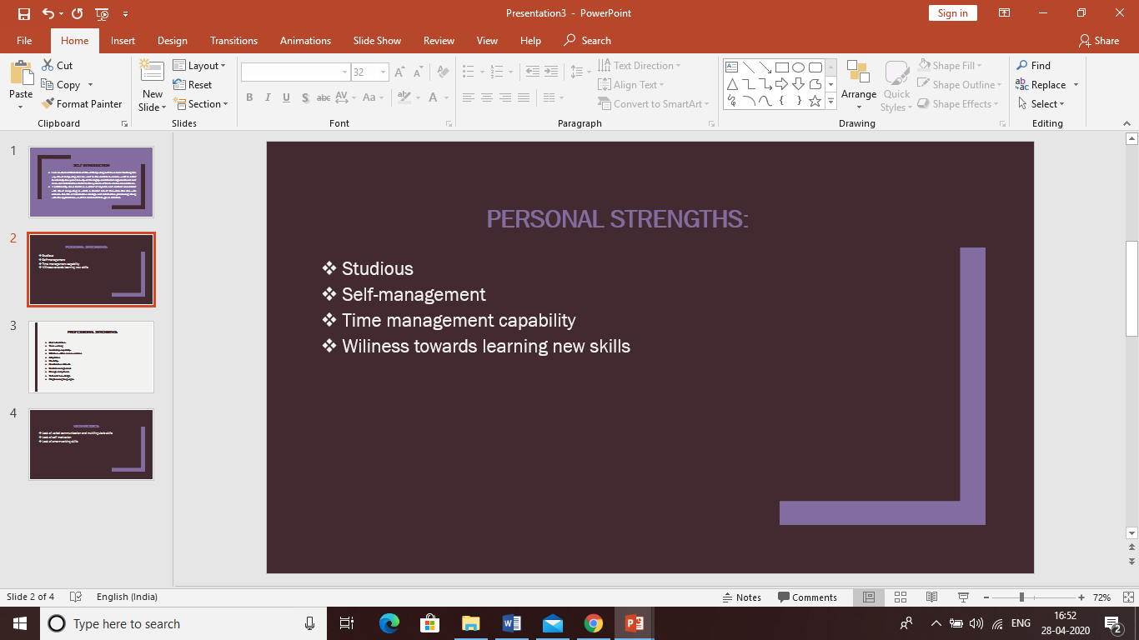
Figure.1 The screenshot of my e-portfolio
(Source: Created by the researcher)
At the end of this report it is concluded that my professional skills would include goal orientation, team management, leadership capabilities, professionalism, team working, adaptability, realism, change adopting, conflict management, flexibility, effective decision-making, self-initiation and coordinative working approach. Notwithstanding that I am a time managed and goal orient individual and thus will in general separation my expert and self-awareness targets into pertinent and feasible short-terms objectives including the particular time span bringing about mine effective accomplishment of these objectives.

Recommendations:
- I require to review my relational abilities, especially the verbal correspondence with the goal that I can impart immaculately in the expert field.
- Notwithstanding that should be progressively sensible and self-propelling and should rehearse brilliant working which is much increasingly significant in the present setting of the dynamic and quickly creating commercial centre.
- Notwithstanding that I have to fortify my scholastic information and aptitudes on security and disaster recover, virtualisation, machine learning and artificial intelligence, programming languages, centralised database management system, information technology and Linux.

References:
Almorsy, M., Grundy, J. and Müller, I., 2016. An analysis of the cloud computing security problem. arXiv preprint arXiv:1609.01107.
Alshammari, M.M., Alwan, A.A., Nordin, A. and Al-Shaikhli, I.F., 2017, November. Disaster recovery in single-cloud and multi-cloud environments: Issues and challenges. In 2017 4th IEEE International Conference on Engineering Technologies and Applied Sciences (ICETAS) (pp. 1-7). IEEE.
Basu, S., Bardhan, A., Gupta, K., Saha, P., Pal, M., Bose, M., Basu, K., Chaudhury, S. and Sarkar, P., 2018, January. Cloud computing security challenges & solutions-A survey. In 2018 IEEE 8th Annual Computing and Communication Workshop and Conference (CCWC) (pp. 347-356). IEEE.
Elzamly, A., Hussin, B., Abu-Naser, S.S., Shibutani, T. and Doheir, M., 2017. Predicting critical cloud computing security issues using Artificial Neural Network (ANNs) algorithms in banking organizations.
Hussein, N.H. and Khalid, A., 2016. A survey of Cloud Computing Security challenges and solutions. International Journal of Computer Science and Information Security, 14(1), p.52.
Jena, T. and Mohanty, J.R., 2016. Disaster recovery services in intercloud using genetic algorithm load balancer. International Journal of Electrical and Computer Engineering, 6(4), p.1828.
Neves, P.C., Schmerl, B.R., Cámara, J. and Bernardino, J., 2016, January. Big Data in Cloud Computing: Features and Issues. In IoTBD (pp. 307-314).
Pancholi, V.R. and Patel, B.P., 2016. Enhancement of cloud computing security with secure data storage using AES. International Journal for Innovative Research in Science and Technology, 2(9), pp.18-21.
Parab, N., NetApp Inc, 2016. Cloud-based disaster recovery of backup data and metadata. U.S. Patent 9,501,365.
Rittinghouse, J.W. and Ransome, J.F., 2016. Cloud computing: implementation, management, and security. CRC press.
Sahi, A., Lai, D. and Li, Y., 2016. Security and privacy preserving approaches in the eHealth clouds with disaster recovery plan. Computers in biology and medicine, 78, pp.1-8.
Singh, S., Jeong, Y.S. and Park, J.H., 2016. A survey on cloud computing security: Issues, threats, and solutions. Journal of Network and Computer Applications, 75, pp.200-222.
Stergiou, C., Psannis, K.E., Kim, B.G. and Gupta, B., 2018. Secure integration of IoT and cloud computing. Future Generation Computer Systems, 78, pp.964-975.
Wang, L., Harper, R.E., Mahindru, R. and Ramasamy, H.V., 2016, June. Disaster Recovery for Cloud-Hosted Enterprise Applications. In 2016 IEEE 9th International Conference on Cloud Computing (CLOUD) (pp. 432-439). IEEE.

Section. 6: Appendices:

Appendix 1:
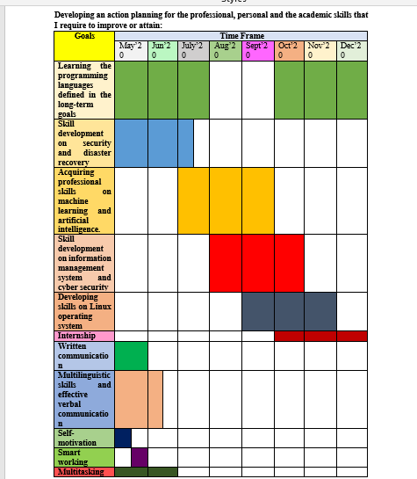

Appendix 2:
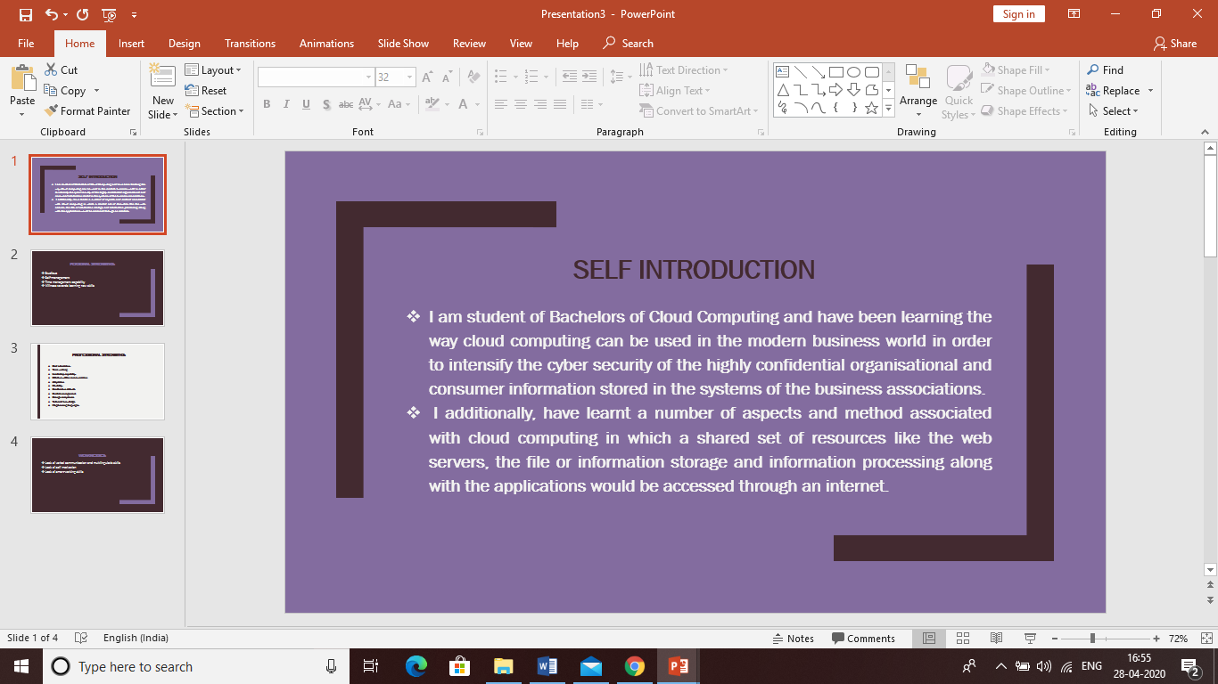

Appendix 3:

Appendix.4:
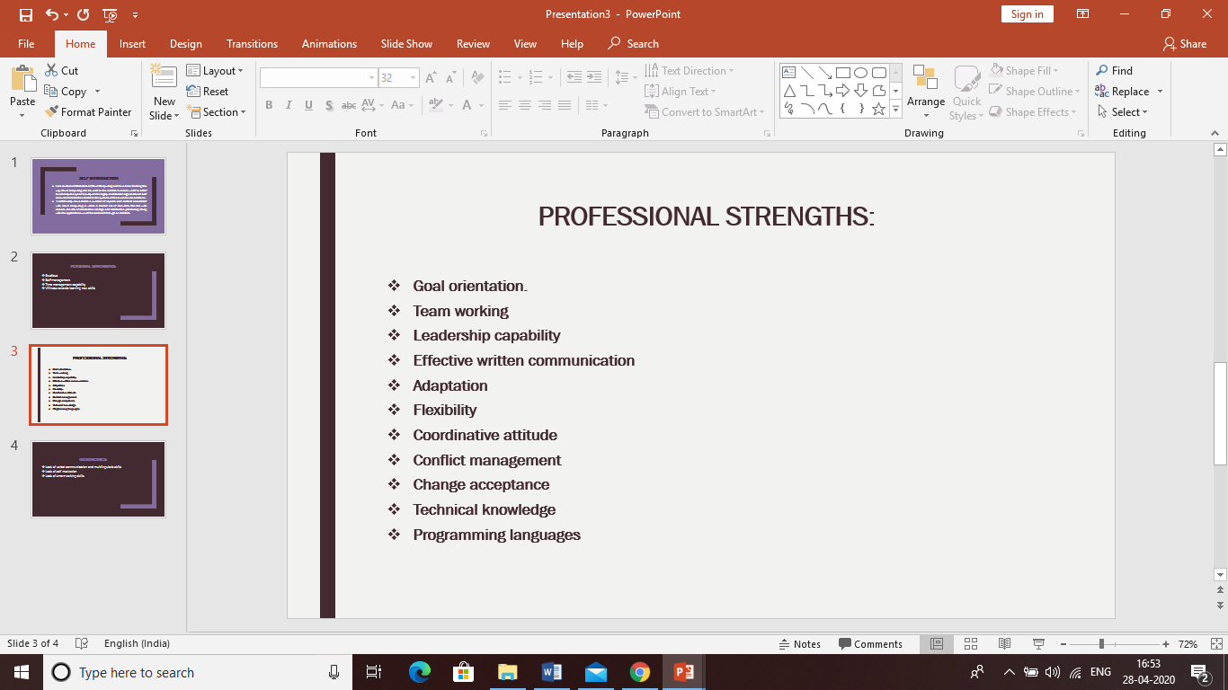

Appendix 5:


