Unit Name: Personnel Resourcing and Development
Unit CODE: BMIH5005
Student Name: Mohammed Robyat Khan
Student ID: 2013063
Lecturer’s Name: Emily Williams

Employee Engagement and Retaining Proper Workforce Contributes to the Organization’s Excellence: A study on Novotel Hotels & Resorts (West London)

Table of Contents
1.0 Introduction 1
1.1 Company Background 1
1.2 The Research Rationale 2
2.0 Research Methodology and Discussion 3
2.1 Research Methodology 3
2.1.1 Data Collection Method 3
2.1.2 Data Collection and Sampling Technique 3
2.1.3 Considering the Ethical Issues 4
2.2 Discussion: Based on Secondary Research 5
2.2.1 Employee Engagement 5
2.2.2 Benefits of Employee Engagement 6
3.0 Evaluation and Conclusion 7
3.1. Evaluation 7
4.0 Conclusion 8
5.0 References 9
5.0 Appendix: Questionnaire 11

List of Figures:
Figure 1:Logo of Novotel Hotels & Resorts (London West) 2
Figure 2: Strategies to improve employee engagement 5
Figure 3: Benefits of Employee Engagement 6

1.0 Introduction

1.1 Company Background
Novotel Hotel is owned by a midscale French hotel chain brand, Accor. In1967, Novotel started its operation in Lille, France, and the brand had established 60 hotels in France and 13 throughout Europe by 1975 (Novotel London West Hotel, 2022). Novotel London West is in the Hammersmith neighbourhood of West London, England. It is well-known among tourists and regular travellers. This hotel's surroundings are well-connected to adjacent stations and public transit systems. Novotel first started its operations in the1967, inspired by American Motels to provide their travellers and tourists comfortable rooms and restaurants and parking space (Info, 2022). Once the brand expanded internationally as a 4-star hotel providing about 600+ rooms in each of their branches, they succeeded in building a solid brand image among their loyal customers and new customers in terms of comfort and location.
As the Novotel Hotel chain is rapidly expanding by serving both their upper and middle scale guests and tourists, their competition in the hotel industry is also increasing simultaneously. Along with their growing brand reputation, they also have to compete against hotels like Holiday Inn, Hilton, Westin Hotels and Resorts etc. In 2021, Novotel managed to generate around 13.5m USD even though there were restrictions regarding the pandemic (Accor - Annual information, 2022). However, they continued their services by following strict safety precautions and maintaining proper hygiene. They attract customers and offer low-cost, high-quality amenities and give the most excellent services at reasonable prices. Unique amenities include free Wi-Fi, party planning, conference space for corporate meetings, and specific discounts or deals on special events or occasions. They also add value to their services by employing well-trained staff members and employees and multilingual receptionists who are available 24 hours a day, seven days a week (Novotel London West Hotel, 2022).


Figure 1:Logo of Novotel Hotels & Resorts (London West)
Source: (Novotel London West Hotel, 2022).

1.2 The Research Rationale:
In any organisation, employee engagement is essential. Effective employee engagement techniques can positively impact employee turnover, working environment, customer engagement and relationships, performance and efficiency, and overall company profitability (Employee Engagement, 2022). As retaining employees or staff members of a hotel is a critical job as many different factors contribute to this matter, retaining an efficient workforce such as hotel staff members, managers, employees, etc., is also a crucial part of hotel businesses. The hotel industry is one of the largest industries in the UK. The pandemic had a significant impact on this industry. The government's core focus was to ensure safety to the people and maintain steady economic growth. Novotel also suffered the consequences of the pandemic, and they got back on track once the lockdown restrictions were eased in 2021 (Sen and Pearson, 2022). Considering the post-pandemic impact within the industry, the purpose of this research is to evaluate the importance of employee engagement and retaining an efficient workforce that positively impacts customer relations, brand image, and overall growth of the organisation.

2.0 Research Methodology and Discussion

2.1 Research Methodology

2.1.1 Data Collection Method
To conduct this research, the researcher will collect both primary and secondary data to evaluate the company's overall performance considering the post-pandemic situation. As the primary data collection requires first-hand data collection, the researcher will follow the qualitative method to collect the preliminary data such as interviews, survey questionnaires, observations etc. The bright side of choosing the qualitative research method is that it helps provide reliable information, allows the development of unique insights and reduces the potential biases (Miller, 2022). Collecting the primary data will enable the researcher to evaluate Novotel's employee engagement and retain efficient staff members compared to the other hotel businesses within the industry. The preliminary data will also help with the post-pandemic scenario of Novotel and the hotel industry of the UK.
On the contrary, the secondary data collection method refers to collecting data that already exists in different forms such as websites, journals, magazines, newspapers, etc. The researcher will also consider the secondary data sources to support the primary data and the research contents to conduct this research. The existing data helps a researcher to have a head start in the research subject as the access to information is comparatively easy, it gives new directions for the research with the previous analysis, saves time and lastly low cost or free of charge (Secondary Data Sources & Types, 2022). Therefore, to support the primary data, the researcher will use the secondary data from various websites, journals, magazines and newspaper articles. The secondary data will give the researcher a good idea of the current scenario of the hotel industry, Novotel's performance, their employee engagement, retention rate of the staff members and possible ways to improve the situation after the significant impact of the pandemic in the last two years' period and suggest ways to improve the employee engagement.

2.1.2 Data Collection and Sampling Technique
The researcher has planned to utilise the survey method to collect the primary data. The survey method will consist of 10/12 questionnaires regarding the research topic and the areas from which the researcher is planning to get their answers. The researcher has opted out for online and offline surveys as whichever is considered convenient for the respondents. The survey questionnaire will be given to 100 employees and staff members. The respondents will be categorised into two age groups; one is from 18 – 35 years old, and the other group is above 40 years years old. This method will help the researcher to differentiate between the performances of the employees and the staff members of two different age groups and its impact on the performance of Novotel, customer relationships and brand image. As for the secondary data collection, the researcher will use both online and offline based news articles, journals, websites etc., to support the primary research data.
In terms of sampling technique, the researcher has planned to use to non-probability sampling method as Non-probability sampling implies generating non-random selections based on convenience or other criteria to make data collection easier (Base, 2022). This method will give an advantage to the researcher if there is any lack of information available in the secondary sources and will allow the researcher to input their insights regarding Novotel.

2.1.3 Considering the Ethical Issues
While the researcher is surveying the employees and staff members of the Novotel, some ethical concerns need to be taken care of before and after conducting the survey and collecting data. Considering these ethical issues will be given great importance. The researcher is planning to apply GDPR – General Data Protection Regulation. The General Data Protection Regulation (GDPR) is being implemented in the United Kingdom by the Data Protection Act 2018. This act establishes the rights of the respondents and how their given information will be utilised. This act allows protecting the respondents' freedom and research purposes (GDPR law, 2022). Under this act, the researcher has to take consent from the respondents to use their given information for only research purposes, total anonymity of the respondents will be maintained, the researcher will not be able to collect any personal identification information of the respondents except their age and use this data for any other purposes except for this research.

2.2 Discussion: Based on Secondary Research

2.2.1 Employee Engagement
Employee engagement is a notion in human resources (HR) that represents a worker's level of passion and commitment to their job (Carbonara, 2013). Employee engagement is a workplace approach that provides a suitable environment for all employees to give their best every day, devoted to their organisation's aims and values, motivated to contribute to organisational success and feel better about themselves. Employee engagement is built on an organisation's members' trust, integrity, two-way commitment, and communication (Employee Engagement, 2022). It's a strategy that helps businesses succeed by improving overall organisational performance, efficiency, and well-being. In the service industry, employee engagement plays a vital role as it has a significant impact on the organisation's success. Employees tend to stay loyal and committed to the organisation and their goals when they are well appropriately treated by the organisation's management. This helps to boost their morale, and consequently, they perform well, and the customer relationship improves, resulting in the betterment of the overall organisation. There are some selective methods to improve employee engagement :
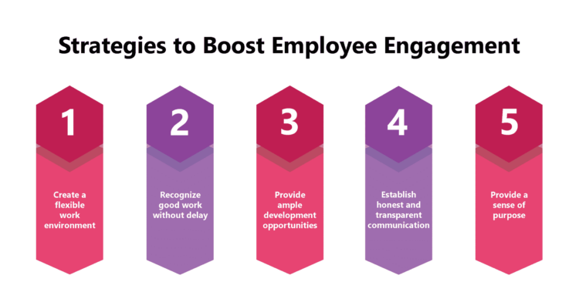
Figure 2: Strategies to improve employee engagement
Source: (Employee Engagement, 2022)

Ensuring the strategies mentioned above will have a tremendous positive impact on Novotel's performance as employees mostly interact with the customers. In this case, when the employees are treated well and are satisfied with their work environment, they will try to increase their efficiency and try to provide the best for their customers.

2.2.2 Benefits of Employee Engagement
As employee engagement is considered vital for any organisation, it also contributes to the organisation's success. It crucially helps the organisation to achieve its goals and objectives. Employee engagement has some significant benefits that directly impact the organisation's performance and allow them to stand out in the industry (Smith and Branston, 2022). Employee engagement benefits a single employee and has an impact on the other staff members. When a group of engaged employees work together, their morale spreads among their team members, allowing them to perform as a team on a higher level.
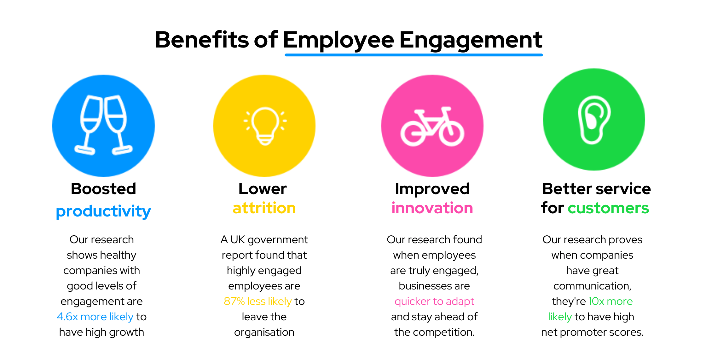
Figure 3: Benefits of Employee Engagement
Source: (Employee Engagement, 2022)
Employees who are personally invested in their jobs and strive to give their best performance tend to have higher work efficiency and higher productivity in their work environment. Also, according to a Gallup survey, engaged teams are 21% more productive. In the hotel industry, ensuring customer satisfaction is considered a top priority as the industry relies on customers' experience and feedback. Ensuring maximum customer satisfaction is not an easy job (Mohd Yusoff, 2019). However, when the strategies of employee engagement are adequately followed, it can help the hotel management ease into their goals of ensuring customer satisfaction (Rostker, Wilson and Hix, 2007). Committed and engaged employees will perform and provide their best services to their customers in this regard, and as a result, customer satisfaction will be improved for the hotels. Internal conflicts, work stress and fewer opportunities in the workplace result in lower retention rates of the employees. According to Gallup's research from 2017, 51% of employees intend to leave their current jobs due to those internal work conflicts, lacks growing opportunities, low pay etc. When employee engagement is improved, it also has a substantial impact on the employees' job satisfaction and staff members. Improved employee engagements also have some other benefits, such as lowering the financial costs, lower absenteeism, lesser work stress, increased profitability, better brand reputation, etc.

3.0 Evaluation and Conclusion

3.1. Evaluation
This research will be conducted using both primary and secondary data. Gathering the preliminary data will help the researcher get the information first-hand (Base, 2022). As employee engagement varies in different organisations, Novotel's employee engagement will differ in the industry. As the researcher will be using the questionnaire method to gather information regarding employee engagement and retention rates of the organisation, it will help to provide authentic, reliable, and updated information regarding the current scenario and the organisation's post-pandemic method. As the primary data will be collected directly from Novotel's employees and staff members, the data has a high accuracy possibility. The researcher will be able to utilise the data as per convenience, maintaining the anonymity of respondents and ensuring proper ethical means.
On the other hand, secondary data collection is as essential as primary data collection. As the information already exists in different forms, the secondary data resources help support the preliminary data and help to develop a solid base for the research. It will help the researcher avoid the issues faced by the previous researchers on the relevant research topic and help with directions and solid facts (Secondary Data Sources & Types, 2022). It also has other benefits such as ease of access, time-saving, low-cost, variety of sources etc.
Combining the primary and secondary methods will give a clear picture of the research topic. It will allow the researcher to evaluate the importance of employee engagement and retaining an efficient workforce that positively impacts customer relations, brand image, and overall growth of the organisation considering the post-pandemic impact within the industry.

4.0 Conclusion
To summarise the report, this research will allow the researcher to find out the issues and the demands of the employees of Novotel. Addressing the problems and their needs will enable them to acknowledge the proper strategies and measurements to improve employee engagement and increase the organisation's retention rates—the pandemic stroke is significant to the hotel industry of the UK. The industry has struggled to get back on track. However, this situation has made Novotel realise the importance of engaging employees and how it contributes to the hotel's overall performance. By implementing the strategies properly, with improved employee engagement, Novotel will also have a chance to increase its profitability and brand image globally.

5.0 References
Base, K., 2022. An introduction to sampling methods. [online] Scribbr. Available at: <https://www.scribbr.com/methodology/sampling-methods/> [Accessed 24 February 2022].
Blog For Data-Driven Business. 2022. Secondary Data Sources & Types. [online] Available at: <https://www.intellspot.com/secondary-data/> [Accessed 23 February 2022].
Blythe, T., 2022. Employee Retention | Strategies in the Hospitality Industry. [online] The Hub | High-Speed Training. Available at: <https://www.highspeedtraining.co.uk/hub/employee-retention-in-hospitality/> [Accessed 23 February 2022].
Carbonara, S., 2013. Manager's Guide to Employee Engagement. New York: McGraw-Hill.
Engage for Success. 2022. What is Employee Engagement - Engage for Success. [online] Available at: <https://engageforsuccess.org/what-is-employee-engagement/> [Accessed 24 February 2022].
GDPR.eu. 2022. GDPR law. [online] Available at: <https://gdpr.eu/what-is-gdpr/> [Accessed 24 February 2022].
Group.accor.com. 2022. Accor - Annual information. [online] Available at: <https://group.accor.com/en/finance/events-and-announcements/annual-and-half-yearly-information> [Accessed 23 February 2022].
Info, Z., 2022. [online] Available at: <https://www.zoominfo.com/c/novotel-hotels/28164480> [Accessed 23 February 2022].
Investopedia. 2022. Employee Engagement. [online] Available at: <https://www.investopedia.com/terms/e/employee-engagement.asp> [Accessed 23 February 2022].
Miller, B., 2022. Advantages and Disadvantages of Qualitative Research Methods. [online] Green Garage. Available at: <https://greengarageblog.org/19-advantages-and-disadvantages-of-qualitative-research-methods> [Accessed 23 February 2022].
Mohd Yusoff, Y., 2019. Actual Practices of Environmental Performance in Hotel Industry. Sains Humanika, 11(2-2).
NovotelLondonWest. 2022. Novotel London West Hotel. [online] Available at: <https://www.novotellondonwest.co.uk/about/overview> [Accessed 23 February 2022].
Nurture and Engaged and Satisfied Workforce | Vantage Circle HR Blog. 2022. Benefits of Employee Engagement that Work. [online] Available at: <https://blog.vantagecircle.com/benefits-of-employee-engagement/> [Accessed 23 February 2022]
Researchguides.ben.edu. 2022. Research Guides: Primary & Secondary Data Definitions. [online] Available at: <https://researchguides.ben.edu/c.php?g=282050&p=4036581> [Accessed 24 February 2022].
Roberthalf.com. 2022. Effective Employee Retention Strategies. [online] Available at: <https://www.roberthalf.com/blog/management-tips/effective-employee-retention-strategies> [Accessed 24 February 2022].
Rostker, B., Wilson, J. and Hix, W., 2007. Recruitment and retention. Santa Monica, CA: Rand Gulf States Policy Institute.
Sen, P. and Pearson, J., 2022. Impact of COVID-19 on the hospitality industry | Deloitte Netherlands. [online] Deloitte Netherlands. Available at: <https://www2.deloitte.com/nl/nl/pages/consumer/articles/impact-of-covid-19-on-the-hospitality-industry.html> [Accessed 23 February 2022].
Seth, T. and Lautner, G., 2022. Hospitality in a post-COVID world. [online] the Deloitte United Kingdom. Available at: <https://www2.deloitte.com/uk/en/pages/consumer-business/articles/hospitality-in-a-post-covid-world.html> [Accessed 23 February 2022].
Sistare, H., Shiplett, M. and Buss, T., 2015. Innovations in Human Resource Management. Hoboken: Taylor and Francis.
Smith, W. and Branston, C., 2022. Why employee engagement is so important in the hospitality industry. [online] Insights. Available at: <https://insights.ehotelier.com/insights/2021/09/20/why-employee-engagement-is-so-important-in-the-hospitality-industry/> [Accessed 23 February 2022].

6.0 Appendix: Questionnaire
1 | 2 | 3 | 4 | 5
No engagement | Little engagement | Average engagement | Above Average Engagement | Highly engaged
Questions | No engagement | Little engagement | Average engagement | Above Average engagement | Highly engaged
Well aware of the work cultures, rules and regulations of Novotel Hotels and Resorts.
My manager allows me to express my opinions while making any decisions.
My manager ensures an appropriate working environment and the necessities of the employees are adequately met.
Novotel Arranges training facilities and seminars to improve their employee's skills and efficiency.
Manager implement proper communication methods between employees and employers.

