Title: Technical Report: Delivery Route Optimization for Grocer Quick

Student Name: Christian Prida
Student Number: 2425771
Course: CertHE Computing Skills for Workplace
Module: Analyzing and Solving Problems
Date: 17 December 2025

Introduction

This report addresses the critical challenge of delivery route optimization faced by Grocer Quick, an online grocery delivery service. The primary objective is to develop a logical and structured solution to improve operational efficiency, specifically by seeking to minimize fuel consumption and ensure the timely delivery of all orders. Route inefficiency directly translates into higher operating costs and decreased customer satisfaction. Consequently, a systematic analysis and the application of advanced problem-solving techniques are required to design a robust routing system. This document presents the problem decomposition, a proposed logical solution (flowchart and pseudocode), and a reflection on the design process.

Problem Decomposition
Effective resolution of a complex problem like route optimization begins with its decomposition into manageable components. The Grocer Quick scenario can be framed in the context of the Vehicle Routing Problem (VRP), which seeks to determine the optimal set of delivery router for a fleet of vehicles, starting from a depot and visiting a series of customers.

Analysis of Requirements and Constraints (MOSCOW Technique)
The MOSCOW technique was used to categorize the requirements derived from the scenario, facilitating the prioritization of features for the proposed system.
- Must have (M):
  - Assignment: All orders must be assigned to a delivery route.
  - Fuel/Distance Minimization: The total travel distance for each route must be minimized to reduce fuel consumption.
  - Time Constraint: The actual delivery time must not exceed the promised delivery time by more than 30 minutes (maximum lateness)
  - Start/End Point: All routes must begin and end at the central depot.
- Should have (S):
  - Vehicle Capacity: The vehicle capacity (weight or volume) must be considered to prevent overloading.
  - Clustering: Orders should be grouped geographically for enhanced efficiency.
  - Driver Interface: A mechanism for drivers to receive the optimized route should be implemented.
- Could have (C):
  - Real-time Traffic: Integration of real-time traffic data for dynamic route adjustment.
  - Vehicle Prioritization: Prioritized assignment of vehicles by type or size.
- Won’t have (W):
  - Loading Optimization: Optimization of the order in which items are loaded into the vehicle.
  - Multi-Depot: Multi-depot or multiple start/end points (a single depot is assumed).

Identification and Explanation of Key Variables (10% of the grade)

The formulation of the solution requires the precise identification of the variables (input, process, and output data) that will be manipulated by the algorithm.
Variable | Description | Variable Type | Function in the System
P_set | Set of all orders to be delivered | Input / Data Set | Foundation of the routing task
Loc(p) | Geographical coordinates (lat/lon) of the delivery address for each order p E P_set. | Input / Geographic Data | Used to calculate distances.
Depot | Geographical coordinates of the Grocer Quick depot | Input / Geographic Data | Start and end point for all routes.
Tmax(p) | Maximum allowed delivery time for order p. | Input / Time | Critical constraint (+30 minutes tolerance).
D(1a,1b) | Distance between two locations 1a and 1b | Process / Calculation | Key objective function to minimize.
V_cap | Maximum capacity (in weight or volume) of a delivery vehicle. | Constraint / Constant | Determines which orders can be grouped into one route.
R_set | The final set of optimized routes (R1, R2, …). | Output / Set of Routes | The final solution to the problem.

These variables, especially D(1a,1b) and Tmax(p), are essential for algorithm development, as they represent the objective function to minimize (distance) and the critical time constraint to satisfy.

Proposed Solution and Explanation
The Proposed solution is based on a heuristic approach, specifically a variation of the Savings Algorithm or Clark & Wright, adapted to consider the strict time window. This method is practical for real-word VRP problems because it provides a good solution within a reasonable computational time. The design is a structured into a flowchart and pseudocode to describe the logic.

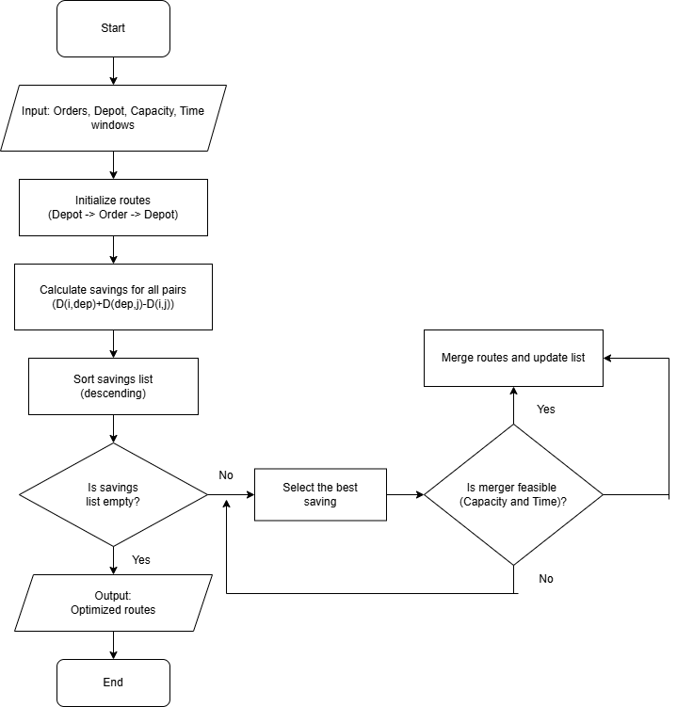

ALGORITHM GROCER_QUICK_OPTIMIZATION
// INPUT: P_set, Depot, V_cap, T_max(p)
// OUTPUT: R_set

// 1. Initialization Phase (Subdivision 1)
CREATE R_set = empty set of routes
CREATE Initial_Routes // Each order is its own route: (Depot -> P_i ->Depot)

FOR EACH order P_i in P_set:
CREATE Route_i = [Depot, P_i, Depot]
ADD Route_i to Initial_Routes
END FOR

// 2. Calculation of Savings
CREATE Savings_List = empty of savings
FOR EACH pair of routes (Route_i, Route_j) where i != j:
// Calculate the saving from joining P_i and P_j (Eliminating the intermediate return trip to the Depot)
Saving = D (P_i, Depot) + D(Depot, P_j) – D(P_i, O_j)
ADD (Saving, P_i, P_j) to Savings_List
END FOR
SORT Savings_List in descending order by Saving

// 3. Route Merging Phase (Subdivision 2 – Main Loop)
WHILE Savings_List IS NOT empty:
TAKE the best Saving = (A, P_i, P_j) from Savings_List
FIND Routes R_A and R_B that contain P_i and P_j

// DECISION POINT: Is the merge valid? (Constraints)
IF (P_i is an endpoint of R_A) AND (P_j is a startpoint or R_B AND
(Capacity(R_A + R_B) <= V_cap) and (Total_Time(R_A + R_B) <= Global_Max_Time):

// DECISION POINT: Time Constraint Check (Must Have)
IF EVERY order p_k in R_A + R_B satisfies (Arrival_Time(p_k) <= T_max(p_k) + 30 minutes):
MERGE R_A and R_B into a new route R_new
REMOVE R_A and R_B from Initial_Routes
ADD R_New to Initial_Routes // Replace
REMOVE (A, P_i, P_j) from Savings_List
END IF

// 4. Output
R_set = Initial_Routes
RETURN R_set

Detailed Explanation of the Solution
The solution applies abstract thinking by modelling the road network and delivery locations as a graph, where nodes are the depot and delivery points, and edges are the travel distances D(1a, 2b). The algorithm operates in several logical stages to address the problem objectives.
Initialization: The process begins with the subdivision of the problem in the initialization phase. It is assumed that each order constitutes its own temporary “route”: the vehicle leaves the depot, delivers a single order, and returns to the depot (Depot -> Pi -> Depot). This abstraction guarantees that all orders are served, fulfilling a fundamental requirement.
Calculation of Savings and Fuel Efficiency: The core of the algorithm is the Saving metric. This metric quantifies the reduction in total distance (and thus, fuel consumption) achieved by replacing two round trips to the depot with single direct segment between two orders (Pi -> Depot ->Pj is replaced by Pi ->Pj). The formula D(Pi, Depot) + D(Depot, Pj) – D(Pi, Pj) represents the distance saving. By sorting the savings in descending order, the algorithm prioritizes merges that offer the greatest benefit in distance reduction, directly addressing the requirement for fuel minimization.
Decision Points and Constraints: Route merging only proceeds if strict conditions are met, acting as the critical decision points:
- Connection Compatibility: Only the ends of routes can be merged. For example, of Pi is the last point or Ra and Pj is the first point of Rb, they merge in the order Ra -> Pj -> … (central joining is not allowed in this simple implementation).
- Capacity Constraint: The sum of the load of orders in Ra, and Rb must not exceed the vehicle’s maximum capacity (V_cap). This ensures the practical feasibility of the route.
- Time Constraint (Timely Delivery): This is the most critical Must Have constraint. After a potential merge, the arrival time at every delivery point in the new route R_New is simulated. If the simulated arrival time at any order exceeds the promised delivery time by more than 30 minutes (Tmax(p) + 30 minutes), the merge is rejected. This rigorous check ensures that the solution meets the objective of timely delivery.
Order Allocation: The assignment or orders to routes (requirement 1) is achieved implicitly though the merging process. Each order starts in its own route, and the heuristic process groups them into efficient routes until no further savings can be made without violating the capacity or time constraints. Upon completion of the main loop, the resulting set R_set represents the optimized set of routes with all orders allocated.

Key Assumptions
- The distance D(1a, 1b) accurately represents the travel time; i.e, traffic is static or predictable (real-time traffic is not used).
- All vehicles are identical in capacity (V_cap) and speed.
- The service/unloading time at each delivery point is a predefined constant.
Reflection on Problem-Solving Techniques
The design of this solution was based on two main thinking techniques:
- Abstract Thinking: This was used to transform the physical real-world problem (rucks driving) into an abstract computational model. The road network was modelled as a graph. The goal of “reducing fuel consumption” was abstracted into the “minimization of total path distance” (the function D(La, Lb)). This abstraction was crucial in allowing the design of a mathematical algorithm.
- Subdivision (Decomposition): The problem was divided into sequential phases: Initializing routes, Calculating the Saving metric, and iteratively merging routes. This subdivision made the complex VRP problem manageable. The approach of “starting with many small routes and merging them” is a construction technique that is inherently simpler than a destruction approach (starting with one large route and splitting it), simplifying the logical flow and the implementation of the pseudocode.
The strategic choice of the Savings Algorithm was not arbitrary; it represents a pragmatic solution to a complex business problem. The primary objective is to balance two competing priorities: cost reduction via minimized fuel consumption (distance) and customer satisfaction via timely delivery (time constraint). The algorithm addresses this duality directly. The score Savings metric ensures greedy progress toward the minimum distance, optimizing the cost factor. Simultaneously, the inclusion of the 30-minute time constraint check acts as a rigid safety filter, preventing any cost-saving merge that would compromise the critical customer service metric. This dual-objective structure is what makes the heuristic approach suitable for Grocer Quick’s operational reality, providing a financially responsible and client-focused outcome.

Justification of the Approach and Limitations
Justification: The Savings algorithm-based approach was chosen because it is a heuristic method of high performance and low complexity. It is appropriate for the Grocer Quick scenario because it delivers a fast solution that is close to the optimum (although it does not guarantee the global optimum) and, crucially, the time window. The justification lies in the balance between accuracy (good distance minimization) and calculation speed (essential for daily planning).
Limitations and Assumptions: Every algorithmic solution has limitations.
- Optimality: The Savings algorithm is a heuristic, meaning the final solution R_set is very good, but it may not be the mathematically perfect solution (the absolute minimum total distance). An exact optimization algorithm (e.g., integer linear programming) would guarantee the optimum but would be unfeasibly slow for a large number of orders.
- Dynamic Traffic: The model assumes constant travel time. In a real environment with fluctuating traffic, the solution could quickly become sub-optimal, potentially violating the 30-minute constraint.
- Single Depot: The solution is limited to a single depot. If Grocer Quick expands to have multiple distribution centers, the algorithm would require an extension to handle the Multi-Depot VRP (MDVRP).

Conclusion
The proposed solution, based on an adapted Savings algorithm heuristic, provides a logical and efficient framework for addressing Grocer Quick’s routing problems. By prioritizing distance “savings”, the objective of minimizing fuel consumption is met. The strict checks on time and capacity constraints at the critical decision point ensure compliance with timely delivery (less than 30 minutes late) and total order allocation. While the approach is heuristic and has inherent limitations regarding dynamic traffic, its simplicity and execution speed make it practical and justified solution for Grocer Quick’s daily route planning.

References
- Clark, G. and Wright, J.W. (1964), Scheduling of vehicles from a central depot a to a number of delivery point. Operations Research, 12(4), 568-581 (A seminal work on the Savings Algorithm).
- Toth, P., & Vigo, D. (Eds.). (2014). Vehicle routing: problems, methods, and applications. Society for Industrial and Applied Mathematics. (A key textbook on VRP).
- K. M. T. Al-Rawahi and A. R. O. J. Al-Sabti, (2015). Requirements Engineering Process Using MoSCoW Technique: A Case Study. International Journal of Computer Applications, 117(2), 26-30.
- D. C. L. Lira and P. A. N. B. Lages, (2017). Decomposing complex systems using abstract thinking. European Journal of Engineering Education, 42(5), 499-511.

