Creative Venture
AC2 - Evaluative Report
M7X01792

By Stacey Mead
P141539
Contents
List of Illustrations Page 3
Executive Summary Page 4
Review of Research Methodology and Methods Page 5
Review of Creative Enterprise Strategy Page 10
Appraisal of Final Proposition Page 17
Future Trajectories Page 19
Bibliography Page 21

List of Illustrations
Figure 1 – Material Lab, London
Figure 2 – Object Rotterdam, Stand
Figure 3 – Object Rotterdam, Poster
Figure 4- Object Rotterdam, Interactive Installation
Figure 5 – SA1 Balustrade, with design Error
Figure 6 – Utility House Second Meeting
Figure 7 – Old Fire Station, Oxford, Brochure Proof, Designed by Alexandria Coke
Figure 8 – Creative Venture Samples, Printed
Figure 9 – Creative Venture Samples, Printed

Executive Summary
The main thing I have realised this year, through all the briefs and the mountains of work is you could always do more. When working with a client there is always that extra email you could have sent or that extra design you could have space mapped. With an exhibition there is the extra planning you could have done or the spare sample you could take just in case. And most importantly with your own work there is always a small change you could have made to make it better or that one last sample. But I always find that one last sample is never the last, that one last sample turns into the next collection of work.
I guess for me this is not just me handing in work because we have a deadline, this is not just passing the year, or completing the work for a certificate. I do this because I love it, I love to make, be that making to draw or making samples. My life is making in one form or another. You could take me away from surface pattern and I am sure I would find another way to make.
My work will always be unfinished but if you look at this in another way, I will always have more to explore, more to say and more to do. Which in design can only be a good thing, there will always be new ideas, new work and new samples.
If when reading this you are thinking something seems unfinished, as if there is more to be said or done, that is probably because there is and if you look me up in a few years’ time hopefully I will have achieved some of it.

Review of Research Methodology and Methods
Theoretical research into philosophers and theorists has helped me to recognise and explain why my practice is shaped in the way that it is. Being able to explain why I enjoy my practice and the way I create my work is important to me as I can link everything together.

Through the Research and Communication Methods module I explored how the starting points for my work effects the way in which I design and the importance of this process for me as a designer. I tend to begin by making and wanted to explore why I do this. I found that I was using making as something to hide behind. What I discovered was that the element of childs play that can be found in making, enhances my creativity and that making is an important part of my identity as a designer. However I also realised that I did not need to use making as my selling point that my work is exciting in its own right and that making is just something I inherently do. I decided that I wanted to explore further how I use everyday objects to make, and focus on the beauty in the overlooked more than using these objects as my making materials.

In contrast to childs play I started research for Creative Venture by exploring Aesthetic philosophy and how it could be used to look at the everyday. I wanted to find affirmation for the notion of everyday design being as important aesthetically as an artwork you may hang in your home.

Aesthetic philosophy is a branch of philosophy concerned with beauty and what is considered beautiful. Within my work I strive to make that which would normally be overlooked into something beautiful. I want to create work that forces one to take notice of a wall or balustrade, to appreciate it for more than just its usefulness and harness beauty for my designs.

In traditional Aesthetic philosophy the everyday could never be considered beautiful, as something with function is not. Beauty is, in this instance reserved for the gallery or only something nature can create. ‘According to the traditional view, aesthetic experience, in its purist form, is to be had either in an art gallery or in wilderness, when we are outside the stream of everyday life.’ Parsons (2008:167) Here ‘aesthetic experience’ is considered to be something that can only happen when one is removed from their comfort zone and pushed out of their normal experience.

Does this then mean that if one was to go into a home or office building and marvel at the interior that this does not qualify as an aesthetic experience? When visiting Material Lab in London as part of my research for Creative Venture, I would argue that I was lost in the beauty of the surfaces available. It could be said that as this is my area of expertise that I was more interested in the practical side of these surfaces and how they could influence my practice. However the beauty of these objects took me out of my every day, I lost track of time and was completely taken in by the surfaces, textures and innovation on display. In this instance I was wholly taken in, so how can this not be called an aesthetic experience? It was purely the appearance of these objects that made me feel this way. It was not until I had absorbed their beauty that I began to question the technical processes that would interest me as a practitioner.

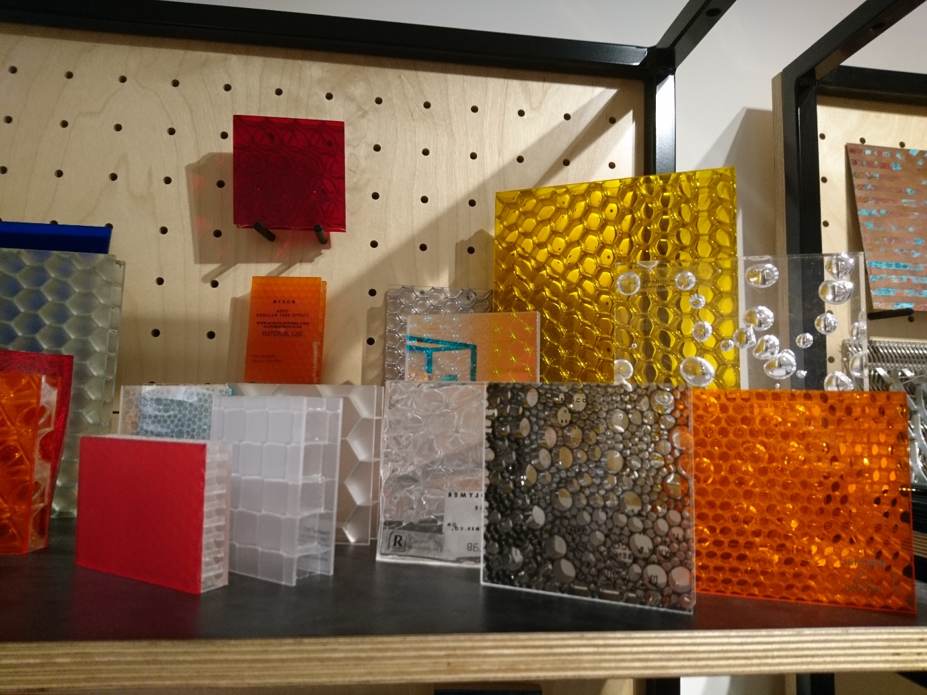
Figure 1 Material Lab, London

Another interpretation of Aesthetic philosophy considers the idea that in order to see a useful object as beautiful you need to take it out of its natural or useful surroundings. Here the context of the piece is as important as the piece itself. One may be able to appreciate something that is well-designed but it is not until it is taken away from the distractions of the home and put into a gallery setting that it can truly be considered beautiful. ‘We may consider that the aesthetic appreciation of everyday objects is, in fact, only possible under certain unusual conditions, such as the ‘art-gallery’ living room above, contrived to make everyday objects closely resemble artworks.’ Parsons (2008:174)Here the use of the word ‘contrived’ implies a negative to the way in which design within the home can lead to more of a non-functional or impractical space that is beautiful. Again the everyday it would seem cannot be considered beautiful and functional. If an object is in use then is seems to follow that it loses its beauty.

If you were to listen to the research I have undertaken into Aesthetic philosophy you would think design cannot be beautiful. The notion that you can only have an aesthetic experience in a gallery overlooks all the beauty that can be found in design. A well designed product or car or interiors is as important as a beautiful painting or landscape. Why would one take pride in owning a certain branded product if not because they found beauty in it? That definition of beauty may not be traditional, it may not have the social standing of an old masters painting but that does not mean that it does not have beauty for the owner of the designed product.

Or as William Morris would say ‘if you want a golden rule to fit everyone this is it: ‘Have nothing in you houses that you do not know to be useful or believe is beautiful’’ Morris (1882:108) However this does still imply that beauty and use are separate qualities.

I want my practice to create that aesthetic experience without the need for being removed from your everyday life and without it being a centre piece in an art gallery or a gallery-like interior. Within my practice instead of my work needing to be separate from everyday life to experience it, I would like it to jolt you from your everyday to create an experience within your life that you did not expect.

More over why should we not spend more time making the surfaces we use beautiful. Within my work the important factor is that the everyday is not overlooked. Be that through my making objects from the everyday to then draw from, or in my choice of what I design. I strive through my designing to highlight interior surfaces that normally would just be a plain choice of material. When designing a new kitchen, bathroom, office, reception area, why can we not invest more time into choosing a work surface or wall cladding that adds pattern to the everyday. As said in the book Simply Pattern, pattern ‘…is not the icing on the cake: it is the cake itself.’ Viction:workshop (2008:6)

Similarly in the book Emotional Design by Donald Norman functionality and beauty are explored, it is found that aesthetically pleasing design can even help the usefulness of an object. In one chapter an experiment by Tractinsky looks at how a well-designed object can be considered more usable even though it has the same functional ability as a less beautiful equivalent. Norman (2006:17) Norman concludes that ‘When people are relaxed and happy, their thought processes expand, becoming more creative, more imaginative.’ Norman (2006:19)

The idea of the mind expanding when relaxed comes back to the research I have previously undertaken for Research and Communications and how child’s play can lead to the most creative outcomes. When at play you are relaxed, as shown by Tractinsky this leads to creativity. As much as I want to move away from explaining my need to make in Creative Venture, I will acknowledge that it is a very important part of my designing and as such the parallels shown with this research are interesting and something I would like to investigate further through my career as a designer.

As well as being able to better explain my work I have found that exploring theory has influenced my designing and helped me to decide what I want to do. I have found that the everyday holds great importance to me. Not only do I use it to inspire my designing but I want to be able to make a feature of the everyday with my work. ‘Pattern constantly reinvents itself but it’s makers objective never changes: to seek for one that can make a bold statement in any place, wrap itself on any surface and look good, and connect us with its beauty.’ Viction:workshop (2008:7) I am one of these makers, my designs will create beauty in unlikely places and push the boundaries of one’s aesthetic experience.
As well as researching the origin on my inspiration I also found through Research Methods and Communications that I find it hard to commit to what I want my work to be. I found that I am scared of admitting that I want to create large site specific architectural interior panelling. Currently I am trying to overcome this by allowing myself embrace the dreams I have for my work. I can be quite confident within some areas but when it comes to my work I find it hard to believe that it could be worthy enough of being placed in high end hotels or public buildings. Within my research I tent to get wrapped up in the theory and the meaning behind my work as a way deflecting the questions about where I see my work and where I want it to be. I am learning that to be more confident of committing to an area of design. And so this is where my next area of research will begin.

Review of Creative Enterprise and Strategy
The Creative Enterprise module allowed me to explore how I work as a designer and how I can ultimately earn a living from my work. Currently I am working on multiple live briefs, these being my first paid commission at the new UWTSD campus SA1, in Swansea, where my work forms part of the library, a collaborative project creating interiors for Utility House, alongside a recent exhibition of work at Object Rotterdam and planning an exhibition and workshop in the Old Fire Station in Oxford. All of these experiences have been a steep learning curve but have been amazing to be a part of, each bringing new and exciting prospects.
I feel extremely privileged to have had these opportunities. I have had to work extremely hard whilst making sure that I put myself out there, by completing competition briefs and contacting potential employers and galleries. I have been doing this alongside completing work of my own and other university commitments. All the extra effort has certainly paid off in both the knowledge and experience I have gained. It has tested my tenacity, time management and communication skills and helped me develop as a designer.
The pivotal experience to my Creative Venture has been exhibiting in Object, Rotterdam. Being selected as part of team of three students, I travelled to and exhibited in Object which is part of Rotterdam Art Week. I found the experience extremely inspiring and started to show me what I am capable of as a young undergraduate designer giving me more confidence in my own abilities for when I graduate and the possibilities of where I could be in the future.
At Object I was part of a three person team who created a display show casing our design work alongside visual interactions. The setup of the stand was an interesting process, within this limited time we experienced how we may self-promote when we leave university. I now feel more confident in setting up the end of year exhibition and to take owner ship of my exhibition space. I also have a clearer idea of the things that I will need to take into account when setting up my solo show in July. Although I have already exhibited in the university end of year show and New Designers in London before the experience of an external exhibition, in a different country like Object gave me far more to think about.
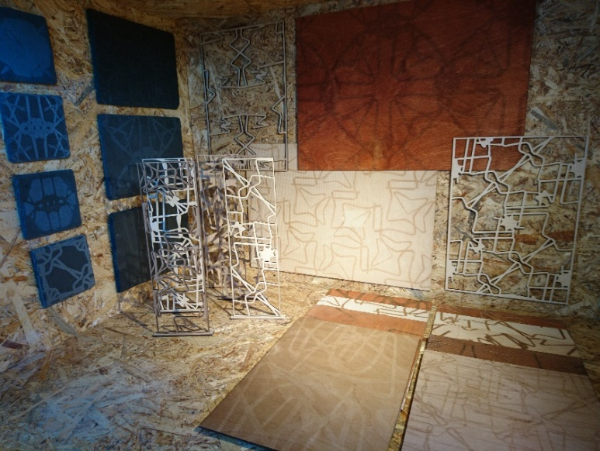
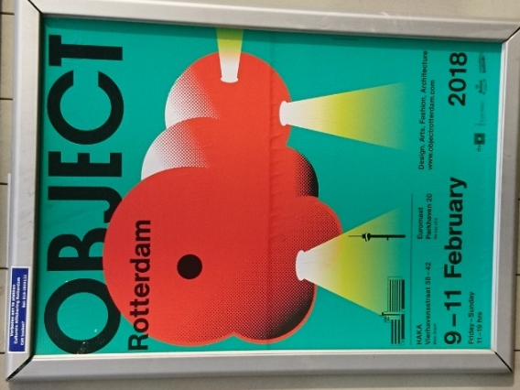
Figure 2 Object Rotterdam Stand
Figure 3 Object Rotterdam Poster

Being at Object also taught me a lot about how to create contacts and that sometimes the most unlikely conversations can be the most rewarding. When at Object I made an effort to talk to as many people as possible, giving business cards and taking business cards where I could. The exposure gained from this experience is amazing, especially as a soon to be graduate. If I were exhibit at a similar event again I would definitely make more of an effort to follow up with the people that I spoke to at the event. By preparing mailing lists and asking for more details from those that I spoke to I would hope to be able to keep in touch with them as it may not lead to anything immediately but could vital to work in the future. I will put this into practice for my solo exhibition by creating a mailing list that visitors could sign up for.
Object was also a great opportunity for primary research for my Creative Venture. As well as showing my designs I had a ‘making’ interactive installation where visitors were encouraged to make using paperclips. I exhibited their pieces on a pin board, this allowed me to explore my Make Draw Make ethos in a new way and see how others may approach the task. It was great to see the evolution of the makes and how people drew creativity from those who had made before them. From these makes I have been able to create a new collection of designs and explore some theories from research methodology.
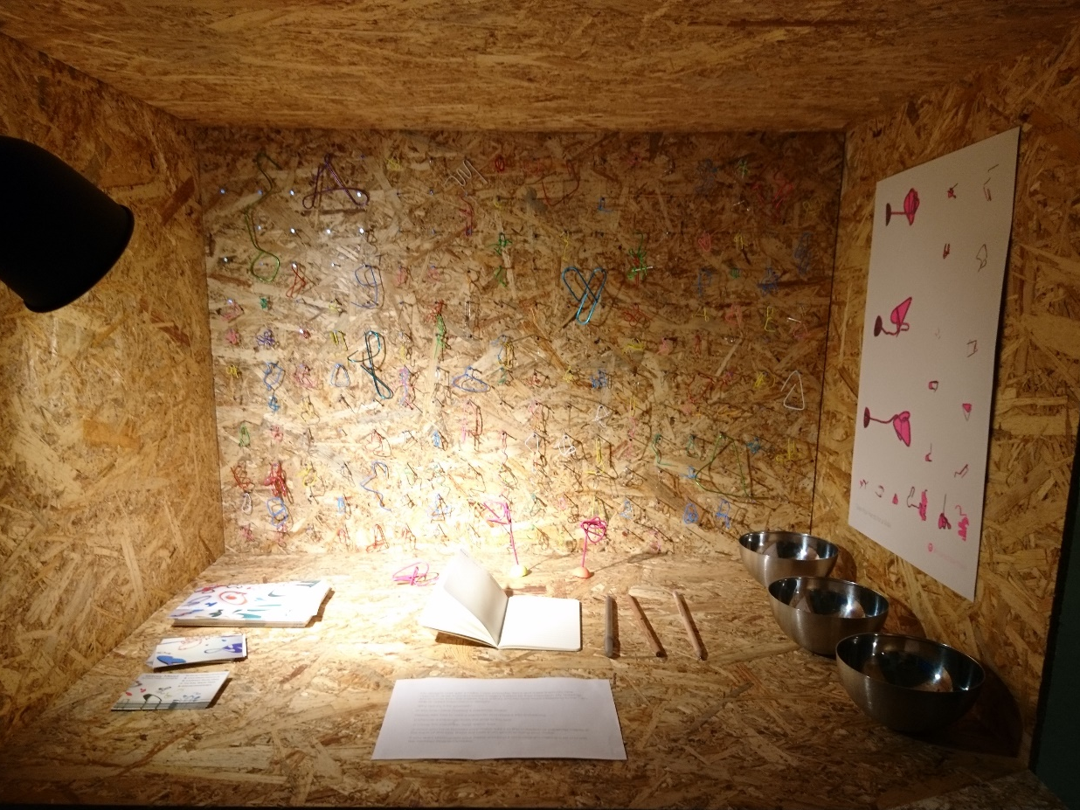
Figure 4 Interaction at Object Rotterdam
The most successful opportunity I have undertaken has been the SA1 project where I have been creating a balustrade for the library in the new SA1 building. Not only have I gained knowledge and experience from all the meetings, I have been able to work on the project from start to finish with a varied range of people in a commercial environment. I have learnt from this project the benefits of being part of a team that it is good to work with others and to make use of facilities like the Architectural Glass Company (AGC) so that I was not taking too much on. Also working with AGC has shown me another side of the production process, by handing over the production over to AGC it allowed me more time to complete other briefs and prepare for other opportunities.
SA1 has taught me the importance of double and triple checking my drawings. Unfortunately I misread the orientation of the architect drawing from which I created my production files. This meant two panels were misaligned and are having to be remade with the correct alignment. AGC have worked with me to rectify the problem and I have been fortunate that the client has taken on the costs of remaking the panels. If this were an external commission undertaken after I graduate I would have had to create the new panels free of charge as it was my oversight and I could have potentially lost me a client.
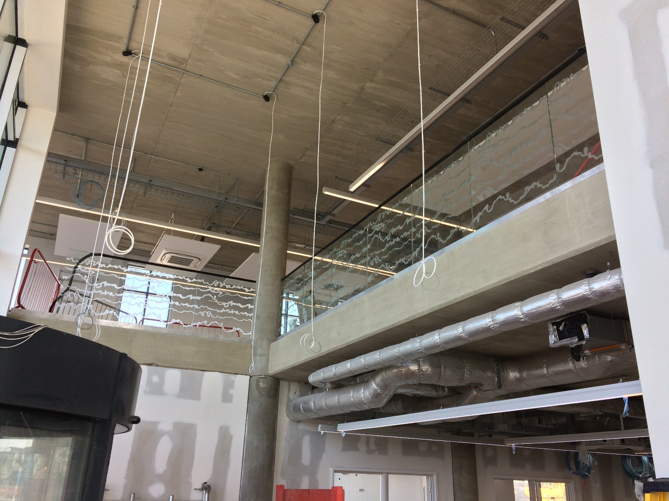
Figure 5 SA1 Balustrade
As well as working with AGC I have been completing work for Willis Newson to design interior pieces for their office building under the brand Utility House. This project has been a steep learning curve, not only because it is separate from university but also learning to work as part of a design collective as I have taken on the project with a fellow student. The main issue throughout this project has been communication. There has been little communication with Jane Willis between meetings that has led to a setback in the design process. I have also found it difficult to keep the project moving when working in collaboration with a fellow student.
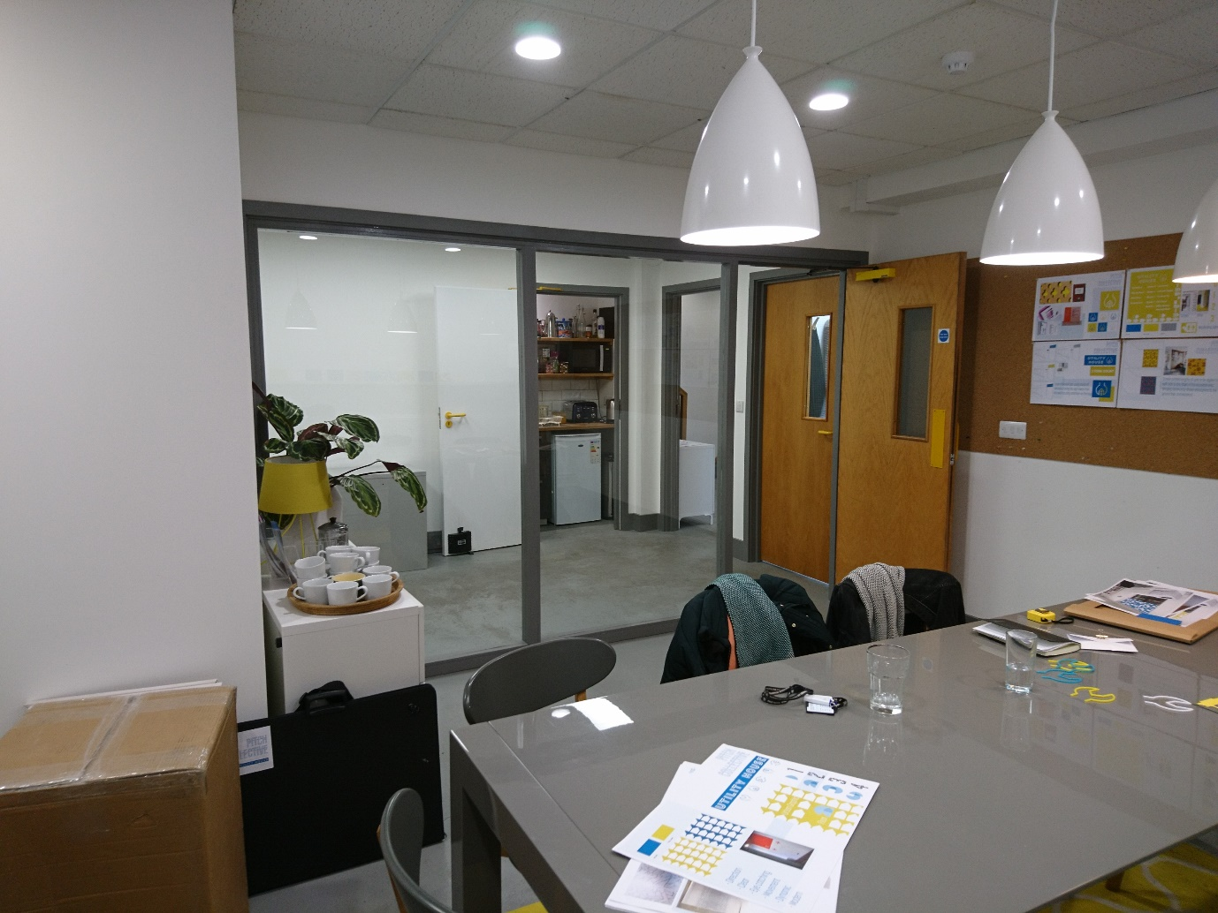
Figure 6 Utility House Second Meeting
When completing the enterprise module I found that we were responding to the client, Jane Willis, more slowly than I would have liked. The collaborative approach we have taken to this project has meant that before replying I would want to check with my fellow student that she agreed with my approach and to make sure we were both involved. This led to a slower response time and to less communication between meetings. Ultimately this led to the client being unhappy with our second submission. It has also been difficult since getting the negative feedback to move forward with our work as my fellow student is not always available to talk to about the project.
I have started to make sure that I reply to emails in a timely manner even if this means taking the initiative and replying on behalf of the team. We have since submitted new designs that we hope take on board the feedback given. Currently we are waiting on a response so that we can move forward and contact production partners for the job.
As well as completing the live briefs I have been in regular contact with the programme manager at the Old Fire Station Oxford. Although the solo exhibition I have coming up is not until July preparation has begun. I have already submitted marketing material and signed contracts for the upcoming exhibition and workshop. This has meant planning well ahead of time and creating marketing material when I was still unsure of the direction of my Creative Venture.
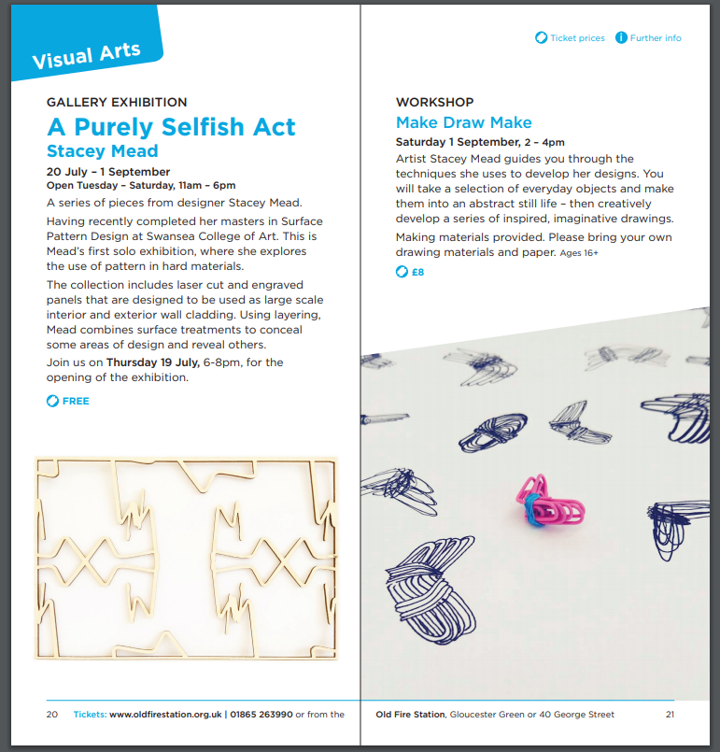
Figure 7 The Old Fire Station Brochure Proof
Exhibiting in Oxford will hopefully allow me to sell my work but the main benefit for me is that it will be great publicity for me as a designer it is in my home town and I want to use the opportunity to gain more contacts and potential clients. Throughout this year I have been trying to move away from seeing my work as artwork however for this exhibition I am going to sell my samples as artworks. They have a shop where they have also agreed to sell some products, as well as postcards of my work. At Object there was a design collective called Our Postmodern selling small works, this was a great way of getting their work selling and could be something to pitch to the shop at the Old Fire Station.

Critical Appraisal of the Final Proposition
As set out in my research methodology the aim of my Creative Venture was to create designs that could be used in commercial interior spaces with a view to gain contract work on buildings such as offices and hotels. I have done this by creating a range of material samples which could be used on many surfaces with a focus on hard materials such as wood, metal, slate and other natural materials.
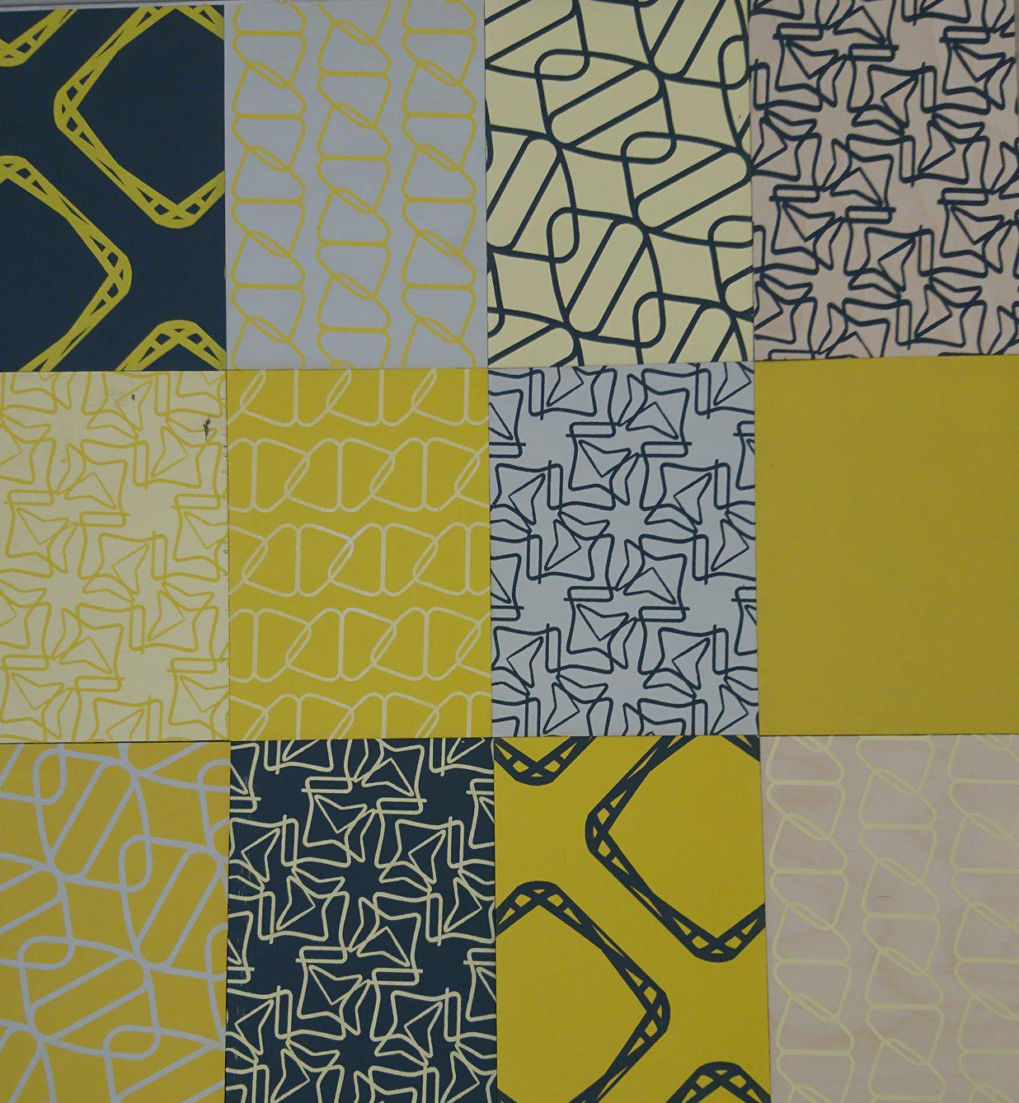
I have explored materials that I have not previously looked at like marble and limestone to expand the areas in which my designs could be used. I chose to stick with natural materials as having previously worked with slate, wood and Perspex I found the natural materials complimented designs more than the man made. I aimed to create a catalogue or library of design that could be used by a client as a source for inspiration when creating an interior space. I want my clients to be able to look at my range of designs, in a variety of materials and apply them to site specific surfaces.
Figure 8 and 9 Creative Venture Printed Samples

I initiated this technical exploration as part of the work I produced for Object Rotterdam. For Object I created a series of wooden samples, using the laser cutter and engraver to create intricate patterns. During the process I soon realised I needed to expand the materials and processes I am using to keep my work exciting and innovative. I did this by looking at more hard materials like stone and different types of wood. I pushed the processes I have used by moving away from lasers and going back into the print room. Print has always been a part of my process of design, by applying layers of print I have created a surface to remove with the laser. However more recently I have wanted to return to the print room and make print as important as the laser by printing my current collection as well as creating laser samples. Print will also be a much more accessible way of working once I graduate and no longer have access to the laser equipment.

My Final Proposition is an ongoing body of work, so far I am really pleased with the outcomes I have produced. Through the exploration of materials I have reignited my passion for hard materials and surface manipulation. Due to the other projects and commissions I have been working on whilst completing my Creative Venture time management has been key to juggling my workload, this has meant that I have not been able to spend as much time as I would have liked to on my own work. However these opportunities will allow me to carry on my work after I graduate. The live projects are integral to me as a young designer to grow and build a client base that will want to invest in my material library.
Taking on the SA1 project has inspired me to look more at this area of design, I would be keen to design one off site specific interiors that are used as statement pieces within new buildings. I would also like to have a commercial range of designs that might be more accessible to manufacturers and that would be a more lucrative option for me as a designer. The range of samples I have created is more aimed at the commercial market and to show employers the range of my design work.
Object Rotterdam has been my main inspiration for my Final Proposition with the city being key to my research. I have been heavily influenced by going to Material Lab in London and seeing how they have collected and curated many material samples. Seeing the work of other designers helped me shape where I wanted my collection to go and how it could be used. Seeing the range of materials and how surface patterns can be added inspired me to develop my designs onto more materials.

Future Trajectories
Once I have completed my degree I will be continuing to expand my practice by promoting myself outside of the university setting. During this last year I have been in contact with a local gallery in my hometown of Oxford called the Old Fire Station and have an exhibition opening in July 2018. After my end of year exhibition last year, I created press packs that I sent to companies and galleries I felt I wanted to work with, from this the Old Fire Station invited me to have an exhibition in their gallery. As part of this exhibition I will be showing work from my Creative Venture, I will also be delivering a drawing workshop exploring making as a source of inspiration. By having this planned it gives me focus for once I have completed my end of year exhibition. It will also help me to promote my designs, hopefully leading to further new and exciting opportunities.
Once I have completed my graduate exhibition within university I plan to see where I want to develop my work further. The Final Proposition I am handing in as part of this module is only the beginning and I feel like I have only scratched the surface with the work I have created to this point. I am hoping that once I have handed in I can be more objective about the work I have created so far and can plan to make more whilst I still have access to the equipment within university. This work will be what I take to New Designers, if I am selected to go, and will form part of my collection for my exhibition in Oxford in July.
I will be pitching to go to week one and two of New Designers. By pitching for both weeks I hope to show that my work pushes the boundaries of what surface design could be. As my work is hard materials and for large scale interiors I would like to see what exciting opportunities may be available in week two in comparison to week one.
Another way I want to explore potential employment is by continuing communications with Willis-Newson. I would like to develop our working relationship and by keeping in touch with this company I hope that I may be able to work with them again. To make sure that this line stays open to me I will continue to provide the highest level of work for my current project with them.
Whist completing Creative Venture I have also been applying for a visa to work in Australia, and in October will be moving out there for six months. I want to use this opportunity to take in new culture and to refresh ready to start my search for employment. By taking a digital portfolio with me I hope to be able to apply for industry related jobs and talk to fellow designers whilst I travel.
In between my exhibition and going traveling I will be adding to my mailing lists to keep any contacts I have made informed of the work I am creating. I will also be refining my CV and digital portfolio to take with me travelling to make sure I make the most of any employment opportunity. I will also be applying for the Churchill Fellowship which encourages research into innovative practice overseas. If successful I would receive a grant to fund a research project, this could be a great way to further my practice and explore further the links between my practical and theoretical work.
Once I return from travelling I will be looking for employment. I hope to exploit all the contacts I have made over the last year.

Bibliography
Books
Antonelli, P. (2006) Safe: Design Tales on Risk. New York: Basic Books
Borchard-Hume, A. (2010) Keeping it Real: From the Readymade to the Everyday. The D. Daskalopoulos Collection. London: Whitechapel Gallery
Buchanan, R, Doordan, D and Margolin, V. (2010) The Designed World: Images, Objects, Environments. Oxford: Berg
Carlson, A and Parsons, G. (2008) Functional Beauty. Oxford: Oxford University Press
Davies King, W. (2008) Collections of Nothing. Chicago: The University of Chicago
Flood, C and Grindon, G. (2014) Disobedient Objects. London: V and A Publishing
Hudek, A. (2014) The Object. London: Whitechapel Gallery
Morris, W. (1882) Hopes and Fears for Art London: Ellis and White
Norman, D. (2004) Emotional Design. New York: Basic Books
Viction:workshop. (2008) Simply Pattern. Hong Kong: Viction:workshop

